ANIL NEERUKONDA INSTITUTE OF TECHNOLOGY AND SCIENCES
(ANITS)
(Autonomous)
Affiliated to Andhra University, Visakhapatnam
Department of Computer Science and Engineering

DATA STRUCTURES AND ALGORITHMS
PROJECT DOCUMENT
Undo / Redo Text Editor Using Two Stacks
A Stack-Based History Mechanism with an Interactive Visualiser
Project document submitted in partial fulfillment of the requirements for
Data Structures and Algorithms
Submitted by
A25126510086 | K. Surya
A25126510102 | P. Leela Seshu
A25126510105 | Teja Ponnada
A25126510113 | R.M. Ksheeraj
A25126510120 | D. Sumanth
Under the Guidance of
Dr. B. Meena
DSA Faculty, Mentor
II/IV B.Tech – CSE
Academic Year 2026–2027

CERTIFICATE
This is to certify that the project document entitled “Undo / Redo Text Editor Using Two Stacks” submitted by the following students of II/IV B.Tech – CSE, Academic Year 2026–2027, is a bonafide record of the work carried out by them under my supervision and guidance.
A25126510086 | K. Surya
A25126510102 | P. Leela Seshu
A25126510105 | Teja Ponnada
A25126510113 | R.M. Ksheeraj
A25126510120 | D. Sumanth

The document has been submitted in partial fulfillment of the requirements for the course Data Structures and Algorithms, and has not been submitted to any other university or institution for the award of any degree or diploma.
Dr. B .Meena  Faculty, Data Structures and Algorithms  ANITS, Visakhapatnam  Signature | Head of the Department  Department of CSE  ANITS, Visakhapatnam  Signature
Date: Place: Visakhapatnam

DECLARATION
We hereby declare that the project work entitled “Undo / Redo Text Editor Using Two Stacks” is an original piece of work carried out by us under the guidance of Dr. B. Meena, Faculty of Data Structures and Algorithms, Anil Neerukonda Institute of Technology and Sciences (ANITS), Visakhapatnam.
We further declare that:
- The work reported in this document is entirely our own and has not been copied from any other source without due acknowledgement.
- All results and behaviour described were obtained by running the implemented programs, and the algorithms follow standard descriptions from the literature.
- This document has not been submitted to any other university or institution, either in full or in part, for the award of any degree, diploma, or certificate.
Place: Visakhapatnam Date:
A25126510086 | K. Surya
A25126510102 | P. Leela Seshu
A25126510105 | Teja Ponnada
A25126510113 | R.M. Ksheeraj
A25126510120 | D. Sumanth

ACKNOWLEDGEMENT
The successful completion of this project would not have been possible without the support and guidance of several people, to whom we owe our sincere gratitude.
We express our deepest gratitude to Dr. ____________________, Faculty of Data Structures and Algorithms, ANITS, for her guidance, patience and constructive feedback at every stage of this project.
We extend our sincere thanks to the Head of the Department of Computer Science and Engineering, ANITS, for providing the academic environment, laboratory facilities and institutional support needed to carry out this project.
We are also grateful to the Management of ANITS for encouraging a culture of learning and innovation among students, and for the computing facilities that made our development and testing possible.
Finally, we thank our family members and friends for their continuous support, encouragement and patience throughout the project.

ABSTRACT
This project presents the design and implementation of an Undo/Redo mechanism for a text editor using the stack data structure. Two stacks, an Undo stack and a Redo stack, hold snapshots of earlier and later versions of the text, while the present text is kept outside both. Every edit pushes the previous text onto the Undo stack and empties the Redo stack; Undo and Redo move the current text between the two stacks.
The history is bounded by a configurable capacity (3 to 50 entries, default 8); when it is full, the oldest entry is discarded. The algorithm is implemented as a standalone C program that needs only the standard library, and as an interactive web visualiser in HTML, CSS and JavaScript that animates every stack operation and records each turn in a history tree. Both implementations follow the same two-stack snapshot algorithm. The report describes the theory, design, implementation, complexity analysis and testing of the system.
Keywords: Stack, LIFO, Undo, Redo, Snapshot, Bounded History, Data Structures.

TABLE OF CONTENTS
Tap or click any entry to jump to that page.
Certificate i
Declaration ii
Acknowledgement iii
Abstract iv
List of Figures vi
List of Tables vi
1 Introduction 1
1.1 Motivation 1
1.2 Problem Statement 1
1.3 Objectives 1
1.4 Scope 1
1.5 Organisation of the Report 1
2 Theoretical Background 2
2.1 The Stack 2
2.2 The Snapshot Approach 2
2.3 Why Two Stacks 2
3 System Design 3
3.1 The Two-Stack Model 3
3.2 Algorithms 3
3.3 Bounded History 3
4 Implementation 4
4.1 Technology Stack 4
4.2 C Program 4
4.3 Web Visualiser 5
5 Complexity Analysis 7
5.1 Time Complexity 7
5.2 Space Complexity 7
6 Testing and Results 8
6.1 Sample Session 8
6.2 Test Cases 8
7 Limitations, Future Work and Conclusion 9
7.1 Limitations 9
7.2 Future Work 9
7.3 Conclusion 9
References 10
Appendix A: Core Source Code 11

LIST OF FIGURES
Figure 3.1: The two-stack model 3
Figure 4.1: The web visualiser after typing three entries and pressing Undo once 6

LIST OF TABLES
Table 4.1: Technology stack. 4
Table 4.2: Principal data items of the C program. 4
Table 4.3: Functions of the C program. 5
Table 4.4: Files of the web visualiser. 6
Table 4.5: Correspondence between the C and JavaScript implementations. 6
Table 5.1: Time complexity of operations (C program). 7
Table 6.1: Sample session trace. 8
Table 6.2: Test cases and results. 8

CHAPTER 1

INTRODUCTION

1.1 Motivation
Undo and Redo are among the most frequently used features of any editor. They allow a user to reverse a mistake and, if necessary, restore it again. Behind this simple behaviour lies a data structure problem: edits must be reversed in the opposite order to that in which they were made. The stack, whose Last-In-First-Out (LIFO) rule gives exactly this order, is the natural choice [1], [3]. Although the idea is short, the interaction between the Undo history, the Redo history and a new edit is subtle, and is hard to appreciate from pseudocode alone. This project therefore pairs a clear C implementation with a visualiser that makes the stacks observable.

1.2 Problem Statement
To design and implement a text-editor history mechanism that:
- reverses edits in the correct order (Undo) and restores them (Redo);
- discards the Redo path as soon as a new edit is made;
- reports safely, without changing any state, when there is nothing to undo or redo; and
- limits memory use by keeping only a bounded number of saved versions.

1.3 Objectives
The project has the following objectives:
- Implement the stack operations push, pop, peek, isEmpty and isFull in C using an array representation.
- Implement Undo and Redo using two stacks and a separately held current text.
- Handle edge cases: empty stacks, unchanged text, and a full history.
- Provide a bounded history with a user-adjustable limit and an oldest-first discard policy.
- Build a browser-based visualiser that shows the stacks and their operations as they happen.
- Analyse the time and space complexity of the design.

1.4 Scope
The project covers a single text buffer whose complete content is saved as a snapshot at every change. It is delivered as a console program in C and as a web application running a separate JavaScript implementation of the same algorithm. Limitations of the design are discussed in Section 7.1.

1.5 Organisation of the Report
Chapter 2 gives the theoretical background: the stack and the snapshot approach. Chapter 3 presents the two-stack model and the Edit, Undo and Redo algorithms. Chapter 4 describes the C program and the web visualiser. Chapter 5 analyses time and space complexity, and Chapter 6 reports a sample session and the test cases. Chapter 7 lists limitations, future work and the conclusion. The core source code is given in Appendix A.
CHAPTER 2

THEORETICAL BACKGROUND

2.1 The Stack
A stack is a linear collection in which insertion (push) and removal (pop) take place at one end only, called the top. When the stack is stored in an array, an integer top marks the index of the most recent item. In this project top starts at -1, which denotes an empty stack; push increments top before storing the item, and pop reads the item and then decrements top [2].

2.2 The Snapshot Approach
There are two common ways to support Undo. A delta (or command) approach records only what changed and how to reverse it [4]. A snapshot approach records the entire state before each change. This project uses snapshots, because they are simple, make Undo and Redo trivially correct, and keep the algorithm focused on the stack operations. The cost is greater memory per entry.

2.3 Why Two Stacks
One stack can reverse edits but cannot restore them once they have been removed. A second stack receives each text that is undone, so that Redo can bring it back in the right order. The current text is kept outside both stacks; it is the state the user sees at present.
CHAPTER 3

SYSTEM DESIGN

3.1 The Two-Stack Model
The state of the editor consists of three parts: the Undo stack (older versions, most recent on top), the current text, and the Redo stack (versions that were undone, the next one to restore on top). Figure 3.1 shows how the current text moves between them.
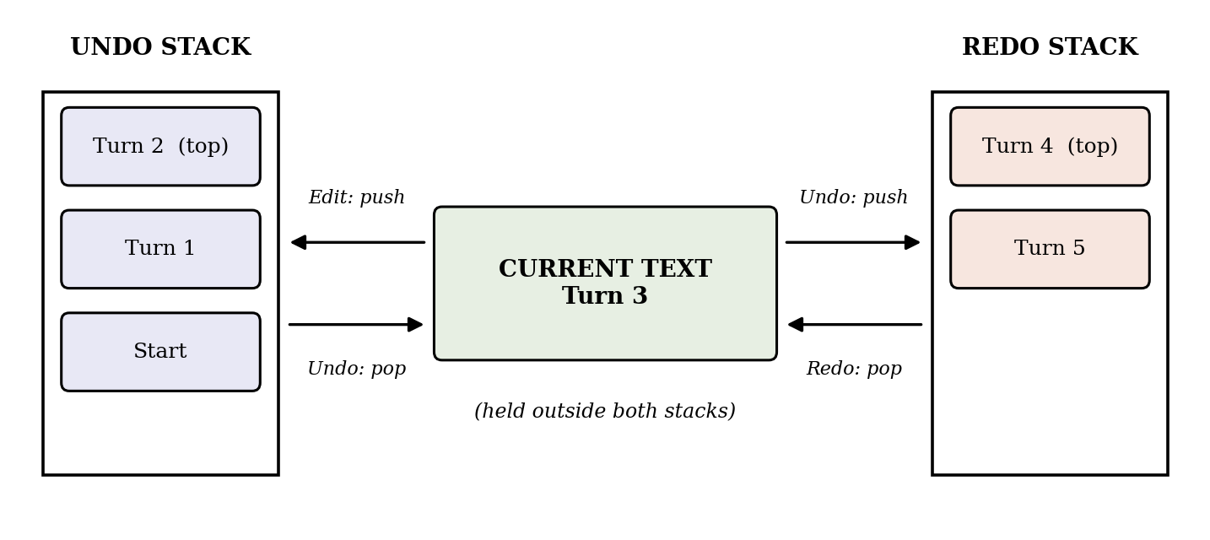
Figure 3.1: The two-stack model. Redo pushes the current text onto the Undo stack; a new Edit empties the Redo stack.

3.2 Algorithms
Edit(newText). Called whenever the text is changed.
- If newText is identical to the current text (or too long), reject it and stop.
- If the Undo stack is full, remove its oldest entry.
- Push the current text onto the Undo stack.
- Set the current text to newText.
- Empty the Redo stack, because the old redo path ends here.
Undo().
- If the Undo stack is empty, report "Nothing to undo" and stop; no state changes.
- If the Redo stack is full, remove its oldest entry.
- Push the current text onto the Redo stack.
- Pop the Undo stack into the current text.
Redo().
- If the Redo stack is empty, report "Nothing to redo" and stop; no state changes.
- If the Undo stack is full, remove its oldest entry.
- Push the current text onto the Undo stack.
- Pop the Redo stack into the current text.

3.3 Bounded History
Each stack holds at most limit entries (default 8). When a stack is full and another entry must be pushed, the oldest entry at the bottom is removed first by makeRoom. This discard policy is separate from the normal LIFO behaviour of push and pop. When the limit is lowered, setLimit removes the oldest entries of both stacks until each fits within the new limit.
CHAPTER 4

IMPLEMENTATION

4.1 Technology Stack
Layer | Technology
Console program | C (C11) compiled with GCC; standard library only (stdio.h, string.h)
Web front end | HTML5, CSS3 and JavaScript (ES6), with no external libraries
Visualisation | DOM, SVG (history tree) and the Web Animations API (card movement)
Hosting | Vercel
Table 4.1: Technology stack.

4.2 C Program
The program is contained in a single file, undo_redo.c, written in standard C11. The stacks are two-dimensional character arrays. Table 4.2 lists the principal data items.
Item | Type | Purpose
MAX_HISTORY | constant (50) | Largest permitted history limit
MAX_TEXT | constant (1024) | Size of one text buffer (1023 usable bytes)
undoStack, redoStack | char [50][1024] | Array storage for the two stacks
currentText | char [1024] | Present text, held outside both stacks
undoTop, redoTop | int | Index of each stack's top; -1 means empty
limit | int (default 8) | Current history capacity
Table 4.2: Principal data items of the C program.
The functions fall into core operations and supporting routines (Table 4.3).
Function | Role | Description
isEmpty, isFull | Core | Test whether a stack has no entries or has reached limit
push | Core | Increment top, then copy the text into that slot with strcpy
pop | Core | Copy the top text out, then decrement top
peek | Core | Copy the top text out without changing top
editText | Core | Record a new text: push the old text, set the new one, clear Redo
undo, redo | Core | Move the current text between the stacks as in Section 3.2
reset | Core | Empty both stacks and the text; restore limit to 8
removeOldest, makeRoom, setLimit | Support | Bounded-history policy
displayStack, display | Support | Print the text and both stacks, top first
readInput | Support | Safe line input with length check
main | Support | Menu loop
Table 4.3: Functions of the C program.
The menu offers: (1) enter or replace the complete text, (2) Undo, (3) Redo, (4) display the text and both stacks, (5) change the history limit, (6) reset, and (0) exit. The program is compiled and run as follows:
gcc -std=c11 -Wall -Wextra undo_redo.c -o undo_redo
./undo_redo

4.3 Web Visualiser
To make the algorithm visible, a web application was built with HTML, CSS and JavaScript. It runs entirely in the browser with no server or installation, and is hosted on Vercel at:
https://vercel.com/ksheeraj007-3360/undo-redo-text-editor-final/3rEhCKA1rdA2sFH3uWt6pgPsTqzgp

Its main features are:
- A text box, with Undo, Redo and Reset buttons and the shortcuts Ctrl+Z and Ctrl+Y.
- A live view of the Undo and Redo stacks as slotted columns; each card names its turn and the change it holds, and cards animate as they move between stacks.
- An adjustable history limit (3 to 50) and a Normal/Slow animation speed.
- A turn-history tree, drawn as a binary tree in first-child / next-sibling form, which archives every turn, including alternatives created by editing after an Undo, together with a ledger of all saved turns.
- A learning panel, opened with the "i" button, that displays the C source and explanatory notes.
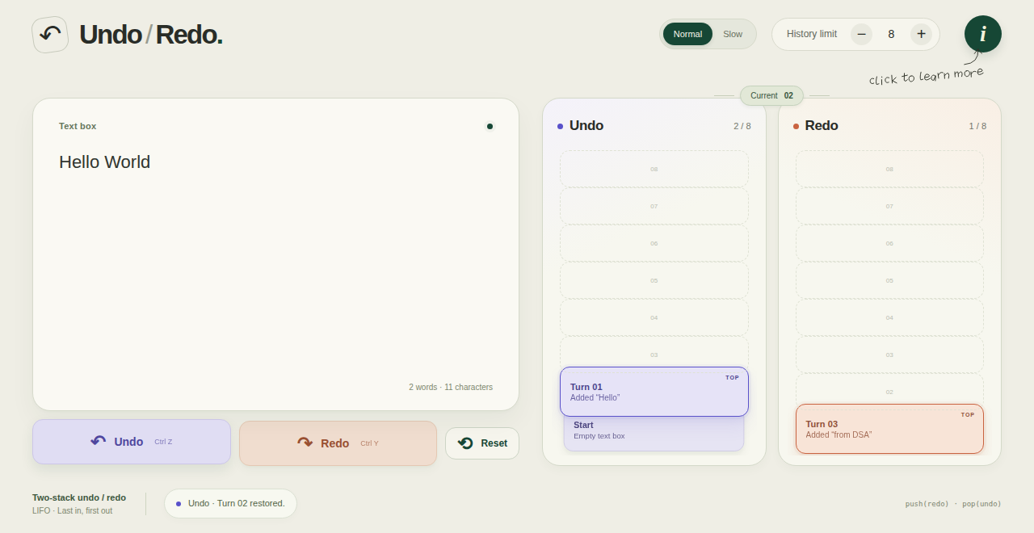
Figure 4.1: The web visualiser after typing three entries and pressing Undo once. The current text is "Hello World"; the Undo stack holds two turns and the Redo stack one.
The browser version follows the same algorithm as the C program, and its data model is kept separate from the display and animation code. Table 4.4 lists the files and Table 4.5 shows how the C functions correspond to the JavaScript methods of the History class.
File | Responsibility
index.html | Page layout
style.css, learning.css | Styling of the visualiser and the learning panel
stack-model.js | Data model: the History class holding both stacks and the current state
editor.js | Typing, buttons, keyboard shortcuts and event handling
animations.js | Card movement and highlights
history.js | Turn-history tree and ledger
learn.js, source-data.js | Learning panel and the source code it displays
undo_redo.c | The standalone C program (Section 4.2)
Table 4.4: Files of the web visualiser.
C function | JavaScript method | Note
isEmpty, push, pop, peek | same names | Operate on arrays
editText | commit | Also records the turn in the tree
undo, redo | undo, redo | Same two-stack transfer
makeRoom, removeOldest | shift inside push | Oldest entry dropped on overflow
setLimit | setLimit | Limit 3 to 50
reset | reset | Default limit 8
Table 4.5: Correspondence between the C and JavaScript implementations.
CHAPTER 5

COMPLEXITY ANALYSIS

5.1 Time Complexity
Let n be the length of the text in bytes and L the history limit (at most 50). Because every entry is a complete snapshot, copying an entry costs O(n), while moving top costs O(1).
Operation | Time | Remark
isEmpty, isFull | O(1) | Single comparison
push, pop, peek | O(n) | strcpy copies one snapshot
removeOldest / makeRoom (when full) | O(L · n) | Shifts up to L entries toward the bottom
editText, undo, redo | O(n) | O(L · n) in the call that discards an entry
reset | O(1) | Resets indices and limit
Table 5.1: Time complexity of operations (C program).

5.2 Space Complexity
The two stacks are static arrays of 50 × 1024 bytes each, about 100 KB in total, plus 1 KB for the current text, whatever the chosen limit; in general the space is O(L · n). In the web version, entries are objects shared by reference, so push and pop take constant time and discarding the oldest entry takes O(L). The turn-history archive is never pruned, so its size grows linearly with the number of turns until Reset.
CHAPTER 6

TESTING AND RESULTS
The C program was compiled with gcc -std=c11 -Wall -Wextra and produced no warnings. It was then run through the scenarios below.

6.1 Sample Session
Table 6.1 follows the state of the editor through a typical session. Stacks are listed with the top entry first; [ ] denotes an empty stack or empty text, and "" an empty text saved in a stack.
Step | Operation | Current text | Undo stack | Redo stack
0 | Start | [ ] | [ ] | [ ]
1 | Enter "Hello" | Hello | "" | [ ]
2 | Enter "Hello World" | Hello World | Hello, "" | [ ]
3 | Undo | Hello | "" | Hello World
4 | Redo | Hello World | Hello, "" | [ ]
5 | Undo | Hello | "" | Hello World
6 | Enter "Hello DSA" | Hello DSA | Hello, "" | [ ] (cleared)
7 | Redo (nothing to redo) | Hello DSA | Hello, "" | [ ]
Table 6.1: Sample session trace.
Step 6 shows the key rule: a new edit made after an Undo empties the Redo stack, so the earlier "Hello World" can no longer be redone.

6.2 Test Cases
No. | Test | Expected and observed result | Status
1 | Undo with an empty Undo stack | "Nothing to undo."; no state change | Pass
2 | Redo with an empty Redo stack | "Nothing to redo."; no state change | Pass
3 | Enter the same text twice | First "Text saved."; then "Text unchanged." | Pass
4 | Enter two texts, Undo, then Redo | Previous text returns, then the later text is restored | Pass
5 | Undo, then enter new text | Redo stack emptied | Pass
6 | Limit 3; enter A, B, C, D, E | Undo stack holds D, C, B; A discarded; current E | Pass
7 | Set limit to 2 and to 99 | "Use a number from 3 to 50."; limit unchanged | Pass
8 | Reset | Empty text, empty stacks, limit 8 | Pass
Table 6.2: Test cases and results.
The web visualiser was also exercised in a browser: typing, Undo, Redo and Reset update the stacks, counters and history tree as described in Section 4.3 (Figure 4.1).
CHAPTER 7

LIMITATIONS, FUTURE WORK AND CONCLUSION

7.1 Limitations
- The C program accepts one line per entry, up to 1023 bytes. Each valid, changed entry counts as one turn; identical text creates no new turn.
- Snapshots store the entire text, so memory use grows with text length rather than with the size of the change.
- The history limit may be set only between 3 and 50 entries.
- The web application is a separate JavaScript implementation; it does not run or compile the C program. In the browser, typing is grouped into one turn after an 800 ms pause.

7.2 Future Work
- Delta-based history: store only the changed portion of the text instead of full snapshots, reducing memory use [4].
- Circular buffer: replace the shifting in removeOldest with a circular array so that discarding the oldest entry takes O(1) time.
- Dynamic storage: use linked or dynamically sized stacks so that history is not limited by a fixed array size.
- Multi-line editing in C: extend the console program to larger, multi-line documents.
- Persistence: save the editor history so that it can be restored in a later session.

7.3 Conclusion
The project shows that two stacks and a separately held current text are sufficient to implement correct Undo and Redo. Edits are reversed in LIFO order, undone versions are restorable in the right sequence, and a new edit correctly ends the redo path. A bounded history keeps memory predictable, and the empty-stack checks make Undo and Redo safe at every point. The C program presents the algorithm in its simplest form for study, while the web visualiser makes the movement of data between the stacks visible, which helps in understanding the technique.

REFERENCES
[1] T. H. Cormen, C. E. Leiserson, R. L. Rivest and C. Stein, Introduction to Algorithms, 4th ed. Cambridge, MA: MIT Press, 2022.
[2] B. W. Kernighan and D. M. Ritchie, The C Programming Language, 2nd ed. Englewood Cliffs, NJ: Prentice Hall, 1988.
[3] M. A. Weiss, Data Structures and Algorithm Analysis in C, 2nd ed. Reading, MA: Addison-Wesley, 1997.
[4] E. Gamma, R. Helm, R. Johnson and J. Vlissides, Design Patterns: Elements of Reusable Object-Oriented Software. Reading, MA: Addison-Wesley, 1994.
[5] ISO/IEC 9899:2011, Information technology — Programming languages — C. International Organization for Standardization, 2011.
APPENDIX A

CORE SOURCE CODE
The listing below is taken from undo_redo.c. The complete program, including display, input and menu code, is supplied with the project.
int isEmpty(int top)
{
return top == -1;
}

int isFull(int top)
{
return top == limit - 1;
}

int push(char stack[][MAX_TEXT], int *top, const char text[])
{
if (isFull(*top) || strlen(text) >= MAX_TEXT)
return 0;

(*top)++; // move top to the next slot
strcpy(stack[*top], text);
return 1;
}

int pop(char stack[][MAX_TEXT], int *top, char text[])
{
if (isEmpty(*top))
return 0;

strcpy(text, stack[*top]);
(*top)--; // the item below becomes the new top
return 1;
}

int peek(char stack[][MAX_TEXT], int top, char text[])
{
if (isEmpty(top))
return 0;

strcpy(text, stack[top]);
return 1;
}

void removeOldest(char stack[][MAX_TEXT], int *top)
{
int i;
if (isEmpty(*top))
return;

for (i = 0; i < *top; i++)
strcpy(stack[i], stack[i + 1]);
(*top)--;
}

void makeRoom(char stack[][MAX_TEXT], int *top)
{
// history is full, so forget only the oldest saved text
if (isFull(*top))
removeOldest(stack, top);
}

int editText(const char newText[])
{
if (strlen(newText) >= MAX_TEXT)
return 0;
if (strcmp(currentText, newText) == 0)
return 0;

makeRoom(undoStack, &undoTop);
push(undoStack, &undoTop, currentText);
strcpy(currentText, newText);
redoTop = -1; // new edit means the old redo path ends here
return 1;
}

int undo(void)
{
if (isEmpty(undoTop))
return 0;

makeRoom(redoStack, &redoTop);
push(redoStack, &redoTop, currentText); // keep this text before going back
pop(undoStack, &undoTop, currentText);
return 1;
}

int redo(void)
{
if (isEmpty(redoTop))
return 0;

makeRoom(undoStack, &undoTop);
push(undoStack, &undoTop, currentText);
pop(redoStack, &redoTop, currentText);
return 1;
}

