Research Paper Summary

* Name: Shefali Kuril
* Roll No: 231230013
* Email-ID: kshefali23@iitk.ac.in
* Degree: MTech
* Course: Geodynamics (ES667)

# Title: Apatite thermochronology in modern geology

# Author: F. LISKER1*, B. VENTURA1 & U. A. GLASMACHER2

# Objectives:

* An overview of apatite thermochronology and its application in modern geological studies.
* Methodological developments in fission-track and (U–Th–Sm)/He thermochronology.
* Concepts and strategies for interpreting thermochronological data.
* Applications = absolute dating of rocks and tectonic processes, investigation of denudation histories, long-term landscape evolution, and basin analysis.

# Methodology:

1. Fission-track thermochronology:

* PRINCIPLE: Analysis of radiation damage trails (‘fission tracks’) in uranium-bearing, non-conductive minerals and glasses.
* Minerals = apatite, zircon and titanite.
* FISSION TRACKS: Fission tracks form over long periods from the spontaneous fission of uranium-238 atoms, appearing as sub-microscopic features typically around 10 nm wide and up to 20 µm long, detectable through chemical etching techniques.
* ANNEALING: Fission tracks can repair themselves over time through annealing when exposed to high temperatures, ultimately shortening or erasing the tracks. The degree of track shortening, revealing exposure to heat, is assessed by analyzing the distribution of track lengths, and substantial shortening can affect the accuracy of age measurements.
* FISSION-TRACK DENSITY: Fission-track density helps calculate the age of a sample by comparing the amount of uranium-238 to its daughter products. To determine this density, scientists count the number of fission tracks visible on a polished surface of a mineral grain under a high-powered microscope, (1000x to 1250x ) . The final age determination often involves averaging multiple single-grain ages, typically ranging from 20 to 100 measurements, to obtain a more accurate estimate known as the weighted mean age.

1. (U–Th–Sm)/He thermochronology:

* Assumptions= apatite closure temperatures (around 70 ± 7°C), partial retention zones (40-75°C), and diffusion models play a crucial role in interpreting (U-Th)/He data.
* PRINCIPLE: (U-Th-Sm)/He thermochronology measures the amount of helium trapped in minerals like apatite to understand the thermal history of a sample, relying on the decay of uranium and thorium to stable helium isotopes.
* APATITE HELIUM AGE: is determined by measuring helium-4 using laser or furnace outgassing, along with uranium and thorium levels measured with solution ICP-MS, reflecting helium accumulation from radioactive decay.
* CLOSURE TEMPERATURE: where helium retention becomes constant in mineral grains, varies depending on factors like crystal shape, cooling rate, and uranium-thorium concentration, impacting age interpretation.
* CORRECTION FACTORS: are applied to account for α-particles ejected or implanted during decay, including numerical corrections based on α-retentivity or physical removal of crystal rims, especially in crystals with uranium-thorium zonation.

# Key Findings:

* FISSION TRACK AGE TYPES: Fission track ages are categorized as event, cooling, or mixed ages, depending on the track length distribution, aiding in understanding when and how geological processes like rapid or gradual cooling occurred.
* UPLIFT, EXUMATION AND DENUDATION: Surface uplift is about how high the land rises, while crustal uplift is about how rocks move up and down vertically. Denudation is the general wearing away of Earth's surface, while exhumation is about exposing specific rocks. 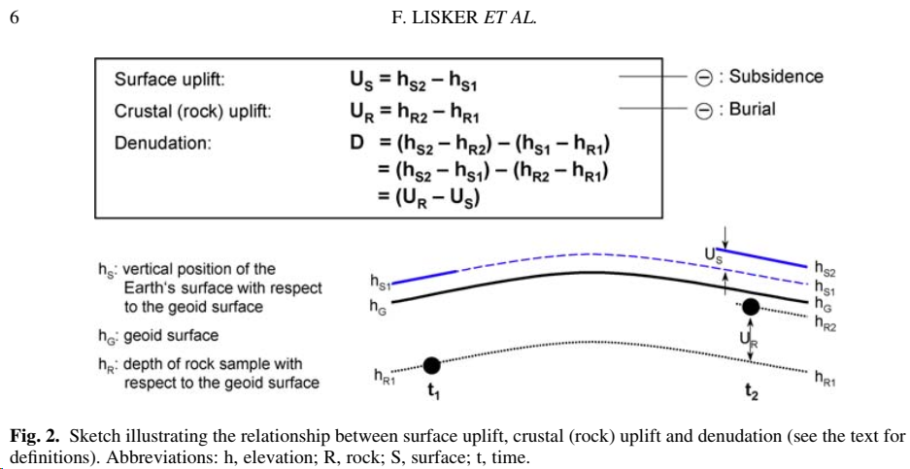 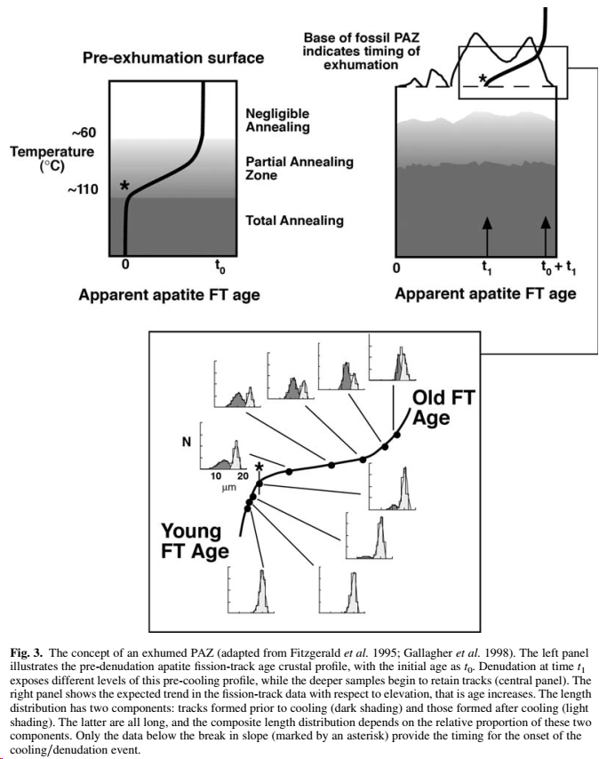
* VERTICAL PROFILES: Studying samples collected from different heights shows how rocks cooled and moved over time
* THERMOCHRONOLOGICAL DATA PATTERNS: like AFT age versus mean track length plots, reveal exhumation trends and identify different geological events. The 'banana' or 'boomerang' shape in these plots shows a mix of two cooling processes.
* APATITE THERMOCHRONOLOGY AND TOPOGRAPHY: In areas with complicated landscapes, reading data from young apatite thermochronology can be tricky because fast rock uplift can mess up how heat moves underground. To simplify this, scientists use various computer models.
* DETRITAL THERMOCHRONOLOGY: It examines grains from sediments to track where they came from and how long they've been exposed.

# Conclusion:

* Apatite thermochronology offers valuable tools for determining the ages of rocks and understanding their cooling histories.
* Applications range from establishing rock ages to investigating tectonic movements and studying long-term landscape changes.
* Advancements in methodology and data interpretation remains crucial.

# Implication:

* RECONSTRUCT EXUMATION HISTORIES of rock formations and while direct dating of rock formations is often difficult due to thermal resetting.
* PROVENANCE STUDIES OF SEDIMENTARY BASINS: By analysing the thermal history of minerals within sedimentary rocks, researchers can infer the source regions and the geological processes that transported and deposited the sediments and can also analyse their thermal histories.
* OROGENIC MOUTAIN BELTS: Researchers can reconstruct the timing and magnitude of tectonic events such as mountain building and erosion.
* CLIMATE-TECTONICS COUPLING: Used to evaluate the role of climatically driven erosion in shaping landscapes and influencing tectonic processes.
* MULTI-METHOD APPROACHES: Integration of data from various disciplines such as stratigraphy, geomorphology, structural geology, remote sensing, petrology, fluid inclusion analysis, and seismic data help to extend geological histories and provide more robust interpretations.
* TECTONIC PROCESSES: can be detected by analyzing disruptions in age patterns across faults, indicating relative uplift and fault throw.
* MISCELLANEOUS: data are often combined with other sources of data, including higher temperature thermochronology and geochronological dating techniques like 40Ar/39Ar and K-Ar dating. Additionally, terrestrial cosmogenic nuclide dating is used to compare erosion rates and understand landscape evolution.

**8.TOOL USAGE:**

1. MS word
2. To search paper = Researchgate, google scholar, webofscience etc
3. Google = to understand the terminology.
4. Chatgpt = First I read the paper and at the same time I extracted the keywords from it and then I searched for their definition from within the paper and google and developed a summary of around 5 pages then I used the chatgpt just to compress few contents to make it a 3 page summary and in some topics I simplified the language myself (since I am from civil engineering background).