CS 4475/8803 Computational Photography
Final Project Report

Kelley Sheffield
ksheffield3@gatech.edu
4/25/2013

Title: Exploring the Research of Efros: Creating Interesting Image Effects with Image Quilting and Texture Mapping

Names: Kelley Sheffield

Description:
I attempted to make two different types of artifacts with this project. The first was a simple texture mapping, and I experimented with different textures and parameters of the algorithm in order to see how the map was affected. The second was implementing a crude version of the Clone Tool found in Photoshop, however, this was not entirely successful. The Clone Tool samples an area of an image for the texture and maps that onto another selected area of the image, and I came quite close to successfully implementing this.

Goals: (what were your goals?, could be a list)

- Original goals
  - Create an iPhone app to generate novelty images
    - The app would have a stock selection of textures (like Instagram does with filters) and would allow the user to take a photo and select the desired texture
    - The app would be optimized to minimize system strain on the phone by me selecting the ideal patch size and amount of iterations necessary to create an acceptable image
- Changing Project Scope
  - After spending about 10 hours attempting to learn the iPhone development process, learning Objective C, and managing to create an app that barely managed to say, “Hello, world!” I realized it was time to change scope of my project so something more feasible in the time frame I had left
  - New goals:
    - Use source code to create a desktop GUI
    - Experiment with settings to learn how the algorithm works
    - Experiment with other applications of the algorithm

Did you meet these goals? If not, why NOT?
I was not able to successfully accomplish my goals of an iPhone app because it was simply too much to accomplish in the period of time I had. I admit this is because of taking extra time on the tablet assignment. Had we finished that on time, perhaps I would have gotten farther along on this goal. However, I did complete the project using the topic I originally set out to learn about, and therefore some goals were accomplished, as well as having a good starting point to continue to develop this idea (creating an app) over the summer as a side project.

Learning Objectives:

- How to take research and apply it
- Begin my journey into mobile app development
- Create a way to experiment with software to see how changing parameters affects the overall output.

Did you meet these objectives? If not, why NOT?
I successfully met these objectives, and I have a better understanding of how to take on a project without much guidance. I mean this in the sense that there was a given rubric or project assignment, we were to choose our own and plan accordingly. Because of this, I feel confident in picking more projects of this nature and executing them, and I have the ability to better judge scope of projects and time it will take to complete them.

Logistics

If done as a team, please list division of labor and tasks. If someone helped, please list them and state how they helped

- I worked alone and without assistance.

If some software was developed, state what it was and in what language. If some APIs were used or some libraries, please list these.

- Matlab
  - Created two GUIs in Matlab
    - Texture mapping GUI
    - Clone Tool GUI
- Xcode when I attempted the iPhone application

If some software/systems were used, state what they were for. Please list these.

- Source code from Efros to build the GUIs

Describe (a figure is fine with boxes) a flow diagram of what were the major tasks in this project.

How many hours of work went into this project?

I estimate I spent around 25-30 hours working on the bulk of this project.

Provide a rough description of percentages of the effort in terms of A. Planning, B. Coding (if any), C. Capturing Content, D. Using software packages, (and list of other tasks from above).

Planning: 10 percent
Coding: 50 percent (for the original effort of the app)
10 percent (for creating the GUIs)
Capturing content: 5 percent
Narrowing scope of project, understanding the algorithm, research, etc: 25 percent
Pick Idea
Research theTopic
Establish goals and timeline
Implementation

How many images were captured and then used? How much video?

The texture mapping GUI uses five source images and five textures to create one output. The clone tool GUI has one image from which to pick a destination and source texture.

Is this a reproducible artifact?

Yes, and may be done so through the GUI.

Any other important facts that you'd like to share?

I think this research is interesting because one of my favorite tools to use in touching up images is the clone tool. It was interesting to learn how an algorithm used to generate novelty images could be applied to a tool I’ve used for years.

Where is the final artifact? (provide a link to it or if small enough, attach it ). If a link, please make sure it is downloadable by me. I would like as good quality a final artifact as possible.

The final artifact is a GUI you can use to test out the algorithm. I will submit the zip file of the code. All you have to do is navigate to the proper directory (in Matlab) and execute newGUI in the command line. Below, I will attach some screenshots of the GUI, the input images, and final results.
These destination/input images vary in lighting, background elements, and in image orientation. This affects the algorithm and is easily testable via the GUI. They also feature my adorable dog, Buttercup.

Do include a few examples in your report of the constituent content and final output.

Input images
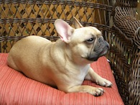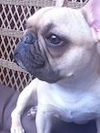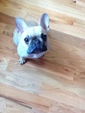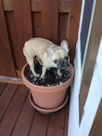

Input Textures
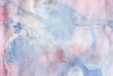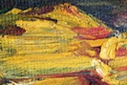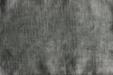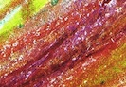

The GUI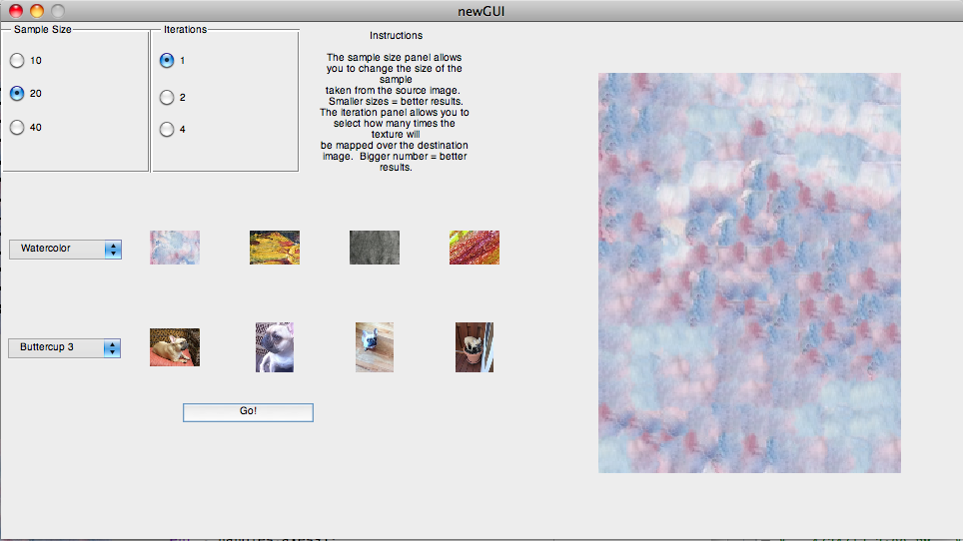
The image on the right is the final output with a sample size of 20, one iteration, and the watercolor texture.
The watercolor texture and charcoal texture worked better than the oil and crayon textures (textures 2 and 4). This is due to the more natural and repetitive texture they have. There is less color and strange patches of contour and texture present which makes them good candidates for this algorithm
These textures vary in color, noise, and natural feel (in terms of what will make a good mapping texture). The effects these have on the output image are easily viewable using the GUI. The first and third textures work better than the third and fourth. Additionally, a smaller sample size and higher iteration count create the best output.
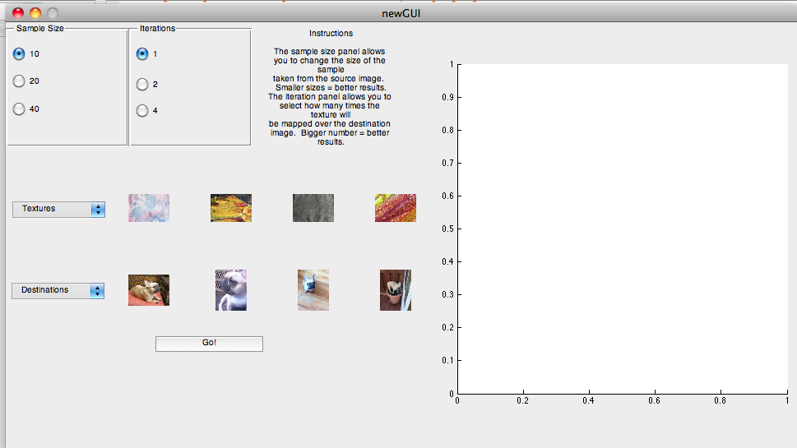
The blank GUI screen.
Select the sample size, iterations desired, a texture, and a destination image.
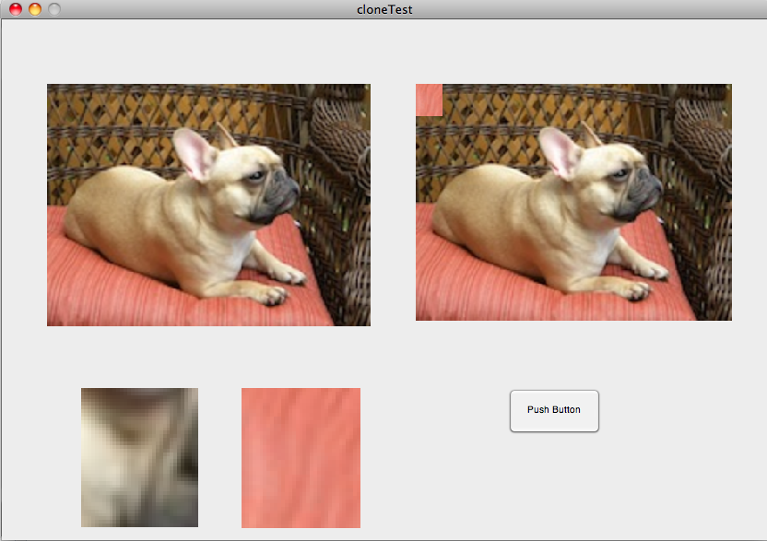
This is my attempt at producing the clone tool in Photoshop. Make a selection by clicking and dragging the bounding box. That will be the destination. Click and drag again for the texture. The result, unfortunately, does not align itself in the image properly.
The destination is featured as the left subimage and the texture is the right subimage in the GUI.
Some Results
Sample size: 10 (small sample)
Iterationes: 1
Texture: Watercolor
Image: Buttercup 1

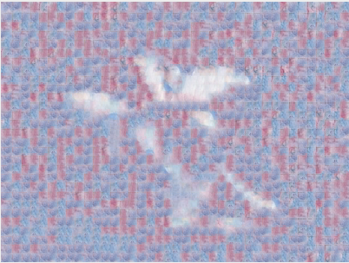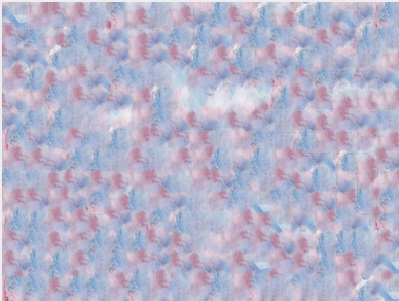

Sample size: 10 (small sample)
Iterationes: 2
Texture: Watercolor
Image: Buttercup 1

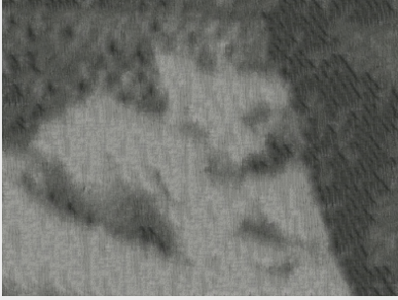
Sample size: 10 (small sample)
Iterationes: 4
Texture: Charcoal
Image: Buttercup 1

