Week 33
Capstone Project: Smart City Traffic Intelligence: From Data Analytics to AI-Powered Mobility
Task 2: Descriptive Statistics and Correlation
Using the traffic dataset, calculate:
2.1 Traffic volume statistics
- Mean
- Median
- Standard deviation
- Variance
- Range
Interpret what these statistics tell you about traffic volume and its variability.
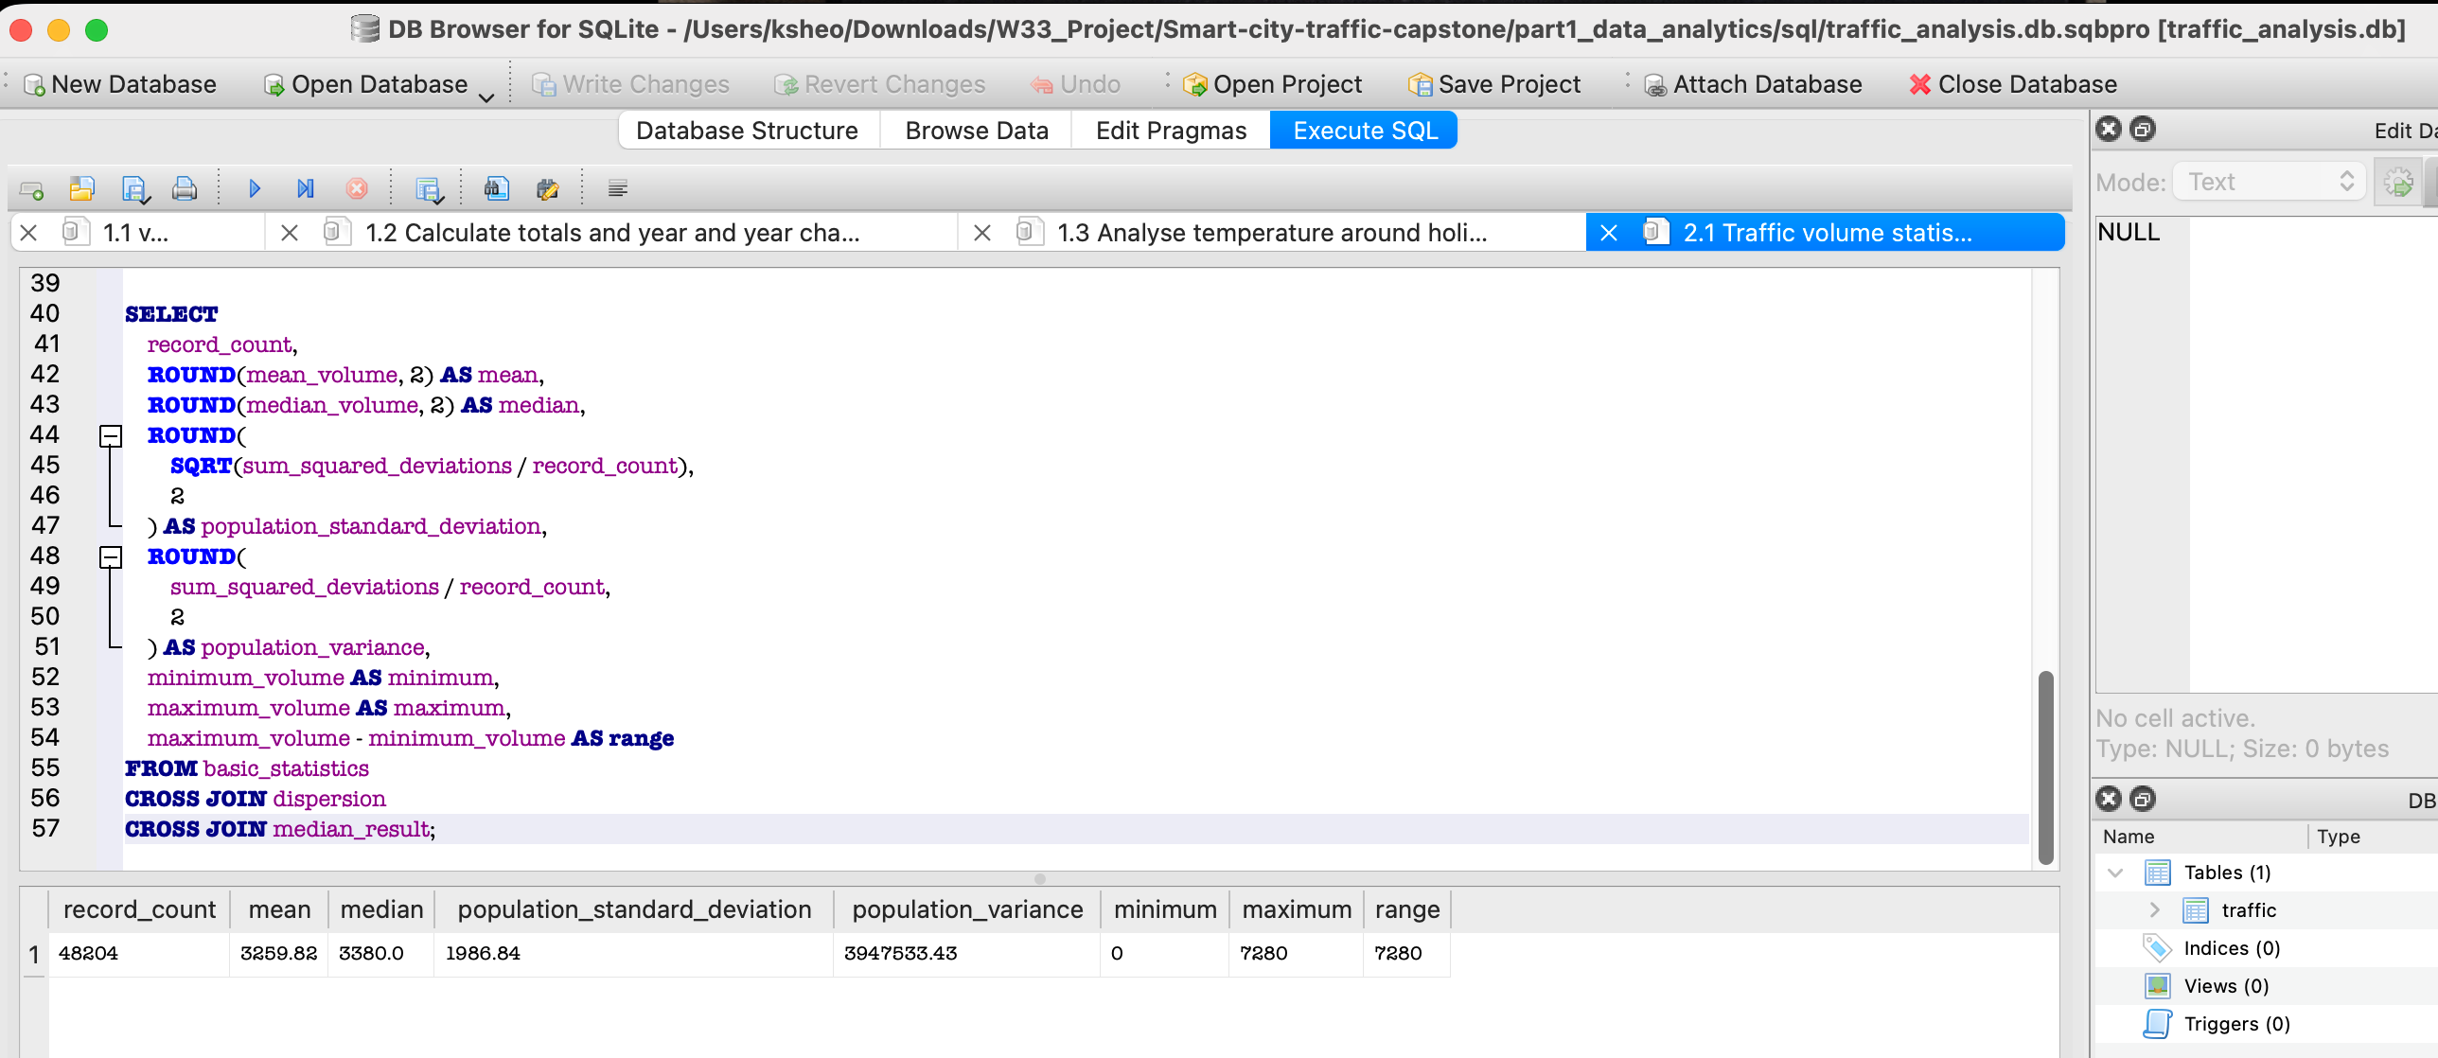
The average traffic volume was 3,259.82 vehicles per hour, while the median was 3,380 vehicles. The population standard deviation was 1,986.84 vehicles, and the population variance was 3,947,533.43 vehicles squared. Traffic volume ranged from zero to 7,280 vehicles. These results demonstrate substantial variability, which is expected because the dataset contains both low-demand overnight periods and high-demand commuting periods. The median was slightly higher than the mean, suggesting that very low traffic observations pulled the mean downward.

2.2 Correlation analysis
Calculate the correlation coefficient between:
- Temperature
- Traffic volume
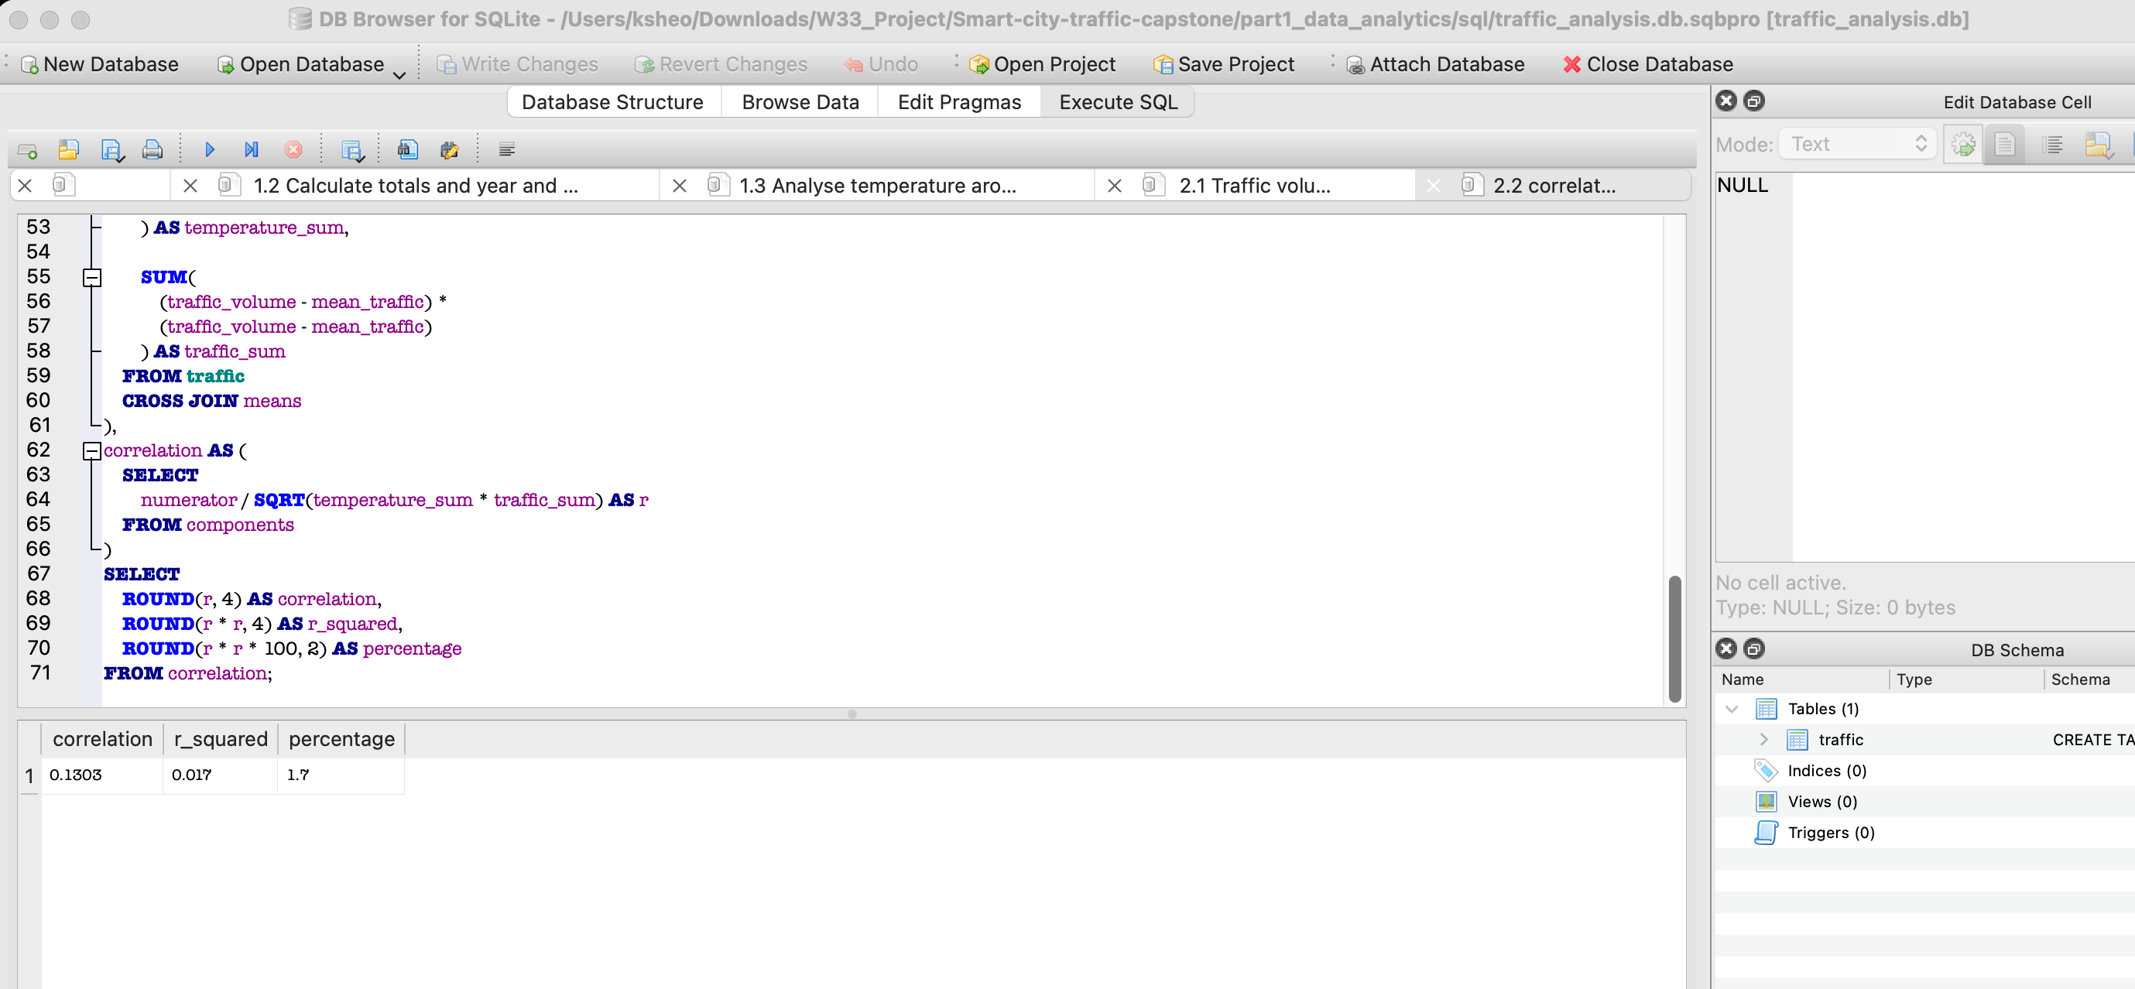
Then:
- Interpret the direction of the relationship.
The correlation coefficient is positive. Therefore, higher temperatures are associated with a slight tendency toward higher traffic volumes.

- Interpret the strength of the relationship.
A correlation of 0.1303 is very close to zero and indicates a very weak positive linear relationship. Temperature alone has little association with traffic volume. The R² value is approximately 0.017, meaning the simple linear relationship accounts for only about 1.70% of the variation in traffic volume.
- Explain why correlation does not necessarily imply causation.
Correlation only shows that two variables move together to some extent. It does not prove that changes in temperature directly cause changes in traffic.
Possible confounding variables include:
- Hour of the day
- Morning and evening commuting periods
- Weekday versus weekend
- Public holidays
- Seasonal travel patterns
- Rain, snow and visibility
- Road conditions
- Special events

Task 3: Probability and Congestion Analysis
Define congestion as: traffic volume > 5,500 vehicles.
Calculate:
3.1 Basic probability
- P(Congestion) =14.73%
- P(Clear Weather) =27.78%
- P(Congestion AND Clear Weather) =3.66%
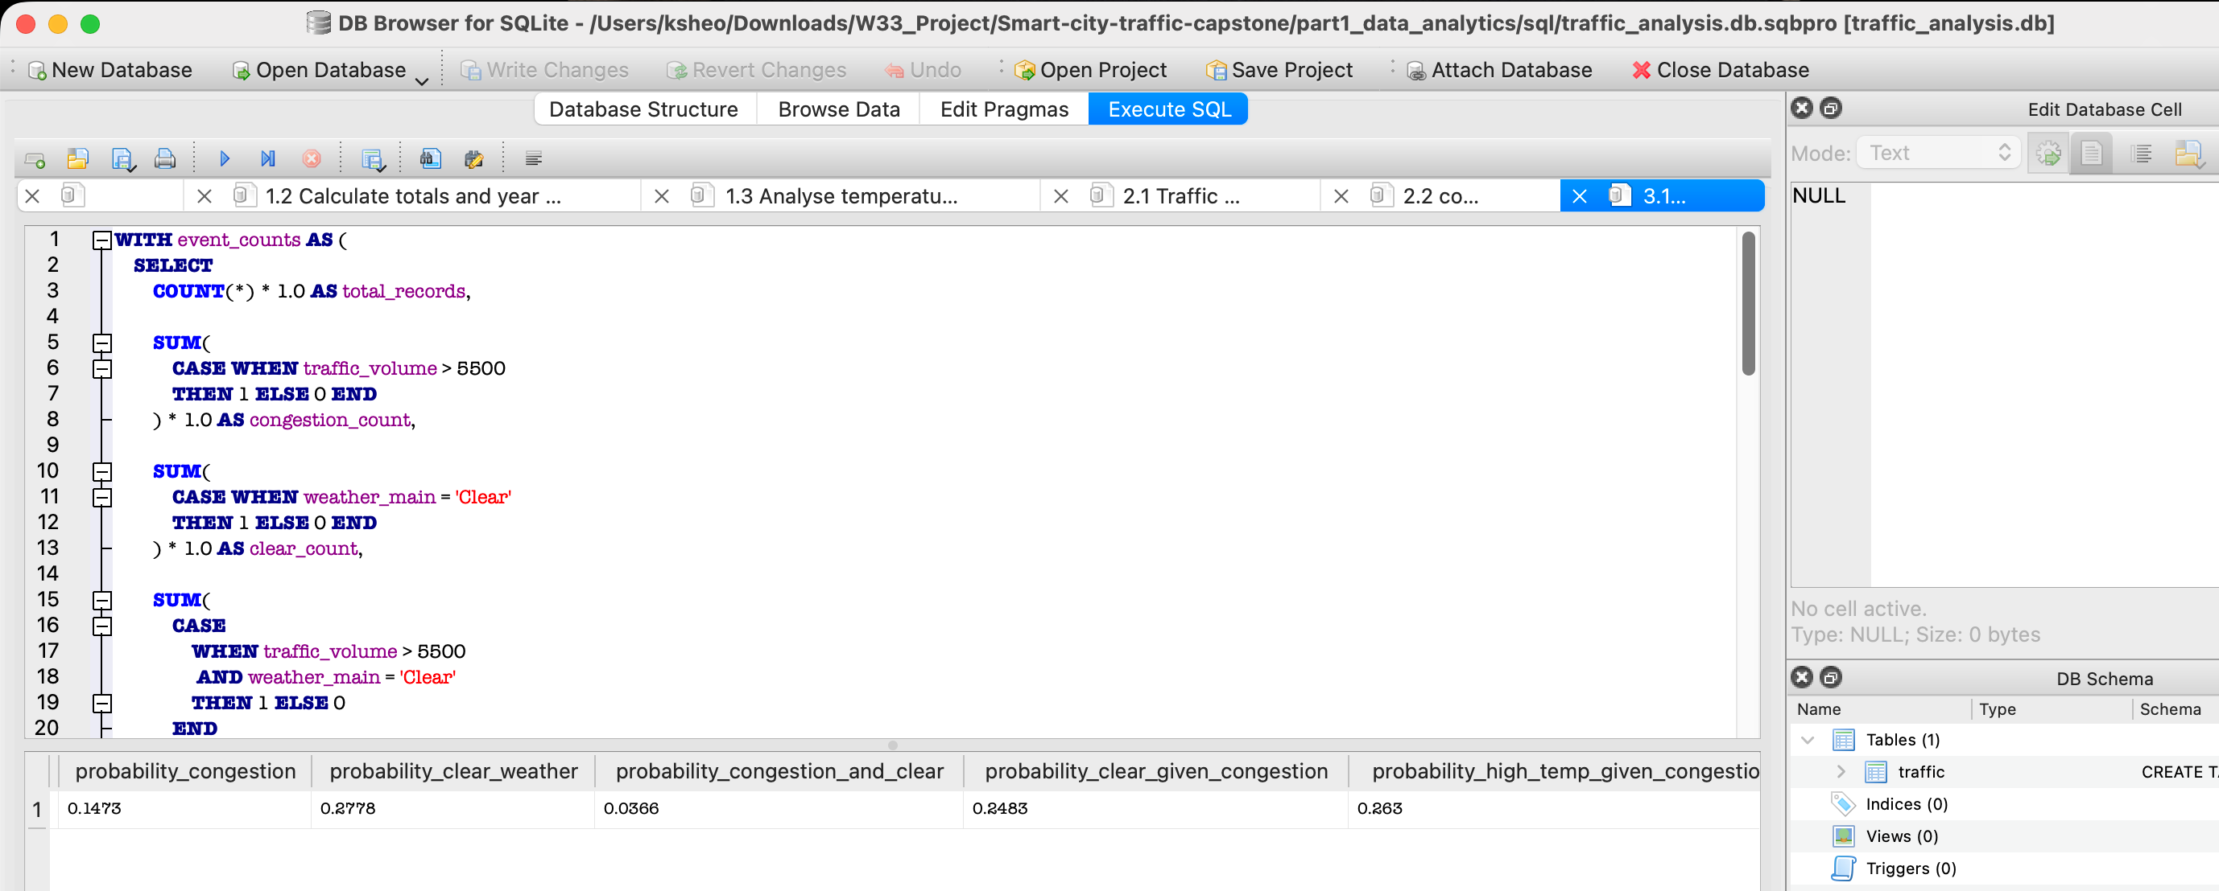
3.2 Conditional probability
Calculate:
- P(Clear Weather | Congestion) =24.83%
- P(High Temperature | Congestion), where high temperature > 292K =26.30%
- Determine whether weather conditions and congestion can be considered independent using P(A ∩ B) = P(A) × P(B)
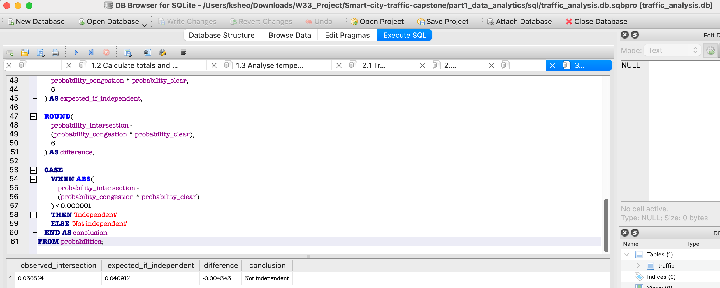
If congestion and clear weather were independent, their expected joint probability would be approximately 4.09%. The observed joint probability was only 3.66%. Because these values are not equal, congestion and clear weather cannot be considered independent according to the specified probability rule.

- Calculate the odds ratio of congestion in clear versus cloudy weather.
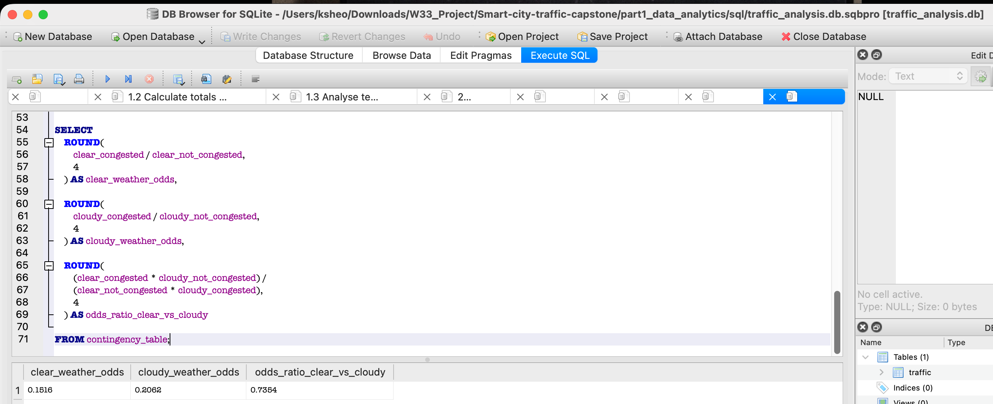
The odds ratio for congestion in clear versus cloudy weather was approximately 0.735. This means the observed odds of congestion during clear weather were about 0.735 times the odds during cloudy weather, or approximately 26.46% lower. Conversely, the odds of congestion during cloudy weather were approximately 1.36 times those during clear weather.
Conclude with a short explanation of what the probability analysis suggests about the relationship between weather and congestion.
Congestion occurred in approximately 14.73% of the dataset, while clear weather occurred in 27.78% of records. The probability of both congestion and clear weather was 3.66%. Clear weather and congestion did not meet the specified independence condition because the observed joint probability differed from the product of their individual probabilities. The odds ratio of 0.735 indicated that congestion odds were approximately 26.46% lower during clear weather than during cloudy weather. However, the analysis does not establish that cloudy weather causes congestion. Factors such as commuting hours, weekdays, seasons and holidays may affect both weather categories and traffic levels.

Part 1 Deliverable
Submit:
- SQLite queries/database or SQL file
- Statistical and probability analysis
- Power BI dashboard
- 1–2 page Data Analytics Insights Report summarising the most important findings and their implications for the smart-city mobility team

