Jenkins Task-2
Here’s the flow: push a commit, GitHub sends Jenkins a webhook (a small HTTP request saying “something changed”), Jenkins pulls the repo and runs your script, then emails you the output.

- Create a dir jenkins-task
- Run git clone command to clone the GitHub repo to this local dir. jenkins-task
- Create a hello.sh file in local repo.
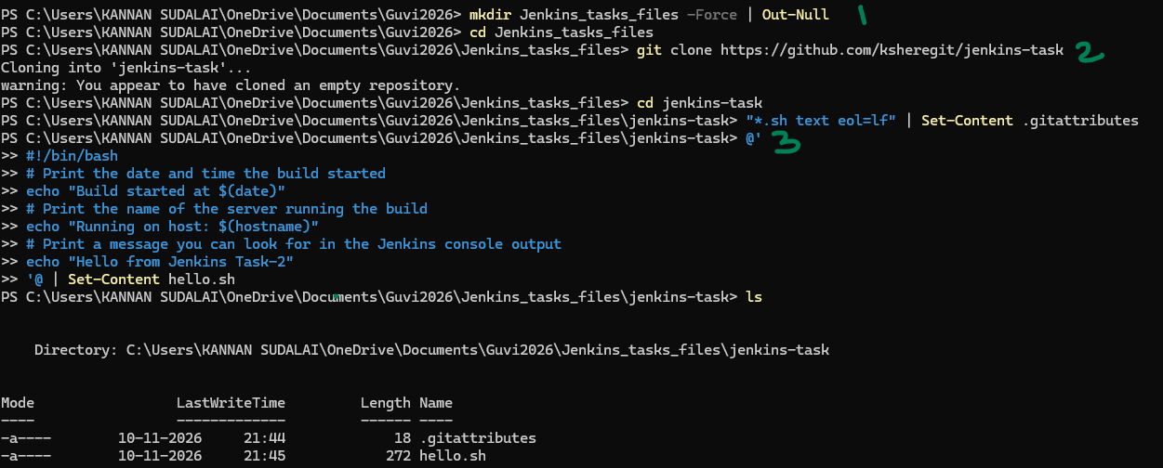
- Stage the new code
- Commit it with msg “Add hello script”
- Push to git-hub repo
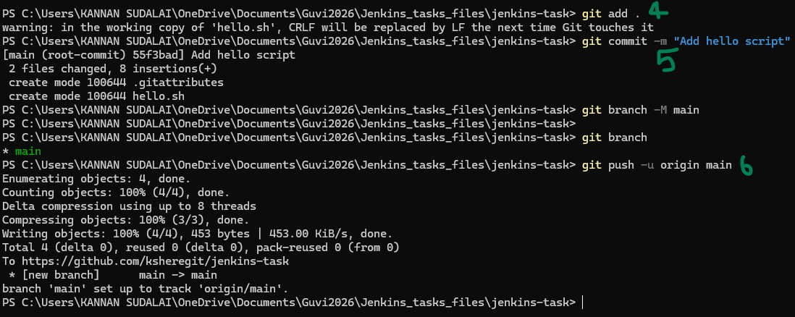
Pre-requisites:
- Setting up App password for my gmail: app name: jenkins
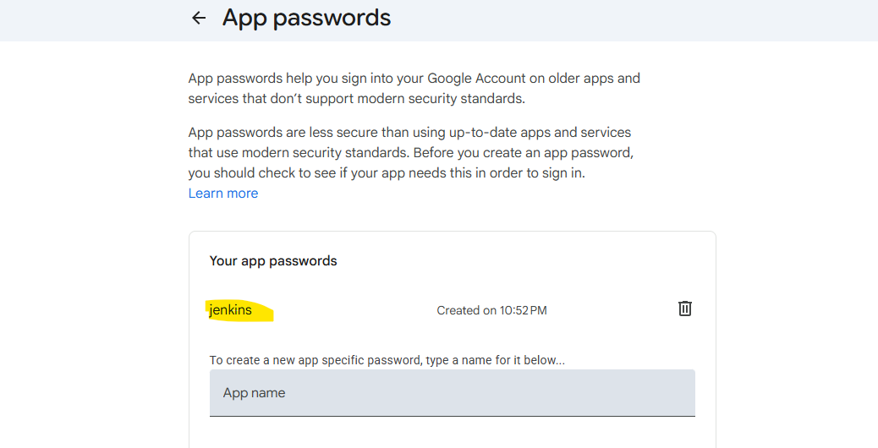
App name: jenkins
Password : 16 digit generated and updated the new 16 digit password as a new password well.
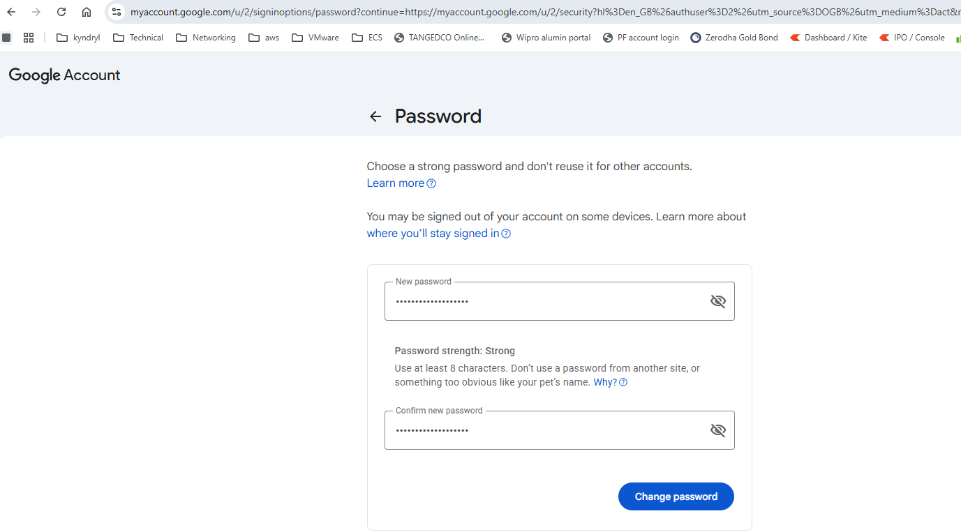
Go to Jenkins --> manage jenkins --> system --> add the gmail as Admin e-mail address
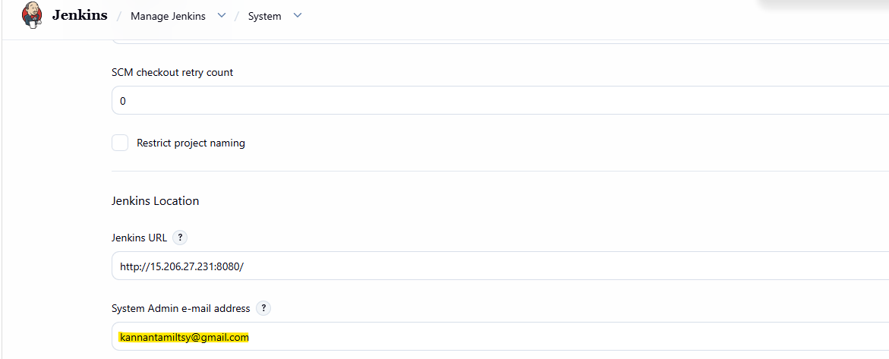

Set the email-notification fields as below screenshots and test configuration:
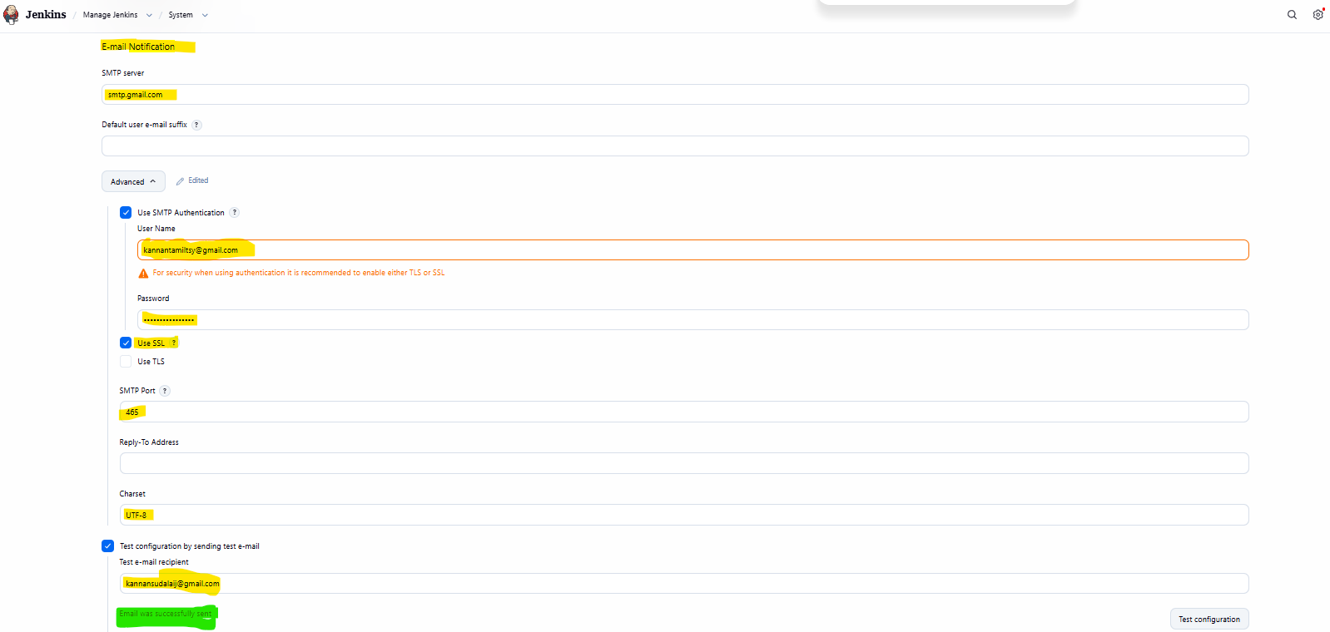

Email received at recipient side successfully:
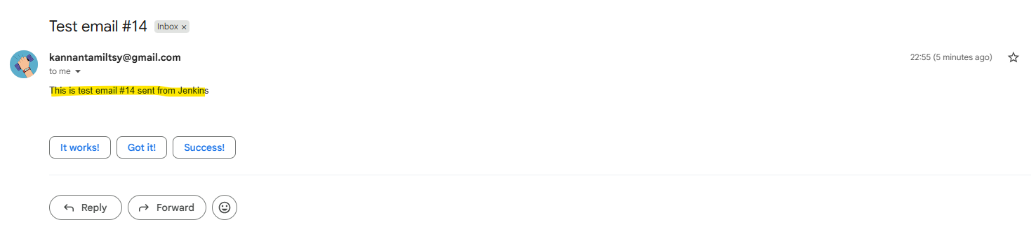

Extended email setup:
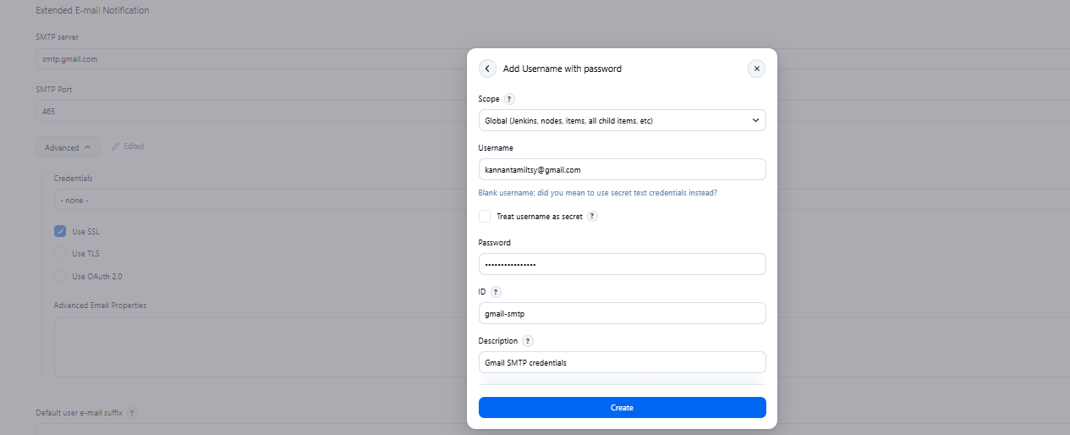

IMPORTANT: Add webhook under the repository setting in GitHub
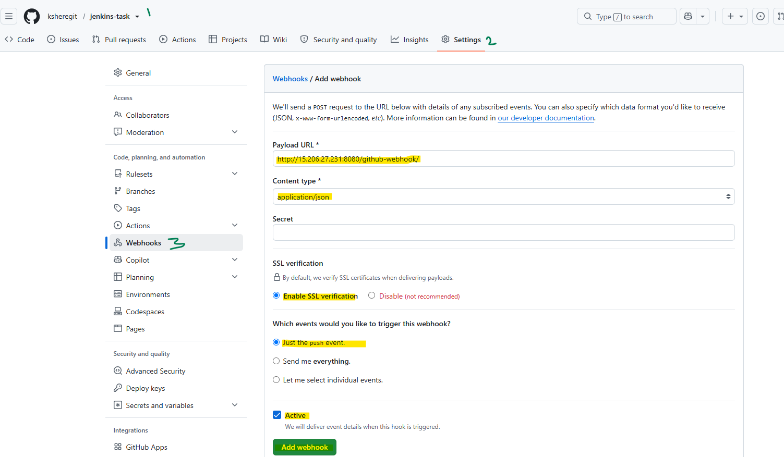

- Create jenkins-tak2 as a new freestyle project to demonstrate the task requirement:
Freestyle project name: jenkins-task2
Git repo : https://github.com/ksheregit/jenkins-task.git (already this is created and pushed a file hello.sh into this)
Branch: */main
Source code management section:
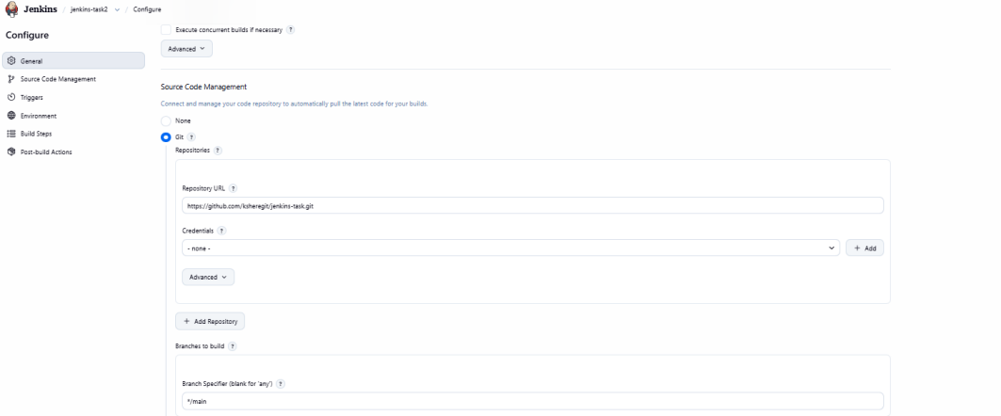

- Triggers section: enable “GitHub hook trigger for GITScm polling?”
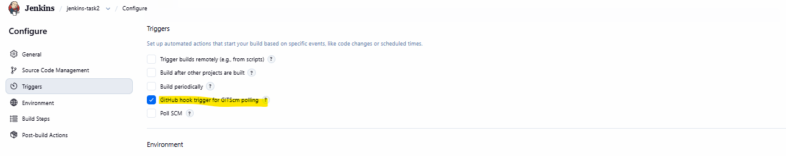

- Build steps section: add a new build step and added a Execute shell that enable execute permission for the helllo.sh file and run.

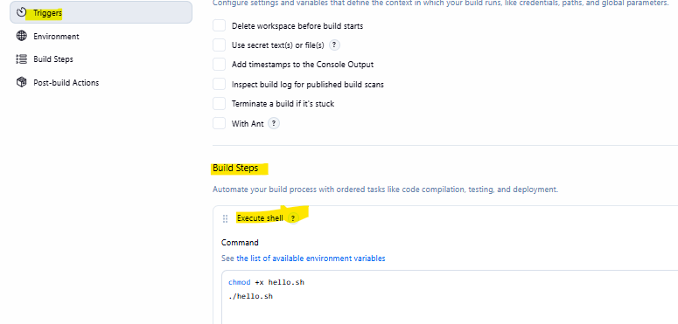

- Post build Action section:
4.1 Choose “editable email notification”
Fill in recipient list, default subject and content information:
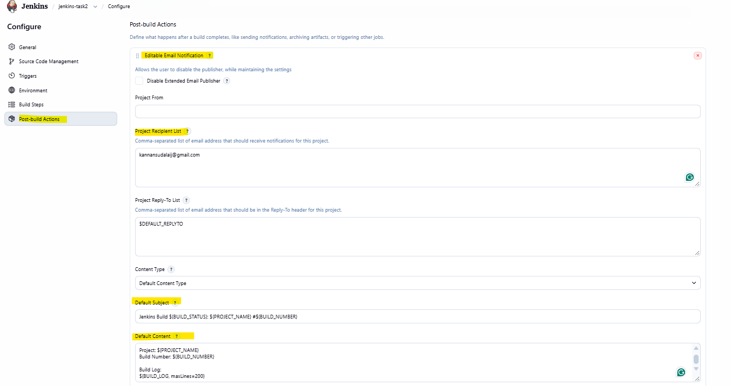

Build Status: ${BUILD_STATUS}

Project: ${PROJECT_NAME}
Build Number: ${BUILD_NUMBER}

Build Log:
${BUILD_LOG, maxLines=200}

4.2 Add Trigger + --> choose always
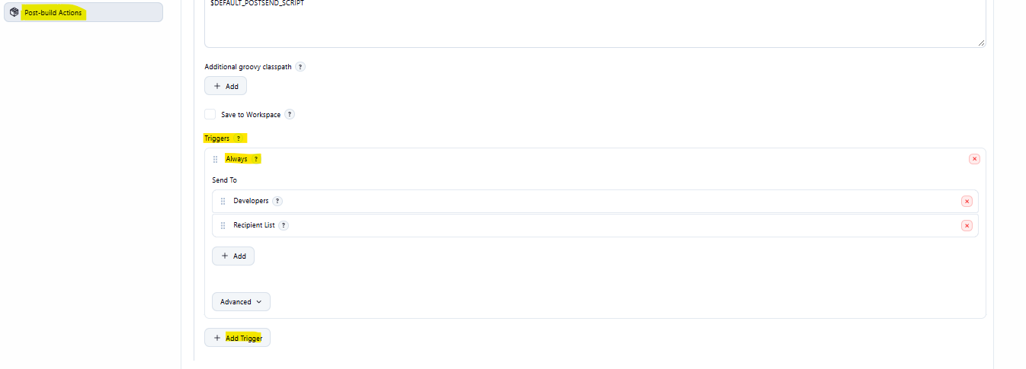

Test the Jenkins job manually:
Steps to follow:
- Open jenkins-task2 free-style project.
- Click Build Now.
- Open the latest build number.
- Click Console Output.

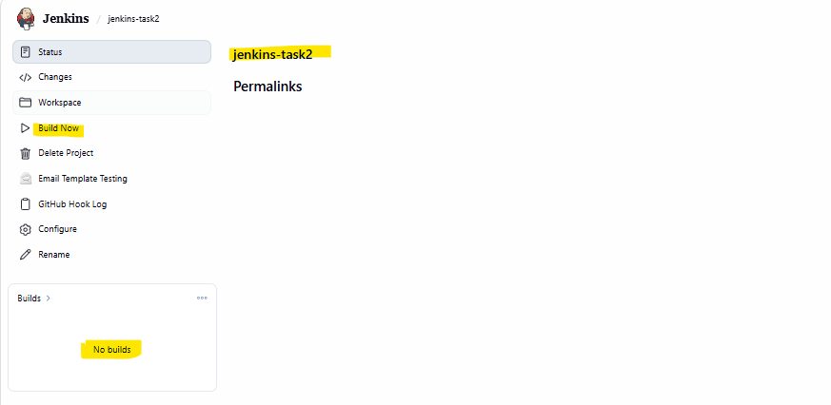

Console output for the build #1:
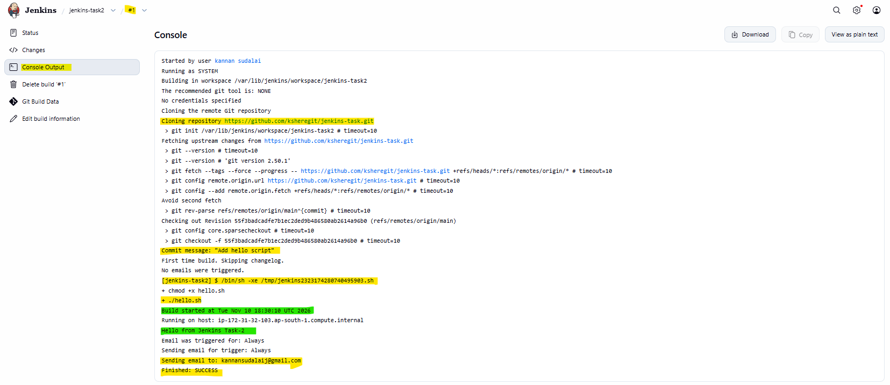

Email sent to my recipient email too:
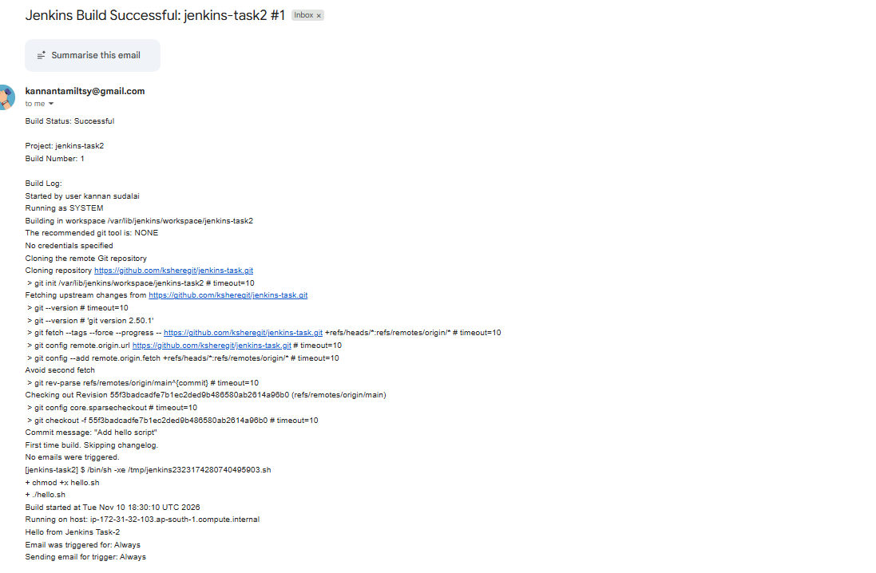

Testing the Flow -2 (Adding changes to the repo script file)
Added line-10 in hello.sh file
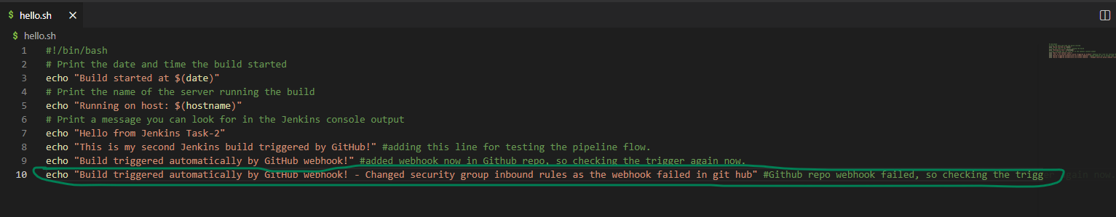
Git add, commit and push commands to push changes in hello.sh file to main git hub branch:
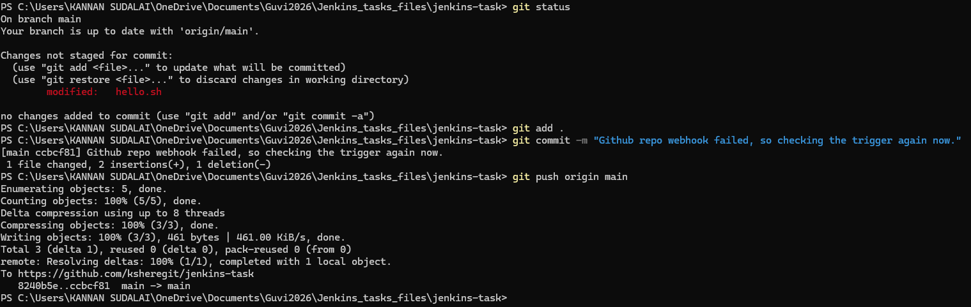
Github repo updated:
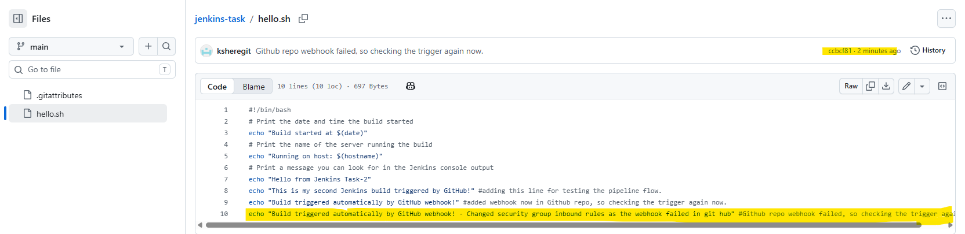
Git Hub webhook says “Last delivery was successful”
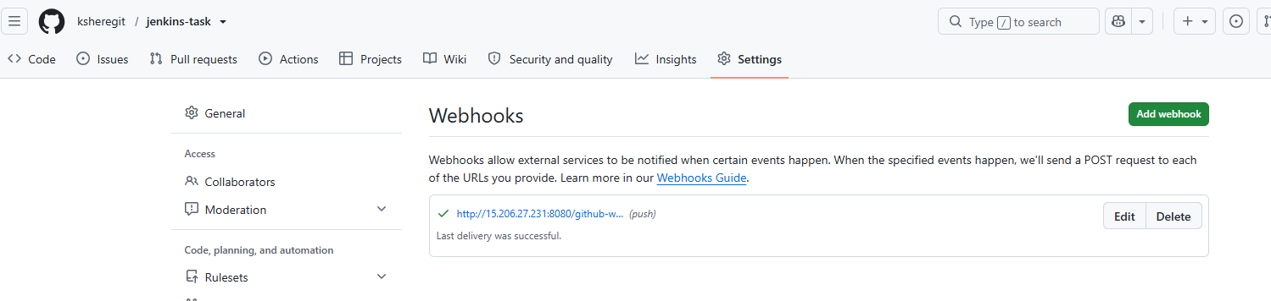

Jenkins “Build history” shows new build #2
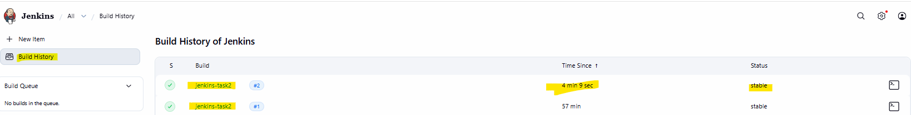

Jenkins pipeline triggered as expected and mail delivered to the recipient:
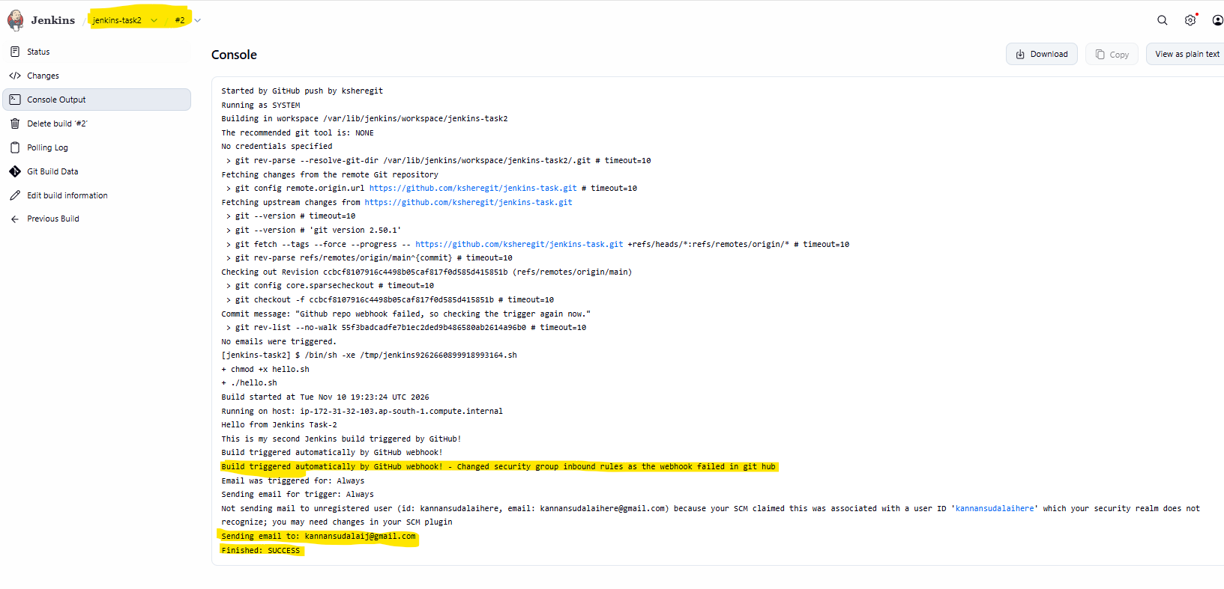

Mail received at kannansudalaij@gmail.com successfully:
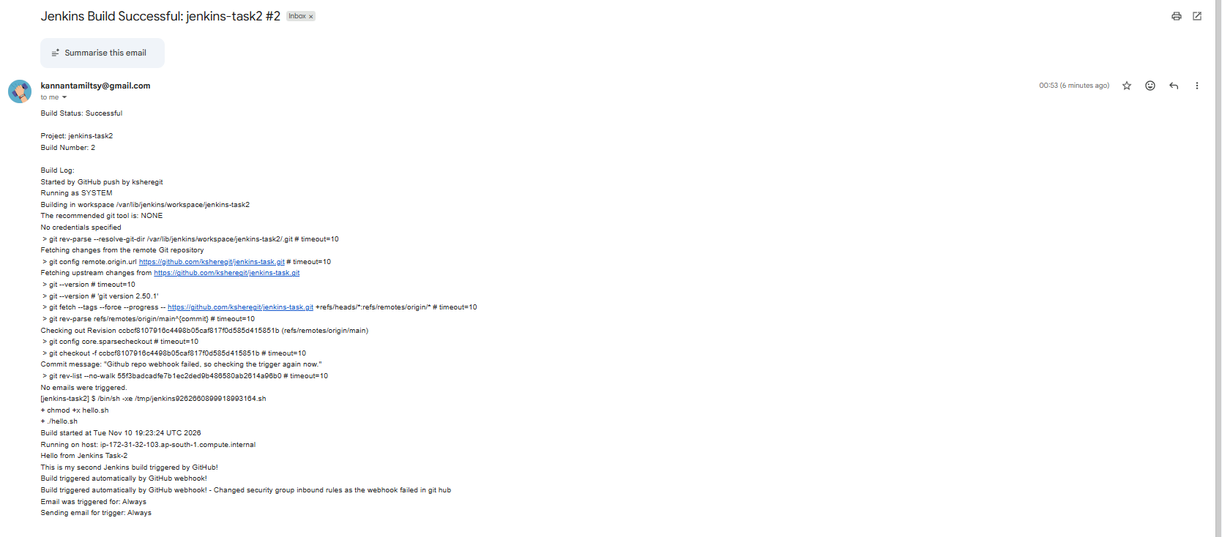

Task completed successfully.

Self notes for future reference:

1. Where was your file initially?
You created hello.sh on your Windows laptop.
Your Windows laptop
Local repository
jenkins-task/
└── hello.sh
This is where you created and edited the script.
Then you pushed it to GitHub using:
git add .
git commit -m "Add hello script"
git push

2. GitHub stores another copy
GitHub
ksheregit/jenkins-task
└── hello.sh
GitHub now has the committed version of your script.
At this point, there are two copies:
- One on your laptop.
- One in GitHub.

3. What happened when you clicked Build Now?
This is where Jenkins comes into the picture.
You configured the Jenkins Freestyle project with:
- Repository URL: https://github.com/ksheregit/jenkins-task.git
- Branch: */main
When you clicked Build Now, Jenkins performed a Git checkout.
- Your console output confirms this:
Building in workspace
/var/lib/jenkins/workspace/jenkins-task2

Cloning the remote Git repository

Cloning repository
https://github.com/ksheregit/jenkins-task.git
Jenkins downloaded the repository onto your EC2 instance.
AWS EC2 – Jenkins server
Jenkins workspace on Linux
/var/lib/jenkins/workspace/
└── jenkins-task2/
├── hello.sh
└── .gitattributes (if committed)
This is where the build executed
Your console output confirms that Jenkins checked out commit:
55f3badcadfe7b1ec2ded9b486580ab2614a96b0
That is the version of hello.sh Jenkins downloaded from GitHub.

4. Jenkins executed the script on EC2
You configured this build step:
chmod +x hello.sh
./hello.sh
Jenkins ran those commands inside its workspace.
Let's understand the output:
Output | What happened
chmod +x hello.sh | Gave the script execute permission on EC2
./hello.sh | Executed the script on EC2
$(date) | Retrieved the EC2 server's date and time
$(hostname) | Retrieved the EC2 server's hostname
That's why you received:
Build started at Tue Nov 10 18:30:10 UTC 2026

Running on host:
ip-172-31-32-103.ap-south-1.compute.internal

Hello from Jenkins Task-2
Notice the hostname. That's your Jenkins EC2 instance!

5. Finally, Jenkins emailed the output
After the script completed, your Email Extension plugin captured the build information and sent it through Gmail SMTP.
- Your Gmail inbox
- Received:
- Build status: SUCCESS
- Project name: jenkins-task2
- Build number
- Console output

