AWS task - 4

Launching windows machine with base windows 2022:
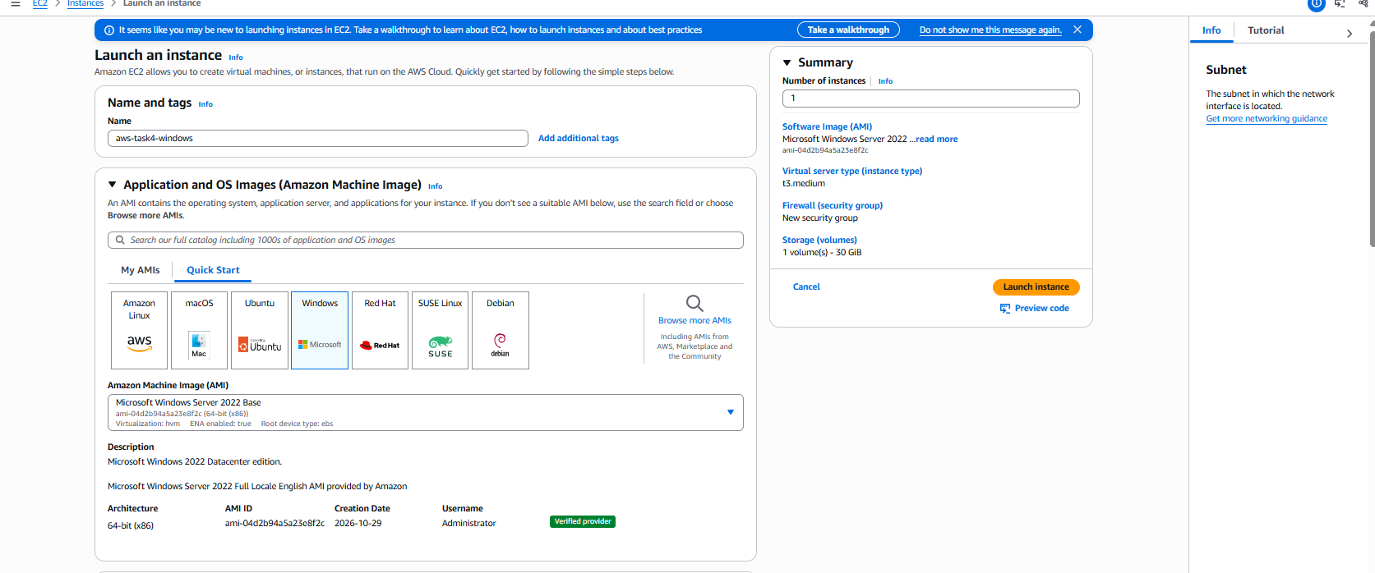

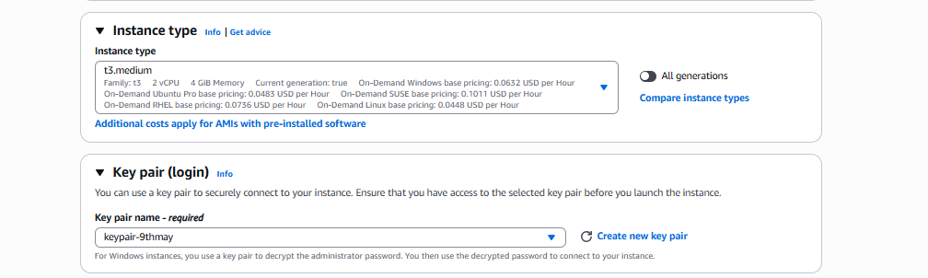
Connecting the RDP from my local IPv4 and allowing HTTP from anywhere:

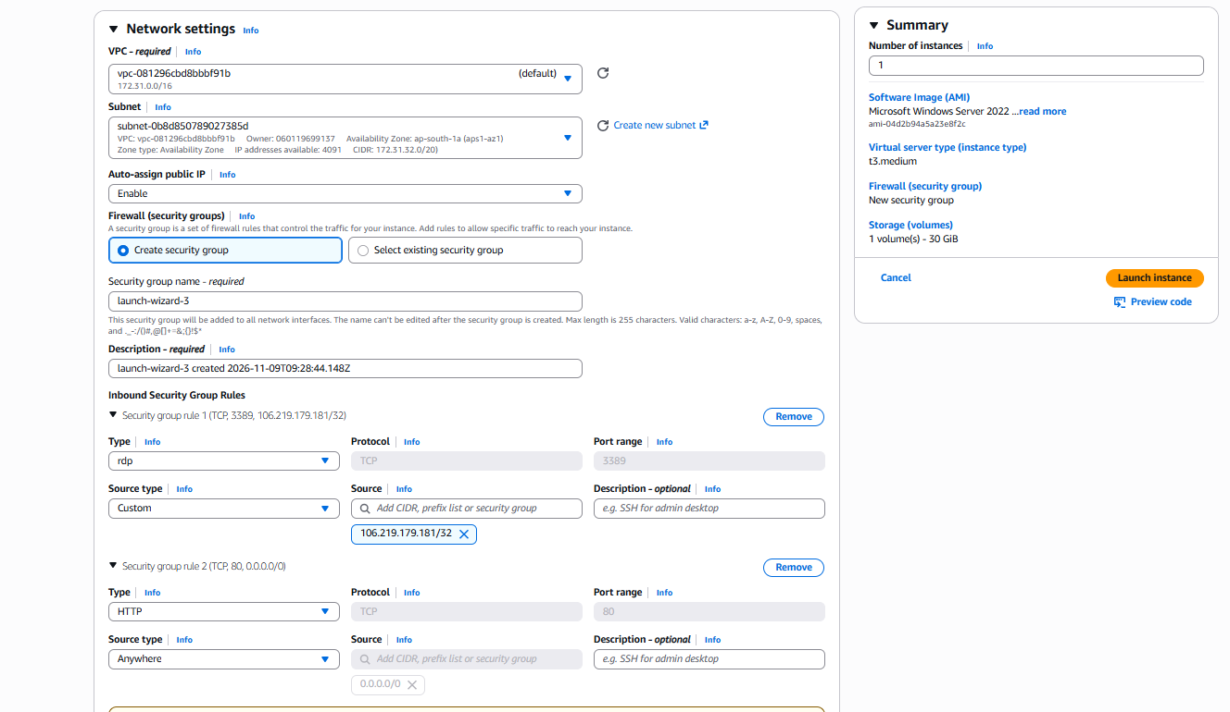

User data added for webserver installation:
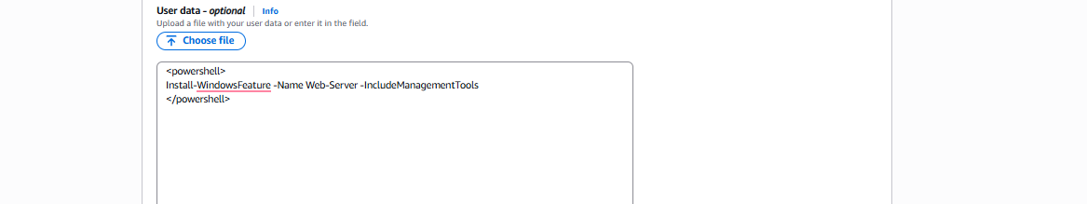

Launching the Linux machine:
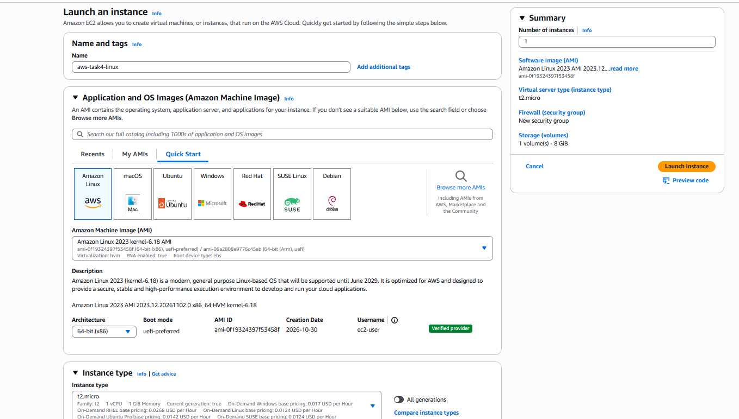

Same VPC,subnect,availability zone selected as windows machine:
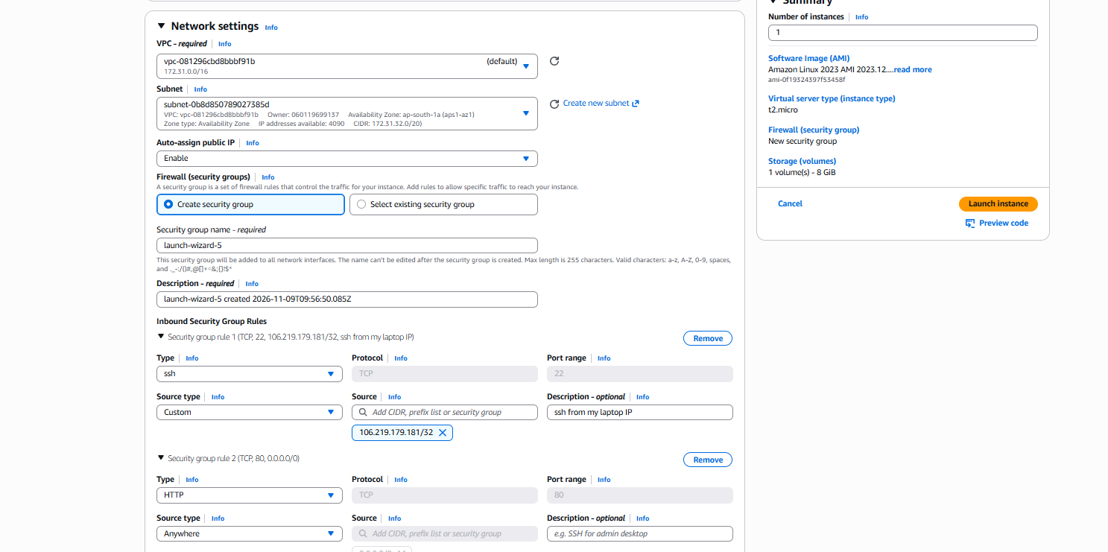
Userdata for nginx installation:
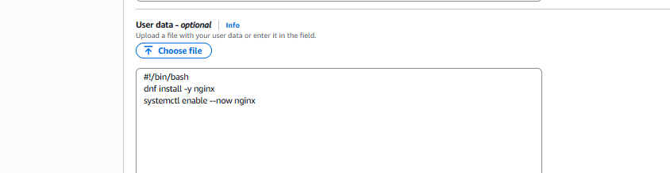
Creating EBS volumes: EC2--> Voolumes --> create volume (same done for windows vol too)
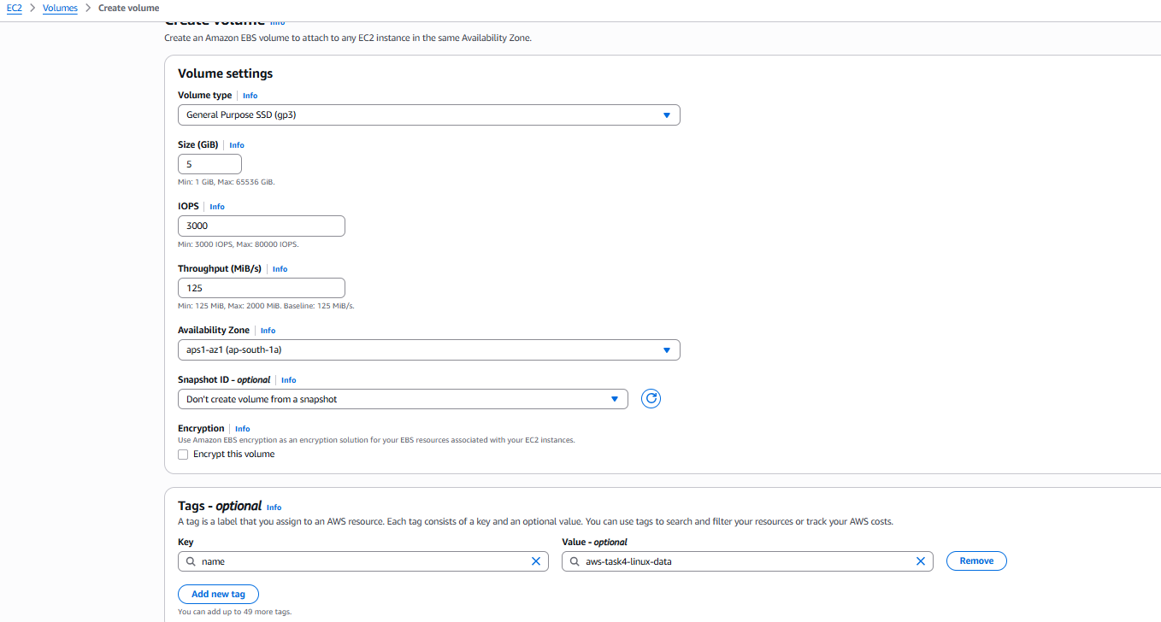

Below highlighted ones created:
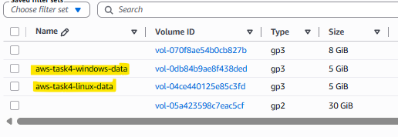

Attaching the EBS volume to the EC2 machine: (same done for windows instance too)
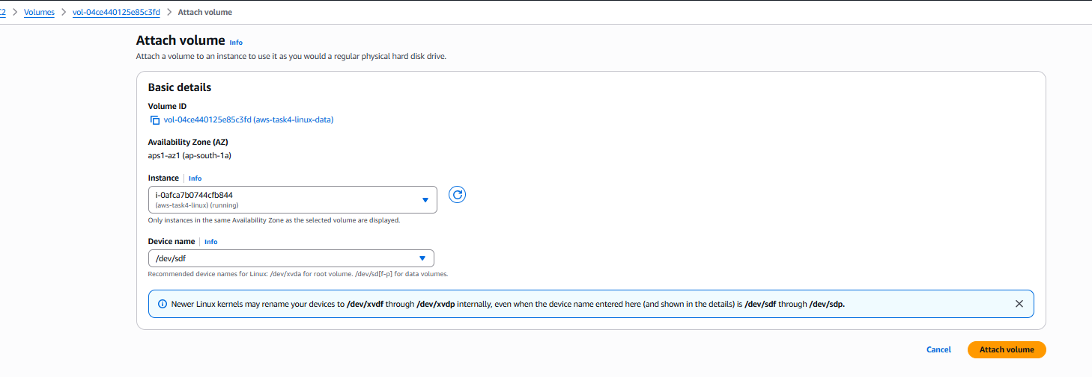
Connected to the same Public IP through super putty from laptop:
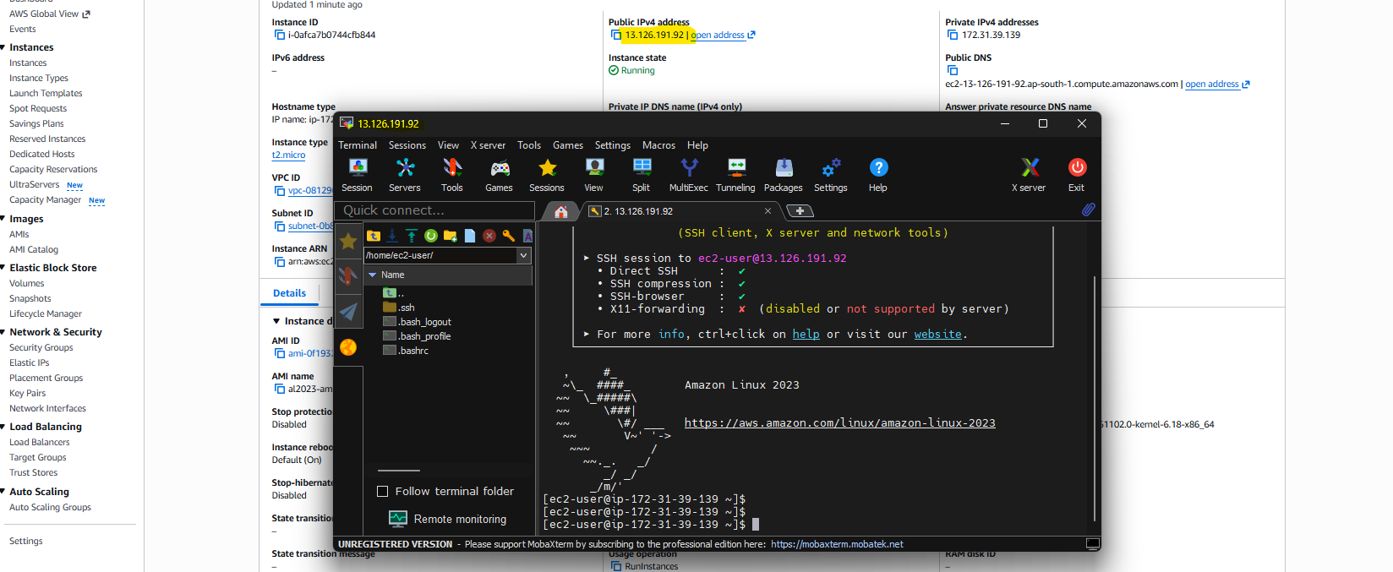

Connected to the EC2 linux machine and mounted the volume, added a new text file with a content “Hello from linux ebs volume”:
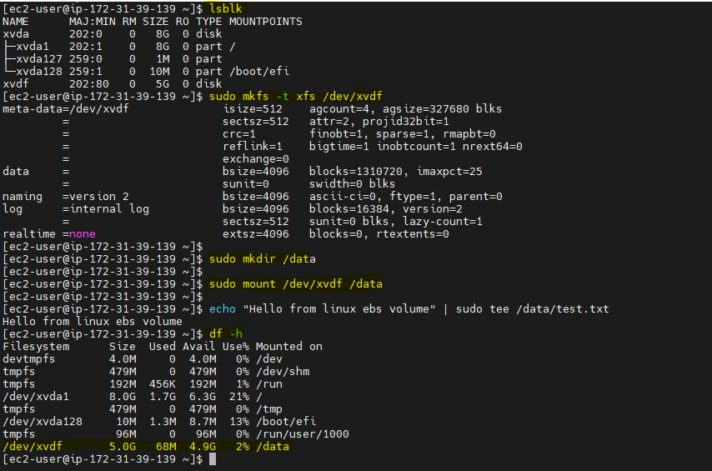

In Windows formatting the 5GiB vol as GPT: (Highlighted the IPs in Aws console and RDP console)
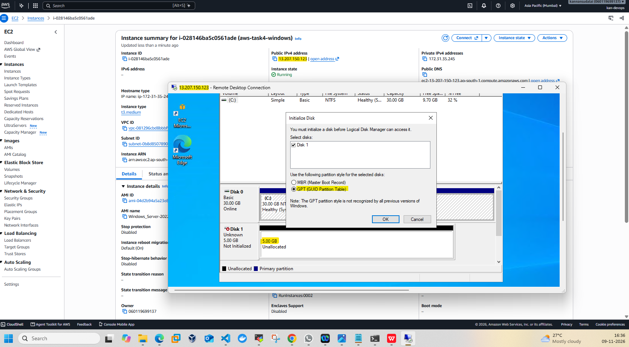

File created in windows new EBS volume:
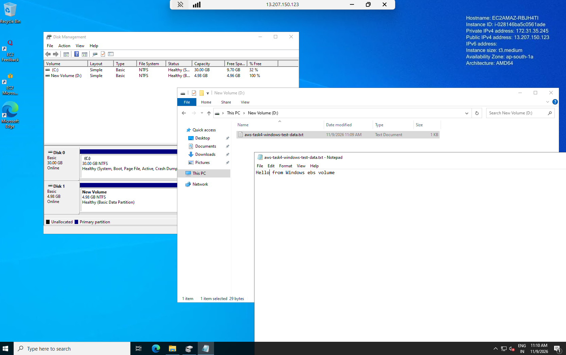

Snapshots taken for both volumes:
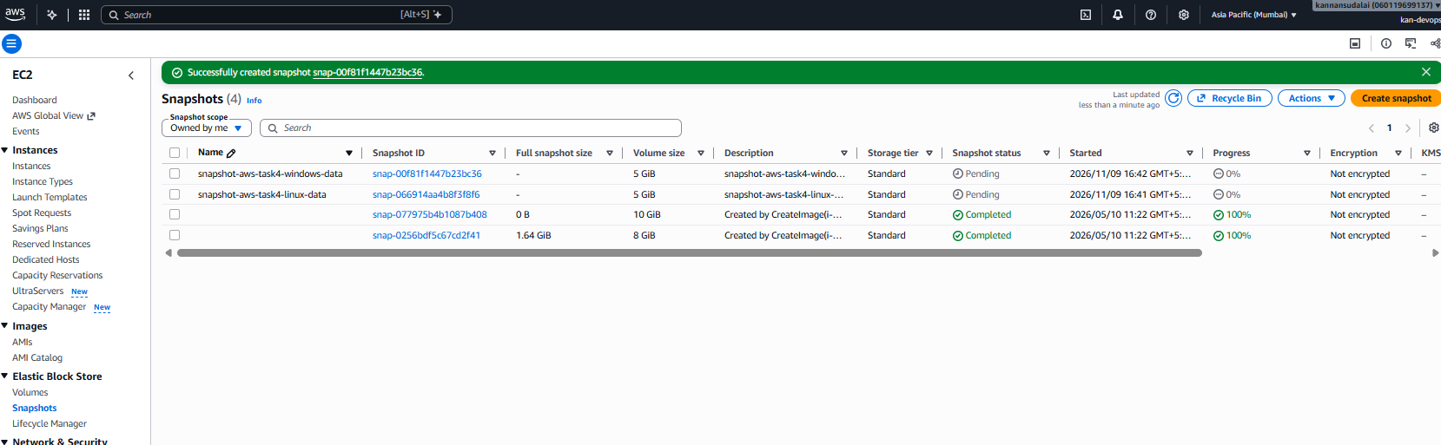

Creating a volume from snapshot:
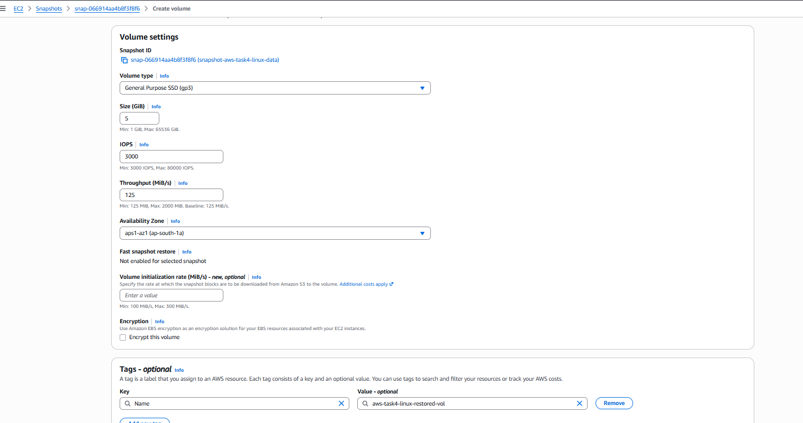

Restored volumes created from snapshots (highlighted):

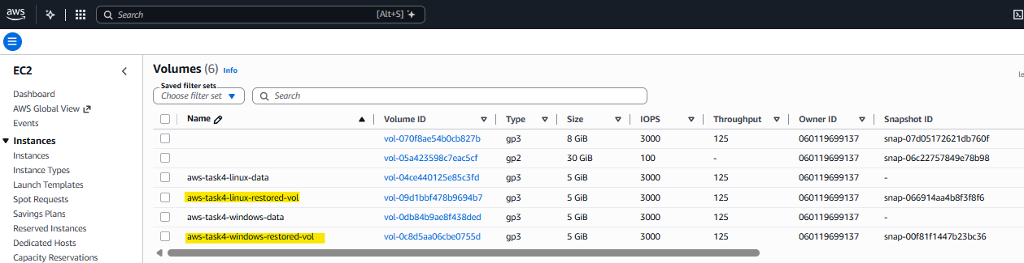

Attaching the restored vols to Ec2 machines: ( same done for both linux and windows machines with their respective restored vols)
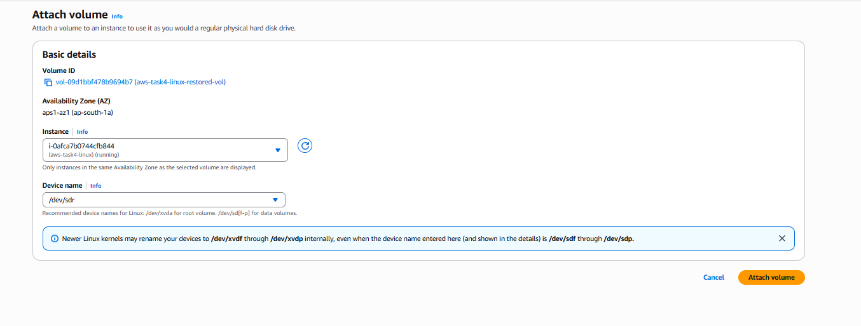

After atatchign the volume lsblk and blkid commands shows the new volume and the new volume have same UUID as the previouse original volume:
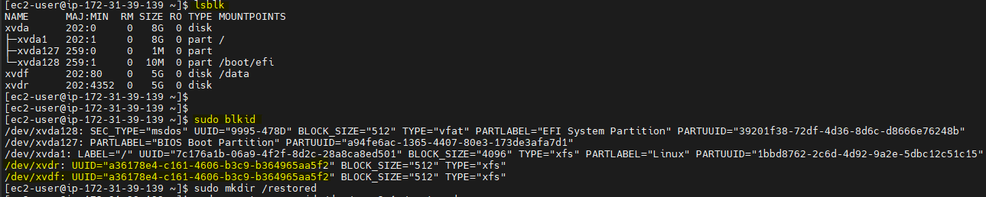

Note: A snapshot is a block-level copy of the whole disk, including the filesystem’s metadata. The XFS UUID is stored inside that metadata, so the restored volume has the same one as the original. This is different from the EBS volume ID (vol-xxxx), which is always unique.

After mounting the restored volume have the same file and the content:

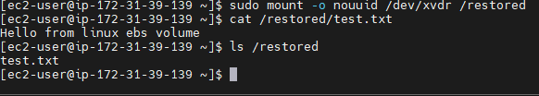
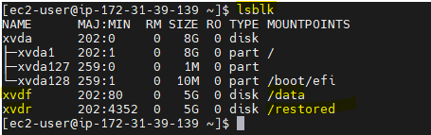

Note: When restoring it from the snapshot should not run mkfs command as that would erase the existing content, but we must use nouuid command to do the mounting.

Windows also shoeing the new volume as offline:
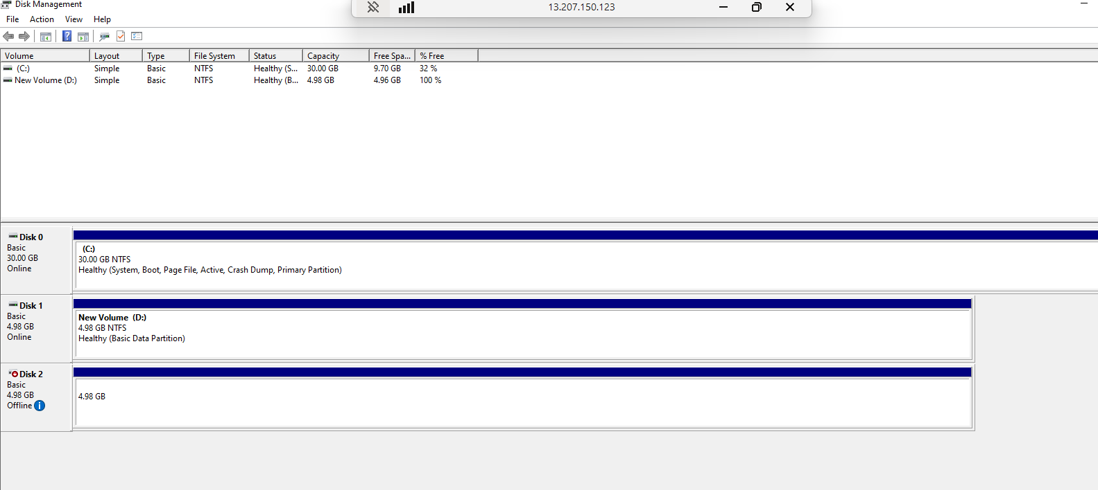

Same file exist in windows too:


