Jenkins Task-1
I have also added the screenshots of jenkins installation for my future reference, actual task content starts from page-4 where I crated two projects (one freestyle and another pipeline) then created another user as well.

- Using existing EC2 machine and adding port 8080 inbound rule for jenkins access
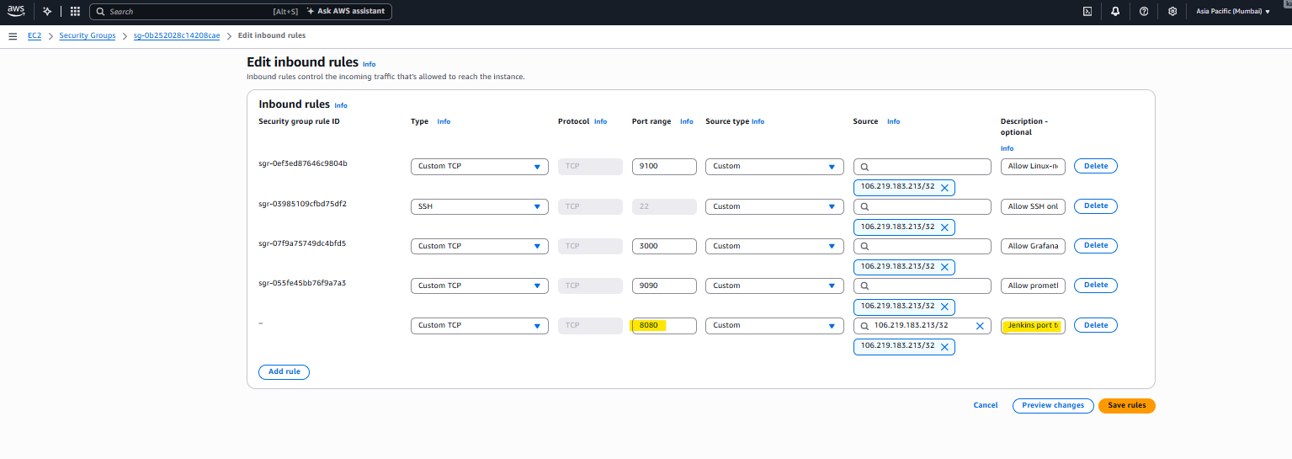

- Install dependencies: ( Install Java, Git and Jenkins. Jenkins is a Java program, and it needs Git to clone repos.)
- ) Java-21 installed
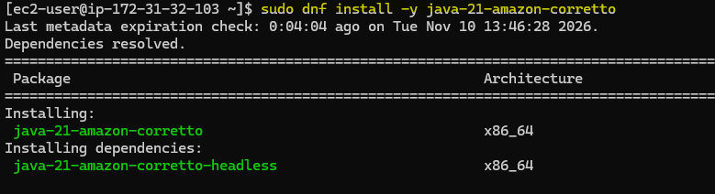
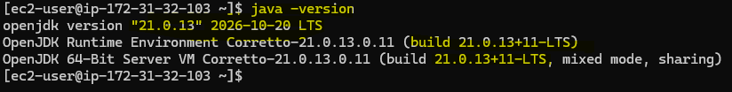
- )Download the official Jenkins repository configuration, here “-O” specifies the destination file
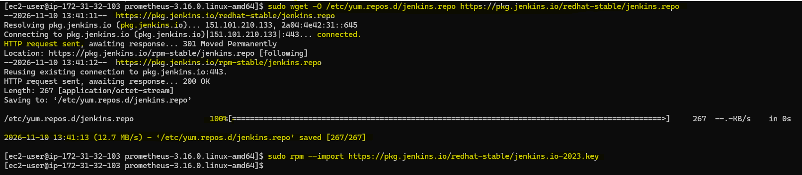

- )Import the Jenkins GPG signing key ( This allows the pkg mgr to verify Jenkins packages are authentic)

- Install Jenkins using DNF
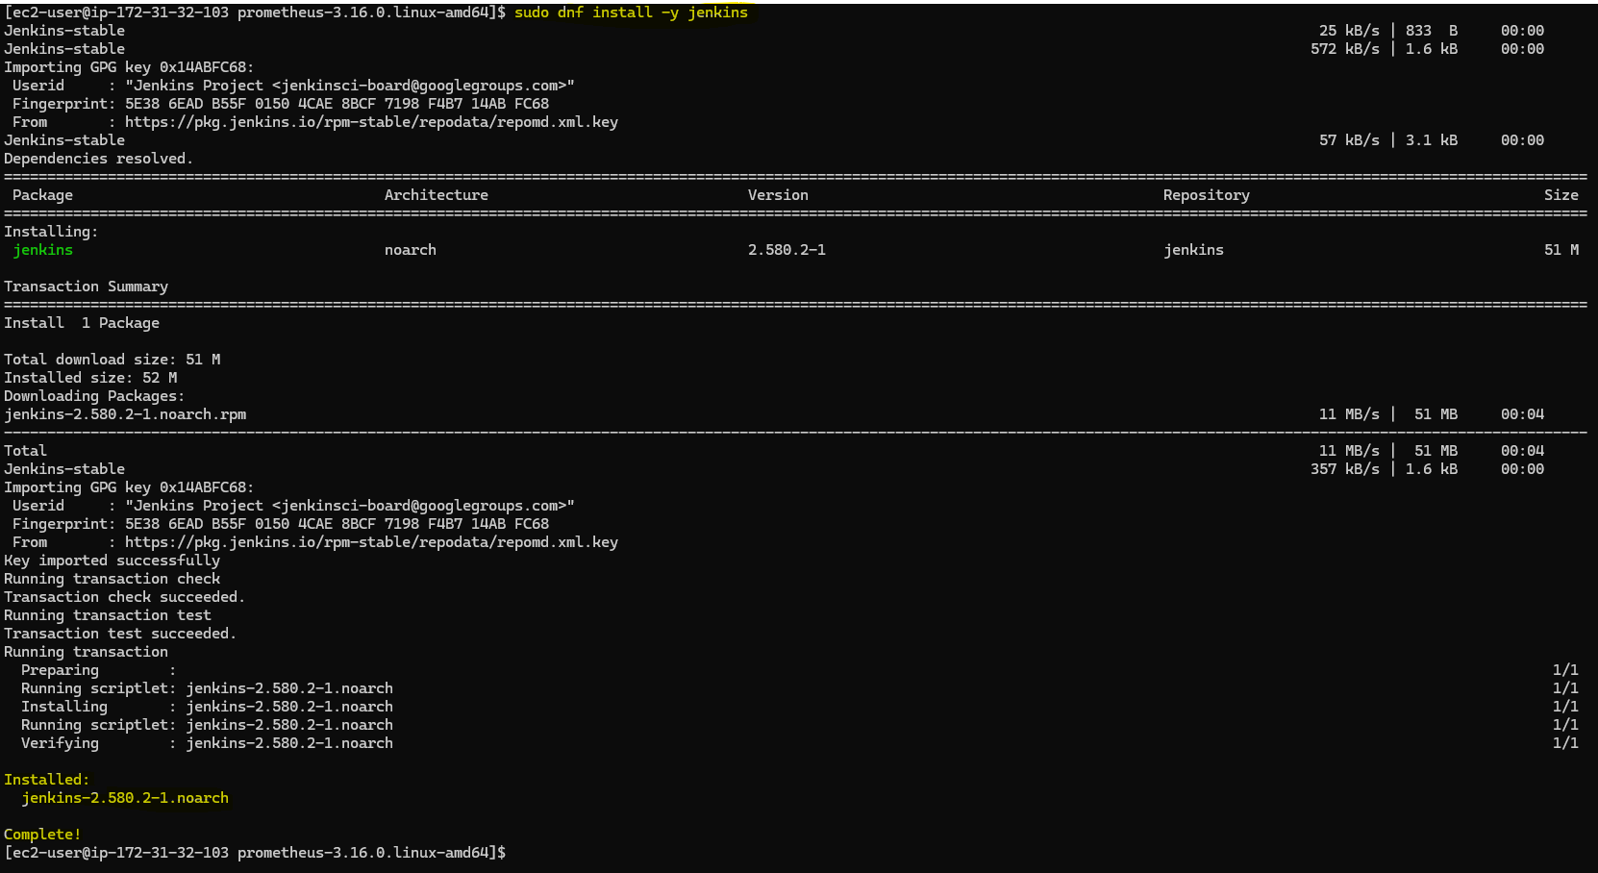

- Enable Jenkins to start automatically during system boot ( Also start the Jenkins service immediately.
sudo systemctl enable --now jenkins

In my case, the above command failed becase of old java version so, executed below comamands after installing correct java version java 21

sudo systemctl reset-failed jenkins
sudo systemctl restart jenkins
systemctl status jenkins --no-pager
Note: The reset-failed is needed because systemd has stopped retrying after too many quick failures.
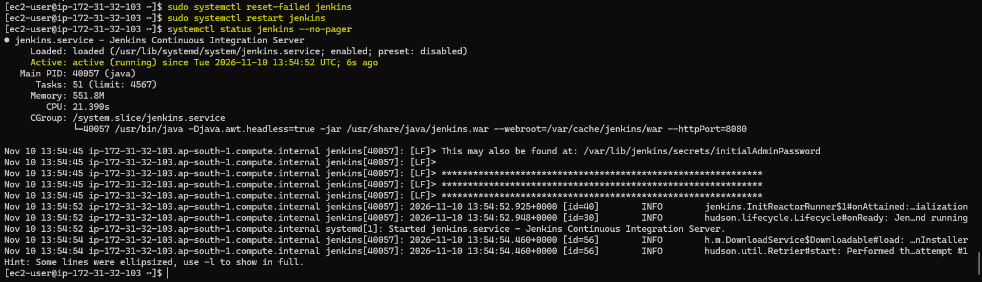

- Get the unlock password by below command:
sudo cat /var/lib/jenkins/secrets/initialAdminPassword
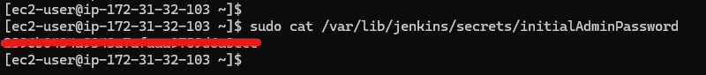

- Use this unlock password to unlock the jenkins at first time
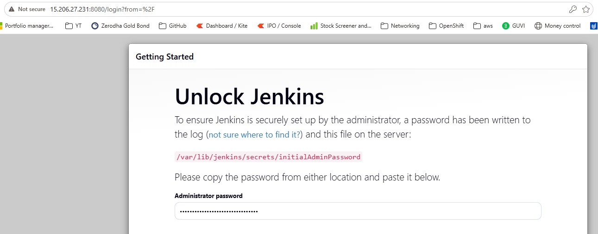
- Creating an account for jenkins
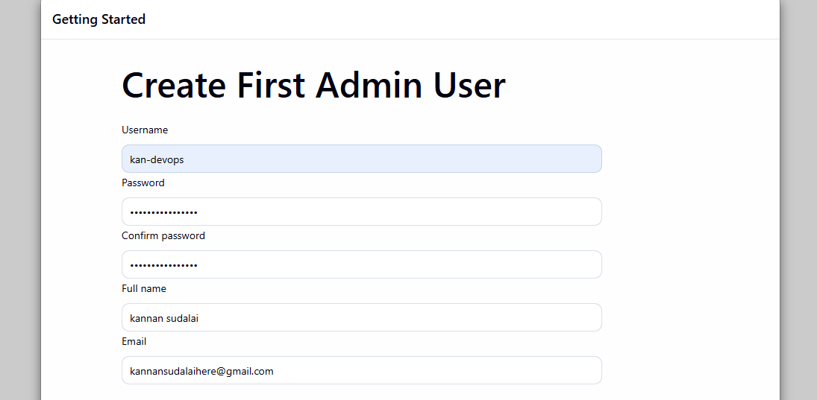

- Jenkins installed successfully.
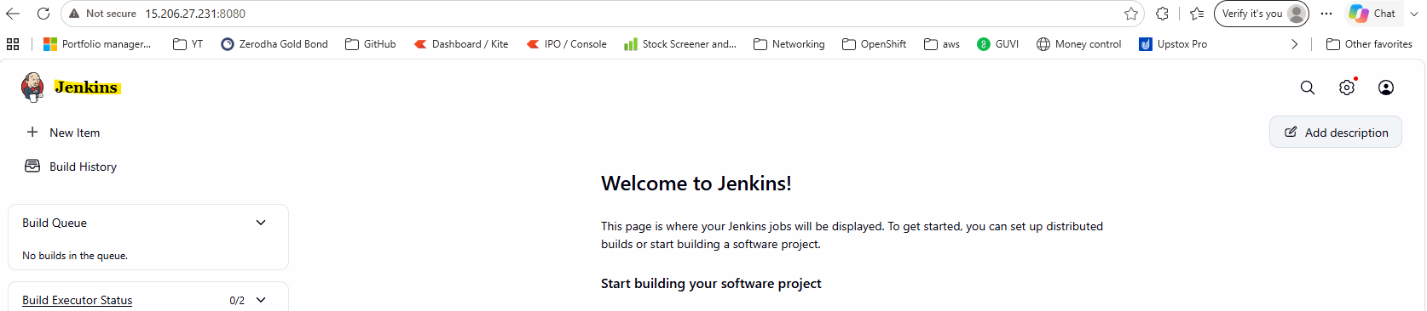

- Creating a freestyle Project
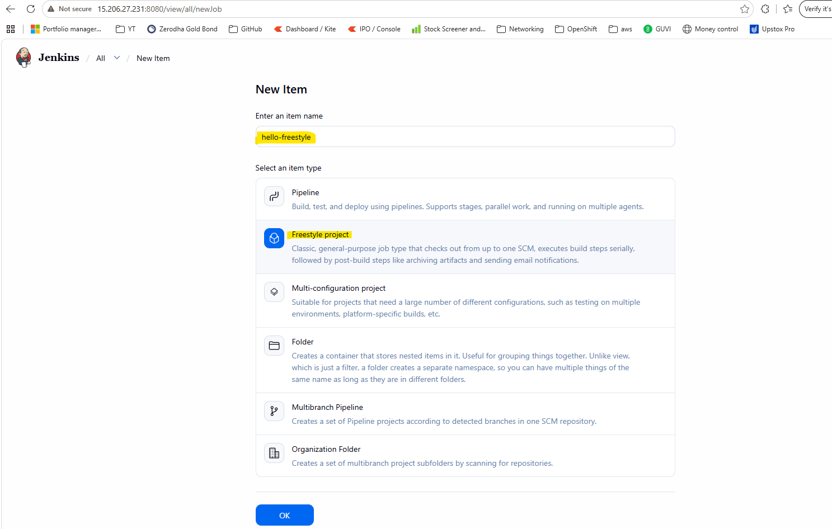

- Add build step and choose execute shell, Paste below code and save.
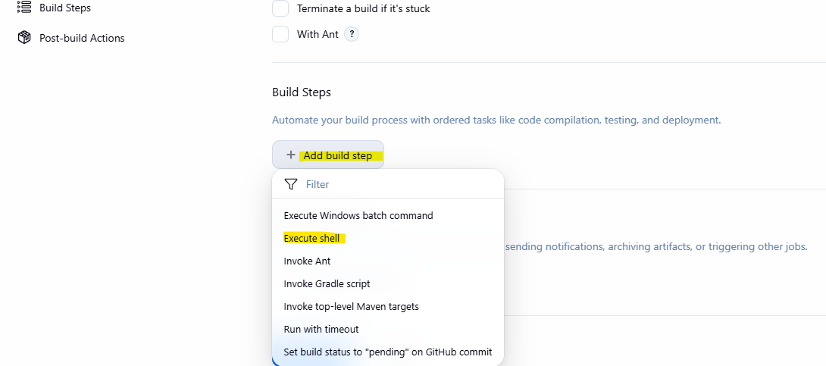
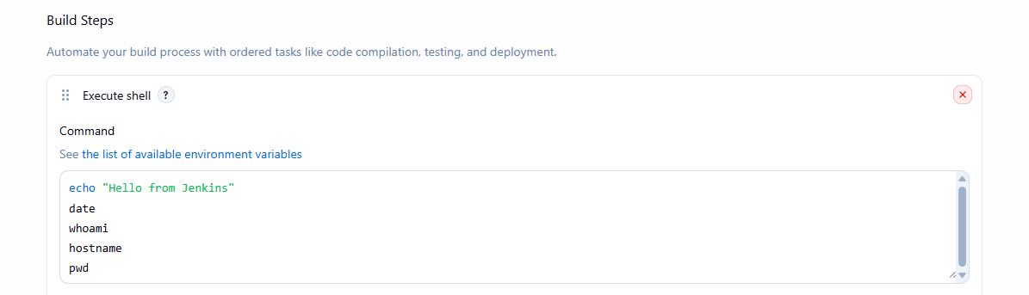
- Click “Build Now”, this will run the build and under “Builds” you can see the build history.
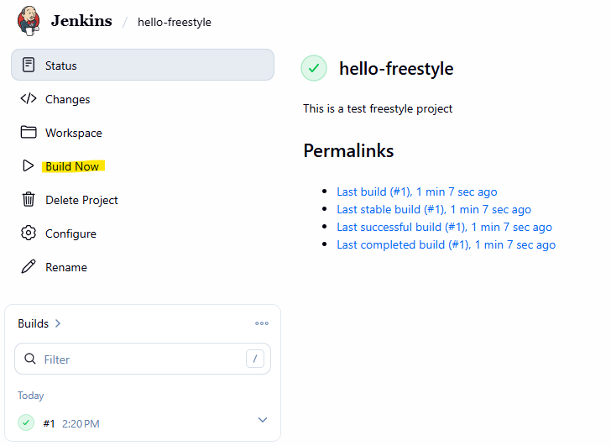

- Build history shows one build #1
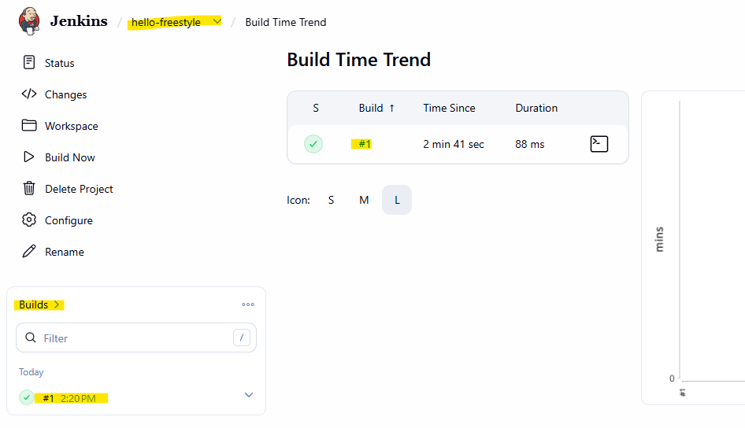

- Under build history click “#1” and go inside --> then click “Console output” shows the output of execute shell commands:
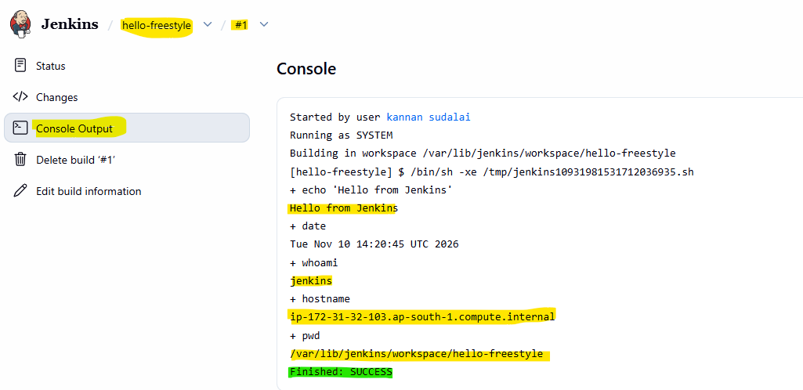
- Jenkins server shows this project under var/lib/Jenkins/workspace/
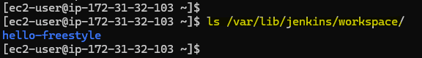

- Creating a pipeline: hello-pipeline and added groovy script to print hello when staging and hello from pupeline when stops:
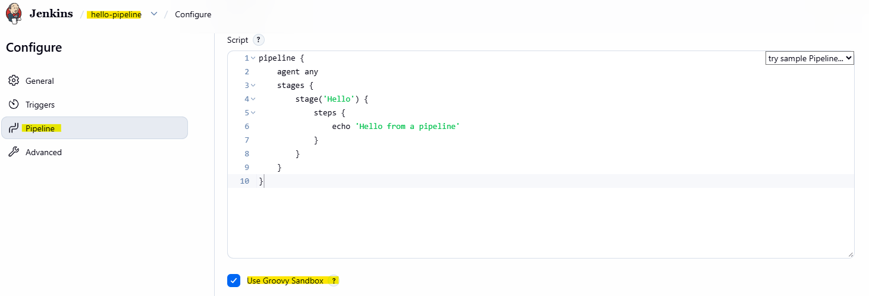

- Click save --> build now --> build history ---> open the build #1 --> Console output:
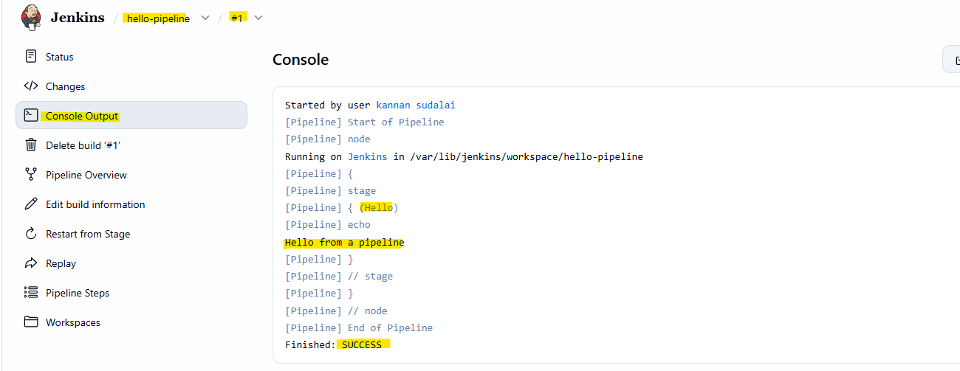

- Creating a new user to manage Jenkins new user: kan-jenkins
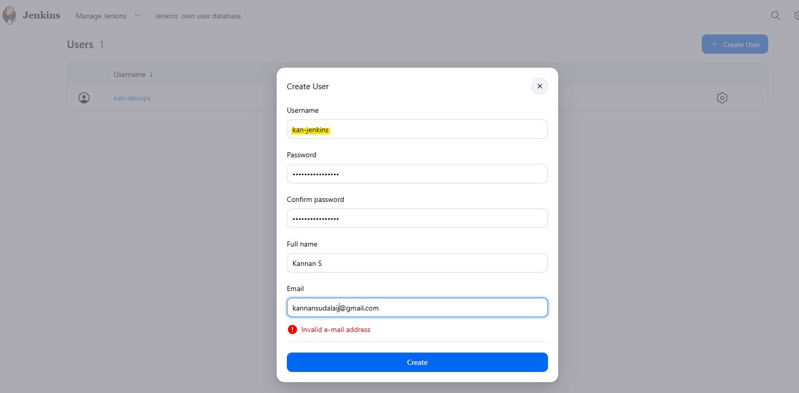

- Logged in with newly created user kan-jenkins
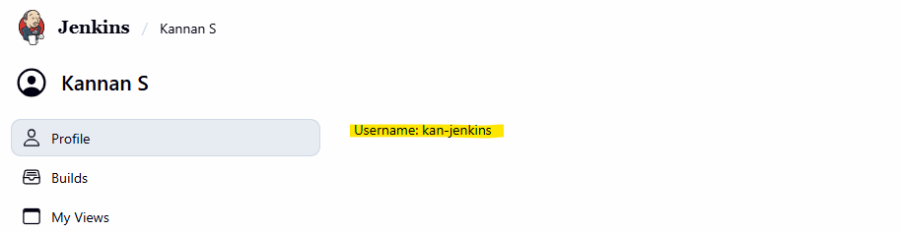

COMPLETED THE PROJECT AND USER CREATIONS IN JENKINS - JENKINS TASK-1 COMPLETED

