Prometheus-Grafana-Node-Exporter Monitoring stack task:
- Launch new EC2 instance with required ports for the monitoring tools and 20GiB capacity.
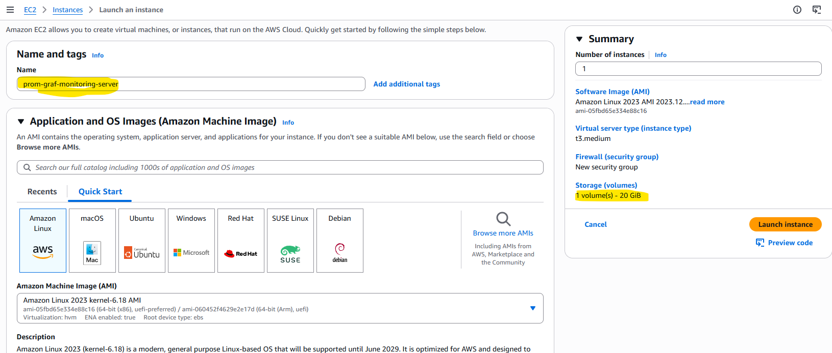

1.2.Creating a new SG with required ports open:
Port | Service | Purpose
22 | SSH | Connect to Linux EC2
9090 | Prometheus | Collect and query metrics
3000 | Grafana | Monitoring dashboards
9100 | Node Exporter | Expose Linux system metrics

Note: T3 Medium instance for better workload handling
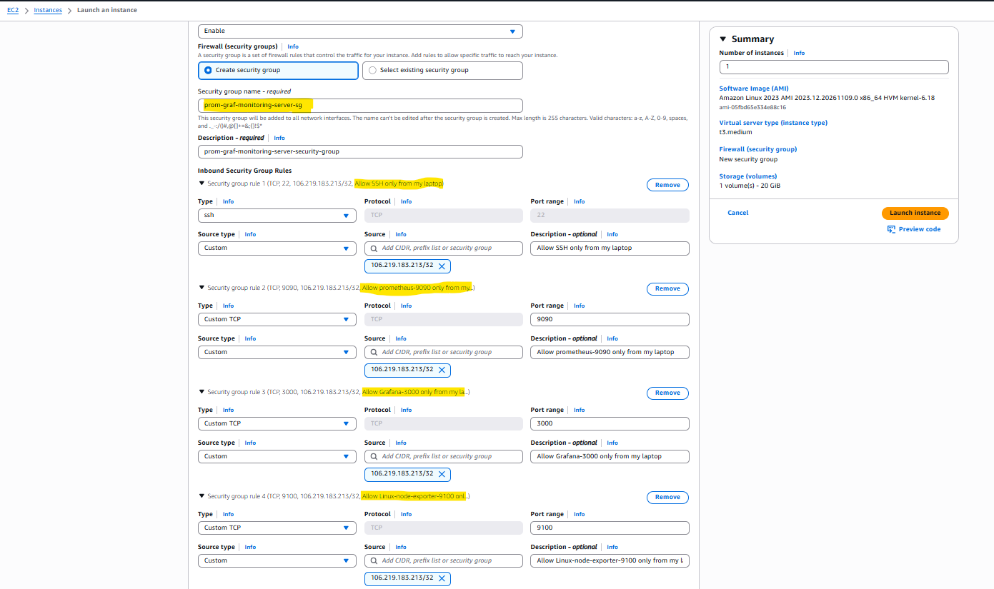
Architecture:
- Node Exporter measures the server (CPU, RAM, disk, network) and publishes the numbers as plain text at :9100/metrics. It doesn’t store anything.
- Prometheus visits that page every 15 seconds (a “scrape”), then stores each number with a timestamp. You tell it where to look in prometheus.yml.
- Grafana collects nothing. It asks Prometheus for data and draws graphs.

1.Install Node Exporter and run this as a service
- Loginto the Monitoring server:
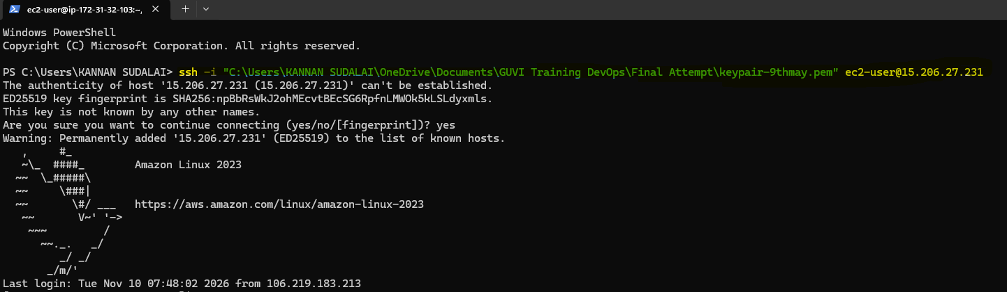
- Run command
“VER=$(curl -s https://api.github.com/repos/prometheus/node_exporter/releases/latest | grep tag_name | cut -d '"' -f4 | sed 's/^v//') to set up the latest version to variable $VER"

- Download the package of node-exporter using curl -LO command
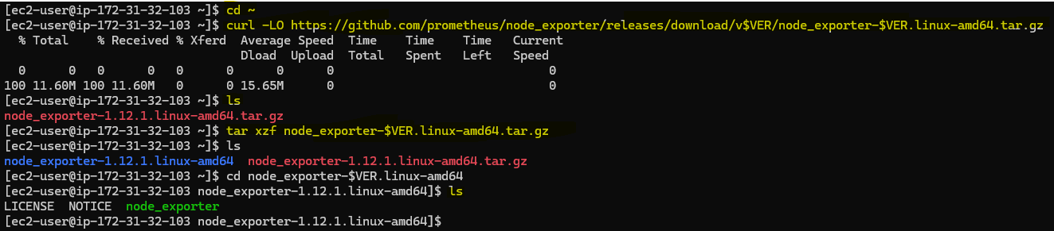

- Kick off node-exporter installation by running ./node_exporter
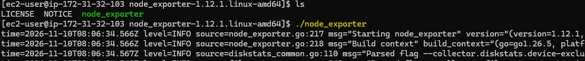

- Installation completed “Listening on addredd 9100” confirms it
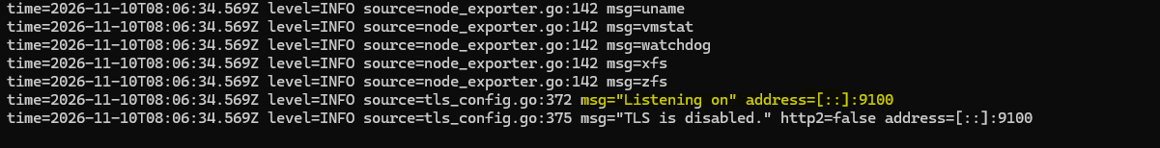

- connect the EC2 public IP with port 9100 to see the metrics (http://15.206.27.231:9100/metrics)
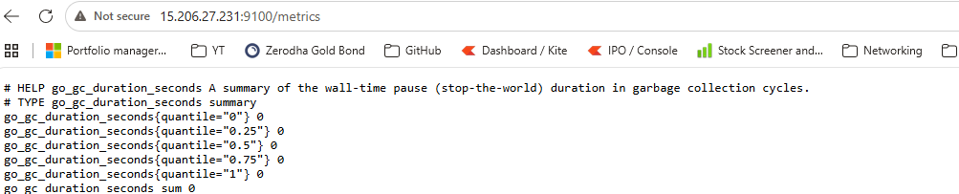

- Confirm it by searching “node_cpu_seconds_total” That is the raw data Prometheus will collect

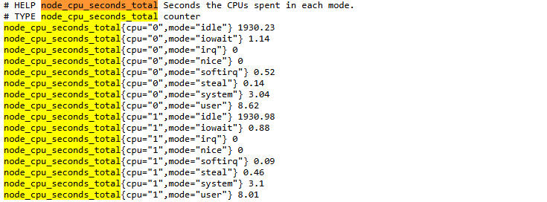

- Now ctrl+c to close and make this as a service to run: (Creating node-exporter as a service)

10.Paste below in the node_exporter.service file
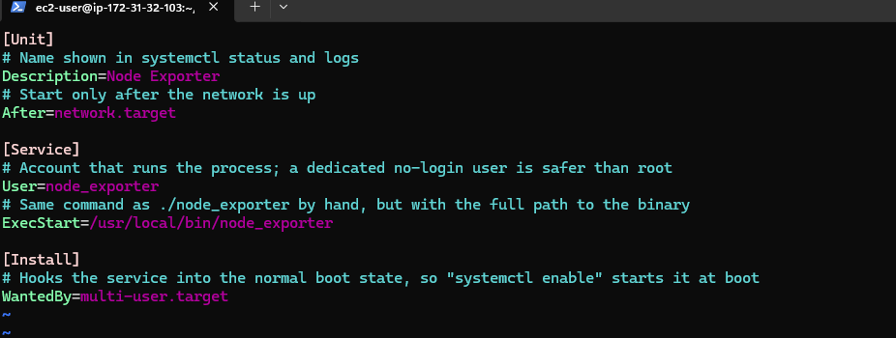

- Enable node_exporter service: Confirmed it’s running and listening on port 9100
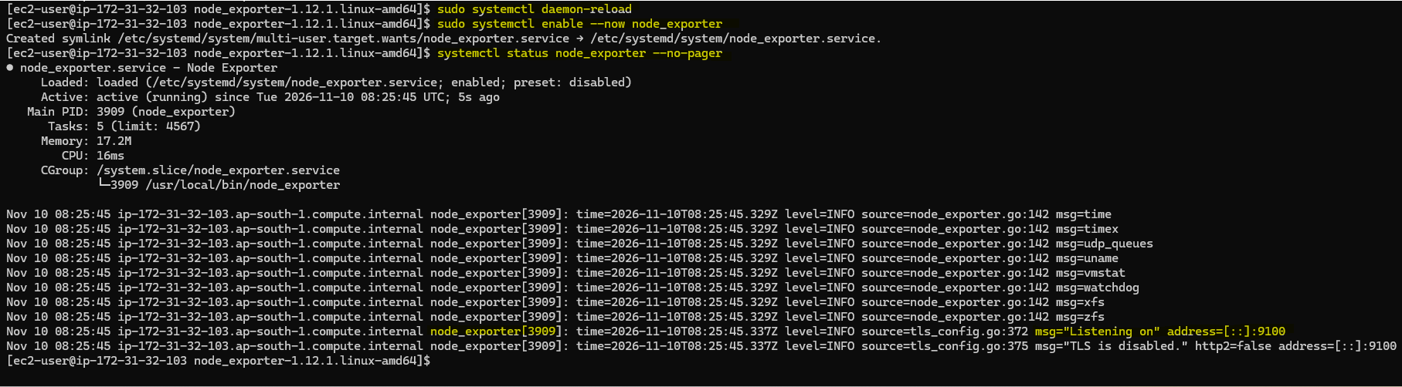

- Confirmed that data is being collected now after service is enabled and running.
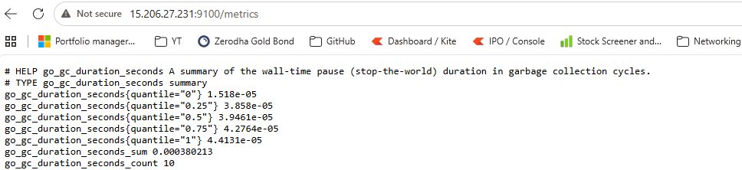

Prometheus installation
- Run command
“VER=$(curl -s https://api.github.com/repos/prometheus/prometheus/releases/latest | grep tag_name | cut -d '"' -f4 | sed 's/^v//')” to set up the latest version to variable $VER"
- Download the package of node-exporter using curl -LO command (Prometheus package highlighted in blue)
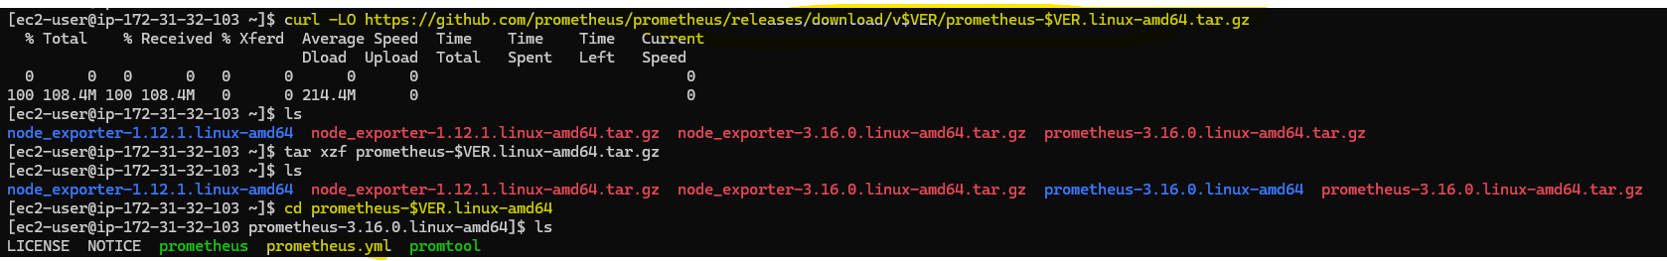
- Cat the prometheus.yml file this have the scrape intervel timings.
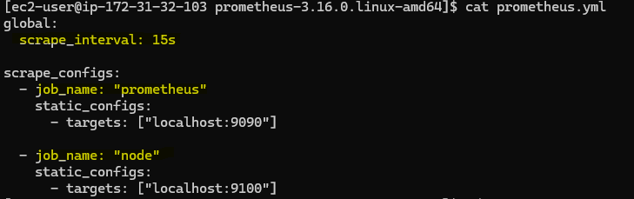
- Use ./promtool check config to validate the syntax of the prometheus.yml file.
Use nohup ./prometheus --config command to intiate the installation detached.
Finally check the prometheus health by running curl localhost:9090/-/healthy
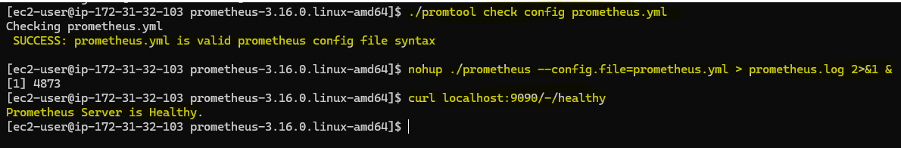
- Prometheus up and running and able to query both node and prometheus
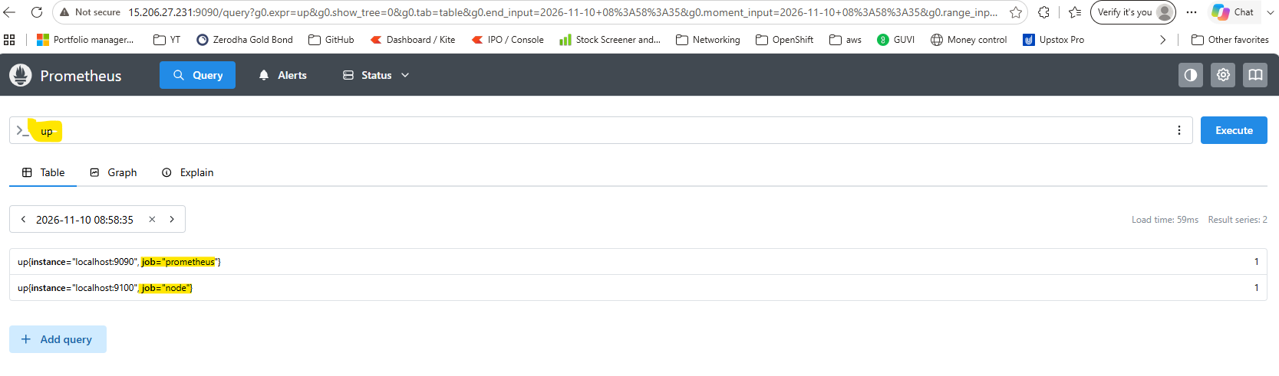

- Run the command to kill the prometheus process that’s running in detached mode in the background:

- Run commdns to Ru this as a permanent service
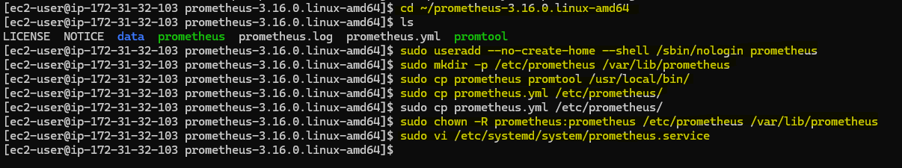
- Prometheus.service File content
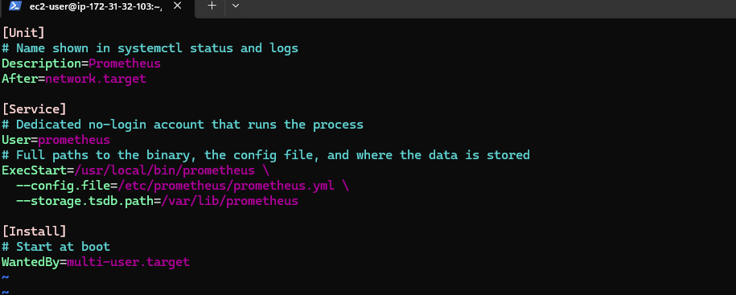
- Resload systemctl deamon and enable the prometheus service
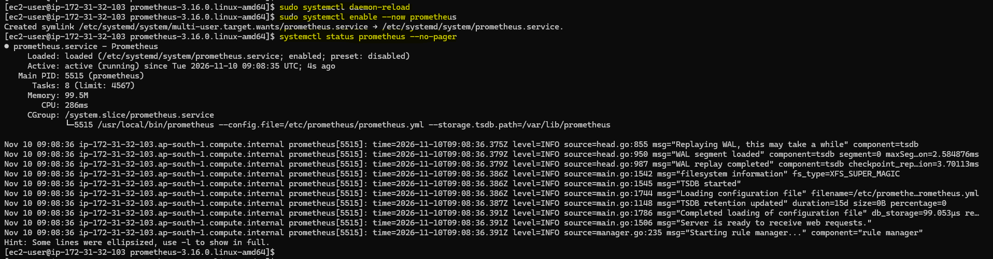
- Run two job to see make some CPU usage to see the metrics in the prometheus end.

- Run query to see live metrics “100 - (avg(rate(node_cpu_seconds_total{mode="idle"}[1m])) * 100)”
This shows CPU usage went to 100% and then came down, observation confirms prometheus works fine.

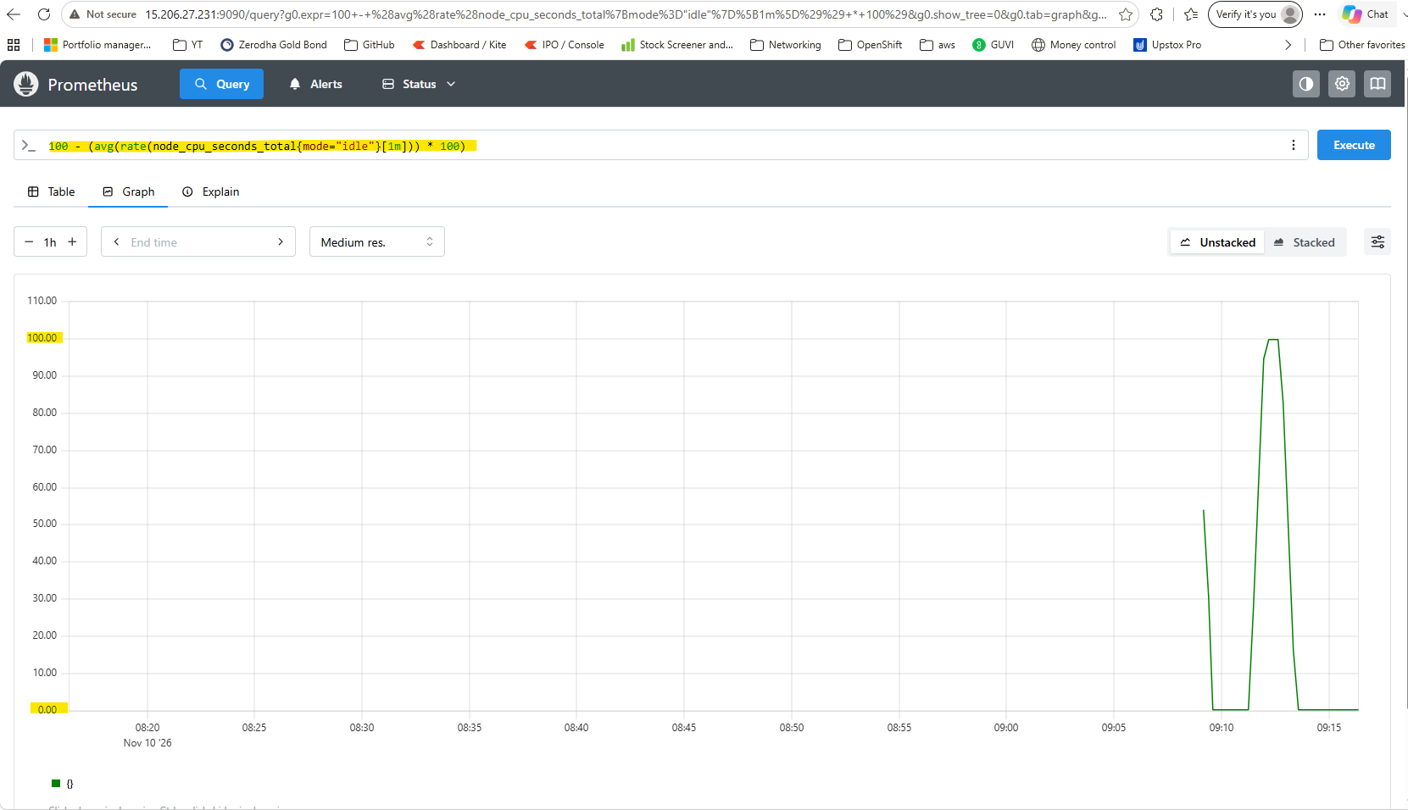

Grafana Installlation
- Add the Grafana repository
Grafana.repo file content:
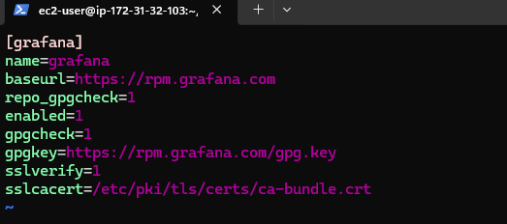
- Run dnf install command to install grafana
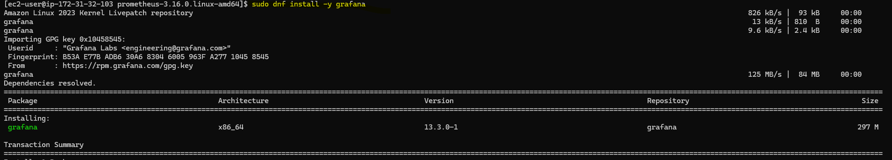
- Grafana installed succesfully
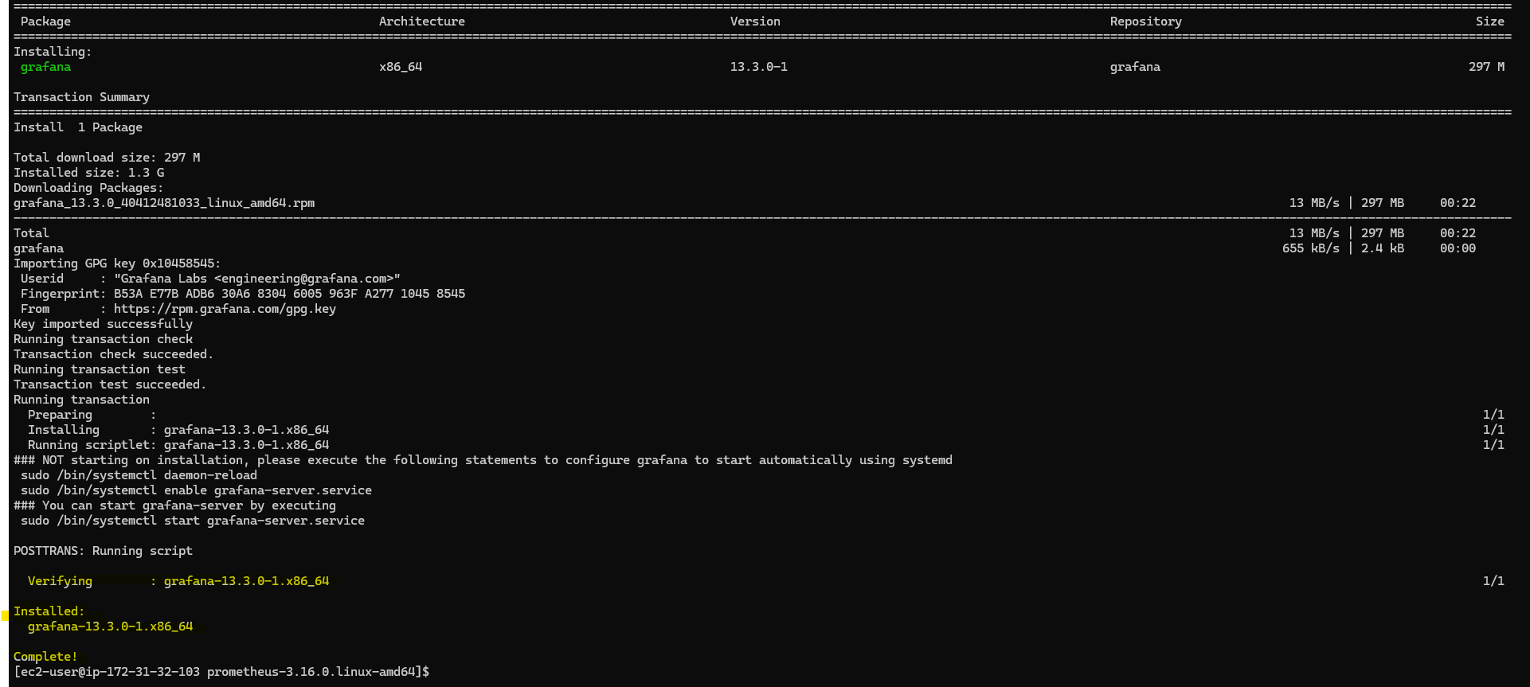
- Enable and check the status of grafana-server service
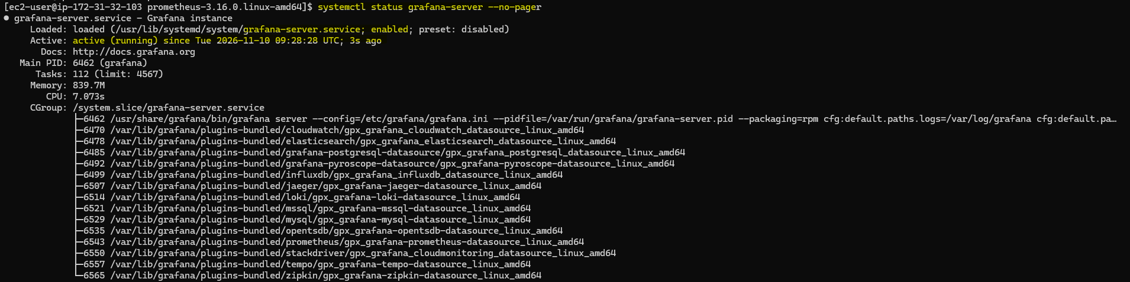

Note: Grafana ships with its own service file, so we don’t write one like we did for prometheus and node-exporter.

- Check if grafana is listening:
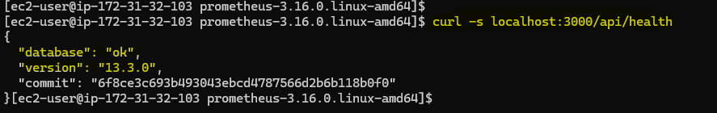
- Successfully deployed Grafana


Link Prometheus and Grafana
- Go to Grafana Connections → Data sources → Add data source → Prometheus add prometheus URL
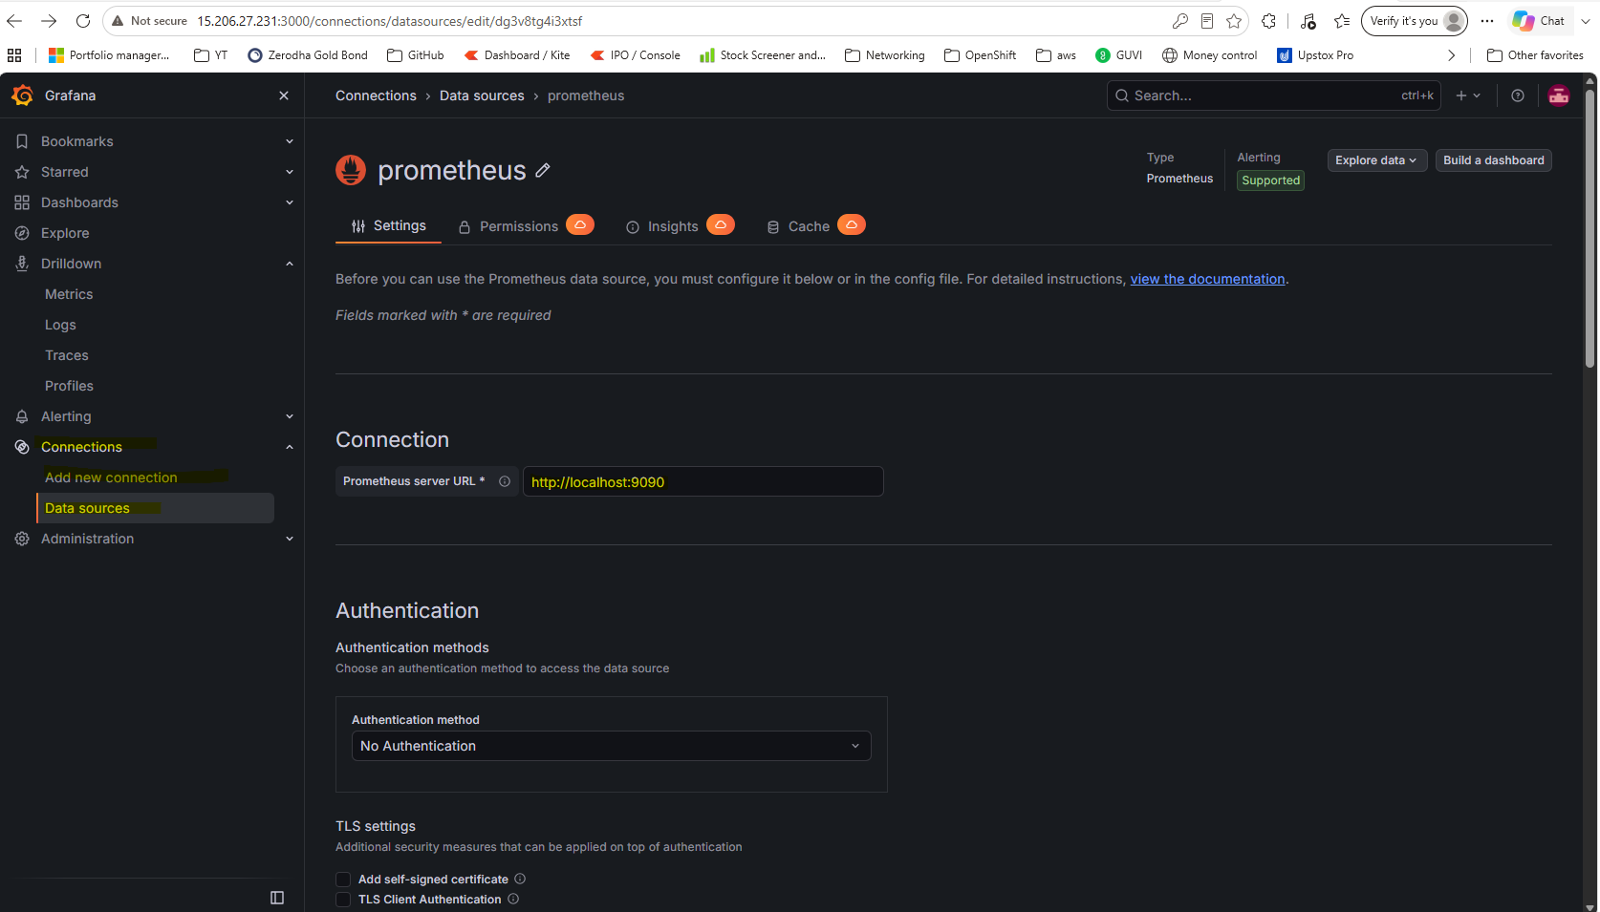
Note: Give http://localhost:9090 as grafana and prometheus runs on same server.

- Successfully queries prometheus API
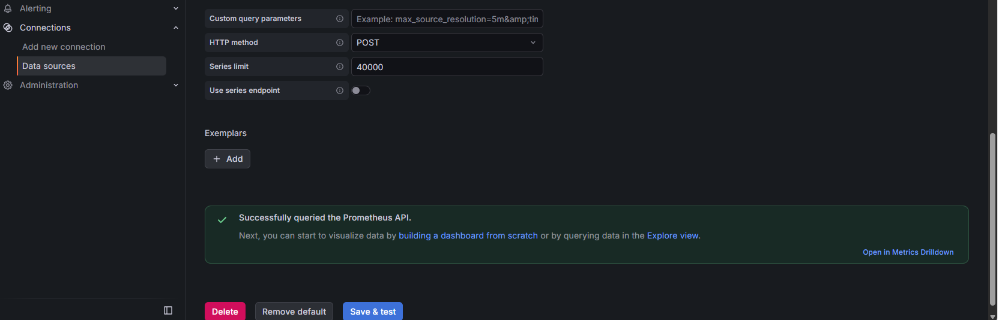

- Go to Dashboards --> Import Dashboard --> type 1860 in ID --> Load
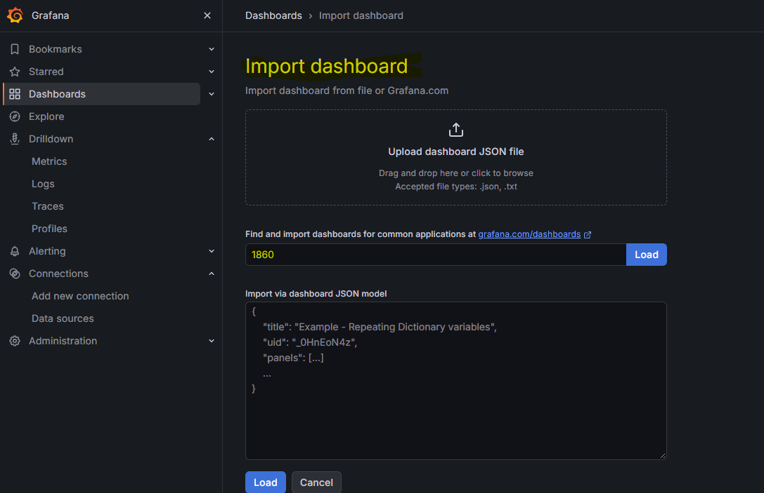

- This imports ready made “node-exporter full”dashboard by Grafana community
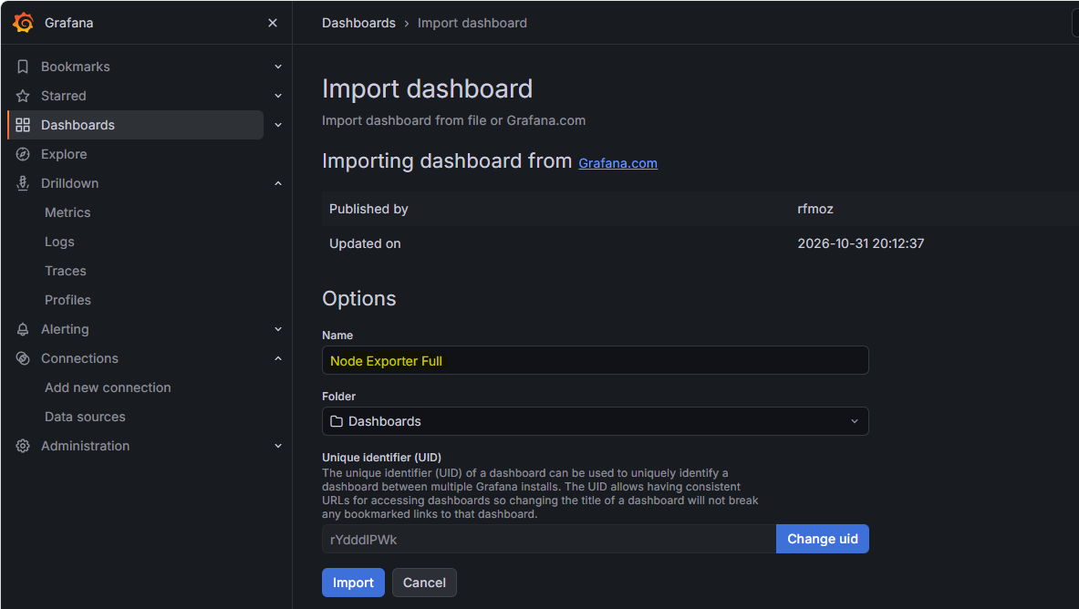

- Quick validation to see if all services (node-exporter, prometheus and grafana) running
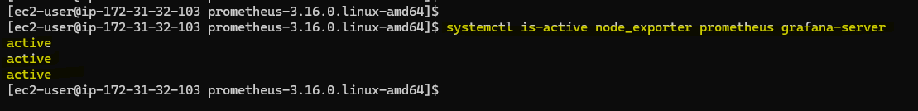
- Grafana dashboard shows the current CPU/ME/Disk status of the server
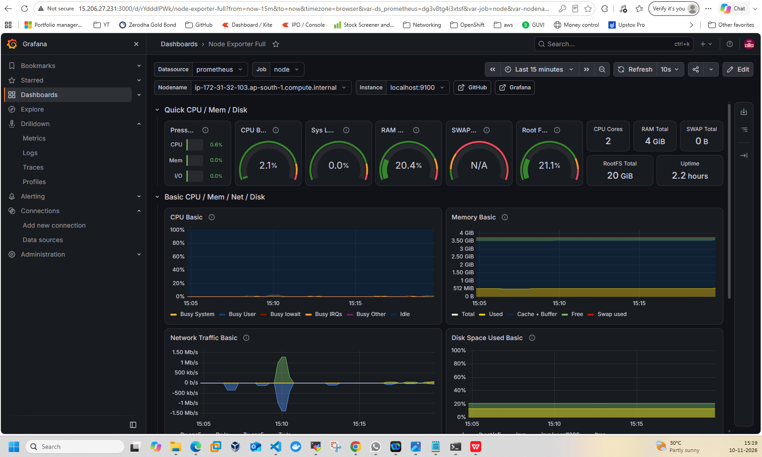

- To test the CPU load data in the Grafana running a CPU burn command
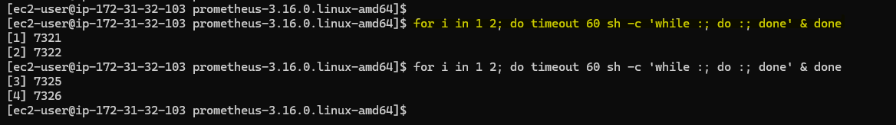

- CPU load increasing
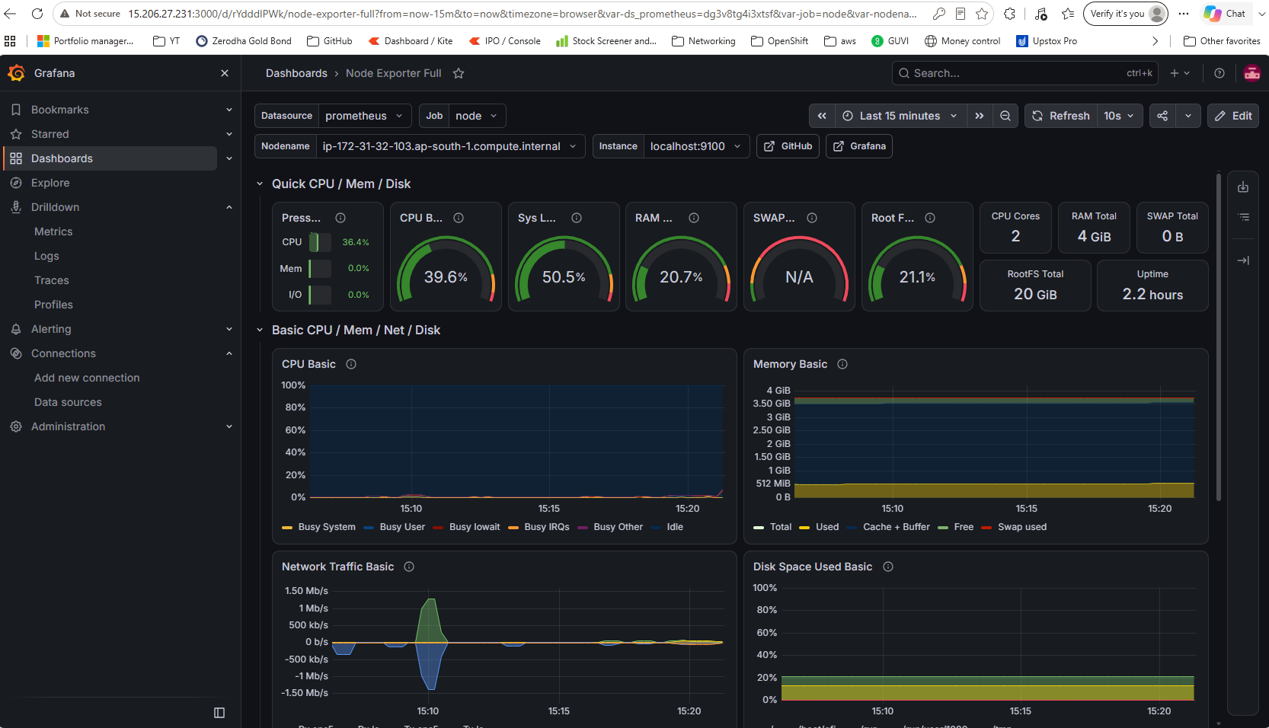

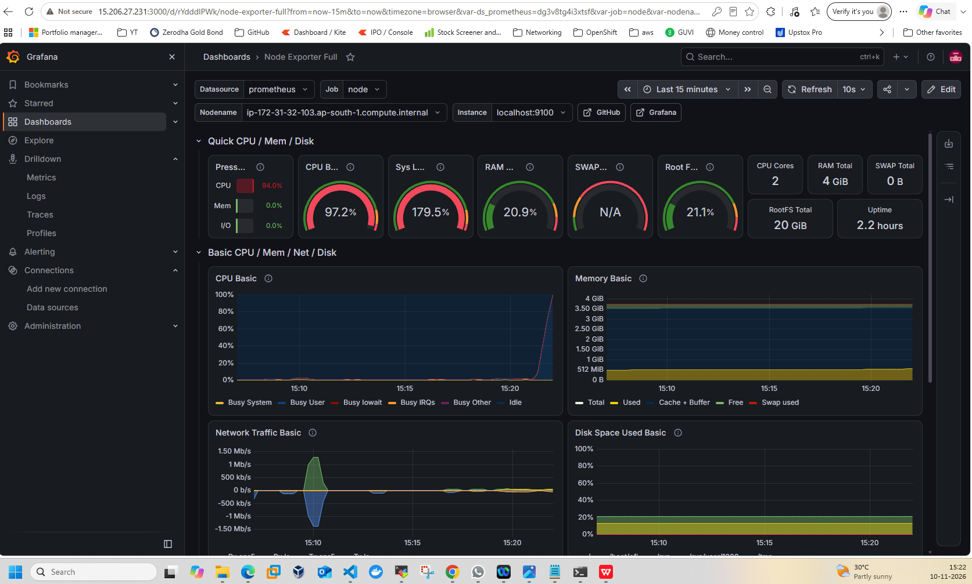

- Back to normal after tasks are completed:
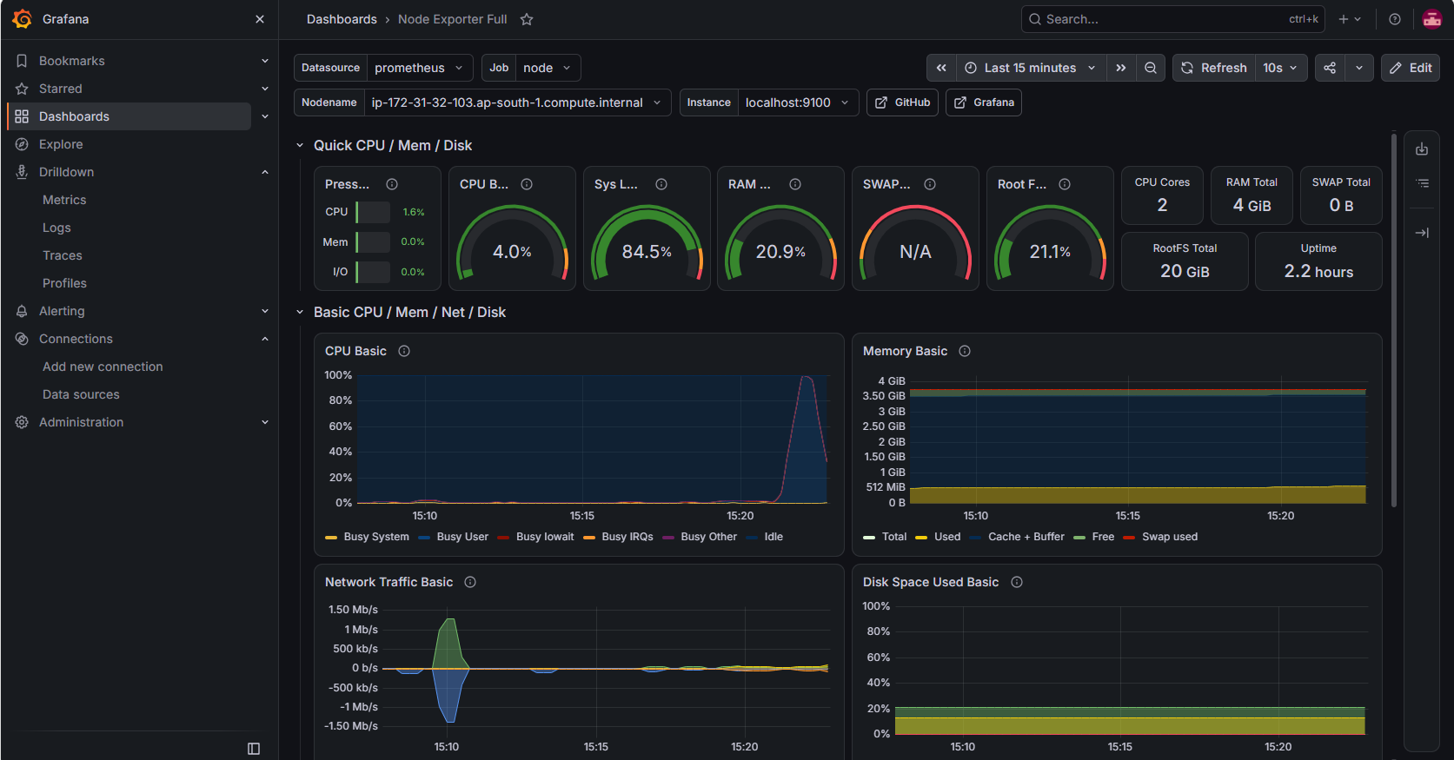

Successfully deployed Node-exporter,Prometheus and fgrafana linked them together and observed the metrics in the dashboard.

Troubleshooting Tips:
- “Save & test” fails: check that Prometheus is running (systemctl is-active prometheus) and that the URL is exactly http://localhost:9090.
- Import can’t load ID 1860: the Grafana server needs outbound internet, which an EC2 with a public IP has. If it still fails, tell me and I’ll give you the manual download route.
- Panels show “No data”: make sure the Job and Host dropdowns at the top of the dashboard are set to node and localhost:9100. A wrong time range will also cause it, so use “Last 15 minutes”.
- Can’t reach port 3000: check that the security group still has the 3000 rule with your current IPv4.

