- Project Overview
- Project Title
Student Dashboard – Modern Academic Portal

- Team Member Name
- Bishal Khadka Kshetri
- Roshan K.C
- Bibek Chaudhary
- Competition Name
Web Design Competition/Challenge

- Submission Date
June-10, 2026

- Brief Description of Websites
The Student Dashboard is a front-end web application designed for university students to manage their academic activities. It provides a centralized platform where students can view results, manage assignments, view class routine, read notices. The website features a modern, responsive design with effects and smooth animations, creating an engaging user experience.
- Target Audience
- University and college students.
- Educational institutions looking for student portals.
- Students needing to track academic progress.
- Objectives
- Academic Overview
- Result viewing
- Assignment management
- Notice board
- Responsive design

- Features
- Dashboard with statistics cards and recent activities
- Subject marks table and search bar
- Assignment card with due dates
- Dark/light mode toggle
- Supportive in Desktop, Tablet and Mobile devices.
- Design Process
- Requirements Analysis
- Dashboards with key statistics
- Profile viewing and editing interface
- Results display with search functionality
- Assignment management
- Notice board
- Responsive design for all devices
- Modern, Professional appearance

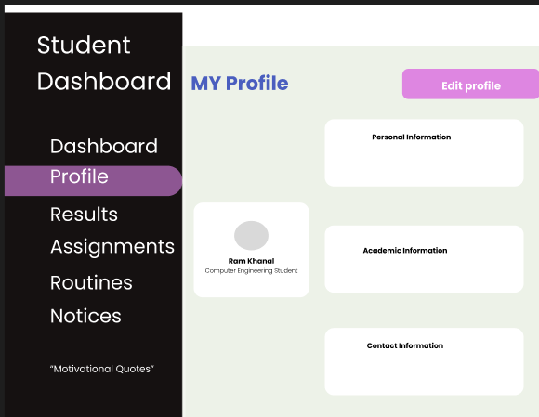
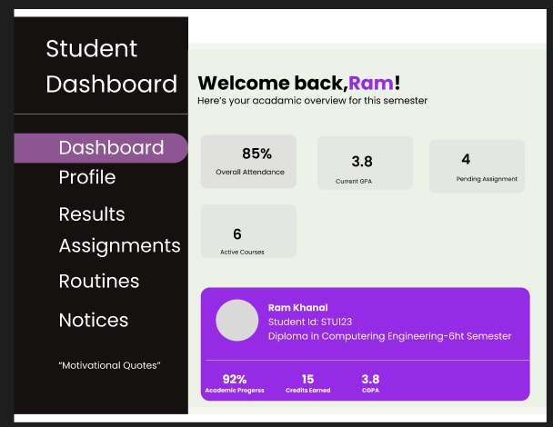
- Wireframe and Sketches

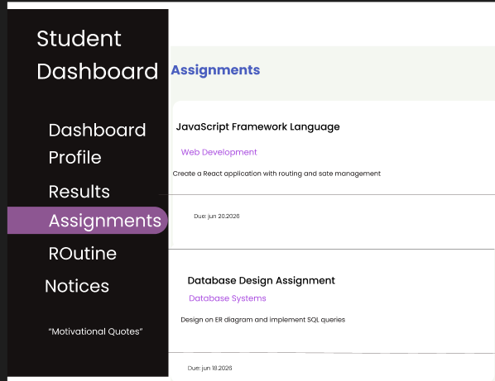
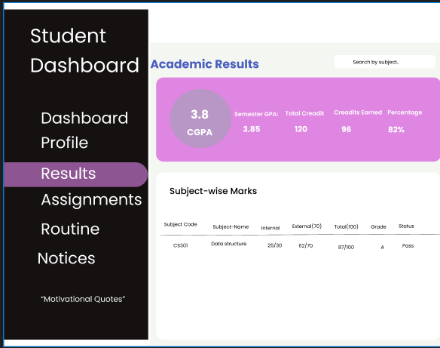

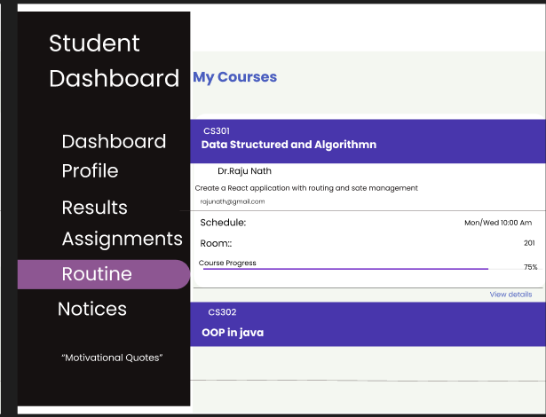
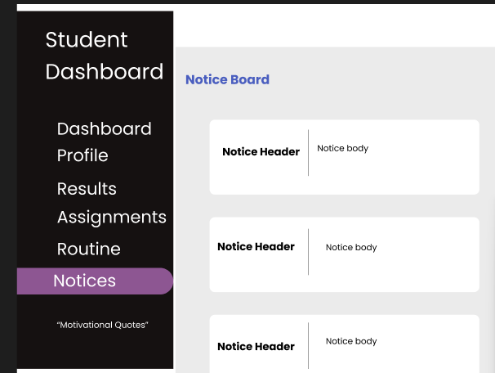

- User Interface Design Decisions
- Gradient Colors :- Linear Gradient for headers, buttons.
- Sidebar Navigation :- Fixed sidebar for easy access to all pages.
- Responsive Table :- Tables transform to scrollable on mobile devices.
- Progress Bar :- Visual representation of attendance and course progress.
- Hover Effects :- Cards lift slightly on hover for interactive feedback.
- Status Badges :- Color-coded badges for assignment status(Pending, Submitted).

- Color Palette and Typography Choices
Color Palette :-
Color Name | Usage
Primary Purple | Gradients
Secondary Purple | Gradients
Dark Blue | Sidebar background
Light Blue | Dark Mode Background
White | Cards backgrounds
Light Gray | Page background
Text Dark | Primary Text
Text Light | Secondary text

Typography:-
Font | Usage
Poppins | Body text, Heading, Labels
- Technologies Used
- Tools and Technologies List
- HTML 5 :- Structure of Web Pages
- CSS 3 :- Add design and animation in web pages
- JavaScript :- Add functionality in web pages
- Font Awesome :- icon library for visual elements
- Code Editor :- Visual Studio Code
- Brower(Firefox) :- Testing and debugging
- GitHub :- Code management
- Challenges Faced During Development and Its Solutions
Challenges | Solutions
Making Responsive sidebar on mobile device | Used CSS media queries and JavaScript toggle
Dark mode implementation across all pages | Use JavaScript toggle
Consistent navigation across all html pages | Create reusable sidebar structure and linked all pages
Search functionality in result page | Used JavaScript filter method on the result
Status badges showing different colors | Created CSS classes for each status(pending, submitted)

- Resource Used
- Images
Image Type | Source
Profile Picture | Google

- Icons
Icon Library | Source
Font Awesome 6.4.0 | https://cdnjs.cloudflare.com/ajax/libs/font-awesome/6.4.0/css/all.min.css

- Icons Used:
- fa-graduation-cap – Logo
- fa-home – Dashboard
- fa-user – Profile
- fa-chart-line – Results
- fa-tasks – Assignments
- fa-book – Routine
- fa-bullhorn – Notices
- fa-search – Search
- fa-edit – Edit Button
- Fonts
Font Name | Source
Poppins | https://fonts.googleapis.com/css2?family=Poppins:wght@300;400;500;600;700&display=swap

- References
- Font Awesome Documentation - https://fontawesome.com/docs
- Responsive Design - https://www.w3schools.com/

