Process Survey
See ../homework/shell-gymnastics/ps for the text dump files for part c of each question.
- a.) The root-owned processes are those in the text dump except for the grep I ran to find it.
b.) ps aux | grep root
- a.) The processes that are running on my account are those that can be see in the text dump file. You can see bash, the chrome browser, and even a ssh client running.
b.)ps aux | grep ksh
- a.)The program running with the most memory is this word processor that I'm using to write up my homework assignment, libreoffice writer. The program running with the most virtual memory is consolekit, which is a GUI which keeps track of logins.
b.) ps aux --sort %mem
ps aux –sort vsz
- a.) Andy, Ashik, and Terran appear to also have ssh'd into the server.
b.) ps aux | grep -v “khiga1” | grep -v “root”

1.)
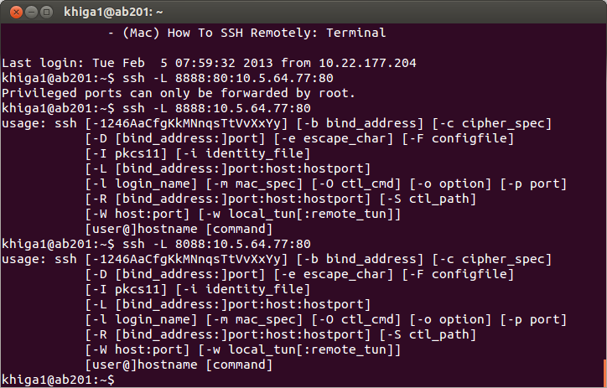
ssh khiga1@my.cs.lmu.edu
ssh -L 8088:10.5.64.77:80

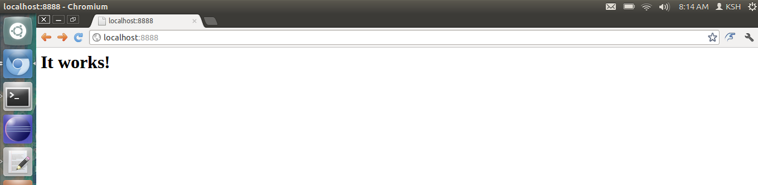

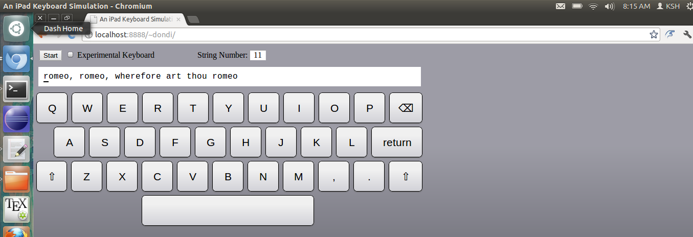

2.)
screen
ping localhost
ctrl+A+D
>logout
>login
screen -r
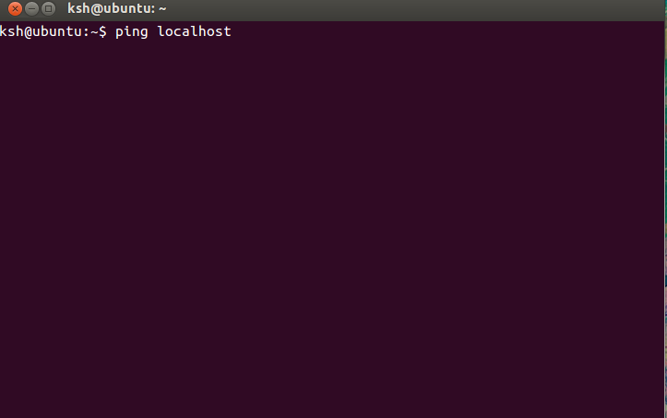

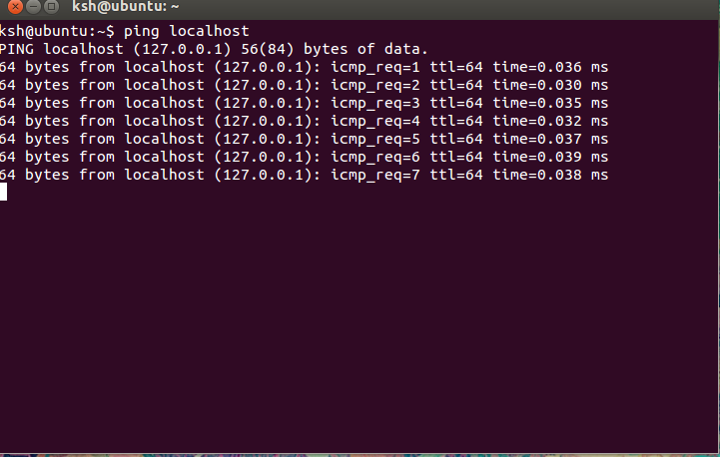
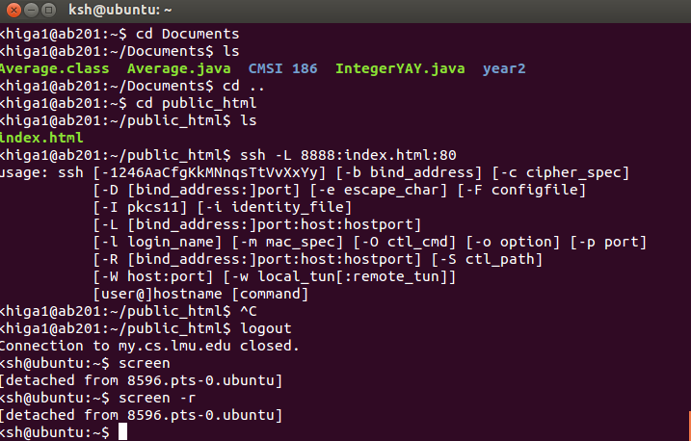

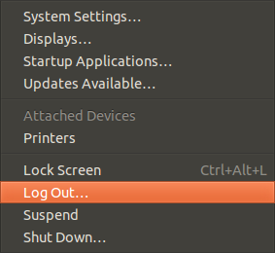

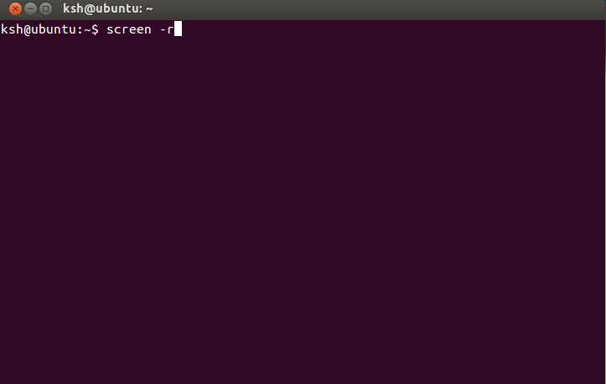

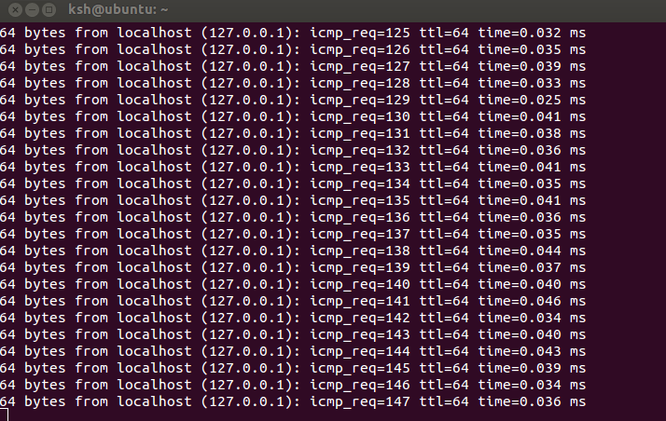
- du –max-depth = 1 > du_home_dir.txt |sort -r -g> du_home_dir_sorted.txt
The biggest appears to be the . configuration folder.
du | grep Documents/CMSI
Finds the disk space used within my computer science folders.

4.) a.)5118227
b.)5512206
c.)5242944
d.)5118227

ls -i | grep 0205.txt

5.) mount | grep ^/dev/

Output:
/dev/loop0 on / type ext3 (rw)
/dev/sda2 on /host type fuseblk (rw,nosuid,nodev,relatime,user_id=0,group_id=0,allow_other,blksize=4096)
/dev/sdb1 on /media/34B5-C699 type vfat (rw,nosuid,nodev,uid=1000,gid=1000,shortname=mixed,dmask=0077,utf8=1,showexec,flush,uhelper=udisks)

