SUPERSTORE SALES PERFORMANCE ANALYSIS USING DATA ANALYTICS
Abstract
This project presents a data analytics study of Superstore retail sales data using Python. The objective is to examine sales trends, profitability, product performance, customer segments, regional performance, and discount patterns. The dataset was processed using Pandas and NumPy, while Matplotlib and Seaborn were used to create visualizations. The analysis follows a structured workflow involving data loading, data cleaning, exploratory data analysis, visualization, and interpretation of business results. The project demonstrates how raw retail transaction data can be transformed into meaningful information that can support data-driven business analysis and decision-making.
Introduction
Retail organizations generate substantial amounts of transactional data through their day-to-day operations. Such data contains useful information about customer purchasing patterns, product demand, regional performance, sales trends, and profitability. However, extracting meaningful information from raw data requires systematic data preparation and analysis.
This project focuses on the analysis of Superstore sales data using Python-based data analytics techniques. The study examines different dimensions of business performance, including sales, profit, product categories, customer segments, regions, and discounts. Through exploratory analysis and visualization, the project aims to identify patterns that can provide a clearer understanding of retail performance
Problem Statement
Raw retail sales data contains a large number of transactions and multiple business attributes, making it difficult to identify important patterns through manual inspection. The problem addressed in this project is to analyze Superstore sales data systematically and identify meaningful trends in sales, profitability, products, customers, regions, and discount behavior.
Objectives
• To analyze overall sales and profit performance.
• To identify sales trends over time.
• To analyze sales and profit by category and sub-category.
• To compare regional sales performance.
• To examine customer segment performance.
• To identify top-performing products.
• To identify products with low profitability.
• To examine the relationship between discounts and profit.
• To visualize important patterns using charts.
• To derive meaningful business insights from the data.
Dataset Description
The project uses the Superstore Sales Dataset obtained from Kaggle. The dataset contains retail transaction information related to orders, customers, products, categories, geographical regions, sales, discounts, quantities, and profits.
The dataset is provided in CSV format and was loaded into Python using the Pandas library.
Dataset:
Kaggle – Superstore Sales Dataset
https://www.kaggle.com/datasets/himanshuuike/superstore-sales-dataset
Technologies Used
Technology | Purpose
Python | Data analysis and processing
pandas | Data manipulation and analysis
NumPy | Numerical operations
Matplotlib | Data visualization
Seaborn | Statistical visualization
Jupyter Notebook | Development and analysis environment
Kaggle | Dataset source

Methodology
Kaggle Dataset
↓
Data Loading
↓
Data Understanding
↓
Data Cleaning
↓
Data Preprocessing
↓
Exploratory Data Analysis
↓
Data Visualization
↓
Business Analysis
↓
Insights
↓
Conclusion
Data Preprocessing
• Dataset information was examined.
• Missing values were checked.
• Duplicate records were identified.
• Duplicate records were removed where necessary.
• Order Date and Ship Date were converted to datetime format.
• Numerical and categorical variables were examined.
• Statistical summaries were generated.
Exploratory Data Analysis
• Total sales
• Total profit
• Total quantity
• Number of orders
• Number of customers
• Sales trends
• Category performance
• Regional performance
• Customer segments
• Product performance
• Discount and profit relationships
Data Visualization
• Monthly Sales Trend
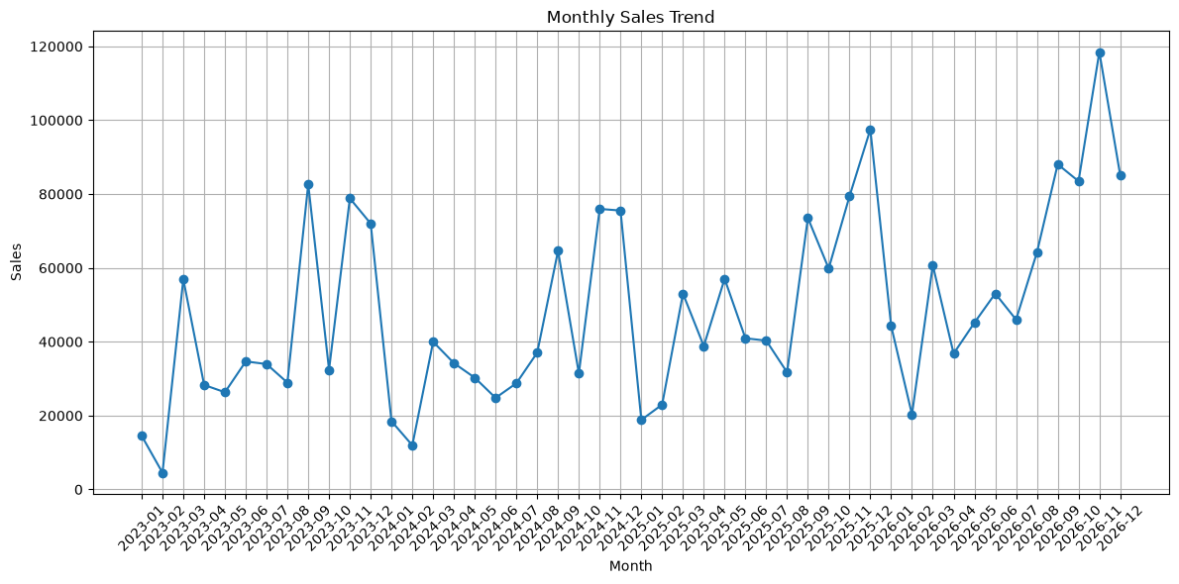
• Yearly Sales
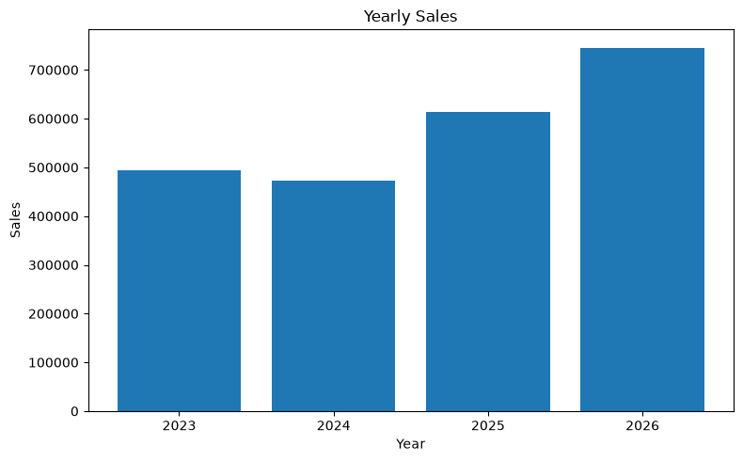
• Sales by Category
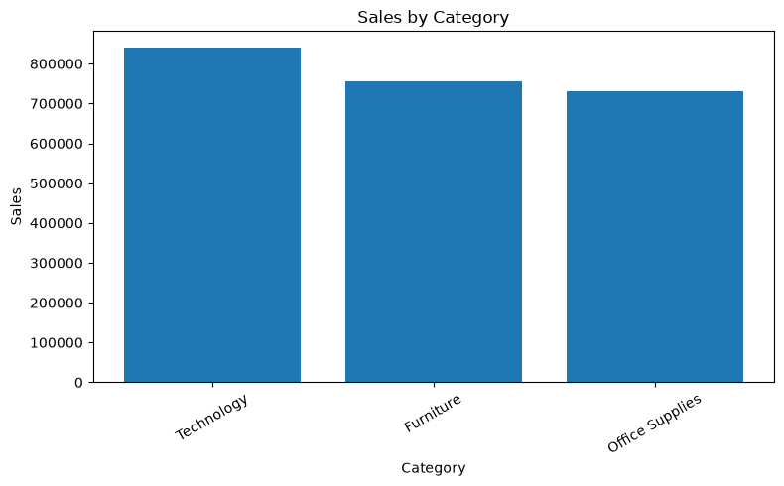
• Sales by Sub-Category
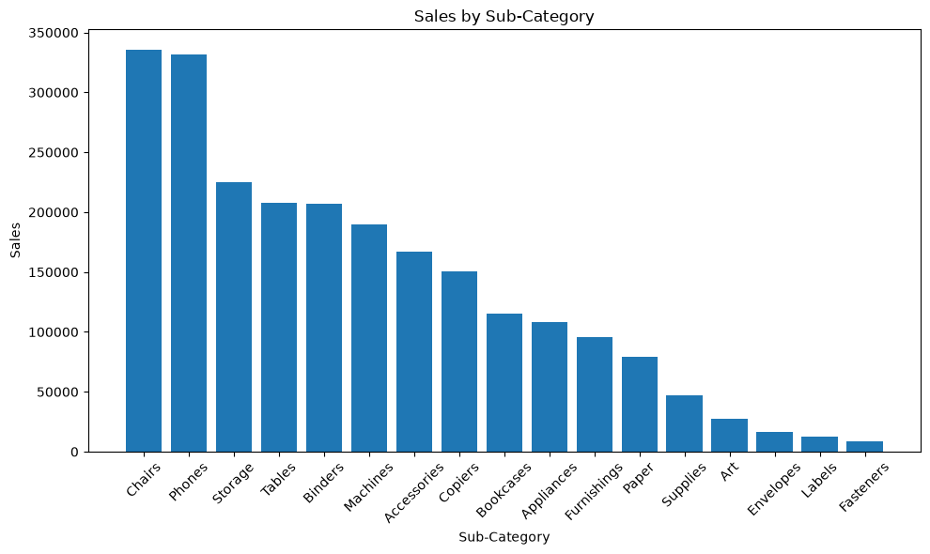
• Sales by Region
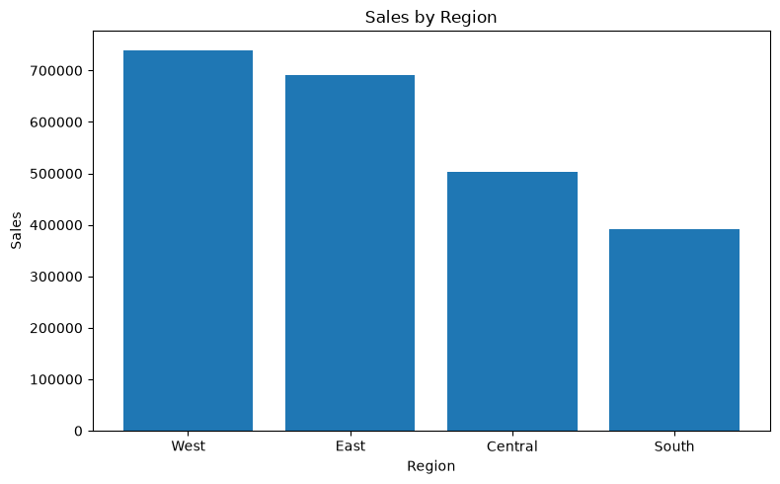
• Sales by Customer Segment
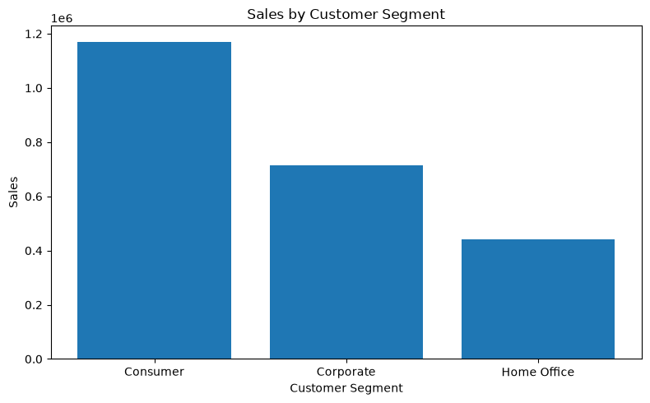
• Top 10 Products by Sales
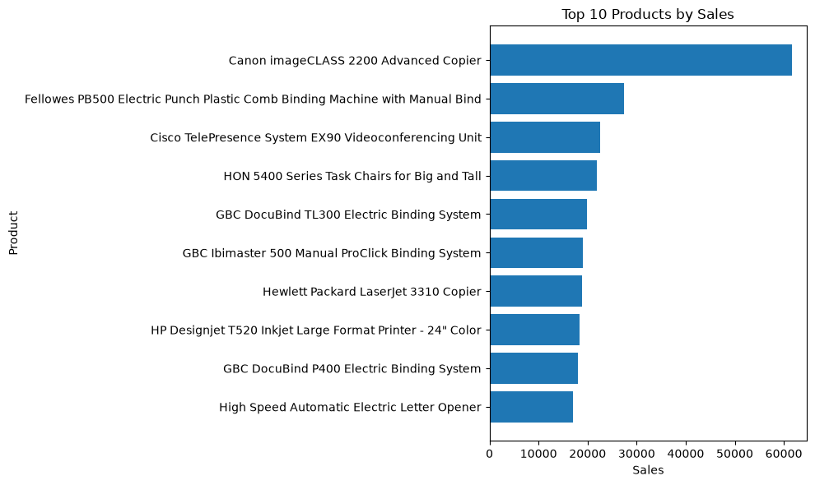
• Profit by Category
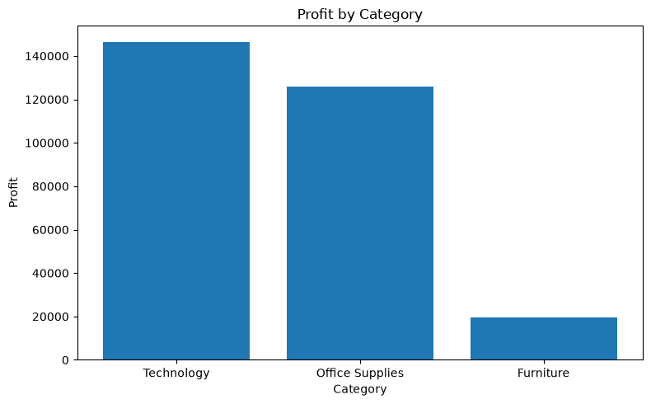
• Profit by Region
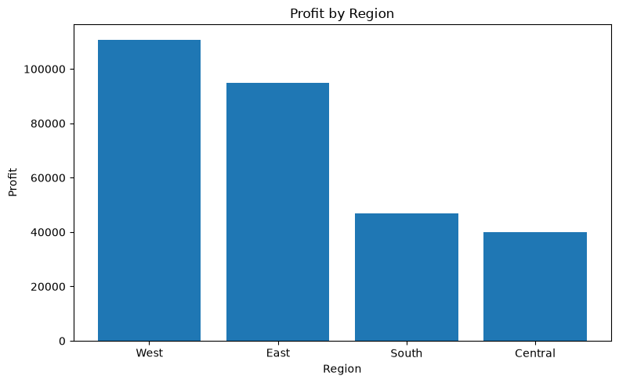
• Average Profit by Discount Level
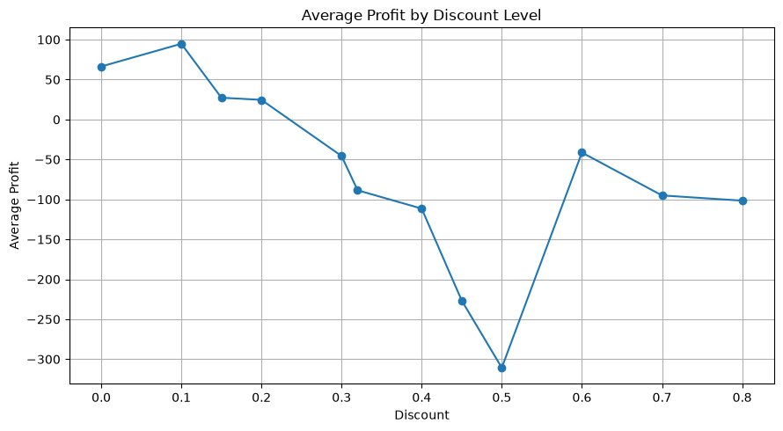
• Sales vs Profit
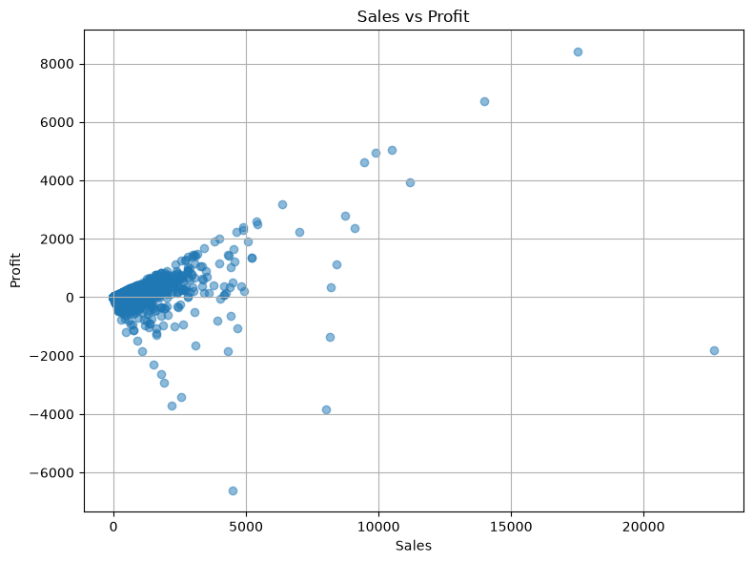
• Correlation Heatmap
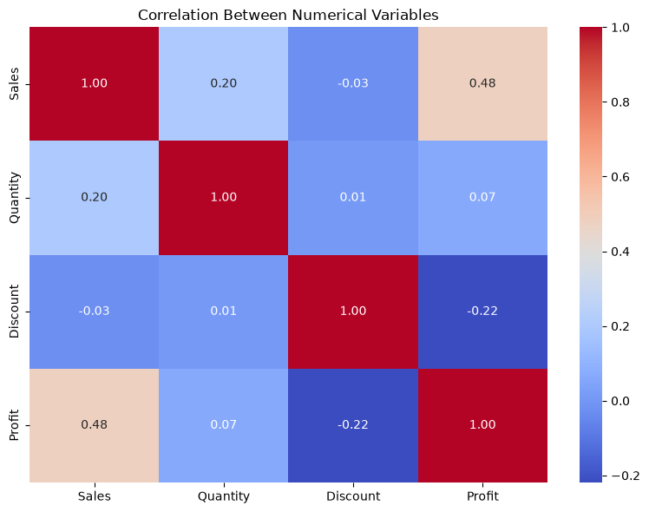
Business Insights
The analysis shows differences in sales and profitability across categories and regions. Category-level analysis helps identify the major contributors to revenue, while profit analysis provides additional information about business performance. Customer-segment analysis shows that different customer groups contribute differently to overall sales and profit. Product-level analysis identifies the products that contribute substantially to sales as well as products requiring further attention. The discount analysis provides an additional perspective on the relationship between pricing decisions and profitability.
Conclusion
This project demonstrated the application of data analytics techniques to a retail sales dataset. The Superstore dataset was cleaned, explored, and analyzed using Python and commonly used data analytics libraries. Different aspects of business performance, including sales, profit, products, customers, regions, and discounts, were examined through statistical analysis and visualization.
The analysis demonstrates how structured data processing and visualization can transform raw transactional data into useful business information. The project also provides a foundation for further work involving interactive dashboards, forecasting, customer segmentation, and predictive analytics.

Future Scope
- Interactive Power BI dashboard
- Sales forecasting
- Customer segmentation
- Product demand prediction
- Profit prediction
- Automated reporting
- Real-time analytics
- Advanced machine-learning analysis

