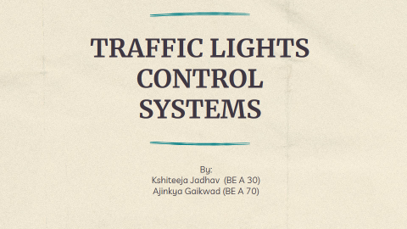

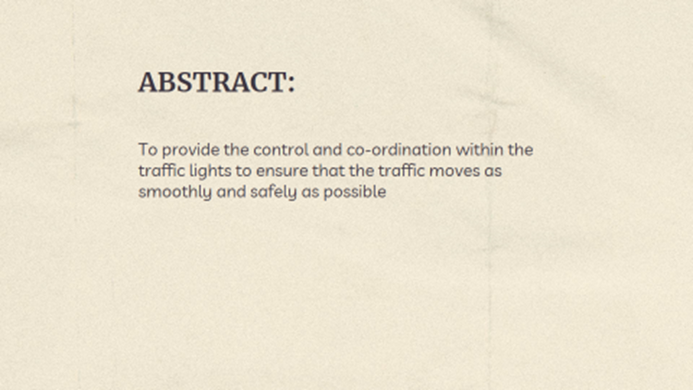

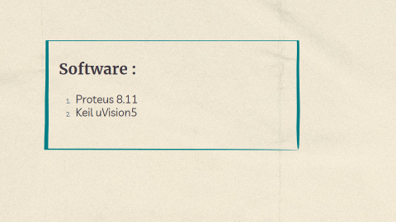

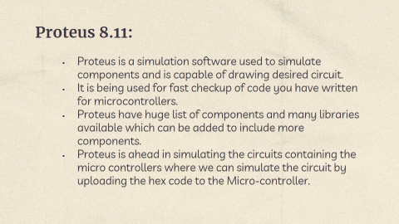

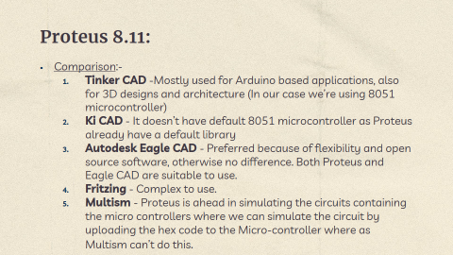

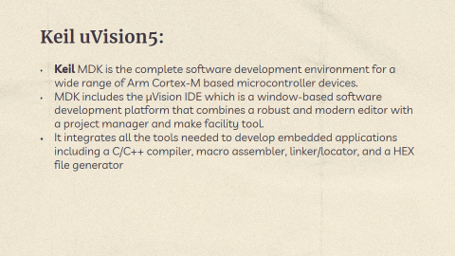

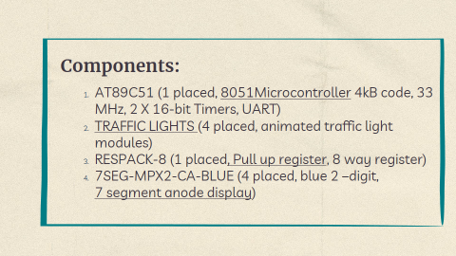

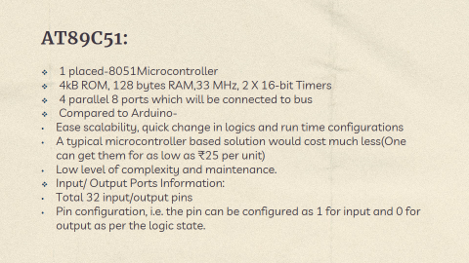

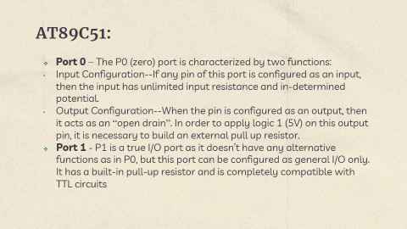

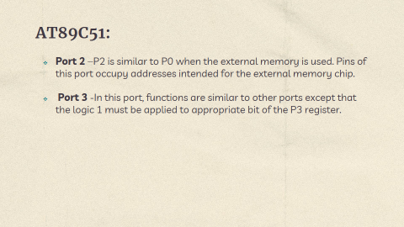

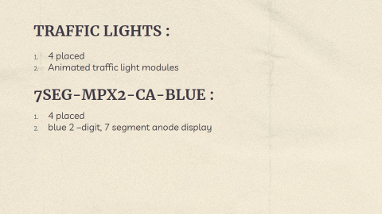

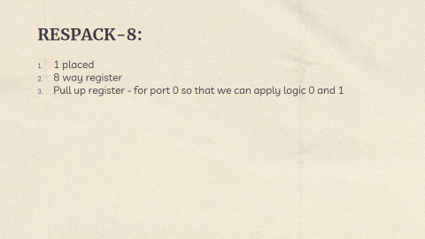

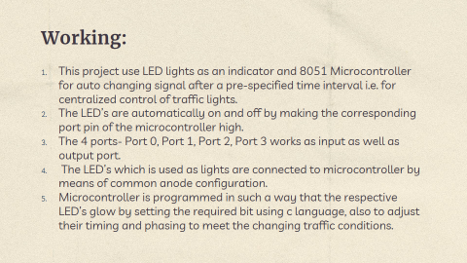

**C Code:**

#include<reg51.h>

sbit east_red=P1^7;

sbit east_yellow=P1^6;

sbit east_green=P1^5;

//ease side//

sbit west_red=P1^4;

sbit west_yellow=P1^3;

sbit west_green=P1^2;

//west side//

sbit north_red=P1^1;

sbit north_yellow=P1^0;

sbit north_green=P0^0;

//north side//

sbit south_red=P0^1;

sbit south_yellow=P0^2;

sbit south_green=P0^3;

//south side//

void delay(unsigned int i)

{

unsigned int j,k;

for(j=0;j<i;j++);

    {

    for(k=0;k<25000;k++);

    }

}

void main()

{

P2=P3=0x00;

    while(1)

    { east_green=west_red=south_red=north_red=1;

        delay(20);

        east_green=north_red=0;

        east_yellow=north_yellow=1;

        delay(10);

        east_yellow=north_yellow=0;

        east_yellow=north_green=1;

        delay(20);

        north_green=west_red=0;

        north_yellow=west_yellow=1;

        delay(10);

        north_yellow=west_yellow=0;

        north_red=west_green=1;

        delay(20);

        west_green=south_red=0;

        west_yellow=south_yellow=1;

        delay(10);

        west_yellow=south_yellow=0;

        west_red=south_green=1;

        delay(30);

        south_green=east_red=0;

 south_yellow=east_yellow=1;

        delay(10);

        south_yellow=east_yellow=0;

    }

}

