Title page
Name : KSHITI ANAND ADHYAPAK
Reg No. 25BAI10330
Branch : CSE AI & ML
Year: 1st year
Course : DIGITAL LITERACY
Code : CSE0001
Date : 25-03-2026

Introduction

You have just been selected as a Student Digital Ambassador at your college. Your role is to help your peers navigate the digital world — from creating professional online profiles, to communicating safely your Digital Literacy Portfolio presentation

Digital Literacy Portfolio – Overview
Digital literacy means having the skills to use digital technology effectively, safely, responsibly, and confidently in academic, professional, and personal life.
As a Student Digital Ambassador, my role is to help students:
- Build a professional digital identity
- Communicate responsibly online
- Protect privacy and data
- Identify misinformation
- Use digital tools productively for learning and collaboration
A digital literacy portfolio demonstrates practical understanding of these skills through examples, reflections, and solutions to real student situations.

Scenario
Imagine a first-year college student who:
- Uses social media actively but has no professional online presence
- Shares passwords casually with friends
- Clicks unknown links without checking authenticity
- Forwards messages without verifying facts
- Uses informal language in academic emails
- Is unaware of privacy settings on apps
This creates risks such as:
- Loss of personal data
- Cyber fraud
- Damage to reputation
- Miscommunication with faculty or recruiters
- Spread of false information
As a Student Digital Ambassador, I guide this student to:
~ Create a professional LinkedIn profile
~ Verify news before sharing
~ Adjust privacy settings on apps
~ Maintain respectful digital behavior

Portfolio Aim
The portfolio should show how students can become:
- Safe digital users
- Responsible communicators
- Critical thinkers online
- Professionally visible in digital spaces

Suggested Portfolio Sections
- Digital Identity
- Cyber Safety
- Professional Communication
- Social Media Responsibility
- Detecting Fake News
- Productivity Tools
- Reflection as Digital Ambassador

As a Student Digital Ambassador, my responsibility is to help fellow students understand how to use digital technology safely, effectively, and responsibly in everyday academic and personal life. Digital literacy is not only about knowing how to use devices or the internet, but also about creating a positive digital identity, protecting personal information, communicating professionally, and making informed decisions online. In today’s digital world, many students use social media, online learning platforms, and messaging apps every day, yet they may not always be aware of the risks involved, such as privacy issues, cyber fraud, misinformation, or inappropriate online behavior. For example, a student may actively use social media but have no professional profile on LinkedIn, may use weak passwords, or may forward unverified information without checking facts. Such habits can affect both personal security and future opportunities. Through this Digital Literacy Portfolio, I aim to demonstrate how students can develop essential digital skills such as maintaining online safety , communicating respectfully , building a professional presence , and using digital platforms wisely for learning and career growth . This portfolio also reflects how a Student Digital Ambassador can guide peers in becoming confident and responsible digital citizens in modern society

Project Report
Task 1
I used Canva to design my digital literacy infographic because it is user-friendly and offers a wide variety of templates, icons, and design elements. My infographic highlights key aspects of digital literacy, including its definition, useful digital tools for students, and safe internet practices. I also included email etiquette as an additional topic to make the design more informative and practical for everyday use.

The design uses simple icons, short bullet points, and a clean layout to ensure that the information is easy to understand and visually appealing. Each section is clearly separated with headings and relevant visuals, making it suitable for quick learning and presentation.

One thing I found interesting while creating this infographic was exploring different design combinations and how visuals can make information more engaging. However, I found it slightly challenging to keep the content concise while still including all important points. Overall, this activity helped me improve both my digital awareness and design skills

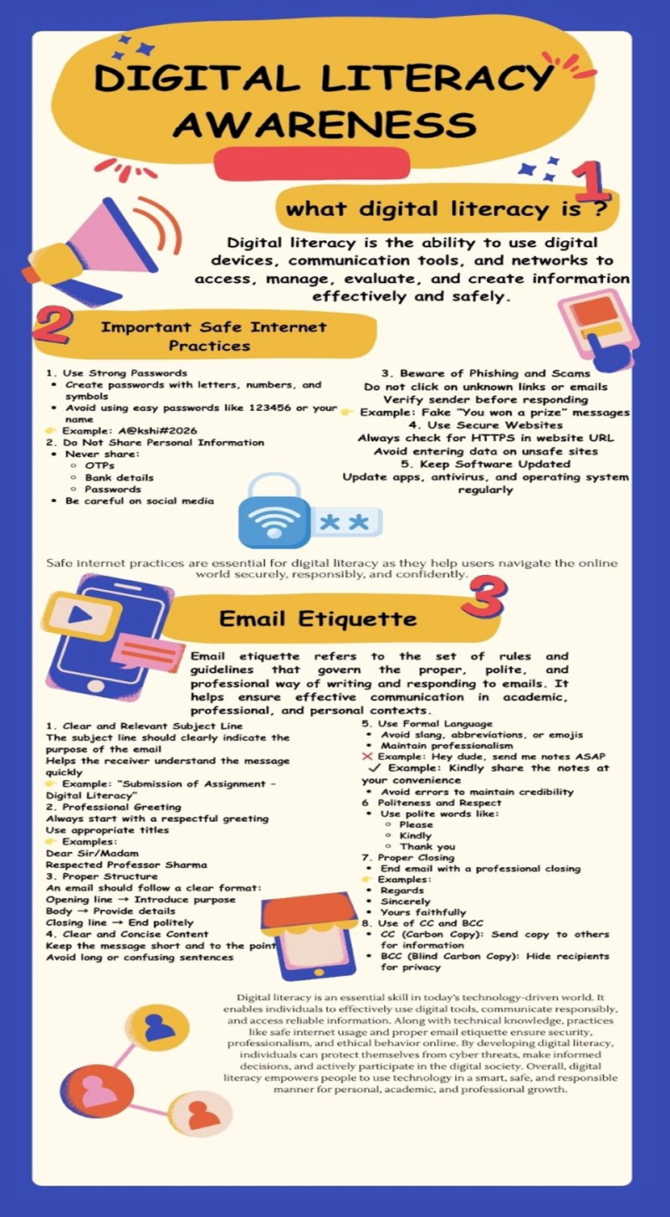

Task 2
For this task, I created profiles on GitHub, LinkedIn, and Kaggle as part of building my digital portfolio. GitHub is mainly used for storing and sharing code, which will help me showcase my projects and improve my programming skills. LinkedIn is a professional networking platform where I can connect with peers, mentors, and industry professionals, and stay updated with career opportunities. Kaggle is a platform for data science and machine learning, where I can practice with datasets and participate in competitions.

Over the next four years, I plan to use GitHub to regularly upload my projects and contribute to open-source repositories. On LinkedIn, I will build a strong professional presence by sharing achievements, certifications, and internships. Through Kaggle, I aim to enhance my analytical and problem-solving skills by working on real-world datasets. These platforms will help me grow academically and professionally, and prepare me for future career opportunities in the field of technology.

- linkedIn
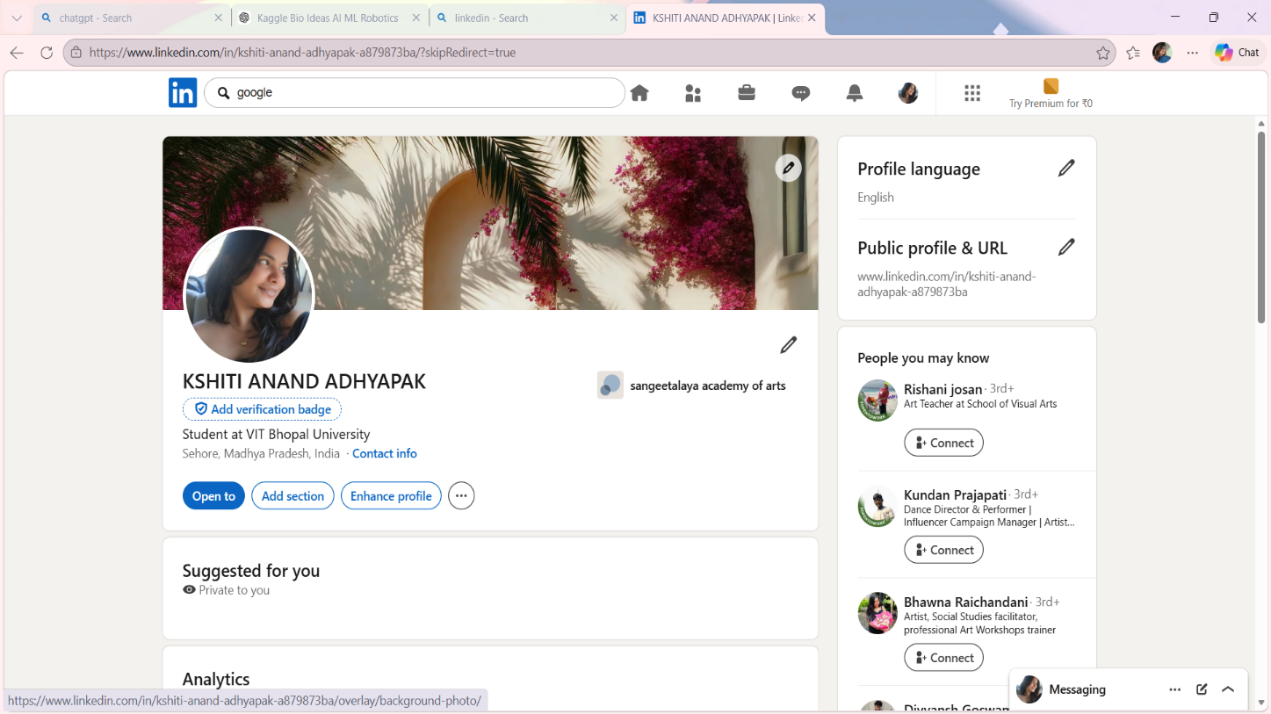

2. Kaggle

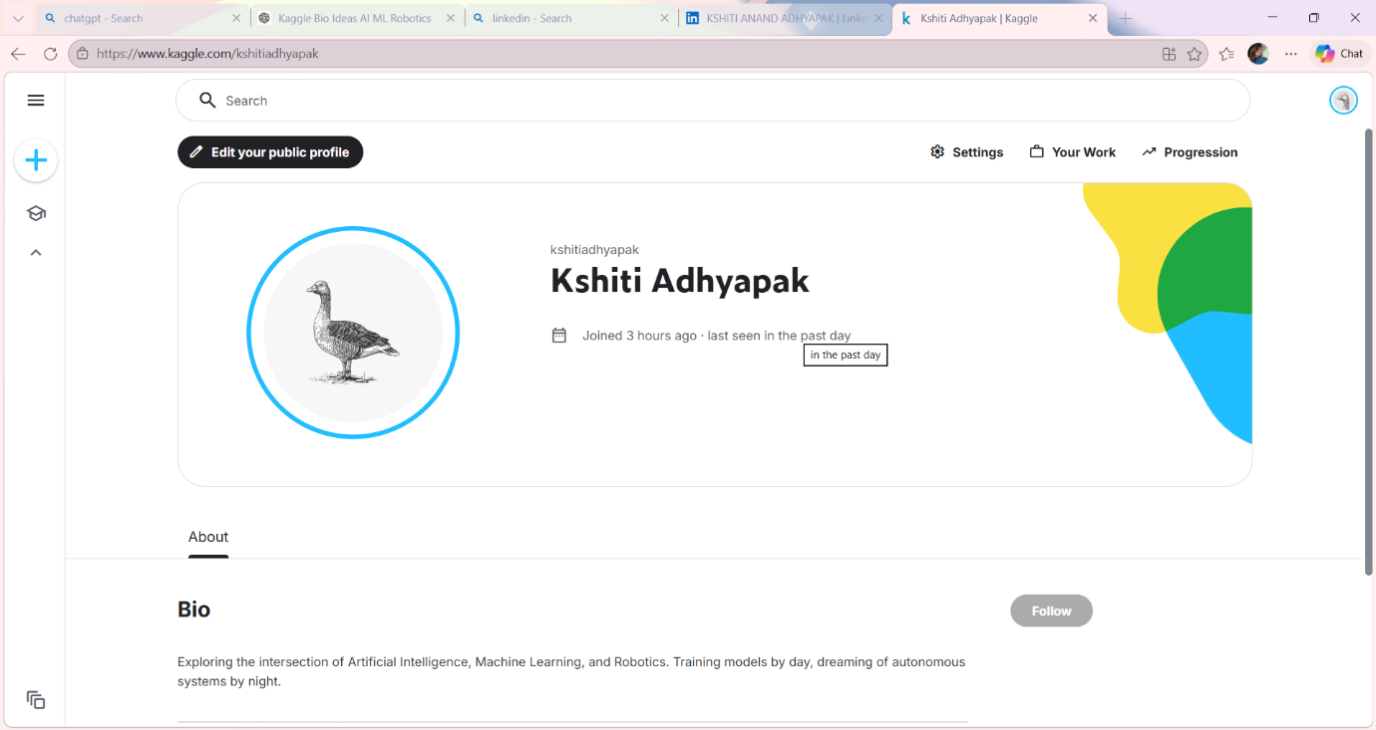

3. GitHUB
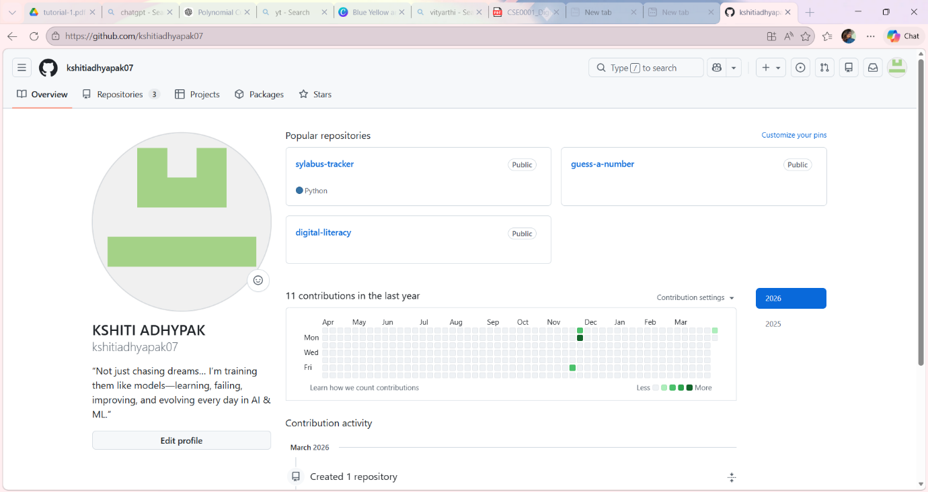

PART A
For this task, I created an account on HackerRank to practice coding and improve my programming skills. I completed a beginner-level challenge called "Solve Me First," which involved taking input and performing a simple calculation. This task helped me understand the basics of coding, including input, output, and logical problem-solving.

While solving the problem, I learned how to write and execute code in an online coding environment. It also gave me confidence in handling simple programming tasks and understanding problem statements clearly. After completing the challenge, I received a successful submission message and score, which I captured as proof.

I have added screenshots of my completed challenge and score to the task-3-platforms folder. This activity was very useful as it introduced me to coding practice platforms. I plan to continue using HackerRank regularly to improve my coding skills and prepare for future academic and placement opportunities.

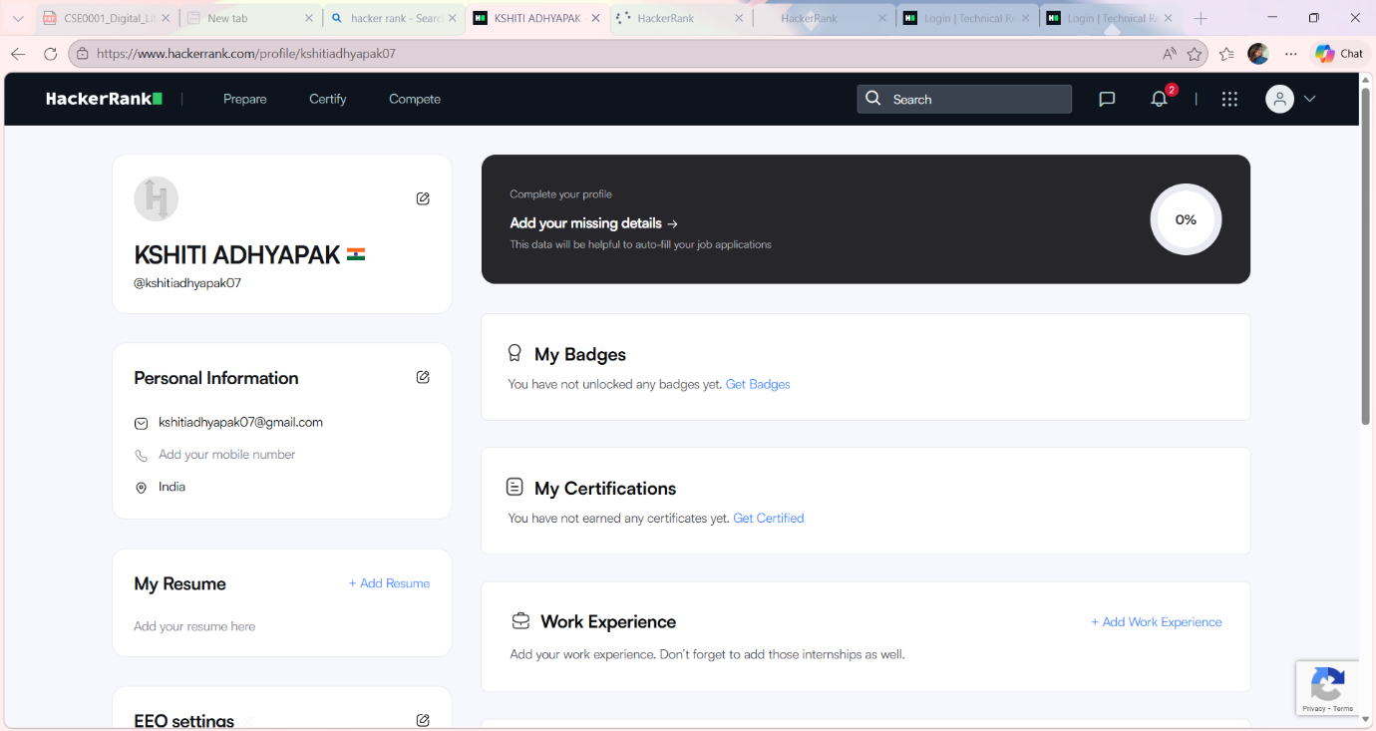

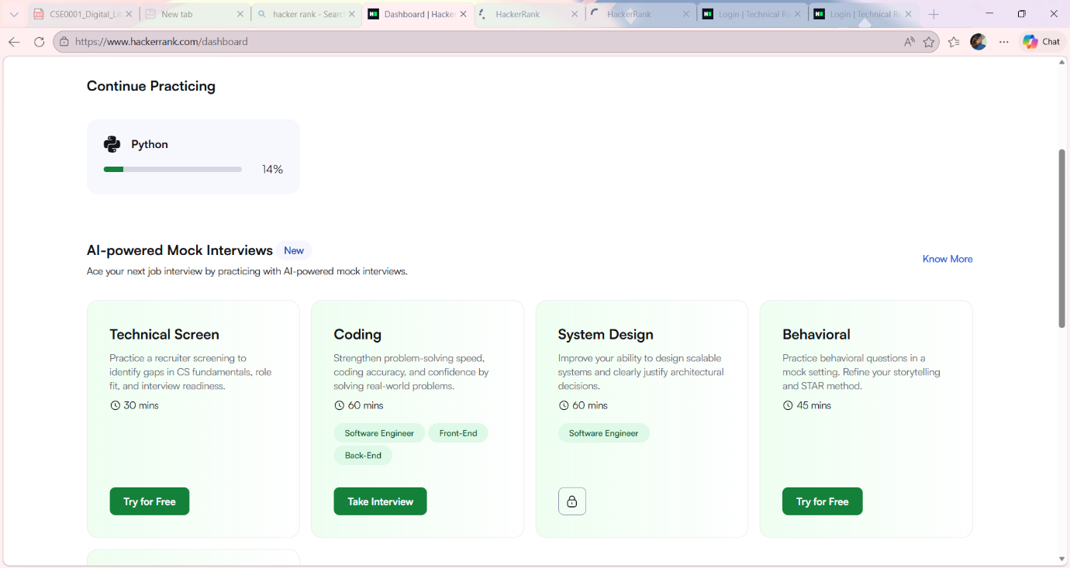

PART B
For this task, I used Google Forms to create a Digital Literacy Awareness Quiz. The form consisted of five questions, including both multiple-choice and short-answer types, to test students’ understanding of digital literacy, safe internet practices, and commonly used digital tools.

While creating the form, I learned how to design questions, organize them properly, and make the quiz simple and user-friendly. I also explored how responses are automatically recorded and stored in Google Sheets, which makes data collection and analysis very efficient.

I shared the form link in my GitHub README and added screenshots of both the form and the response sheet in the task-3-platforms folder. This task helped me understand the importance of digital collaboration tools.

These tools will be very useful in my academic journey, as I can use Google Forms to conduct surveys, collect feedback, and manage data easily. It will also help me in group projects and research work by simplifying information collection and organization.

Google form
formhttps://docs.google.com/forms/d/e/1FAIpQLSfboY_MkA9yrkEyjG9-VuA1ErltW-QjkuapylXFPKgrJoCn-A/viewform?usp=dialog
Response
https://docs.google.com/spreadsheets/d/16iZC_sjgL3M6F7FnrFkSD83aLJH1rab7FtNKFOdTQGA/edit?usp=sharing

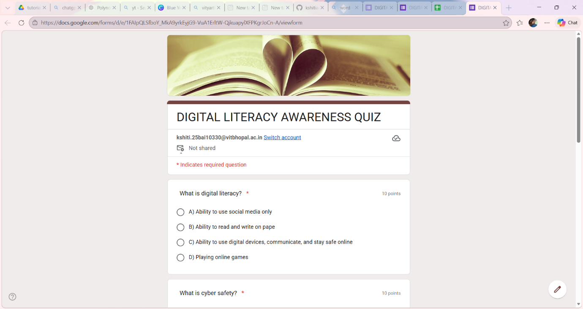

Task 4
Poor digital communication can often lead to misunderstandings and serious problems. For example, a student once sent an email to a professor without a proper subject line and used informal language. The message was unclear and appeared disrespectful, which led to the professor ignoring the request. As a result, the student missed an important deadline.

This situation could have been handled better by following proper email etiquette. The student should have used a clear subject line, a polite greeting, and a well-structured message explaining the situation respectfully. Proofreading the email before sending would also have helped in avoiding errors.

This example shows the importance of professional communication in digital platforms. Using clear, respectful, and formal language ensures that the message is understood correctly and creates a positive impression on the receiver.

Email 1
From:kshitiadhyapak07@gmail.com
To: xyz@gmail.com
Subject: Extension on submission deadline

Respected Professor
I hope this message finds you well.
I am writing to respectfully request an extension for the submission of my assignment for Digital Literacy , originally due on 31 -03-2026 .Due to health issue I was on medical leave .I have been unable to complete the assignment to the best of my ability within the given timeframe.
I sincerely value the quality of my work and would greatly appreciate additional time to ensure that I can submit a well-prepared assignment. If possible, I kindly request an extension until 02-04-2026
I understand the importance of deadlines and apologize for any inconvenience caused. Thank you very much for your understanding and consideration.
Yours sincerely,
Kshiti Adhyapak
25BAI10330
BTECH CSE AI &ML

Email 2
From:kshitiadhyapak07@gmail.com
To: xyz@gmail.com
Subject: Application for Summer Internship Opportunity

Dear Internship Coordinator,
I hope you are doing well.
My name is [KSHITI ANANAD ADHYAPAK and I am currently a student pursuing B.Tech in Computer Science at VIT BHOPAL UNIVERSITY .I am writing to express my keen interest in applying for a summer internship opportunity at your esteemed organization.
I have a strong interest in Artificial Intelligence and Machine Learning, and I have been actively developing my skills through academic coursework and personal projects. I am particularly impressed by your company's work in ROBOTICS], and I am eager to gain practical experience while contributing to your team.
I would be grateful if you could provide me with information regarding available internship opportunities, application procedures, and any requirements. I have attached my resume for your consideration.
Thank you for your time and consideration. I look forward to your response.
Yours sincerely,
KSHITI ANAND ADHYAPAK
7041980906
Kshitiadhyapak07@gmail.com

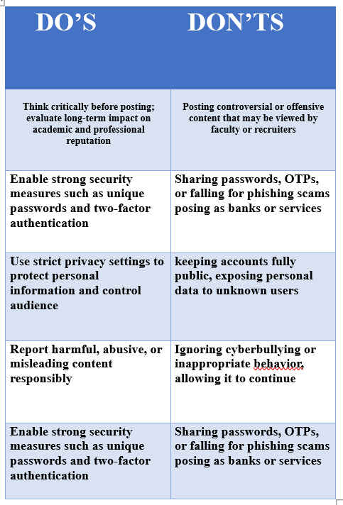

While researching about phishing attacks, I was surprised to learn how easily people can be tricked by messages that appear genuine. Many phishing attempts use urgent language and official-looking designs, making it difficult for users to identify them as fake. I realized that even a small mistake, such as clicking on an unknown link, can lead to serious consequences like financial loss or data theft.

One habit I will personally change is being more cautious before clicking on any link or sharing information online. I will always verify the source of messages and avoid responding to suspicious emails or calls. This task made me more aware of online risks and the importance of practicing safe digital behavior in everyday life.

Cybercrime Case Study: UPI / Online Payment
Fraud
UPI/Online Payment Fraud is a common cybercrime in India where attackers trick users into
transferring money through digital payment platforms. A real-life inspired example involves a
college student who wanted to sell a used phone online. The student listed the product on a
marketplace, and soon received a call from a “buyer” claiming interest. Step-by-step, the fraudster
built trust by speaking politely and agreeing to pay immediately. Instead of sending money, the
attacker sent a “payment request” link via a UPI app and instructed the student to “accept” it to
receive payment. Confused but trusting, the student entered their UPI PIN. Instead of receiving
money, 10,000 was deducted from their account. Such scams typically target students, elderly
people, and individuals unfamiliar with digital payments. Fraudsters exploit lack of awareness and
urgency to manipulate victims. The consequences include financial loss, emotional stress, and
sometimes leakage of sensitive banking details. Victims often struggle to recover money due to
delayed reporting. This case highlights the importance of digital awareness: never enter your UPI
PIN to receive money, verify unknown requests, and avoid sharing personal details. Reporting fraud
immediately to the bank and cybercrime portal can help reduce damage

Safe Online – Prevention Checklist (For College Students in India)
GENERAL SAFETY TIPS
- Use strong and unique passwords for each account (mix letters, numbers, symbols)
- Enable two-factor authentication (2FA) on email, social media, and banking apps
- Avoid clicking on unknown links in emails, messages, or social media
- Do not share OTP, passwords, or personal details with anyone
- Always check website URLs (look for https:// and correct spelling)
- Keep your phone and laptop updated with latest security patches
- Install apps only from trusted sources like Play Store or App Store
- Avoid using public Wi-Fi for sensitive transactions
UPI / FINANCIAL SAFETY TIPS
- Never enter your UPI PIN to receive money (PIN is only for sending money)
- Always verify payment requests before approving them
- Do not scan random QR codes sent by strangers
- Set daily transaction limits in your banking apps
REPORTING CYBERCRIME
- Report fraud immediately at: National Cyber Crime Portal
https://www.cybercrime.gov.in
- Call Cybercrime Helpline: 1930 for urgent financial fraud cases
d banking apps
- Avoid clicking on unknown links in emails, messages, or social media
- Do not share OTP, passwords, or personal details with anyone
- Always check website URLs (look for https:// and correct spelling)
- Keep your phone and laptop updated with latest security patches
- Install apps only from trusted sources like Play Store or App Store
- Avoid using public Wi-Fi for sensitive transactions

UPI / FINANCIAL SAFETY TIPS
- Never enter your UPI PIN to receive money (PIN is only for sending money)

- Conclusion
This Digital Literacy Portfolio highlights the importance of using digital technologies in a safe, responsible, and effective manner. Along with understanding email etiquette, cybercrime awareness, and safe online practices, the project also emphasized the concept of platform building—creating and maintaining a positive and professional digital presence.
Through the cybercrime case study, it was evident how easily users, especially students, can become victims of online fraud such as UPI scams due to lack of awareness. The prevention checklist provided practical and actionable steps to enhance online safety and protect personal and financial information.
Additionally, platform building teaches students how to use digital tools not only for communication but also for personal branding, collaboration, and career growth. Overall, this project demonstrates that digital literacy is a combination of technical skills, critical thinking, responsible behavior, and the ability to build a trustworthy digital identity. By applying these learnings, students can confidently and safely navigate the digital world.
ays verify payment requests before approving them
- Do not scan random QR codes sent by strangers
- Set daily transaction limits in your banking apps

REPORTING CYBERCRIME
- Report fraud immediately at: National Cyber Crime Portal
https://www.cybercrime.gov.in
- Call Cybercrime Helpline: 1930 for urgent financial fraud cases

QUICK REMINDER
- Think before you click
- Verify bd sources like Play Store or App Store
- Avoid using publ

