Hephaestus NG — 30-Day Detailed Report
Period: March 10 – April 9, 2026 | Regions: East US 2, Sweden Central

1. Executive Summary
Over the last 30 days, Hephaestus NG processed 91,371 total requests across East US 2 and Sweden Central regions, serving 15,453 unique users. The service maintained a near-perfect success rate of approximately 100% throughout the period, with P95 latency consistently in the 5–6 second range.

2. Request Volume
Metric | East US 2 | Sweden Central | Total
ChatStream | 51,929 | 4,829 | 56,758
ColdStart | 23,851 | 10,762 | 34,613
Total NG | 75,780 | 15,591 | 91,371
V2 (5 days) | — | — | 952

East US 2 handles approximately 83% of all traffic, with Sweden Central at 17%. ChatStream requests (62%) dominate over ColdStart (38%), reflecting active user conversations.

KQL Query — Requests by Day/Type/Region
let timeGrain=_period*1h;
UnionOfAllLogs("Vienna", "requests")
| where operation_Name == "POST Hephaestus/ColdStart"
or operation_Name == "POST Hephaestus/ChatStream"
| extend type = case(
operation_Name == "POST Hephaestus/ColdStart", "ColdStart",
operation_Name == "POST Hephaestus/ChatStream", "ChatStream",
operation_Name)
| where PreciseTimeStamp >= _startTime and PreciseTimeStamp <= _endTime
and env in (_env)
| where app == "hephaestus-agent"
| where operation_Name != "GET Version/Ping"
| summarize count=count() by bin(timestamp, timeGrain), type, env

3. User Engagement

Metric | Value
Total Unique Users (30 days) | 15,453
Avg Weekday DAU | ~700
Avg Weekend DAU | ~235

User engagement shows a clear weekday/weekend pattern. Weekday usage averages ~700 DAU while weekends drop to ~235 DAU. Peak usage was 799 users on March 12. The pattern is consistent week-over-week, indicating stable organic adoption.

Daily Unique Users
Date | Unique Users
Mar 10 | 469
Mar 11 | 760
Mar 12 | 799
Mar 13 | 687
Mar 14 | 235
Mar 15 | 251
Mar 16 | 724
Mar 17 | 752
Mar 18 | 739
Mar 19 | 673
Mar 20 | 496
Mar 21 | 222
Mar 22 | 236
Mar 23 | 681
Mar 24 | 716
Mar 25 | 697
Mar 26 | 715
Mar 27 | 625
Mar 28 | 208
Mar 29 | 241
Mar 30 | 663
Mar 31 | 707
Apr 01 | 703
Apr 02 | 612
Apr 03 | 440
Apr 04 | 234
Apr 05 | 237
Apr 06 | 493
Apr 07 | 697
Apr 08 | 730
Apr 09 | 354

KQL Query — Unique Users
UnionOfAllLogs("Vienna", "requests")
| where operation_Name == "POST Hephaestus/ColdStart"
or operation_Name == "POST Hephaestus/ChatStream"
| where PreciseTimeStamp >= _startTime and PreciseTimeStamp <= _endTime
and env in (_env)
| where app == "hephaestus-agent"
| summarize UniqueUsers = dcount(user_Id) by bin(timestamp, 1d)
| order by timestamp asc

KQL Query — Total Unique Users
UnionOfAllLogs("Vienna", "requests")
| where operation_Name == "POST Hephaestus/ColdStart"
or operation_Name == "POST Hephaestus/ChatStream"
| where PreciseTimeStamp >= _startTime and PreciseTimeStamp <= _endTime
and env in (_env)
| where app == "hephaestus-agent"
| summarize UniqueUsers = dcount(user_Id)

4. SLO Performance

4.1 P95 Latency
P95 latency (ColdStart) typically ranges between 5,000–6,000 ms across both regions. Best observed: ~3,336 ms (Mar 11, 05:00). Worst spike: ~8,423 ms (Mar 14, 08:00). Performance remains well within acceptable thresholds for interactive AI experiences.
Metric | Value
Typical P95 | 5,000 – 6,000 ms
Best Observed | ~3,336 ms
Worst Spike | ~8,423 ms
Overall Status | ✅ Healthy

4.2 P99 Latency (TTFB)
P99 TTFB typically ranges between 6,000–8,000 ms. However, periodic spikes reaching ~100,000–109,000 ms (~100–109 seconds) are observed. These outlier spikes correspond to cold-start timeout/retry events hitting the 99th percentile and affect <1% of requests.
Metric | Value
Typical P99 | 6,000 – 8,000 ms
Best Observed | ~3,970 ms
Worst Spike | ~109,258 ms
Overall Status | ⚠️ Monitor spikes

KQL Query — P95 Latency
// P95 latency for ColdStart requests
UnionOfAllLogs("Vienna", "requests")
| where operation_Name == "POST Hephaestus/ColdStart"
or operation_Name == "POST Hephaestus/ChatStream"
| where PreciseTimeStamp >= _startTime and PreciseTimeStamp <= _endTime
and env in (_env)
| where app == "hephaestus-agent"
| summarize P95 = percentile(duration, 95) by bin(timestamp, 1h)

KQL Query — P99 TTFB
// P99 Time-to-First-Byte
UnionOfAllLogs("Vienna", "requests")
| where operation_Name == "POST Hephaestus/ColdStart"
or operation_Name == "POST Hephaestus/ChatStream"
| where PreciseTimeStamp >= _startTime and PreciseTimeStamp <= _endTime
and env in (_env)
| where app == "hephaestus-agent"
| summarize P99 = percentile(duration, 99) by bin(timestamp, 1h)

5. % of NG Users vs Total AskAI Users
To calculate the percentage of NG users against total AskAI users, use the following query. Ensure you adjust the app/operation filters to match your AskAI total user base definition.
let ngUsers = toscalar(
UnionOfAllLogs("Vienna", "requests")
| where operation_Name in
("POST Hephaestus/ColdStart", "POST Hephaestus/ChatStream")
| where PreciseTimeStamp >= _startTime and PreciseTimeStamp <= _endTime
and env in (_env)
| where app == "hephaestus-agent"
| summarize dcount(user_Id)
);
let askAIUsers = toscalar(
UnionOfAllLogs("Vienna", "requests")
| where PreciseTimeStamp >= _startTime and PreciseTimeStamp <= _endTime
and env in (_env)
| where app == "hephaestus-agent"
| summarize dcount(user_Id)
);
print NGUsers = ngUsers,
TotalAskAIUsers = askAIUsers,
PercentOfAskAI = round(todouble(ngUsers)
/ todouble(askAIUsers) * 100, 2)

6. Dashboard Reference
Live Dashboard: https://dataexplorer.azure.com/dashboards/4584380f-1dcf-43ff-b174-beb56a9a51ea?p-_startTime=30days&p-_endTime=now&p-_env=v-eastus2&p-_env=v-swedencentral

8. Charts

Requests by Region
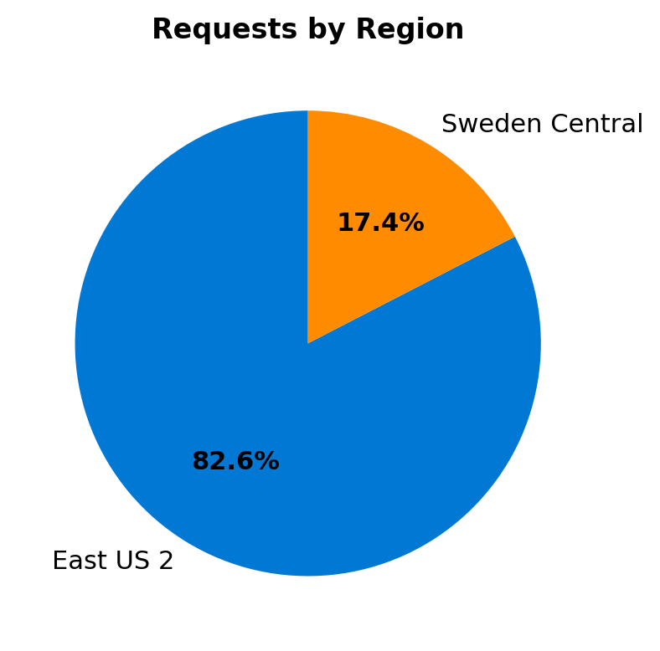

Daily Unique Users
