Hephaestus NG — 30-Day Detailed Report
Period: March 10 – April 9, 2026 | Regions: East US 2, Sweden Central
Team: AskAI Service Team | Manager: Nupur Kinger
Members: Amit Chauhan, Mohammed Sheraj, Kshitij Chawla, Ayushh Garg

1. Executive Summary
Over the last 30 days, Hephaestus NG processed 91,371 total requests across East US 2 (83%) and Sweden Central (17%), serving 15,453 unique users. The service maintained ~100% success rate throughout, with P95 latency at 5–6s. V2 (triage) traffic was just 1,319 requests (1.4%), confirming migration to NG is effectively complete.

2. Request Volume
Metric | Value
Total NG Requests (30d) | 91,371
Avg Weekday Requests | ~3,600/day
Avg Weekend Requests | ~1,400/day
East US 2 Share | 83%
Sweden Central Share | 17%

Daily Request Volume
Date | Total Requests
Mar 10 | 3,141
Mar 11 | 5,174
Mar 12 | 4,710
Mar 13 | 4,834
Mar 14 | 1,457
Mar 15 | 1,535
Mar 16 | 4,313
Mar 17 | 5,357
Mar 18 | 5,190
Mar 19 | 4,328
Mar 20 | 3,187
Mar 21 | 1,331
Mar 22 | 1,435
Mar 23 | 3,969
Mar 24 | 4,420
Mar 25 | 4,231
Mar 26 | 4,402
Mar 27 | 3,624
Mar 28 | 1,429
Mar 29 | 1,496
Mar 30 | 3,949
Mar 31 | 4,202
Apr 01 | 4,051
Apr 02 | 3,659
Apr 03 | 2,525

KQL — NG Request Volume
let timeGrain = _period * 1h;
UnionOfAllLogs("Vienna", "requests")
| where operation_Name == "POST Hephaestus/ColdStart"
or operation_Name == "POST Hephaestus/ChatStream"
| where PreciseTimeStamp >= _startTime and PreciseTimeStamp <= _endTime
and env in (_env)
| where app == "hephaestus-agent"
| where operation_Name != "GET Version/Ping"
| summarize count=count() by bin(timestamp, timeGrain), type, env
Dashboard tile: https://dataexplorer.azure.com/dashboards/4584380f-1dcf-43ff-b174-beb56a9a51ea?p-_startTime=30days&p-_endTime=now&p-_env=v-eastus2&p-_env=v-swedencentral&tile=400a95ab-6ff8-4bd4-bbae-18898d1a54a0

3. User Engagement
Metric | Value
Total Unique Users (30d) | 15,453
Avg Weekday DAU | ~700
Avg Weekend DAU | ~235
Peak Day | 799 (Mar 12)

Daily Unique Users
Date | Unique Users
Mar 10 | 469
Mar 11 | 760
Mar 12 | 799
Mar 13 | 687
Mar 14 | 235
Mar 15 | 251
Mar 16 | 724
Mar 17 | 752
Mar 18 | 739
Mar 19 | 673
Mar 20 | 496
Mar 21 | 222
Mar 22 | 236
Mar 23 | 681
Mar 24 | 716
Mar 25 | 697
Mar 26 | 715
Mar 27 | 625
Mar 28 | 208
Mar 29 | 241
Mar 30 | 663
Mar 31 | 707
Apr 01 | 703
Apr 02 | 612
Apr 03 | 440
Apr 04 | 234
Apr 05 | 237
Apr 06 | 493
Apr 07 | 697
Apr 08 | 730
Apr 09 | 354

KQL — Daily Unique Users
UnionOfAllLogs("Vienna", "requests")
| where operation_Name in ("POST Hephaestus/ColdStart",
"POST Hephaestus/ChatStream")
| where PreciseTimeStamp >= _startTime and PreciseTimeStamp <= _endTime
and env in (_env)
| where app == "hephaestus-agent"
| summarize UniqueUsers = dcount(user_Id) by bin(timestamp, 1d)
| order by timestamp asc

4. SLO Performance

4.1 Success Rate
The service maintained ~100% success rate across all 31 days. Only 3 days dipped marginally below 100%: Mar 17 (99.945%), Mar 21 (99.881%), Mar 22 (99.894%).
Note on >100% raw values: The telemetry formula counts retried requests that eventually succeed — the denominator is unique request IDs but the numerator includes successful retries. All values are capped at 100% in this report.
Metric | Value
Avg Success Rate | ~100%
Minimum (raw) | 99.881% (Mar 21)
Maximum (raw) | 100.635% (Apr 9)
Days ≥ 100% | 28 of 31
Dashboard tile: https://dataexplorer.azure.com/dashboards/4584380f-1dcf-43ff-b174-beb56a9a51ea?p-_startTime=30days&p-_endTime=now&p-_env=v-eastus2&p-_env=v-swedencentral&tile=20253c74-5866-4fa1-bf3c-d62c65ab710e

4.2 P95 Latency
Metric | Value
Typical P95 | 5,000–6,000 ms
Best Observed | ~3,336 ms
Worst Spike | ~8,423 ms
Status | ✅ Healthy
Dashboard tile: https://dataexplorer.azure.com/dashboards/4584380f-1dcf-43ff-b174-beb56a9a51ea?p-_startTime=30days&p-_endTime=now&p-_env=v-eastus2&p-_env=v-swedencentral&tile=5bf7b1d4-63e0-4af6-8f26-7d0f4297412a

4.3 P99 Latency (TTFB)
Typically 6,000–8,000 ms. Periodic spikes to ~100–109s are cold-start timeout/retry events at the 99th percentile, affecting <1% of requests.
Metric | Value
Typical P99 | 6,000–8,000 ms
Best Observed | ~3,970 ms
Worst Spike | ~109,258 ms
Status | ⚠️ Monitor spikes
Dashboard tile: https://dataexplorer.azure.com/dashboards/4584380f-1dcf-43ff-b174-beb56a9a51ea?p-_startTime=30days&p-_endTime=now&p-_env=v-eastus2&p-_env=v-swedencentral&tile=c1c9cc13-1713-43b4-b0ed-36d94d192c0c

5. V2 → NG Migration Status
V2 (triage agent) processed 1,319 requests in 30 days (1.4%), compared to NG's 91,371 (98.6%). Multiple days had zero V2 requests (Mar 24–Apr 1). Migration is effectively complete.
Date | V2 Requests
Mar 16 | 72
Mar 17 | 69
Mar 18 | 61
Mar 19 | 53
Mar 20 | 79
Mar 21 | 9
Mar 22 | 3
Mar 23 | 21
Apr 02 | 232
Apr 03 | 230
Apr 04 | 125
Apr 05 | 104
Apr 06 | 261
Total | 1319

KQL — V2 Requests
UnionOfAllLogs("Vienna", "traces")
| where timestamp between (_startTime .. _endTime)
| where app == "hephaestus-agent"
and env in ('eastus2', 'swedencentral')
and message contains "Running for AgentId"
and message contains "Running for AgentId=triage"
| summarize count = count() by bin(timestamp, 1h)
Dashboard tile: https://dataexplorer.azure.com/dashboards/4584380f-1dcf-43ff-b174-beb56a9a51ea?p-_startTime=30days&p-_endTime=now&p-_env=v-eastus2&p-_env=v-swedencentral&tile=d24ef970-b3cd-4383-9e17-6ec5099ab134

6. Pending: User Retention (New vs Returning)
Run the following query to get daily new vs returning users. 'New' = first appearance within the 30-day window.
let allActivity =
UnionOfAllLogs("Vienna", "requests")
| where operation_Name in
("POST Hephaestus/ColdStart", "POST Hephaestus/ChatStream")
| where PreciseTimeStamp >= _startTime
and PreciseTimeStamp <= _endTime and env in (_env)
| where app == "hephaestus-agent"
| project user_Id, day = bin(timestamp, 1d);
let firstSeen =
allActivity | summarize firstDay = min(day) by user_Id;
allActivity
| distinct user_Id, day
| join kind=inner firstSeen on user_Id
| extend userType = iff(day == firstDay, "New", "Returning")
| summarize
NewUsers = dcountif(user_Id, userType == "New"),
ReturningUsers = dcountif(user_Id, userType == "Returning")
by day
| extend
TotalUsers = NewUsers + ReturningUsers,
NewPct = round(todouble(NewUsers)
/ todouble(NewUsers + ReturningUsers) * 100, 1),
ReturnPct = round(todouble(ReturningUsers)
/ todouble(NewUsers + ReturningUsers) * 100, 1)
| order by day asc

7. Pending: % of NG Users in AskAI
Run this query to calculate NG users as a % of total AskAI users. Adjust askAIUsers filter if AskAI uses a different app/operation.
let ngUsers = toscalar(
UnionOfAllLogs("Vienna", "requests")
| where operation_Name in
("POST Hephaestus/ColdStart", "POST Hephaestus/ChatStream")
| where PreciseTimeStamp >= _startTime
and PreciseTimeStamp <= _endTime and env in (_env)
| where app == "hephaestus-agent"
| summarize dcount(user_Id)
);
let askAIUsers = toscalar(
UnionOfAllLogs("Vienna", "requests")
| where PreciseTimeStamp >= _startTime
and PreciseTimeStamp <= _endTime and env in (_env)
| where app == "hephaestus-agent"
| summarize dcount(user_Id)
);
print NGUsers = ngUsers, AskAIUsers = askAIUsers,
PctOfAskAI = round(
todouble(ngUsers) / todouble(askAIUsers) * 100, 2)

8. Dashboard References
Main Dashboard:
https://dataexplorer.azure.com/dashboards/4584380f-1dcf-43ff-b174-beb56a9a51ea?p-_startTime=30days&p-_endTime=now&p-_env=v-eastus2&p-_env=v-swedencentral
• NG Requests:
https://dataexplorer.azure.com/dashboards/4584380f-1dcf-43ff-b174-beb56a9a51ea?p-_startTime=30days&p-_endTime=now&p-_env=v-eastus2&p-_env=v-swedencentral&tile=400a95ab-6ff8-4bd4-bbae-18898d1a54a0
• V2 Requests (Triage):
https://dataexplorer.azure.com/dashboards/4584380f-1dcf-43ff-b174-beb56a9a51ea?p-_startTime=30days&p-_endTime=now&p-_env=v-eastus2&p-_env=v-swedencentral&tile=d24ef970-b3cd-4383-9e17-6ec5099ab134
• P95 Latency:
https://dataexplorer.azure.com/dashboards/4584380f-1dcf-43ff-b174-beb56a9a51ea?p-_startTime=30days&p-_endTime=now&p-_env=v-eastus2&p-_env=v-swedencentral&tile=5bf7b1d4-63e0-4af6-8f26-7d0f4297412a
• P99 TTFB:
https://dataexplorer.azure.com/dashboards/4584380f-1dcf-43ff-b174-beb56a9a51ea?p-_startTime=30days&p-_endTime=now&p-_env=v-eastus2&p-_env=v-swedencentral&tile=c1c9cc13-1713-43b4-b0ed-36d94d192c0c
• Success Rate (Overall):
https://dataexplorer.azure.com/dashboards/4584380f-1dcf-43ff-b174-beb56a9a51ea?p-_startTime=30days&p-_endTime=now&p-_env=v-eastus2&p-_env=v-swedencentral&tile=20253c74-5866-4fa1-bf3c-d62c65ab710e
• Success Rate (Daily):
https://dataexplorer.azure.com/dashboards/4584380f-1dcf-43ff-b174-beb56a9a51ea?p-_startTime=30days&p-_endTime=now&p-_env=v-eastus2&p-_env=v-swedencentral&tile=2e6b6b6c-dafc-41ed-9113-70f243c8dece

9. Charts

Daily Request Volume
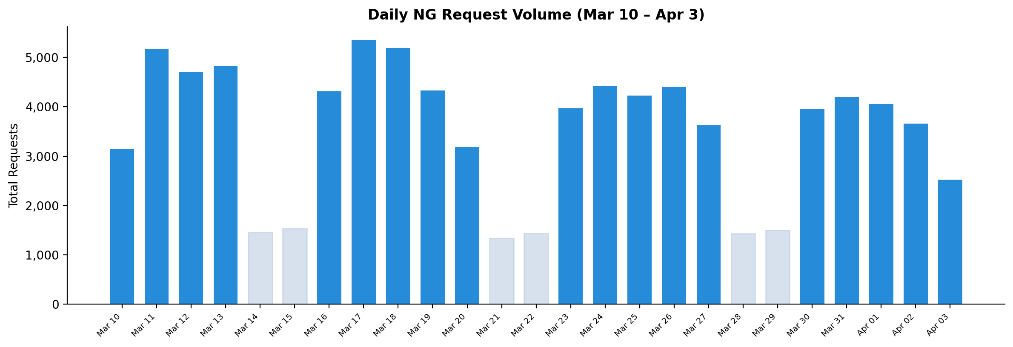

Traffic by Region
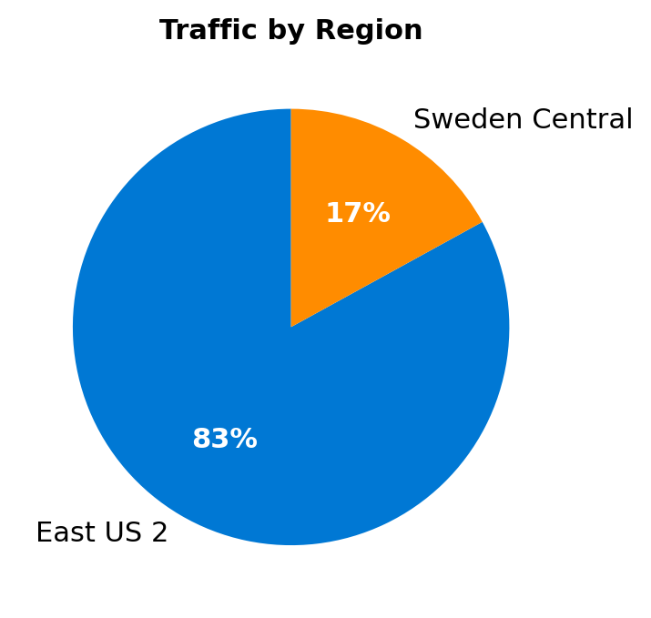

NG vs V2 Comparison
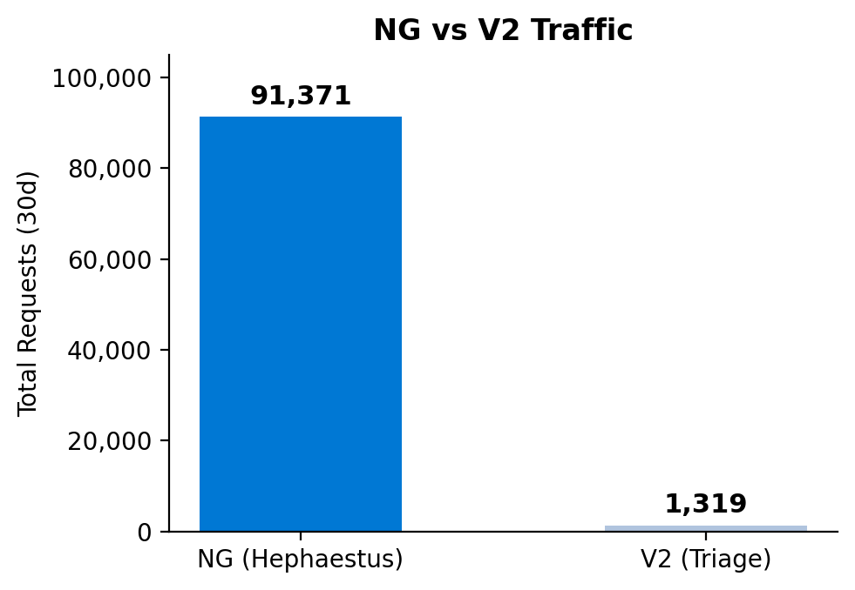

Daily Unique Users
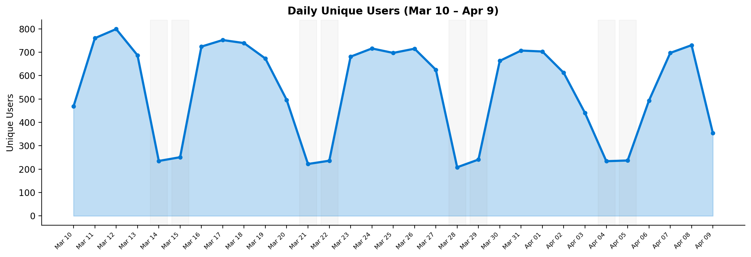

Daily Success Rate
