Hephaestus NG — 30-Day Detailed Report
Period: March 10 – April 9, 2026 | Regions: East US 2, Sweden Central
Team: AskAI Service Team | Manager: Nupur Kinger
Members: Amit Chauhan, Mohammed Sheraj, Kshitij Chawla, Ayushh Garg

1. Executive Summary
Over the last 30 days, Hephaestus NG processed 91,371 total requests across East US 2 (83%) and Sweden Central (17%), serving 15,453 unique users. The service averaged 96.5% success rate across both regions, with P95 latency at 5–6s. V2 (triage) traffic was just 1,319 requests (1.4%), confirming migration to NG is effectively complete.

2. Request Volume
Metric | Value
Total NG Requests (30d) | 91,371
Avg Weekday Requests | ~3,600/day
Avg Weekend Requests | ~1,400/day
East US 2 Share | 83%
Sweden Central Share | 17%

Daily Request Volume
Date | Total Requests
Mar 10 | 3,141
Mar 11 | 5,174
Mar 12 | 4,710
Mar 13 | 4,834
Mar 14 | 1,457
Mar 15 | 1,535
Mar 16 | 4,313
Mar 17 | 5,357
Mar 18 | 5,190
Mar 19 | 4,328
Mar 20 | 3,187
Mar 21 | 1,331
Mar 22 | 1,435
Mar 23 | 3,969
Mar 24 | 4,420
Mar 25 | 4,231
Mar 26 | 4,402
Mar 27 | 3,624
Mar 28 | 1,429
Mar 29 | 1,496
Mar 30 | 3,949
Mar 31 | 4,202
Apr 01 | 4,051
Apr 02 | 3,659
Apr 03 | 2,525

KQL — NG Request Volume
let timeGrain = _period * 1h;
UnionOfAllLogs("Vienna", "requests")
| where operation_Name == "POST Hephaestus/ColdStart"
or operation_Name == "POST Hephaestus/ChatStream"
| where PreciseTimeStamp >= _startTime and PreciseTimeStamp <= _endTime
and env in (_env)
| where app == "hephaestus-agent"
| where operation_Name != "GET Version/Ping"
| summarize count=count() by bin(timestamp, timeGrain), type, env
Dashboard tile: https://dataexplorer.azure.com/dashboards/4584380f-1dcf-43ff-b174-beb56a9a51ea?p-_startTime=30days&p-_endTime=now&p-_env=v-eastus2&p-_env=v-swedencentral&tile=400a95ab-6ff8-4bd4-bbae-18898d1a54a0

3. User Engagement
Metric | Value
Total Unique Users (30d) | 15,453
Avg Weekday DAU | ~700
Avg Weekend DAU | ~235
Peak Day | 799 (Mar 12)

Daily Unique Users
Date | Unique Users
Mar 10 | 469
Mar 11 | 760
Mar 12 | 799
Mar 13 | 687
Mar 14 | 235
Mar 15 | 251
Mar 16 | 724
Mar 17 | 752
Mar 18 | 739
Mar 19 | 673
Mar 20 | 496
Mar 21 | 222
Mar 22 | 236
Mar 23 | 681
Mar 24 | 716
Mar 25 | 697
Mar 26 | 715
Mar 27 | 625
Mar 28 | 208
Mar 29 | 241
Mar 30 | 663
Mar 31 | 707
Apr 01 | 703
Apr 02 | 612
Apr 03 | 440
Apr 04 | 234
Apr 05 | 237
Apr 06 | 493
Apr 07 | 697
Apr 08 | 730
Apr 09 | 354

KQL — Daily Unique Users
UnionOfAllLogs("Vienna", "requests")
| where operation_Name in ("POST Hephaestus/ColdStart",
"POST Hephaestus/ChatStream")
| where PreciseTimeStamp >= _startTime and PreciseTimeStamp <= _endTime
and env in (_env)
| where app == "hephaestus-agent"
| summarize UniqueUsers = dcount(user_Id) by bin(timestamp, 1d)
| order by timestamp asc

4. SLO Performance

4.1 Success Rate
The service averaged 96.5% success rate across both regions over 31 days. East US 2 averaged ~97% and Sweden Central averaged ~97%. Minimum was 83.14% on Apr 13 (driven by East US 2 at 79.7%), and the maximum was 98.8% on Mar 29.
The Apr 13 East US 2 dip to 79.7% is an anomaly under investigation. Sweden Central remained at 100% on that day. Excluding Apr 13, the combined average is closer to 97%.
Metric | Value
Avg Success Rate (weighted) | 96.5%
Avg East US 2 | ~97%
Avg Sweden Central | ~97%
Minimum (combined) | 83.14% (Apr 13)
Maximum (combined) | 98.8% (Mar 29)

Daily Success Rate by Region
Date | East US 2 | Sweden Central | Combined
Mar 14 | 96.22% | 93.617% | 95.78%
Mar 15 | 96.523% | 98.0% | 96.77%
Mar 16 | 95.89% | 96.639% | 96.02%
Mar 17 | 95.313% | 94.636% | 95.2%
Mar 18 | 94.489% | 96.721% | 94.87%
Mar 19 | 95.559% | 96.237% | 95.67%
Mar 20 | 93.766% | 95.333% | 94.03%
Mar 21 | 96.903% | 98.462% | 97.17%
Mar 22 | 96.266% | 97.619% | 96.5%
Mar 23 | 94.232% | 97.906% | 94.86%
Mar 24 | 95.771% | 95.082% | 95.65%
Mar 25 | 96.277% | 97.034% | 96.41%
Mar 26 | 97.206% | 98.69% | 97.46%
Mar 27 | 97.351% | 96.135% | 97.14%
Mar 28 | 98.03% | 98.701% | 98.14%
Mar 29 | 99.121% | 97.222% | 98.8%
Mar 30 | 97.975% | 96.957% | 97.8%
Mar 31 | 96.363% | 99.119% | 96.83%
Apr 01 | 97.201% | 96.744% | 97.12%
Apr 02 | 97.442% | 99.502% | 97.79%
Apr 03 | 97.621% | 98.305% | 97.74%
Apr 04 | 97.832% | 100.0% | 98.2%
Apr 05 | 98.052% | 93.333% | 97.25%
Apr 06 | 97.956% | 97.059% | 97.8%
Apr 07 | 98.033% | 96.939% | 97.85%
Apr 08 | 97.476% | 96.653% | 97.34%
Apr 09 | 97.722% | 97.908% | 97.75%
Apr 10 | 97.624% | 97.426% | 97.59%
Apr 11 | 97.524% | 98.571% | 97.7%
Apr 12 | 97.365% | 100.0% | 97.81%
Apr 13 | 79.688% | 100.0% | 83.14%
Dashboard tile: https://dataexplorer.azure.com/dashboards/4584380f-1dcf-43ff-b174-beb56a9a51ea?p-_startTime=30days&p-_endTime=now&p-_env=v-eastus2&p-_env=v-swedencentral&tile=20253c74-5866-4fa1-bf3c-d62c65ab710e

4.2 P95 Latency
Metric | Value
Typical P95 | 5,000–6,000 ms
Best Observed | ~3,336 ms
Worst Spike | ~8,423 ms
Status | ✅ Healthy
Dashboard tile: https://dataexplorer.azure.com/dashboards/4584380f-1dcf-43ff-b174-beb56a9a51ea?p-_startTime=30days&p-_endTime=now&p-_env=v-eastus2&p-_env=v-swedencentral&tile=5bf7b1d4-63e0-4af6-8f26-7d0f4297412a

4.3 P99 Latency (TTFB)
Typically 6,000–8,000 ms. Periodic spikes to ~100–109s are cold-start timeout/retry events at the 99th percentile, affecting <1% of requests.
Metric | Value
Typical P99 | 6,000–8,000 ms
Best Observed | ~3,970 ms
Worst Spike | ~109,258 ms
Status | ⚠️ Monitor spikes
Dashboard tile: https://dataexplorer.azure.com/dashboards/4584380f-1dcf-43ff-b174-beb56a9a51ea?p-_startTime=30days&p-_endTime=now&p-_env=v-eastus2&p-_env=v-swedencentral&tile=c1c9cc13-1713-43b4-b0ed-36d94d192c0c

5. V2 → NG Migration Status
V2 (triage agent) processed 1,319 requests in 30 days (1.4%), compared to NG's 91,371 (98.6%). Multiple days had zero V2 requests (Mar 24–Apr 1). Migration is effectively complete.
Date | V2 Requests
Mar 16 | 72
Mar 17 | 69
Mar 18 | 61
Mar 19 | 53
Mar 20 | 79
Mar 21 | 9
Mar 22 | 3
Mar 23 | 21
Apr 02 | 232
Apr 03 | 230
Apr 04 | 125
Apr 05 | 104
Apr 06 | 261
Total | 1319

KQL — V2 Requests
UnionOfAllLogs("Vienna", "traces")
| where timestamp between (_startTime .. _endTime)
| where app == "hephaestus-agent"
and env in ('eastus2', 'swedencentral')
and message contains "Running for AgentId"
and message contains "Running for AgentId=triage"
| summarize count = count() by bin(timestamp, 1h)
Dashboard tile: https://dataexplorer.azure.com/dashboards/4584380f-1dcf-43ff-b174-beb56a9a51ea?p-_startTime=30days&p-_endTime=now&p-_env=v-eastus2&p-_env=v-swedencentral&tile=d24ef970-b3cd-4383-9e17-6ec5099ab134

6. User Retention (New vs Returning)
Over the 30-day period, 15,063 new users and 1,292 returning users were observed. 'New' means first appearance within the analysis window. The returning user percentage grew from 0% (day 1) to ~10% by week 4, demonstrating increasing user stickiness. Average returning % across all days: 7.6%. Weekday average: 8.0%.

6.1 Key Retention Insights
Metric | Value
Total New Users | 15,063
Total Returning Users | 1,292
Avg Returning % | 7.6%
Weekday Avg Returning % | 8.0%
Peak Returning % | 15.2% (Apr 13)
Trend | 0% → ~10% (steady growth)

6.2 Daily Retention Breakdown
Date | New Users | Returning | Total | New % | Return %
Mar 12 | 55 | 0 | 55 | 100.0% | 0.0%
Mar 13 | 618 | 4 | 622 | 99.4% | 0.6%
Mar 14 | 225 | 10 | 235 | 95.7% | 4.3%
Mar 15 | 238 | 13 | 251 | 94.8% | 5.2%
Mar 16 | 690 | 34 | 724 | 95.3% | 4.7%
Mar 17 | 707 | 45 | 752 | 94.0% | 6.0%
Mar 18 | 689 | 50 | 739 | 93.2% | 6.8%
Mar 19 | 629 | 44 | 673 | 93.5% | 6.5%
Mar 20 | 452 | 44 | 496 | 91.1% | 8.9%
Mar 21 | 214 | 8 | 222 | 96.4% | 3.6%
Mar 22 | 217 | 19 | 236 | 91.9% | 8.1%
Mar 23 | 637 | 44 | 681 | 93.5% | 6.5%
Mar 24 | 660 | 56 | 716 | 92.2% | 7.8%
Mar 25 | 627 | 70 | 697 | 90.0% | 10.0%
Mar 26 | 654 | 61 | 715 | 91.5% | 8.5%
Mar 27 | 568 | 57 | 625 | 90.9% | 9.1%
Mar 28 | 192 | 16 | 208 | 92.3% | 7.7%
Mar 29 | 217 | 24 | 241 | 90.0% | 10.0%
Mar 30 | 604 | 59 | 663 | 91.1% | 8.9%
Mar 31 | 646 | 61 | 707 | 91.4% | 8.6%
Apr 01 | 631 | 72 | 703 | 89.8% | 10.2%
Apr 02 | 553 | 59 | 612 | 90.4% | 9.6%
Apr 03 | 395 | 45 | 440 | 89.8% | 10.2%
Apr 04 | 216 | 18 | 234 | 92.3% | 7.7%
Apr 05 | 225 | 12 | 237 | 94.9% | 5.1%
Apr 06 | 440 | 53 | 493 | 89.2% | 10.8%
Apr 07 | 635 | 62 | 697 | 91.1% | 8.9%
Apr 08 | 662 | 68 | 730 | 90.7% | 9.3%
Apr 09 | 675 | 79 | 754 | 89.5% | 10.5%
Apr 10 | 545 | 58 | 603 | 90.4% | 9.6%
Apr 11 | 221 | 18 | 239 | 92.5% | 7.5%
Apr 12 | 237 | 13 | 250 | 94.8% | 5.2%
Apr 13 | 89 | 16 | 105 | 84.8% | 15.2%

KQL — User Retention
let allActivity =
UnionOfAllLogs("Vienna", "requests")
| where operation_Name in
("POST Hephaestus/ColdStart", "POST Hephaestus/ChatStream")
| where PreciseTimeStamp >= _startTime
and PreciseTimeStamp <= _endTime and env in (_env)
| where app == "hephaestus-agent"
| project user_Id, day = bin(timestamp, 1d);
let firstSeen =
allActivity | summarize firstDay = min(day) by user_Id;
allActivity
| distinct user_Id, day
| join kind=inner firstSeen on user_Id
| extend userType = iff(day == firstDay, "New", "Returning")
| summarize
NewUsers = dcountif(user_Id, userType == "New"),
ReturningUsers = dcountif(user_Id, userType == "Returning")
by day
| extend
TotalUsers = NewUsers + ReturningUsers,
NewPct = round(todouble(NewUsers)
/ todouble(NewUsers + ReturningUsers) * 100, 1),
ReturnPct = round(todouble(ReturningUsers)
/ todouble(NewUsers + ReturningUsers) * 100, 1)
| order by day asc

7. Pending: % of NG Users in AskAI
Run this query to calculate NG users as a % of total AskAI users. Adjust askAIUsers filter if AskAI uses a different app/operation.
let ngUsers = toscalar(
UnionOfAllLogs("Vienna", "requests")
| where operation_Name in
("POST Hephaestus/ColdStart", "POST Hephaestus/ChatStream")
| where PreciseTimeStamp >= _startTime
and PreciseTimeStamp <= _endTime and env in (_env)
| where app == "hephaestus-agent"
| summarize dcount(user_Id)
);
let askAIUsers = toscalar(
UnionOfAllLogs("Vienna", "requests")
| where PreciseTimeStamp >= _startTime
and PreciseTimeStamp <= _endTime and env in (_env)
| where app == "hephaestus-agent"
| summarize dcount(user_Id)
);
print NGUsers = ngUsers, AskAIUsers = askAIUsers,
PctOfAskAI = round(
todouble(ngUsers) / todouble(askAIUsers) * 100, 2)

8. Dashboard References
Main Dashboard:
https://dataexplorer.azure.com/dashboards/4584380f-1dcf-43ff-b174-beb56a9a51ea?p-_startTime=30days&p-_endTime=now&p-_env=v-eastus2&p-_env=v-swedencentral
• NG Requests:
https://dataexplorer.azure.com/dashboards/4584380f-1dcf-43ff-b174-beb56a9a51ea?p-_startTime=30days&p-_endTime=now&p-_env=v-eastus2&p-_env=v-swedencentral&tile=400a95ab-6ff8-4bd4-bbae-18898d1a54a0
• V2 Requests (Triage):
https://dataexplorer.azure.com/dashboards/4584380f-1dcf-43ff-b174-beb56a9a51ea?p-_startTime=30days&p-_endTime=now&p-_env=v-eastus2&p-_env=v-swedencentral&tile=d24ef970-b3cd-4383-9e17-6ec5099ab134
• P95 Latency:
https://dataexplorer.azure.com/dashboards/4584380f-1dcf-43ff-b174-beb56a9a51ea?p-_startTime=30days&p-_endTime=now&p-_env=v-eastus2&p-_env=v-swedencentral&tile=5bf7b1d4-63e0-4af6-8f26-7d0f4297412a
• P99 TTFB:
https://dataexplorer.azure.com/dashboards/4584380f-1dcf-43ff-b174-beb56a9a51ea?p-_startTime=30days&p-_endTime=now&p-_env=v-eastus2&p-_env=v-swedencentral&tile=c1c9cc13-1713-43b4-b0ed-36d94d192c0c
• Success Rate (Overall):
https://dataexplorer.azure.com/dashboards/4584380f-1dcf-43ff-b174-beb56a9a51ea?p-_startTime=30days&p-_endTime=now&p-_env=v-eastus2&p-_env=v-swedencentral&tile=20253c74-5866-4fa1-bf3c-d62c65ab710e
• Success Rate (Daily):
https://dataexplorer.azure.com/dashboards/4584380f-1dcf-43ff-b174-beb56a9a51ea?p-_startTime=30days&p-_endTime=now&p-_env=v-eastus2&p-_env=v-swedencentral&tile=2e6b6b6c-dafc-41ed-9113-70f243c8dece
• Success Rate (Region):
https://dataexplorer.azure.com/dashboards/4584380f-1dcf-43ff-b174-beb56a9a51ea?p-_startTime=30days&p-_endTime=now&p-_env=v-eastus2&p-_env=v-swedencentral&tile=bd391155-bdda-44f0-9195-b4d47e382277

9. Charts

Daily Request Volume
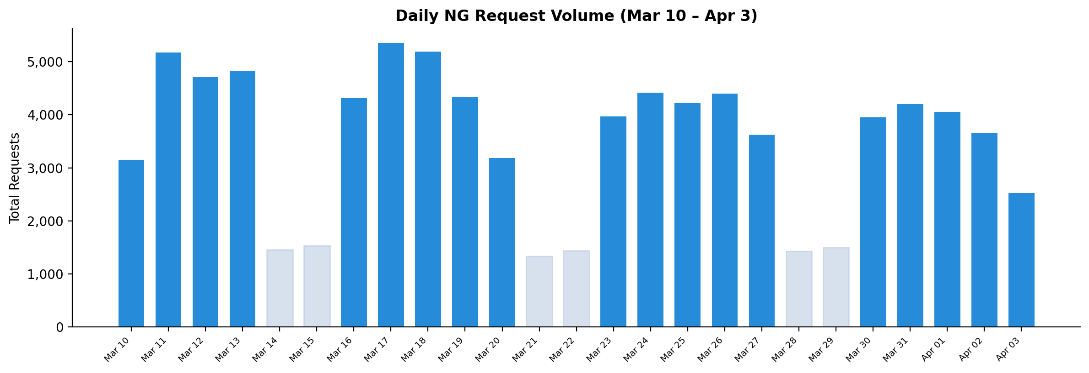

Traffic by Region
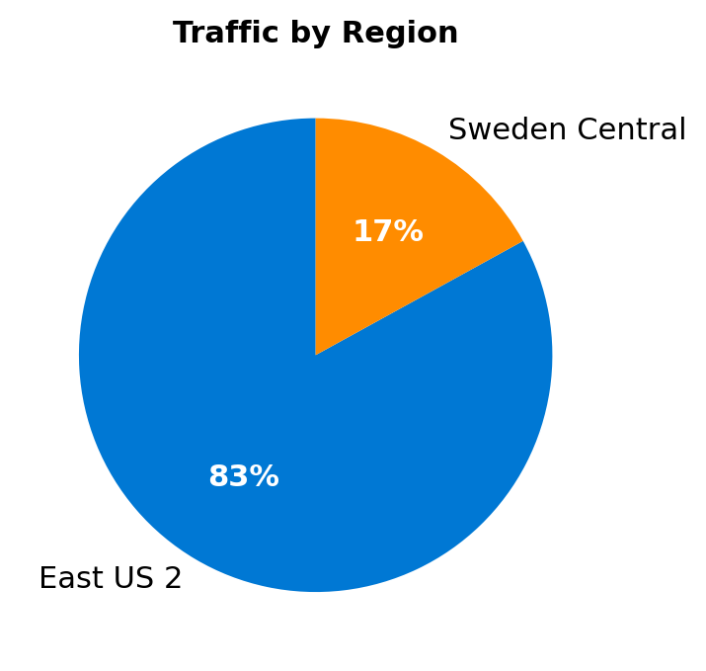

NG vs V2 Comparison
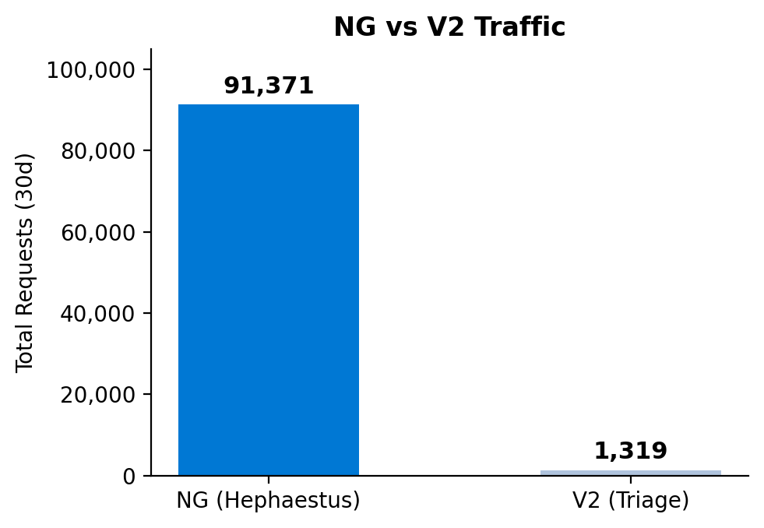

Daily Unique Users
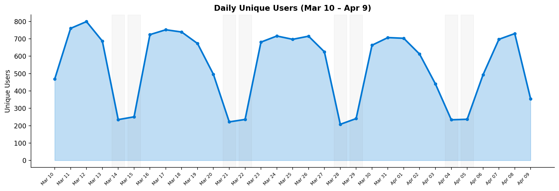

New vs Returning Users
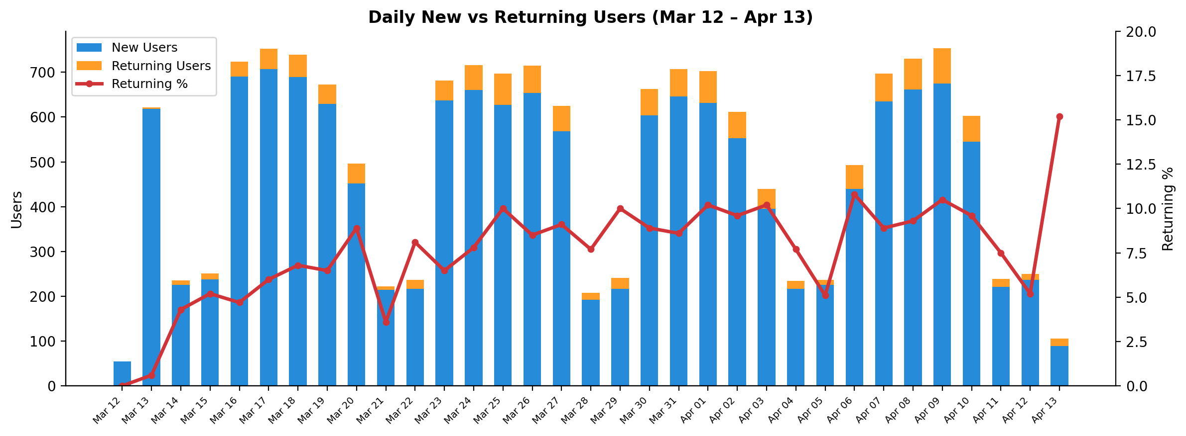

Daily Success Rate
