**Lab Assignment 7**

**(Week 5 – Lab A and Lab B)**

**Q1.** It is desiredto store the information (1, 2, 3 ... 24) into the data structure depicted in following figure:

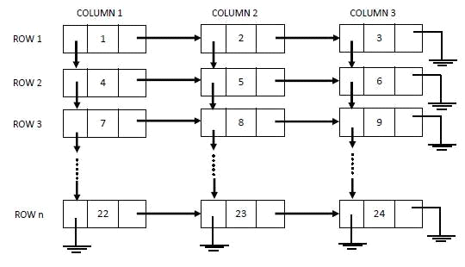

Write a program to create above structure and display its contents row wise and column wise.

Further use this structure to store following information (marks scored (out of 100) by students in different subjects):

**Col heads represent the subject ID and entries in the table represent the marks scored by student(s) in different subject(s)**

**Row heads represent the student enrolment number**

|  |  |  |  |  |  |
| --- | --- | --- | --- | --- | --- |
|  | **1** | **2** | **3** | **4** | **5** |
| **101** | 26 | 83 | 75 | 72 | 61 |
| **102** | 87 | 58 | 68 | 79 | 81 |
| **103** | 74 | 79 | 85 | 78 | 47 |
| **104** | 68 | 64 | 81 | 69 | 42 |
| **105** | 83 | 47 | 93 | 66 | 64 |

Write programs to perform following queries:

1. Considering that passing criteria is 50% marks (average), which subject is having maximum number of failure students
2. Display the topper student

Q2. Create and display (row wise elements) two multi-lists as shown below

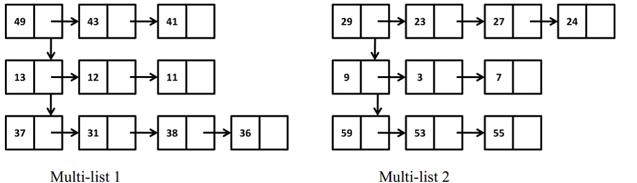

Sort each row of the both structures (Multi-list 1 and Multi-list 1) and merge the sorted multi-lists to create a single sorted multi-list

Q3. The standard use of multi-linked lists is to organize a collection of elements in two different ways. For example, suppose the elements in node include the name of a person and his/her age. e.g.

(FRED, 19) (MARY, 16) (JACK, 21) (JILL, 18)

There is need to order these elements alphabetically and also to order them by age. There will be need for two pointers - NEXT-alphabetically, NEXT-age - and the list header would have two pointers, one based on name, the other on age [as shown in figure below].

Implement the following operations,

* Insertion of new nodes in the multilinked list such that the list is sorted after insertion
* Deletion of a node from the multilinked list based on the user inputted age/name
* Display the multilinked list

