**CPU Scheduling Algorithm**

**FCFS :**

import java.util.*;

import java.io.*;

public class fcfs

{

public static void main(String args[])

{

int n,sum=0;

float total_tt=0,total_waiting=0;

Scanner s=new Scanner(System.in);

System.out.println("Enter Number Of Process U want 2 Execute---");

n=s.nextInt();

int arrival[]=new int[n];

int cpu[]=new int[n];

int finish[]=new int[n];

int turntt[]=new int[n];

int wait[]=new int[n];

int process[]=new int[n];

// int pro[][]=new int[3][3];

for(int i=0;i<n;i++)

{

System.out.println("Enter arrival time of "+(i+1)+" Process : ");

arrival[i]=s.nextInt();

System.out.println("Enter CPU time of "+(i+1)+" Process : ");

cpu[i]=s.nextInt();

process[i]=i+1;

}

for(int i=0;i<n;i++)

{

sum=sum+cpu[i];

finish[i]=sum;

}

for(int i=0;i<n;i++)

{

turntt[i]=finish[i]-arrival[i];

total_tt=total_tt+turntt[i];

wait[i]=turntt[i]-cpu[i];

total_waiting+=wait[i];

}

System.out.println("\n\nProcess\t\tAT\tCPU_T");

for(int i=0;i<n;i++)

{

System.out.println(process[i]+"\t\t"+arrival[i]+"\t"+cpu[i]);

}

System.out.println("\n\n");

System.out.println("Total turn around time is : "+(total_tt/n));

System.out.println("Total waiting time is : "+(total_waiting/n));

}

}

**OUTPUT :**

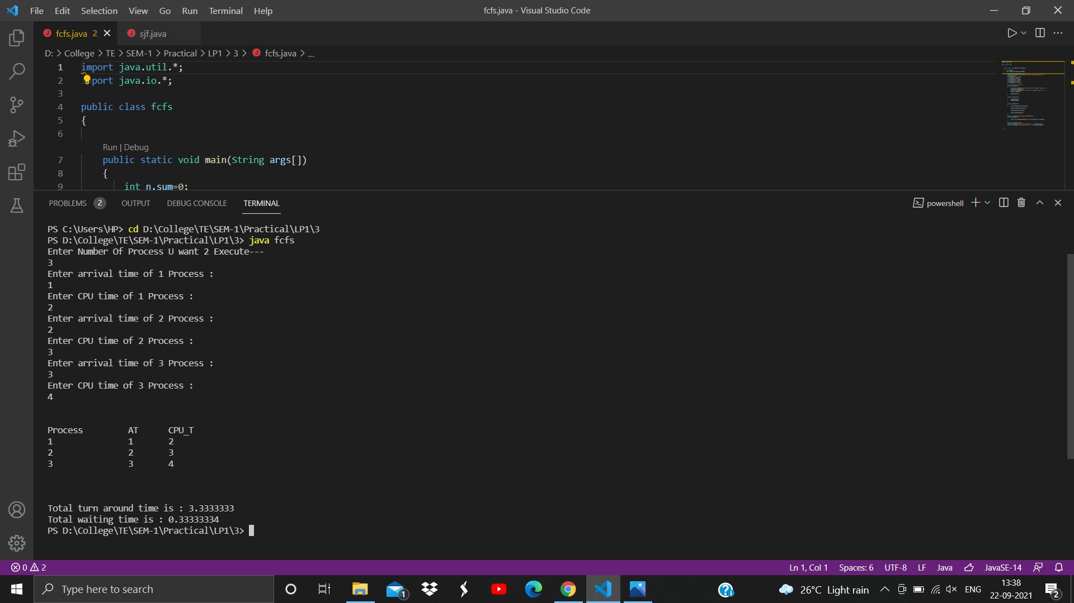

**SJF :**

import java.util.*;

import java.io.*;

public class sjf

{

public static void main(String args[])

{

int n,sum=0;

float total_tt=0,total_waiting=0;

Scanner s=new Scanner(System.in);

System.out.println("Enter Number Of Process U want 2 Execute---");

n=s.nextInt();

int arrival[]=new int[n];

int cpu[]=new int[n];

int finish[]=new int[n];

int turntt[]=new int[n];

int wait[]=new int[n];

int process[]=new int[n];

// int pro[][]=new int[3][3];

for(int i=0;i<n;i++)

{

System.out.println("Enter arrival time of "+(i+1)+" Process : ");

arrival[i]=s.nextInt();

System.out.println("Enter CPU time of "+(i+1)+" Process : ");

cpu[i]=s.nextInt();

process[i]=i+1;

}

for(int i=0;i<n-1;i++)

{

for(int j=i+1;j<n;j++)

{

if(cpu[i]>cpu[j])

{

int temp=cpu[i];

cpu[i]=cpu[j];

cpu[j]=temp;

temp=arrival[i];

arrival[i]=arrival[j];

arrival[j]=temp;

temp=process[i];

process[i]=process[j];

process[j]=temp;

}

}

}

for(int i=0;i<n;i++)

{

sum=sum+cpu[i];

finish[i]=sum;

}

for(int i=0;i<n;i++)

{

turntt[i]=finish[i]-arrival[i];

total_tt=total_tt+turntt[i];

wait[i]=turntt[i]-cpu[i];

total_waiting+=wait[i];

}

System.out.println("\n\nProcess\t\tAT\tCPU_T");

for(int i=0;i<n;i++)

{

System.out.println(process[i]+"\t\t"+arrival[i]+"\t"+cpu[i]);

}

System.out.println("\n\n");

System.out.println("Total turn around time is : "+(total_tt/n));

System.out.println("Total waiting time is : "+(total_waiting/n));

}

}

**OUTPUT :**

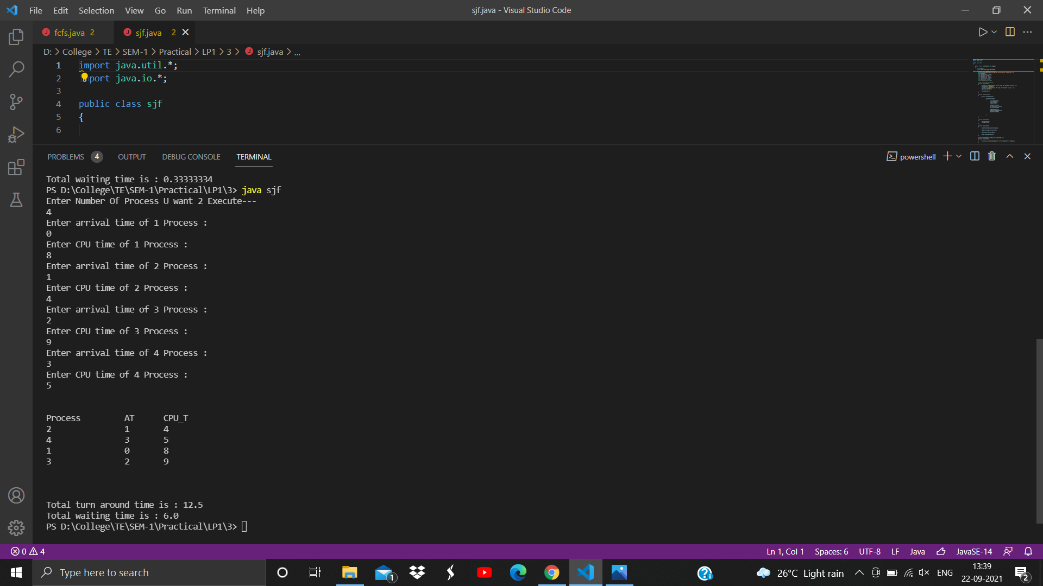

**PRIORITY :**

import java.util.*;

import java.io.*;

public class priority

{

public static void main(String args[])

{

int n,sum=0;

float total_tt=0,total_waiting=0;

Scanner s=new Scanner(System.in);

System.out.println("Enter Number Of Process U want 2 Execute---");

n=s.nextInt();

int arrival[]=new int[n];

int cpu[]=new int[n];

int pri[]=new int[n];

int finish[]=new int[n];

int turntt[]=new int[n];

int wait[]=new int[n];

int process[]=new int[n];

// int pro[][]=new int[3][3];

for(int i=0;i<n;i++)

{

System.out.println("Enter arrival time of "+(i+1)+" Process : ");

arrival[i]=s.nextInt();

System.out.println("Enter CPU time of "+(i+1)+" Process : ");

cpu[i]=s.nextInt();

System.out.println("Enter Priority of "+(i+1)+" Process : ");

pri[i]=s.nextInt();

process[i]=i+1;

}

for(int i=0;i<n-1;i++)

{

for(int j=i+1;j<n;j++)

{

if(pri[i]>pri[j])

{

int temp=cpu[i];

cpu[i]=cpu[j];

cpu[j]=temp;

//temp=arrival[i];

//arrival[i]=arrival[j];

//arrival[j]=temp;

temp=process[i];

process[i]=process[j];

process[j]=temp;

temp=pri[i];

pri[i]=pri[j];

pri[j]=temp;

}

}

}

for(int i=0;i<n;i++)

{

sum=sum+cpu[i];

finish[i]=sum;

}

for(int i=0;i<n;i++)

{

turntt[i]=finish[i]-arrival[i];

total_tt=total_tt+turntt[i];

wait[i]=turntt[i]-cpu[i];

total_waiting+=wait[i];

}

System.out.println("\n\nProcess\t\tAT\tCPU_T");

for(int i=0;i<n;i++)

{

System.out.println(process[i]+"\t\t"+arrival[i]+"\t"+cpu[i]);

}

System.out.println("\n\n");

System.out.println("Total turn around time is : "+(total_tt/n));

System.out.println("Total waiting time is : "+(total_waiting/n));

}

}

**OUTPUT :**

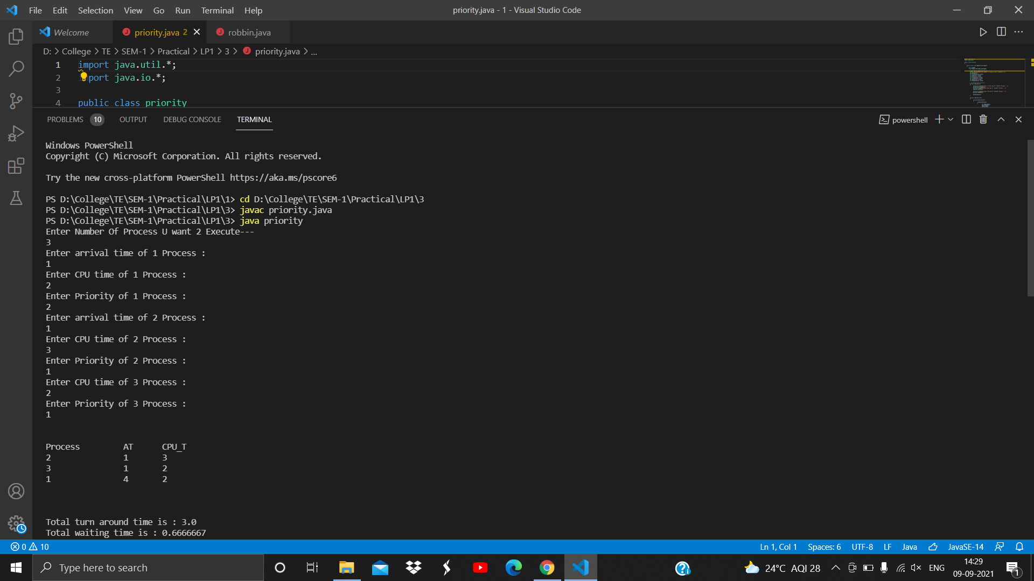

**ROBBIN :**

import java.util.*;

import java.io.*;

public class robbin

{

public static void main(String args[])

{

int n,sum=0;

float total_tt=0,total_waiting=0;

Scanner s=new Scanner(System.in);

System.out.println("Enter Number Of Process U want 2 Execute---");

n=s.nextInt();

int arrival[]=new int[n];

int cpu[]=new int[n];

int ncpu[]=new int[n];

int pri[]=new int[n];

int finish[]=new int[100];

int turntt[]=new int[n];

int wait[]=new int[n];

int process[]=new int[n];

int t_quantum,difference,temp_sum=0,k=0;

int seq[]=new int[100];

// int pro[][]=new int[3][3];

for(int i=0;i<n;i++)

{

System.out.println("Enter arrival time of "+(i+1)+" Process : ");

arrival[i]=s.nextInt();

System.out.println("Enter CPU time of "+(i+1)+" Process : ");

ncpu[i]=cpu[i]=s.nextInt();

process[i]=i+1;

}

System.out.println("Enter time quantum : ");

t_quantum = s.nextInt();

int tv=0;

for(int i=0;i<n;i++){temp_sum=temp_sum+cpu[i];}

//System.out.println(temp_sum);

System.out.println("Process execution sequence : ");

while(sum!=temp_sum){

for(int i=0;i<n;i++)

{

if(ncpu[i]<t_quantum)

{

difference=ncpu[i];

tv=ncpu[i];

ncpu[i]=0;

}

else

{

difference = ncpu[i]-t_quantum;

tv=t_quantum;

ncpu[i]=difference;

}

if(tv > 0)

{

sum=sum+tv;

finish[k]=sum;

seq[k]=i;

System.out.print(seq[k]+1+" ");

k++;

}

}

}

System.out.println();

for(int i=0;i<n;i++)

{

int carr=0,tt=0;

carr=arrival[i];

for(int j=0;j<k;j++)

{

if(seq[j]==i)

{

tt=tt+(finish[j]-carr);

carr=finish[j];

}

}

turntt[i]=tt;

System.out.println("Turn around time for "+(i+1)+" process : "+turntt[i]);

total_tt=total_tt+turntt[i];

wait[i]=turntt[i]-cpu[i];

System.out.println("Waiting time for "+(i+1)+" process : "+wait[i]);

total_waiting+=wait[i];

}

System.out.println("\n\nProcess\t\tAT\tCPU_T");

for(int i=0;i<n;i++)

{

System.out.println(process[i]+"\t\t"+arrival[i]+"\t"+cpu[i]);

}

System.out.println("\n\n");

System.out.println("Total turn around time is : "+(total_tt/n));

System.out.println("Total waiting time is : "+(total_waiting/n));

}

}

**OUTPUT :**

