SECURELINK VPN LAB
Research Project | Secure VPN for Remote Access

VPN Architecture Design Document
Establishing a Secure VPN for Remote Access
Deliverable D1 of 6
Organisation | Research project (lab build)
Author | Kshitij Rajesh Randhire
Version | 1.0 (final)
Basis | Lab build on VMware; evidence IDs [E01]-[E38] refer to the evidence screenshot set
Status | Lab design document. Not certified and not presented as production-ready.

Contents
1 Scope and objectives
2 Address plan
3 Topology diagrams
4 Technology selection
5 Data flow
6 Split-tunnel rationale
7 Lab-to-production mapping
8 Implementation status
9 Limitations
Appendix A Evidence cited

1 Scope and objectives
The brief asks for a VPN that gives a multinational corporation both site-to-site and client-to-site access, with confidentiality, integrity and authentication. This document describes what I actually built and tested in a small lab for this research project, and how it would carry over to a production design. The lab runs on my Windows 10 laptop under VMware (16 GB RAM) on a NAT network, 192.168.232.0/24, and all three virtual machines share that one host.
I label each item as Implemented and verified, Implemented but limited, or Recommended, not implemented. Evidence is cited as [E05] and so on; the screenshots are in the Evidence folder.

2 Address plan
Element | Address / network | Role | Evidence
gw-hq | 192.168.232.131 (Ubuntu 24.04.5) | HQ gateway: OpenVPN 2.6.19, strongSwan, iptables, rsyslog sender, fail2ban | [E10]
gw-branch | 192.168.232.132 | Branch gateway: strongSwan, rsyslog receiver | [E01]
Kali client | 192.168.232.128 (Kali 2026.1, OpenVPN 2.7.5) | Remote user device | [E05]
HQ LAN (simulated) | 10.10.1.0/24, dummy0 10.10.1.1 on gw-hq | Stands in for corporate network; no real hosts | [E10]
Branch LAN (simulated) | 10.10.2.0/24, dummy0 10.10.2.1 on gw-branch | Stands in for branch network; no real hosts | [E01]
OpenVPN instance 1 | UDP 1194, tun0 10.8.0.1/24; client 10.8.0.2 | Client-to-site pool 1 | [E10][E16]
OpenVPN instance 2 | UDP 1195, tun1 10.9.0.1/24; client 10.9.0.2 | Client-to-site pool 2 | [E10][E16]

3 Topology diagrams

3.1 Site-to-site
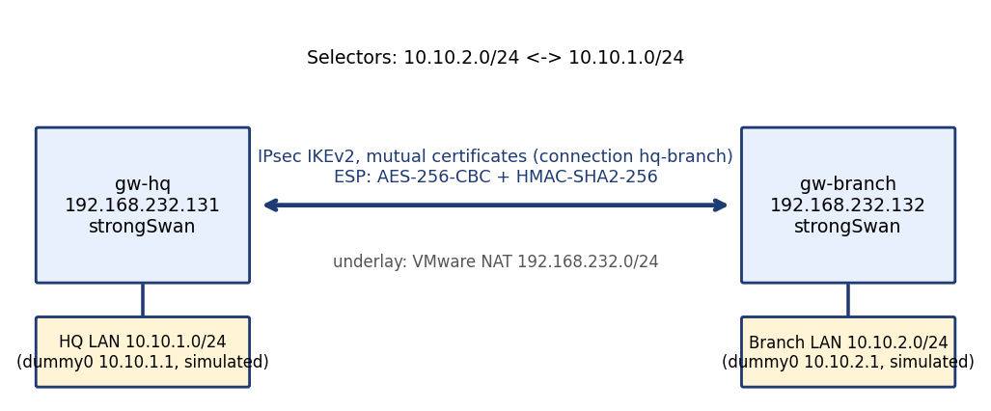
Figure 1. Site-to-site IPsec topology between gw-hq and gw-branch [E01][E10]
The tunnel uses strongSwan IKEv2 with mutual certificate authentication (connection hq-branch). IKE proposal: AES_CBC_256, PRF_HMAC_SHA2_256, HMAC_SHA2_256_128, MODP_2048. ESP: AES_CBC-256 with HMAC_SHA2_256_128 (CBC with HMAC, not GCM). Selectors are 10.10.2.0/24 <-> 10.10.1.0/24. A ping across the tunnel returned 4/4 with 0% loss and ESP packets were captured [E01].
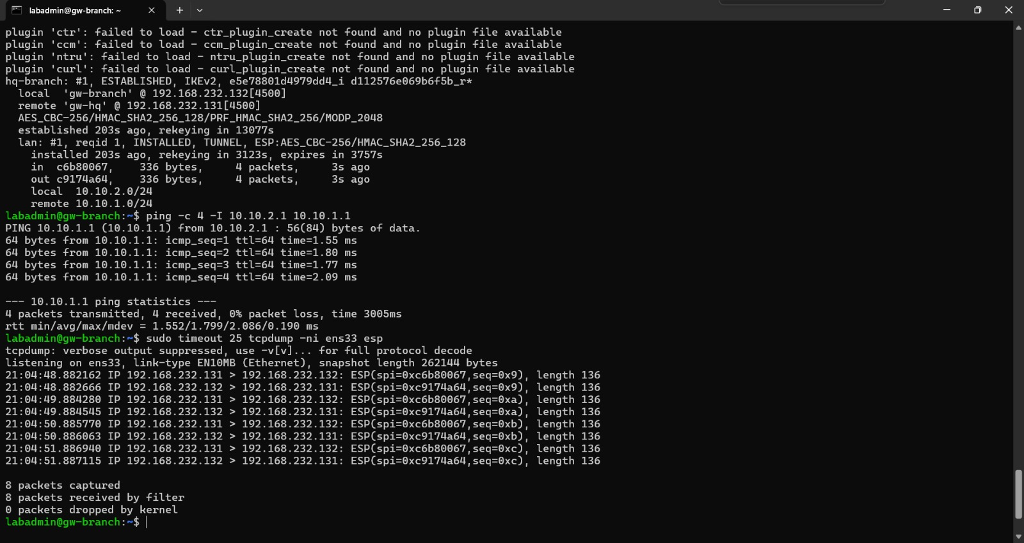
Figure 2. IPsec tunnel ESTABLISHED, ping 0% loss, ESP in tcpdump [E01]

3.2 Client-to-site
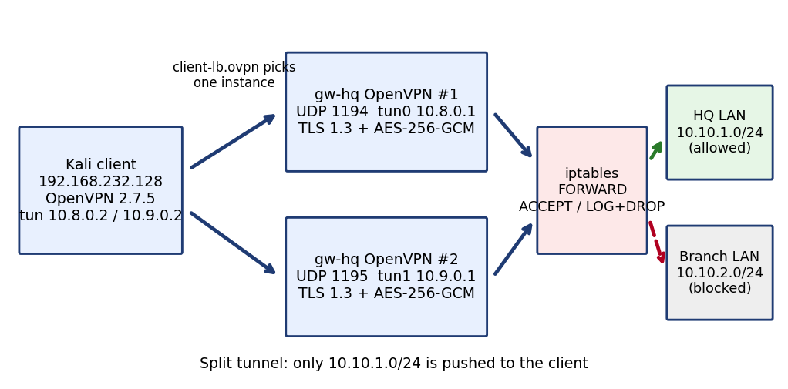
Figure 3. Client-to-site OpenVPN topology with two instances and iptables control [E05][E10][E11][E16]
Two OpenVPN instances run on gw-hq: UDP 1194 (tun0, 10.8.0.0/24) and UDP 1195 (tun1, 10.9.0.0/24) [E16]. Both negotiate TLS 1.3 with TLS_AES_256_GCM_SHA384, an RSA 2048 server certificate and X25519, with AES-256-GCM for data [E05]. The client authenticates with a certificate plus a TOTP code (see D2).
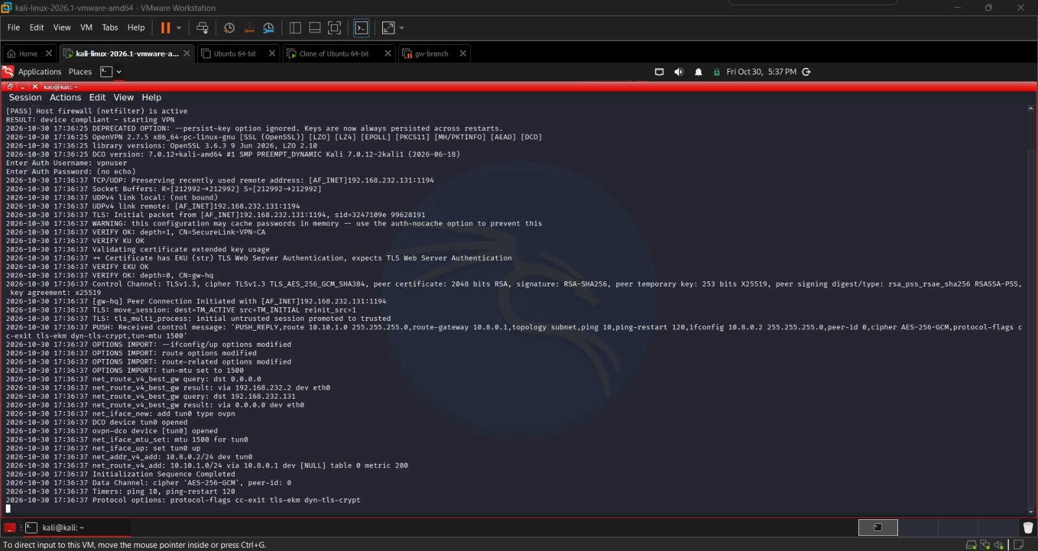
Figure 4. Compliant client connects; TLS 1.3, AES-256-GCM, one pushed route [E05]

4 Technology selection
I chose open-source tools for cost and for fit with the brief. I compared the alternatives on paper only; none of them was deployed or tested.
Need | Chosen (built) | Alternatives assessed on paper | Reason for choice
Site-to-site | strongSwan, IPsec IKEv2, certificates | WireGuard; OpenVPN site-to-site | IPsec is the standard for gateway-to-gateway and interoperates with most vendors
Client-to-site | OpenVPN (TLS), UDP | WireGuard; SoftEther | Mature TLS-based client with clients for Linux, Windows and macOS, and PAM plugin support for TOTP
Authentication | Certificates + TOTP via PAM (pam_google_authenticator) | FreeRADIUS | Fewer components for a small lab; RADIUS recommended for central user management at scale
Certificates | Easy-RSA / OpenSSL 3.0.13 | Larger PKI tooling | Sufficient for a lab; two-tier PKI recommended
Logging | rsyslog, journald, fail2ban | ELK stack | Light enough for the lab hardware; ELK suggested for searching and dashboards
Monitoring | OpenVPN status file, logs | Nagios Core; Zabbix | Not deployed; see D4

Status: ELK, Nagios, Zabbix, FreeRADIUS, WireGuard and SoftEther are not part of the lab build.

5 Data flow
- Client opens a UDP session to gw-hq (1194 or 1195) using the tls-crypt protected channel and a client certificate [E10].
- gw-hq checks the client certificate against the CA and the CRL (crl-verify) and runs the PAM plugin, which validates the TOTP code typed at the password prompt [E07][E09].
- A TLS 1.3 session is set up; the data channel uses AES-256-GCM with auth SHA256 [E05][E10].
- gw-hq pushes the route 10.10.1.0/24 and assigns the tunnel address [E05][E07].
- Traffic leaving the tunnel goes through iptables FORWARD: ACCEPT only to 10.10.1.0/24, otherwise LOG with prefix VPN-DENY then DROP [E11].
- Events are logged locally and forwarded to gw-branch over TCP 514 (see D4) [E27][E28].

6 Split-tunnel rationale
The client profile ignores redirect-gateway and dhcp-option, so only 10.10.1.0/24 is routed through the VPN [E06]. Internet traffic stays on the user's own connection.
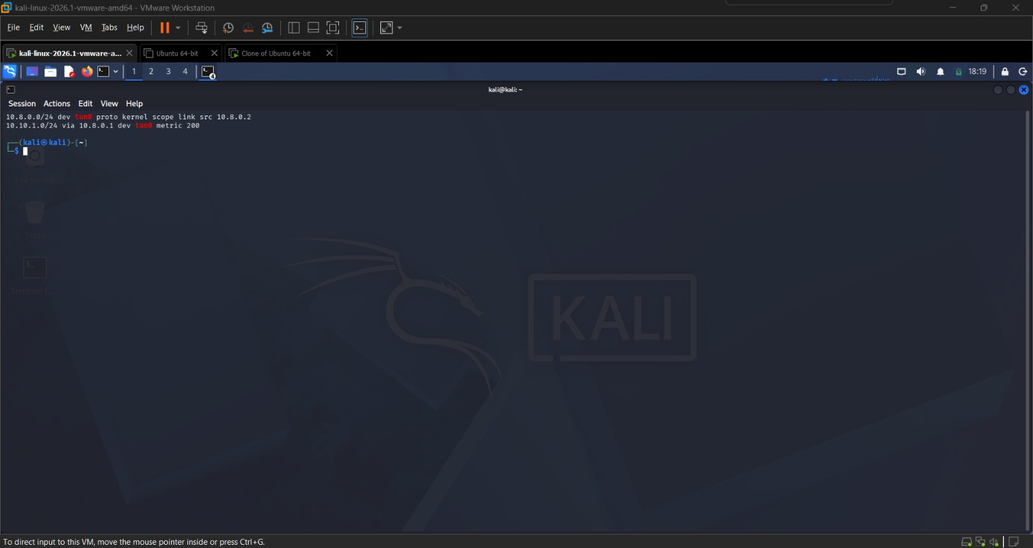
Figure 5. Client routing table with a single pushed route [E06]
Aspect | Split tunnel (built) | Full tunnel (not built)
Gateway load | Only corporate traffic | All traffic, higher load
Inspection of internet traffic | None by the company | Possible at the gateway
Exposure of client | Client is reachable from its local network while connected | Reduced, but depends on client firewall

I chose split tunnelling to keep the load low on a small lab gateway. A company with stricter requirements could move to a full tunnel, but I did not test that.

7 Lab-to-production mapping
Lab element | Production recommendation | Status
dummy0 simulated LANs | Real HQ and branch subnets with firewall rules per segment | Recommended, not implemented
Single self-signed CA | Two-tier PKI with an offline root | Recommended (planned, not done)
One client certificate / account | Per-user certificates and accounts | Recommended, not implemented
One gateway with two instances | Multiple gateways with real load balancing | Recommended, not implemented
TCP 514 without TLS | TLS-protected syslog | Recommended, not implemented
Windows/macOS clients | OpenVPN GUI (Windows); Tunnelblick or OpenVPN Connect (macOS) | Recommended, not tested

8 Implementation status
Category | Items
Implemented and verified | IPsec site-to-site tunnel [E01]; OpenVPN client-to-site with TLS 1.3 / AES-256-GCM [E05]; split tunnel [E06]; iptables allow/deny to 10.10.1.0/24 only [E11][E12]; two instances active [E16]
Implemented but limited | Two instances on one gateway with client-side selection [E21][E22] (no high availability); iptables rules are network-based, not per user, and persistence after reboot was not verified; lab uses simulated LANs
Recommended, not implemented | Two-tier PKI, per-user certificates, TLS syslog, alerting, retention, multi-gateway HA, macOS testing

9 Limitations
- The LANs are simulated; there are no real LAN hosts behind either gateway.
- All machines share one Windows 10 host with 16 GB RAM; results may not reflect production hardware.
- One certificate and one account were used, so per-user separation is not shown.
- Hardening notes from client logs: persist-key is deprecated and auth-nocache is not set.
- Scalability and capacity figures in other documents are recommendations or estimates, not measurements.

Appendix A Evidence cited
ID | Content
E01 | IPsec established, ESP captured, ping 0% loss
E05 | Client connect, TLS 1.3, AES-256-GCM, pushed route
E06 | Client routing table
E07 | Server log: TOTP accepted, route pushed
E09 | PAM configuration and auth.log
E10 | Interfaces and key server.conf settings
E11 / E12 | iptables FORWARD rules, VPN-DENY, client blocked
E16 | Both OpenVPN instances active
E21 / E22 | client-lb profile to 1194 / 1195
E27 / E28 | rsyslog forwarding and received logs

Full configuration files stay on the gateways and are not reproduced here; the key settings are visible in the cited screenshots.

