SECURELINK VPN LAB
Research Project | Secure VPN for Remote Access

VPN Client Configuration Guide
Establishing a Secure VPN for Remote Access
Deliverable D3 of 6
Organisation | Research project (lab build)
Author | Kshitij Rajesh Randhire
Version | 1.0 (final)
Basis | Lab build on VMware; evidence IDs [E01]-[E38] refer to the evidence screenshot set
Status | Lab documentation. Not certified and not presented as production-ready.

Contents
1 Client matrix
2 Linux client: step-by-step
3 Client profile explained
4 Device compliance check
5 Troubleshooting from real messages
6 Windows (tested) and macOS (not tested)
7 Implementation status

1 Client matrix
Platform | Software | Status
Linux (Kali 2026.1) | OpenVPN 2.7.5 with client.ovpn and vpn-connect.sh | Implemented and verified [E05][E14]
Windows | OpenVPN GUI | Tested (see D3A)
macOS | Tunnelblick or OpenVPN Connect | Recommended, not tested

2 Linux client: step-by-step
- Install OpenVPN version 2.6.0 or later (the compliance script enforces this; the lab client runs 2.7.5).
- Place the profile client.ovpn [E04] and the certificate and key files it refers to in the client directory. Private key permissions must be 600 or stricter [E15].
- Make sure the system clock is synchronized and a firewall is present; both are checked by vpn-connect.sh [E13][E14].
- Run vpn-connect.sh. If a check fails, the connection is blocked [E13]; if all checks pass, the VPN starts [E14].
- When prompted, enter the user name vpnuser and type the current TOTP code from the authenticator app at the password prompt [E05][E09].
- Verify: the client log shows the server certificate verified, TLS 1.3 with TLS_AES_256_GCM_SHA384 and AES-256-GCM, and one pushed route 10.10.1.0/24 [E05]; the routing table has that single VPN route [E06]; 10.10.1.1 answers ping [E12].
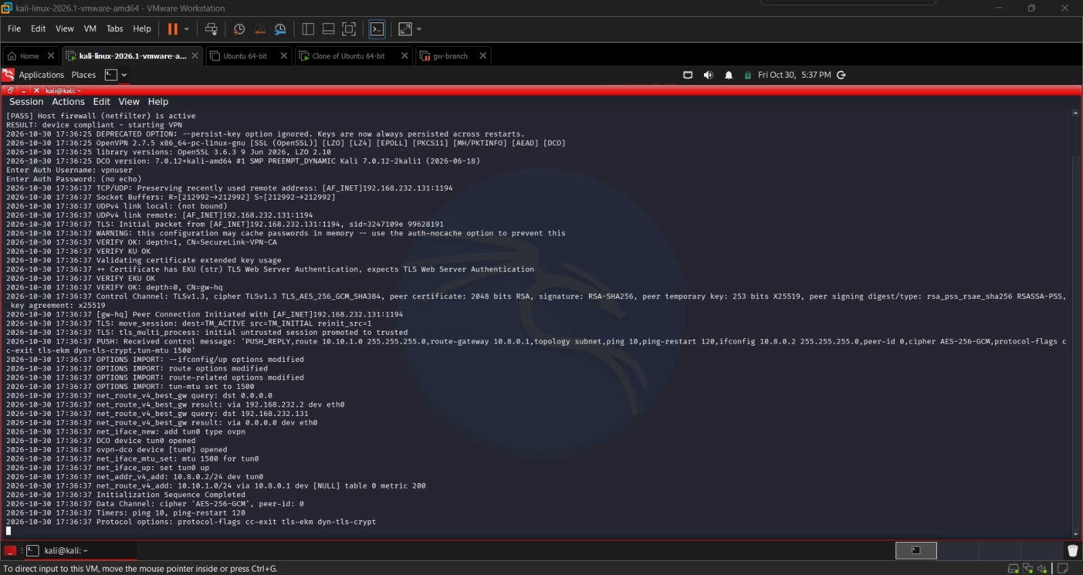
Figure 1. Compliant client connects; TLS 1.3, AES-256-GCM, one pushed route [E05]
Load-balancing profile: client-lb.ovpn connects to either instance (UDP 1194 or 1195) [E21][E22]. The choice is made by the client; there is no automatic failover.

3 Client profile explained
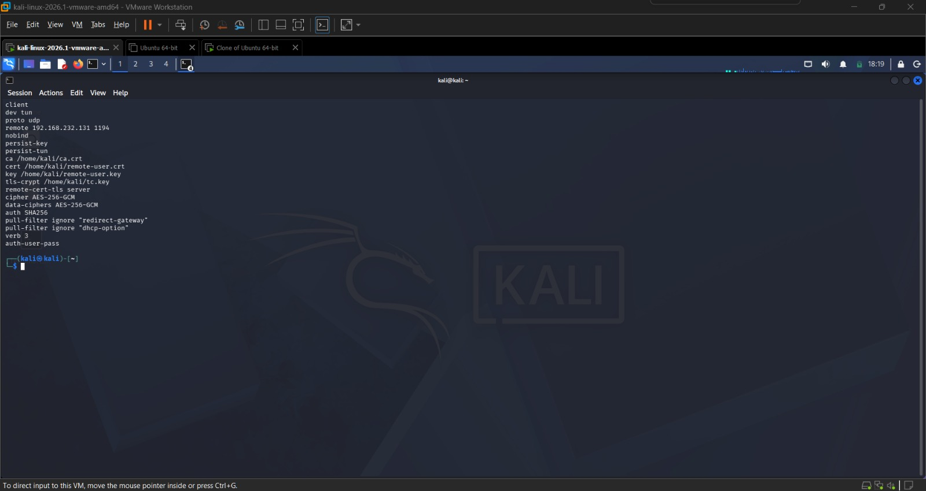
Figure 2. client.ovpn client profile [E04]
Behaviour | Meaning
Server certificate is verified | The client checks the gateway identity before sending credentials [E05]
Ignores redirect-gateway and dhcp-option | Split tunnel: only 10.10.1.0/24 is sent through the VPN; other traffic uses the local network [E06]
Certificate plus password prompt | Client certificate and TOTP code are both required (see D2)
Hardening notes from client logs | persist-key is deprecated; auth-nocache is not set

The complete profile is shown in Figure 2; the behaviours above are the ones that matter for security.

4 Device compliance check
Check (vpn-connect.sh) | Rule
Key file permissions | 600 or stricter
OpenVPN version | 2.6.0 or later
Clock | System clock synchronized
Firewall | A firewall is present

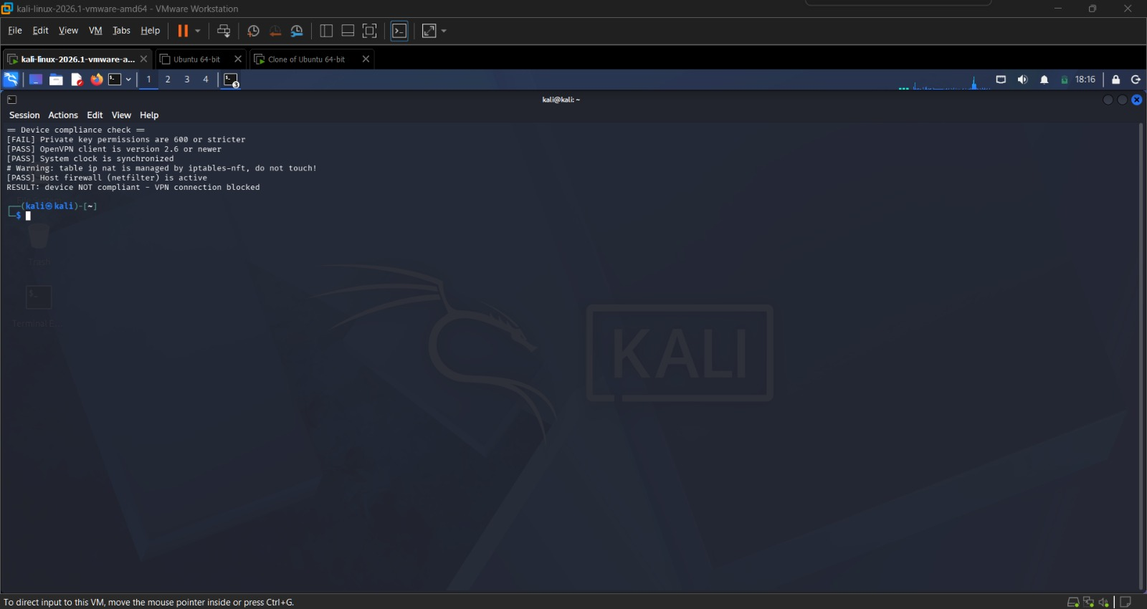
Figure 3. Compliance check fails and the connection is blocked [E13]
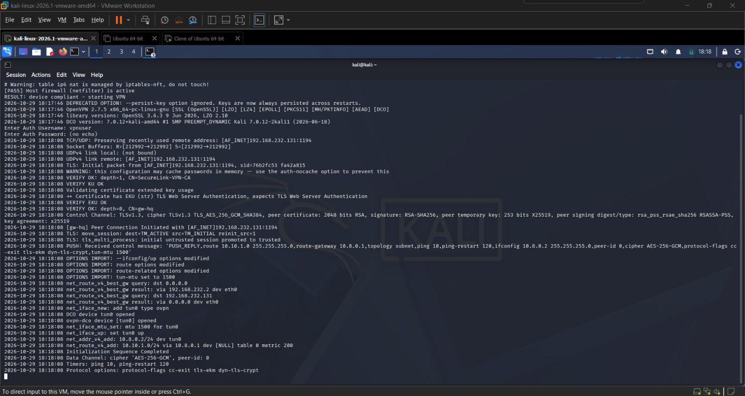
Figure 4. Compliance check passes and the VPN starts [E14]
Limits: the script runs on the client (Linux only) and can be bypassed by starting OpenVPN directly. A server-enforced posture check is recommended, not implemented. A scripted Windows/macOS compliance check was not built (Windows posture was checked manually, see D3A).

5 Troubleshooting from real messages
Message / symptom | Meaning | Action | Evidence
AUTH_FAILED (client); "Invalid verification code" (server) | Wrong or expired TOTP code | Wait for a new code, check the device clock, retry | [E08][E09]
TLS key negotiation failed; "certificate revoked" | Client certificate is on the CRL | Request a new certificate from the administrator | [E24][E25]
Connection blocked before start | A compliance check failed | Correct the failed item (permissions, version, clock, firewall) and rerun | [E13]
Traffic to 10.10.2.1 times out | Destination not allowed by firewall policy | Expected: only 10.10.1.0/24 is permitted | [E11][E12]

Note: the Kali clock is UTC minus 4 hours, so client log times differ from server logs by 4 hours.

6 Windows (tested) and macOS (not tested)
Windows was tested in the lab; see Appendix D3A (D3A_Windows_OpenVPN_Test_Report) and evidence [E29] to [E38]. The steps below are the standard procedure; macOS was not tested and should be checked on a real device before rollout.
- Install OpenVPN GUI (Windows) or Tunnelblick / OpenVPN Connect (macOS).
- Import the profile supplied by the administrator, with the certificate and key files it references.
- Connect and enter the user name and the current TOTP code at the password prompt.
- Check that only the 10.10.1.0/24 route is added and that 10.10.1.1 is reachable.

7 Implementation status
Category | Items
Implemented and verified | Linux client connection with certificate and TOTP [E05]; split tunnel [E06]; compliance fail and pass [E13][E14]
Implemented but limited | Compliance check is client-side, Linux-only and bypassable; load-balancing profile is client-chosen
Recommended, not implemented | Tested macOS client; server-enforced posture checks; remove persist-key and set auth-nocache

