SECURELINK VPN LAB
Research Project | Secure VPN for Remote Access

Monitoring & Logging Plan
Establishing a Secure VPN for Remote Access
Deliverable D4 of 6
Organisation | Research project (lab build)
Author | Kshitij Rajesh Randhire
Version | 1.0 (final)
Basis | Lab build on VMware; evidence IDs [E01]-[E38] refer to the evidence screenshot set
Status | Lab documentation. Not certified and not presented as production-ready.

Contents
1 Objectives
2 Log sources
3 Central logging design
4 rsyslog configuration
5 Detection use cases
6 Limits and next steps
7 Implementation status

1 Objectives
The aim is to track VPN usage, keep an audit trail and support incident analysis. All server times are UTC; dates are as shown in the cited screenshot. ELK, Nagios and Zabbix were not deployed, so monitoring in this lab is log-based.

2 Log sources
Source | What it records | Evidence
OpenVPN status file | Currently connected client | [E19]
journald / OpenVPN logs | Connections, TLS and auth results | [E09][E24]
auth.log (PAM) | TOTP accepted and invalid code | [E09]
Kernel log (iptables) | VPN-DENY drops of non-permitted traffic | [E11]
charon (strongSwan) | IPsec tunnel events | [E01][E28]
fail2ban sshd jail | SSH failures, ban and unban | [E17]
sshd / sudo | Logins and privileged commands | [E27][E28]

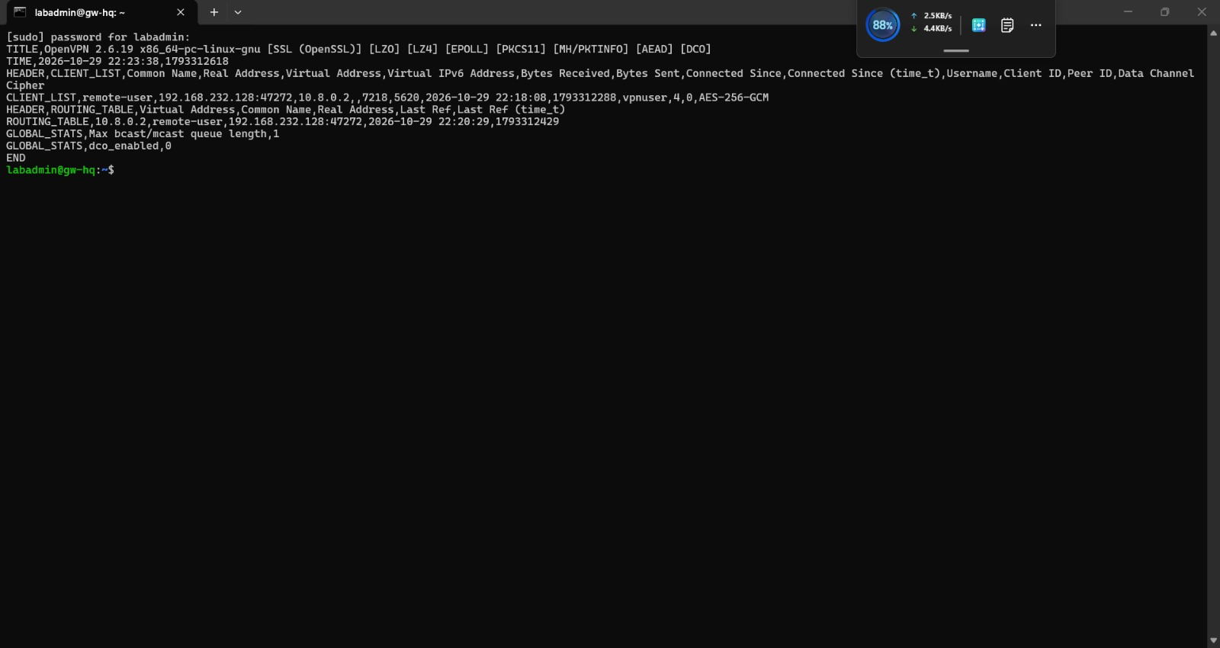
Figure 1. OpenVPN status file listing the connected client [E19]

3 Central logging design
gw-hq forwards openvpn*, sshd, sudo, charon*, vpn-test and kernel messages to gw-branch (192.168.232.132) over plain TCP port 514 with a disk-assisted queue [E27]. gw-branch stores them under /var/log/remote/gw-hq/ in separate files: charon-systemd, kernel, openvpn, sshd, sudo and vpn-test .log [E28]. A test message sent at 31 Oct 16:06:02 UTC arrived [E28].
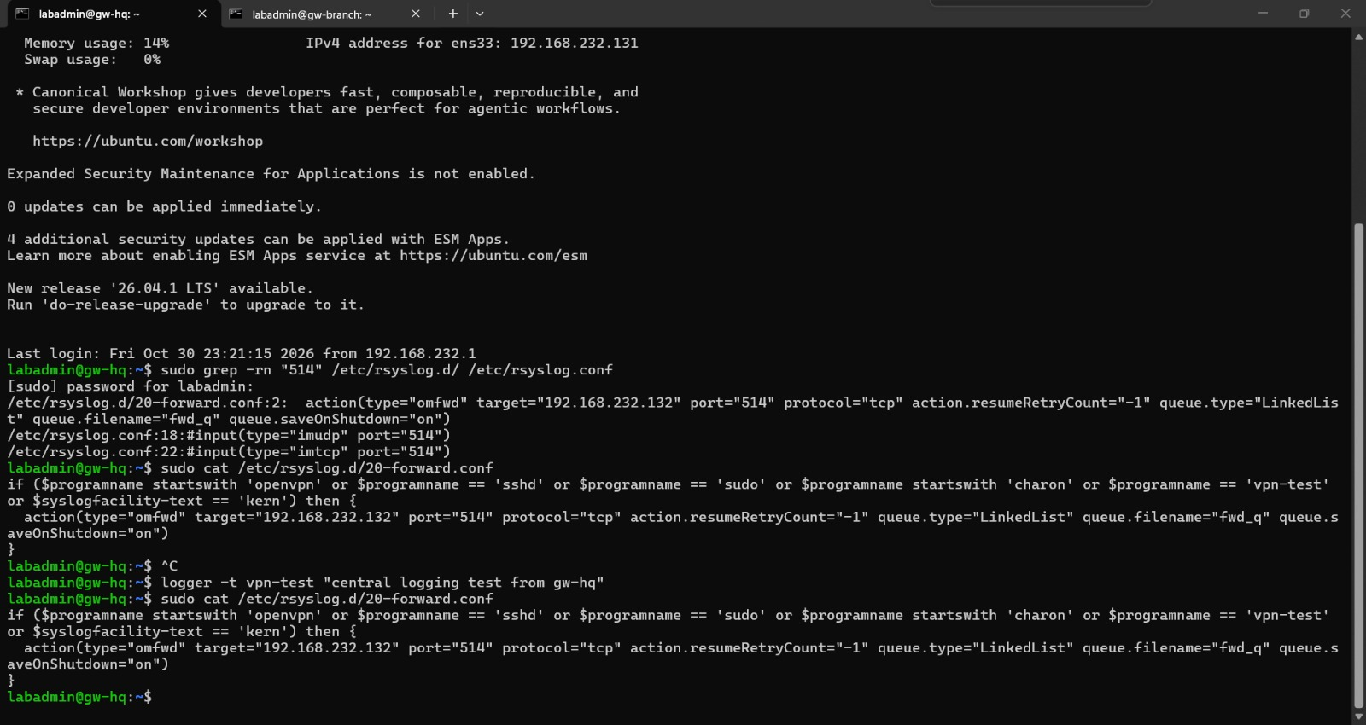
Figure 2. rsyslog forwarding rule on gw-hq [E27]
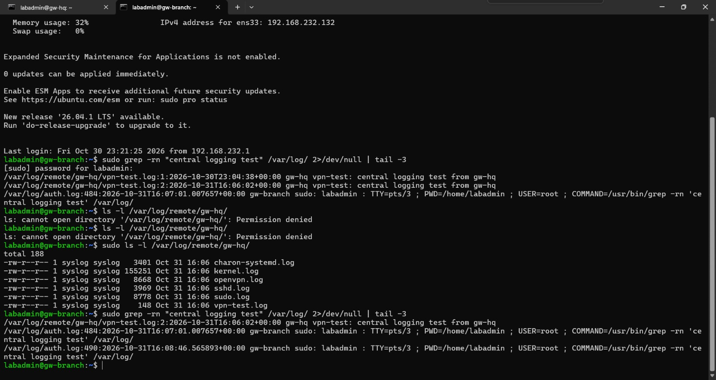
Figure 3. Test message received and per-service files on gw-branch [E28]
Weakness: TCP 514 has no TLS, so log content can be read or altered on the network between the two gateways.

4 rsyslog configuration
The sender rule on gw-hq is shown in [E27]. The receiver on gw-branch listens on TCP 514 and writes one file per service, as shown in [E28]. Full configuration files stay on the gateways.

5 Detection use cases
Use case | Indicator | Real example (UTC) | Evidence
Brute-force or wrong MFA code | "Invalid verification code"; AUTH_FAILED | 23:55:36 | [E08][E09]
Revoked certificate used | "certificate revoked" | From 23:40:48 | [E24][E25]
Access to a forbidden network | Kernel log lines prefixed VPN-DENY | 3 lines, 23:47:38-23:47:40 | [E11]
Repeated SSH failures | fail2ban sshd jail: 3 failures from gw-branch, ban, then unban | See screenshot | [E17]
Who is connected | Client listed in status file | See screenshot | [E19]
Pipeline health | Test message from vpn-test arrives on gw-branch | 31 Oct 16:06:02 | [E28]

Exact fail2ban ban-time and retry values are not stated here; the ban and unban behaviour itself is shown in [E17].
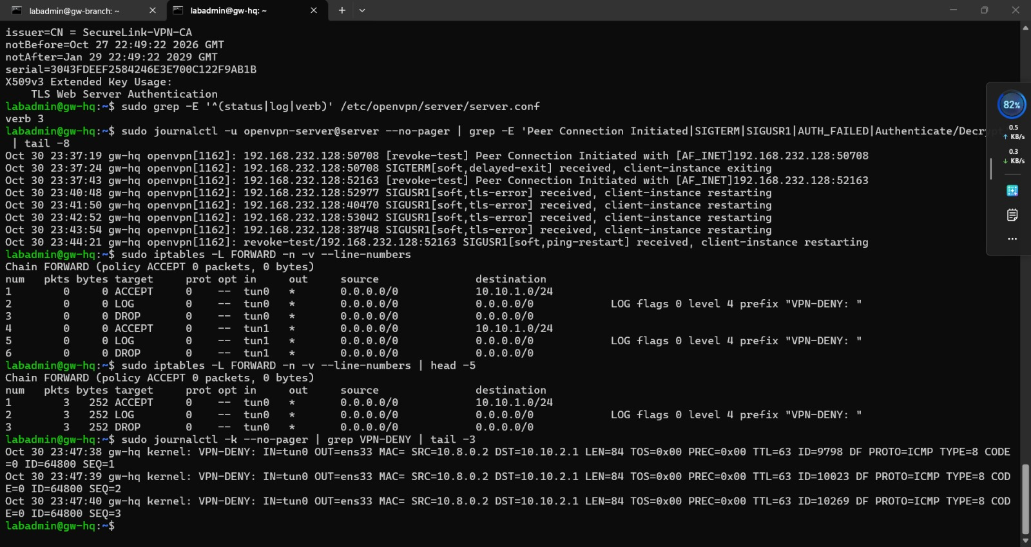
Figure 4. iptables rules, counters and VPN-DENY log lines [E11]

6 Limits and next steps
Logs can contain personal data such as user names and IP addresses (see D6). Time sync matters: server logs are UTC and the Kali client is UTC minus 4 hours.
Gap | Recommendation (not implemented)
No dashboards or alerting | Add alert rules for the use cases above; consider Zabbix or Nagios for uptime and ELK for search (assessed on paper only)
No retention settings | Define retention and rotation periods with the data protection officer
Plain TCP 514 | Move to TLS-protected syslog
Single log server on the branch gateway | Use a separate, access-controlled log host

7 Implementation status
Category | Items
Implemented and verified | Local logs; VPN-DENY logging; central forwarding gw-hq to gw-branch; fail2ban sshd jail
Implemented but limited | Central logging without TLS; no dashboards, alerting or retention
Recommended, not implemented | TLS syslog; alerting; retention policy; monitoring platform

