SECURELINK VPN LAB
Research Project | Secure VPN for Remote Access

Performance & Scalability Report
Establishing a Secure VPN for Remote Access
Deliverable D5 of 6
Organisation | Research project (lab build)
Author | Kshitij Rajesh Randhire
Version | 1.0 (final)
Basis | Lab build on VMware; evidence IDs [E01]-[E38] refer to the evidence screenshot set
Status | Lab documentation. Not certified and not presented as production-ready.

Contents
1 Method
2 Results
3 Analysis
4 Load balancing as built
5 Scalability recommendations
6 Fuller test plan (not run)
7 Implementation status

1 Method
iperf3 was run from the Kali client against gw-hq, with and without the VPN. The host is a shared Windows 10 machine (16 GB RAM) running all VMs on a virtual network, so the numbers show relative behaviour in this lab only. The load was one client, not many users.

2 Results
Run | Duration | No VPN | VPN 1 stream | VPN 5 streams | VPN 10 streams
Run 1 [E20] | 8 s | 3.40 Gbit/s | 196 Mbit/s | 151 Mbit/s | 173 Mbit/s
Run 2 [E15] | 10 s | 1.90 Gbit/s | not run | 153 Mbit/s (1020 retransmits) | 97.5 Mbit/s (455 retransmits)

VPN values are receiver-side throughput. The two runs are shown separately and not averaged.
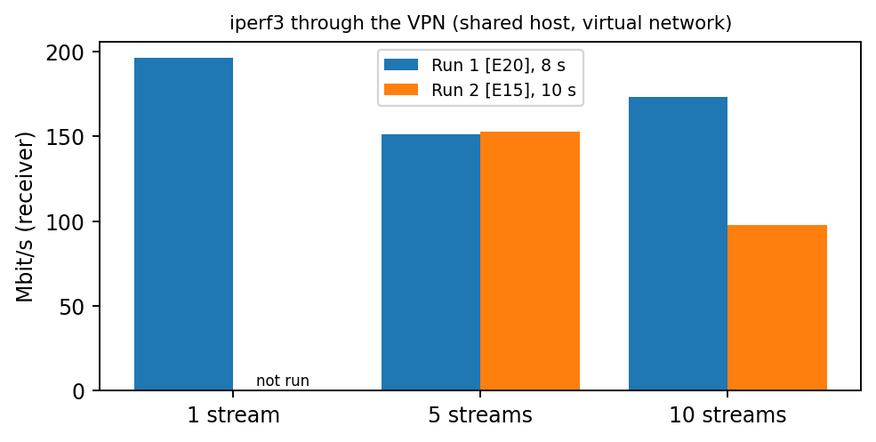
Figure 1. VPN throughput by number of streams, both runs [E20][E15]
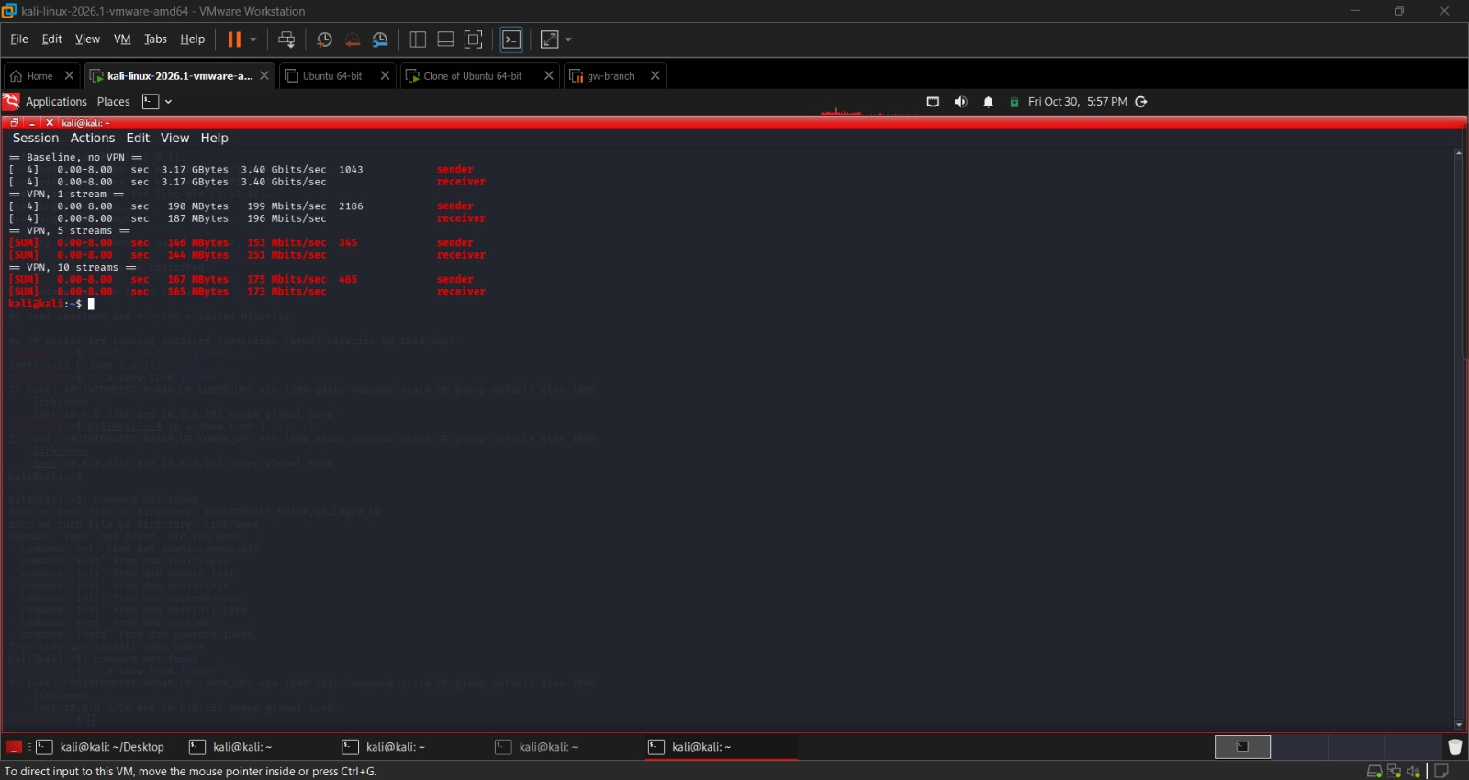
Figure 2. iperf3 run 1: baseline and VPN with 1, 5 and 10 streams [E20]
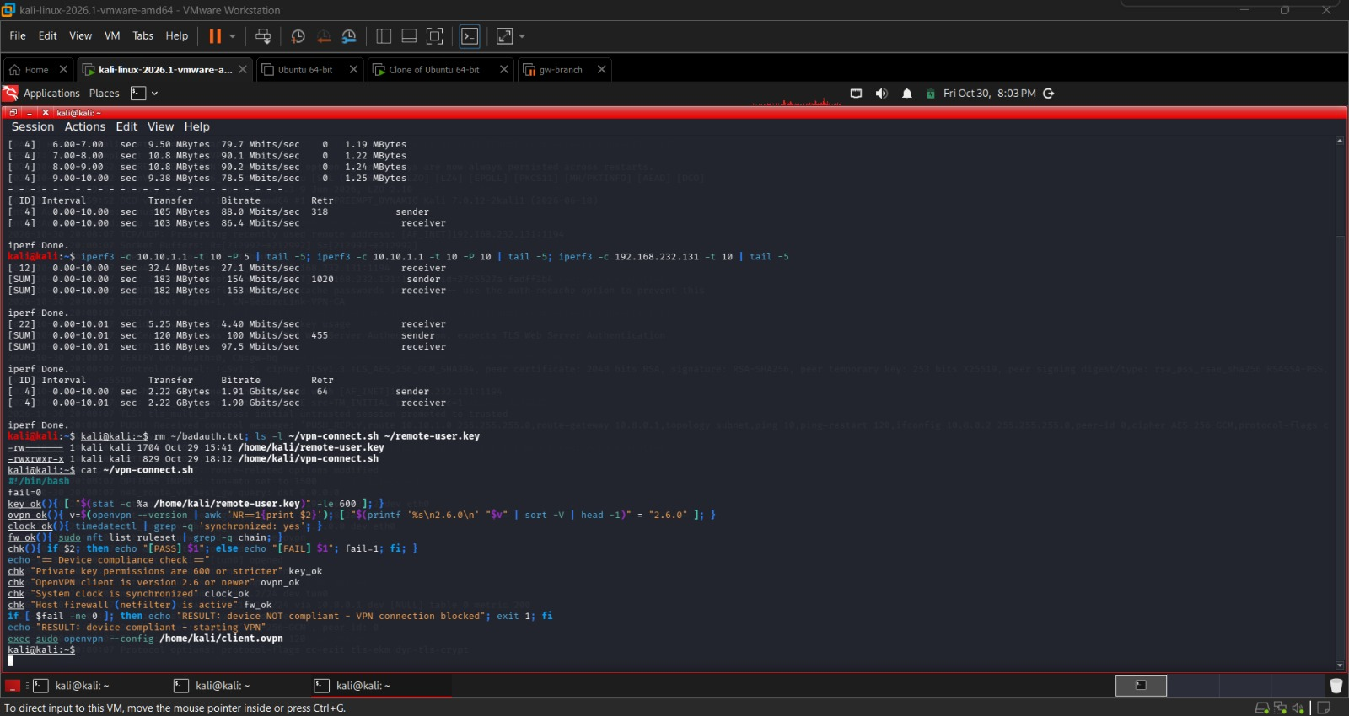
Figure 3. iperf3 run 2 (with vpn-connect.sh source) [E15]

3 Analysis
- VPN throughput was far below the no-VPN baseline in both runs, in the range of roughly 100 to 200 Mbit/s.
- Throughput did not scale with the number of streams; in run 2, 10 streams gave less than 5 streams.
- The baseline itself differed between runs (3.40 versus 1.90 Gbit/s), so the runs cannot be compared directly.
- Run 2 shows retransmits (1020 and 455). No cause has been established.
- CPU or virtualization overhead on the shared host is an untested hypothesis only.

4 Load balancing as built
Two OpenVPN instances run on one gateway (UDP 1194 with tun0, UDP 1195 with tun1) and the profile client-lb.ovpn connects to each [E21][E22]. Both instances were active [E16].
Aspect | Position
Who chooses the instance | The client
High availability | None: both instances share one gateway, so a gateway failure stops both
Traffic distribution | Not automatic and not measured
Status | Implemented but limited

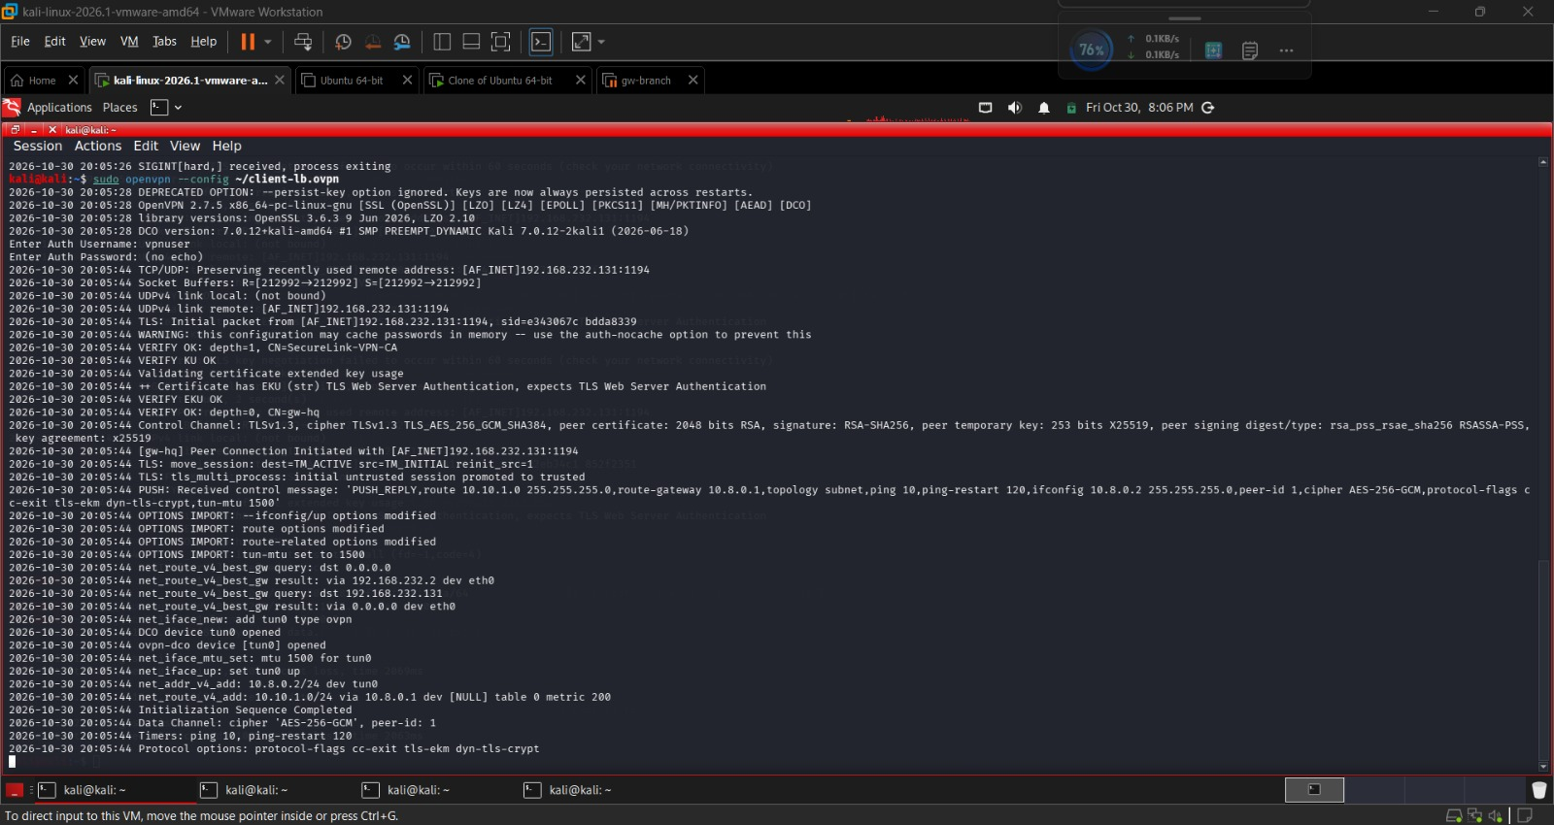
Figure 4. client-lb profile connected to instance 1, UDP 1194 [E21]
The connection to instance 2 (UDP 1195) is shown in [E22].

5 Scalability recommendations
All items below are recommendations, not implemented.
Area | Recommendation
Gateways | Several VPN gateways behind a real load balancer or DNS-based distribution, in more than one location
Identity | Per-user certificates and a central user directory (for example RADIUS) so users can be added and removed at scale
Address pools | Larger client pools and routes planned per gateway
Hardware | Test on dedicated hardware with AES acceleration before sizing
Monitoring | Track CPU, sessions and throughput per gateway

Capacity arithmetic (estimate, not measured): if one gateway sustained the lab's best VPN result of about 150 Mbit/s in total and an average user needed an assumed 2 Mbit/s, one gateway would serve roughly 75 concurrent users. The 2 Mbit/s figure is an assumption, and lab throughput may not carry over to production hardware.

6 Fuller test plan (not run)
- Many simultaneous clients with realistic traffic instead of one iperf3 client.
- Repeat runs on a quiet host with a fixed baseline, recording CPU on client and gateway.
- Compare UDP and TCP transport and different ciphers.
- Failover test with a second gateway.
- Long-duration soak test and tuning of retransmit sources.

7 Implementation status
Category | Items
Implemented and verified | iperf3 measurements with and without VPN [E15][E20]; both instances active [E16]
Implemented but limited | Two-instance setup on one gateway, client-chosen, no HA [E21][E22]; single-client load only
Recommended, not implemented | Real load balancing, multi-gateway scaling, capacity testing with many users

