SECURELINK VPN LAB
Research Project | Secure VPN for Remote Access

Policy & Compliance Documentation
Establishing a Secure VPN for Remote Access
Deliverable D6 of 6
Organisation | Research project (lab build)
Author | Kshitij Rajesh Randhire
Version | 1.0 (final)
Basis | Lab build on VMware; evidence IDs [E01]-[E38] refer to the evidence screenshot set
Status | Lab documentation. Not certified and not presented as production-ready.

Contents
1 Document control
2 Acceptable use policy
3 Security guidelines
4 Access control policy
5 Incident response
6 Roles and responsibilities
7 GDPR alignment
8 HIPAA Security Rule alignment
9 Gaps

1 Document control
Field | Value
Title | VPN Usage and Compliance Policy (lab draft)
Owner | Security officer (proposed role)
Author | Kshitij Rajesh Randhire
Version | 1.0
Review cycle | Recommended: annually and after any incident
Status | Draft for review; not approved by any authority

This document aligns lab controls with GDPR and the HIPAA Security Rule. It is an alignment mapping, not legal advice and not a statement of compliance.

2 Acceptable use policy
- Use the VPN only for authorized company work.
- Do not share certificates, passwords or TOTP codes or devices with the VPN profile.
- Connect only from devices that pass the compliance check.
- Report a lost device or a suspected compromise immediately.
- Do not attempt to reach networks outside your authorization; blocked attempts are logged [E11].

3 Security guidelines
- AES-256 encryption and certificate plus TOTP authentication for every connection (D2).
- Keep OpenVPN at version 2.6.0 or later, keep private keys at mode 600 or stricter, keep the clock synchronized and a firewall active [E13][E14].
- Split tunnel is used; only corporate traffic goes through the VPN [E06].
- Logs are forwarded centrally (D4) and treated as sensitive.

4 Access control policy
Access is granted by network destination: VPN clients may reach 10.10.1.0/24 only; other destinations are logged and dropped [E11][E12]. Access requires a valid, unrevoked certificate and a TOTP code. Limits: the policy is network-based, not per user; the lab used one certificate and one account, so unique user identification is not demonstrated; rule persistence after reboot was not verified.

5 Incident response
Example: a lost or compromised client certificate, using the revocation test.
Phase | Action | Evidence
Detect | Alerts or log review: wrong-code failures, VPN-DENY lines, unusual connections | [E09][E11][E19]
Contain | Revoke the certificate and regenerate the CRL (test at 23:39:38 UTC) | [E23]
Verify | Confirm new attempts are rejected (from 23:40:48 UTC, "certificate revoked") | [E24][E25]
Eradicate and recover | Reissue a new certificate and reset the user's TOTP enrolment | D2
Review | Record timeline, root cause and improvements; update this policy | -

Not tested: ending a session that was already established when the certificate was revoked. Add a manual step to disconnect the live session.
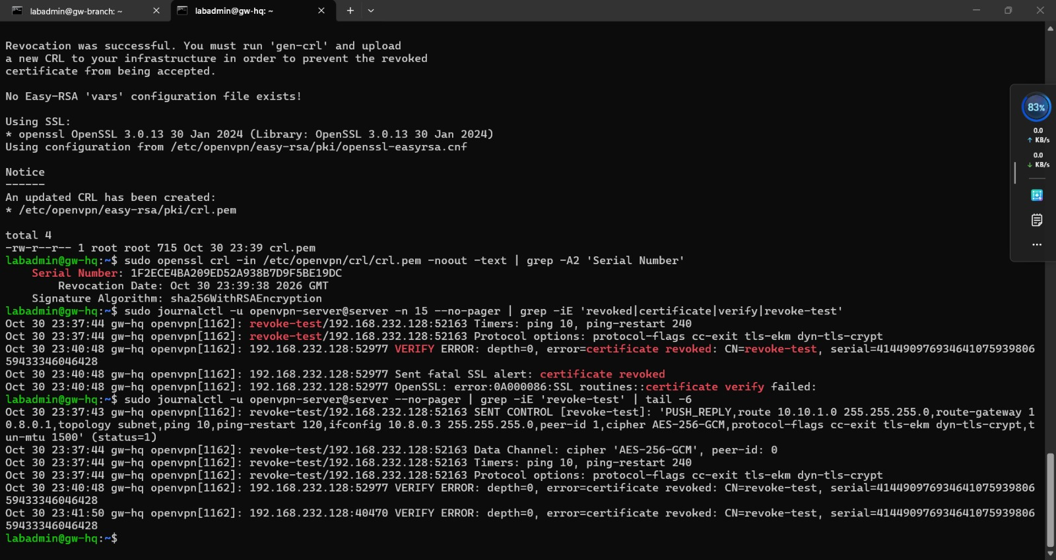
Figure 1. Revoked certificate accepted before revocation, rejected after [E24]
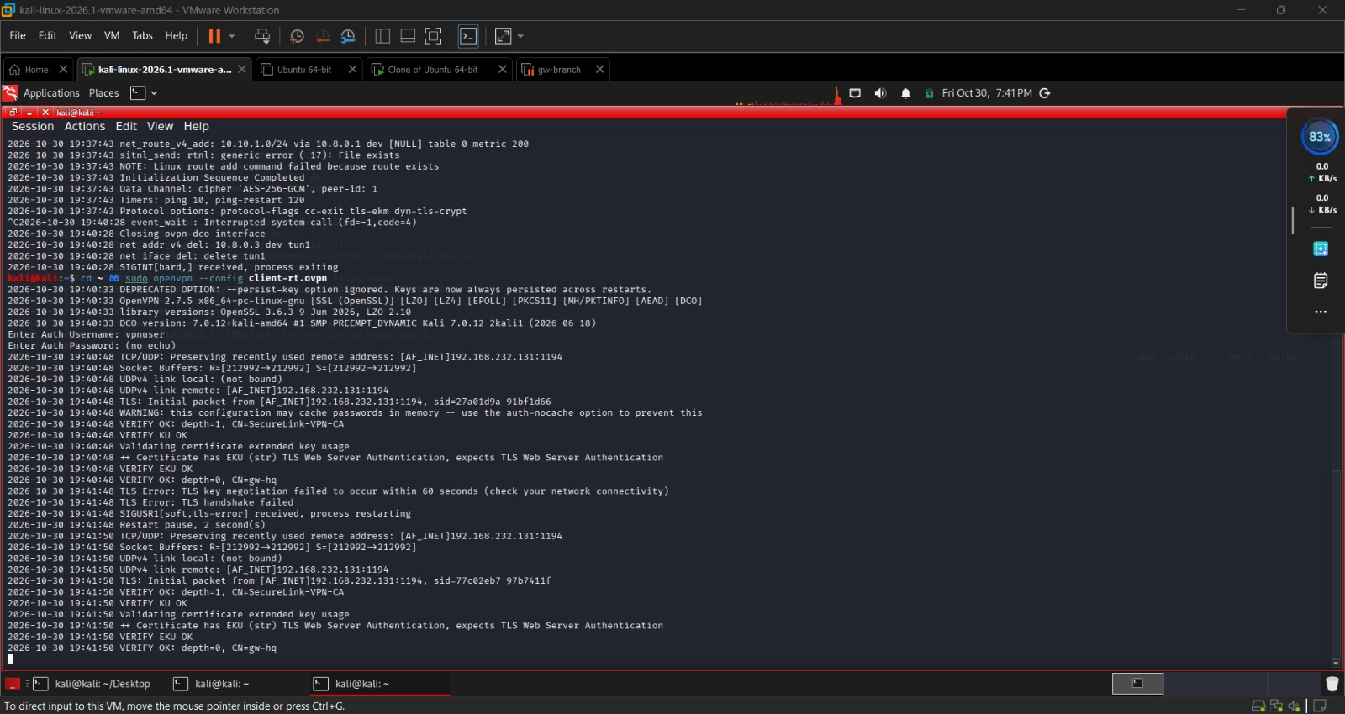
Figure 2. Client side: TLS key negotiation fails with the revoked certificate [E25]

6 Roles and responsibilities
Role | Responsibility
VPN administrator | Issues and revokes certificates, maintains gateways and logs
Security officer | Owns this policy, reviews logs, leads incident response
Data protection officer | Advises on GDPR matters, retention and breach notification
Users | Follow the acceptable use policy and report incidents
Management | Approves the policy and resources

Role names are proposals; the organisation would assign named people.

7 GDPR alignment
VPN and log data can include personal data such as user names and IP addresses.
Article | Requirement (summary) | Control / evidence | Status
Art. 5 | Lawfulness, minimisation, integrity and confidentiality, storage limitation | Encryption and access limits [E05][E11]; logs may contain personal data; no retention settings | Partial; retention gap
Art. 25 | Data protection by design and default | Split tunnel and destination-limited access [E06][E11] | Partial
Art. 30 | Records of processing | VPN and log processing not yet recorded | Gap
Art. 32 | Security of processing | AES-256, certificates, TOTP, logging [E05][E09][E27] | Partial; plain TCP 514 and single-tier PKI
Art. 33 | Notify the authority within 72 hours of becoming aware of a breach | Incident procedure in section 5; no notification procedure written | Partial

8 HIPAA Security Rule alignment (45 CFR 164.312)
Standard | Control / evidence | Status
(a)(1) Access control | Certificate plus TOTP; destination-limited iptables [E07][E11]; one account used, so unique user identification not shown | Partial
(b) Audit controls | Logs from OpenVPN, auth, kernel; central forwarding [E09][E11][E28]; no alerting or retention | Partial
(c)(1) Integrity | AES-256-GCM, SHA-256 file match [E17][E18] | Implemented in lab
(d) Person or entity authentication | Certificates and TOTP [E05][E09] | Implemented in lab; per-user identity not demonstrated
(e)(1) Transmission security | IPsec and OpenVPN encryption [E01][E05]; syslog link not encrypted | Partial

9 Gaps
Open gaps: per-user certificates and accounts; two-tier PKI; retention policy; records of processing; TLS syslog; alerting; tested macOS client; established-session cut-off; a named policy owner.

