Cryptocurrency Exchange Hack Investigation
Detailed Incident Report: Coincheck NEM theft, 26 January 2018
Prepared by: Kshitij Randhire
Project: Cryptocurrency Exchange Hack Investigation (independent research project)

1. Scope and method
This report reconstructs the January 2018 Coincheck NEM theft from public information. I used three kinds of evidence. The first is statements by Coincheck, the regulator and the NEM Foundation, as reported by Reuters, the BBC, CryptoNinjas and the FSA’s own website. The second is blockchain records that I collected myself from a public NEM (NIS1) node. The third is my own analysis of those records, which I label as interpretation. I used an AI assistant (Claude) to review my processing scripts and to help draft and edit this report.
Each finding carries a confidence label. Confirmed means I observed it directly on the blockchain or it comes from a government record. Strongly supported means a company or foundation statement reported by a reputable outlet. Interpretation is my reading of the evidence. Unknown means I could not establish it.
Times: NEM records each timestamp as a number of seconds after its own start time, 00:06:25 UTC on 29 March 2015. My first collection script used 00:00:00 UTC by mistake, so its times came out 6 minutes 25 seconds early. Every time in this report uses the corrected start time (process_raw.py) and is shown in Japan Standard Time (JST, UTC+9). After the correction, the onward transfers line up with the start time Coincheck reported, which is a useful cross-check.

1.1 AI assistance and how it was checked
Because an AI assistant helped with the scripts and the text, no finding depends on AI output alone. Each part of the work has a check that does not need the AI, listed below.
Part of the work | How it was checked
Processing scripts and the code fixes in Section 7.7 | Re-run from the raw node data (EVD-011, 012). The outputs match the expected counts and totals (4,350 rows; 11 transfers, 526,300,010 XEM; 8 transfers, 523,000,000 XEM), and the derived files match the hashes in the evidence register. Repeated on 2 October 2026 before publication.
Numbers and times in the text | Each is listed in the finding-to-evidence matrix (Evidence Portfolio, Section 8) with its evidence ID and the script step that produces it.
Statements by Coincheck, the FSA, the NEM Foundation and the press | Tied to the saved screenshots (EVD-001 to 004), so a reader can compare the wording with the source.
DISC-001 and DISC-002 | The arithmetic is Confirmed from the data. The explanations are labelled Interpretation and are not presented as verified.
Figures 1 and 2 | Built from the transfer tables (EVD-018, 019).
Not yet checked: the blockchain data has not been confirmed against a second node (Section 7.1).

2. Case selection
I chose Coincheck because the public record is solid and the NEM blockchain can still be queried. That meant I could pull the transactions myself and check the reported numbers against them, instead of only reading about them.

3. Timeline
The table mixes public statements with events I observed on the blockchain. The dates are 26 January 2018 unless another date is shown.
Time (JST) | Event | Evidence | Confidence
00:02:13 | First transfer out of Coincheck’s wallet (Address A): 10 XEM to Address B. It looks like a test. | Blockchain (EVD-011, 018) | Confirmed
00:04:56 to 00:21:14 | Seven transfers move 523,000,000 XEM from A to B (five of 100M, then 20M and 3M). | Blockchain (EVD-018) | Confirmed
02:57:24 to 03:29:54 | Address B sends exactly 523,000,000 XEM on to eight new addresses in eight transfers. | Blockchain (EVD-012, 019) | Confirmed
about 02:57 | Coincheck’s COO gives about 3 a.m. (02:57) as the start of the unauthorised transfers. | Reuters (EVD-001) | Strongly supported
03:35:09, 04:33:20, 08:26:13 | Three more transfers from A to B: 1.5M, 1M and 0.8M XEM (3.3M in total). | Blockchain (EVD-018) | Confirmed
11:25 | Coincheck notices an abnormal drop in its NEM balance, over eight hours after its stated start. | Reuters (EVD-001) for “over eight hours”; 11:25 from the ScienceDirect case study (Section 12) | Strongly supported
26 Jan, after detection | Coincheck freezes deposits and withdrawals for all cryptocurrencies except Bitcoin. | BBC (EVD-004) | Strongly supported
27 to 28 Jan | Coincheck pledges to refund about 260,000 customers from its own funds. | BBC, CryptoNinjas (EVD-003, 004) | Strongly supported
28 Jan | NEM Foundation says it has a full account of the stolen XEM and will tag it within 24 to 48 hours. | CryptoNinjas (EVD-003) | Strongly supported
29 Jan | FSA issues a business improvement order to Coincheck (the reporter says “yesterday” on 30 Jan). | FSA transcript (EVD-002); Japan Times, 29 Jan 2018 | Confirmed
30 Jan, 08:38 to 08:41 | Deputy PM Aso answers questions on the order at a press conference. | FSA transcript (EVD-002) | Confirmed
Table 1. Timeline of the incident. Full transfer lists are in the Forensic Evidence Portfolio.
The gap between the theft and its discovery depends on where you start counting. From Coincheck’s stated start (02:57) to detection (11:25) is about 8 hours 28 minutes. From the first transfer out of Address A (00:02:13) it is about 11 hours 23 minutes. Section 7.5 discusses the difference.

4. Attack vector
What is known. Coincheck said it detected “unauthorised access” (BBC). The transfers out of Address A were signed with Address A’s own key, so whoever made them could use that key. The XEM was in a hot wallet (Reuters, BBC).
What is not established. How the attacker obtained access to the key or the system that held it. Phishing, malware on an employee machine, an insider and a server compromise are all possible, and I have no primary source that says which one it was. One published case study (ScienceDirect, Section 12) says a company terminal was infected with malware that was used to steal the private keys. I could not trace that to a primary source, so I treat it as reported, not confirmed. Blog-level sources give other specific mechanisms, but I could not trace any of them to a checkable source, so I have not relied on them. I have marked the initial access method as Unknown.

5. Vulnerability assessment
Weakness | What the evidence shows | Confidence
Large balance in an internet-connected hot wallet | The COO and the BBC both describe the XEM as held in a hot wallet, not a cold wallet (EVD-001, 004). | Strongly supported
One key could move the funds | All 11 transfers are plain transfers (type 257) signed by Address A’s own key, with no co-signatures (EVD-011). The current account record for A shows no co-signatories either (EVD-015, current state only). | Confirmed for the transfers
Slow detection | Coincheck noticed at 11:25. That is about 8 h 28 min after the first onward transfer, and about 11 h 23 min after the first transfer out of A. The first 100M XEM transfer (00:04:56) went out about 11 h 20 min before detection. | Confirmed (chain times) and strongly supported (11:25)
Weak internal controls and resourcing | The president cited technical difficulties and a shortage of staff (EVD-001). The FSA issued a business improvement order requiring Coincheck to look into the causes, prevent a repeat and protect customers (EVD-002). | Strongly supported
Table 2. Weaknesses supported by the evidence.
I did not find public evidence that Coincheck was offered NEM’s multisignature feature and declined it. Some articles say so, but I could not trace the claim to a solid source, so it stays out of this report.

6. Impact assessment

6.1 Financial loss
Source | Figure | Note
My blockchain analysis | 526,300,010 XEM | 11 transfers from A to B
Coincheck COO, via Reuters | about 523 million XEM | Sent from a NEM address at Coincheck
Reuters | 58 billion yen ($532.6 million) | Value at the time
BBC | $534 million (£380 million) | Value at the time
NEM Foundation, via CryptoNinjas | $534 million | Value at the time
Table 3. Reported amounts. Dollar and yen values differ because they were calculated at different times and rates.
The theft was in a single asset, NEM (XEM). Coincheck promised to repay customers more than 46 billion yen (about $423 million), close to 90% of the loss, from its own funds (BBC).

6.2 Data compromise
None of the sources I collected says anything about customer personal data or credentials being exposed. I cannot say whether it happened. This is Unknown, and it should not be read as evidence that no data was taken.

6.3 User impact
About 260,000 customers were reported as affected (BBC). Coincheck froze deposits and withdrawals for all cryptocurrencies except Bitcoin after it detected the loss, so customers could not move their other assets during that time. I did not find a public breakdown of who the affected customers were.

7. Forensic investigation

7.1 Data collection
On 28 September 2026 I queried a public NIS1 node (7338.work:7890) for every transfer involving Address A (Coincheck’s hot wallet) and Address B (the first destination), from 19 January 2018 onward. That gave 4,100 records for A and 250 for B. I saved the raw JSON, calculated SHA-256 hashes, and listed everything in the evidence register. I used one node only and did not cross-check it against a second. A script for that check is included (scripts/crosscheck_second_node.py, EVD-027); I have not yet run it against a second node.

7.2 From Address A to Address B
There are exactly 11 transfers from A to B, totalling 526,300,010 XEM. The first is a 10 XEM transfer at 00:02:13. Two minutes 43 seconds later the first 100 million XEM transfer follows. Seven transfers, from 00:04:56 to 00:21:14, move 523,000,000 XEM. Three smaller transfers follow later, at 03:35, 04:33 and 08:26. Every one is a plain transfer signed by Address A’s key with no co-signatures.

7.3 From Address B onward
Address B does not hold the coins for long. Between 02:57:24 and 03:29:54 it sends them to eight new addresses, in eight transfers that add up to exactly 523,000,000 XEM. I followed only this one hop. I did not trace where those eight addresses sent the coins. My filter picks out plain transfers of 500,000 XEM or more sent from B before 26 January 00:00 UTC, so it finds these eight and is not proof of every movement from B. B also sent about 3.3 million XEM in 37 smaller later transfers (the largest 2.07 million), which roughly matches the last three transfers into B. I did not trace those.
# | Time (JST) | Recipient (shortened) | XEM
1 | 02:57:24 | NCTWFIOO…53EWFQ | 30,000,000
2 | 02:58:42 | NA7SZ75K…5PXCKW | 50,000,000
3 | 03:00:33 | NDODXOWE…56V7SQ | 50,000,000
4 | 03:02:12 | NBKLQYXE…PU6NP4 | 750,000
5 | 03:14:09 | NDZZJBH6…R53HAW | 100,000,000
6 | 03:18:07 | NB4QJJCL…K3G524 | 100,000,000
7 | 03:28:44 | NDDZVF32…ZJVCJI | 100,000,000
8 | 03:29:54 | NA6JSWNF…RL7KU5 | 92,250,000
Table 4. B’s eight onward transfers. Full addresses and hashes are in the Evidence Portfolio.
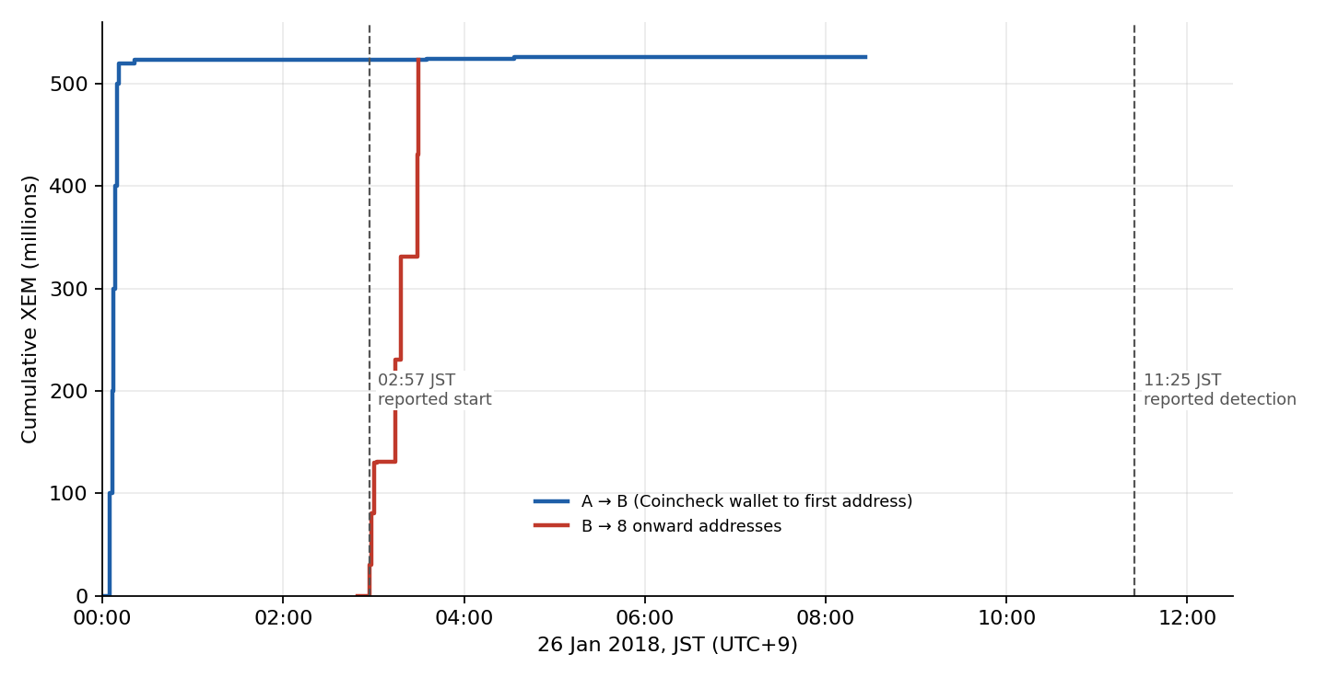
Figure 1. Cumulative XEM moved, against the times Coincheck reported.
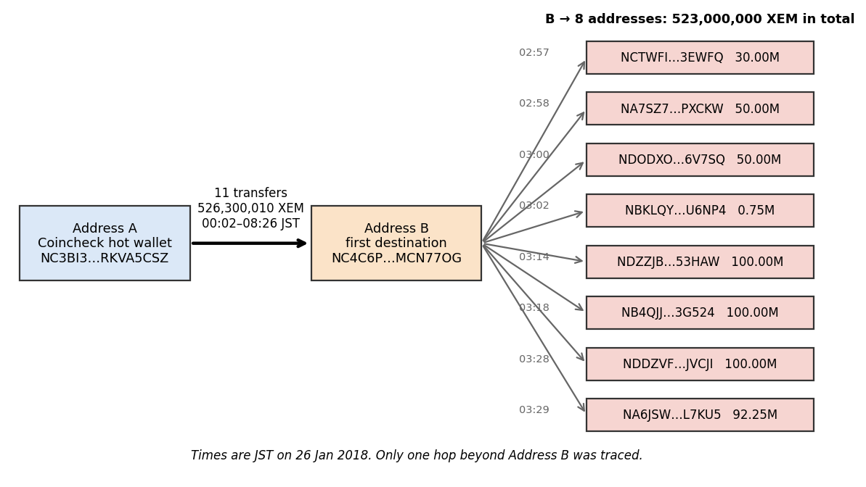
Figure 2. Flow of funds from Address A to Address B to eight addresses.

7.4 Discrepancy DISC-001: how much was stolen
Coincheck said about 523 million XEM was taken. The blockchain shows 526,300,010 XEM moving from A to B. The first eight transfers add up to 523,000,010 XEM (523,000,000 plus the 10 XEM test), and B then sent on exactly 523,000,000. The last three transfers add up to exactly 3,300,000, which is the gap.
Interpretation. Coincheck’s figure matches the first eight transfers. The last three (3.3 million XEM) are not reflected in it, even though all three were completed hours before the 11:25 detection, so this is not a matter of activity after detection. I do not know why, and I do not claim anything was left out on purpose. Rounding or a different counting basis are possible, but the sources I collected do not say. Confidence: Interpretation. The arithmetic itself is Confirmed.

7.5 Discrepancy DISC-002: when it started
Coincheck’s COO gave the start of the unauthorised transfers as about 3 a.m. (02:57). The first transfer out of Address A is at 00:02:13, nearly three hours earlier, and 523 million XEM had already reached Address B by 00:21. The first onward transfer from B is at 02:57:24.
Interpretation. The time Coincheck gave matches, to the minute, the start of the onward transfers from Address B, not the first transfer out of its own wallet. My reading is that the company’s figure describes when the coins began to be spread out. If that is right, the true detection gap is about 11 hours 23 minutes and not 8.5. Other explanations I cannot exclude: the company’s time was approximate, or came from internal logs I have not seen. Confidence: Interpretation.

7.6 Malware and tool review
I found no public malware sample, indicator report or tool analysis for this incident, so there is nothing to review. One published case study (ScienceDirect, Section 12) says a company terminal was infected with malware that was used to steal the private keys. I could not trace that to a primary source, so I treat it as reported, not confirmed. I have not repeated other unsourced claims about specific malware.
Common tools for this kind of work include Wireshark, Volatility, Autopsy, OSINT Framework, Blockchair and Maltego CE. I did not use Wireshark, Volatility or Autopsy because they need packet captures, memory dumps or disk images, and none is public for this incident. As far as I could find, Blockchair and Blockchain.com do not cover NEM’s NIS1 chain, so I queried a NIS1 node directly. I did not use Maltego CE; I drew the fund-flow diagram from the transaction data instead (Figure 2). Public news and blockchain records were my open-source sources.

7.7 Logs and data quality
No Coincheck logs, disk images, memory dumps or network captures are public. The blockchain is the only log I could examine. I checked my data for problems and found these:
- The first collector script used the wrong epoch (6 min 25 s early) and labelled every row’s “source” with the address I queried, not the actual sender. It also added incoming and outgoing amounts together in its printed total. The reprocessing script fixes all three.
- 138 of the 4,350 records are multisignature-wrapped transactions (type 4100) and 39 carry mosaics. The first script read the wrapped ones as zero XEM. None of the 11 A to B transfers or the 8 onward transfers is affected, because all of them are plain XEM transfers.
- The current account records (EVD-015, 016) show balances of 19,318.995 XEM for A and 0.001 XEM for B. They describe today, not 2018.
- I used a single node. A second node should be used to confirm the key transactions.

7.8 After the theft
The NEM Foundation said on 28 January that it had a full account of the stolen XEM and that the hacker had not moved any of it to an exchange or to community members’ accounts (CryptoNinjas). That fits my data, because by then the coins had only been split across the eight addresses. Later reporting says the Foundation switched off its tagging system in March 2018 and that the coins were later laundered. I have not verified those later claims and I treat them as secondary (Cointelegraph and the ScienceDirect paper listed in Section 12).

8. Response and regulatory action
After it detected the loss, Coincheck froze deposits and withdrawals for everything except Bitcoin and, within about two days, pledged to refund affected customers from its own funds (BBC). The NEM Foundation moved quickly to track the coins and announced a tagging system (CryptoNinjas). On 30 January Deputy Prime Minister Taro Aso said, in answer to a reporter, that the FSA had issued a business improvement order requiring Coincheck to look into the causes of the incident, take steps to prevent a repeat and protect its customers (EVD-002). He added that the FSA had asked other virtual currency dealers to check their own systems and might carry out on-site inspections. The FSA’s own published transcript therefore confirms that the order was issued. The date of 29 January follows from the reporter’s reference to “yesterday” and matches press reports from that day (Japan Times, FinanceFeeds). The transcript is a provisional translation. It does not list the specific control failures or say how the attacker gained access, so I have not attributed either to it.

9. Summary of findings
Finding | Type | Confidence
526,300,010 XEM moved from A to B in 11 transfers, starting 00:02:13 JST | Fact (blockchain) | Confirmed
B sent exactly 523,000,000 XEM to eight addresses between 02:57:24 and 03:29:54 | Fact (blockchain) | Confirmed
All 11 transfers were single-signer transfers from Address A | Fact (blockchain) | Confirmed
XEM was held in a hot wallet, and the president cited technical difficulties and staff shortage | Company statement | Strongly supported
About 260,000 customers affected; refund of more than 46bn yen pledged | Company statement | Strongly supported
FSA issued a business improvement order | Government record | Confirmed
Coincheck’s 523M figure matches the first eight transfers; why the last three are not reflected is unknown | My interpretation | Interpretation
Coincheck’s stated start time matches the onward transfers, not the first transfer | My interpretation | Interpretation
How the attacker got access; who they were; customer data exposure; where the coins went after the eight addresses | Not established | Unknown

10. Recommendations
The full recommendations, split into immediate actions and long-term measures, are in the Mitigation Plan. The three that would have changed this outcome most are: requiring several approvals before funds can leave a wallet, keeping most funds offline, and alerting within minutes when large amounts leave.

11. Limitations
- This is a reconstruction from public information. It is not a full digital forensic examination.
- I did not have Coincheck’s internal logs, endpoint images, memory dumps, network captures or any malware sample.
- Blockchain data came from one public node and one collection session. A cross-check script is included (EVD-027) but has not yet been run.
- Only one hop beyond Address B was traced, and only B’s large first-day transfers (500,000 XEM or more, before 26 January 00:00 UTC) were selected.
- The timestamp epoch (00:06:25 UTC) should be confirmed against NEM documentation or a second data source.
- Dollar and yen values in the sources differ because of timing and exchange rates.
- The FSA transcript (EVD-002) confirms that the business improvement order was issued but does not give its date or full terms. The date of 29 January rests on the reporter’s reference to “yesterday” and on news reports from that day (Japan Times, FinanceFeeds).
- My Reuters capture does not show the article’s date or byline, or the 11:25 detection time; that time comes from a secondary source (the ScienceDirect case study in Section 12).

12. Sources
- Reuters, Q&A on the Coincheck hack and the issue with crypto assets on centralised exchanges, January 2018 (screenshot EVD-001).
- BBC News, article on Coincheck’s refund pledge, bbc.com/news/world-asia-42850194 (EVD-004).
- CryptoNinjas, NEM Foundation response to the Coincheck theft, 28 January 2018, cryptoninjas.net/2018/01/28/nem-foundation-responds-534-million-xem-stolen-coincheck/ (EVD-003).
- Financial Services Agency of Japan, press conference by Deputy Prime Minister Taro Aso, 30 January 2018, fsa.go.jp/en/conference/minister/2018/20180130.html (EVD-002).
- NEM Foundation blog, statement on the Coincheck theft, blog.nem.io, 1 February 2018 (secondary reading).
- Cointelegraph, “Coincheck: NEM Foundation stops tracing stolen coins, hackers’ account at zero”, March 2018 (secondary).
- “How cryptocurrency is laundered: case study of Coincheck hacking incident”, ScienceDirect, article S2665910721000724 (secondary; source of the 11:25 detection time).
- The Japan Times, “Financial watchdog raps Coincheck over lax security following massive hack”, 29 January 2018 (secondary, for the date of the FSA order).
- FinanceFeeds, article on the FSA business improvement order to Coincheck, 29 January 2018 (secondary).
- NIS1 node data collected 28 September 2026 (EVD-011, 012), processed with the scripts in EVD-020 to 022.

