Forensic Evidence Portfolio
Coincheck NEM theft, 26 January 2018
Prepared by: Kshitij Randhire
Project: Cryptocurrency Exchange Hack Investigation (independent research project)

1. About this portfolio
This portfolio holds the evidence behind the incident report: the register of every item, the screenshots, the transaction data, the figures and the scripts. The files themselves are in the accompanying folder, 6_Evidence_Files/. Evidence IDs match those used in the report.
I collected the blockchain data on 28 September 2026 from a public NIS1 node and saved it as raw JSON. I then calculated a SHA-256 hash for each file, so anyone can check later that a file has not changed. The article and government screenshots were captured on the same day. All times below are JST (UTC+9) unless marked UTC, using the corrected NEM epoch described in the report.

2. Evidence register
ID | Item | File | Confidence
EVD-001 | Reuters Q&A on the Coincheck hack (screenshot). COO and President statements: hot wallet, ~523M XEM, ~3 a.m., noticed 8+ hours later. | screenshots/news_source1.png | Strongly supported
EVD-002 | FSA press conference excerpt, 30 Jan 2018, Deputy PM Taro Aso (provisional translation). | screenshots/fsa_notice.png | Confirmed (government record)
EVD-003 | CryptoNinjas article carrying the NEM Foundation statement of 28 Jan 2018. | screenshots/nem_foundation_response.png | Strongly supported
EVD-004 | BBC News article on Coincheck's refund pledge. | screenshots/reimbursement_announcement.png | Strongly supported
EVD-011 | Raw transfer records for Address A (Coincheck hot wallet), 4,100 records. | raw/addressA_raw.json | Confirmed
EVD-012 | Raw transfer records for Address B (first destination), 250 records. | raw/addressB_raw.json | Confirmed
EVD-013 | First-pass combined table of A and B transfers (4,350 rows). | data/transactions.csv | Superseded
EVD-014 | First-pass table of the 11 A to B transfers. | data/theft_transactions.csv | Superseded
EVD-015 | Screenshot of the live account record for Address A (balance, no co-signatories). | screenshots/explorer_addressA.png | Confirmed (current state only)
EVD-016 | Screenshot of the live account record for Address B (balance 0.001 XEM). | screenshots/explorer_addressB.png | Confirmed (current state only)
EVD-017 | Re-processed table of all 4,350 records: corrected epoch, direction, multisig unwrapped, mosaic flag. | data/transactions_corrected.csv | Confirmed
EVD-018 | The 11 transfers from A to B (526,300,010 XEM). | data/theft_transactions_corrected.csv | Confirmed
EVD-019 | The 8 onward transfers from B (523,000,000 XEM). | data/hop2_sweeps.csv | Confirmed
EVD-020 | Collector script used on 28 Sep 2026 (as run, unchanged). | scripts/coincheck_collector.py | n/a
EVD-021 | Processing script with the fixes. | scripts/process_raw.py | n/a
EVD-022 | Script that finds the A to B and B onward transfers. | scripts/find_theft_and_sweeps.py | n/a
EVD-023 | Figure 1: cumulative XEM moved, A to B and B onward, against reported times. | figures/fig1_cumulative_movement.png | Analysis
EVD-024 | Figure 2: flow of funds from A to B to eight addresses. | figures/fig2_fund_flow.png | Analysis
EVD-025 | Reproducibility notes: steps, expected output, method notes and limitations. | REPRODUCIBILITY.md | n/a
EVD-026 | Chain of custody: source, method, collector, date, storage and transformations for each item. | CHAIN_OF_CUSTODY.csv | n/a
EVD-027 | Script that cross-checks the 19 key transactions against a second NIS1 source (not yet run on a second node). | scripts/crosscheck_second_node.py | n/a
EVD-028 | Finding-to-evidence matrix: each finding with its evidence IDs and processing step. | FINDINGS_MATRIX.csv | n/a
Table 1. Evidence register. Two first-pass files (EVD-013, 014) are kept for the record and are superseded by EVD-017 and 018.

SHA-256 hashes
ID | SHA-256
EVD-001 | ec0127f24353ecc96db56eeccf19c81ba8c4f0a25c924e049fd4a2ac061388ef
EVD-002 | ad4267a630331be3bcc07107c6b52a835b4df64a8e5c645e63f8e539a360a787
EVD-003 | 8ade9cd8038f21621ff0414ab7b25ddc39ee25eacfd8fe30daa0fb2d8f901aed
EVD-004 | e7ea2d0ac0480fff7f40ba92324c0a60d145621acca7c3dd2983559cc64c2f1c
EVD-011 | 662d1bc39d48f14ec6da63365c3868d1efba88c423d4bef94d7eb403ea853344
EVD-012 | 9a6c67bbda4f1081448722daf88433f141ea26c958aea13a8c80ab90e1641831
EVD-013 | e862fdc910a231da090f9fffca99cc734ef6d56f91778fec896d7863ae016d69
EVD-014 | 47dab81a3a6d70d067dd2b651c0646ad3b723743cd59bb3974de4ba9c810d32f
EVD-015 | 336586b3ed110cd67d51599429df3f23f57be8b84b4a5c0f696a7a179b83424b
EVD-016 | 5aeefaffab0a21c817594a935fac306e2935e7b7372a031b48c188b01aaa1320
EVD-017 | d6429cb5033390848fe254b926b7c3689b002a1636e30c6aaf396daf184a2936
EVD-018 | bc65946bee862dddf2d656e9817a24741227b79b427295883e5d25b3952965c3
EVD-019 | d8a1d52bbf3adb994110a1d78f3fc892565c56ae8992b9cbdc16aa6894f53798
EVD-020 | 3f11fcd3e51521aab107a8d1ba86d856674a26324d7a6369714402102cb1d098
EVD-021 | 8999f87d22d68ec644e5b204214a061efe8f63df538b13f965e87746f9dd7bff
EVD-022 | 21d34ad714857935025a09c5e9af1670141bd2b3b88c3705cc651707949d3c29
EVD-023 | f7deb82db49bf2a9dea1db73bdf568509dbfa7979e41979965464d8fe50409a3
EVD-024 | 8f115c5d5fc80cf03b018537a9c2cef75604e03217ba6bfcc0eb67cd97fc4235
EVD-025 | 529082d19afae4d022138391d3063a4740db90942dabeba8badede03265972d1
EVD-026 | 00436ac8c1bda74c546e8c68b9c5fd56d4612681165a8f3586b5d7c89f6cf919
EVD-027 | 3b0ac347e0e91bb295c10bf7747b114df6432e0f48c9c91123cf9958654e9037
EVD-028 | 10ebff9d9fb3bb0750a125d7a90926c47ea644af82cd159b331cfd34d863aec8
Table 2. Full SHA-256 values. The same list is in EVIDENCE_REGISTER.csv.

3. Screenshots
Each screenshot below is listed in the register with its hash. The article screenshots do not all show the publication date, so the URL and source are recorded in the register.
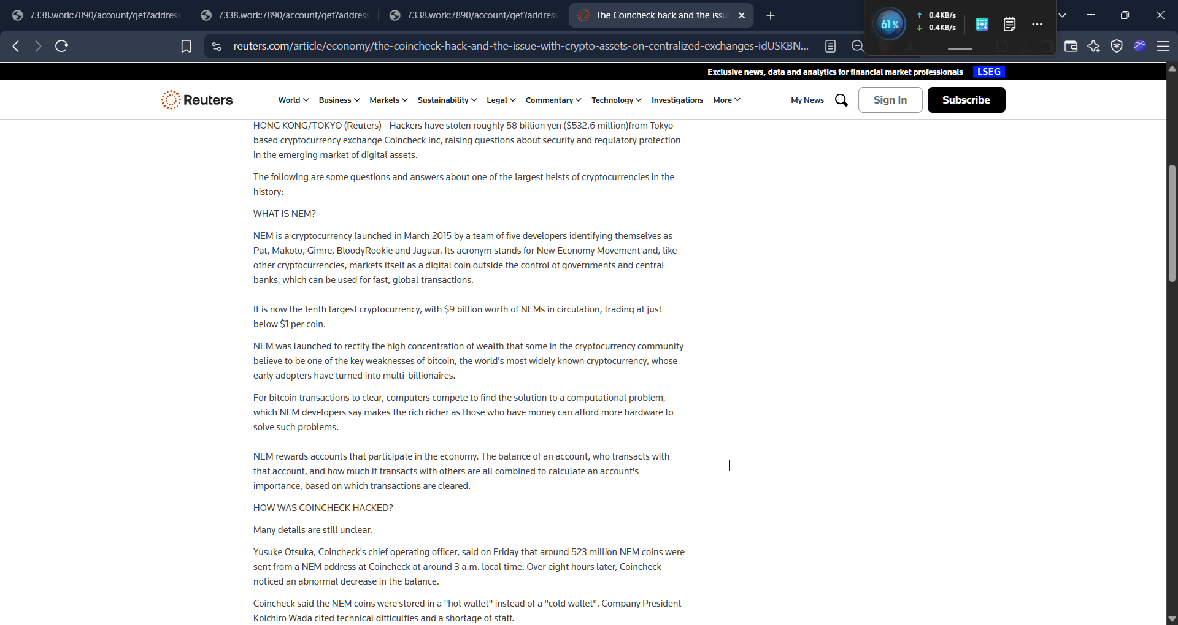
EVD-001. Reuters Q&A. Shows the COO saying about 523 million NEM coins were sent from a Coincheck address at around 3 a.m. and that Coincheck noticed over eight hours later, that the coins were in a hot wallet, and the president citing technical difficulties and a shortage of staff.
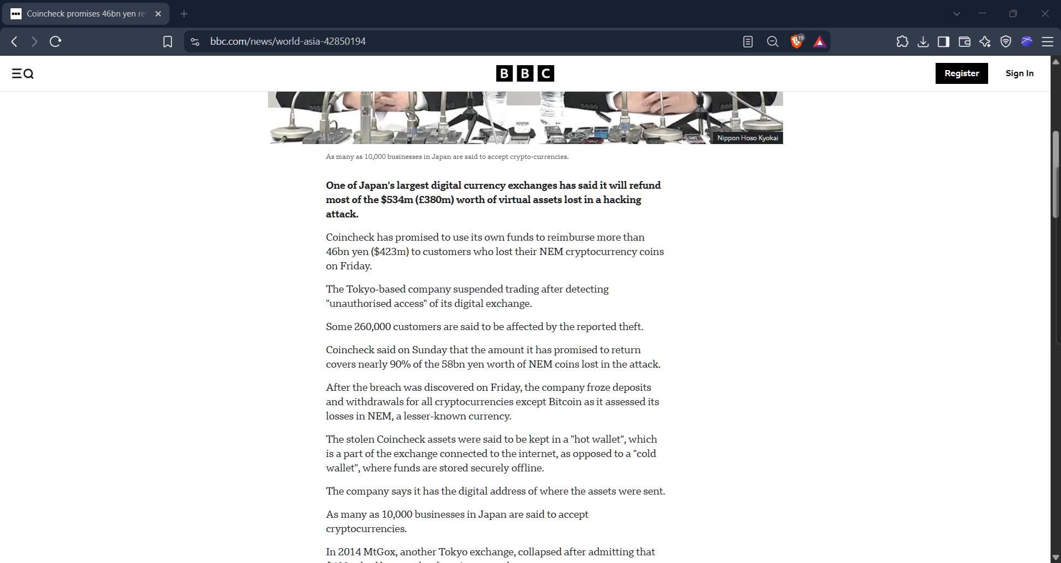
EVD-004. BBC News. Shows the $534 million figure, the more than 46bn yen refund pledge, about 260,000 affected customers, the freeze on all cryptocurrencies except Bitcoin, and the hot wallet description.
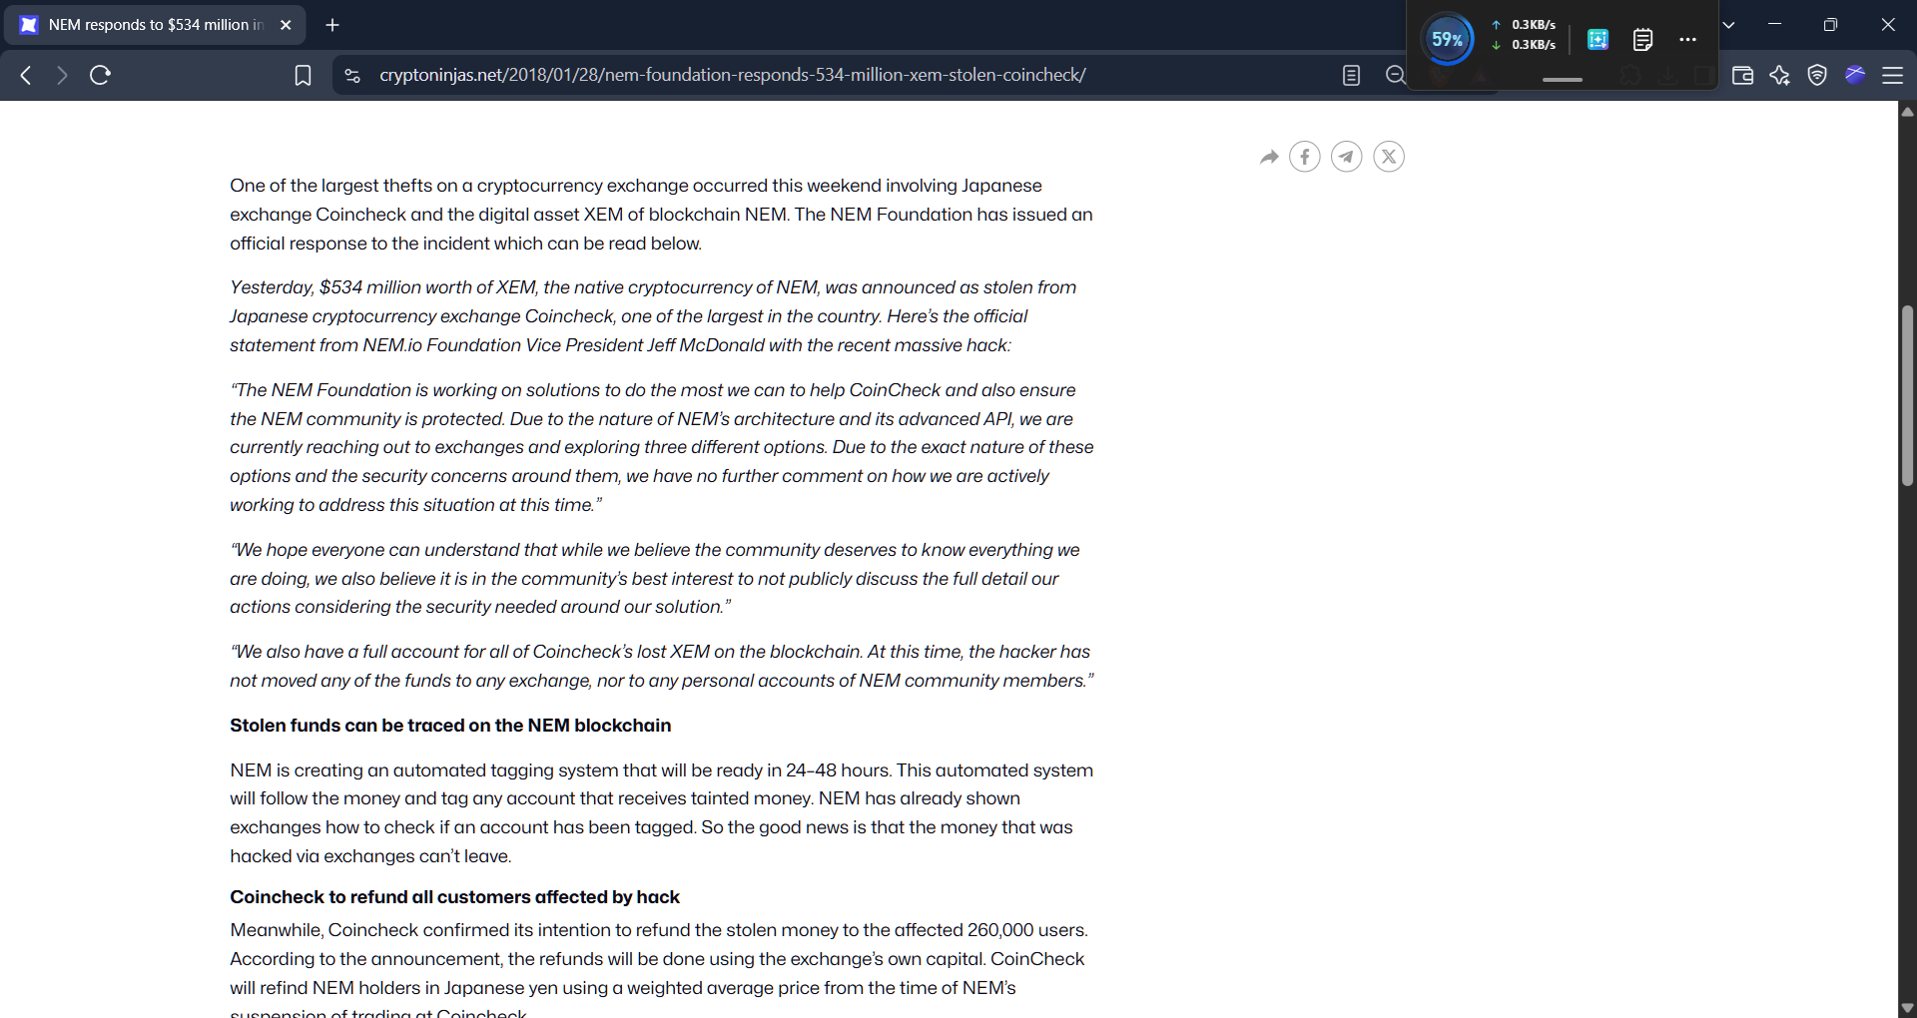
EVD-003. CryptoNinjas, 28 January 2018. Carries the NEM Foundation vice president’s statement about having a full account of the stolen XEM, and the plan for an automated tagging system.
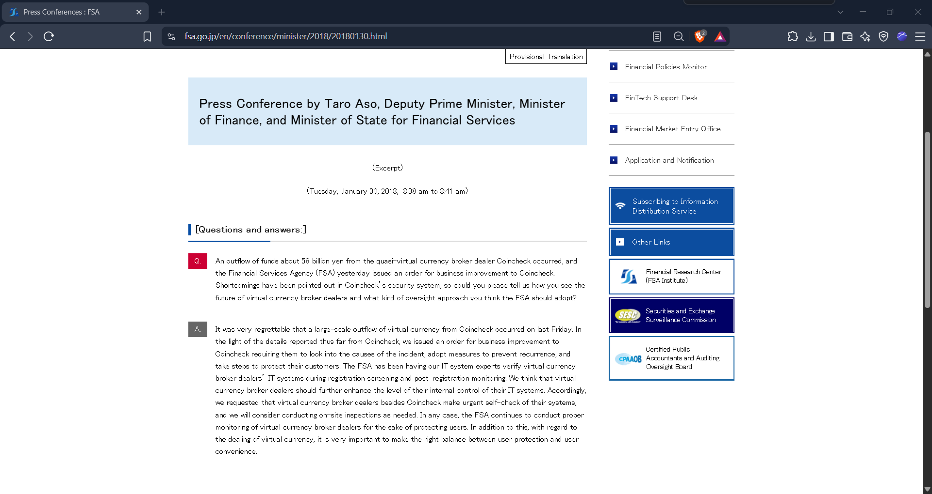
EVD-002. FSA press conference, 30 January 2018. Shows the reporter’s question and Deputy Prime Minister Aso’s answer about the business improvement order. It is marked as a provisional translation.
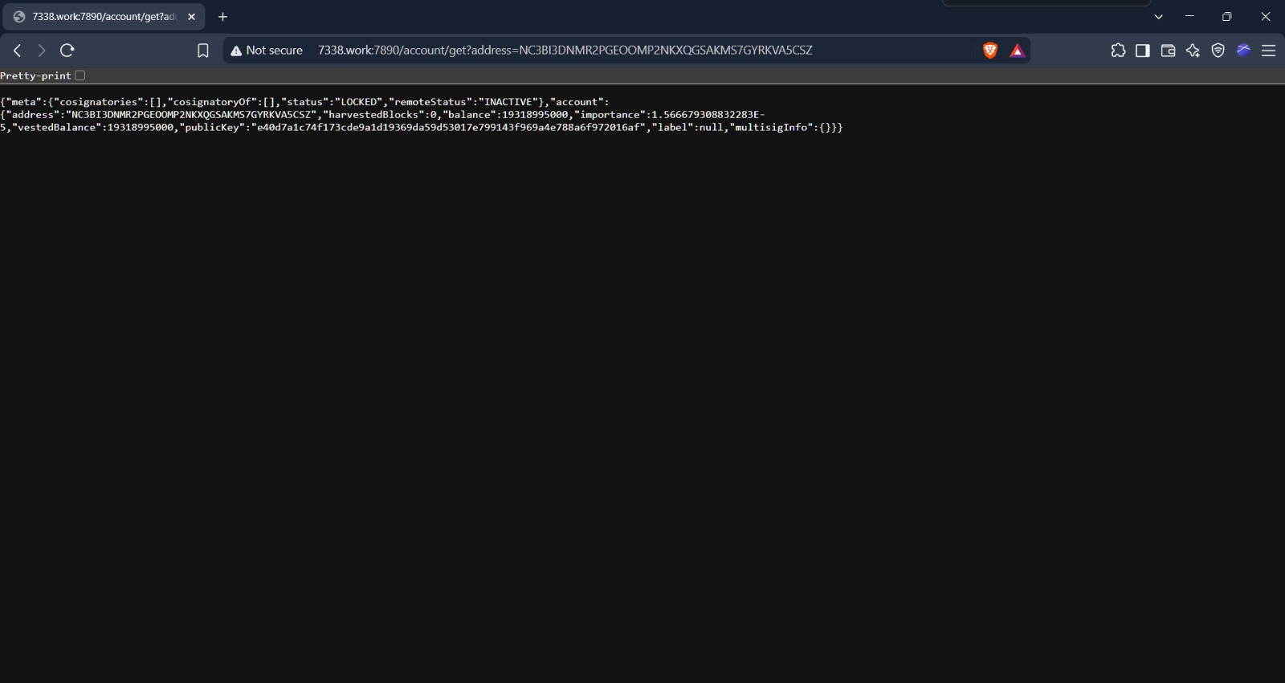
EVD-015. Address A account record (captured 28 September 2026). Balance 19,318.995 XEM, no co-signatories and no multisig information. This is the current state only.
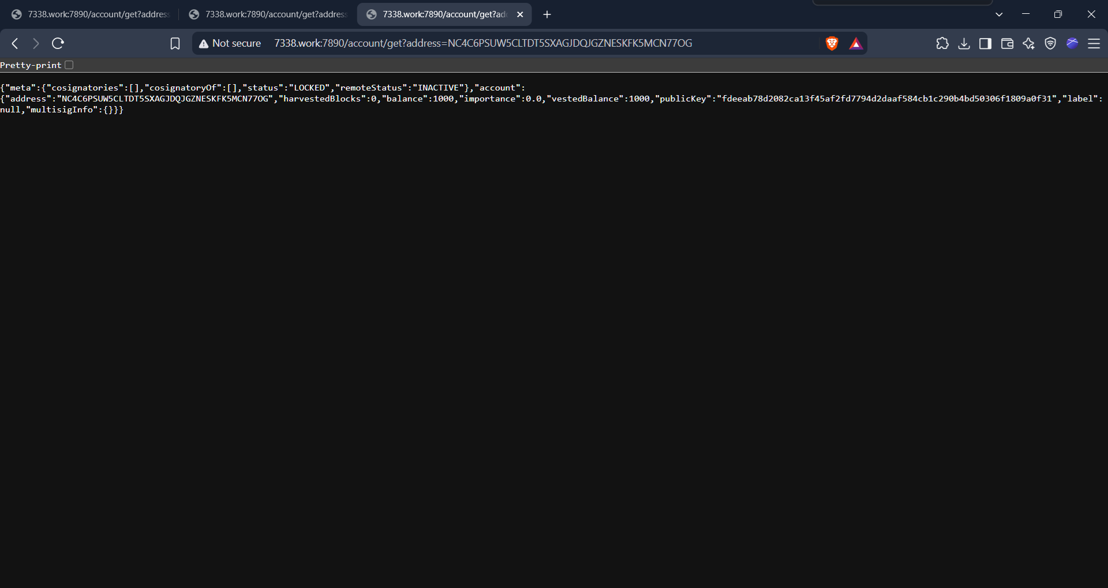
EVD-016. Address B account record (captured 28 September 2026). Balance 0.001 XEM, no co-signatories. This is the current state only.

4. Transaction data

4.1 Transfers from Address A to Address B
# | UTC | JST | Block | XEM | Transaction hash
1 | 2018-01-25 15:02:13 | 2018-01-26 00:02:13 | 1475043 | 10 | 95c508af56b5b3cf40bd01bdeb72e9d316a90b60611e0f1c03860b7e6e5f1494
2 | 2018-01-25 15:04:56 | 2018-01-26 00:04:56 | 1475044 | 100,000,000 | c2921d538a6192bf35e0bb49cefcf6aa8e19acb3fef08f70f5b6b977d9d50aee
3 | 2018-01-25 15:06:46 | 2018-01-26 00:06:46 | 1475045 | 100,000,000 | 913fb7766fe10b7ca0955f1806772b167d92cd4b1495e9f315f194f3589a8660
4 | 2018-01-25 15:07:04 | 2018-01-26 00:07:04 | 1475045 | 100,000,000 | 94cb4ac7c0a45a9678abf8ca087e087c2a813c1b1c2db2dfb12a37387a0c27aa
5 | 2018-01-25 15:08:21 | 2018-01-26 00:08:21 | 1475046 | 100,000,000 | 1a4075a308bc965d1b8a3dc62109f70c52f59036f5bde6e80799067536d1404d
6 | 2018-01-25 15:09:22 | 2018-01-26 00:09:22 | 1475047 | 100,000,000 | f05bc90416ba4a435120cff3cef5bbba2c832c48a437ddbfb6dee6d78528cc56
7 | 2018-01-25 15:10:36 | 2018-01-26 00:10:36 | 1475048 | 20,000,000 | 282fbe0ca9aca9540adc2a1950144fca8e890c2bffac7e989a9450b2f8292021
8 | 2018-01-25 15:21:14 | 2018-01-26 00:21:14 | 1475058 | 3,000,000 | 3c7c835a1d8df946536bb3c0dd23c10c3b02a22220bac3fe3f9b871d26be5424
9 | 2018-01-25 18:35:09 | 2018-01-26 03:35:09 | 1475257 | 1,500,000 | f37bf19fb5533e7bb86696906bf0dde08707cd2a3cb888f518f9cc5019e1163d
10 | 2018-01-25 19:33:20 | 2018-01-26 04:33:20 | 1475309 | 1,000,000 | b74df48a67f93a7224d9b34645c409ee859b9b220551a06c0b68a9fab8e2a38e
11 | 2018-01-25 23:26:13 | 2018-01-26 08:26:13 | 1475553 | 800,000 | 2705bbd6b00b0d2d3c1c69d254b0fc2e7af71e1ba353a24fcd736a69a00f585e
Table 3. The 11 transfers, 526,300,010 XEM in total (EVD-018). The first eight add up to 523,000,010 and the last three to 3,300,000.

4.2 Transfers from Address B to eight addresses
# | JST | XEM | Recipient | Transaction hash
1 | 2018-01-26 02:57:24 | 30,000,000 | NCTWFIOOVITRZYSYIGQ3PEI3IMVB25KMED53EWFQ | 77b1a737756aa0bec76a109fbd712639869ed390d68c907cedc0f10258df7600
2 | 2018-01-26 02:58:42 | 50,000,000 | NA7SZ75KF6ZKK267TRKCJDJBWP5JKIC2HA5PXCKW | c088ad69ea7ef4f3895081e8c3b5495162e2083647a15364574bd3eeb1cba057
3 | 2018-01-26 03:00:33 | 50,000,000 | NDODXOWEIZGJSMAEURXACF4IEHC2CB7Q6T56V7SQ | 1efe1dd9cdb87fafcba2228a36f5dd3b5a29e456d85e49a22688234797be920a
4 | 2018-01-26 03:02:12 | 750,000 | NBKLQYXEIVEEGARYPUM62UJIFHA3Y6R4LAPU6NP4 | 73078db7610025490da5bda2c430b35c0c5dca74fd506895137257d5734f8672
5 | 2018-01-26 03:14:09 | 100,000,000 | NDZZJBH6JZPYSWRPRYHALLWMITWHOYTQGXR53HAW | 5d3da55670fb26339484612f2917d10f3f41eea19cafde981f03ceaf7299d43c
6 | 2018-01-26 03:18:07 | 100,000,000 | NB4QJJCLTZWVFWRFBKEMFOONOZFDH3V5IDK3G524 | 7d8693ea074a44aafac69ed05cd4bd23b6ad2177605c8f14ac8657e7931fa974
7 | 2018-01-26 03:28:44 | 100,000,000 | NDDZVF32WB3LWRNG3IVGHCOCAZWENCNRGEZJVCJI | bf46435b77bac25284e1c082acce28ca065ecd650476045650f18dbfc2d8eb23
8 | 2018-01-26 03:29:54 | 92,250,000 | NA6JSWNF24Y7DVIUVPKRNAY7TPOFJJ7G2URL7KU5 | c39cce21c937167b211c7eb104a98e66f1c496103a8f35caea30968bab233dc1
Table 4. The eight onward transfers, 523,000,000 XEM in total (EVD-019).

4.3 Figures
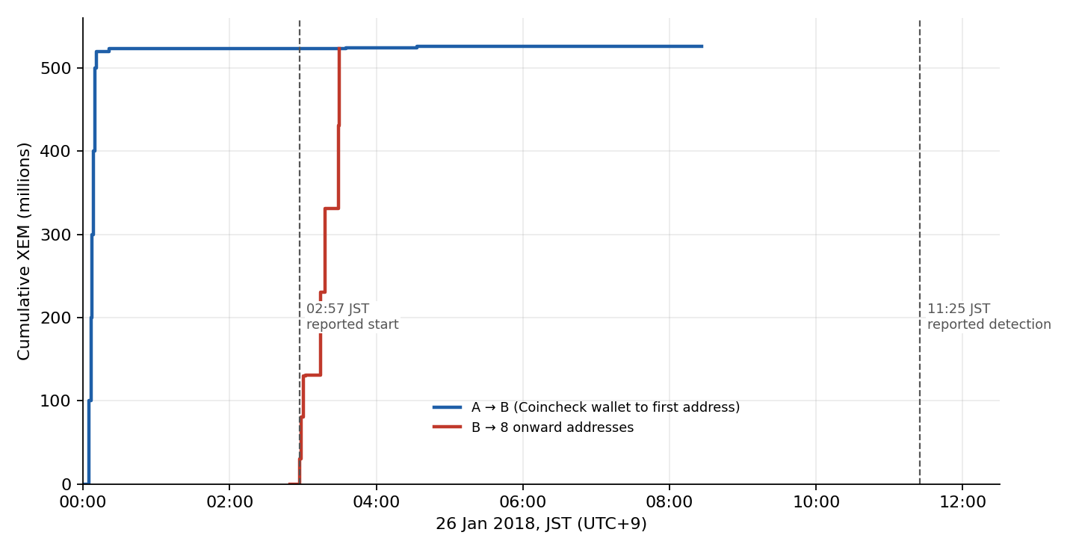
Figure 1. Cumulative XEM moved from A to B and from B onward, against the reported start and detection times (EVD-023).
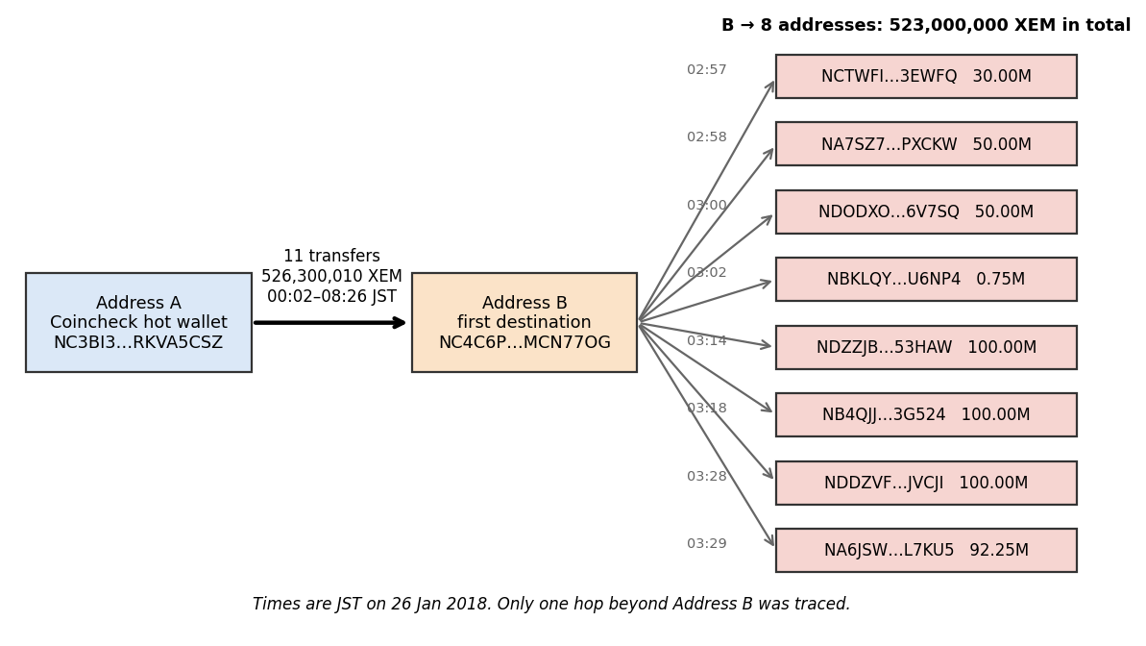
Figure 2. Flow of funds from Address A to B to eight addresses (EVD-024).

5. Reproducing the analysis
- Run scripts/coincheck_collector.py to download the raw records from a NIS1 node, or use the saved raw/addressA_raw.json and raw/addressB_raw.json.
- Run python scripts/process_raw.py to build data/transactions_corrected.csv.
- Run python scripts/find_theft_and_sweeps.py to list the A to B transfers and B’s onward transfers. The expected output is 11 transfers (526,300,010 XEM) and 8 onward transfers (523,000,000 XEM).
- Optional: run python scripts/crosscheck_second_node.py --node <second NIS1 node URL> to compare the 19 key transactions with another node. This has not yet been run.

6. Data quality notes
- The first collector script used an epoch of 00:00:00 UTC, so its times are 6 minutes 25 seconds early. process_raw.py uses 00:06:25 UTC.
- 138 of 4,350 records are multisignature-wrapped and 39 carry mosaics. None of the transfers used in the report is one of them.
- The current balances in the two account screenshots describe the present, not 2018.
- Data came from a single node and should be cross-checked against a second node. scripts/crosscheck_second_node.py (EVD-027) is ready for this check; it has not yet been run.
- The eight onward transfers (EVD-019) were selected as plain transfers of 500,000 XEM or more from B before 26 January 00:00 UTC. B also made 37 smaller later transfers totalling about 3.3 million XEM, which are not traced.

7. Chain of custody
CHAIN_OF_CUSTODY.csv, in the evidence folder, records for every item where it came from, how it was acquired, who collected it, when, where it is stored and what was done to it afterwards. Table 5 summarises it. Kshitij Randhire, the author, collected every acquired item. Derived files were produced by the scripts named in the table.
Items | Source or endpoint | How acquired | Collected | Transformation
EVD-001 to 004 | News and government pages (URLs in the register) | Browser screenshot taken manually | 28 Sep 2026 | None recorded
EVD-011, 012 | NIS1 node 7338.work:7890, /account/transfers/all, 100 records per page | scripts/coincheck_collector.py (EVD-020) | 28 Sep 2026 | Saved by the script as formatted JSON; values unchanged
EVD-015, 016 | 7338.work:7890/account/get?address=… for A and B (URL visible in the screenshot) | Browser screenshot taken manually | 28 Sep 2026 | None recorded; current state only
EVD-013, 014 | Derived from EVD-011, 012 | First-pass processing | Not recorded | Epoch error (6 min 25 s early); superseded
EVD-017 to 019 | Derived from EVD-011, 012 | scripts/process_raw.py, then scripts/find_theft_and_sweeps.py | Not recorded | Corrected epoch, direction, multisig unwrap, mosaic flag; then filters
EVD-023, 024 | Derived from EVD-018, 019 | Figures | Not recorded | None
EVD-020 to 022, 025 to 028 | Written for this project | Authored | Not recorded (EVD-020 run on 28 Sep 2026) | EVD-025 edited before publication; its hash is for the published version
Table 5. Chain of custody summary.
Not recorded: the time of day of each collection and the exact command line used. They are marked as not recorded in CHAIN_OF_CUSTODY.csv instead of being reconstructed from memory. For any later collection, record the UTC time, the full command and the node address at the moment of collection.

8. Finding-to-evidence matrix
Each major conclusion is mapped to its evidence IDs and the processing step behind it, so a reader can verify it without searching the five deliverables. FINDINGS_MATRIX.csv holds the same table with a column saying how to verify each finding.
ID | Finding | Report | Evidence | Processing step | Confidence
F-01 | 526,300,010 XEM moved from A to B in 11 transfers, the first at 00:02:13 JST | 7.2 | EVD-011, 017, 018 | collector, process_raw.py, find_theft_and_sweeps.py | Confirmed
F-02 | B sent exactly 523,000,000 XEM to eight addresses, 02:57:24 to 03:29:54 JST | 7.3 | EVD-012, 017, 019 | find_theft_and_sweeps.py (first sweep filter) | Confirmed
F-03 | All 11 transfers were single-signer plain transfers (type 257) | 5, 7.2 | EVD-011, 017, 018 | process_raw.py (type, multisig unwrap) | Confirmed for the transfers
F-04 | XEM in a hot wallet; president cited technical difficulties and staff shortage | 5 | EVD-001, 004 | None (source statements) | Strongly supported
F-05 | About 260,000 customers affected; more than 46bn yen refund pledged | 6 | EVD-004 | None (source statement) | Strongly supported
F-06 | FSA issued a business improvement order (29 Jan date inferred) | 8 | EVD-002 | None (source statement) | Confirmed (order); date inferred
F-07 | DISC-001: Coincheck's ~523M matches the first eight transfers; last three (3,300,000 XEM) not reflected | 7.4 | EVD-001, 018 | find_theft_and_sweeps.py (first 8 and last 3 sums) | Arithmetic Confirmed; explanation Interpretation
F-08 | DISC-002: reported ~02:57 start matches the first onward transfer from B, not the first from A | 7.5 | EVD-001, 018, 019 | process_raw.py (corrected epoch), then time comparison | Interpretation
F-09 | Detection gap about 8 h 28 min from the stated start, about 11 h 23 min from the first transfer | 3, 5 | EVD-001, 018 and a secondary source for 11:25 | Time arithmetic on corrected JST times | Confirmed (chain times); strongly supported (11:25)
F-10 | First collector used the wrong epoch, times 6 min 25 s early; corrected | 1, 7.7 | EVD-013, 014, 017, 018, 020, 021 | process_raw.py | Confirmed
F-11 | Not established: access method, attacker, customer data exposure, onward flow of funds | 4, 6.2, 9 | None | None | Unknown
Table 6. Finding-to-evidence matrix.

