Alignment of My Profile, CV, Skill, My Disposition, About me, Qualification, Disposition text are not in correct way.

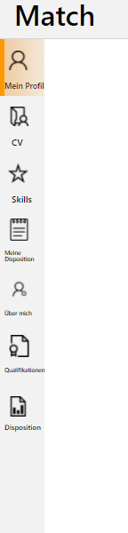

CV Tab – Display of screen is not fit while compere to windows and web applications.

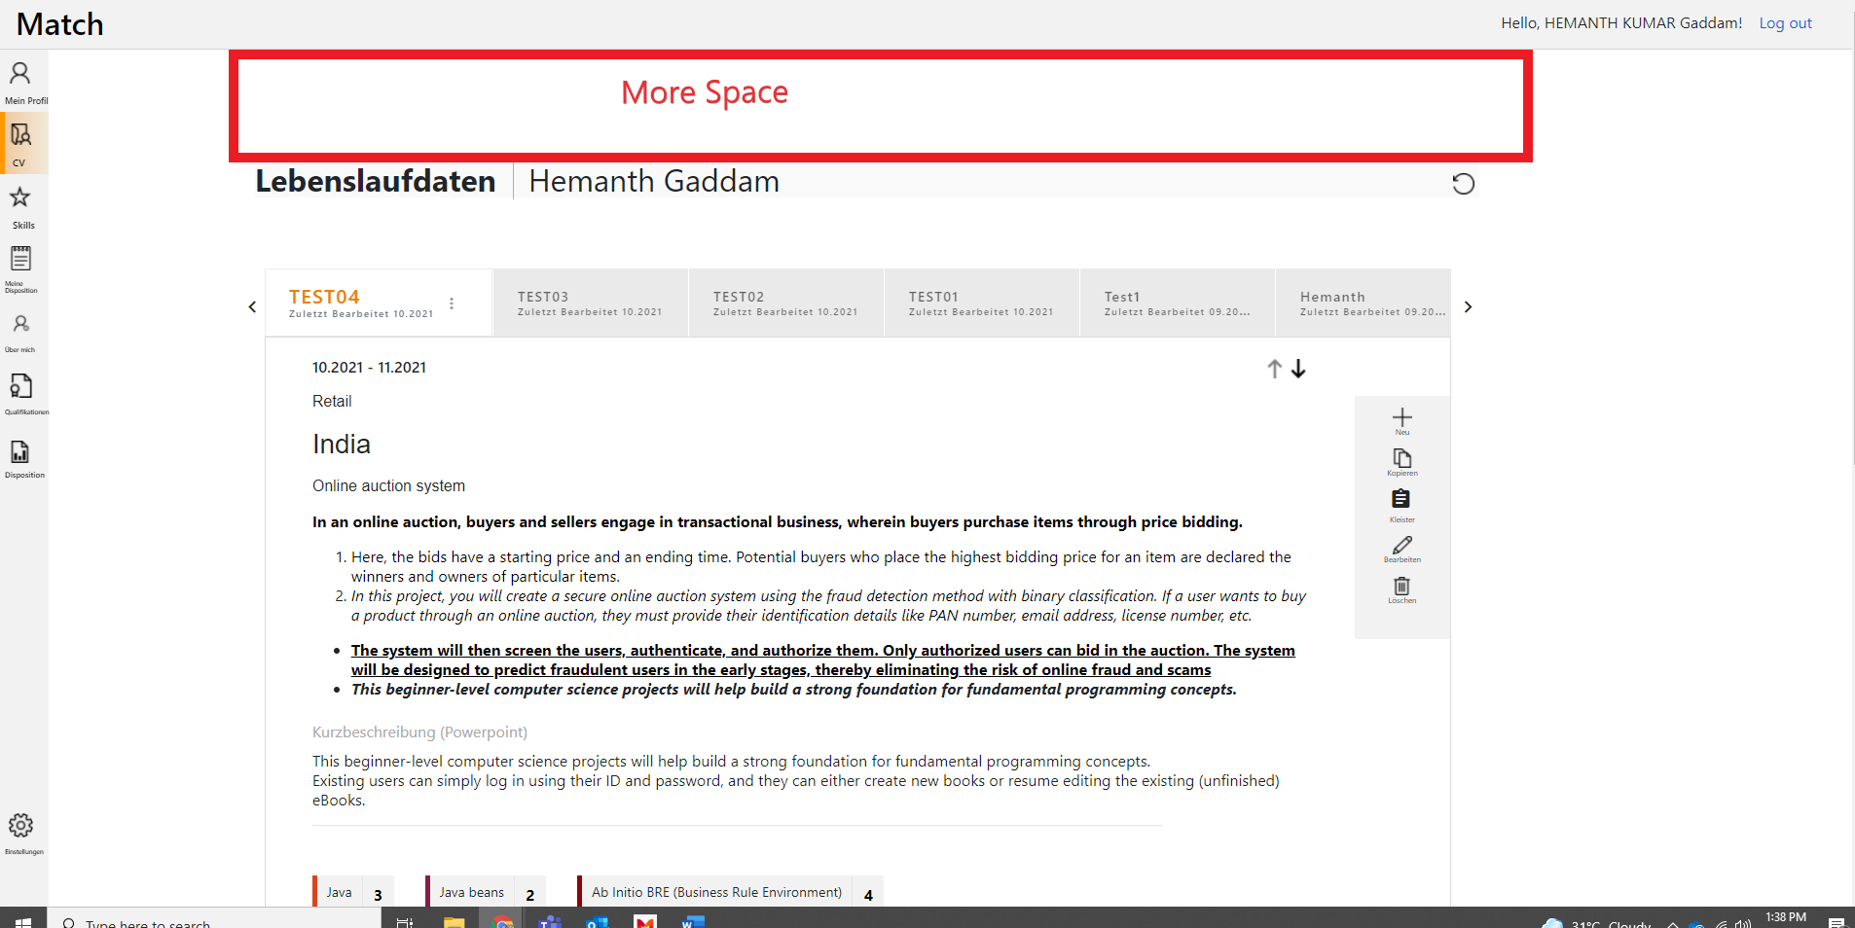

CV tab – Alignment is incorrect for Lebenslaufdaten | Hemanth Gaddam table and CV’s table.

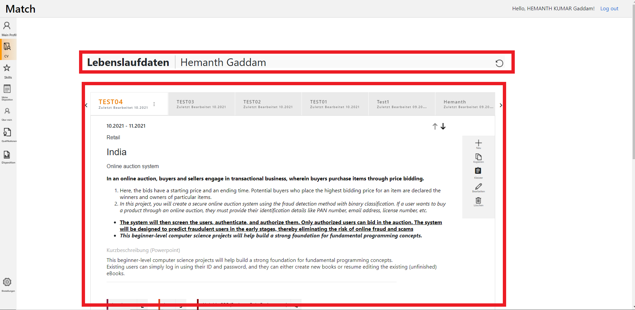

Skill Tab – If you enter DummySkill it will Show text “Tag not found click here to Add in the catalogue” is incorrect before “Add” should be contain a Space.

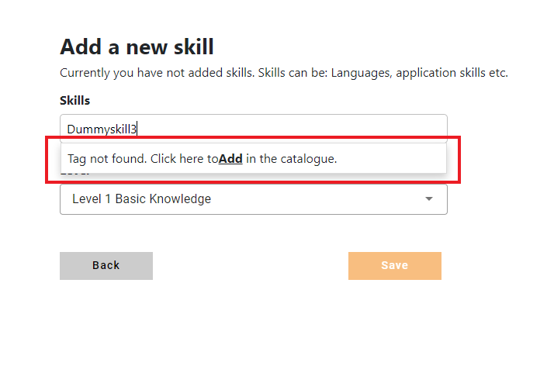My Disposition Tab -   icon display is incorrect as compare to windows application.

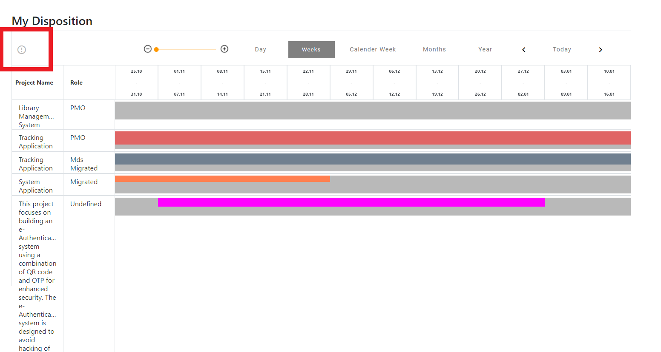

Disposition Tab – Click on Add Project then in the next page in between the titles and field box should be a space.

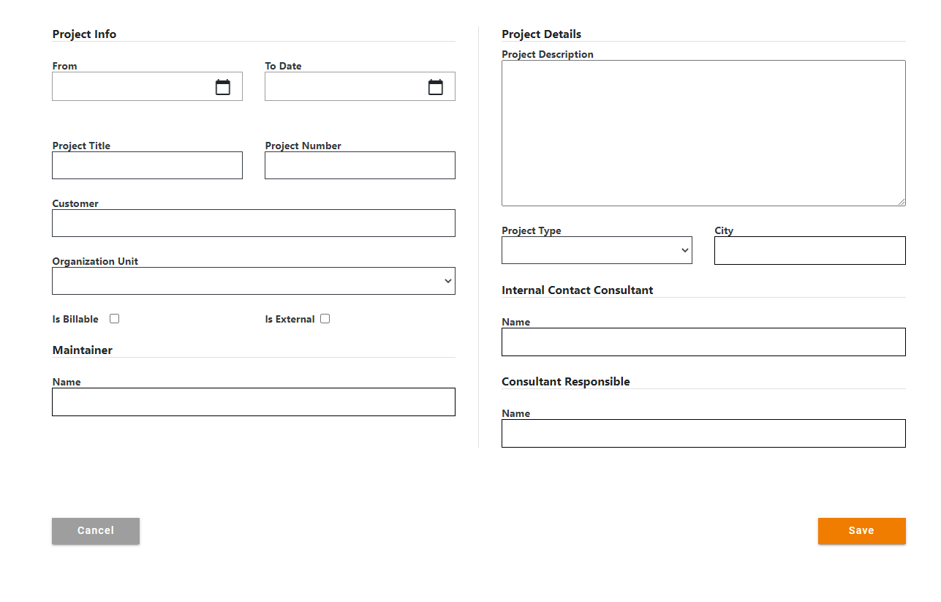

Disposition Tab – Click on Add project then fill the details then click on save button after that it will open new page in that click on Add position then pop-up screen will appears in that Delete icon and Save icon are alignment incorrect and different.

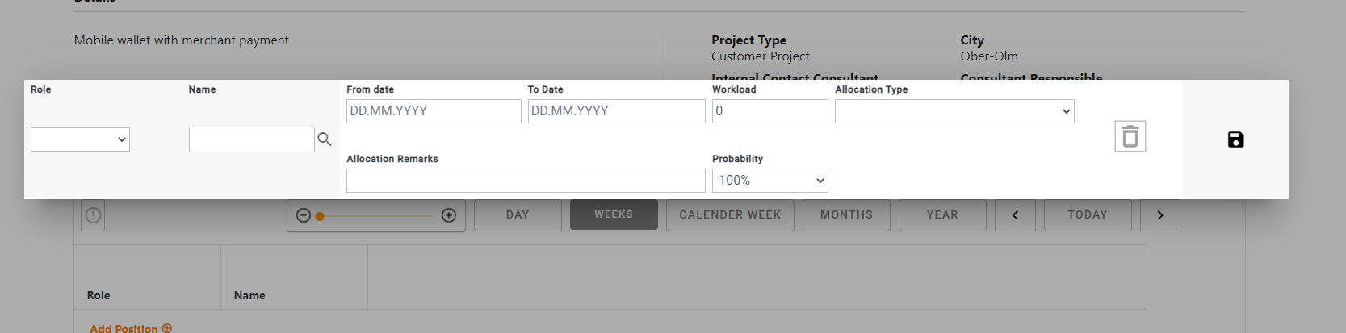

CV Tab – Skill Level field that levels are alignment is incorrect.

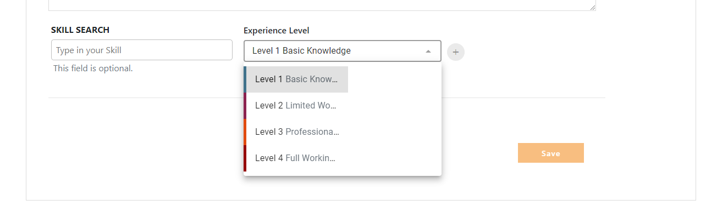

CV Tab – Skill Search is in capital letters.

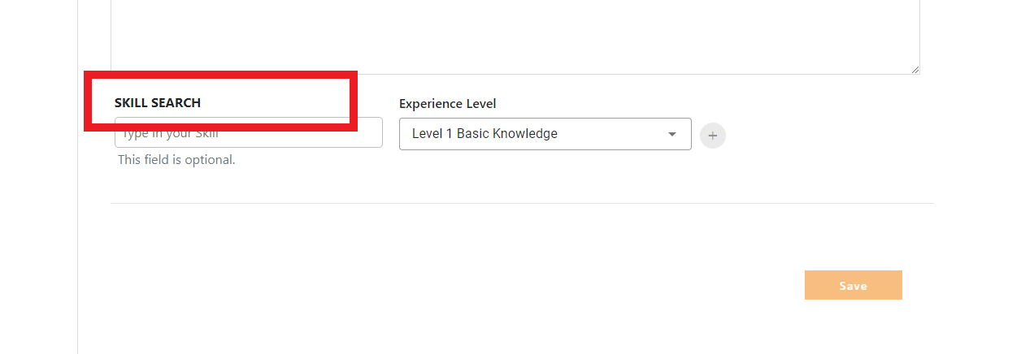

Settings tab – Buttons of English and Deutsch are alignment is incorrect.

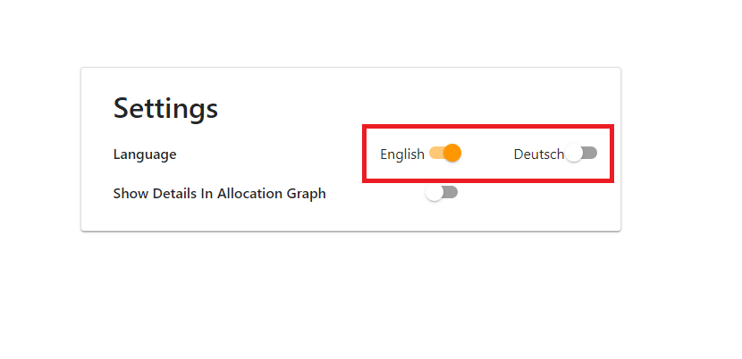

Disposition Tab – Click on Add Disposition to Project then Alignment of Projects.

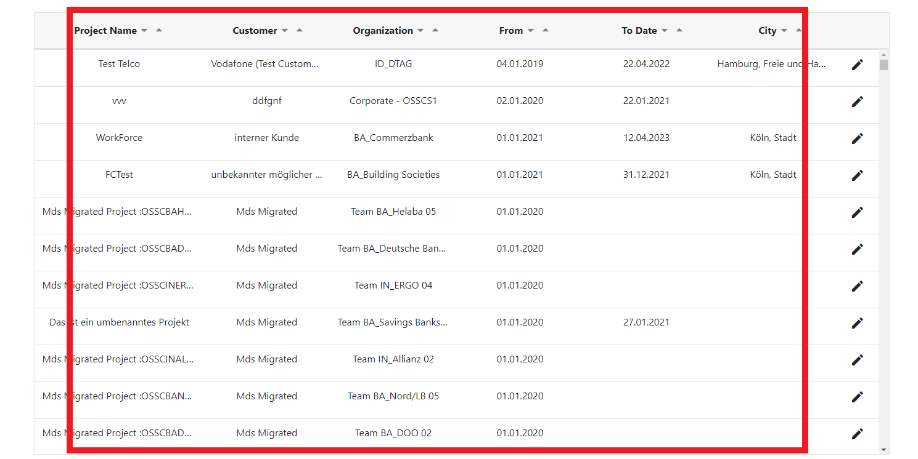

My Disposition Tab – “My Disposition” text and table between should be a Space

