Linux Server Precheck Usage

# Overview

This script automates the precheck process across multiple Linux servers. It helps verify server accessibility, SSH connectivity, sudo privileges, disk space usage, and outbound network connectivity. The script reads a list of servers from a file named `server.txt`, then attempts to connect to each one and collects relevant system information.

# Key Checks Performed

1. Ping Check - Determines if the server is reachable via ping.

2. SSH Check - Confirms if SSH access using the provided user is functional.

3. OS Detection - Identifies the OS type and version (RedHat or Ubuntu).

4. Sudo Privilege Check - Verifies if the user has passwordless sudo access.

5. Disk Usage Check - Reports disk usage of `/var/log` and `/tmp` directories.

6. Outbound Network Check - Based on OS, checks if the server can reach a specific external IP and port using TCP.

# Generated Output Files

1. final_status.csv - Consolidated status of all checks per server.

2. sudo_success_status.txt - Servers with working sudo access.

3. sudo_failed_status.txt - Servers where sudo access failed.

4. ssh_failed_status.txt - SSH key-related issues.

5. ssh_failed_status1.txt - Servers where the SSH port is closed or unreachable.

# Usage Instructions

1. Populate `server.txt` with the list of server IPs or hostnames, one per line.

2. Ensure SSH key-based authentication is set up for root user access to all listed servers.

3. Make the script executable using: chmod +x precheck.sh

4. Run the script: ./precheck.sh

# Dependencies

• Bash shell  
• SSH access with appropriate key permissions  
• Outbound internet access from target servers (for TCP connectivity check)

# Notes

• Adjust USER variable in the script.  
• The outbound IP and port targets are hardcoded per OS and can be modified based on your infrastructure needs.  
• This script does not make any permanent changes on target servers.

# Precheck script



# Precheck script test screenshot

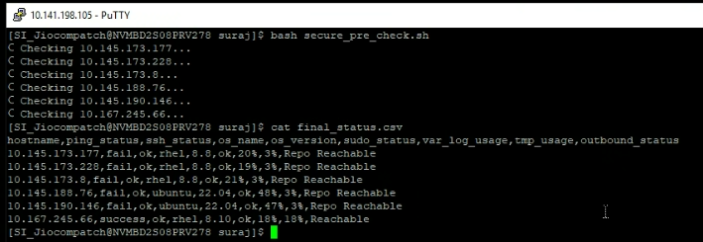

# Precheck status csv screenshot

