CST1510 Programming for data communication and networks – CW2
Title: Smart Vending Machine for Digital Goods
Credentials
- Name: [Your Full Name]
- Student Number: [Your Student Number]

1. Project Overview
- [Describe the project objective and what you focused on in your implementation]
- [List the list of class of files used]
  - Client/GUI
  - Server
  - MySQL
  - DB

2. UML Diagram
You can create the UML diagram using tools like app.diagrams.net. Below is an example representation.
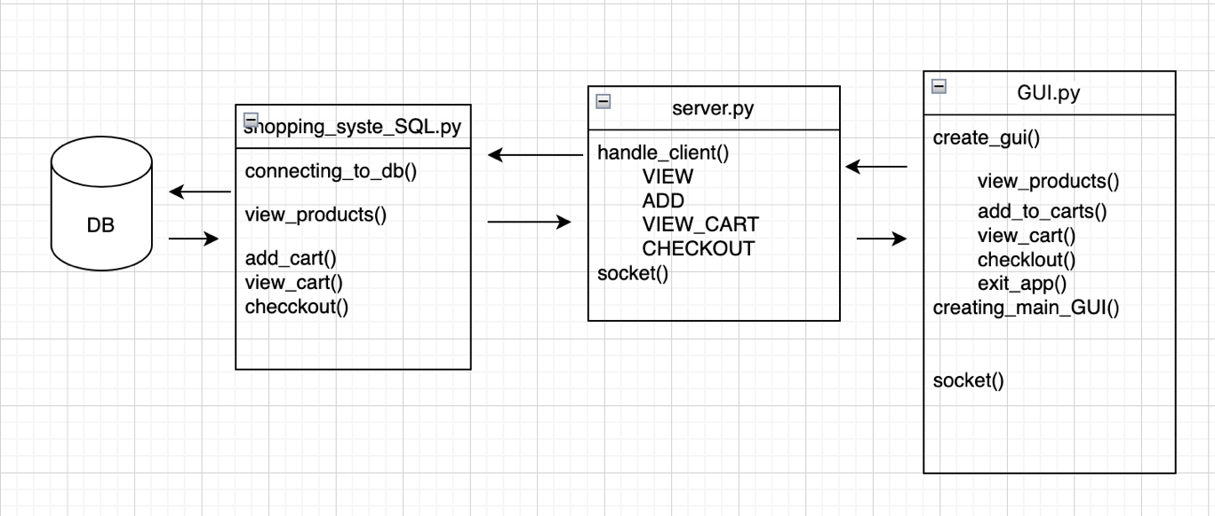
Description of File Functionalities:
- shopping_site_SQL.py: Handles database connections and operations, such as fetching products and recording transactions.
- server.py: Processes client requests, including viewing products, managing the cart, and checkout.
- GUI.py: Implements the graphical user interface, enabling users to interact with the vending machine functionalities.

3. Implementation Plan
3.1 The project was implemented in the following stages:
- Initial Text-Based Setup:
  - Created a text-based inventory using inventory.txt.
  - Implemented basic functionalities for product viewing, adding items to the cart, and processing checkout.
  - Saved transaction logs in transactions.txt for record-keeping.
- Object-Oriented Refactoring:
  - Defined classes such as Product, Cart, and VendingMachine to encapsulate the logic.
  - Added methods for stock adjustments, cart operations, and checkout processes.
- Client-Server Model:
  - Developed a server program using Python sockets to manage inventory and transactions.
  - Created a client application to request product data, manage the cart, and handle purchases.
- Database Integration:
  - Transitioned from text files to an SQLite database for better performance and scalability.
  - Used SQL queries for managing inventory and transaction records.
- GUI Implementation:
  - Built a Tkinter-based graphical interface for product browsing, cart management, and completing transactions.

4. Running Instructions
4.1 Prerequisites:
- Python 3.x installed on your system.
- Required libraries: socket, sqlite3, tkinter, mysql-connector-python (install via pip install [library_name]).
4.2 Steps to Run:
- Start the server: server.py
- Run the client application: GUI.py

5.1 Learning Highlights:
Reflect on the skills and concepts you gained during the project:
- Inventory management using both text files and databases.
- Application of Object-Oriented Programming (OOP) principles.
- Developing and troubleshooting client-server communication models.
5.2 Challenges and Solutions:
- Challenge: Maintaining reliable communication in the client-server model.
  - Solution: Implement structured protocols to ensure consistent data transfer.
- Challenge: Handling dynamic stock updates.
  - Solution: Use SQLite transactions to maintain data consistency.
5.3 Potential Improvements:
- Implement real-time analytics for stock trends using matplotlib.
- Optimize for scalability to handle multiple clients simultaneously.

6. Technical Specifications
- Programming Language: Python 3.x
- Libraries Used:
  - socket: For managing communication between client and server.
  - sqlite3: For database operations.
  - tkinter: For building the graphical user interface.
  - mysql-connector-python: For integrating with MySQL databases.
- Platform Compatibility: Designed to run on any environment supporting Python 3.x.

Reference
Define to what extent you used ChatGPT or other AI tools in generating your code for this project. Specify the areas where AI assistance was applied (e.g., code snippets, debugging, logic refinement), ensuring that all outputs were critically reviewed and adapted to meet project requirements.

