**a**

**Mini- PROJECT REPORT ON**

**AUTOMATIC BABY CRY DETECTOR**

SUBMITTED to UNIVERSITY OF PUNE

FOR PARTIAL FULFILLMENT

OF THE REQUIREMENTS for the DEGREE OF

**BACHELOR OF ENGINEERING**

in

Electronics and Telecommunication

By-

KSHITIJ GAJBHIYE T150073036

NAZNEEN PINJARI T150073114

DIPALI TATE



**DEPT. OF ELECTRONICS AND TELECOMMUNICATION**

**PUNE VIDYARTHI GRIHA’S COLLEGE OF ENGINEERING AND TECHNOLOGY,**

PUNE-9

2018-19

ACKNOWLEDGEMENT

The completion of any project brings with it a sense of satisfaction, but it is never complete without thanking those people who made it possible and whose constant support has crowned our efforts with success.

We take this opportunity to express our heartfelt gratitude towards our Project Guide, **Prof. Mrs. Vinaya Deshmukh** whose skilful guidance helped us in materializing our ideas.

We take this opportunity to express gratitude towards our Head of the Department, **Prof. Mrs.Bavkar** for her valuable guidance and support.

We would also like to thank the teaching as well as non-teaching staff of our department for extending their helping hand whenever required.

We are extremely happy to acknowledge and express our sincere gratitude to our parents for their constant support and encouragement and last but not least, friends and well, wishers for their help and cooperation and solutions to the problems during the course of the project

KSHITI GAJBHIYE

NAAZNEEN PINJARI

DIPALI TATE

CERTIFICATE

This is to certify that the Mini-Project Report entitled

**AUTOMATIC BABY CRY DETECTOR**

Has been successfully completed by

KSHITIJ GABHIYE

NAAZNEEN PINJARI

DIPALI TATE

towards the partial fulfilment of the degree of **Bachelor of Engineering** in **Electronics and Telecommunication** as awarded by the Savitribai Phule Pune University, at **Pune Vidyarthi Griha’s College of Engineering** during the academic year 2018-19.

(Prof.Vinaya Deshmukh) (Dr.Prof.K.J.Kulkarni)

Mini-Project Guide Head, Department Of E &TC

Place: PVG COET PUNE

Date: 1/4/19

**CONTENTS**

**Index**

|  |  |  |
| --- | --- | --- |
| Chapter No. | Title | Page No. |
|  | Abstract |  |
| 1. | Introduction | 6 |
| 2. | Design of the System | 7 |
| 2.1. | Block Diagram | 7 |
| 2.2. | Working of the System | 8 |
| 2.3. | Specifications of the system | 9 |
| 2.4. | Specifications of the Components | 10 |
| 2.5. | Selection of Component | 13 |
| 2.6. | Hardware Design | 14 |
| 2.7. | System Enclosure | 15 |
| 5. | Conclusion | 16 |
| 6. | Future Scope | 17 |
|  | Appendix |  |
|  | 1. References | 18 |

# ABSTRACT

Parents in the present world are very busy in their professional life, they do not get sufficient time to take care of their babies.it is not possible for parents to constantly watch over their new born baby while doing their work. If there was a smart equipment which would put the crying baby automatically to sleep it will help the parents to be carefree about the baby, so we have designed a simple self-soothing system which helps parents in taking care of the baby.

This System consists of a simple voice detection mechanism which can be applied for designing a device with capability to detect baby cry sound and automatically turning on a sleep music.

The Sound sensor detects the baby cry sound as an input and using pic microcontroller the output side has a toy which will turn on the projector to soothe the baby and buzzer which will alarm the parents about the crying baby

# CHAPTER 1

# INTRODUCTION

Nowadays the world has become digital so that we can easily deal with real time system, currently there are different types of baby monitoring systems with android applications, wireless controlled camera system, these products are not easy to set up and are very much costly and by fixing it near the baby may cause health problems due to electromagnetic radiation.

These baby monitoring products are easily available in market but we have designed a system which is less costly and it will not harm the baby in any manner. In our project we can add features such as GSM which will send a message to the parents about the crying baby.

The Idea of implementing an affordable baby cry detector sleep mechanism will put the baby automatically to sleep even if the parents are not around and it is easily affordable.

# CHAPTER 2

# DESIGN OF THE SYSTEM

# 2.1: BLOCK DIAGRAM-

The following is the block diagram for the prototype:-

PIC

Microcontroller

Buzzer

Power Supply

Microphone Sensor

Toy

Relay

Comparator circuit

# 2.2: WORKING OF THE SYSTEM-

**Power Supply-** A single power supply of 5v is used for pic microcontroller, electret condenser Microphone input, buzzer, relay etc.

**Sensor –** Electret condenser microphone is used as the sound sensing unit, this type of microphone is typically not used in any headsets or earphones, since practically it has a very low sensitivity which makes detection of sound hard. This Sensor is used to detect the baby cry sound, since the output of the MIC has a very small voltage which makes it hard for the microcontroller to read it a comparator circuit is used at the output of the MIC which ideally produces output voltage in 1 or 0 depending upon whether input sound is given or not.

**Microcontroller-**the microcontroller will turn on the toy interfaced with the relay and turn on the buzzer at the same time whenever the baby cry sound is detected by the microphone at the input.

**Relay –**It acts as an electromagnetic switch for turning on and off the Toy.

**Buzzer-** It is used to produce a buzzing sound.

# 2.3: SPECIFICATIONS OF THE SYSTEM-

**1-**INPUT-The input to the system is provided with the help of a linear power supply, if the product is manufactured for commercial purpose then a dc adapter can be used.

**2-**Operating Frequency-Internal Oscillator block from 31 kHz to 8 MHz.

**3-**Range of sensor – Since the available Electret condenser Microphone has low sound sensing capability the range of sensing a baby cry sound is up to few centimetres.

**4-**Temprature Range – The temperature range for the operation of the system is -33 to 70 degree Celsius.

# 2.4: SPECIFICATIONS OF THE COMPONENTS-

|  |  |
| --- | --- |
| **Name Of The Component** | **Specifications** |
| Microcontroller | PIC 18f4550 |
| Capacitors | 1000uf,100uf,0.1uf |
| Regulator IC | LM7805,LM358 |
| Diode | 1n4007 |
| Resistor | 1k |
| Sound Sensor | Electret Condenser MIC |
|  |  |

**MICROCONTROLLER (PIC 18F4550) -**

1-Program Memory Type-Flash

2-Program Memory (Kb)-32

3-CPU speed (MIIPS)-12

4-RAM bytes-2048

5-DATA EEPROM (Bytes)-256

6-Digital Communication Peripherals 1-UART, 1-SPI, 1-I2CI-MSSP (SPI/I2C)

7-Capture/Compare/PWM Peripherals-2 CCP

8-Timers-1x 8bit, 3x 16bit.

9-ADC-13 channels, 10 bit

10-Comparators-2

11-Temprature Range- -40 to 85 degree Celsius.

12-Operating Voltage range - -2 to 5.5V

13- Pin Out- 40

**POWER SUPPLY –** A Single linear power supply of 5V is used for microcontroller, MIC, buzzer, relay.

**BUZZER –** 1-Supply Voltage – 3-20V

2-Current Consumption – 20mA

3-Temprature Range - -20 to 70 degree Celsius

4-Physical Characteristics – 30 mm.

Light weight.

**RELAY –** 1-Supply Voltage – 5V

2-Current Consumption -70mA

3-Physical Characteristics – weight-10 gm

32.2 x 27.6 x 27.6mm

**TOY –** 1-Dimensions – 17 x 15 x 10 cm

2-Supply Voltage – 4.5 V

**LM358 –** Supply Voltage – 3V- 36V

Current Consumption – 300uA

# Overview of Electret Condenser Microphone-

An Electret Condenser Microphone is widely used for audio recording. It has low cost and are easily manufactured are most commonly used microphones for all types of devices. These Types of Microphones are used in Telephones, Smartphones, Computers, and Headsets etc. Almost everyone uses these types of microphones on a daily basis.

An Electret Condenser Microphone has a ferroelectric material which is an electret that has been permanently charged to be polarized as positive and negative side. Due to this the electret microphones do not need an external power source to polarize electric plates.

Gerhard Sessler and Jim West invented the electret condenser microphone at bells lab in 1962. This type of microphone started as a low quality device, steady progress were made to the point where electret microphones can be used in recording studios and live music performances.

**FEATURES –** operating voltage 2V to 10V

Current Consumption 0.5mA

Recommended Operating Voltage – 2V

Operating Frequency – 20Hz to 17,000 Hz

# 

# 2.5: SELECTION OF COMPONENTS

|  |  |  |  |  |
| --- | --- | --- | --- | --- |
| FEATURES | PIC18F2455 | PIC18F2550 | PIC18F4455 | PIC18F4550 |
| Program memory(bytes) | 24576 | 32768 | 24576 | 32768 |
| Program memory(instructions) | 12288 | 16384 | 12288 | 16384 |
| I/O ports | Ports A,B,C,E | Ports A,B,C,E | Ports A,B,C,D,E | Ports A,B,C,D,E |
| Streaming parallel port (SPP) | No | No | Yes | Yes |
| Packages | 28-pin PDIP  28-pin SOIC | 28-pin PDIP  28-pin SOIC | 40-pin PDIP  44-pin QFN  44-pin TQFP | 40-pin PDIP  44-pin QFN  44-pin TQFP |

# 2.6: HARDWARE DESIGN -

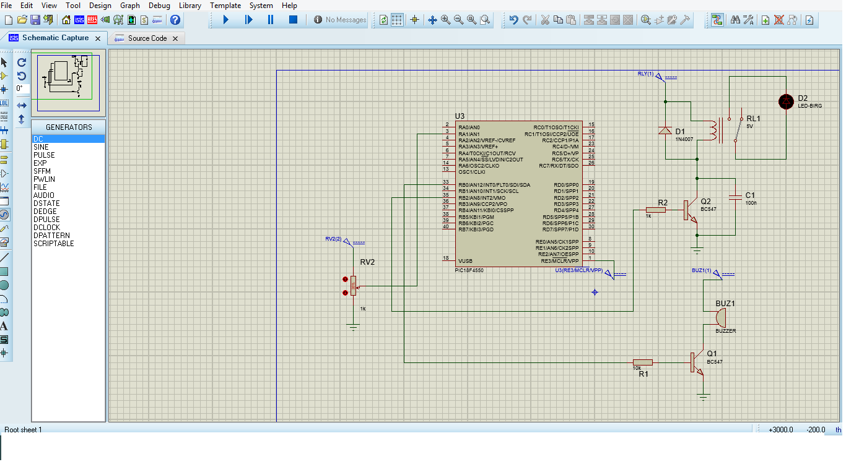

# 2.7: SYSTEM ENCLOUSURE-

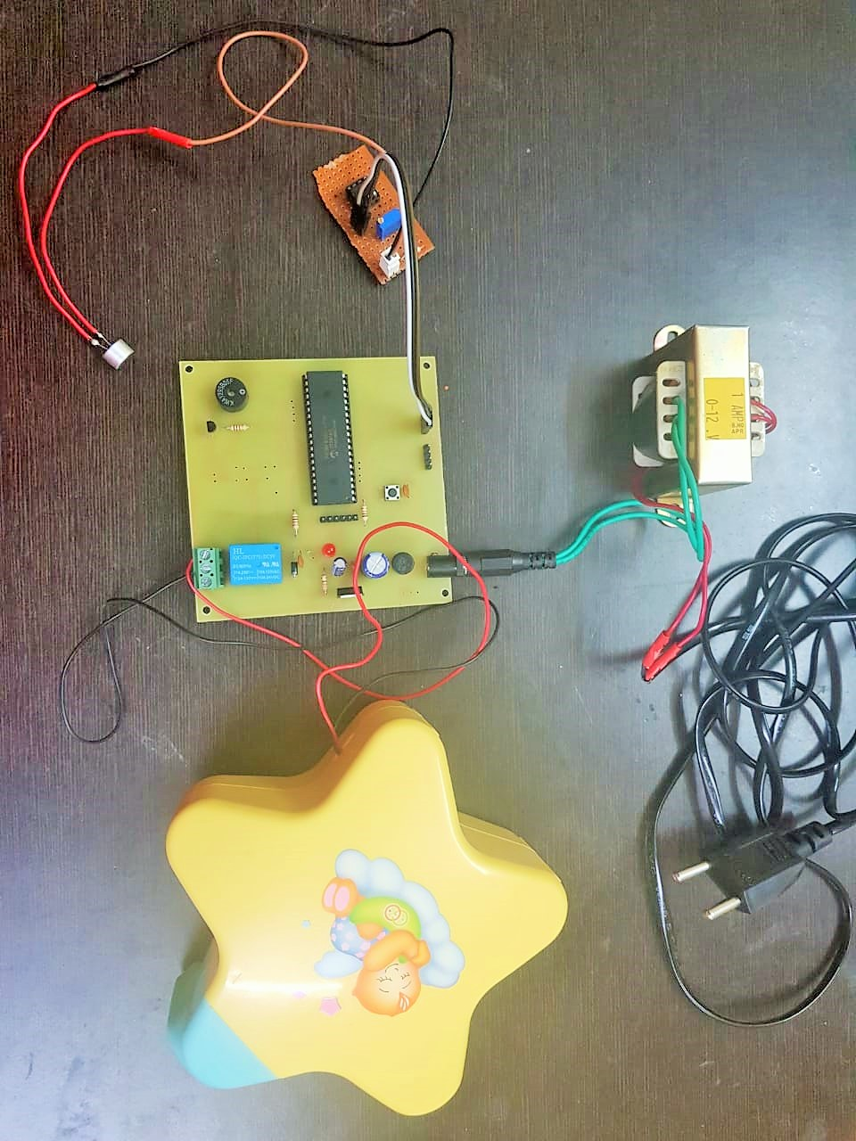

# 

# CHAPTER 3

# CONCLUSION -

With the help of proposed baby cry detection system, we can easily identify infants cry and provide an affordable self-soothing system. This System has more advantages than the commercially available baby cry detection systems since it is cheap and does not harm the baby.

The baby cry detection system (prototype) containing an electret condenser mic cannot distinguish the baby cry voice with other sounds since this feature is not available in the pic microcontroller.

The baby cry detection circuit can be used profoundly using a raspberry pie by simply loading the baby cry in it.

# CHAPTER 4

# FUTURE SCOPE

Some Improvements in this Prototype-

- Cry detection is challenging because of the variable input speech signals.

a) Baby’s voice changes with time.

b) Variations in recording environment.

- A GSM module can be used which will be very helpful to notify the parents about the baby cry when they are far away from the baby.

-Improving the audio processing algorithms to detect and notify the reason for baby cry

-We can test the self-soothing system in real environments by getting the parents feedback regarding the product.

# A.REFERENCES

1-PIC micontroller and embedded system 3rd edition, Pearson publication.

2-www.microchip.com

3-Infant Cry Detection System application note JETOUSLvol5

4-Recording audio using raspberry pie using python

[www.engineersportal.com](http://www.engineersportal.com).