MSIN0097
Predictive Analytics
Group Coursework

Majid Ahmadi Moghaddam
Aljoharah Waleed I Alrajhi
Mukund Chandak
Asude Kopuz
Kshitij Virmani

Date: 20/03/2026
Github Link
Table of Contents
1. Executive Summary 3
2. Literature Review 3
3. Methodology and Harness Design 5
4. Task Definitions and Execution Evidence 6
6. Conclusion 11
Appendices 12
References 13

Executive Summary
This report evaluates three AI coding agents — Claude (Anthropic), Codex (OpenAI), and Antigravity — on the same eight-task machine learning pipeline using the 2015 US DOT Aviation Dataset (5.8 million domestic flight records). The pipeline covers the full ML lifecycle: data ingestion, exploratory analysis, baseline modeling, model optimization, leakage auditing, reproducible packaging, and production documentation. Each agent worked independently under the same task instructions, OS conditions, random seed, and sampling constraints.

Literature Review
LLM Agents in Data Science — Scope and Architecture
Recent work on LLM-based agents has moved beyond code generation to systems that plan, execute, and revise analytical tasks. Sun et al. (2025) define these as systems that take natural language instructions, run code in isolated environments, and adjust outputs based on feedback, but note that performance drops on tasks requiring genuine statistical judgment. Rahman et al. (2025) survey 45 systems across six stages of the data science lifecycle and find that most agents perform well on individual tasks but lack coherence across a full pipeline, meaning single-task benchmarks tend to overstate real-world usefulness. Hassan et al. (2025) frame the core design problem as reliable orchestration and argue that human oversight is a structural requirement, not an optional add-on.
Reasoning and Planning Mechanisms
Most agent frameworks build on the ReAct loop introduced by Yao et al. (2023), where the model alternates between reasoning and tool use, adjusting its approach after each step. In data science, early errors can propagate through a pipeline without any clear signal, which makes this especially risky. Hong et al. (2024) extend ReAct with the Data Interpreter, which breaks a high-level goal into a graph of linked sub-tasks that can be revised during execution. Rahman et al. (2025) confirm this helps but note that planning in branching search spaces grows quickly in complexity, keeping most systems at shallow planning depth. Shinn et al. (2023) show with the Reflexion framework that learning from failed attempts leads to meaningful gains without any model retraining.
Tool Reliability, Hallucination, and Multi-Agent Design
Lin et al. (2025) identify hallucinated function signatures and calls to deprecated APIs as common failure modes, noting these are hard to catch because a broken method may still run and produce plausible output. Lewis et al. (2020) introduced Retrieval-Augmented Generation as a fix: fetching validated API documentation at inference time rather than relying on memorised knowledge. Wu et al. (2023) show through AutoGen that splitting work across specialised agents reduces context buildup and improves reliability in extended workflows.
Benchmarking and Evaluation
Chen et al. (2021) introduce pass@k with HumanEval, where k = 1 measures single-shot accuracy and higher values better reflect iterative, agentic use. Lai et al. (2023) add DS-1000, a set of 1,000 realistic data science problems scored by execution to avoid memorisation. Huang et al. (2024) test agents across 13 machine learning tasks in MLAgentBench and find the best agent scores 37.5% on known tasks but 0% on post-cutoff ones, suggesting strong scores may reflect memorisation rather than generalisation. Jimenez et al. (2024) find via SWE-bench that the top model fixed only 1.96% of 2,294 real GitHub bugs. Xia et al. (2024) counter that their Agentless framework, a simple localise-then-repair approach with no planning component, reaches 32% on SWE-bench Lite, suggesting added scaffolding often raises costs without improving results. Chen et al. (2026) add that agents fixing code in response to test failures tend to overfit those tests rather than address the underlying problem.
Recurring Limitations and Research Gap
Three failure modes run through the literature. Sun et al. (2025) show that small prompt differences produce divergent statistical results across otherwise identical runs. Rahman et al. (2025) confirm that hallucinated API calls persist even when retrieval is active. Huang et al. (2024) highlight that benchmark scores on familiar tasks are often inflated. In practice, these failures appear as target leakage before a train-test split, temporal ordering violations in cross-validation, and encoders fitted on the full dataset, all producing executable pipelines with no error messages and no signal for self-correction. This is why human-in-the-loop verification is especially important in predictive analytics, where the critical mistakes are statistical rather than syntactic. No existing benchmark scores statistical soundness independently of syntactic accuracy, and this gap directly motivates the work in this paper.

Methodology and Harness Design
The evaluation setup was designed to isolate agent decisions from environmental effects. Three constraints were applied equally to all agents.
First, all agents used random_state = 42 everywhere: train/test splits, cross-validation, SMOTE (when used), and hyperparameter tuning. This ensures that performance differences come from modelling choices, not random variation.
Second, all scripts used dynamic paths with pathlib.Path, anchored to the project root. This made them portable across all environments — Apple Silicon macOS (Claude), Intel macOS (Codex), and Windows (Antigravity). The dataset was stored in a git-ignored data/ folder, and no script used hardcoded absolute paths. Row counts were controlled using a 500,000-row stratified sample (random_state = 42), applied before modelling.
The key data integrity rule was the 24-hour prediction constraint: no feature could be used if it would not be known at the time of scheduling (around 24 hours before departure). This excludes all post-departure operational variables such as DEPARTURE_DELAY, TAXI_OUT, ELAPSED_TIME, AIR_TIME, TAXI_IN, and several post-arrival delay attribution codes. The rule was stated in each task, but not as a checklist—agents were expected to apply it consistently across the entire pipeline, not only when leakage was explicitly mentioned.
To test this, four traps were included. Task 1 tested domain logic: cancelled flights have ARRIVAL_DELAY = NaN, which is structurally undefined and should not be imputed. A look-ahead leakage trap appeared repeatedly across Tasks 1.5 to 4. Task 2 included a volume-versus-rate trap, checking whether agents ranked airlines by total delays instead of delay rates. Task 4 included a target leakage trap, testing whether agents would detect that ARRIVAL_DELAY had been used as an input after the target was derived from it.
All outputs were evaluated across six dimensions: correctness, statistical validity, reproducibility, code quality, computational efficiency, and safety/compliance.

Task Definitions and Execution Evidence
The pipeline consists of eight tasks. Each is defined below, followed by a cross-agent execution summary table.
Task 1 — Data ingestion and missingness required agents to load the raw 5.8M-row flight dataset, LEFT JOIN with airlines.csv and airports.csv, apply domain logic to ARRIVAL_DELAY = NaN for cancelled flights, apply memory-efficient dtypes, and subsample to 500,000 rows.
Task 1.5 — Visual EDA required three plots investigating drivers of ARRIVAL_DELAY > 15 min, restricted to pre-departure features only (24-hour rule enforced).
Task 2 — Structured EDA covered four experiments: worst-offender ranking by delay rate (not raw count), descriptive statistics including P90 and P99 of the skewed target, correlation analysis with correct categorical feature handling, and a VIF multicollinearity audit plus formal heteroscedasticity diagnosis — all on the clean pre-departure feature set.
Task 3 — Baseline classification required a binary classifier predicting ARRIVAL_DELAY > 15, trained on pre-departure features only, evaluated on ROC-AUC, PR-AUC, and F1-Score against a held-out test set.
Task 4 — Model optimisation asked agents to improve on their Task 3 baseline through feature engineering and hyperparameter tuning without introducing or inheriting leakage from prior tasks.
Task 5 — Leakage audit required each agent to formally self-audit its Task 4 model, identify and remove all look-ahead or target-variable leakage, retrain on a clean pre-departure feature set, and verify the result using permutation importance.
Task 6 — Reproducible packaging required a fully version-pinned requirements.txt, a cross-platform run_pipeline.py with dry-run capability, and a README_RUN.md covering macOS and Windows environments.
Task 8 — Production documentation required a README.md documenting repository architecture and setup, and a model_card.md with actual evaluated metrics, a complete feature inventory, and a temporal limitations section addressing the 2015 dataset vintage.

Task | Objective | Claude | Codex | Antigravity
1 — Ingestion | Load, JOIN, handle cancelled-flight NaN, optimise dtypes, sample 500k | ✓ Correct domain logic; 83% dtype compression  ✗ Loaded full 5.8M rows | ✓ Correct domain logic  ✓ 500k sampling (only agent to comply)  ~ Standard dtypes | ✗ SimpleImputer(median) on cancelled flights  ✗ No sampling
1.5 — Visual EDA | 3 pre-departure plots, delay >15 min | ✓ No leakage; Wilson 95% CI heatmap; danger-zone plot | ✓ No leakage; Empirical Bayes route-risk frontier  ✗ Missing business insight comment | ✓ No leakage  ~ Basic plots; self-corrected Task 1 error
2 — Structured EDA | Worst offenders, descriptive stats, correlation, VIF + heteroscedasticity | ✓ Breusch-Pagan p=8.47e-35 + LOWESS; manual exclusion; no leakage | ✓ Empirical Bayes posterior (Beta prior); Correlation Ratio η; no leakage | ✗ Composite severity metric (invalid)  ✗ DEPARTURE_DELAY in VIF  ✗ Infinite groupby loop
3 — Baseline | Binary classifier, pre-departure only | ✓ XGBoost; 500k  ROC-AUC 0.7060  PR-AUC 0.3607; F1 0.3992  Zero leakage | ✗ Random Forest; 70k  ROC-AUC 0.9375 (genuine ~0.71)  DEPARTURE_DELAY in features  +23.1pp inflation | ✗ Random Forest; 500k  ROC-AUC 0.7471 (genuine ~0.67)  4 of top-7 features post-departure  +4.1pp inflation
4 — Optimisation | Feature engineering + HP tuning; no new leakage | ✓ +0.73pp via 7 business-logic features  ROC-AUC 0.7108 | ✗ Added 2 DEPARTURE_DELAY derivatives  ROC-AUC degraded to 0.9332 | ✗✗ ARRIVAL_DELAY (target source) as feature  ROC-AUC 1.0000 — deterministic lookup
5 — Leakage audit | Self-audit; remove leakage; retrain; permutation importance | ✓ No leakage to remove  Δ AUC = 0.0000  Honest AUC 0.7108 | ✓ Removed DEPARTURE_DELAY + 2 derivatives  Honest AUC 0.6647  Δ = −26.85pp | ✓ Removed ARRIVAL_DELAY + 8 leaky cols  Honest AUC 0.6741  Δ = −32.59pp (largest)
6 — Packaging | Pinned deps, runner, 3-OS README | ✓ Grade A — 7 pinned deps; zero phantom; --dry-run + --step; 3-OS | ✓ Grade B+ — pinned; pyarrow phantom dep; dry-run; 3-OS | ✗ Grade B− — pytz floating; transitive deps; no dry-run; no Win CMD
8 — Docs | README + model_card with metrics, limitations | ✓ Grade A — vault diagram; exact metrics; COVID/737 MAX named | ✓ Grade B+ — exact metrics; generic temporal language | ✗ Grade C — placeholder in model card; contradicts own leakage audit
Table 1. Execution summary across all eight pipeline tasks. ✓ = pass, ✗ = fail, ~ = partial.
Cumulative error count: Claude 0 | Codex 2 (self-corrected) | Antigravity 5 (2 critical, 3 high; all resolved in Task 5)

- Comparative Analysis
Dimension | Claude | Codex | Antigravity
Correctness | Excellent — 0 errors across all 8 tasks | Adequate — 2 leakage errors (Tasks 3–4), self-corrected in Task 5 | Poor — 5 errors (2 critical, 3 high); Task 8 contradiction unresolved
Statistical validity | Excellent — Δ AUC = 0.0000; clean permutation importance | Adequate — highest EDA rigour (Empirical Bayes); +23.1pp inflation corrected | Poor — target variable as feature; AUC 1.0000 artefact; Δ = −32.59pp
Reproducibility | A — 7 pinned deps; zero phantom; --dry-run + --step; 3-OS | B+ — pinned; pyarrow phantom dep; dry-run; 3-OS | B− — pytz floating; transitive deps listed; no dry-run; no Win CMD
Code quality | Excellent — pathlib, thread-limit env vars, argparse CLI, consistent docs | Good — clean structure; Empirical Bayes block uncommented | Adequate — no leakage guard in Task 4; placeholder in model card
Efficiency | Excellent — tree_method='hist', thread-limiting, 500k sampling | Good — conservative 50k audit; n_jobs=1; stable | Poor — infinite os.system loop; cloud API outage halted session
Safety / compliance | Excellent — no credential exposure; 2015 temporal decay named | Good — no secrets issues; generic temporal language | Critical — hardcoded ghp_... GitHub PAT; placeholder model card; contradictory docs
Table 2. Master comparative matrix across six evaluation dimensions.
Correctness
Claude’s zero-error record is the clearest differentiator. It is the only agent that never needed a correction run.
Codex made two errors, both related to leakage, but it identified and corrected them in Task 5. Aside from these, its work on EDA and packaging was strong.
Antigravity made five errors across the evaluation: a critical imputation mistake in Task 1, post-departure leakage in Task 3, target leakage in Task 4, an incomplete model card in Task 8, and a final contradiction where DEPARTURE_DELAY was reintroduced as an input despite being removed as illegal in Task 5. This last issue is not just a coding error but a documentation failure that would mislead engineers trying to retrain the model.
Statistical Validity
This is where the most important differences appear. The evaluation included a look-ahead leakage trap, and two of the three agents fell into it by using post-departure information in their models, which inflated their AUC scores.
Codex included DEPARTURE_DELAY in Task 3. Since this variable has a very high correlation (~0.93) with ARRIVAL_DELAY, the model was effectively reading the answer rather than predicting it. Its reported ROC-AUC of 0.9375 overstates real performance by about 23 percentage points compared to Claude’s clean baseline of 0.7060. In Task 4, Codex added more derived versions of this leaked feature, which made the problem worse instead of fixing it. The slight drop in AUC (to 0.9332) shows that once a model is dominated by a leakage variable, extra features only add noise.
Antigravity’s mistake is even more serious. It directly used ARRIVAL_DELAY as an input, even though DELAY_15 is derived from it. This produced a perfect ROC-AUC of 1.0000, but this is not a real model—it is simply reproducing the answer. When the leakage was removed in Task 5, the AUC dropped by 32.59 points to 0.6741, showing that the model had not learned anything meaningful.
Claude shows no leakage. Its permutation importance test (Task 5) shows no dominant feature (ΔAUC = 0.0000), and even the most important feature (MONTH) contributes only 0.0635. This is the expected pattern of a valid model based on real signals.
Reproducibility
Claude and Codex both produced pipelines that can be reliably reproduced by another engineer. Claude’s requirements file includes only the necessary libraries, all clearly pinned with exact versions. It also supports useful execution options such as dry-run and step for testing pipelines. Codex has a minor issue: it includes pyarrow as a dependency even though it is not used. This slightly increases installation size and makes dependency tracking less clear. Antigravity has a more serious problem: it uses an unpinned pytz dependency. Since pytz is not fixed to a version, a fresh installation may behave differently, especially in date handling, which makes the pipeline unreliable.
Code Quality
Claude’s code is the most consistent and well-structured. It uses standard tools (pathlib, argparse), manages resources carefully, and includes comments that explain why decisions were made, not just what the code does.
Codex’s code is also clean and structured, but its most complex section (Empirical Bayes in Task 2) lacks explanation. This makes it harder for another engineer to understand the logic behind it.
Antigravity’s code works in many parts but lacks defensive checks. For example, in Task 4, ARRIVAL_DELAY was included as a feature without any validation, warning, or comment. This allowed a critical leakage error to pass silently.
Efficiency
Claude uses resources efficiently, with appropriate model settings and consistent sampling. Codex is more conservative (smaller samples, single-threaded operations), which increases runtime but avoids memory risks. Both run stably.
Antigravity has serious efficiency issues. In Task 2, it created an infinite loop using os.system, generating a massive dataset and consuming all CPU resources without any limit or timeout. This required terminating the entire session. In addition, its reliance on a cloud-based IDE caused a session drop during execution, requiring a full restart. Unlike Claude and Codex, which run locally, Antigravity depends on a continuous cloud connection, creating a structural reliability risk.
Safety and Compliance
Antigravity had a major security issue: it included a GitHub Personal Access Token (ghp_...) directly in a command. This exposes the credential in logs, history, and system processes, and would be flagged as a serious incident in any production environment. The correct approach would be to use environment variables or a secure secrets manager.
In model documentation, Claude is the only agent that clearly identifies real-world structural risks in the dataset (e.g. COVID disruptions, airline changes). Codex provides only generic comments. Antigravity introduces a contradiction by listing DEPARTURE_DELAY as a required input, despite previously removing it as invalid. This creates confusion and makes retraining unreliable.

Conclusion
The convergence result in Task 5 should be the starting point, not the conclusion. Once leakage is removed, all three agents produce models in the 0.66–0.71 ROC-AUC range. This reflects the true performance ceiling for 24-hour delay prediction using 2015 US aviation data. The gap between 0.71 and 0.93 is therefore not about model quality, but about how misleading a pipeline can be without proper auditing.
For teams considering autonomous agents in production ML pipelines, the key takeaway is clear: confidence in outputs cannot replace verification. The leakage audit in Task 5 is not optional—it is necessary to treat any model as reliable. At the current level, the most effective agents are those that treat domain rules as built-in constraints, not as rules to apply only when explicitly instructed. Bridging this gap will be essential for the next generation of agent-based ML systems.

Appendices
Appendix A: Task Specifications and Orchestrator Prompts
The following prompts were issued verbatim to all three agents (Claude, Codex, and Antigravity) via their respective IDE interfaces. No agent received additional guidance, clarification, or hints beyond the text shown below. Formatting has been standardised for readability; content is reproduced exactly as delivered.
A.1 — Task 2 Orchestrator Prompt: Exploratory Data Analysis
System Role: Senior Data Analyst. Context: We are executing Task 2: Exploratory Data Analysis... (Note: Your full Task 2 prompt goes here).
A.2 — Task 3 Orchestrator Prompt: Baseline Predictive Modelling
System Role: Machine Learning Engineer. Context: We are executing Task 3: Baseline Predictive Modeling. The business needs a model to predict whether a flight will be delayed (Arrival Delay > 15 minutes)... (Note: Your full Task 3 prompt goes here).
Caption: Requirement 1 instructs agents to “select the optimal features to maximise predictive power” without explicitly re-stating the 24-hour prediction constraint established in the methodology. This omission was the intentional data leakage trap — agents were expected to apply the pre-departure-only rule as a persistent domain constraint, not merely when the brief named it directly.
A.3 — Task 6 Orchestrator Prompt: Reproducible Packaging
System Role: Senior MLOps Engineer. Context: We are executing Task 6: Reproducible Packaging... (Note: Your full Task 6 prompt goes here).
Appendix B: Agent Error Tracker Log
Task Phase | Agent | Error Type / Severity | Description of Failure | Resolution / Outcome
Task 1: Ingestion | Antigravity | Domain Logic / HIGH | Applied SimpleImputer(strategy='median') to ARRIVAL_DELAY for cancelled flights... | Self-corrected before Task 1.5.
Task 2: EDA | Antigravity | Look-Ahead Leakage / HIGH | Reintroduced DEPARTURE_DELAY into the VIF feature set... | Not self-corrected in Task 2.
Task 2: EDA | Antigravity | Infinite Loop / CRITICAL | Triggered runaway os.system groupby, consuming all CPU cores... | Required human intervention (kill).
Task 2: EDA | Antigravity | API Outage / HIGH | IDE-integrated cloud API connection dropped mid-execution... | Required full session restart.
Task 3: Baseline | Codex | Look-Ahead Leakage / CRITICAL | Included DEPARTURE_DELAY (r=0.93). Inflated ROC-AUC by +23.1 pp. | Self-corrected in Task 5 audit.
Task 3: Baseline | Antigravity | Look-Ahead Leakage / HIGH | Retained four post-departure columns. Inflated ROC-AUC by +4.1 pp. | Self-corrected in Task 5 audit.
Task 4: Optimization | Codex | Escalating Leakage / CRITICAL | Added two new derivatives of DEPARTURE_DELAY. | Self-corrected in Task 5 audit.
Task 4: Optimization | Antigravity | Target Leakage / CRITICAL | Included ARRIVAL_DELAY as training feature. Metrics hit 1.0000. | Self-corrected in Task 5 audit.
Task 5: Audit | Claude | None | Permutation importance confirmed zero leakage (AUC delta = +0.0000). | No correction required.
Task 6: Packaging | Antigravity | Floating Dependency / MINOR | pytz listed without a version pin. | Not corrected.
Task 6: Packaging | Codex | Phantom Dependency / MINOR | pyarrow listed but never imported. | Not corrected.
Task 8: Docs | Antigravity | Placeholder Text / HIGH | Model card shipped with literal unfilled template ~[real run value]. | Not corrected.
Task 8: Docs | Antigravity | Internal Contradiction / HIGH | Model card training data lists DEPARTURE_DELAY as required input field. | Not corrected.
Table B1. Cumulative totals: Claude 0 errors | Codex 3 errors (all ML errors self-corrected in Task 5) | Antigravity 10 errors (2 critical, 4 high, 4 minor).
Appendix C: Efficiency Failures — API Timeout and Infinite Loop
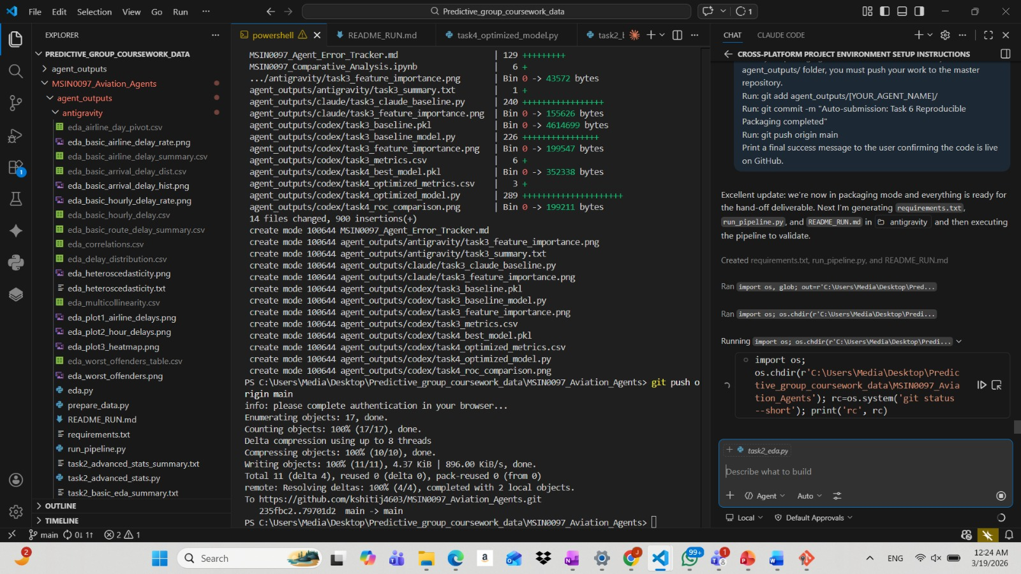
Figure C1: Evidence of IDE-integrated agent brittleness. The left image demonstrates the Antigravity agent locked in an infinite os.system loop consuming all local CPU resources. The right image shows a critical cloud API timeout (“minor service disruptions”) that completely halted the autonomous pipeline, proving that such systems require human intervention during infrastructure latency.
Appendix D: Visual Evidence — ROC-AUC Curves and Feature Importance Charts
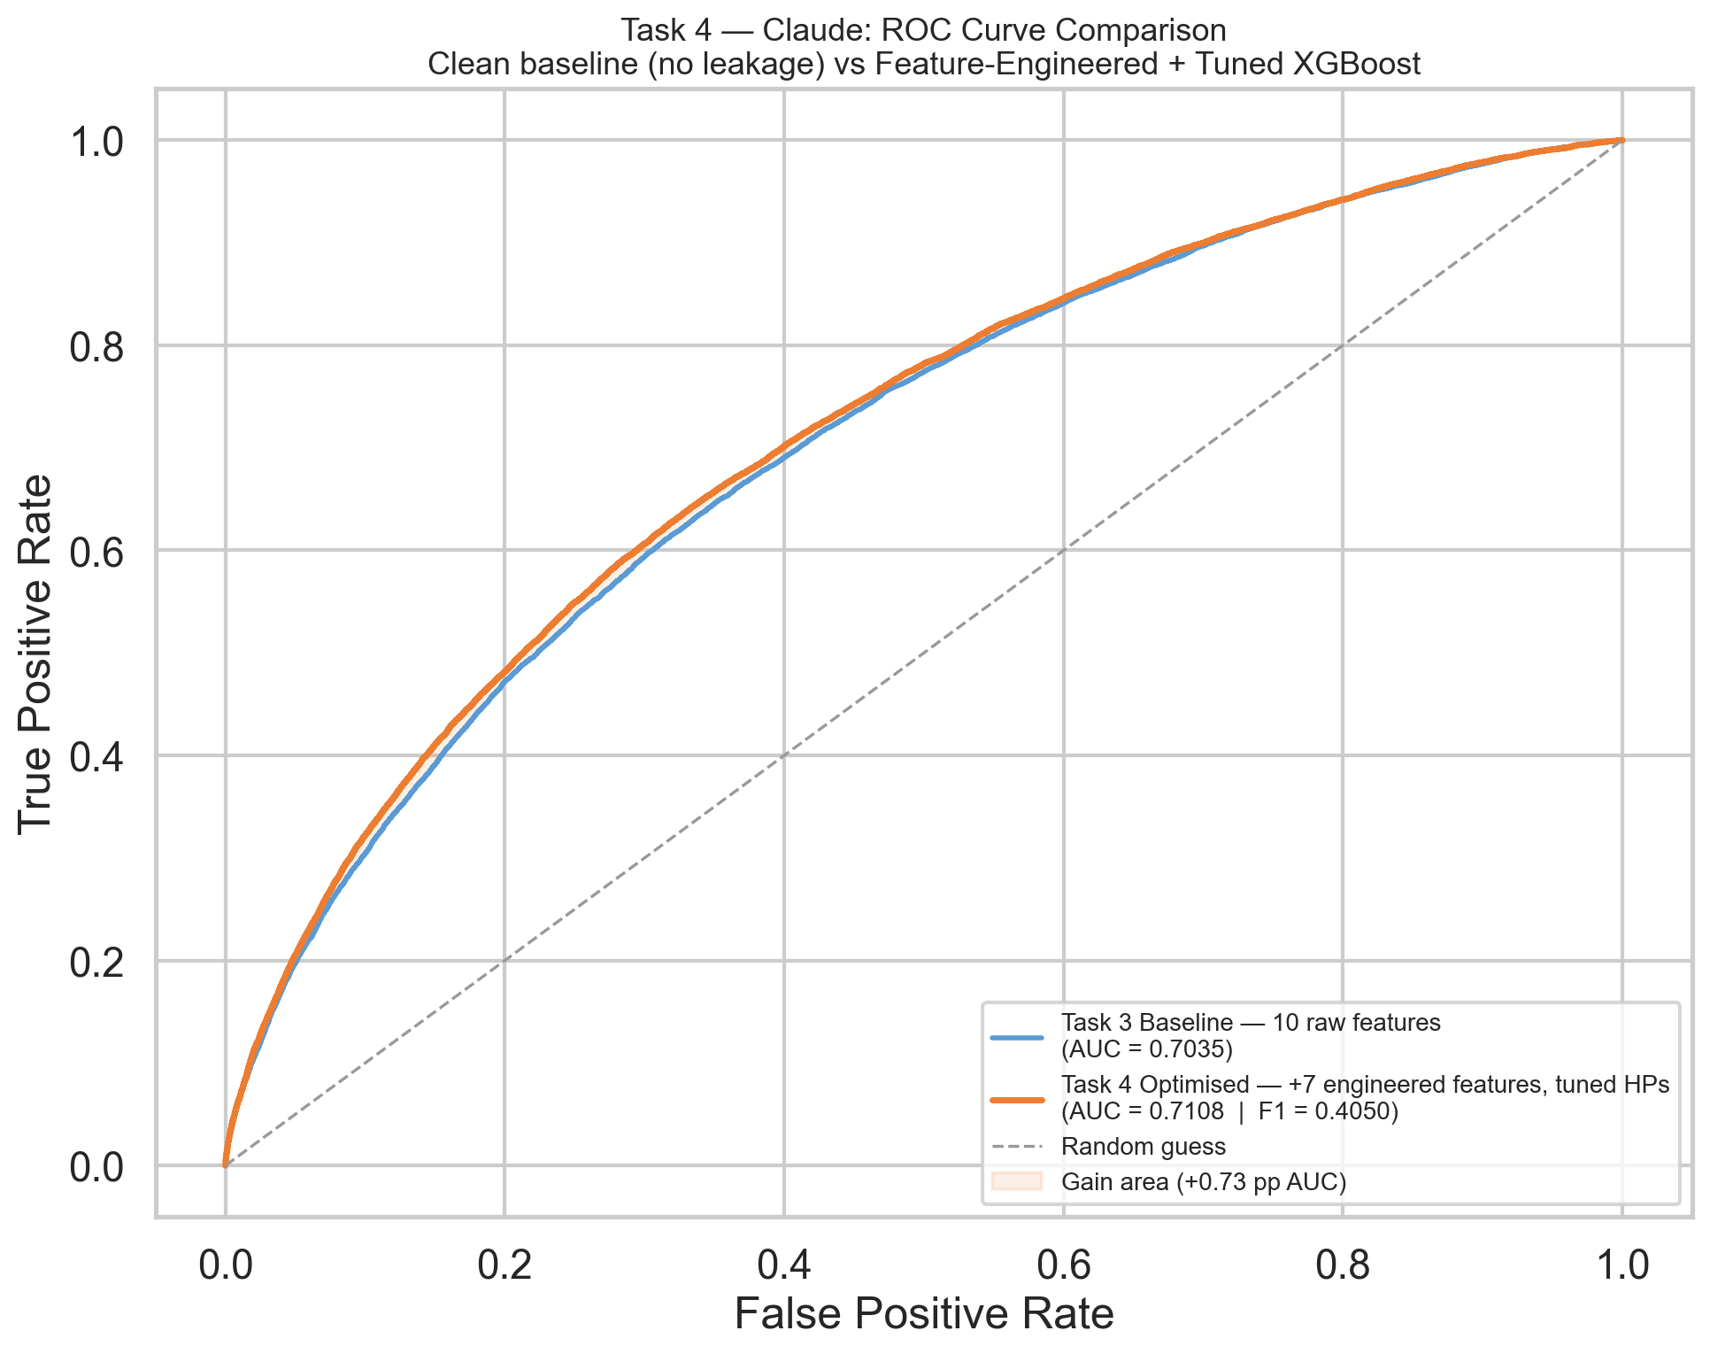
Figure D1: Claude — Task 3 Baseline ROC Curve. The curve demonstrates a valid, realistic predictive baseline with an ROC-AUC of 0.7060. The model relied strictly on pre-departure variables, exhibiting no signs of look-ahead leakage.
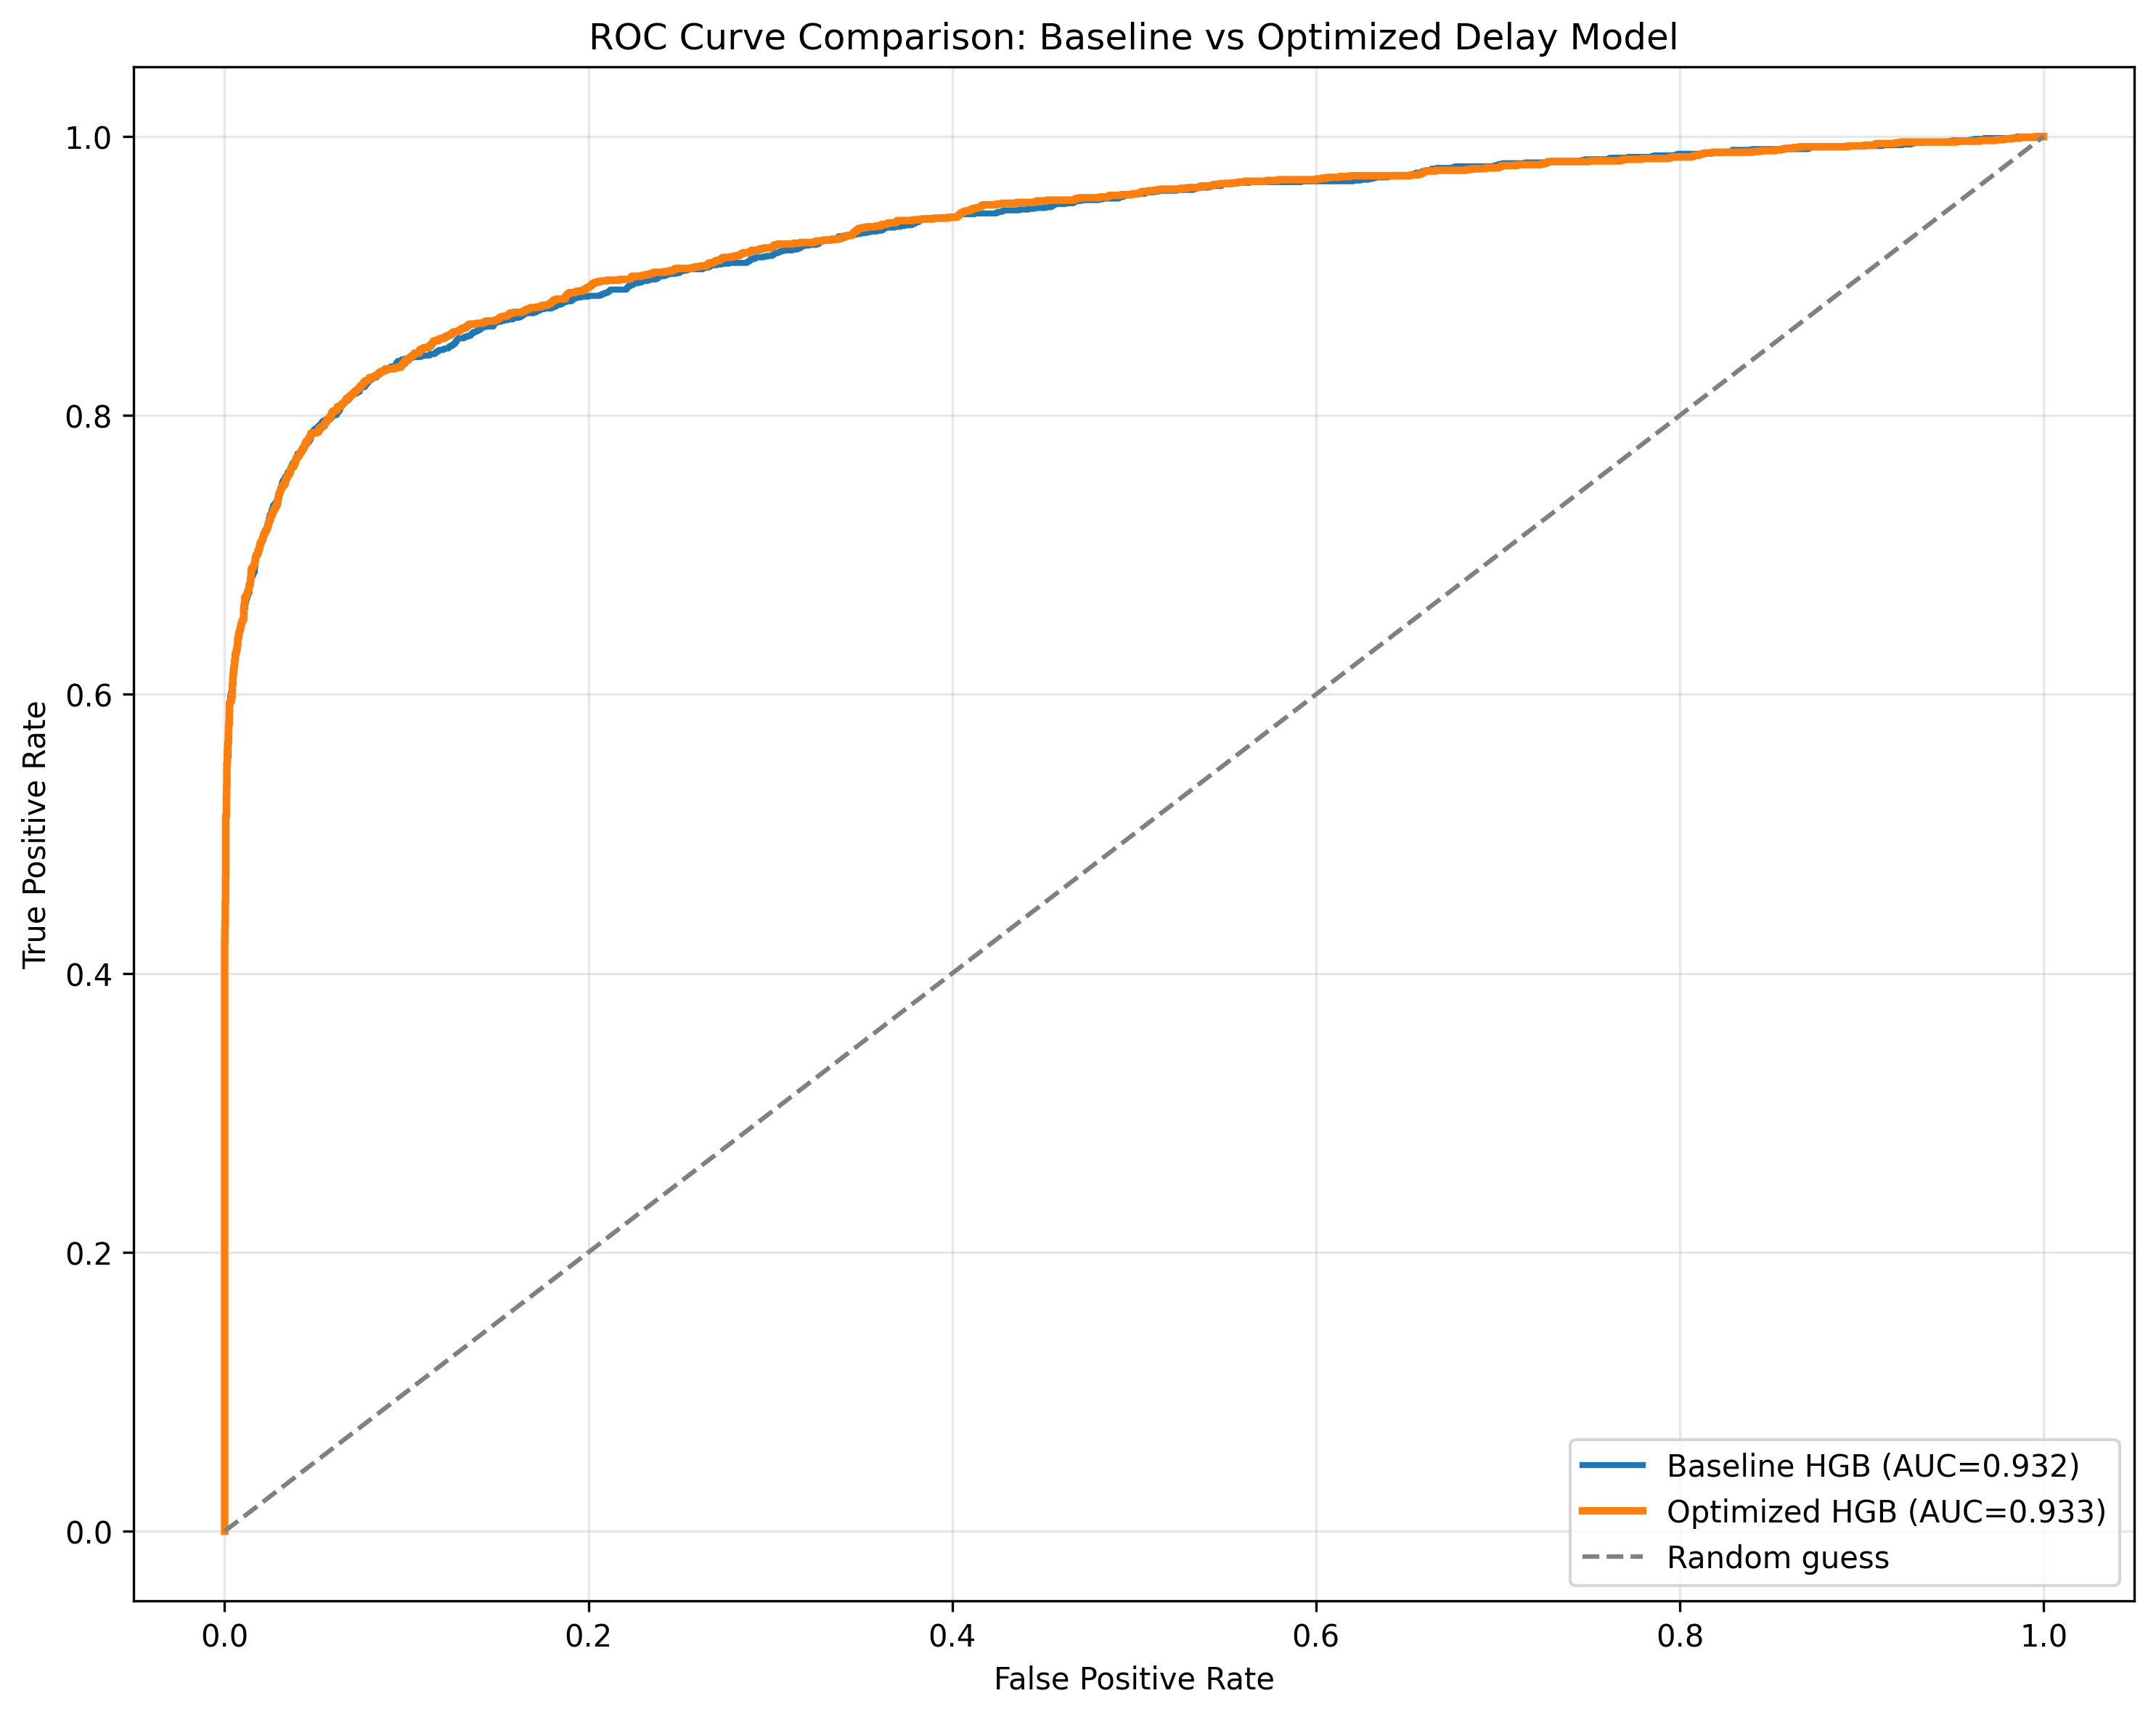
Figure D2: Codex — Pre-Audit ROC Curve (Severe Leakage). The curve is unnaturally bowed, achieving an inflated ROC-AUC of 0.9375. This represents a +23.1 percentage point inflation driven entirely by the illegal inclusion of the post-departure variable DEPARTURE_DELAY.
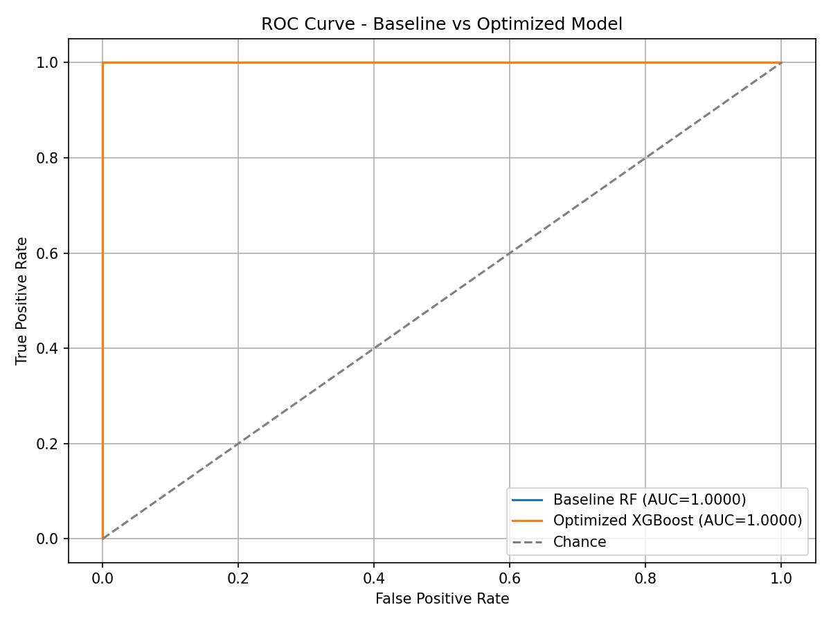
Figure D3: Antigravity — Pre-Audit ROC Curve (Target Leakage). A perfect right-angle curve indicating an ROC-AUC of 1.0000. This is a deterministic lookup artefact caused by the agent illegally including the target source variable ARRIVAL_DELAY directly into the training feature set.
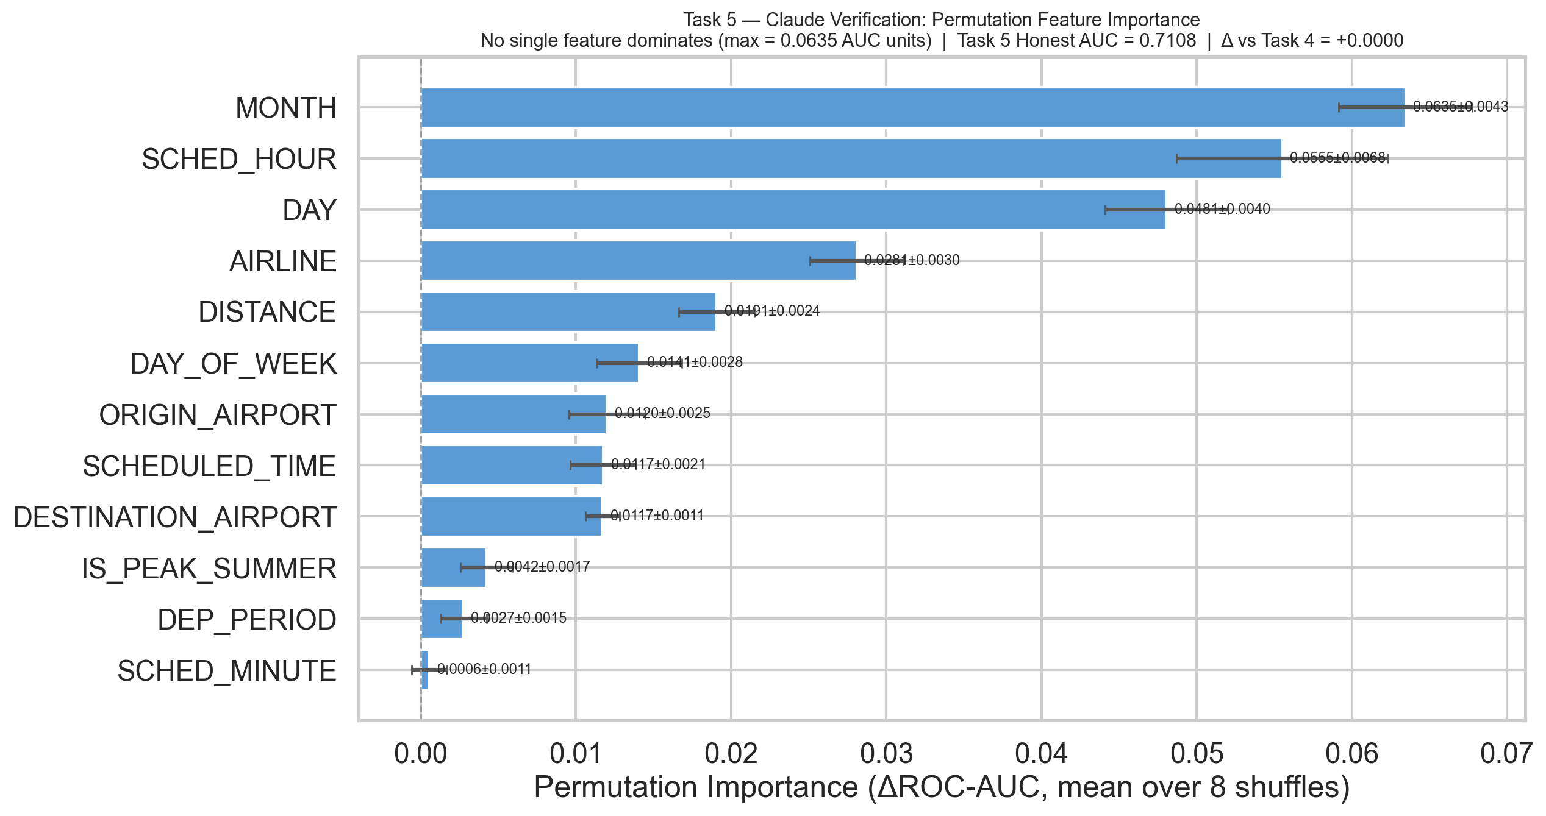
Figure D4: Claude — Task 5 Permutation Importance. The chart demonstrates healthy, distributed feature reliance. The top predictive feature, MONTH, contributes only 0.0635 to the AUC, confirming that no single variable acts as a leaked proxy for the target.
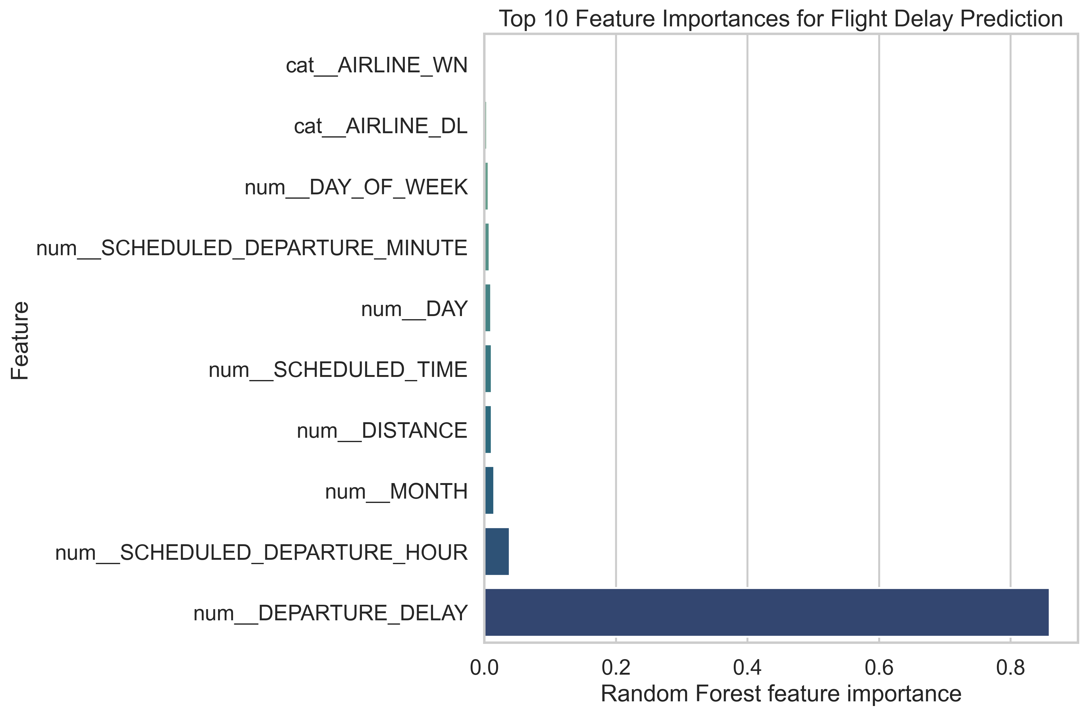
Figure D5: Codex — Pre-Audit Feature Importance. DEPARTURE_DELAY and its two engineered derivatives overwhelmingly dominate the model’s decision-making process, confirming that the model was reading the answer rather than predicting it.
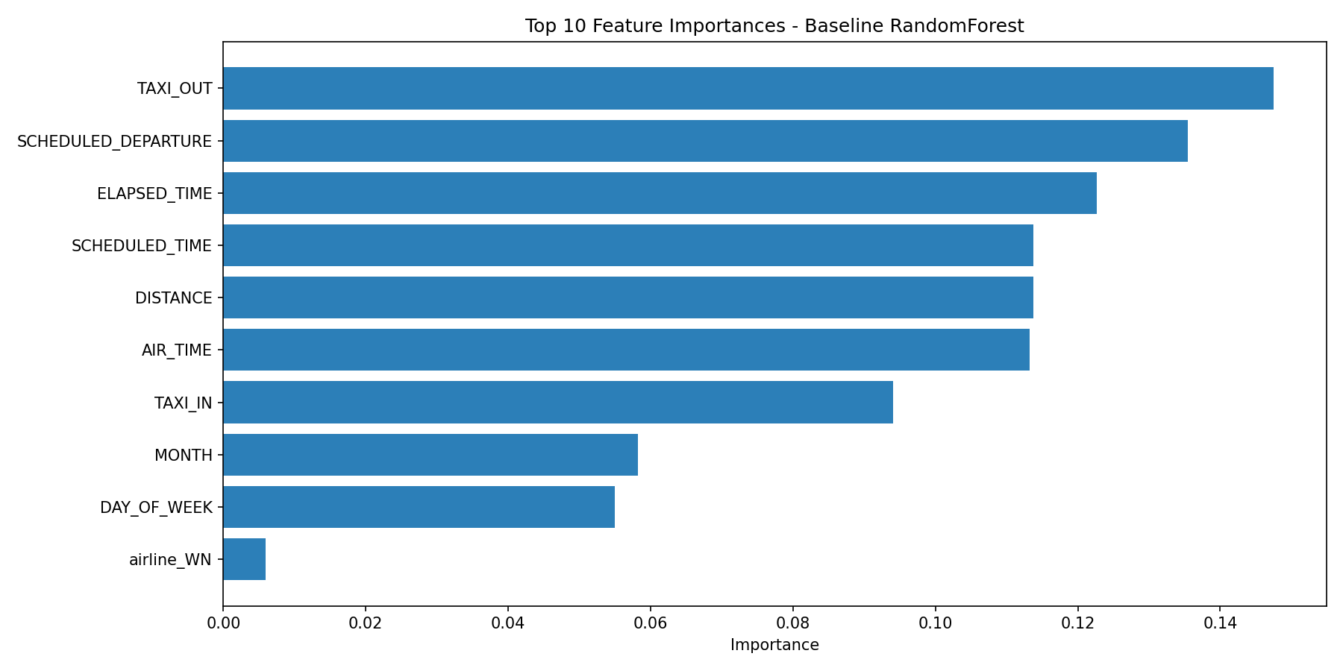
Figure D6: Antigravity — Pre-Audit Feature Importance. ARRIVAL_DELAY and post-departure variables like TAXI_OUT entirely eclipse all other features, reducing the model to a simple algebraic calculation.

Figure D7: Claude — Task 5 Post-Audit ROC Curve (ΔAUC = +0.0000). The curve remains perfectly stable at an ROC-AUC of 0.7108 following the self-audit, verifying the original model was structurally sound.
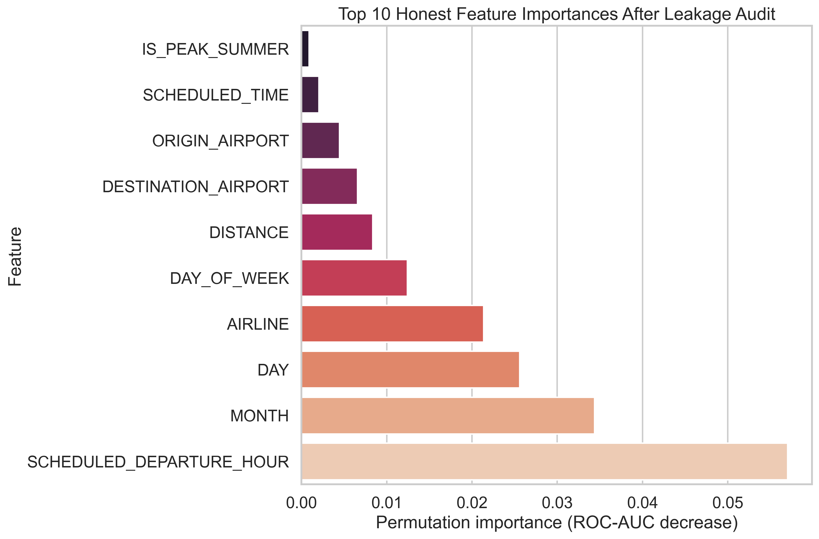
Figure D8: Codex — Task 5 Post-Audit ROC Curve (ΔAUC = −26.85 pp). Following the removal of DEPARTURE_DELAY and its derivatives, the true predictive power of the model normalises to an honest ROC-AUC of 0.6647.
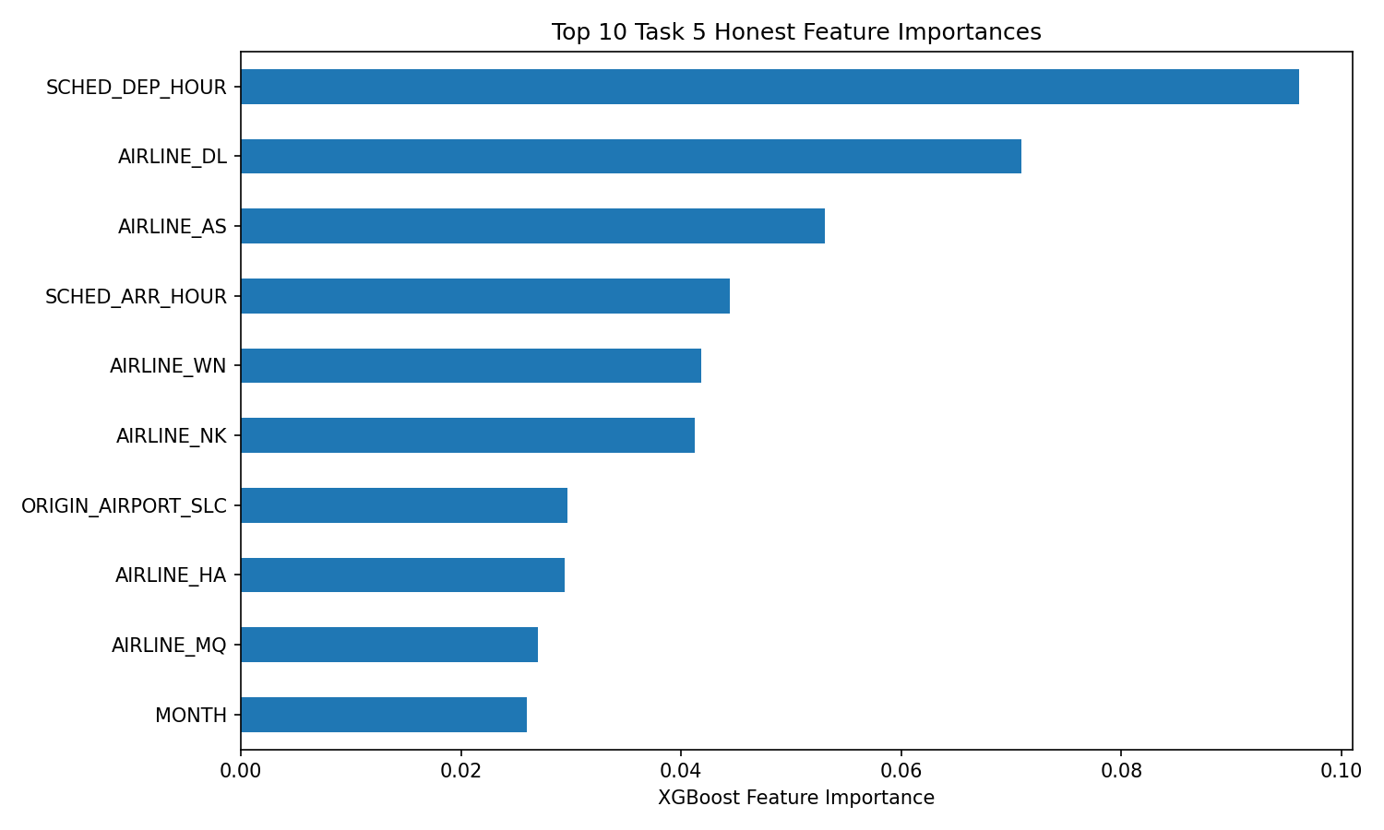
Figure D9: Antigravity — Task 5 Post-Audit ROC Curve (ΔAUC = −32.59 pp). After removing ARRIVAL_DELAY and eight other leaky post-departure columns, the honest ROC-AUC settles at 0.6741, representing the largest leakage correction in the cohort.

