Note the scales (particularly y-axis)

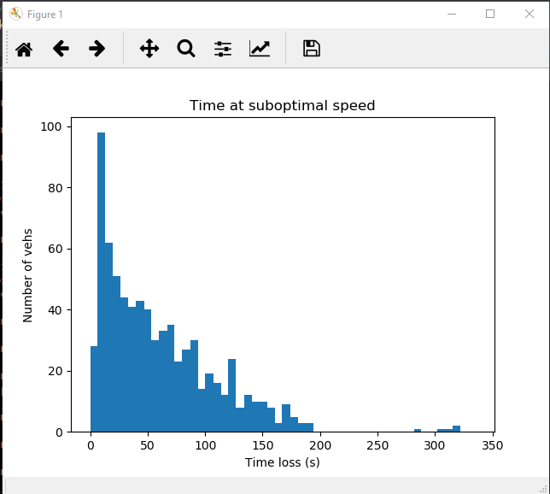

Figure : EDF time loss

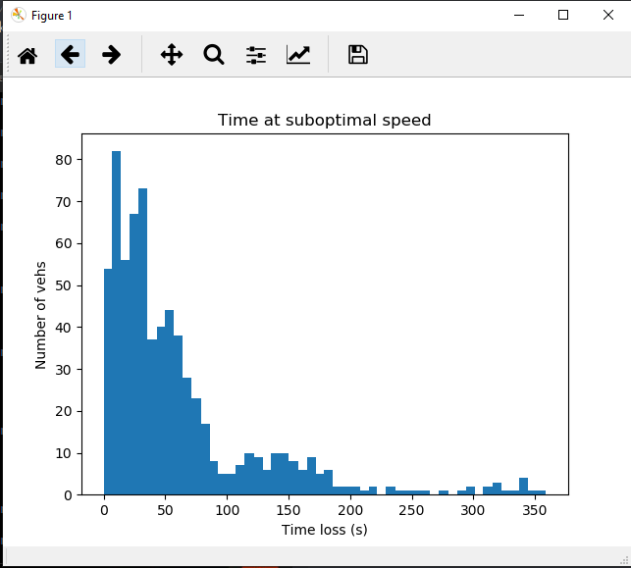

Figure : SCATS time loss

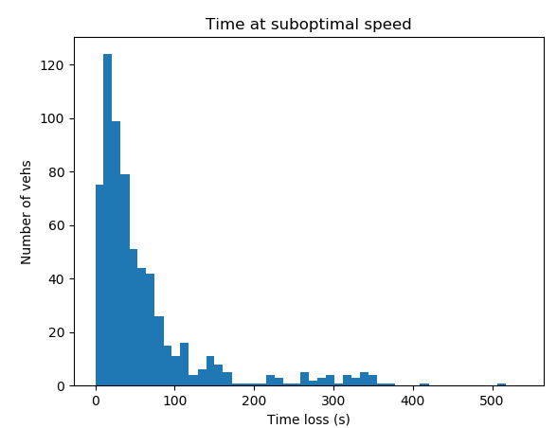

Figure : RL time loss

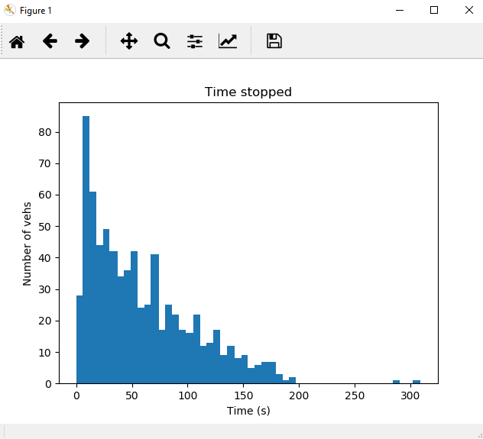

Figure : EDF time stopped

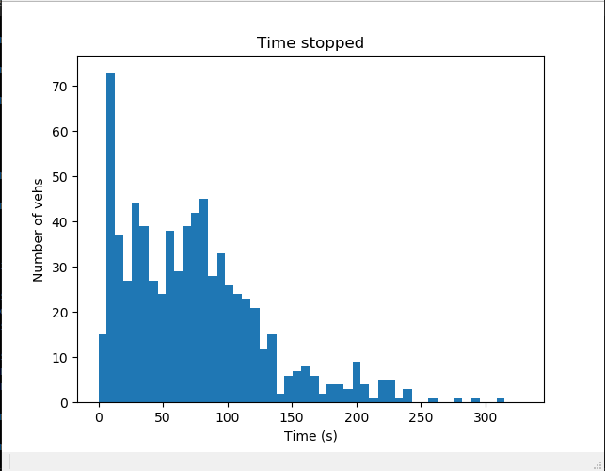

Figure : SCATS time stopped

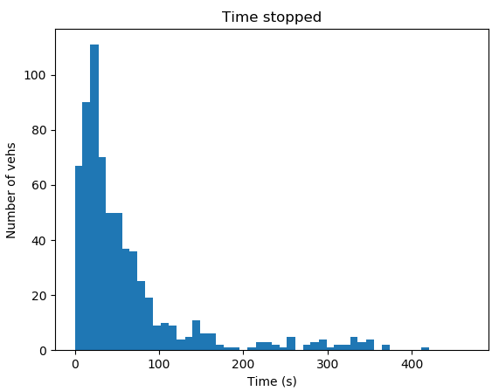 REDO

Figure : RL time stopped

EDF:

timeLoss: mean = 49 Std Dev = 43

timeStopped: mean = 31 Std Dev = 41

number of vehicle that completed their routes = 711

SCATS:

timeLoss: mean = 73.89 Std Dev = 55.03

timeStopped: mean = 53.47 Std Dev = 50.91

number of vehicle that completed their routes = 736

RL:

timeLoss: mean = 62.93 Std Dev = 77.31

timeStopped: mean = 39.23 Std Dev = 69.82

routes completed = 665

Hypothesis: vehicles may not be generated? Thus timeloss isn’t counted? Could try extend incoming roads and test again.

REDO with graphs

New EDF:

timeLoss: mean = 59.4 Std Dev = 51.0

timeStopped: mean = 39.6 Std Dev = 45.1

number of vehicle that completed their routes = 790

EDF seeds 43-47:

|  |  |  |
| --- | --- | --- |
| timeLoss mean | timeStopped mean | Mean speed |
| 57 | 39 | 7.78 |
| 51 | 35 | 7.57 |
| 50 | 32 | 8.25 |
| 54 | 36 | 7.87 |
| 58 | 39 | 7.79 |
| Avg: 54 | 36.2 | 7.852 |