Do Extra Paid Classes Improve Mathematics Grades? A Learning Comparison Using the Student Performance Dataset
Kshitij Taluja, Sahaja D, Devansh Chhabria, Aliston Laiju
Golden Gate University
Statistics project | Education: Learning comparison | Prepared for Dr Durga Sharma

Abstract
Many school students take extra paid classes in mathematics, but the evidence on whether they help is mixed. This study compares learning modes using the Student Performance dataset from Kaggle, which contains records for 395 secondary school students in Portugal. The main comparison is between students who took extra paid mathematics classes and those who did not, with extra school support and family support as two further modes. Preprocessing showed that 38 students had a final grade of 0 even though they had real grades earlier in the year, so these were treated as missing final grades and the analysis used 357 students. Four techniques were applied: 95% confidence intervals with Welch t-tests, a chi-square test, Pearson correlation and multiple linear regression. With the zeros left in, students with paid classes appeared to score 0.94 points higher (p = 0.038). After cleaning, the difference was −0.19 points (95% CI −0.86 to 0.48, p = 0.585), pass rates were similar (75.1% and 73.4%, p = 0.70), and the adjusted regression effect was −0.17 (p = 0.31). First period grade was the strongest predictor of the final grade (r = 0.89). Students who received extra school support scored lower, which most likely reflects who is offered support rather than harm from it. The results show that paid classes were not linked with higher final grades in this sample, and that a single preprocessing decision can reverse a conclusion.
Keywords: learning comparison; private tutoring; mathematics achievement; hypothesis testing; regression; data preprocessing

1. Introduction
Students today learn mathematics in more than one place. There is the regular classroom, but there are also extra paid classes, support sessions run by the school, help from family at home and, more recently, AI tutors. Each of these is a different learning mode, and parents and students spend real time and money choosing between them. Paid tuition in particular has become so common in many countries that researchers call it "shadow education", because it follows and copies the school curriculum (Zhang & Bray, 2020).
The question of whether these modes actually improve marks is not settled. Some large studies find a positive effect of tutoring on mathematics, others find almost none, and some even find negative associations once background is taken into account (Bray, 2014; Karakuş et al., 2024). One reason for the confusion is that students do not end up in paid classes at random. Families with more resources are more likely to pay for classes, and weaker students are often sent to them for remedial help. A simple comparison of averages can therefore mislead.
This project uses a public dataset to compare learning modes in a careful way. The data come from Cortez and Silva (2008), who collected school reports and questionnaires from students in two Portuguese secondary schools and published them for research use. The dataset records whether each student took extra paid classes in mathematics, whether they received extra educational support from the school, and whether their family supported their studies, along with their grades in three periods of the school year.
The research problem is to find out whether students who take extra paid mathematics classes achieve higher final grades than students who do not, and whether any difference remains after accounting for earlier grades and background. The objectives are:
- to clean and prepare the dataset, with clear rules for missing or impossible values and outliers;
- to describe the grades of each group with summary statistics and graphs;
- to compare final grades and pass rates between groups using confidence intervals, Welch t-tests and a chi-square test;
- to measure how final grades relate to earlier grades, study time, past failures and absences using correlation;
- to estimate the effect of paid classes while holding prior grade and other factors constant using multiple regression;
- to compare paid classes with two other learning support modes, extra school support and family support.
The contribution of the project is a learning comparison that the original dataset paper did not make. Cortez and Silva (2008) used the data to predict grades with data mining models. This project instead asks an inferential question about learning modes, adjusts for prior attainment, and shows how the treatment of zero final grades changes the answer.

2. Literature Review

2.1 Statistical basis for comparing two groups
The base paper for this topic, Shreffler and Huecker (2023), explains the two errors that a hypothesis test can make. A Type I error is concluding that two groups differ when they do not, and a Type II error is concluding that there is no difference when one exists. Statistical power is the probability of correctly rejecting a false null hypothesis, and many researchers treat a power of 80% or higher as adequate. Power depends on the significance level, the sample size and the size of the effect. The authors also warn that very large samples can make small differences statistically significant, so the size of a difference matters as much as its p value. This guidance shapes how the present study reports results: every test is reported with an effect size and a confidence interval, not a p value alone.
For comparing two group means, Delacre et al. (2017) recommend Welch's t-test as the default instead of Student's t-test. Welch's test does not assume that the two groups have equal variances, and it performs almost as well as Student's test when the variances happen to be equal. The authors also advise against first testing for equal variances and then choosing the test, because that two step procedure distorts error rates. The present study follows this advice.
Regression analysis estimates how a dependent variable changes with one or more independent variables, usually by the method of least squares (Encyclopaedia Britannica, n.d.). In a learning comparison, multiple regression is useful because it can estimate the difference between groups while holding other variables, such as a student's earlier grade, constant.

2.2 Educational data mining and the Student Performance dataset
Educational data mining applies statistical and machine learning methods to data from educational settings. Baker and Yacef (2009) reviewed the field and grouped its methods into prediction, clustering, relationship mining, distillation of data for human judgment, and discovery with models. Most early work focused on prediction, for example predicting which students will fail a course.
Cortez and Silva (2008) is a clear example of this predictive approach. They built a dataset from school reports and questionnaires in two Portuguese secondary schools and used decision trees, random forests, neural networks and support vector machines to predict grades in mathematics and Portuguese. They found that good predictive accuracy was possible when the first and second period grades were available, and that other features such as absences, parents' jobs and education, and alcohol use were also relevant. However, their aim was prediction. They did not test whether a particular learning mode, such as extra paid classes, was linked with better grades, and they did not report how zero final grades were handled.

2.3 What existing work says about paid classes and tutoring
Bray (2014) explains why research on the effect of private tutoring on achievement is inconclusive and even contradictory. Tutoring comes in many formats, intensities and qualities, students take it for different reasons, and many studies have weak data or methods. Zhang and Bray (2020) reviewed two decades of comparative research on shadow education and reached a similar conclusion: the field has grown quickly, but definitions and methods still need attention, and new forms of tutoring linked to technology need study.
Large scale studies show how mixed the results are. Karakuş et al. (2024) analysed PISA 2022 data from 55 countries using multilevel regression. Only one form of tutoring, asynchronous video recorded instruction, was associated with higher mathematics performance. Some live forms of tutoring had negative associations, which the authors suggest may reflect their use for remedial purposes, since weaker students are the ones sent for extra help.
Other studies find positive but uneven effects. Tan and Liu (2023) used the China Education Panel Survey and hierarchical linear models to study eighth grade students. Tutoring had a positive average effect on mathematics and English, but the benefit was larger for students with weaker prior performance and those in lower ranked schools, and richer families were more likely to use tutoring. Benz et al. (2024) compared longitudinal data from Ireland and Germany and found that shadow education improved performance only for students with lower prior achievement, and that its link with performance was not much stronger than that of other structured activities outside school.
Two lessons follow for this project. First, prior achievement must be controlled, because it affects both who takes paid classes and how well they do later. Second, a raw difference in averages between tutored and untutored students should not be read as the effect of tutoring.

2.4 New learning modes
AI tutors are now a further learning mode. In a field experiment with high school mathematics students, Bastani et al. (2025) found that unrestricted GPT-4 access improved performance during practice but lowered performance once access was removed, while a tutor designed with learning safeguards largely avoided this harm. In a physics course, Kestin et al. (2025) found that a carefully designed AI tutor produced larger learning gains than in-class active learning. These studies suggest that the design of a learning mode matters more than its label, which is the same lesson the tutoring literature reaches.

2.5 Research gap
Existing work leaves three gaps that this project addresses. First, the Student Performance dataset has mostly been used for prediction, not for testing a learning comparison with inferential statistics. Second, many tutoring studies compare raw means without showing how sensitive the conclusion is to data cleaning decisions. Third, few studies compare several support modes, paid classes, school support and family support, side by side on the same students with the same outcome. This project combines confidence intervals, Welch t-tests, a chi-square test, correlation and multiple regression on one dataset, adjusts for the first period grade, and reports the comparison both before and after cleaning.

3. Methodology

3.1 Research questions and hypotheses
The primary research question is whether students who took extra paid mathematics classes have a different mean final grade from students who did not.
- H1. Null: the mean final grade (G3) is the same in both groups. Alternative: the means differ.
- H2. Null: the pass rate (G3 of 10 or more) is independent of extra paid classes. Alternative: the pass rate depends on group.
- H3. Null: after controlling for first period grade, past failures, study time, absences, school support, family support and mother's education, the coefficient for extra paid classes is zero. Alternative: it is not zero.
A secondary question compares the three support modes. All tests are two-sided at a significance level of 0.05.

3.2 Data source
The data are secondary data from the Student Performance dataset (Cortez & Silva, 2008). The mathematics file, student-mat.csv, was used. It is available on Kaggle as part of the Student Alcohol Consumption dataset and on the UCI Machine Learning Repository. It contains 395 students and 33 variables collected from school reports and questionnaires in two public secondary schools in Portugal. Students are anonymous, so no ethical approval was needed for this secondary analysis. A student identifier (S001 to S395) was added to keep track of rows. Table 1 lists the variables used.
Table 1. Variables used in the analysis.
Variable | Description | Values
paid | Extra paid classes in mathematics | yes / no
schoolsup | Extra educational support from the school | yes / no
famsup | Family educational support | yes / no
G1, G2 | First and second period grades | 0 to 20
G3 | Final grade (outcome) | 0 to 20; pass if 10 or more
studytime | Weekly study time | 1 (under 2 h) to 4 (over 10 h)
failures | Number of past class failures | 0 to 3
absences | Number of school absences | 0 to 75 in these data
Medu | Mother's education | 0 (none) to 4 (higher education)
age | Student age in years | 15 to 22

3.3 Data preprocessing
Missing values were checked first. There were no blank cells in any of the 33 variables.
The final grade needed closer attention. Thirty eight students had a final grade of 0 (Figure 1). These students had real grades earlier in the year, with a mean first period grade of 7.53, and every one of them had 0 absences recorded. A grade of 0 on a scale where the next lowest final grade is 4 is very unlikely to be a measured score. It is much more likely that these students left the course or did not sit the final assessment, so that no final grade was recorded. These 38 rows were therefore treated as missing final grades and removed from the main analysis, leaving 357 students. Because this decision could change the result, the main comparison was also repeated with the zeros included, and the rate of missing final grades was compared between groups.
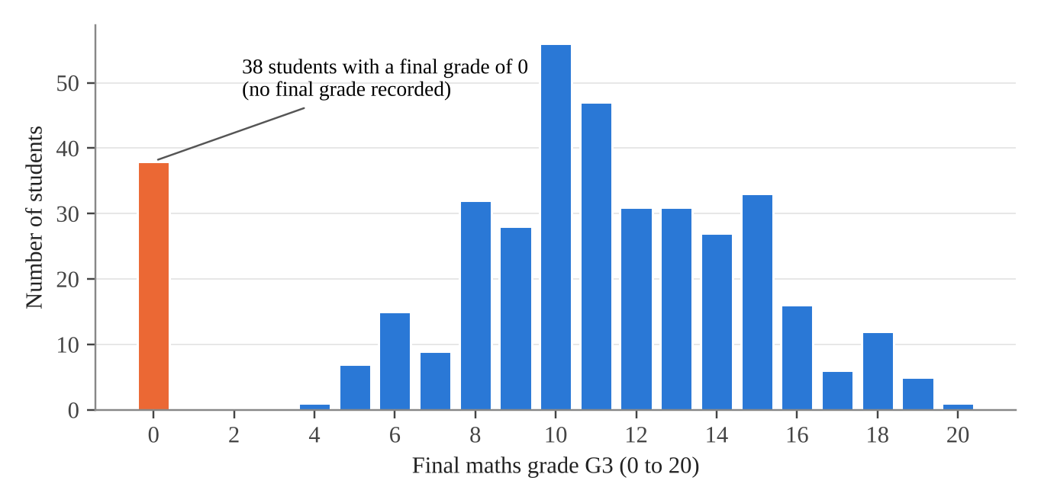
Figure 1. Distribution of the final grade G3 for all 395 students before cleaning.
Outliers were checked with the 1.5 × IQR rule. No final grades fell outside the fences after the zeros were removed. Twenty five students had more absences than the upper fence of 17. These were kept, because high absence counts are real records and not errors, but the regression was repeated without them as a sensitivity check.
Three transformations were made. The yes and no variables were recoded as 1 and 0. A pass variable was created, equal to 1 when G3 was 10 or more, the pass mark on the 0 to 20 scale. A grade change variable was created as G3 minus G1. Table 2 summarises the preprocessing.
Table 2. Preprocessing summary.
Step | Result | Decision
Missing values | 0 blank cells in 395 rows | No imputation needed
Final grade of 0 | 38 students; all had 0 absences; mean G1 = 7.53 | Treated as missing final grade; removed from main analysis (n = 357); comparison repeated with zeros
Outliers in G3 | None outside 1.5 × IQR fences after cleaning | None removed
Outliers in absences | 25 students above the fence of 17 | Kept; regression repeated without them
Recoding | yes/no to 1/0; pass = G3 of 10 or more; change = G3 minus G1 | Used in tests and regression

3.4 Statistical techniques
Five techniques were used. Descriptive statistics and graphs (histograms, boxplots and scatter plots) were used for exploratory analysis. Then four inferential techniques were applied:
- Confidence intervals: 95% t-based intervals for each group mean and for the difference between means.
- Hypothesis testing: Welch's two sample t-test for H1, and a chi-square test of independence for H2 and for the missing final grade rate.
- Correlation: Pearson correlation between the final grade and earlier grades, study time, failures, absences, mother's education and age.
- Regression: multiple linear regression of G3 on extra paid classes and seven control variables for H3.
All calculations were done in Microsoft Excel using built-in functions (AVERAGE, STDEV, TINV, TTEST, CHITEST, CORREL and LINEST). Every result was checked against the same analysis in Python with SciPy and statsmodels, and the two gave identical values. A Mann-Whitney U test and regression with robust (HC3) standard errors were run in Python as further checks.

4. Data Analysis

4.1 Descriptive statistics
Table 3 gives summary statistics for the 357 students in the cleaned data. The mean final grade was 11.52 out of 20 (SD 3.23) and the median was 11. The first and second period grades had almost the same mean and spread as the final grade. Absences were strongly right skewed, with a median of 4 but a maximum of 75. Most students had no past failures.
Table 3. Descriptive statistics for the cleaned data (n = 357).
Variable | Mean | SD | Min | Q1 | Median | Q3 | Max
G1 | 11.27 | 3.24 | 3 | 9 | 11 | 14 | 19
G2 | 11.36 | 3.15 | 5 | 9 | 11 | 14 | 19
G3 | 11.52 | 3.23 | 4 | 9 | 11 | 14 | 20
absences | 6.32 | 8.19 | 0 | 2 | 4 | 8 | 75
studytime | 2.04 | 0.83 | 1 | 1 | 2 | 2 | 4
failures | 0.27 | 0.67 | 0 | 0 | 0 | 0 | 3
Medu | 2.80 | 1.09 | 0 | 2 | 3 | 4 | 4
age | 16.66 | 1.27 | 15 | 16 | 17 | 18 | 22

The two groups were similar at the start of the year. Students with paid classes had a mean first period grade of 11.19 and those without had 11.34. Students with paid classes had slightly fewer past failures (0.19 and 0.35 on average) and mothers with slightly more education (2.97 and 2.63 on the 0 to 4 scale).

4.2 Exploratory graphs
Figure 1 shows the full grade distribution before cleaning. Apart from the spike at 0, the final grades form a single hump centred near 10 to 11, with a slight right skew. Figure 2 compares the cleaned final grades of the two groups. The medians are both 11, and the boxes overlap almost completely. The group without paid classes has a slightly wider spread.
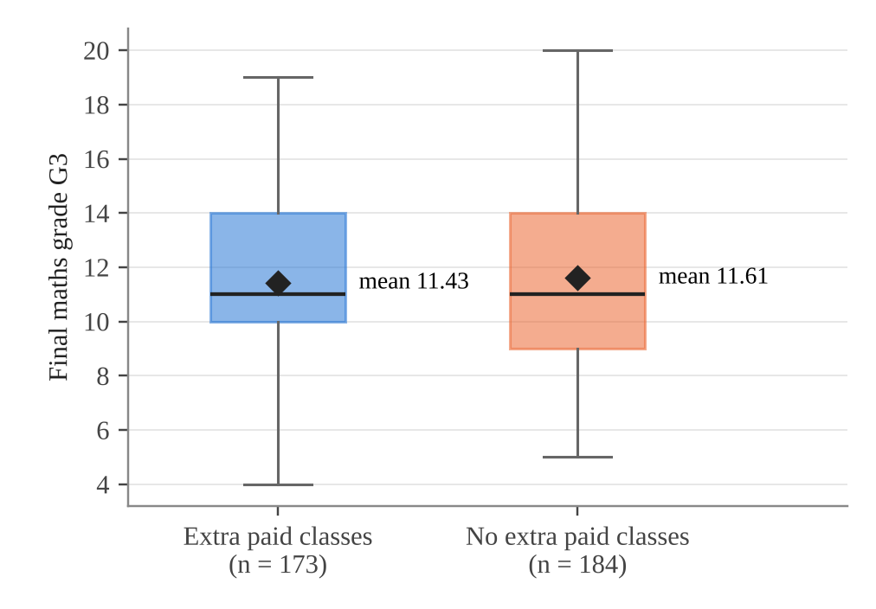
Figure 2. Final grade by extra paid classes (cleaned data). Diamonds mark the means.
Figure 3 plots each student's final grade against their first period grade. The points lie close to a straight line, and the fitted lines for the two groups are almost on top of each other. This already suggests that once the first period grade is known, taking paid classes adds little information about the final grade.
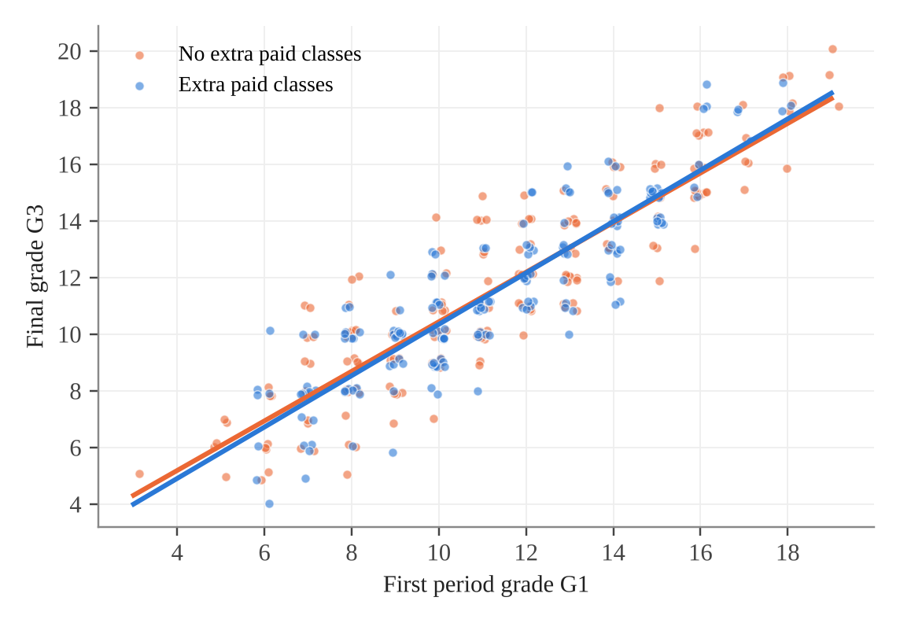
Figure 3. Final grade against first period grade, with a fitted line for each group (points slightly jittered).

4.3 Confidence intervals and Welch t-tests
Table 4 shows the group comparisons. In the cleaned data, students with paid classes had a mean final grade of 11.43 (95% CI 10.97 to 11.88) and students without had 11.61 (95% CI 11.12 to 12.11). The difference was −0.19 points, with a 95% CI of −0.86 to 0.48. Welch's t-test gave t(354.1) = −0.55, p = 0.585, and Cohen's d was −0.06. The Mann-Whitney U test agreed (p = 0.608).
With the 38 zeros left in, the result changes. Students with paid classes then appear to score 0.94 points higher (10.92 against 9.99), t(386.4) = 2.08, p = 0.038. This apparent advantage comes from the zeros, not from higher grades among students who sat the final assessment.
The grade change from the first to the final period was almost identical in the two groups (0.24 and 0.27 points, p = 0.827).
Table 4. Comparison of final grades by learning support mode (Welch t-tests).
Comparison | Yes: mean (n) | No: mean (n) | Difference [95% CI] | t (df) | p
Extra paid classes, G3, cleaned | 11.43 (173) | 11.61 (184) | −0.19 [−0.86, 0.48] | −0.55 (354.1) | 0.585
Extra paid classes, G3, zeros included | 10.92 (181) | 9.99 (214) | 0.94 [0.05, 1.82] | 2.08 (386.4) | 0.038
Extra paid classes, G3 minus G1 | 0.24 (173) | 0.27 (184) | −0.03 [−0.35, 0.28] | −0.22 (354.4) | 0.827
Extra school support, G3 | 9.62 (50) | 11.83 (307) | −2.21 [−3.02, −1.41] | −5.46 (76.9) | < 0.001
Family support, G3 | 11.35 (219) | 11.80 (138) | −0.45 [−1.13, 0.24] | −1.28 (296.4) | 0.202
Difference is yes minus no. All rows except the second use the cleaned data.
Figure 4 compares the three support modes. Family support showed no significant difference (11.35 against 11.80, p = 0.202). Students receiving extra school support scored much lower than those who did not (9.62 against 11.83, difference −2.21, t(76.9) = −5.46, p < 0.001). This result stays significant after a Holm correction for the three comparisons.
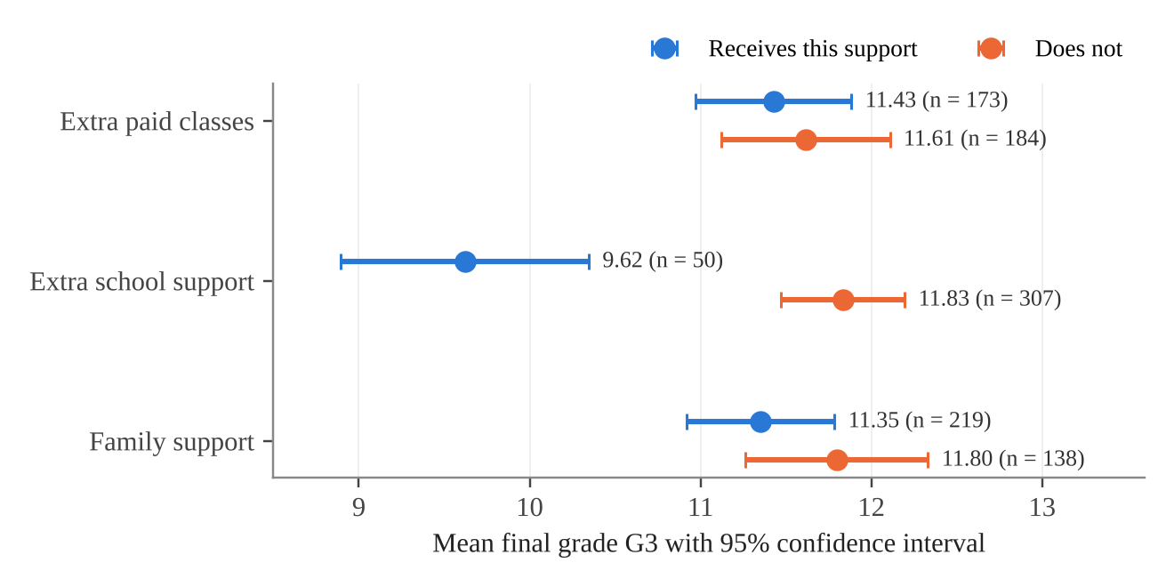
Figure 4. Mean final grade with 95% confidence intervals for three learning support modes (cleaned data).

4.4 Chi-square tests
Pass rates were close in the two groups: 75.1% of students with paid classes passed (130 of 173) and 73.4% of those without passed (135 of 184). The chi-square test gave χ²(1) = 0.15, p = 0.70, so H2 is not rejected.
The rate of missing final grades did differ. Only 4.4% of students with paid classes (8 of 181) had no final grade recorded, against 14.0% of students without paid classes (30 of 214), χ²(1) = 10.39, p = 0.001.

4.5 Correlation
Table 5 shows the correlation of each variable with the final grade. The first and second period grades were very strongly correlated with the final grade (r = 0.89 and r = 0.97). Past failures (r = −0.29), absences (r = −0.21) and age (r = −0.14) had weak negative correlations, and mother's education (r = 0.19) and study time (r = 0.13) had weak positive correlations. All were significant at the 0.05 level. The very strong link between earlier and final grades confirms that prior grade must be controlled when comparing groups.
Table 5. Pearson correlation of each variable with the final grade G3 (n = 357).
Variable | r | p
G1 | 0.89 | < 0.001
G2 | 0.97 | < 0.001
failures | −0.29 | < 0.001
absences | −0.21 | < 0.001
Medu | 0.19 | < 0.001
age | −0.14 | 0.008
studytime | 0.13 | 0.017

4.6 Multiple regression
Table 6 shows the regression of the final grade on extra paid classes and seven controls. The model explained 81.0% of the variation in final grades (adjusted R² = 0.805, F(8, 348) = 185.17, p < 0.001). Holding the other variables constant, the coefficient for paid classes was −0.17 (95% CI −0.48 to 0.15, p = 0.307), so H3 is not rejected. The first period grade was the strongest predictor: each extra point in G1 went with 0.87 more points in G3. Each additional absence went with a 0.045 point lower final grade (p < 0.001). Mother's education was close to significance (p = 0.052). Once G1 was in the model, extra school support was no longer linked with the final grade (coefficient −0.05, p = 0.835).
Table 6. Multiple linear regression of the final grade G3 (n = 357).
Term | Coefficient | SE | t | p | 95% CI
Intercept | 1.725 | 0.406 | 4.25 | < 0.001 | [0.93, 2.52]
Extra paid classes (yes = 1) | −0.165 | 0.161 | −1.02 | 0.307 | [−0.48, 0.15]
G1 | 0.865 | 0.026 | 33.15 | < 0.001 | [0.81, 0.92]
failures | −0.033 | 0.122 | −0.27 | 0.786 | [−0.27, 0.21]
studytime | −0.025 | 0.094 | −0.27 | 0.790 | [−0.21, 0.16]
absences | −0.045 | 0.009 | −4.72 | < 0.001 | [−0.06, −0.03]
Extra school support (yes = 1) | −0.047 | 0.228 | −0.21 | 0.835 | [−0.49, 0.40]
Family support (yes = 1) | 0.129 | 0.167 | 0.77 | 0.442 | [−0.20, 0.46]
Medu | 0.143 | 0.073 | 1.95 | 0.052 | [0.00, 0.29]
R² = 0.810, adjusted R² = 0.805, F(8, 348) = 185.17, p < 0.001.
The conclusion did not change in the sensitivity checks. With robust HC3 standard errors the paid classes coefficient had p = 0.327, and without the 25 students above the absence fence it was −0.16 with p = 0.338.

5. Results and Discussion
The main result is clear. In this sample, students who took extra paid mathematics classes did not achieve higher final grades than those who did not. The difference in means was small and not significant, the pass rates were almost the same, the grade change over the year was the same, and the adjusted regression effect was close to zero with a confidence interval that rules out any gain larger than about 0.15 points on a 20 point scale.
This fits the mixed picture in the literature. Bray (2014) argued that tutoring effects are hard to pin down because tutoring varies so much, and large international studies such as Karakuş et al. (2024) also find little or no average link between tutoring and mathematics scores. Benz et al. (2024) and Tan and Liu (2023) found benefits mainly for weaker students. In the present data the paid classes group started the year at the same level as the others, so there is no sign that these classes were mainly remedial, and no average benefit appears.
The second result is about method. If the 38 zero grades had been treated as real scores, the analysis would have reported a significant advantage for paid classes (p = 0.038). This advantage came entirely from the fact that students without paid classes were more likely to have no final grade recorded. One possible reading is that students in paid classes were less likely to drop out of the course. However, this is an observational dataset, and families who pay for classes may differ in motivation or resources, so the difference in missing final grades cannot be read as an effect of the classes. What the result does show is that a single preprocessing decision can reverse the conclusion of a learning comparison, which supports the call by Zhang and Bray (2020) for more care with methods.
The third result concerns school support. Students receiving extra school support had final grades more than two points lower, but this gap disappeared once the first period grade was controlled. This is consistent with schools giving support to students who were already struggling, the same remedial pattern described by Karakuş et al. (2024). It shows why the raw comparison of support modes in Figure 4 should not be read as a ranking of how well each mode works.
The correlation and regression results also show that earlier grades and attendance matter far more than the type of extra support. The first period grade alone explained most of the variation in the final grade, and absences had a clear negative link. For students and parents, this suggests that steady attendance and early performance are better guides to the final result than whether a student pays for extra classes.
The study has limitations. The data are observational, so none of the comparisons prove cause and effect. The paid classes variable is a simple yes or no and does not record the hours, quality or format of the classes, which Bray (2014) identifies as key reasons tutoring effects vary. The sample comes from two schools in one country in the 2005 to 2006 school year, so the results may not apply to other systems such as Indian coaching classes today. The meaning of the zero grades is inferred from the pattern in the data, since the dataset does not explain them. Finally, with 173 and 184 students the study had good power to detect a medium effect but limited power to detect a very small one.

6. Conclusion and Future Scope
This project compared learning modes in mathematics using a public dataset of 395 secondary school students. After removing 38 final grades of 0 that most likely meant no grade was recorded, students who took extra paid classes had almost exactly the same final grades and pass rates as those who did not, and the difference stayed near zero after controlling for first period grade and background. Earlier grades and absences were much stronger predictors of the final grade. Students given extra school support scored lower, but this reflected their weaker starting point rather than any harm from the support.
The project makes two contributions. It turns a dataset that was built for prediction into a learning comparison tested with confidence intervals, hypothesis tests, correlation and regression. It also shows that the conclusion depends on how missing final grades are handled: with the zeros left in, paid classes appear to help, and with them treated correctly, they do not.
Future work could extend this in several ways. The same analysis could be repeated on the Portuguese language file of the same dataset to see whether the pattern holds in another subject. Data that record the hours and type of paid classes would allow a closer test of which forms of tutoring help. Longitudinal data with several measures before and after tutoring would support stronger causal methods such as propensity score matching. Finally, AI tutors are now a fourth learning mode alongside paid classes, school support and family help. Building on Bastani et al. (2025), a natural next step would be a randomized comparison of AI tutoring designs, for example teaching students a structured routine for checking AI-generated mathematics solutions, against ordinary checking advice.

Declarations
Data availability: The dataset is publicly available on Kaggle (https://www.kaggle.com/datasets/uciml/student-alcohol-consumption, file student-mat.csv) and on the UCI Machine Learning Repository (https://archive.ics.uci.edu/dataset/320/student+performance). The cleaned dataset and the Excel workbook containing every calculation are provided as supporting files.
Ethics: This study used anonymous, publicly available secondary data. No new data were collected from participants.
Author contributions: All four authors contributed to the literature review, data analysis, interpretation and writing, and approved the final version.
AI assistance: AI tools assisted with editing and with checking calculations. All results were verified by the authors in Excel, and the authors are responsible for the content.
Funding and competing interests: None.

References
Baker, R. S. J. d., & Yacef, K. (2009). The state of educational data mining in 2009: A review and future visions. Journal of Educational Data Mining, 1(1), 3–17. https://doi.org/10.5281/zenodo.3554658
Bastani, H., Bastani, O., Sungu, A., Ge, H., Kabakcı, Ö., & Mariman, R. (2025). Generative AI without guardrails can harm learning: Evidence from high school mathematics. Proceedings of the National Academy of Sciences, 122(26), e2422633122. https://doi.org/10.1073/pnas.2422633122
Benz, R., Darmody, M., & Smyth, E. (2024). Participation in shadow education and academic performance: A comparison of upper secondary school students in Ireland and Germany. International Journal of Comparative Sociology. Advance online publication. https://doi.org/10.1177/00207152241266791
Bray, M. (2014). The impact of shadow education on student academic achievement: Why the research is inconclusive and what can be done about it. Asia Pacific Education Review, 15(3), 381–389. https://doi.org/10.1007/s12564-014-9326-9
Cortez, P., & Silva, A. M. G. (2008). Using data mining to predict secondary school student performance. In A. Brito & J. Teixeira (Eds.), Proceedings of the 5th Future Business Technology Conference (FUBUTEC 2008) (pp. 5–12). EUROSIS-ETI.
Delacre, M., Lakens, D., & Leys, C. (2017). Why psychologists should by default use Welch's t-test instead of Student's t-test. International Review of Social Psychology, 30(1), 92–101. https://doi.org/10.5334/irsp.82
Encyclopaedia Britannica. (n.d.). Regression analysis. In Encyclopaedia Britannica. Retrieved November 10, 2026, from https://www.britannica.com/science/regression-analysis
Karakuş, M., Tlessov, A., Hajar, A., & Courtney, M. (2024). Illuminating the shadows: The role of private supplementary tutoring on student math performance in PISA 2022. Large-scale Assessments in Education, 12, Article 42. https://doi.org/10.1186/s40536-024-00228-5
Kestin, G., Miller, K., Klales, A., Milbourne, T., & Ponti, G. (2025). AI tutoring outperforms in-class active learning: An RCT introducing a novel research-based design in an authentic educational setting. Scientific Reports, 15, 17458. https://doi.org/10.1038/s41598-025-97652-6
Shreffler, J., & Huecker, M. R. (2023). Type I and type II errors and statistical power. In StatPearls. StatPearls Publishing. https://www.ncbi.nlm.nih.gov/books/NBK557530/
Tan, M., & Liu, S. (2023). A way of human capital accumulation: Heterogeneous impact of shadow education on students' academic performance in China. SAGE Open, 13(4). https://doi.org/10.1177/21582440231207189
UCI Machine Learning. (n.d.). Student alcohol consumption [Data set; file student-mat.csv]. Kaggle. https://www.kaggle.com/datasets/uciml/student-alcohol-consumption
Zhang, W., & Bray, M. (2020). Comparative research on shadow education: Achievements, challenges, and the agenda ahead. European Journal of Education, 55(3), 322–341. https://doi.org/10.1111/ejed.12413

