ANGRY BIRDS
FALCON
STRATEGY AND CODE
EXPLANATION
By: Nikhil Jain(201201183)
Anish Goel(201201212)
Mayank Kunawat(201201213)

TOTAL SCORE : 1014000(Level Wise Score at last)

We need to kill all pigs with minimum number of birds causing as much damage as possible to the structure.

A state can be defined by the number of birds left and the number of pigs left with the score till now.
The terminating states are when no pig is left or no bird is left and there is at least one pig left.
The goal state is when no pig is left.
The utility of all terminating states is as follows:
1. No pig left: score at that instant.
2. Pigs left but no birds left: -1.
Of all goal states the optimal goal states are the one with maximum scores.
The goal is to reach the goal state with the maximum utility.
The problem required us to solve the following sub problems in a sequential manner:
- Finding the appropriate target point.
- Choosing an appropriate trajectory (high or low) or a release point.
- Computing the optimal tap time if required.

Strategy Outline

- Finding the appropriate target point
First of all we try to hit at a point near some pig. In deciding a point near to some pig as the target point we used the following heuristics.
Heuristics used:
- HIT_BASE_HUERISTIC: Hitting at the base of a pig if the base is not stone and the trajectory to this base is obstacle free that is it can be hit directly would cause more damage to the structure and the pig itself than some other point.

- HIT_TOP_HUERISTIC: Hitting at the top of a pig would also a cause a lot damage to the structure and the pig itself.
That is for points near to the pig, choosing the base or the top would be optimal.

If no top or base point found, then we hit at the center of mass (COM) assuming the following heuristic.

- HIT_COM_HUERISTIC: Hitting at the point where the whole mass of the structure can be assumed to be concentrated would cause a lot of damage to the structure.

The functions needed to compute BASE, TOP and COM are described below.
Using these, the target point is found.

- Choosing the appropriate trajectory or release point

- LOW_TRAJACTORY_HUERISTIC : The trajectory with the smaller release angle or the low one would cause more damage than the one with large release angle or the high one since it has more speed and thus more energy. So we choose a low trajectory if and only if there are no obstacles in the path of trajectory from sling to target point.

The function Select_trajectory described below selects the appropriate trajectory or the release point.
- Computing the appropriate tap time if required

- TAP_BEFORE_HIT: The damage to the structure or the impact of the shot would be maximum when the tap point is just before hitting the structure that is just before the trajectory enters the structure.

The function Compute_Tap_Interval compute the optimal tap point or the tap time.

New Functions Included

COM_Dynamic: Calculates Center of Mass(COM) with dynamic masses i.e. the average mass of pig, stone, wood and ice is computed dynamically (at run time) using the formula :
mass_stone = total_mass(say,stone) / #stones
The mass of stone is divided by 2 and the mass of pig is mutiplied by 3, so that COM lies close to pigs and far from stones.

Then we iterate over each type of object,
i.e. say, for each stone
com.x += mass_stone*stone.getX();
com.y += mass_stone*stone.getY();
total_mass = mass_stone;

com.x = com.x/total_mass;
com.y = com.y/total_mass;
This gives us the COM;

COM_Static : Calculates Center of Mass(COM) same as COM4 but with static masses, found by hit and trial i.e. each type of object is assigned a fixed mass.

Compute_Tap_Interval : Calculates tap point for blue, yellow and other birds. We consider the part of trajectory between the sling the first point of the trajectory in any block and we choose to tap at 80 – 90% of this part of trajectory.

This is shown in the figure below:

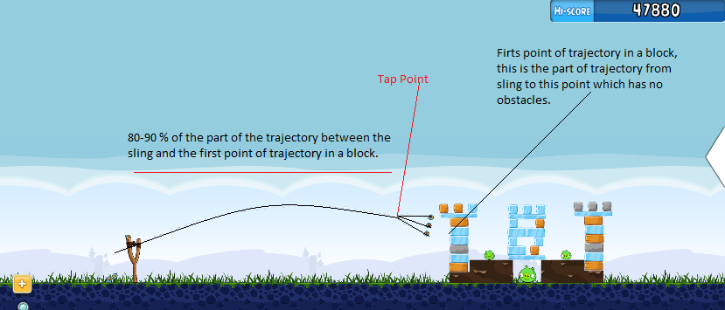

Compute_Top : Calculates a list of object which appears as tops of pigs i.e. whose
- y-coordinate is less than pig's y-coordinate and
- x-coordinate is less than or equal to pigs' x-coordinate and the sum of object's x-coordinate and it's width is greater than or equal to sum of pig's x-coordinate and its width.

For example, the tops are shown in figure below:

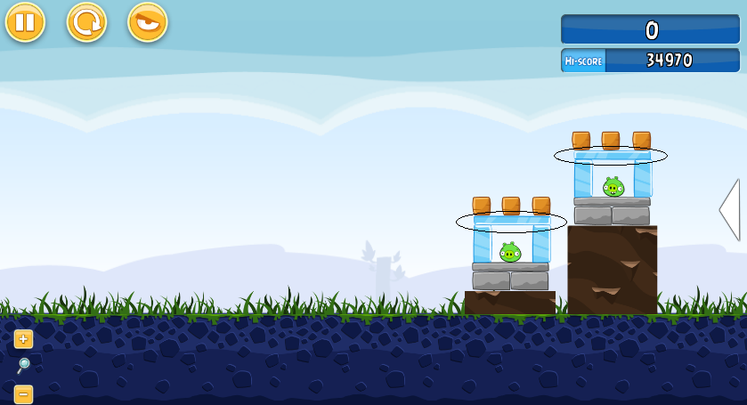

Compute_Base: Calculates a list of object which appears as bases of pigs i.e. whose
- y-coordinate is greater than pig's y-coordinate and the sum of pig’s y-coordinate , some constant(say, 8) and pig’s height is greater than or equal to y-coordinate of the object and the sum of y-coordinate of the pig and its height is less than or equal to the object’s y-coordinate and
- the sum of the object’s x-coordinate and it’s width is greater than or equal to the pigs' x-coordinate and it is less than or equal to the sum of pig’s width and pig’s x-coordinate or the object’s x-coordinate is greater than or equal to pig’s x-coordinate and it is less than or equal to sum of pig's x-coordinate and its width.

For example, the bases are shown in figure below:

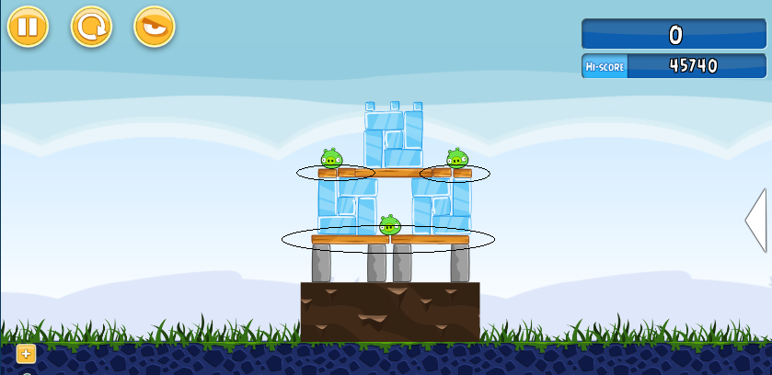

COM_Check: Checks if the COM is not so far away from pigs(may be because of some objects lying far way) by calculating the minimum distance between COM and all pigs and if this difference exceeds a threshold then the target point is set to point to the pig closest to the COM.

Select_Trajectory : Selects between the high and the low trajectory. If there is any block that blocks the trajectory path before the target point then we choose the high trajectory otherwise we choose the low one since it is expected to cause more damage.

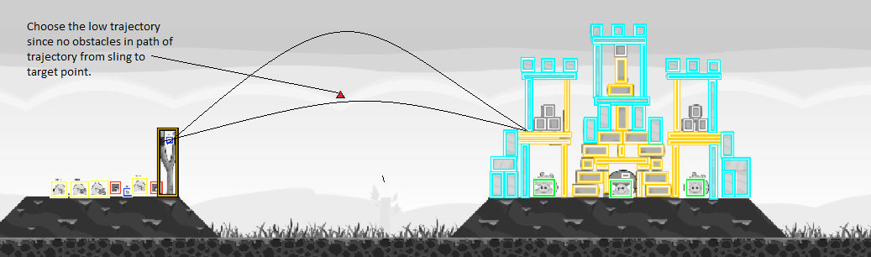

CODE_FLOW

Find the base say, BASE with least x-coordinate and max y-coordinate (returned by Compute_Base function) and which has no obstacle before it in the path of trajectory to this base.

Find the top say, TOP with least max y-coordinate (returned by Compute_Top function).

IF(BASE and TOP exists)
Then the object with larger width is selected as target point.

ELSE IF(Only BASE exists)
Target_point = BASE;

ELSE IF(Only TOP exists)
Target_point = TOP;

ELSE (None of them exists)
Target_point = COM(as computed by COM_Dynamic);

IF(COM is selected )
It is checked by COM_Check so that it is not so far away from pigs and COM is updated to hit the closest pig to COM, if COM is too far away from the pigs.

After the target_point has been selected and the corresponding release points have been evaluated.
Select_trajectory selects trajectory or the appropriate release point if there are more than one.
Compute_Tap computes tap time.
Shot is made.

SCOREBOARD
Level Number | Score
1 | 29930
2 | 52320
3 | 41910
4 | 36850
5 | 65080
6 | 37000
7 | 45720
8 | 56920
9 | 53420
10 | 65440
11 | 54610
12 | 38570
13 | 50100
14 | 48350
15 | 47230
16 | 50110
17 | 43010
18 | 50880
19 | 30030
20 | 45020
21 | 71550
Total 1014000

