create table Vehicle(

vid int primary key,

vname varchar(10),

price float,

description varchar(30));

create table customer(

cust_id int primary key,

cname varchar(10),

address varchar(10));

create table salesaman(

sid int primary key,

sname varchar(30),

address varchar(30));

create table custVehicle(

custid int,

vid int,

sid int,

buyPrice float,

constraint fk_cid foreign key(custid) references customer(cust_id)

on delete set null

on update cascade,

constraint fk_sid foreign key(sid) references salesaman(sid)

on delete set null

on update cascade,

constraint fk_vid foreign key(vid) references vehicle(vid)

on delete set null

on update cascade);

INSERT into Vehicle(vid,vname,price,description) values

(1,'Activa',80000,'Better Average'),

(2,'Santro',800000,'luxrious'),

(3,'Motor Bike',100000,'Speedy');

Query OK, 3 rows affected (0.00 sec)

Records: 3 Duplicates: 0 Warnings: 0

insert into customer(cust_id,cname,address) values

(1,'Nilima','Pimpari'),

(2,'kavya','Pune'),

(3,'Pankaj','Mumbai'),

(4,'Ketan','Nashik');

insert into salesaman(sid,sname,address) values

(10,'Rajesh','Mumbai'),

(11,'Seema','Pune'),

(13,'Rakhi','Pune');

1. create all given tables

→

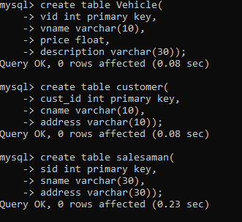

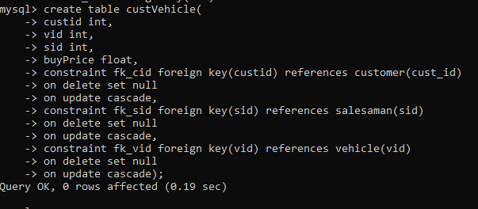

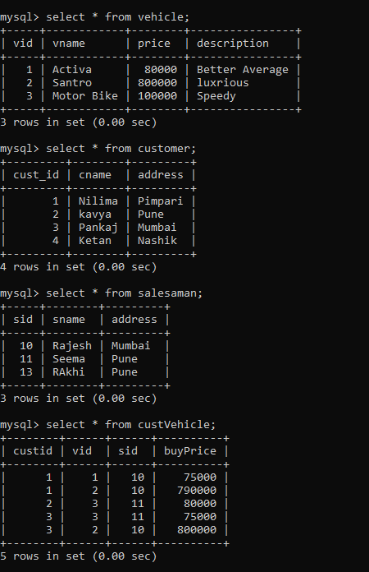

2. create index on vehicle table based on price

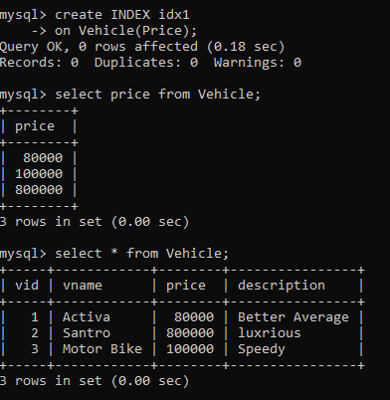

3. find all customer name,vehicle name, salesman name, discount earn by all customer.

→

create view v2

as

select c.cname, v.vname, s.sname,(v.price - cv.buyPrice) discount

from customer c, vehicle v, salesaman s, custVehicle cv

where c.cust_id = cv.custid and (cv.vid=v.vid and cv.sid=s.sid);

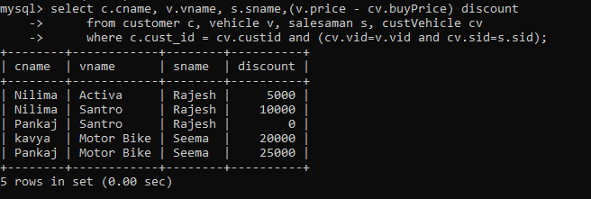

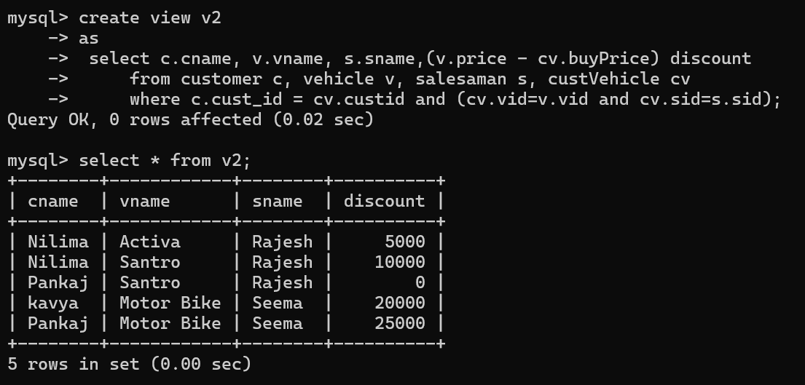

4. find all customer name,vehicle name,salesman name for all salesman who stays in pune

→

create view v1

as

select c.cname, v.vname, s.sname

from customer c, vehicle v, salesaman s,custVehicle cv

Where cv.custid = c.cust_id and v.vid = cv.vid and cv.sid=s.sid and

s.address='pune';

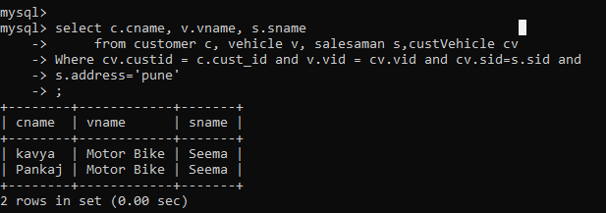

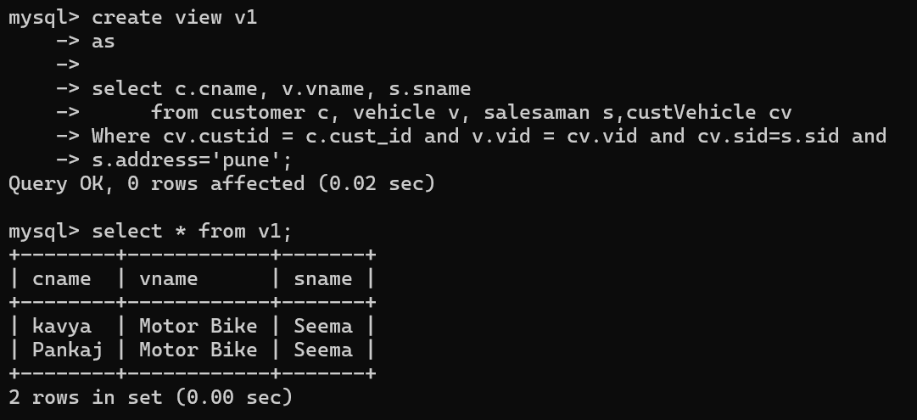

5. find how many customers bought motor bike

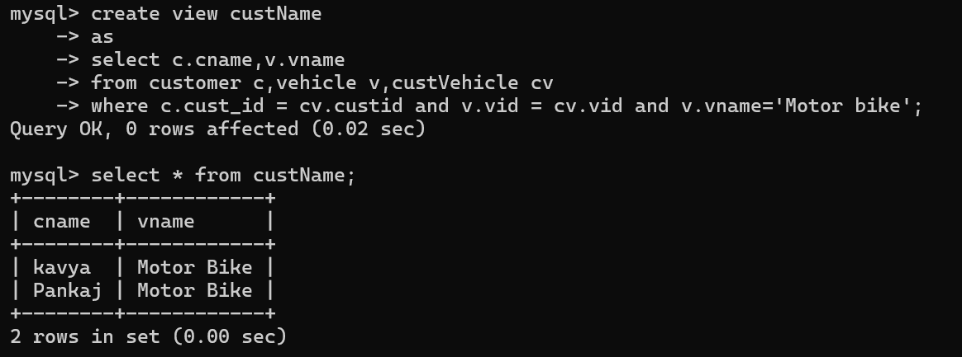

6. create a view find_discount which displays output

-------to create view

create view find_discount

-> as

-> select c.cname, v.vname, s.sname,(v.price - cv.buyPrice) discount

-> from customer c, vehicle v, salesaman s, custVehicle cv

-> where c.cust_id = cv.custid and (cv.vid=v.vid and cv.sid=s.sid);

--------to display discount

select * from find_discount;

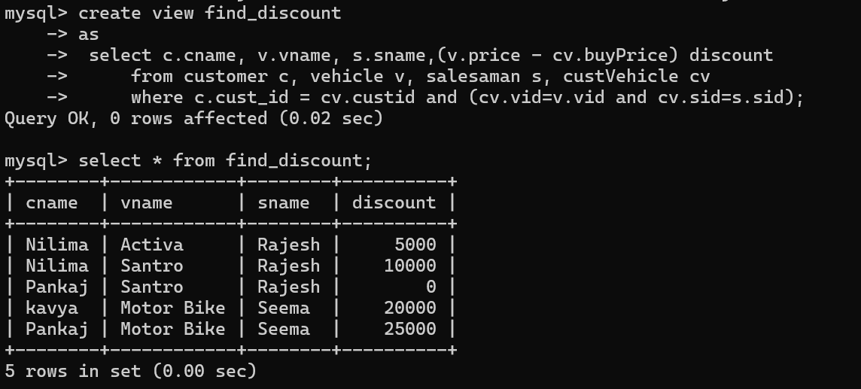

7. find all customer name, vehicle name, salesman name, discount earn by all customer



8. create view my_hr to display empno,ename,job,comm for all employees who earn

Commission

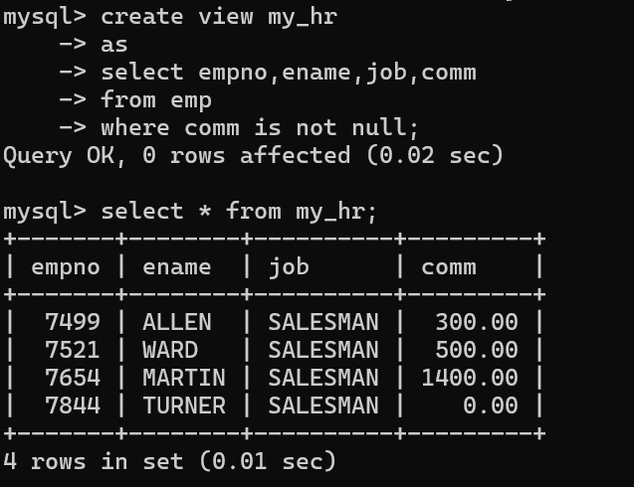

9. create view mgr30 to display all employees from department 30

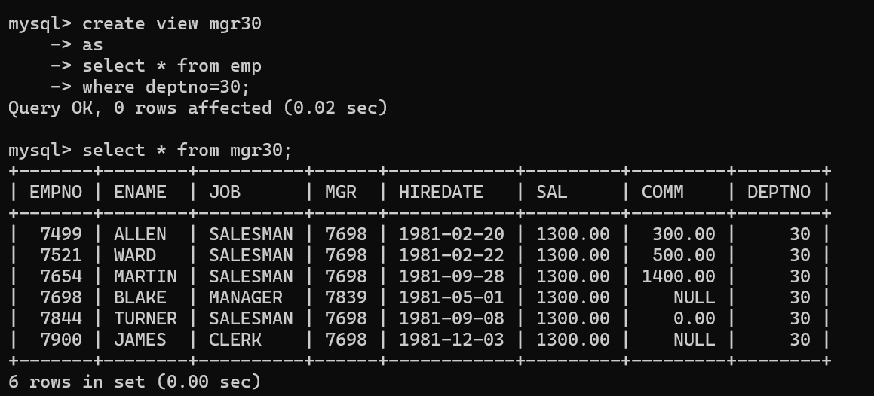

10. insert 3 employees in view mgr30 check whether insertion is possible

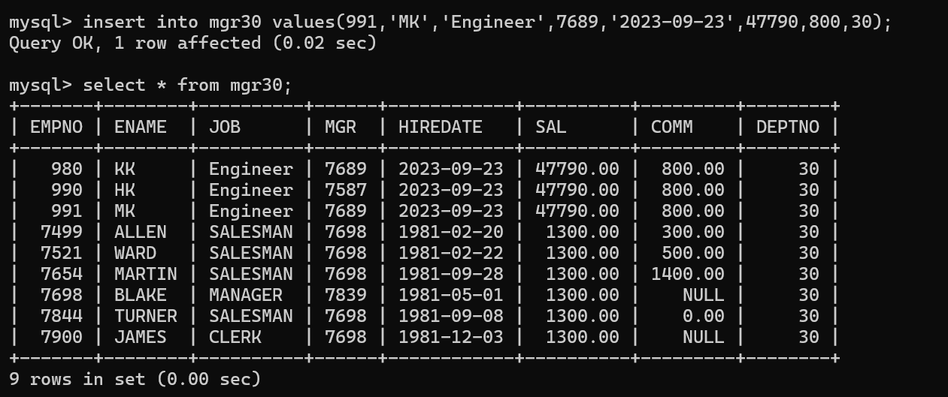

11. insert 3 records in dept and display all records from dept

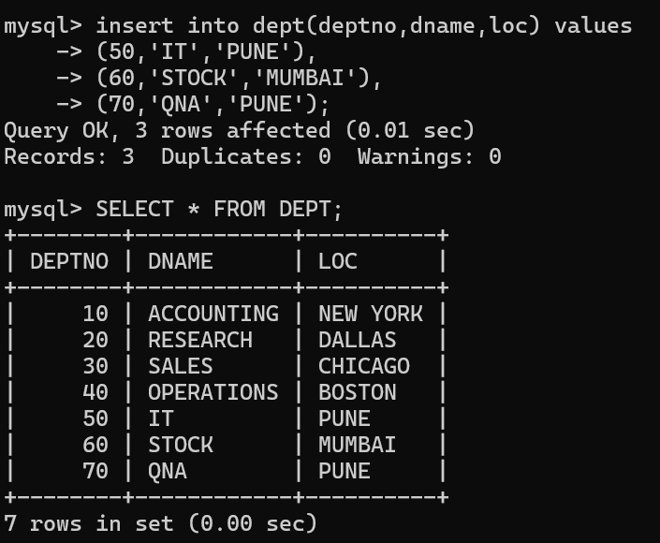

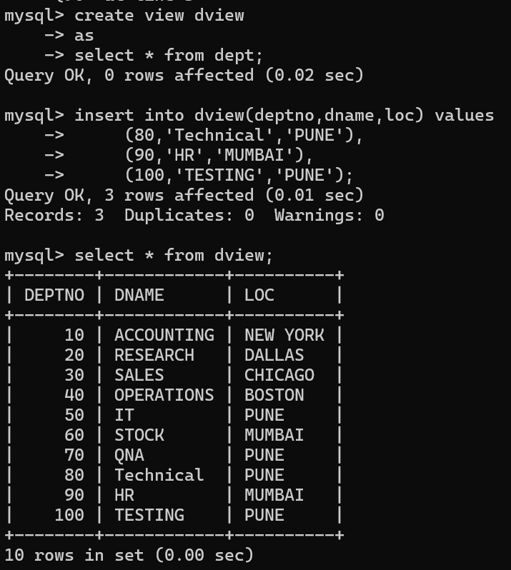

12. use rollback command check what happens

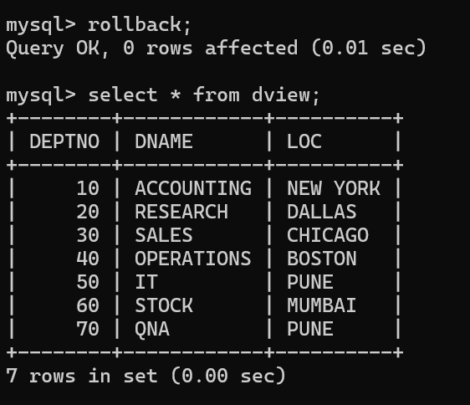

13. do the following

insert row in emp with empno 100

insert row in emp with empno 101

insert row in emp with empno 102

add savepoint A

insert row in emp with empno 103

insert row in emp with empno 104

insert row in emp with empno 105

add savepoint B

delete emp with empno 100

delete emp with emp no 104

rollback upto svaepoint B

check what all records will appear in employee table

rollback upto A

check what all records will appear in employee table

commit all changes

check what all records will appear in employee table

check whether you can roll back the contents.

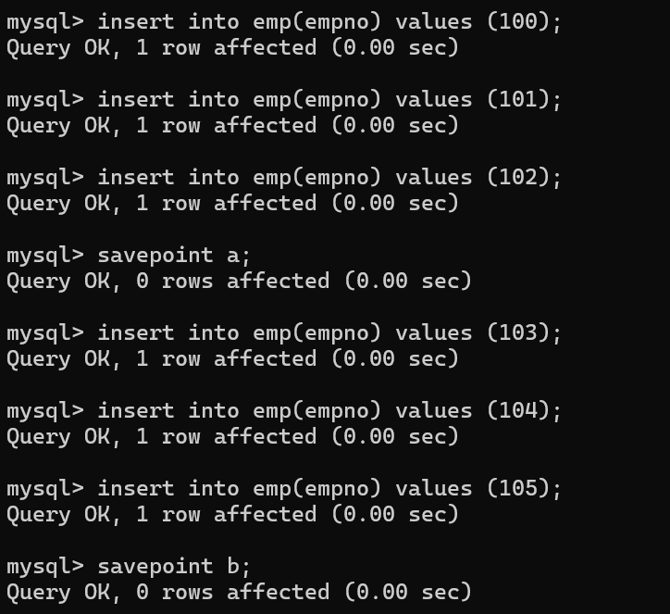

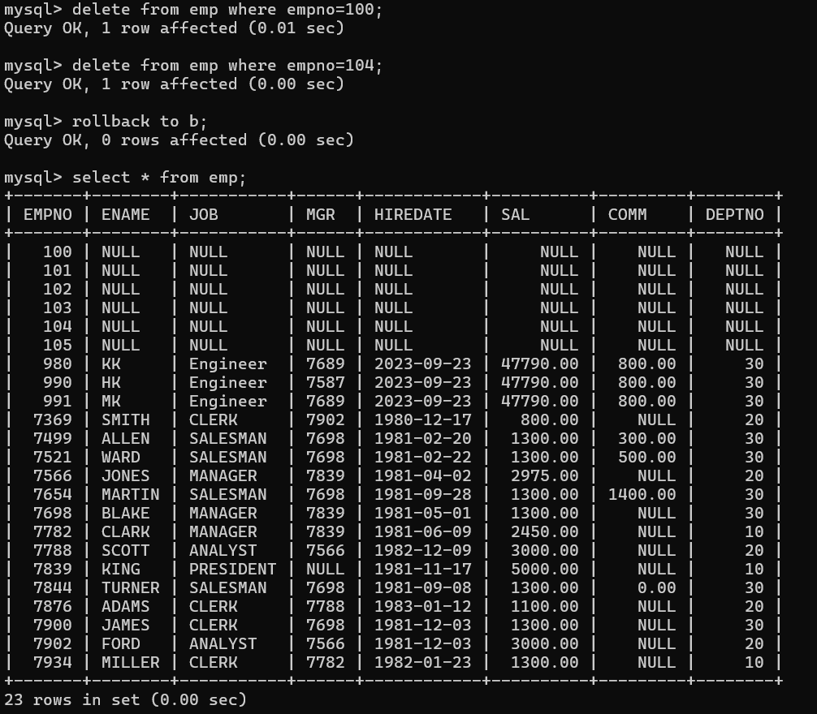

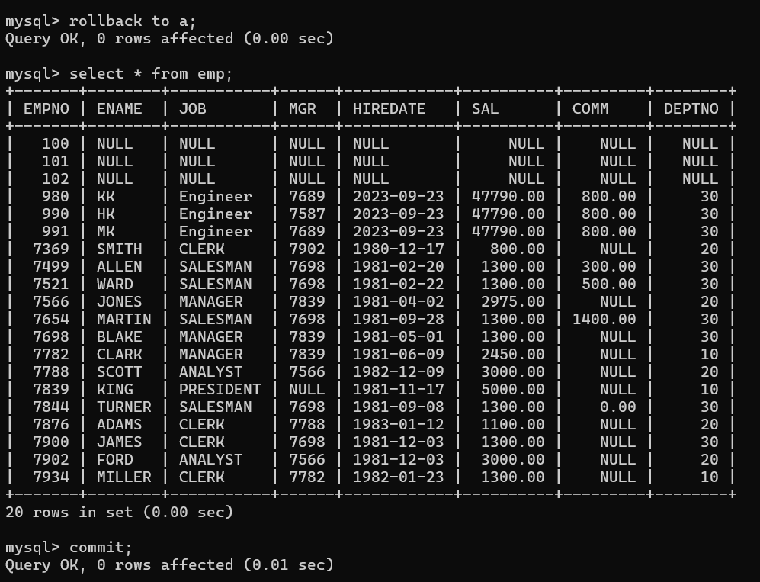

14. create a procedure getMin(deptno,minsal) to find minimum salary of given table.