SOFTWARE REQUIREMENT SPECIFICATION (SRS)
IEEE 830-Standard SRS Document

Case Study: Student Attendance System

Prepared by: Kshitija Renuke
B.Tech (CSE), ITM Skills University — Kharghar, Navi Mumbai
Practical 2 · Software Engineering — Software Requirement Specification
Tools used: Draw.io · MS Word · Lucidchart · Google Forms

1. Introduction

1.1 Purpose
This Software Requirement Specification (SRS) document describes the functional and non-functional requirements for a Student Attendance System (SAS) intended for use by educational institutions to automate the recording, monitoring, and reporting of student attendance. It is intended for the development team, project stakeholders, and evaluators as the authoritative reference for what the system must do.

1.2 Scope
The SAS will support multiple attendance-capture modes (RFID, biometric, QR code, and manual entry), role-based portals for students, faculty, parents, and administrators, automated low-attendance alerting, leave request/approval workflows, and exportable analytics. It will integrate with the institution's existing ERP/Learning Management System (LMS) for enrollment and timetable data. The following are explicitly out of scope for this release: payroll/HR management, examination management, and hostel/fee management.

1.3 Definitions, Acronyms, and Abbreviations
Term | Definition
SAS | Student Attendance System
RFID | Radio Frequency Identification
LMS | Learning Management System
ERP | Enterprise Resource Planning
RBAC | Role-Based Access Control
DPDP Act | Digital Personal Data Protection Act, 2023 (India)
API | Application Programming Interface
UI | User Interface
RTM | Requirement Traceability Matrix
HOD | Head of Department

1.4 References
- IEEE Std 830-1998, IEEE Recommended Practice for Software Requirements Specifications
- Institution Academic Attendance Policy Handbook (internal document)
- India's Digital Personal Data Protection (DPDP) Act, 2023
- UGC Regulations on Minimum Attendance Criteria (reference circular)

1.5 Document Overview
Section 2 describes the overall system and its operating context. Section 3 presents the stakeholder analysis. Section 4 documents the requirement-gathering methodology. Section 5 presents the system context diagram. Sections 6 and 7 specify functional and non-functional requirements. Section 8 presents use cases. Sections 9 and 10 list constraints and assumptions. Section 11 provides the Requirement Traceability Matrix.

2. Overall System Description

2.1 Product Perspective
The SAS is a new, standalone web and mobile-based system that integrates with the institution's existing ERP/LMS platform for enrollment and timetable data, and with an SMS/email gateway for notifications. It replaces the institution's current manual, register-based attendance process.

2.2 Product Functions (Summary)
- Multi-mode attendance capture: RFID, biometric, QR code, and manual entry
- Role-based dashboards for students, faculty, parents, and administrators
- Automated low-attendance detection and alerting via SMS/email
- Leave request submission and approval workflow
- Attendance analytics dashboards and exportable reports
- Timetable, course, and user-account management

2.3 Operating Environment
- Client: modern web browsers (Chrome, Edge, Firefox); Android 10+ and iOS 14+ mobile apps
- Server: cloud-hosted (AWS/Azure), containerized microservice architecture
- Hardware: RFID/biometric readers at classroom entry points; existing campus network infrastructure

3. Stakeholder Analysis
Stakeholders were identified through interviews and classified by category, interest in the system, level of influence over requirements, and expected involvement during the project. The Stakeholder Matrix below summarizes this analysis.

Stakeholder Matrix
Stakeholder | Category | Interest / Role | Influence | Involvement
Students | Primary | Mark attendance, view own records, apply for leave | Medium | High
Faculty / Teachers | Primary | Mark session attendance, approve leave, view class reports | High | High
Academic Admin / Registrar | Primary | Configure courses, users, and rules; generate institution-wide reports | High | High
Parents / Guardians | Secondary | View child's attendance, receive low-attendance alerts | Low | Medium
HOD / Academic Coordinators | Secondary | Monitor department-wide attendance compliance | Medium | Medium
IT / System Administrators | Secondary | Maintain system, manage integrations and uptime | High | Medium
Institution Management | Tertiary | Track compliance and accreditation metrics | Medium | Low
Accreditation Bodies (UGC/AICTE) | Tertiary | Require minimum-attendance compliance records | Low | Low

4. Requirement Gathering
Requirements were elicited using a combination of techniques to capture both the explicit needs of primary users and the implicit constraints of the institutional process. The table below summarizes the methodology and key outcomes.
Technique | Participants | Purpose | Key Outcome
Stakeholder Interviews | Faculty, admin staff, 3 students | Understand current manual-process pain points | Identified delays and errors in register-based tracking
Questionnaires / Surveys | 50 students, 10 faculty | Quantify feature preferences and pain points | 82% wanted mobile check-in; 68% wanted parent alerts
Document Analysis | Academic policy handbook, UGC circular | Extract compliance and minimum-attendance rules | Defined the 75% minimum-attendance threshold rule
Direct Observation | 5 live classroom attendance sessions | Observe real capture workflow and timing | Manual roll-call took 5-8 minutes per 60-student class
JAD / Prototype Walkthroughs | Admin + 2 faculty representatives | Validate draft workflows and UI mockups | Refined the leave-approval and alerting workflows

5. System Context
The context diagram (Level 0 Data Flow Diagram) below shows the Student Attendance System as a single process and identifies every external entity it exchanges data with, together with the major data flows in each direction.
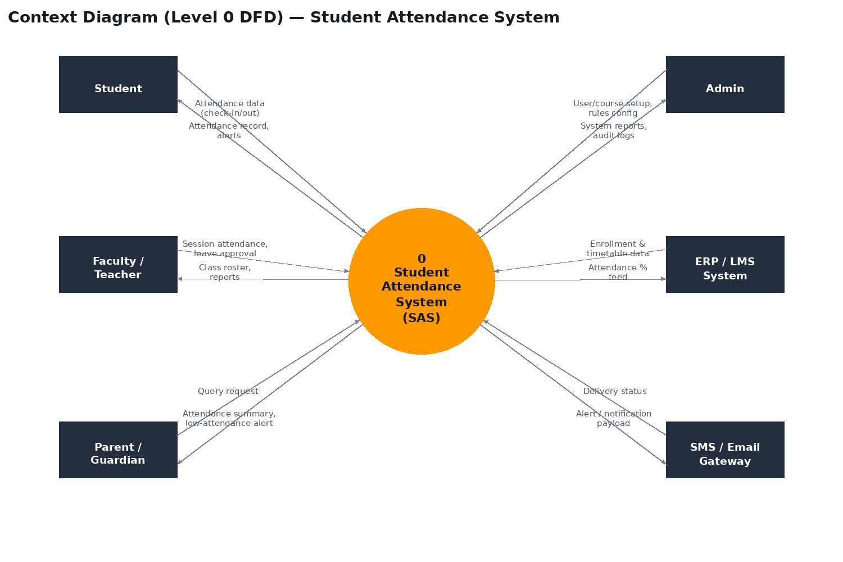
Figure 1: Context Diagram (Level 0 DFD) for the Student Attendance System.
- Student — submits attendance check-in/out and leave requests; receives attendance records and alerts
- Faculty / Teacher — records session attendance, approves/rejects leave; receives class rosters and reports
- Parent / Guardian — queries attendance status; receives attendance summaries and low-attendance alerts
- Admin — configures users, courses, and rules; receives system reports and audit logs
- ERP / LMS System — supplies enrollment and timetable data; receives attendance-percentage feed
- SMS / Email Gateway — receives alert/notification payloads and returns delivery status

6. Functional Requirements
The following table lists the functional requirements grouped by category, each with a unique identifier and assigned priority.
ID | Category | Requirement Description | Priority
FR-01 | Attendance Capture | System shall allow faculty to mark attendance for an entire class session | High
FR-02 | Attendance Capture | System shall support RFID/biometric-based check-in for students | High
FR-03 | Attendance Capture | System shall allow students to self-check-in via a session QR code | Medium
FR-04 | Attendance Capture | System shall timestamp every attendance entry with session, subject, and date | High
FR-05 | Leave Management | System shall allow students to submit leave requests with reason and optional supporting document | Medium
FR-06 | Leave Management | System shall allow faculty to approve or reject pending leave requests | Medium
FR-07 | Leave Management | Approved leave shall automatically factor into attendance-percentage calculations | Medium
FR-08 | Reporting & Analytics | System shall generate attendance reports filtered by student, course, or date range | High
FR-09 | Reporting & Analytics | System shall export attendance reports to PDF and Excel formats | Medium
FR-10 | Reporting & Analytics | System shall display a class-wise attendance analytics dashboard for faculty and HOD | Medium
FR-11 | Notifications & Alerts | System shall automatically send an SMS/email alert when a student's attendance drops below 75% | High
FR-12 | Notifications & Alerts | System shall notify a parent/guardian of a child's daily absence | Medium
FR-13 | User & System Admin | Admin shall be able to manage user accounts and role assignments | High
FR-14 | User & System Admin | Admin shall be able to configure courses, timetables, and attendance rules | High
FR-15 | User & System Admin | System shall maintain an audit log of all attendance edits with user ID and timestamp | Medium
FR-16 | Integration | System shall synchronize enrollment and timetable data with the institution's ERP/LMS | High

7. Non-Functional Requirements
Category | Requirement
Performance | Attendance capture (RFID/biometric scan) shall complete within 2 seconds per student
Scalability | System shall support 10,000+ concurrent students during peak class-change hours (8-9 AM)
Availability | System shall maintain 99.5% uptime during institutional working hours
Reliability | Mobile app shall cache attendance offline and auto-sync on reconnect, with zero data loss
Security | System shall enforce role-based access control (RBAC) and encrypt biometric templates at rest and in transit
Data Privacy | System shall comply with India's DPDP Act, 2023 for storage and processing of biometric and personal data
Usability | Faculty shall be able to complete a full class attendance session in no more than 3 taps/clicks per student
Maintainability | System shall use a modular architecture allowing new capture modes (e.g., face recognition) without disrupting existing modules
Interoperability | System shall expose REST APIs for integration with the institution's ERP/LMS
Portability | Mobile application shall run on Android 10+ and iOS 14+

8. Use Cases
The use case diagram below identifies the four primary actors and their interactions with the Student Attendance System.
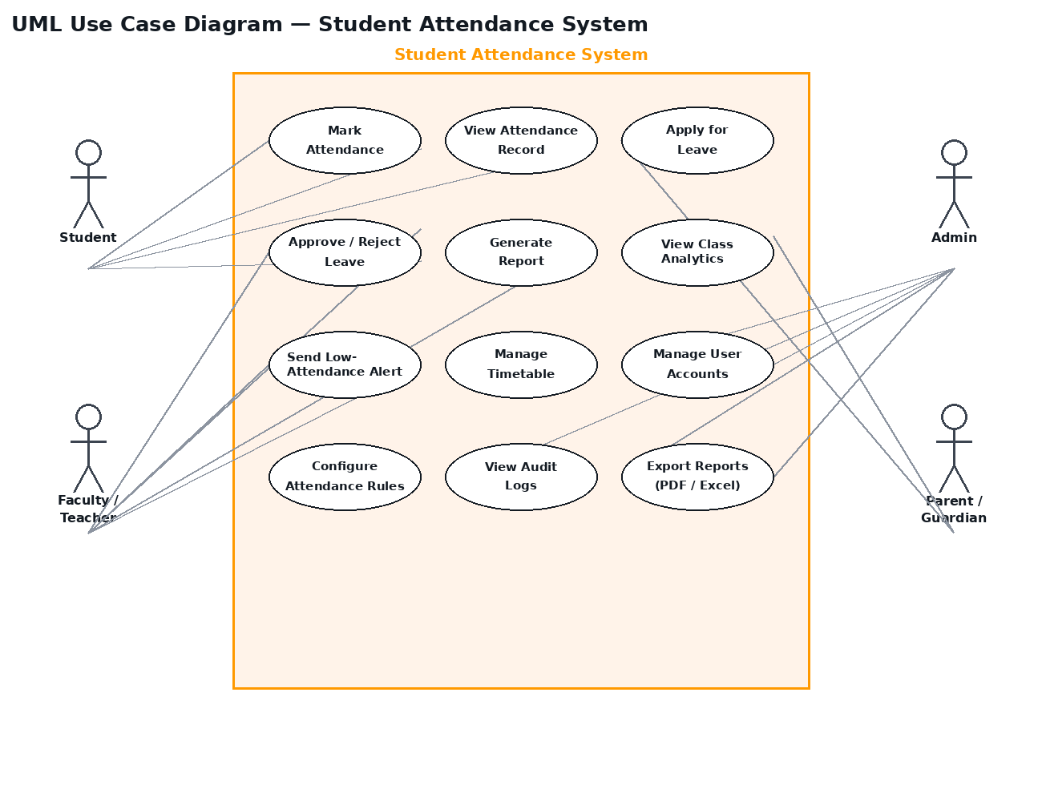
Figure 2: UML Use Case Diagram for the Student Attendance System.

Use Case Descriptions
UC ID | Use Case | Primary Actor | Description
UC-01 | Mark Attendance | Faculty / Student | Faculty or student records attendance for a session via RFID, biometric, QR, or manual entry
UC-02 | View Attendance Record | Student / Parent | Authenticated user views attendance history and current percentage
UC-03 | Apply for Leave | Student | Student submits a leave request with reason and an optional supporting document
UC-04 | Approve / Reject Leave | Faculty | Faculty reviews and approves or rejects a pending leave request
UC-05 | Generate Report | Faculty / Admin | User generates an attendance report filtered by course, date range, or student
UC-06 | View Class Analytics | Faculty / HOD | User views visual analytics of class-wise attendance trends
UC-07 | Send Low-Attendance Alert | System (automated) | System automatically notifies student and parent when attendance falls below the configured threshold
UC-08 | Manage Timetable | Admin | Admin creates or updates course schedules and session mappings
UC-09 | Manage User Accounts | Admin | Admin creates, updates, or deactivates student, faculty, and parent accounts
UC-10 | Configure Attendance Rules | Admin | Admin sets the minimum-attendance threshold and alert rules
UC-11 | View Audit Logs | Admin | Admin reviews a log of all attendance edits and system actions
UC-12 | Export Reports | Faculty / Admin | User exports a generated report to PDF or Excel

9. Constraints
- Must integrate with RFID/biometric hardware already installed in existing classrooms; no budget for hardware replacement
- Must operate within the institution's approved technology stack, prioritizing open-source components due to limited licensing budget
- Biometric data storage and processing must comply with the DPDP Act, 2023 and institutional data-protection policy
- Mobile application must remain functional under low-bandwidth or intermittent-offline conditions common in some campus buildings
- System must align with the academic calendar, including semester resets, holiday calendars, and mid-semester course changes
- Project timeline is constrained to a single academic semester for full institutional rollout

10. Assumptions and Dependencies
- All students and faculty will be issued a unique ID card/RFID tag, or enrolled biometrically, before go-live
- Classrooms are equipped with, or will be equipped with, an attendance-capture device (fixed reader or faculty-carried tablet)
- Reliable Wi-Fi or campus network connectivity is available in most academic buildings
- Faculty will receive basic training on the digital attendance tools before rollout
- Parents/guardians provide and maintain valid contact details for alerting purposes
- The institution's ERP/LMS exposes APIs (or will be extended to expose APIs) for enrollment and timetable synchronization

11. Requirement Traceability Matrix
The Requirement Traceability Matrix (RTM) below maps each key requirement to its originating stakeholder, the use case that realizes it, and the test case that will verify it, ensuring full coverage from elicitation through validation.
Req ID | Requirement | Source | Use Case | Test Case | Priority
FR-01 | Faculty marks session attendance | Faculty | UC-01 | TC-01 | High
FR-02 | RFID/biometric student check-in | Student | UC-01 | TC-02 | High
FR-05 | Submit leave request | Student | UC-03 | TC-03 | Medium
FR-06 | Approve/reject leave | Faculty | UC-04 | TC-04 | Medium
FR-08 | Generate attendance report | Faculty / Admin | UC-05 | TC-05 | High
FR-09 | Export report (PDF/Excel) | Faculty / Admin | UC-12 | TC-06 | Medium
FR-11 | Low-attendance alert | System / Parent | UC-07 | TC-07 | High
FR-13 | Manage user accounts | Admin | UC-09 | TC-08 | High
FR-14 | Configure timetable/rules | Admin | UC-08, UC-10 | TC-09 | High
FR-16 | ERP/LMS synchronization | Admin / System | — | TC-10 | High
NFR-Sec | RBAC + biometric encryption | Admin / IT | — | TC-11 | High
NFR-Perf | Capture response < 2 seconds | Student / Faculty | UC-01 | TC-12 | High

12. Appendix — Tools Used
- Draw.io — context diagram and UML use case diagram drafting
- Microsoft Word — SRS documentation and formatting
- Lucidchart — alternative UML diagramming and stakeholder mapping
- Google Forms — requirement-gathering surveys and questionnaires

