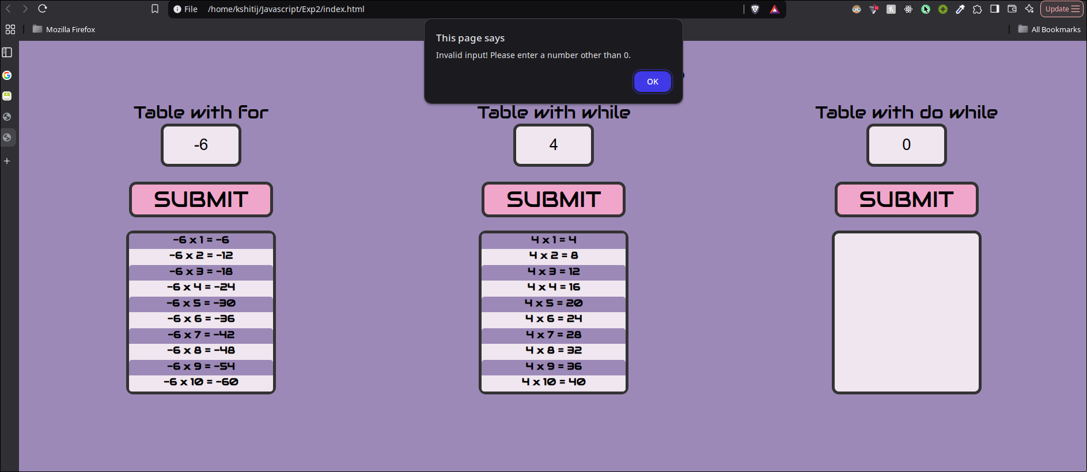

**Fig. Negative number, positive number, 0 (fails)**