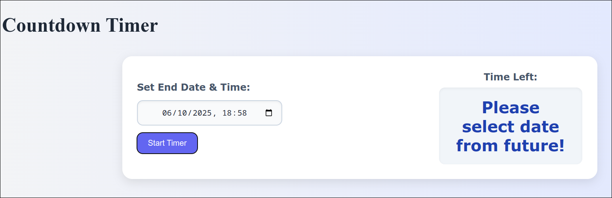

**Fig. Invalid date (past date) entered**