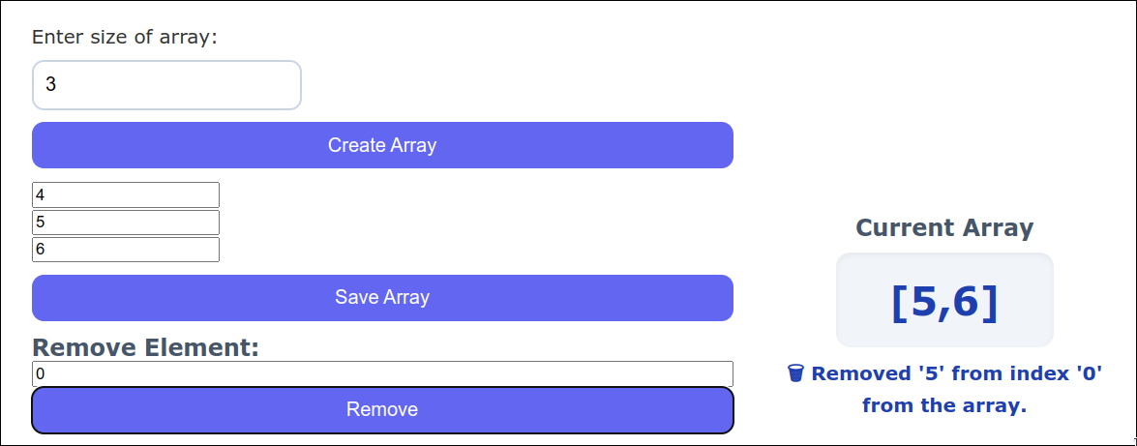

**Fig. Remove index 0**

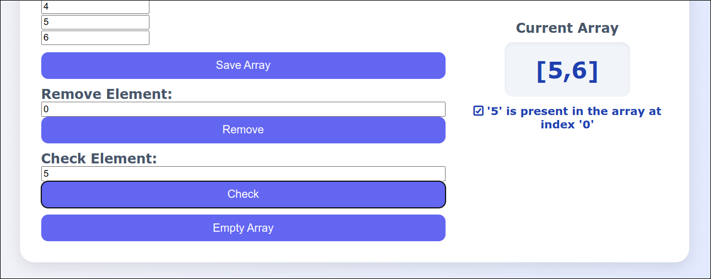

**Fig. Check 5 (present at 0)**

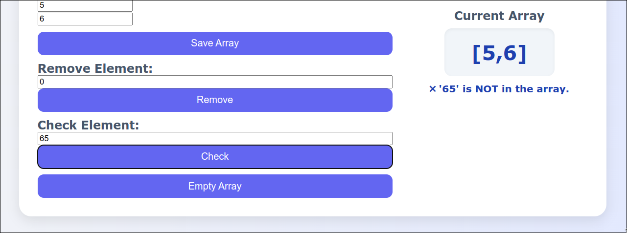

**Fig. Check 65 (not present)**