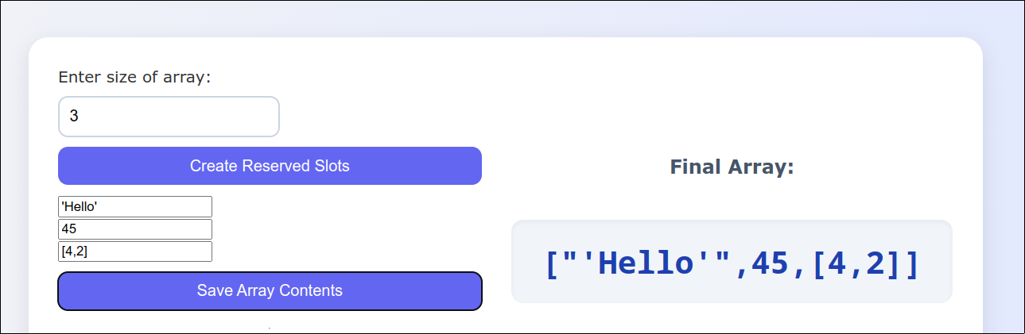

**Fig. Creation and Saving**

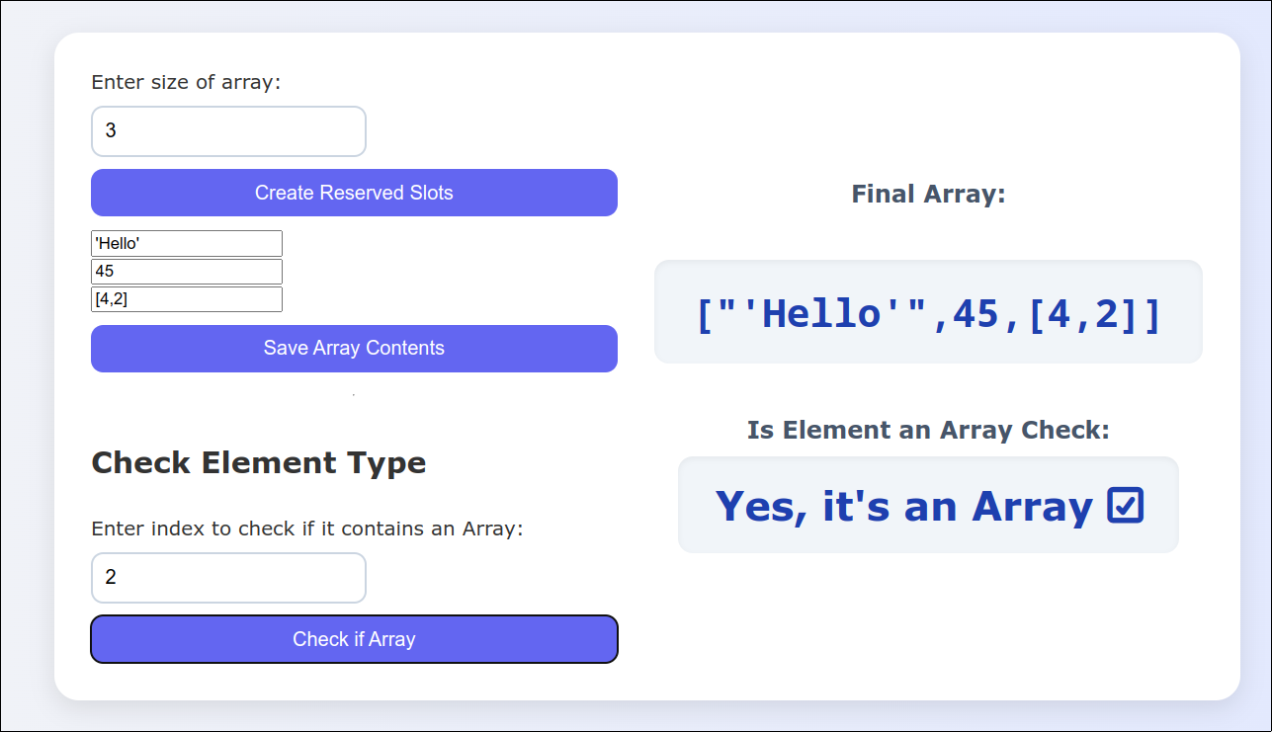

**Fig. Checking index 2 (is Array)**

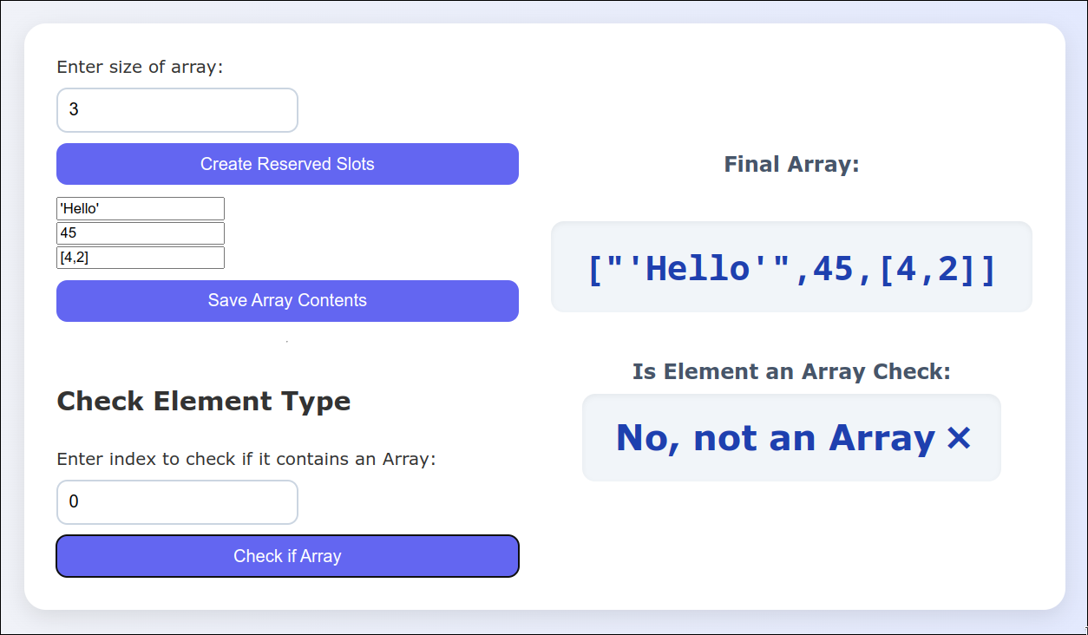

**Fig. Checking at index 0 (not Array)**

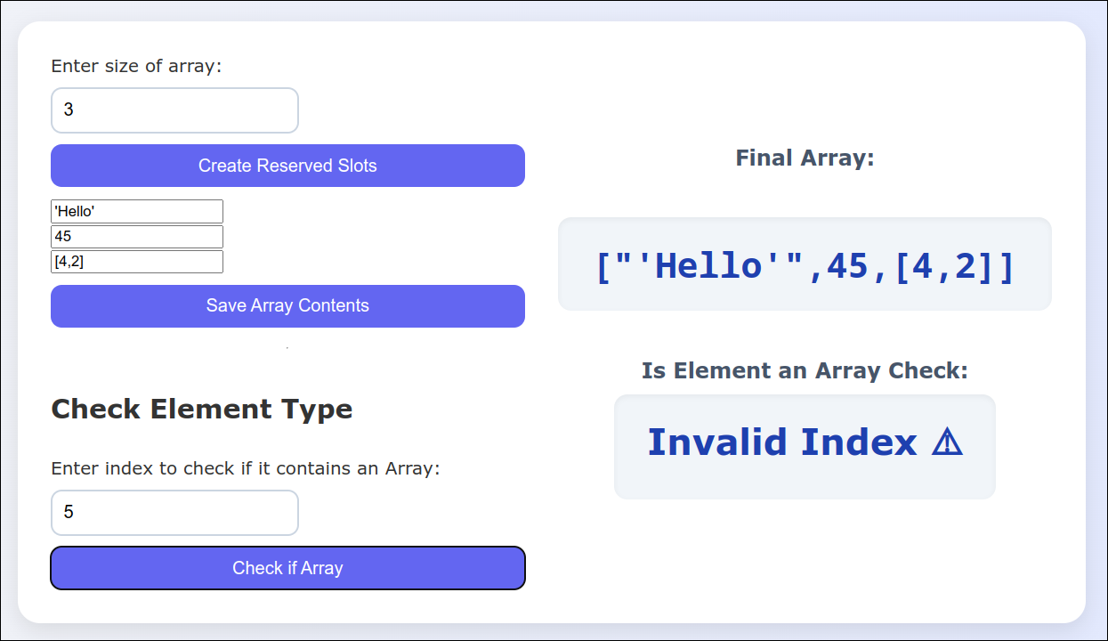

**Fig. Checking at index that doesn’t exist**