**Output:**

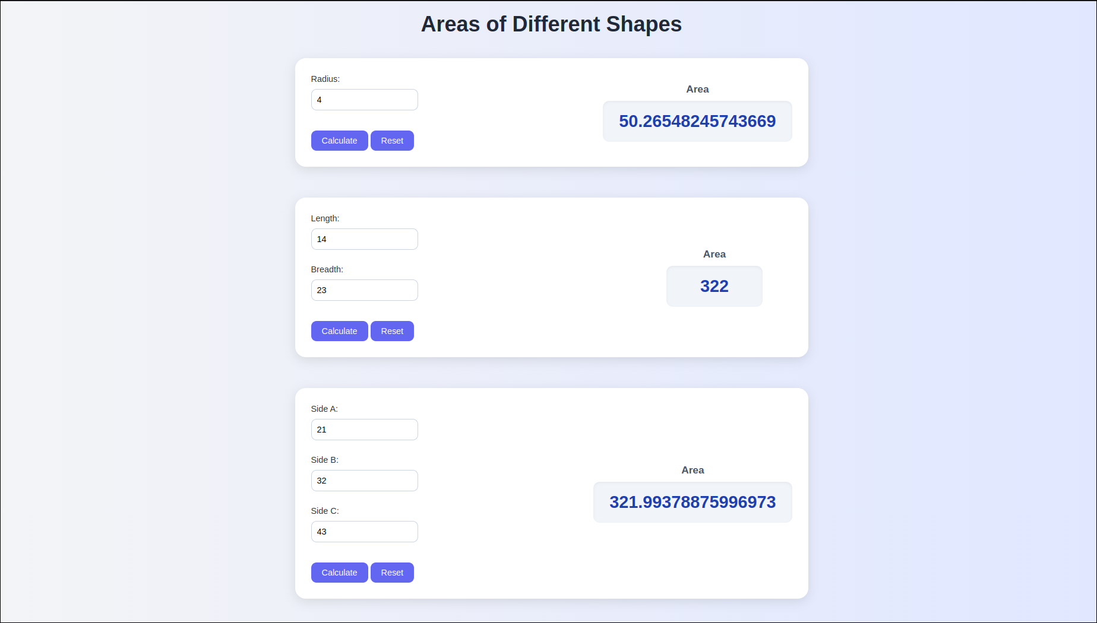

**Code:**

1. **HTML:**

<script type="text/javascript" src="areas.js"></script>

<link rel="stylesheet" href="style.css">

<body>

<h1> Areas of Different Shapes </h1>

<div class="shape-box">

<div class="form-section">

Radius: <input id="radiusOfCircle" placeholder=0 type="number"><br/>

<div class="button-row">

<button onclick="circle_area()"> Calculate </button>

<button id="ResetCircle" onclick="reset()"> Reset </button>

</div>

</div>

<!-- <canvas id="myCanvas" width="300" height="300" style="border:4px solid #000000; border-radius: 10px;"></canvas> -->

<div class="result-section">

<div class="area-label">Area</div>

<div class="area-box" id="AreaCircle">0</div>

</div>

</div>

<br/>

<div class="shape-box">

<div class="form-section">

Length: <input id="lengthOfRect" placeholder=0 type="number"><br/>

Breadth: <input id="breadthOfRect" placeholder=0 type="number"><br/>

<div class="button-row">

<button onclick="rect_area()"> Calculate </button>

<button id="ResetRect" onclick="reset()"> Reset </button>

</div>

</div>

<!-- <canvas id="myCanvas" width="300" height="300" style="border:4px solid #000000; border-radius: 10px;"></canvas> -->

<div class="result-section">

<div class="area-label">Area</div>

<div class="area-box" id="AreaRect">0</div>

</div>

</div>

<br/>

<div class="shape-box">

<div class="form-section">

Side A: <input id="sideA" placeholder=0 type="number"><br/>

Side B: <input id="sideB" placeholder=0 type="number"><br/>

Side C: <input id="sideC" placeholder=0 type="number"><br/>

<div class="button-row">

<button onclick="triangle_area()"> Calculate </button>

<button id="ResetTriangle" onclick="reset()"> Reset </button>

</div>

</div>

<!-- <canvas id="myCanvas" width="300" height="300" style="border:4px solid #000000; border-radius: 10px;"></canvas> -->

<div class="result-section">

<div class="area-label">Area</div>

<div class="area-box" id="AreaTriangle">0</div>

</div>

</div>

<br/>

</body>

</html>

1. **CSS:**

body {

font-family: 'Segoe UI', Tahoma, Geneva, Verdana, sans-serif;

background: linear-gradient(to right, #f3f4f6, #e0e7ff);

margin: 0;

padding: 20px;

color: #333;

}

h1 {

text-align: center;

color: #1f2937;

margin-bottom: 40px;

font-size: 2.5rem;

animation: fadeIn 1s ease;

}

.shape-box {

background-color: #ffffff;

max-width: 900px;

margin: 20px auto;

padding: 30px;

border-radius: 20px;

box-shadow: 0 6px 20px rgba(0, 0, 0, 0.1);

transition: transform 0.3s ease;

animation: slideUp 0.7s ease;

display: flex;

justify-content: space-between;

align-items: center;

gap: 30px;

}

.form-section {

flex: 2;

display: flex;

flex-direction: column;

gap: 10px;

}

.result-section {

flex: 1;

text-align: center;

display: flex;

flex-direction: column;

align-items: center;

gap: 10px;

}

.area-label {

font-size: 1.2rem;

color: #475569;

font-weight: 600;

}

.area-box {

background-color: #f1f5f9;

padding: 20px 30px;

border-radius: 12px;

box-shadow: inset 0 2px 5px rgba(0, 0, 0, 0.05);

font-size: 2rem;

color: #1e40af;

font-weight: bold;

min-width: 120px;

transition: all 0.3s ease;

}

input[type="number"] {

padding: 10px;

border: 2px solid #cbd5e1;

border-radius: 10px;

font-size: 1rem;

width: 200px;

transition: border 0.3s;

}

input[type="number"]:focus {

border-color: #6366f1;

outline: none;

}

button {

background-color: #6366f1;

color: white;

padding: 10px 20px;

border: none;

border-radius: 10px;

cursor: pointer;

font-size: 1rem;

transition: background-color 0.3s, transform 0.2s;

}

button:hover {

background-color: #4f46e5;

transform: scale(1.05);

}

/* Animations */

@keyframes fadeIn {

from { opacity: 0; transform: translateY(-20px); }

to { opacity: 1; transform: translateY(0); }

}

@keyframes slideUp {

from { transform: translateY(30px); opacity: 0; }

to { transform: translateY(0); opacity: 1; }

}

1. **Javascript:**

function circle_area() {

var radius = document.getElementById("radiusOfCircle").value;

if (radius < 0)

// Alert

return null;

let area = Math.PI * radius * radius;

console.log(area);

document.getElementById("AreaCircle").innerHTML = area;

}

function rect_area() {

var length = document.getElementById("lengthOfRect").value;

var breadth = document.getElementById("breadthOfRect").value;

if (length < 0 || breadth < 0)

// Alert

return null;

let area = (length * breadth);

// Debug

console.log(area);

document.getElementById("AreaRect").innerHTML = area;

}

function triangle_area() {

var a = +document.getElementById("sideA").value;

var b = +document.getElementById("sideB").value;

var c = +document.getElementById("sideC").value;

// Semi Perimeter

console.log(a + " " + b + " " + c);

var s = (a + b + c) / 2;

var val = s * (s - a) * (s - b) * (s - c);

console.log(val);

if (val < 0) {

alert("Not a triangle !!");

return;

}

var area = Math.sqrt(val);

console.log(area);

document.getElementById("AreaTriangle").innerHTML = area;

}

function reset() {

var id = "";

switch (event.target.id) {

case "ResetCircle":

id = "AreaCircle"

break;

case "ResetRect":

id = "AreaRect"

break;

case "ResetTriangle":

id = "AreaTriangle"

break;

default:

alert("Nope");

}

document.getElementById(id).innerHTML = "-";

}