**Output:**

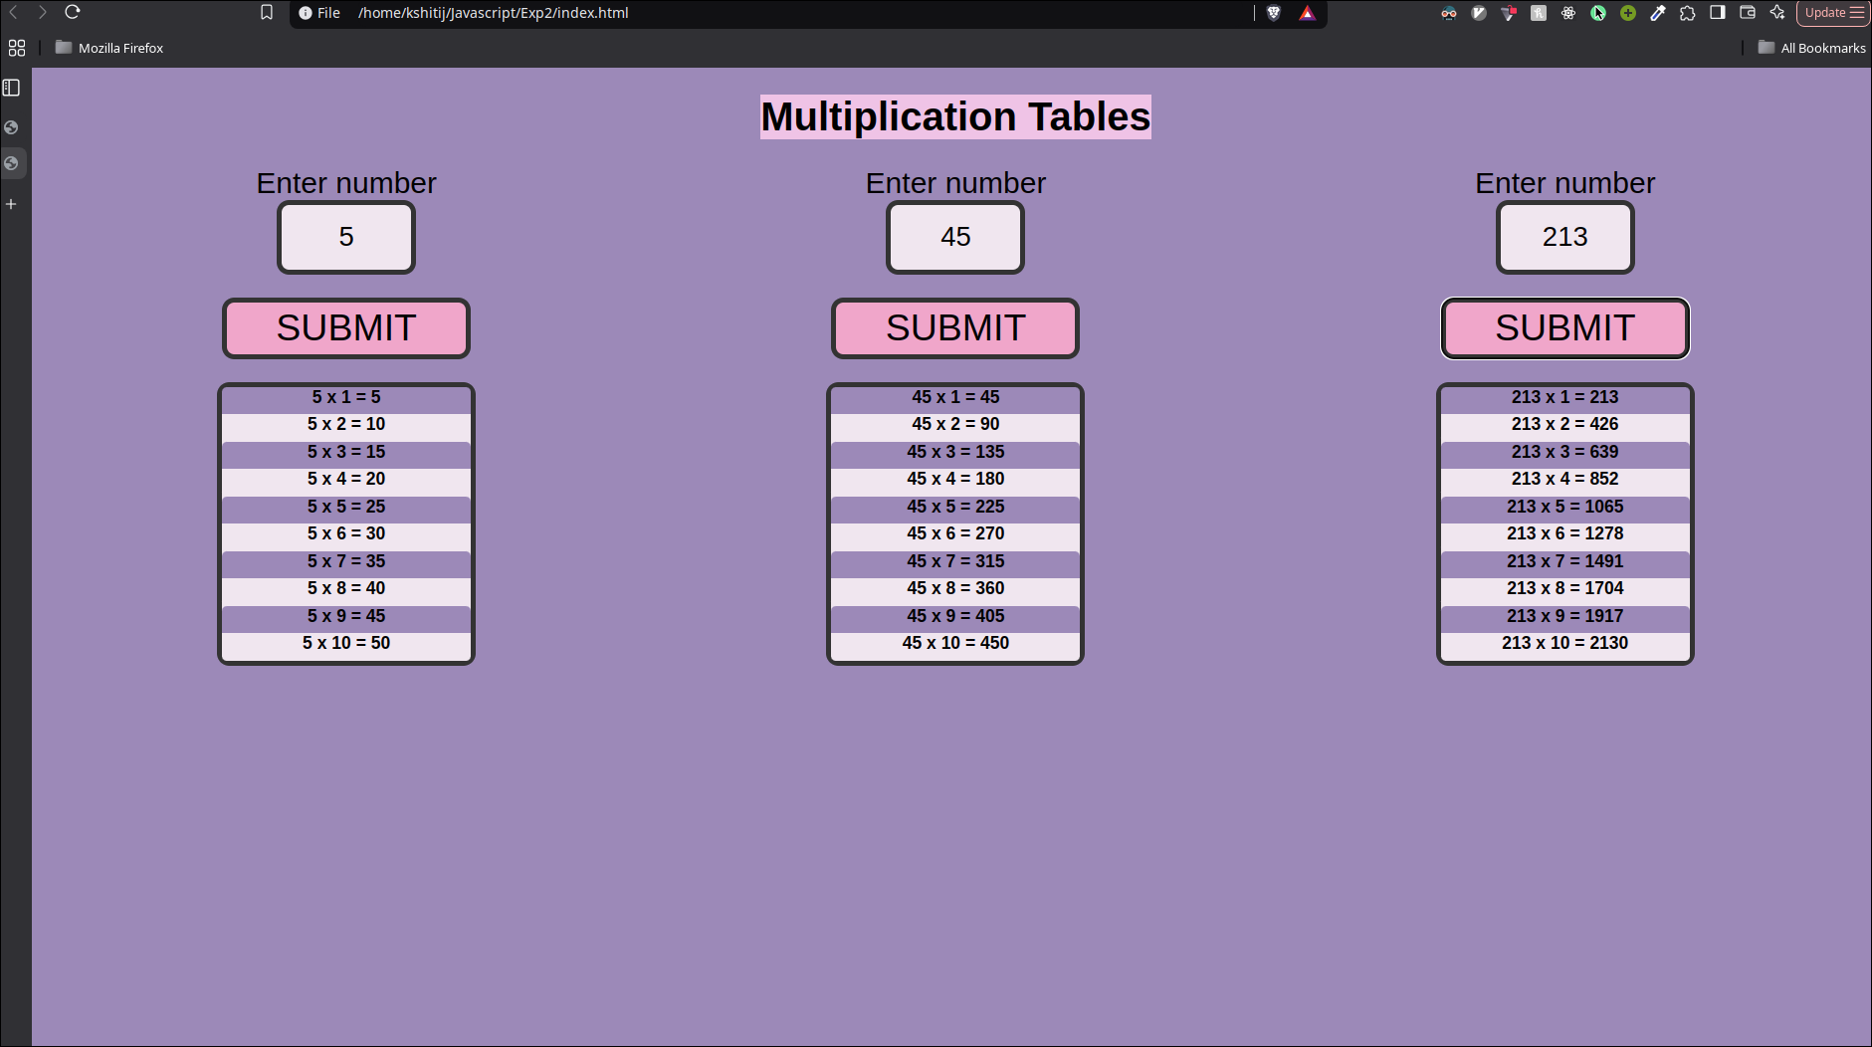

**Code:**

1. **HTML:**

<!DOCTYPE html>

<html lang="en">

<head>

<meta charset="UTF-8">

<meta name="viewport" content="width=device-width, initial-scale=1.0">

<!-- Logic Sits here -->

<script src=tables.js></script>

<!-- Visuals Sit here -->

<link rel="stylesheet" href="styles.css">

<title>Tables</title>

</head>

<body>

<h1 id="title">Multiplication Tables</h1>

<div class="row-format">

<div class="block">

<label id="label"> Enter number </label>

<input id="in_for" type="number"></input><br>

<button id="btn_for" onclick="table_with_for()"> Submit </button>

<div class="table">

<p id="table_for"></p>

</div>

</div>

<div class="block">

<label id="label"> Enter number </label>

<input id="in_while" type="number"></input><br>

<button id="btn_while" onclick="table_with_while()"> Submit </button>

<div class="table">

<p id="table_while"></p>

</div>

</div>

<div class="block">

<label id="label"> Enter number </label>

<input id="in_dowhile" type="number"></input><br>

<button id="btn_dowhile" onclick="table_with_dowhile()"> Submit </button>

<div class="table">

<p id="table_dowhile"></p>

</div>

</div>

</div>

</body>

</html>

1. **Javascript:**

// For CSS

let ll = "lightline";

let dl = "darkline";

function table_with_for() {

let n = Number(document.getElementById("in_for").value);

let full_text = "";

for (let i = 1; i <= 10; i++) {

let text = `${n} x ${i} = ${n * i}`;

let line = (i % 2 == 0) ? ll : dl;

let final_line = `<h3 id="${line}">` + text + "</p><br>";

full_text += final_line;

}

document.getElementById("table_for").innerHTML = `${full_text}`

}

function table_with_while() {

let n = Number(document.getElementById("in_while").value);

let full_text = "";

let i = 1;

while (i <= 10) {

let text = `${n} x ${i} = ${n * i}`;

let line = (i % 2 == 0) ? ll : dl;

let final_line = `<h3 id="${line}">` + text + "</p><br>";

full_text += final_line;

i++;

}

document.getElementById("table_while").innerHTML = `${full_text}`

}

function table_with_dowhile() {

let n = Number(document.getElementById("in_dowhile").value);

let full_text = "";

let i = 1;

do {

let text = `${n} x ${i} = ${n * i}`;

let line = (i % 2 == 0) ? ll : dl;

let final_line = `<h3 id="${line}">` + text + "</p><br>";

full_text += final_line;

i++;

} while (i <= 10);

document.getElementById("table_dowhile").innerHTML = `${full_text}`

}