**Output:**

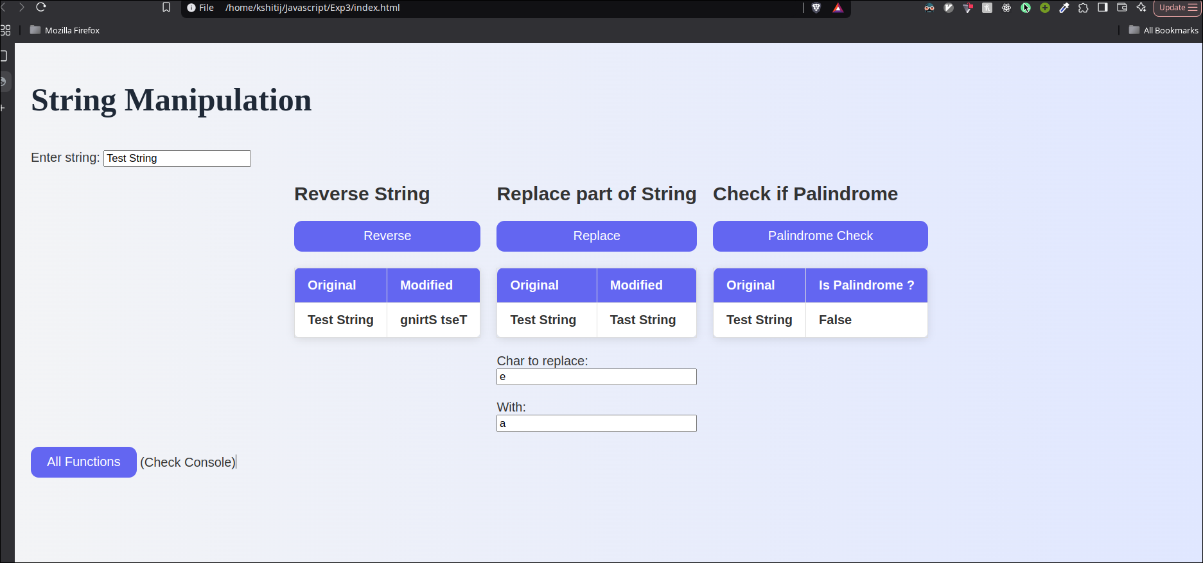

**Code:**

1. **HTML:**

<!DOCTYPE html>

<html lang="en">

<head>

<script type="text/javascript" src="strings.js"></script>

<link rel="stylesheet" href="style.css">

<meta charset="UTF-8">

<meta name="viewport" content="width=device-width, initial-scale=1.0">

<title>Document</title>

</head>

<body>

<h1> String Manipulation</h1>

Enter string: <input id="string" type="text" value="Pune Institute of Computer Technology"> </input>

<div class="all">

<div class="operation">

<h2> Reverse String </h2>

<button onclick="reverse()">Reverse</button>

<table>

<thead>

<tr>

<th> Original </th>

<th> Modified </th>

</tr>

</thead>

<tr>

<th id='original_rev'> </th>

<th id='reversed_rev'> </th>

</tr>

</table>

</div>

<div class="operation">

<h2> Replace part of String </h2>

<button onclick="replace()">Replace</button>

<table>

<thead>

<tr>

<th> Original </th>

<th> Modified </th>

</tr>

</thead>

<tr>

<th id='original_rep'> </th>

<th id='replaced_rep'> </th>

</tr>

</table>

Char to replace: <input id='to_replace'> </input>

<br/>

With: <input id='with_replace'> </input>

<br/>

</div>

<div class="operation">

<h2> Check if Palindrome </h2>

<button onclick="checkPalindrome()">Palindrome Check</button>

<table>

<thead>

<tr>

<th> Original </th>

<th> Is Palindrome ? </th>

</tr>

</thead>

<tr>

<th id='original_pal'> </th>

<th id='palindrome'> </th>

</tr>

</table>

</div>

</div>

</body>

1. **Javascript:**

// reverse

function reverse() {

let s = document.getElementById("string").value;

// Reverse

let k = s.split('').reverse().join('');

document.getElementById("original_rev").innerHTML = s;

document.getElementById("reversed_rev").innerHTML = k;

}

// replace

function replace() {

let s = document.getElementById("string").value;

let a = document.getElementById("to_replace").value;

let b = document.getElementById("with_replace").value;

let ans = s.replace(a, b);

document.getElementById("original_rep").innerHTML = s;

document.getElementById("replaced_rep").innerHTML = ans;

}

// palindrome (or not)

function checkPalindrome() {

let s = document.getElementById("string").value;

// Reverse

let rev = s.split('').reverse().join('');

let ans = (rev === s) ? "True" : "False";

document.getElementById("original_pal").innerHTML = s;

document.getElementById("palindrome").innerHTML = ans;

}