**Output:**

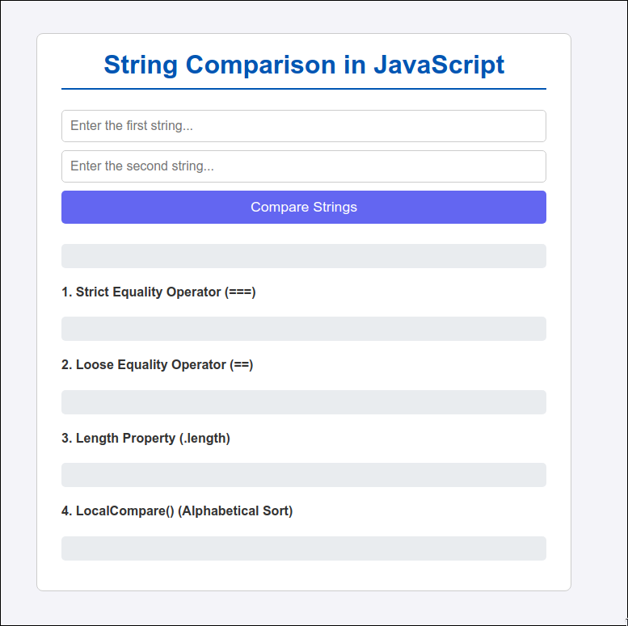

**Fig. Basic Website**

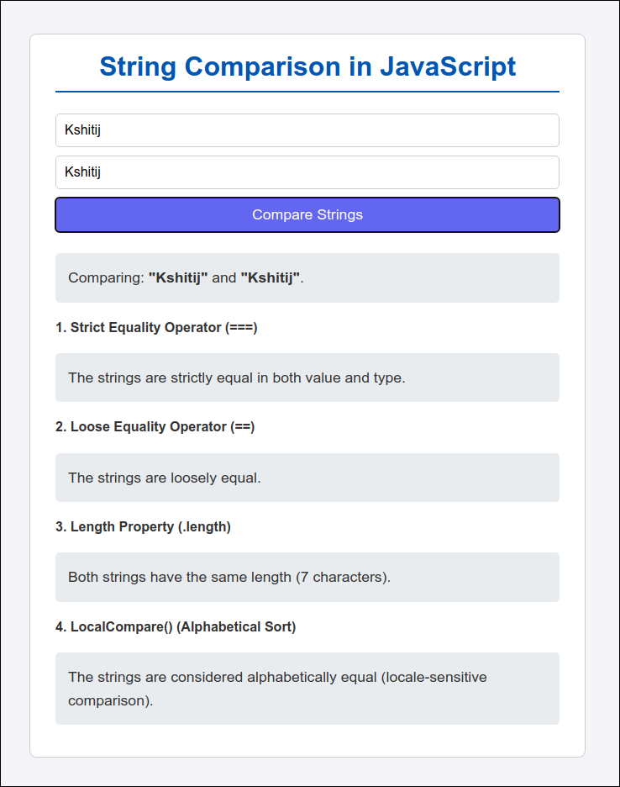

**Fig. Equal Strings**

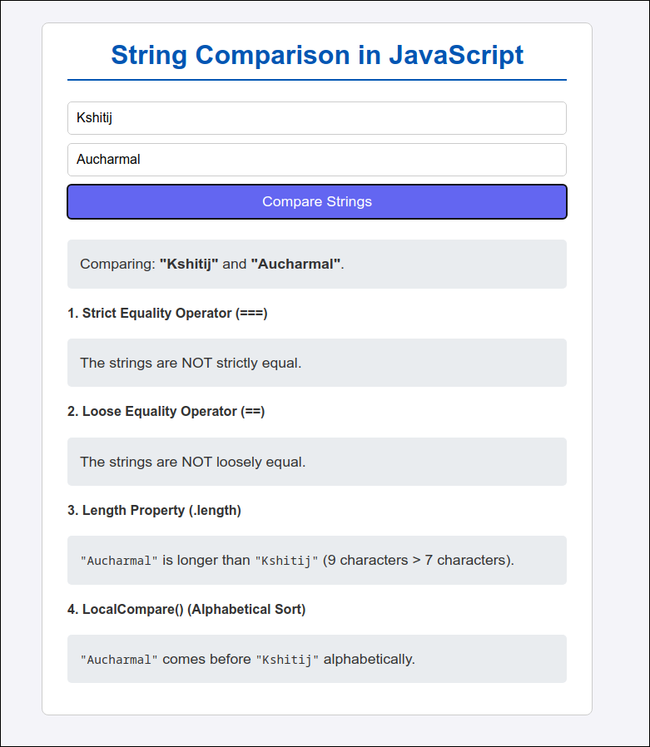

**Fig. Not Equal**

**Code:**

1. **HTML:**

<!doctype html>

<html lang="en">

<head>

<meta charset="UTF-8" />

<meta name="viewport" content="width=device-width, initial-scale=1.0" />

<title>String Comparison in JavaScript</title>

<link rel="stylesheet" href="style.css" />

</head>

<body>

<div class="container">

<h1>String Comparison in JavaScript</h1>

<div class="input-area">

<input

type="text"

id="stringInput1"

placeholder="Enter the first string..."

/>

<input

type="text"

id="stringInput2"

placeholder="Enter the second string..."

/>

<button id="compareBtn" onclick="compareStrings()">

Compare Strings

</button>

</div>

<div id="results-area" class="hidden">

<p id="comparisonIntro"></p>

<h4>1. Strict Equality Operator (===)</h4>

<p id="strictEqualityResult"></p>

<h4>2. Loose Equality Operator (==)</h4>

<p id="looseEqualityResult"></p>

<h4>3. Length Property (.length)</h4>

<p id="lengthResult"></p>

<h4>4. LocalCompare() (Alphabetical Sort)</h4>

<p id="localeResult"></p>

</div>

</div>

<script>

function compareStrings() {

const string1 = document.getElementById("stringInput1").value;

const string2 = document.getElementById("stringInput2").value;

const resultsArea = document.getElementById("results-area"); // Dev.logic: Guard clause to prevent comparison on empty input

if (string1.trim() === "" || string2.trim() === "") {

resultsArea.classList.add("hidden");

return;

}

resultsArea.classList.remove("hidden");

document.getElementById("comparisonIntro").innerHTML =

`Comparing: <strong>"${string1}"</strong> and <strong>"${string2}"</strong>.`; // 1. Strict Equality (===)

let strictEqualityOutput;

if (string1 === string2) {

strictEqualityOutput = `The strings are strictly equal in both value and type.`;

} else {

strictEqualityOutput = `The strings are NOT strictly equal.`;

}

document.getElementById("strictEqualityResult").innerHTML =

strictEqualityOutput;

// 2. Loose Equality (==)

let looseEqualityOutput;

if (string1 == string2) {

looseEqualityOutput = `The strings are loosely equal.`;

} else {

looseEqualityOutput = `The strings are NOT loosely equal.`;

}

document.getElementById("looseEqualityResult").innerHTML =

looseEqualityOutput; // 3. Length Compare

let lengthOutput;

const len1 = string1.length;

const len2 = string2.length;

if (len1 > len2) {

lengthOutput = `<code>"${string1}"</code> is longer than <code>"${string2}"</code> (${len1} characters > ${len2} characters).`;

} else if (len1 < len2) {

lengthOutput = `<code>"${string2}"</code> is longer than <code>"${string1}"</code> (${len2} characters > ${len1} characters).`;

} else {

lengthOutput = `Both strings have the same length (${len1} characters).`;

}

document.getElementById("lengthResult").innerHTML = lengthOutput; // 4. localCompare

let localeOutput; // Dev.logic: Returns negative, positive, or zero based on alphabetical order.

const comparisonResult = string1.localeCompare(string2);

if (comparisonResult < 0) {

localeOutput = `<code>"${string1}"</code> comes before <code>"${string2}"</code> alphabetically.`;

} else if (comparisonResult > 0) {

localeOutput = `<code>"${string2}"</code> comes before <code>"${string1}"</code> alphabetically.`;

} else {

localeOutput = `The strings are considered alphabetically equal (locale-sensitive comparison).`;

}

document.getElementById("localeResult").innerHTML = localeOutput;

}

</script>

w

</body>

</html>

1. **Javascript:**

function compareStrings() {

const string1 = document.getElementById("stringInput1").value;

const string2 = document.getElementById("stringInput2").value;

const resultsArea = document.getElementById("results-area");

if (string1.trim() === "" || string2.trim() === "") {

resultsArea.classList.add("hidden");

return;

}

resultsArea.classList.remove("hidden");

let equalityOutput;

if (string1 === string2) {

equalityOutput = `The strings are strictly equal.`;

} else {

equalityOutput = `The strings are NOT strictly equal.`;

}

document.getElementById("equalityResult").innerHTML = equalityOutput;

let lengthOutput;

const len1 = string1.length;

const len2 = string2.length;

if (len1 > len2) {

lengthOutput = `<code>string1</code> is longer than <code>string2</code> (${len1} > ${len2}).`;

} else if (len1 < len2) {

lengthOutput = `<code>string2</code> is longer than <code>string1</code> (${len2} > ${len1}).`;

} else {

lengthOutput = `Both strings have the same length (${len1}).`;

}

document.getElementById("lengthResult").innerHTML = lengthOutput;

let localeOutput;

const comparisonResult = string1.localeCompare(string2);

if (comparisonResult < 0) {

localeOutput = `<code>"${string1}"</code> comes before <code>"${string2}"</code> alphabetically.`;

} else if (comparisonResult > 0) {

localeOutput = `<code>"${string2}"</code> comes before <code>"${string1}"</code> alphabetically.`;

} else {

localeOutput = `The strings are alphabetically equal.`;

}

document.getElementById("localeResult").innerHTML = localeOutput;

}