**Output:**

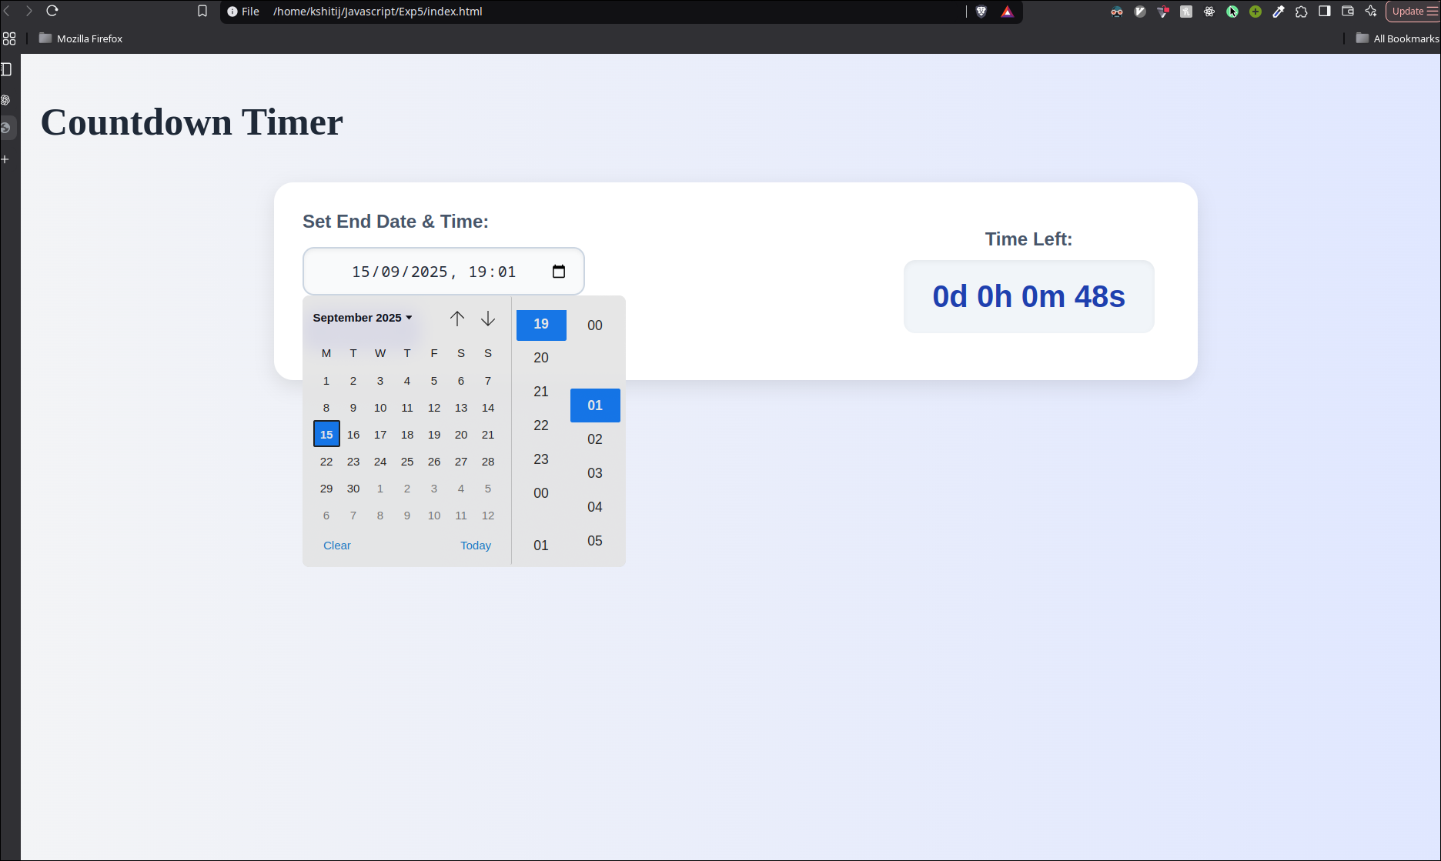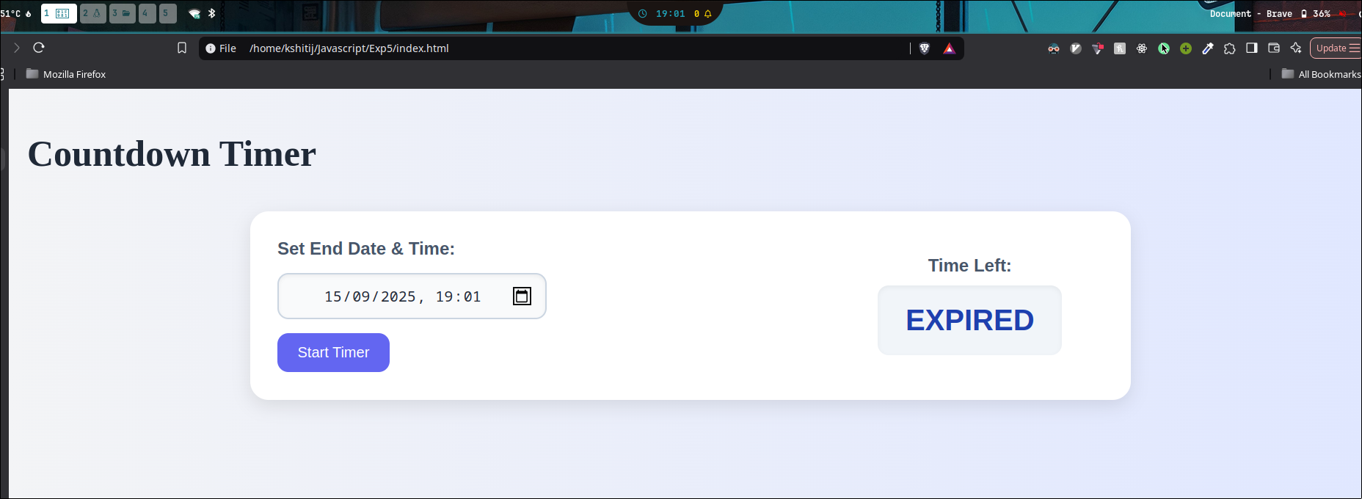

**Code:**

1. **HTML:**

<!DOCTYPE html>

<html lang="en">

<head>

<script type="text/javascript" src="timer.js"></script>

<link rel="stylesheet" href="style.css">

<meta charset="UTF-8">

<meta name="viewport" content="width=device-width, initial-scale=1.0">

<title>Document</title>

</head>

<body>

<h1>Countdown Timer</h1>

<div class="shape-box">

<!-- Input Section -->

<div class="form-section">

<label class="area-label" for="endtime">Set End Date & Time:</label>

<input type="datetime-local" id="endtime">

<button onclick="startCountdown()">Start Timer</button>

</div>

<!-- Output Section -->

<div class="result-section">

<div class="area-label">Time Left:</div>

<div id="timer" class="area-box">--d --h --m --s</div>

</div>

</div>

</body>

1. **Javascript:**

let countdownInterval;

// set default value to current date/time

window.onload = function () {

let now = new Date();

let local = new Date(now.getTime() - now.getTimezoneOffset() * 60000)

.toISOString()

.slice(0, 16);

document.getElementById("endtime").value = local;

};

function startCountdown() {

clearInterval(countdownInterval); // reset if already running

let endTimeInput = document.getElementById("endtime").value;

if (!endTimeInput) {

alert("Please select a valid end date and time!");

return;

}

let countDownDate = new Date(endTimeInput).getTime();

countdownInterval = setInterval(function () {

let now = new Date().getTime();

let distance = countDownDate - now;

if (distance < 0) {

clearInterval(countdownInterval);

document.getElementById("timer").innerHTML = "EXPIRED";

return;

}

let days = Math.floor(distance / (1000 * 60 * 60 * 24));

let hours = Math.floor(

(distance % (1000 * 60 * 60 * 24)) / (1000 * 60 * 60)

);

let minutes = Math.floor((distance % (1000 * 60 * 60)) / (1000 * 60));

let seconds = Math.floor((distance % (1000 * 60)) / 1000);

document.getElementById("timer").innerHTML =

days + "d " + hours + "h " + minutes + "m " + seconds + "s";

}, 1000);

}