**Output:**

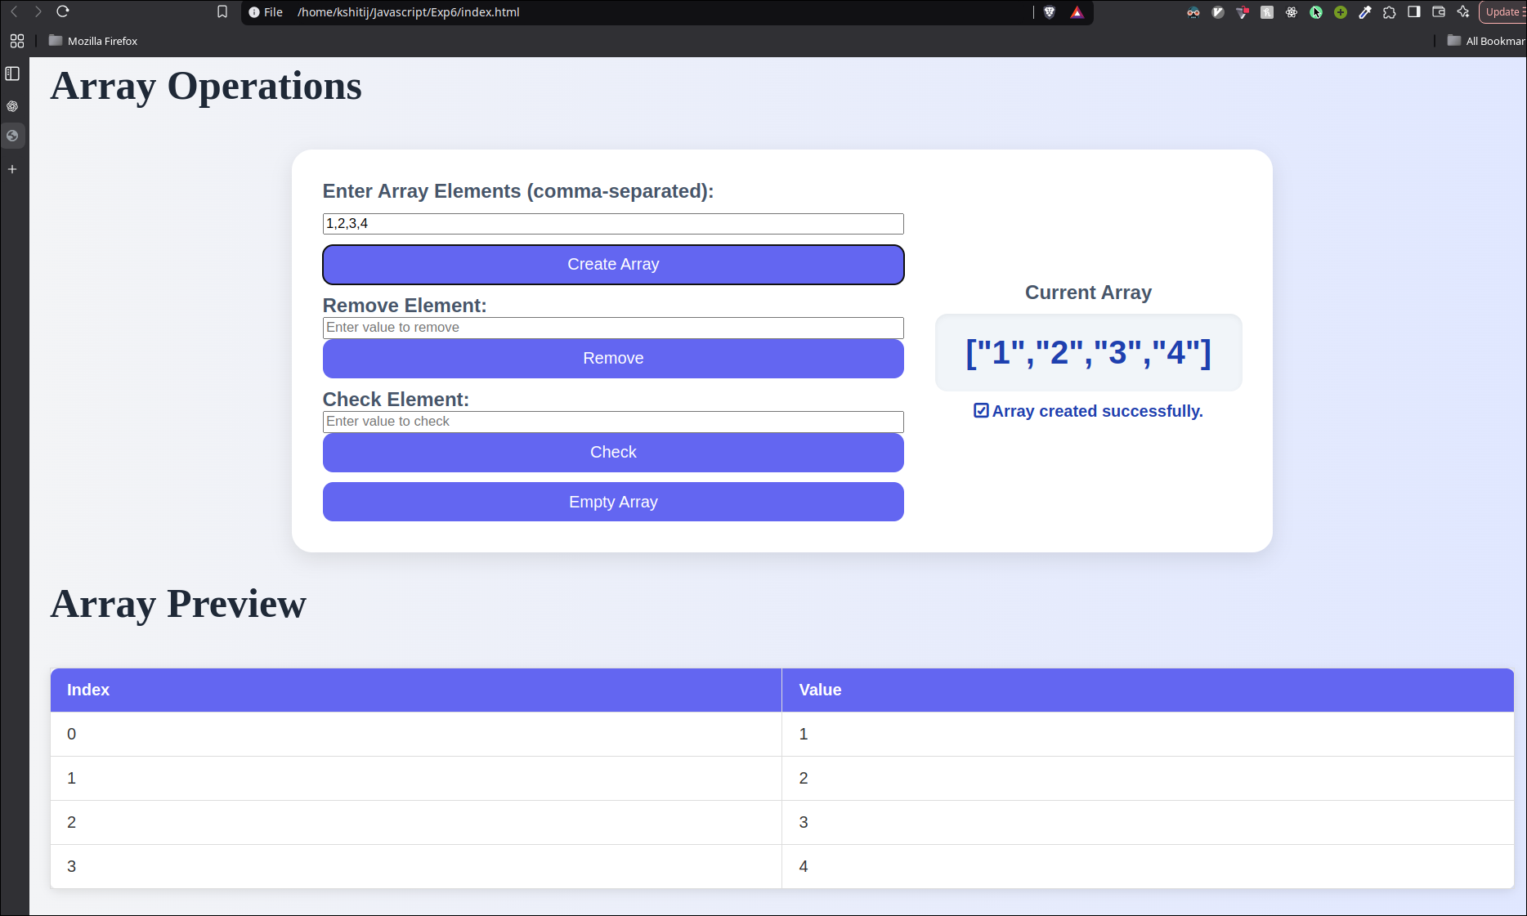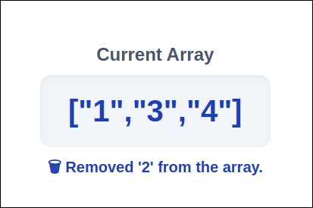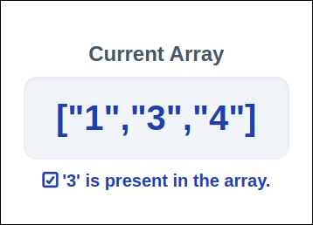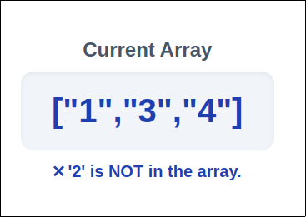

**Code:**

1. **HTML:**

<!DOCTYPE html>

<html lang="en">

<head>

<script type="text/javascript" src="array_ops.js"></script>

<link rel="stylesheet" href="style.css">

<meta charset="UTF-8">

<meta name="viewport" content="width=device-width, initial-scale=1.0">

<title>Document</title>

</head>

<body>

<h1>Array Operations</h1>

<div class="shape-box">

<!-- Input Section -->

<div class="form-section">

<label class="area-label">Enter Array Elements (comma-separated):</label>

<input type="text" id="arrayInput" placeholder="e.g. 10, 20, 30, 40">

<button onclick="createArray()">Create Array</button>

<div class="operation">

<label class="area-label">Remove Element:</label>

<input type="text" id="removeInput" placeholder="Enter value to remove">

<button onclick="removeElement()">Remove</button>

</div>

<div class="operation">

<label class="area-label">Check Element:</label>

<input type="text" id="checkInput" placeholder="Enter value to check">

<button onclick="checkElement()">Check</button>

</div>

<button onclick="emptyArray()">Empty Array</button>

</div>

<!-- Result Section -->

<div class="result-section">

<div class="area-label">Current Array</div>

<div class="area-box" id="arrayDisplay">[]</div>

<div id="message" style="color:#1e40af; font-weight:600;"></div>

</div>

</div>

<h1>Array Preview</h1>

<!-- Table Section -->

<table id="arrayTable" style="display:none;">

<thead>

<tr>

<th>Index</th>

<th>Value</th>

</tr>

</thead>

<tbody></tbody>

</table>

</body>

1. **Javascript:**

let arr = [];

// Update array display and table

function updateDisplay(message="") {

document.getElementById("arrayDisplay").textContent = JSON.stringify(arr);

document.getElementById("message").textContent = message;

const table = document.getElementById("arrayTable");

const tbody = table.querySelector("tbody");

tbody.innerHTML = "";

if (arr.length > 0) {

table.style.display = "table";

arr.forEach((val, index) => {

const row = document.createElement("tr");

row.innerHTML = `<td>${index}</td><td>${val}</td>`;

tbody.appendChild(row);

});

} else {

table.style.display = "none";

}

}

// Create array from input

function createArray() {

const input = document.getElementById("arrayInput").value.trim();

if (!input) {

updateDisplay("⚠️ Please enter some elements first.");

return;

}

arr = input.split(",").map(el => el.trim()).filter(el => el !== "");

updateDisplay("✅ Array created successfully.");

}

// Remove element

function removeElement() {

if (arr.length === 0) {

updateDisplay("⚠️ Array is empty. Nothing to remove.");

return;

}

const value = document.getElementById("removeInput").value.trim();

if (!value) {

updateDisplay("⚠️ Enter a value to remove.");

return;

}

const index = arr.indexOf(value);

if (index !== -1) {

arr.splice(index, 1);

updateDisplay(`🗑️ Removed '${value}' from the array.`);

} else {

updateDisplay(`❌ '${value}' not found in the array.`);

}

}

// Check element

function checkElement() {

if (arr.length === 0) {

updateDisplay("⚠️ Array is empty. Nothing to check.");

return;

}

const value = document.getElementById("checkInput").value.trim();

if (!value) {

updateDisplay("⚠️ Enter a value to check.");

return;

}

if (arr.includes(value)) {

updateDisplay(`✅ '${value}' is present in the array.`);

} else {

updateDisplay(`❌ '${value}' is NOT in the array.`);

}

}

// Empty array

function emptyArray() {

if (arr.length === 0) {

updateDisplay("⚠️ Array is already empty.");

return;

}

arr = [];

updateDisplay("🧹 Array emptied.");

}