**Output:**

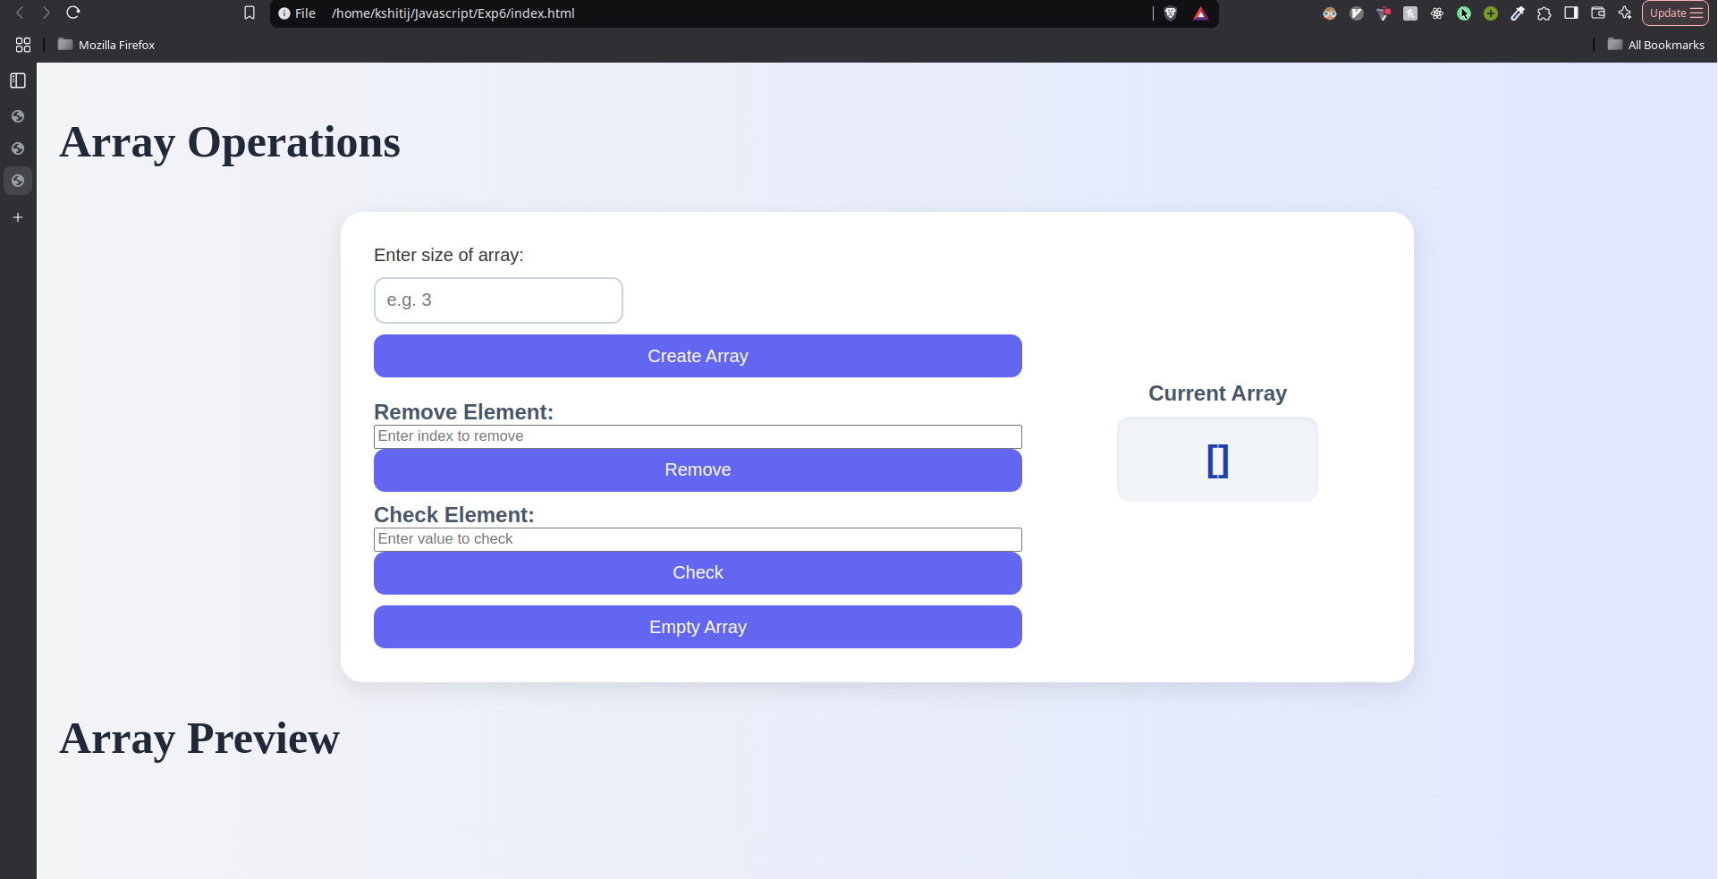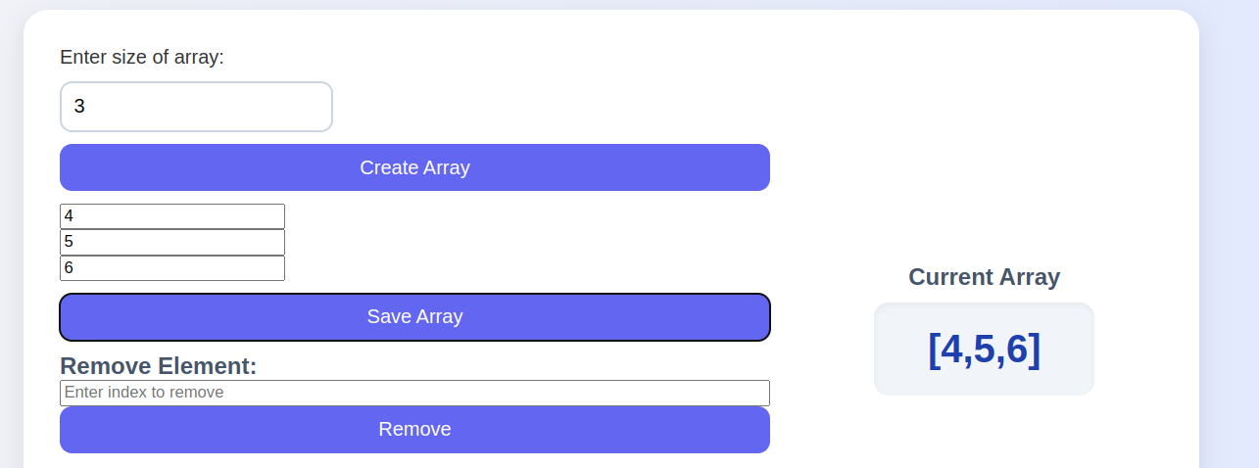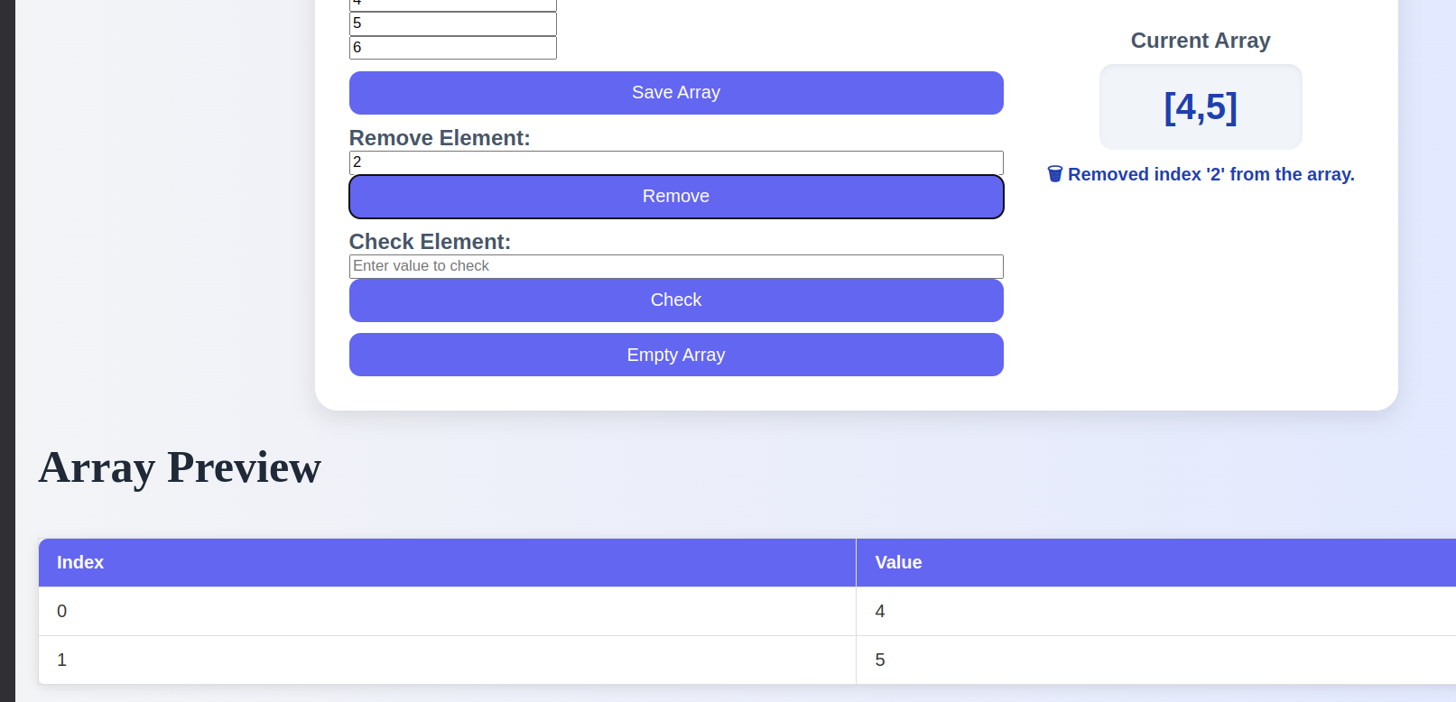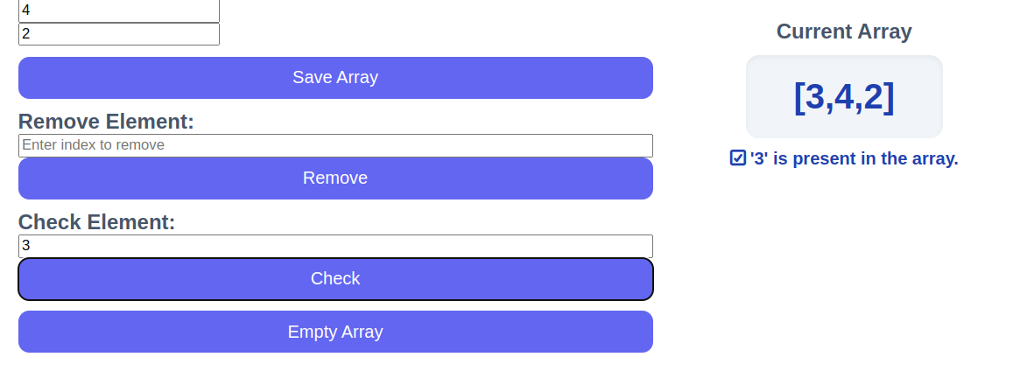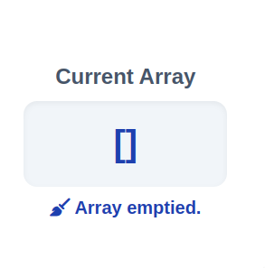

**Code:**

1. **HTML:**

<!DOCTYPE html>

<html lang="en">

<head>

<script type="text/javascript" src="array_objects.js"></script>

<link rel="stylesheet" href="style.css">

<meta charset="UTF-8">

<meta name="viewport" content="width=device-width, initial-scale=1.0">

<title>Document</title>

</head>

<body>

<h1>Array Operations</h1>

<div class="shape-box">

<!-- Input Section -->

<div class="form-section">

<label for="arraySize">Enter size of array:</label>

<input type="number" id="arraySize" min="1" placeholder="e.g. 3" />

<button onclick="createArray()">Create Array</button>

<div id="arrayInputs"></div>

<button id="saveArrayBtn" style="display: none" onclick="saveArray()">

Save Array

</button>

<div class="operation">

<label class="area-label">Remove Element:</label>

<input

type="text"

id="removeInput"

placeholder="Enter index to remove"

/>

<button onclick="removeElement()">Remove</button>

</div>

<div class="operation">

<label class="area-label">Check Element:</label>

<input

type="text"

id="checkInput"

placeholder="Enter value to check"

/>

<button onclick="checkElement()">Check</button>

</div>

<button onclick="emptyArray()">Empty Array</button>

</div>

<!-- Result Section -->

<div class="result-section">

<div class="area-label">Current Array</div>

<div class="area-box" id="arrayDisplay">[]</div>

<div id="message" style="color: #1e40af; font-weight: 600"></div>

</div>

</div>

<h1>Array Preview</h1>

<!-- Table Section -->

<table id="arrayTable" style="display: none">

<thead>

<tr>

<th>Index</th>

<th>Value</th>

</tr>

</thead>

<tbody></tbody>

</table>

</body>

1. **Javascript:**

let arr = [];

// Update array display and table

function updateDisplay(message = "") {

document.getElementById("arrayDisplay").textContent = JSON.stringify(arr);

document.getElementById("message").textContent = message;

const table = document.getElementById("arrayTable");

const tbody = table.querySelector("tbody");

tbody.innerHTML = "";

if (arr.length > 0) {

table.style.display = "table";

arr.forEach((val, index) => {

const row = document.createElement("tr");

row.innerHTML = `<td>${index}</td><td>${val}</td>`;

tbody.appendChild(row);

});

} else {

table.style.display = "none";

}

}

function saveArray() {

const size = parseInt(document.getElementById("arraySize").value);

userArray = [];

for (let i = 0; i < size; i++) {

let val = document.getElementById(`element-${i}`).value.trim();

// Try parsing numbers or arrays

try {

val = JSON.parse(val);

} catch (e) {

// keep as string if not JSON parsable

}

userArray.push(val);

}

document.getElementById("arrayDisplay").innerText = JSON.stringify(userArray);

arr = userArray;

}

function createArray() {

const size = parseInt(document.getElementById("arraySize").value);

const container = document.getElementById("arrayInputs");

container.innerHTML = "";

if (isNaN(size) || size <= 0) {

alert("Please enter a valid array size.");

return;

}

for (let i = 0; i < size; i++) {

const input = document.createElement("input");

input.type = "text";

input.placeholder = `Element ${i + 1}`;

input.id = `element-${i}`;

container.appendChild(input);

container.appendChild(document.createElement("br"));

}

document.getElementById("saveArrayBtn").style.display = "inline-block";

}

// Remove element

function removeElement() {

if (arr.length === 0) {

updateDisplay("⚠️ Array is empty. Nothing to remove.");

return;

}

const value = document.getElementById("removeInput").value.trim();

if (!value) {

updateDisplay("⚠️ Enter an index to remove.");

return;

}

const index = value;

if (index !== -1) {

arr.splice(index, 1);

updateDisplay(`🗑️ Removed index '${value}' from the array.`);

} else {

updateDisplay(`❌ index '${value}' not found in the array.`);

}

}

// Check element

function checkElement() {

if (arr.length === 0) {

updateDisplay("⚠️ Array is empty. Nothing to check.");

return;

}

const rawValue = document.getElementById("checkInput").value.trim();

const numValue = Number(rawValue);

if (!rawValue) {

updateDisplay("⚠️ Enter a value to check.");

return;

}

if (arr.includes(rawValue) || arr.includes(numValue)) {

updateDisplay(`✅ '${rawValue}' is present in the array.`);

} else {

updateDisplay(`❌ '${rawValue}' is NOT in the array.`);

}

}

// Empty array

function emptyArray() {

if (arr.length === 0) {

updateDisplay("⚠️ Array is already empty.");

return;

}

arr = [];

updateDisplay("🧹 Array emptied.");

}