**Output:**

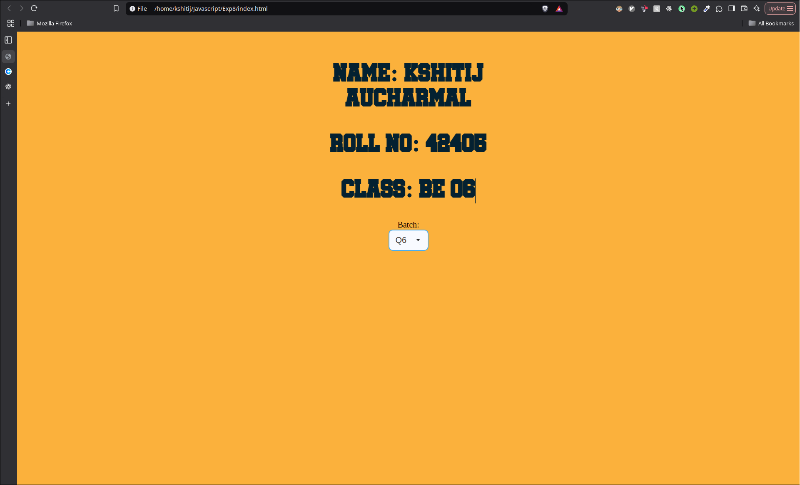

**Fig. Normal Window Yellow Background**

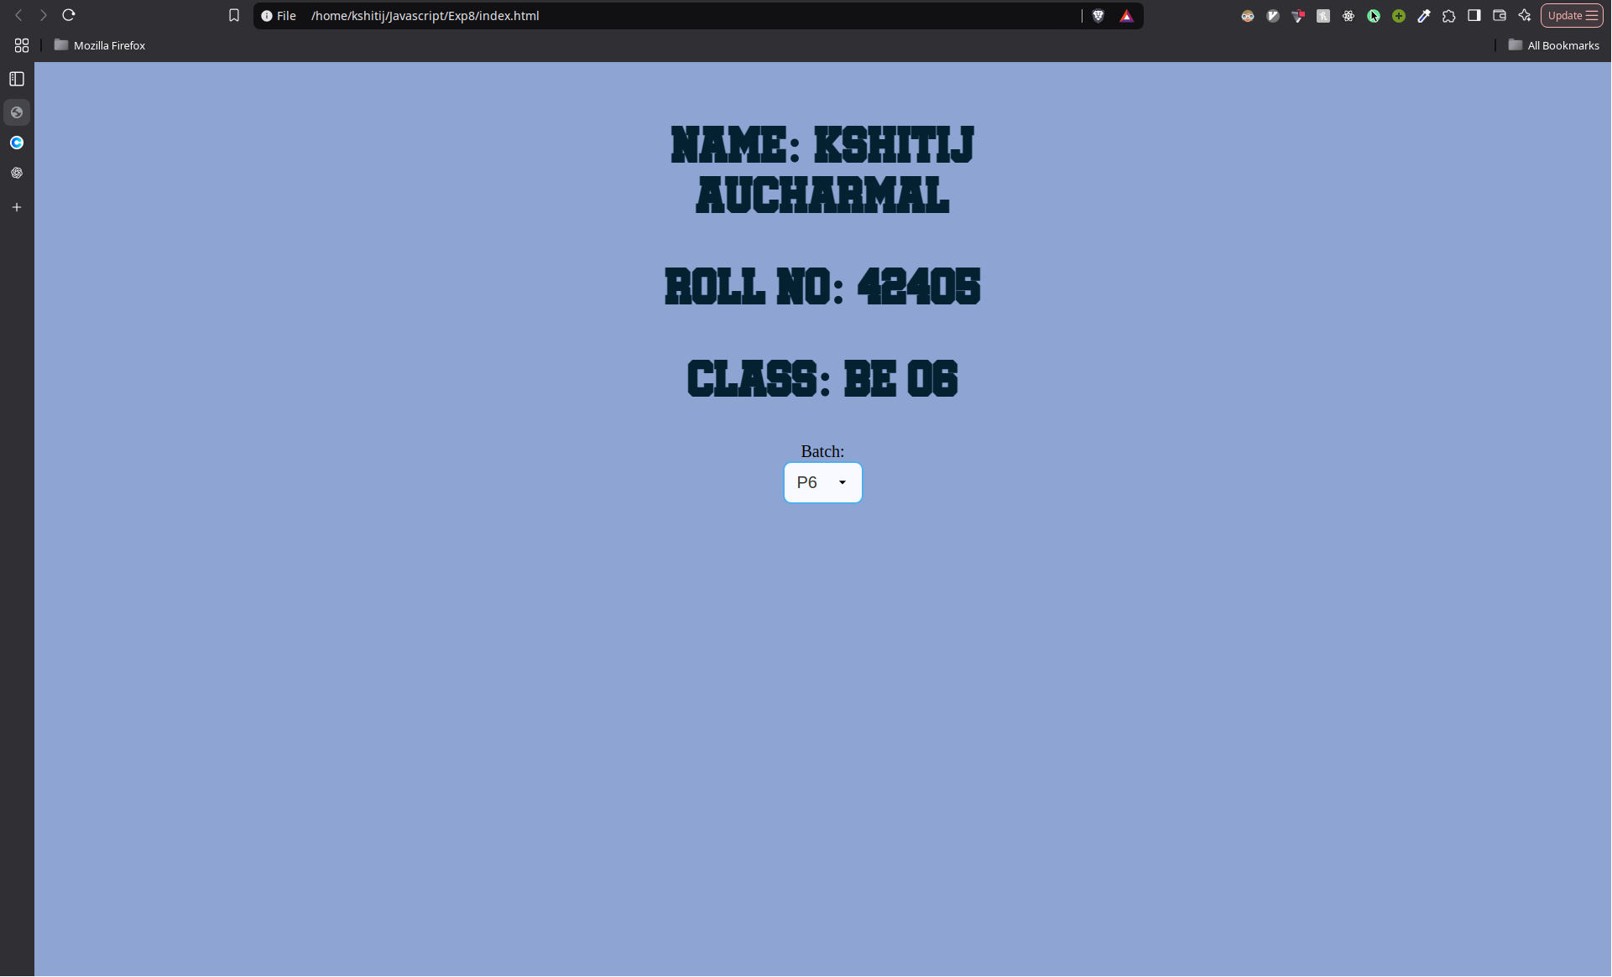

**Fig. OnMouseOver event on Text**



**Fig. OnMouseLeave event**

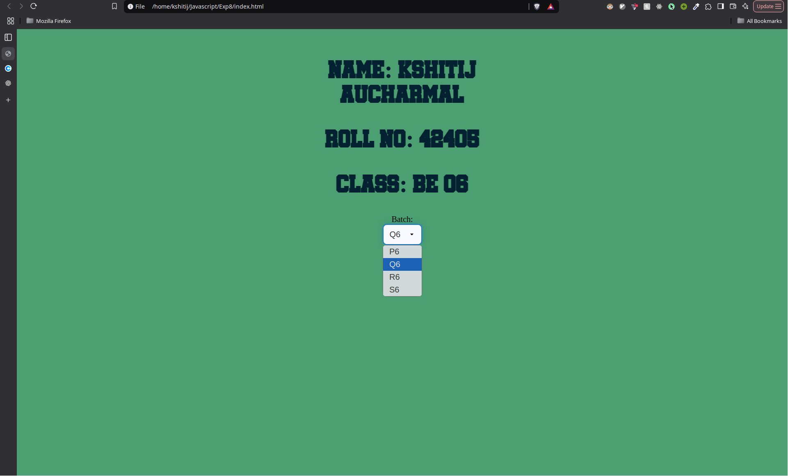

**Fig. onfocus event on Batch Select element**



**Fig. onblur event**

**Code:**

1. **HTML:**

<!doctype html>

<html lang="en">

<head>

<link rel="stylesheet" href="style.css" />

<meta charset="UTF-8" />

<meta name="viewport" content="width=device-width, initial-scale=1.0" />

<title>Document</title>

</head>

<body>

<div id="p_hover">

<h1>Name: KSHITIJ AUCHARMAL</h1>

<h1>Roll no: 42405</h1>

<h1>Class: BE 06</h1>

</div>

<label for="batch">Batch:</label>

<select id="batch">

<option value="p6">P6</option>

<option value="q6">Q6</option>

<option value="r6">R6</option>

<option value="s6">S6</option>

</select>

<script type="text/javascript" src="event_manager.js"></script>

</body>

</html>

1. **Javascript:**

let default_color = "#FBB13C";

let focus_color = "#4c9f70";

let hover_color = "#8EA4D2";

// Set to default

document.body.style.backgroundColor = default_color;

let header_text = document.getElementById("p_hover");

header_text.addEventListener("mouseover", function (event) {

const curColour = document.body.style.backgroundColor;

document.body.style.backgroundColor = hover_color;

});

header_text.addEventListener("mouseleave", function (event) {

const curColour = document.body.style.backgroundColor;

document.body.style.backgroundColor = default_color;

});

let batch_select = document.getElementById("batch");

batch_select.addEventListener("focus", function (event) {

const curColour = document.body.style.backgroundColor;

document.body.style.backgroundColor = focus_color;

});

batch_select.addEventListener("blur", function (event) {

const curColour = document.body.style.backgroundColor;

document.body.style.backgroundColor = default_color;

});