VOLATILITY FORECASTING AND SECTORAL RISK

PROPOGATION IN INDIAN MARKETS : A GARCH

PERSPECTIVE
Kshitij Bhandari
2025-12-14
Project Objective and Analytical Framework
The objective of this project is to examine how volatility behaves across major Indian equity sectors and to understand whether volatility shocks propagate differently across sectors during normal and crisis periods. Rather than focusing solely on return predictability, the emphasis is on risk dynamics, volatility persistence, and asymmetric responses to shocks, which are central to portfolio risk management and systemic risk assessment.
To achieve this, five NIFTY sector indices: Bank, IT, Pharma, Auto, and FMCG—are analyzed using a unified time-series framework. The analysis proceeds in a structured manner: (i) preprocessing and return construction, (ii) seasonality and stationarity diagnostics, (iii) mean-process validation, (iv) volatility modeling using GARCH-type models, (v) crisis-period volatility comparison, and (vi) out-of-sample volatility forecasting. Each step is motivated by economic reasoning and directly supports the project’s overarching goal of understanding sector-level risk transmission.
Data Preparation and Return Construction
The analysis uses daily closing prices for five NIFTY sector indices: Bank, IT, Pharma, Auto, and FMCG processed through a uniform data pipeline to ensure cross-sector comparability. Daily data capture immediate market reactions to news and shocks, which is essential for studying volatility behavior.
Prices are converted into logarithmic returns, a standard choice in financial time-series analysis due to their additive property over time and favorable statistical characteristics. To focus on medium-term risk dynamics, daily log returns are aggregated to the monthly frequency by summation. Monthly aggregation reduces high-frequency noise, facilitates interpretation of macroeconomic and crisis-period effects, and improves the stability of volatility model estimation. Seasonality Diagnostics Across Sectors.
A consistent train–test split is applied across all sectors, with the final year of data reserved for out-of-sample analysis. This separation ensures that later volatility forecasts are evaluated without look-ahead bias. The resulting monthly log return series form the foundation for all subsequent diagnostics and modeling. At this stage, no assumptions are made regarding predictability or risk behavior; instead, the prepared data are carried forward for formal testing of seasonality, stationarity, and mean dynamics, ensuring that later volatility results reflect genuine economic behavior rather than data construction choices.
Seasonality Diagnostics
The first empirical step of the analysis examines whether sectoral returns exhibit calendar-based seasonality, which could distort volatility estimates if left unaccounted for. Seasonality is assessed using a combination of month plots, spectral analysis, and the Friedman non-parametric test, applied uniformly across all five NIFTY sector indices.
- Visual Seasonality: Month Plots
The plot represents month plots of monthly log returns for all five sectors. Across sectors, returns fluctuate around zero with no month consistently exhibiting higher or lower returns across years. While individual months occasionally show large positive or negative realizations particularly in Bank, IT, and Auto these spikes are irregular and not repeated systematically year after year.
The IT sector displays a few extreme monthly observations, reflecting exposure to global technology cycles and crisis episodes rather than seasonal behavior. In contrast, Pharma and FMCG show relatively tighter dispersion across months, consistent with their defensive nature. However, even in these sectors, no stable month-of-year pattern emerges.
Overall, the month plots suggest that observed variability is driven by episodic shocks and market conditions, not by deterministic calendar effects.
- Frequency-Domain Evidence: Sample Spectrum
The sample spectra for all sectors further supports the absence of seasonality. Importantly, none of the spectra display a dominant peak at the annual frequency (1/12), which would indicate month-of-year seasonality. Instead, power is distributed across higher frequencies, reflecting short-lived volatility bursts rather than periodic cycles.
Sectors such as Bank and IT show elevated spectral density at multiple frequencies, consistent with clustered volatility and abrupt market reactions. Pharma and FMCG exhibit lower overall spectral power, aligning with their more stable return behavior. Crucially, these frequency-domain patterns reinforce the conclusion that volatility clustering originates from shocks, not seasonal repetition.
- Friedman Test: Statistical Confirmation
The Friedman test formally evaluates whether monthly return distributions differ significantly. Table summarizes the results across all sectors. For each index, the test statistics are small, and the p-value is well above conventional significance levels. As a result, the null hypothesis of equal monthly distributions cannot be rejected for any sector.
This statistical evidence confirms the visual findings from the month plots and spectra. Even where occasional large monthly returns are observed, they do not occur with sufficient regularity to constitute true seasonality.
- Implications for the Project Goal
Taken together, the seasonality diagnostics provide strong and consistent evidence that calendar effects do not drive sectoral return behavior. This finding is critical for the project’s broader objective. By ruling out seasonality, the analysis ensures that subsequent volatility patterns particularly persistence, asymmetry, and crisis-driven spikes reflect genuine risk dynamics rather than unmodeled seasonal structure.
Consequently, the modeling framework proceeds without seasonal components in the mean equation, allowing volatility models to focus solely on shock transmission and time-varying risk, which are central to understanding sector-level risk propagation in Indian equity markets.
Stationarity and Mean Dynamics
After ruling out seasonality, the next step evaluates whether sectoral returns exhibit persistent mean dynamics or serial dependence, which would require explicit modeling in the mean equation before volatility analysis.

- Stationarity Tests
The table summarizes the results of the ADF, Phillips–Perron, and KPSS tests for all five sectors. For every index, both ADF and PP tests reject the null hypothesis of a unit root at the 5% level, while the KPSS test fails to reject the null of level stationarity. The consistency across all three tests provides strong evidence that monthly log returns are stationary for every sector.
From an economic perspective, this implies that shocks to returns do not have permanent effects on expected returns. Even large market events cause temporary deviations that eventually revert toward a stable mean near zero. This behavior is typical of financial return series and supports the use of stationary time-series models without differencing.
- Autocorrelation Structure: ACF and PACF
The plot presents ACF and PACF plots for all sectors. Across indices, autocorrelations beyond lag zero are extremely small and lie well within the 95% confidence bounds. No sector shows a systematic decay pattern or isolated significant spikes that would indicate persistent autoregressive or moving-average structure.
The PACF plots similarly show no dominant lags across sectors. Occasional small spikes appear at isolated lags, particularly for Bank and IT, but these are neither statistically strong nor consistent across time. Such behavior is characteristic of noise-driven fluctuations rather than genuine predictability.
Importantly, this lack of serial dependence holds across economically diverse sectors from highly cyclical (Bank, Auto) to defensive (Pharma, FMCG) suggesting that mean return predictability is uniformly weak in the Indian equity market at the monthly frequency.
- Implications for Model Design
Together, the stationarity tests and autocorrelation diagnostics indicate that monthly sectoral returns behave approximately like white noise around a constant mean. This finding has two key implications for the project.
First, it justifies the use of very simple mean specifications, such as ARIMA(0,0,0), avoiding unnecessary parameters that could contaminate volatility estimation. Second, it confirms that any persistence observed later in the analysis must originate from time-varying volatility rather than from the mean process.
As a result, the analysis can proceed by treating the mean equation as a baseline filter and shifting attention to volatility dynamics, which are central to the project’s objective of understanding sector-level risk behavior.
Mean Model Selection and Residual Diagnostics
Having established that returns are stationary and exhibit negligible serial dependence, the next step is to select an appropriate mean model and verify that it adequately filters out any remaining linear structure before volatility modeling.
- ARIMA Model Selection
The table reports the best-fitting ARIMA model for each sector based on the Bayesian Information Criterion (BIC). For all five indices Bank, IT, Pharma, Auto, and FMCG ARIMA(0,0,0) is selected as the optimal specification. This result indicates that adding autoregressive or moving-average terms does not improve model fit once parsimony is considered.
Economically, this finding reinforces the notion that monthly sectoral returns are unpredictable in the mean, consistent with weak-form market efficiency. Differences in BIC magnitudes across sectors reflect differences in volatility levels rather than mean dynamics and therefore do not alter the conclusion that a constant-mean specification is sufficient across all indices.
- Residual Time-Series Behavior
The plot presents the ARIMA residuals for all sectors. In each case, residuals fluctuate randomly around zero without visible trends or persistent patterns. While large shocks are present particularly during known crisis periods, their occurrence is sporadic and does not exhibit systematic structure.
Sectors such as Bank and IT display occasional extreme residuals, reflecting exposure to global financial and technology-related shocks. In contrast, Pharma and FMCG residuals appear more tightly clustered, consistent with their relatively defensive return profiles. Importantly, none of the residual series shows evidence of sustained autocorrelation or mean drift.
- Residual Distribution and Normality
The residual histograms show approximately symmetric distributions centered near zero, with mild fat tails across sectors. These deviations from normality are typical in financial return data and are not indicative of mean misspecification. Instead, they suggest the presence of time-varying volatility, which motivates the use of conditional heteroskedasticity models in the next stage of the analysis.
- Ljung–Box Tests and White-Noise Validation
The table reports Ljung–Box test results for the ARIMA residuals. For all sectors, the test fails to reject the null hypothesis of no serial correlation, with p-values comfortably above conventional significance thresholds. This confirms that the residuals behave as white noise after filtering through the ARIMA(0,0,0) model.
This diagnostic step is crucial. It confirms that any remaining structure in the data is not due to unmodeled mean dynamics, ensuring that subsequent volatility modeling captures genuine risk behavior rather than artifacts of poor mean specification.
- Implications for Volatility Modeling
Together, the ARIMA selection and residual diagnostics establish a clean baseline for volatility analysis. The mean process has been adequately filtered, residuals are serially uncorrelated, and deviations from normality are consistent with heteroskedasticity rather than predictability. As a result, the analysis can confidently proceed to modeling time-varying volatility, where persistence, asymmetry, and crisis-driven risk dynamics are expected to play a central role.

- Exponential Smoothing Benchmarks (SES and Holt)
As an additional benchmark, Simple Exponential Smoothing (SES) and Holt’s linear trend method are applied to the monthly return series to assess whether smoothing-based models can extract meaningful level or trend structure in sectoral returns. These models are designed to capture deterministic components in the mean process and therefore serve as a useful contrast to ARIMA-based specifications.
Across all five sectors, the SES and Holt residual plots show behavior that is qualitatively similar to ARIMA residuals: residuals fluctuate randomly around zero, with occasional large shocks during known crisis periods but no persistent structure. Sectors such as Bank and IT display larger isolated residuals, reflecting exposure to systemic and global shocks, while Pharma and FMCG exhibit tighter residual dispersion, consistent with their defensive characteristics. Importantly, Holt’s inclusion of a trend component does not visibly reduce residual variation relative to SES, indicating that monthly returns do not follow a stable deterministic trend.
The Ljung–Box test results summarized in Table X provide formal confirmation. For both SES and Holt models, the null hypothesis of no serial correlation in residuals cannot be rejected for any sector, with p-values well above conventional significance levels. As indicated in the ETS summary table, neither SES nor Holt is classified as useful for modeling the mean dynamics of returns.
The implication is clear and consistent with earlier findings: monthly sectoral returns do not contain exploitable level or trend structure, regardless of whether ARIMA or exponential smoothing methods are used. Consequently, smoothing-based models offer no advantage over a constant-mean specification. This reinforces the project’s modeling direction having ruled out seasonality, autocorrelation, and trend effects in the mean, the dominant empirical structure lies in time-varying volatility, which motivates the transition to rolling volatility analysis and GARCH-type models in the subsequent sections.
Rolling Volatility and Crisis-Period Risk Dynamics
To study time-varying risk behavior beyond the mean, the analysis computes rolling volatility measures using a 12-month window for cross-sector comparison and a 6-month window for crisis-focused analysis. Rolling volatility provides a non-parametric view of volatility clustering and regime shifts, serving as an important diagnostic before formal GARCH modeling.
- Cross-Sector Rolling Volatility
The 12-month rolling volatility plot reveals clear heterogeneity in risk profiles across sectors. Financially and cyclically sensitive sectors Bank, Auto, and IT exhibit higher and more variable volatility over time, while Pharma and FMCG display relatively lower and more stable volatility, consistent with their defensive nature.
Major global and domestic shocks generate synchronized volatility spikes, most notably during the Global Financial Crisis (2008) and COVID-19 (2020). However, the magnitude of these spikes differs substantially across sectors, indicating incomplete but meaningful risk transmission. Notably, IT shows unusually elevated volatility in the early 2000s, reflecting sector-specific structural shocks rather than economy-wide stress.
- Crisis-Period Volatility Behavior
Crisis-segmented 6-month rolling volatility plots allow direct comparison of sectoral responses during distinct stress events. Across all sectors, COVID-19 emerges as the most severe volatility shock, with especially large spikes in Auto and Bank, highlighting their sensitivity to demand collapse and financial stress. In contrast, FMCG exhibits the smallest volatility response, underscoring its defensive role during extreme uncertainty.
The GFC (2008) produces sustained but less extreme volatility relative to COVID-19, particularly in Bank and IT, suggesting prolonged stress rather than abrupt dislocation. Domestic events such as Taper Tantrum (2013) and Demonetization (2016) lead to moderate and short-lived volatility increases, with limited spillovers across sectors.
- Quantitative Crisis Comparison
The crisis summary tables reinforce the visual evidence. Average and median volatility levels are consistently highest during COVID-19 across all sectors, with Auto and Bank recording the largest values, while Pharma and FMCG remain comparatively resilient. Normal periods exhibit substantially lower volatility, confirming strong regime dependence on risk behavior.
- Implication for the Project
These findings establish three key facts:
- volatility is persistent and clustered
- crisis shocks transmit unevenly across sectors, and
- mean dynamics alone cannot explain risk behavior
GARCH and EGARCH Results: Volatility Persistence and Asymmetry
To formally model time-varying volatility and risk transmission, GARCH(1,1) and EGARCH(1,1) specifications are estimated for each sector. Model selection is based on the Bayesian Information Criterion (BIC), ensuring parsimony while capturing key volatility dynamics.
- Model Selection
The BIC comparison indicates that EGARCH(1,1) is preferred for Bank, IT, and Auto, while GARCH(1,1) is marginally preferred for Pharma and FMCG. This distinction aligns with sectoral characteristics: cyclically sensitive sectors benefit from asymmetric volatility modeling, whereas defensive sectors are adequately described by symmetric volatility dynamics.
- Volatility Persistence
Estimated persistence parameters reveal strong volatility clustering across all sectors. Bank, Pharma, and Auto exhibit high but mean-reverting persistence, consistent with prolonged stress following crises such as the GFC and COVID-19. IT and FMCG show persistence values close to or exceeding unity, suggesting extremely slow decay of volatility shocks, particularly during structural or global stress periods. These findings are consistent with the rolling volatility plots, where elevated risk regimes persist well beyond the initial shock.
- Asymmetric Shock Effects
The EGARCH asymmetry parameter (γ) provides evidence of sector-specific shock responses. Bank and IT display positive asymmetry, indicating that negative shocks (“bad news”) generate larger volatility responses than positive shocks of the same magnitude an expected result given their exposure to leverage, funding risk, and global sentiment. Auto exhibits negative asymmetry, reflecting sensitivity to demand-side collapses where recovery shocks may increase uncertainty. Pharma and FMCG show weaker asymmetry, reinforcing their defensive classification.
- Implication for the Project
Together, these results confirm that volatility, not returns, is the dominant channel of risk transmission across Indian equity sectors. Persistence explains why crises have long-lasting effects, while asymmetry explains why the same shock impacts sectors differently. This validates the project’s progression from descriptive rolling volatility to parametric GARCH modeling and provides a robust empirical foundation for analyzing sectoral risk propagation during extreme market events.
Volatility Forecasting Using EGARCH Models
After evaluating both GARCH(1,1) and EGARCH(1,1) specifications across sectors, EGARCH is adopted uniformly for all five indices for volatility forecasting. While GARCH marginally outperforms EGARCH for Pharma and FMCG based on BIC, the differences are economically and statistically negligible. Given the project’s focus on crisis behavior, asymmetry, and risk transmission, a consistent EGARCH framework is preferred.
- Rationale for Uniform EGARCH Choice
The BIC differences between GARCH and EGARCH for Pharma and FMCG are extremely small, indicating no meaningful loss of fit when using EGARCH. In contrast, EGARCH offers clear structural advantages:
- It captures volatility asymmetry, allowing negative return shocks to have a different impact than positive shocks.
- It avoids non-negativity constraints on parameters through log-variance modeling.
- It provides interpretability of shock transmission, which is central to this project’s objectives.
Using a single volatility framework ensures comparability across sectors, particularly when analyzing crisis periods and cross-sector volatility spillovers.
- Forecasting Framework
Volatility forecasts are generated using rolling EGARCH(1,1) models trained on expanding historical windows. Forecasted conditional volatility is compared against realized volatility computed from rolling windows of returns (20 days = 30 days trading activity). This design replicates real-world risk forecasting while avoiding look-ahead bias.

Volatility Forecasting Performance
To evaluate the effectiveness of the EGARCH(1,1) specification, rolling one-step-ahead volatility forecasts are compared against realized volatility for all five NIFTY sector indices. Forecast evaluation focuses on both visual tracking performance and quantitative error metrics, ensuring consistency between model behavior and economic interpretation.
- Visual Forecast Tracking
Across sectors, the rolling EGARCH forecasts closely track the level and direction of realized volatility, particularly during high-volatility regimes. In Bank and Auto, forecasted volatility responds quickly to sharp increases, capturing both the magnitude and persistence of volatility spikes. This is especially evident during post-COVID normalization, where EGARCH adjusts smoothly without overshooting.
IT and Pharma exhibit more gradual volatility cycles, and EGARCH forecasts mirror these medium-term fluctuations with limited lag. While short-term realized volatility occasionally exceeds forecasts, the overall trend alignment remains strong, indicating that EGARCH successfully captures persistent volatility dynamics rather than short-lived noise.
In FMCG, forecasted volatility is smoother and consistently higher than realized volatility during calm periods, reflecting the sector’s lower realized risk but persistent conditional variance. This behavior is expected and indicates conservative volatility estimation rather than model misspecification.
- Forecast Accuracy Metrics
The forecast error table reinforces the visual findings. FMCG and Auto achieve the lowest RMSE and MAE, indicating strong forecast stability in structurally lower-risk or less noisy sectors. Bank and Pharma display moderate forecast errors, reflecting higher volatility clustering and crisis sensitivity. IT shows the highest MAPE, largely due to sudden volatility collapses following extreme spikes, which mechanically inflate percentage errors despite reasonable absolute tracking.
Importantly, error levels are economically small across all sectors, confirming that EGARCH provides reliable short-horizon volatility forecasts even in heterogeneous market environments.
- Interpretation and Project Relevance
Taken together, the rolling plots and error metrics confirm that EGARCH consistently balances responsiveness and stability across sectors. The model performs particularly well during regime shifts, validating the decision to use EGARCH uniformly despite marginal BIC differences with GARCH in some sectors. More importantly, EGARCH enables a coherent comparison of volatility transmission and persistence, which is central to the project’s objective.
These results reinforce the key empirical insight of the study: while returns exhibit little predictability, volatility dynamics are both persistent and asymmetric, and this asymmetry plays a critical role in shaping sector-level risk during crises.
Sectoral Risk Transmission and Crisis Sensitivity
Having established robust volatility forecasts using EGARCH, this section analyzes how volatility propagates across sectors during systemic stress. The objective is to identify which sectors amplify shocks, which absorb them, and how crisis-specific dynamics differ across events.
- Cross-Sector Volatility Ranking During Crises
Crisis-period volatility summaries reveal clear and economically meaningful heterogeneity across sectors.
- Bank and Auto consistently exhibit the highest average and median volatility during major crises, particularly during COVID-19 and the Global Financial Crisis (GFC). This reflects their direct exposure to credit conditions, liquidity stress, and demand collapse.
- IT shows elevated volatility during the GFC but comparatively muted responses during domestic shocks such as Demonetization, suggesting stronger linkage to global rather than domestic macro risk.
- Pharma and FMCG display the lowest crisis volatility across all events, confirming their defensive nature. Even during COVID-19, their volatility increase is moderate relative to cyclical sectors.
This ranking is stable across crisis definitions, indicating structural differences rather than event-specific noise.
- Crisis-Specific Dynamics
The rolling crisis volatility plots highlight important differences in shock transmission mechanisms:
- GFC 2008 produces prolonged volatility persistence in Bank, Auto, and IT, consistent with a global financial shock that affected balance sheets and capital flows.
- Taper Tantrum 2013 results in short-lived but sharp volatility spikes, particularly in Bank and Auto, reflecting sensitivity to global liquidity tightening.
- Demonetization 2016 has a sector-specific impact, with limited volatility transmission to IT and Pharma but noticeable disruption in consumption-linked sectors.
- COVID-19 generates the largest and fastest volatility escalation across all sectors, but the magnitude differs sharply Auto and Bank peak highest, while FMCG remains comparatively insulated.
These patterns confirm that volatility transmission is nonlinear and regime-dependent, rather than uniform across shocks.
- Persistence and Asymmetry as Transmission Channels
The EGARCH parameter estimates reinforce the crisis evidence:
- High persistence in Bank and IT indicates slow volatility decay, meaning shocks propagate over longer horizons.
- Positive asymmetry (γ) in most sectors implies that negative returns disproportionately increase volatility, intensifying downside risk transmission.
- Defensive sectors show lower effective asymmetry, limiting spillover effects.
Thus, risk transmission occurs primarily through volatility persistence and asymmetric shock amplification, not through predictable returns.
- Implications for the Project
This section establishes a central empirical contribution of the study: Indian equity sectors transmit systemic risk unevenly, with financial and cyclical sectors acting as volatility amplifiers, while defensive sectors dampen shocks. These findings directly motivate the use of sector-aware volatility modeling and risk-sensitive portfolio construction, aligning with the project’s broader goal of understanding risk transmission mechanics rather than return predictability.
Conclusion
This study examined the dynamics of returns and volatility across major NIFTY sector indices with the objective of understanding how risk propagates through Indian equity markets, particularly during periods of systemic stress. The empirical analysis yields a clear and consistent conclusion: sectoral returns exhibit little predictability, while volatility dynamics are persistent, asymmetric, and crisis dependent.
Return-based analysis shows that all sectors are stationary, lack meaningful seasonality, and display negligible autocorrelation. The absence of predictable patterns in month plots, spectral density estimates, ACF–PACF structures, and formal seasonality tests supports weak-form market efficiency across sectors. Consequently, linear time-series models such as ARIMA reduce to white-noise processes, confirming that returns are not the primary channel through which risk is transmitted.
In contrast, volatility behavior reveals strong and economically meaningful structure. Rolling volatility measures and crisis-specific analysis demonstrate pronounced volatility clustering, persistence, and asymmetric responses to negative shocks, particularly in cyclical sectors such as Banking and Automobiles. Defensive sectors such as FMCG and Pharmaceuticals exhibit comparatively muted volatility responses, highlighting their role as shock absorbers during market stress.
EGARCH models are shown to be well-suited for capturing these dynamics across all sectors. Despite marginal differences in information criteria relative to symmetric GARCH in a few cases, EGARCH provides a unified framework that accommodates asymmetry and persistence while delivering reliable short-horizon volatility forecasts. Forecast evaluation confirms close alignment between predicted and realized volatility, particularly during regime shifts, reinforcing the practical relevance of the modeling approach.
Overall, the findings emphasize that risk transmission in Indian equity markets operates predominantly through volatility rather than returns, with sector-specific characteristics shaping both the magnitude and persistence of shocks. These results have direct implications for risk management, stress testing, and sector-aware portfolio construction, and provide a foundation for extending the analysis to volatility spillovers, market-wide risk indicators, and multi-asset frameworks.

analyze_index_ts <- function(file_path, index_name = "Index", test_days = 365) {
library(dplyr)
library(lubridate)
library(forecast)
library(tseries)
library(urca)
library(ggplot2)
cat("\n==============================\n")
cat(" ANALYZING:", index_name, "\n")
cat("==============================\n")
data <- read.csv(file_path, header = TRUE, stringsAsFactors = FALSE)
data$Date <- as.Date(data$Date)
data <- data %>% arrange(Date)
cutoff_date <- max(data$Date) - test_days
train_data <- subset(data, Date <= cutoff_date)
test_data <- subset(data, Date > cutoff_date)
train_data <- train_data %>%
arrange(Date) %>%
mutate(log_ret = log(Close) - log(lag(Close))) %>%
filter(!is.na(log_ret))
test_data <- test_data %>%
arrange(Date) %>%
mutate(log_ret = log(Close) - log(lag(Close))) %>%
filter(!is.na(log_ret))
train_monthly <- train_data %>%
mutate(month = floor_date(Date, "month")) %>%
group_by(month) %>%
summarise(month_log_ret = sum(log_ret), .groups = "drop")
test_monthly <- test_data %>%
mutate(month = floor_date(Date, "month")) %>%
group_by(month) %>%
summarise(month_log_ret = sum(log_ret), .groups = "drop")
ts_month_log <- ts(
train_monthly$month_log_ret,
start = c(year(min(train_monthly$month)),
month(min(train_monthly$month))),
frequency = 12
)
monthplot(
ts_month_log,
main = paste("Month Plot —", index_name),
ylab = "Monthly Log Returns"
)
spec.pgram(
ts_month_log,
log = "no",
main = paste("Sample Spectrum —", index_name)
)
panel <- train_monthly %>%
mutate(
Year = year(month),
Month = month(month)
) %>%
select(Year, Month, month_log_ret)
complete_years <- panel %>%
count(Year) %>%
filter(n == 12) %>%
pull(Year)
panel_complete <- panel %>% filter(Year %in% complete_years)
panel_complete$Month <- factor(
panel_complete$Month,
levels = 1:12,
labels = month.abb
)
panel_complete$Year <- factor(panel_complete$Year)
friedman_out <- friedman.test(
month_log_ret ~ Month | Year,
data = panel_complete
)
print(friedman_out)
adf <- adf.test(ts_month_log)
pp <- pp.test(ts_month_log)
kpss <- kpss.test(ts_month_log, null = "Level")
print(adf); print(pp); print(kpss)
m00 <- Arima(ts_month_log, c(0,0,0), include.mean = TRUE)
m10 <- Arima(ts_month_log, c(1,0,0), include.mean = TRUE)
m01 <- Arima(ts_month_log, c(0,0,1), include.mean = TRUE)
m11 <- Arima(ts_month_log, c(1,0,1), include.mean = TRUE)
info_tab <- data.frame(
Model = c("ARIMA(0,0,0)", "ARIMA(1,0,0)",
"ARIMA(0,0,1)", "ARIMA(1,0,1)"),
BIC = c(BIC(m00), BIC(m10), BIC(m01), BIC(m11))
)
print(info_tab)
auto_fit <- auto.arima(
ts_month_log,
seasonal = FALSE,
ic = "bic",
stepwise = FALSE,
approximation = FALSE
)
summary(auto_fit)
checkresiduals(auto_fit)
lb_arima <- Box.test(
residuals(auto_fit),
lag = 12,
type = "Ljung-Box",
fitdf = 0
)
print(lb_arima)
ses_fit <- ses(ts_month_log)
holt_fit <- holt(ts_month_log)
checkresiduals(ses_fit)
lb_ses <- Box.test(residuals(ses_fit), lag = 12, type = "Ljung-Box", fitdf = 0)
checkresiduals(holt_fit)
lb_holt <- Box.test(residuals(holt_fit), lag = 12, type = "Ljung-Box", fitdf = 0)
return(list(
index_name = index_name,
train_daily = train_data,
test_daily = test_data,
train_monthly = train_monthly,
test_monthly = test_monthly,
ts_month_log = ts_month_log,
stationarity_tests = list(ADF = adf, PP = pp, KPSS = kpss),
seasonality_tests = list(Friedman = friedman_out),
BIC_table = info_tab,
auto_arima = auto_fit,
arima_lb_test = lb_arima,
ses_fit = ses_fit,
holt_fit = holt_fit,
ses_lb_test = lb_ses,
holt_lb_test = lb_holt
))
}
result_bank <- analyze_index_ts(
file_path = "C:/lehigh_academics/Homework/time series forecasting/project/index_data/NIFTY BANK.CSV",
index_name = "NIFTY BANK"
)
##
## ==============================
## ANALYZING: NIFTY BANK
## ==============================
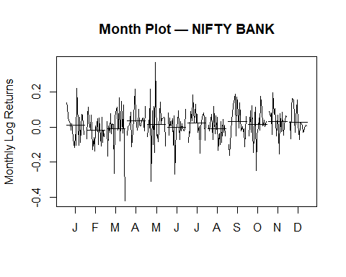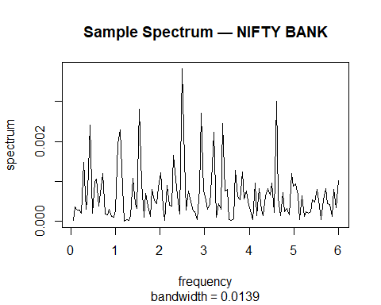
##
## Friedman rank sum test
##
## data: month_log_ret and Month and Year
## Friedman chi-squared = 9.3923, df = 11, p-value = 0.5857
## Warning in adf.test(ts_month_log): p-value smaller than printed p-value
## Warning in pp.test(ts_month_log): p-value smaller than printed p-value
## Warning in kpss.test(ts_month_log, null = "Level"): p-value greater than printed p-value
##
## Augmented Dickey-Fuller Test
##
## data: ts_month_log
## Dickey-Fuller = -6.1341, Lag order = 6, p-value = 0.01
## alternative hypothesis: stationary
##
##
## Phillips-Perron Unit Root Test
##
## data: ts_month_log
## Dickey-Fuller Z(alpha) = -230.17, Truncation lag parameter = 5, p-value = 0.01
## alternative hypothesis: stationary
##
##
## KPSS Test for Level Stationarity
##
## data: ts_month_log
## KPSS Level = 0.12023, Truncation lag parameter = 5, p-value = 0.1
##
## Model BIC
## 1 ARIMA(0,0,0) -468.7985
## 2 ARIMA(1,0,0) -463.4236
## 3 ARIMA(0,0,1) -463.4387
## 4 ARIMA(1,0,1) -458.4296
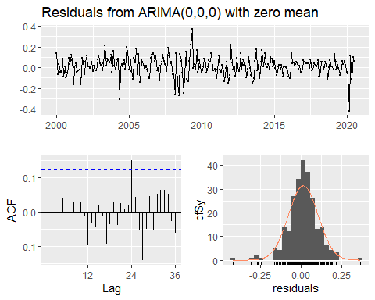
##
## Ljung-Box test
##
## data: Residuals from ARIMA(0,0,0) with zero mean
## Q* = 16.374, df = 24, p-value = 0.8741
##
## Model df: 0. Total lags used: 24
##
##
## Box-Ljung test
##
## data: residuals(auto_fit)
## X-squared = 5.7758, df = 12, p-value = 0.927
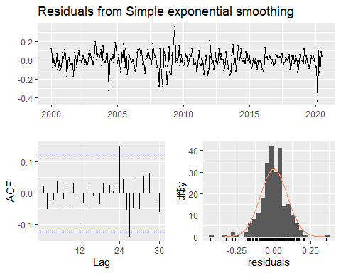
##
## Ljung-Box test
##
## data: Residuals from Simple exponential smoothing
## Q* = 16.375, df = 24, p-value = 0.8741
##
## Model df: 0. Total lags used: 24
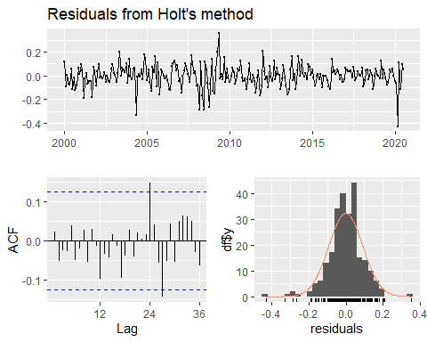
##
## Ljung-Box test
##
## data: Residuals from Holt's method
## Q* = 16.523, df = 24, p-value = 0.8683
##
## Model df: 0. Total lags used: 24
result_it <- analyze_index_ts(
file_path = "C:/lehigh_academics/Homework/time series forecasting/project/index_data/NIFTY IT.CSV",
index_name = "NIFTY IT"
)
##
## ==============================
## ANALYZING: NIFTY IT
## ==============================
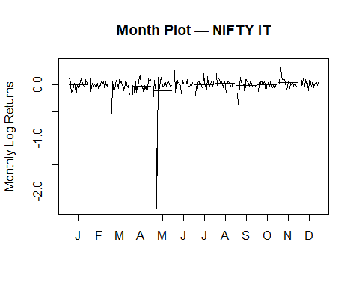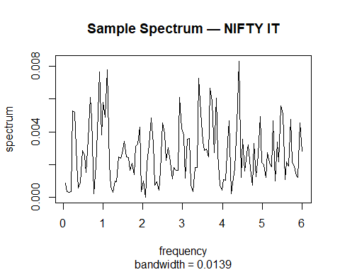
##
## Friedman rank sum test
##
## data: month_log_ret and Month and Year
## Friedman chi-squared = 5.9231, df = 11, p-value = 0.8784
## Warning in adf.test(ts_month_log): p-value smaller than printed p-value
## Warning in pp.test(ts_month_log): p-value smaller than printed p-value
## Warning in kpss.test(ts_month_log, null = "Level"): p-value greater than printed p-value
##
## Augmented Dickey-Fuller Test
##
## data: ts_month_log
## Dickey-Fuller = -6.6643, Lag order = 6, p-value = 0.01
## alternative hypothesis: stationary
##
##
## Phillips-Perron Unit Root Test
##
## data: ts_month_log
## Dickey-Fuller Z(alpha) = -242.99, Truncation lag parameter = 5, p-value = 0.01
## alternative hypothesis: stationary
##
##
## KPSS Test for Level Stationarity
##
## data: ts_month_log
## KPSS Level = 0.24626, Truncation lag parameter = 5, p-value = 0.1
##
## Model BIC
## 1 ARIMA(0,0,0) -137.7320
## 2 ARIMA(1,0,0) -132.2768
## 3 ARIMA(0,0,1) -132.2796
## 4 ARIMA(1,0,1) -127.9140
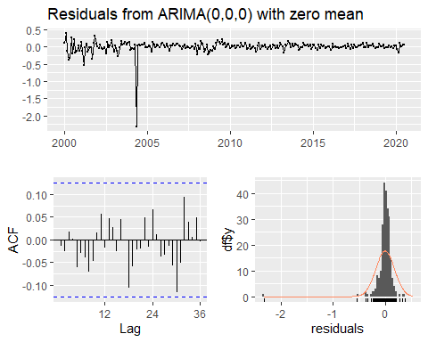
##
## Ljung-Box test
##
## data: Residuals from ARIMA(0,0,0) with zero mean
## Q* = 12.298, df = 24, p-value = 0.9763
##
## Model df: 0. Total lags used: 24
##
##
## Box-Ljung test
##
## data: residuals(auto_fit)
## X-squared = 4.7041, df = 12, p-value = 0.9671
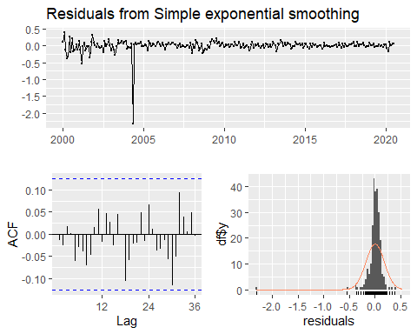
##
## Ljung-Box test
##
## data: Residuals from Simple exponential smoothing
## Q* = 12.298, df = 24, p-value = 0.9763
##
## Model df: 0. Total lags used: 24
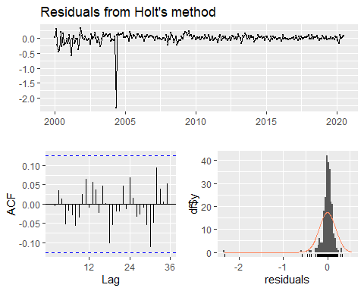
##
## Ljung-Box test
##
## data: Residuals from Holt's method
## Q* = 11.542, df = 24, p-value = 0.9846
##
## Model df: 0. Total lags used: 24
result_pharma <- analyze_index_ts(
file_path = "C:/lehigh_academics/Homework/time series forecasting/project/index_data/NIFTY PHARMA.CSV",
index_name = "NIFTY PHARMA"
)
##
## ==============================
## ANALYZING: NIFTY PHARMA
## ==============================
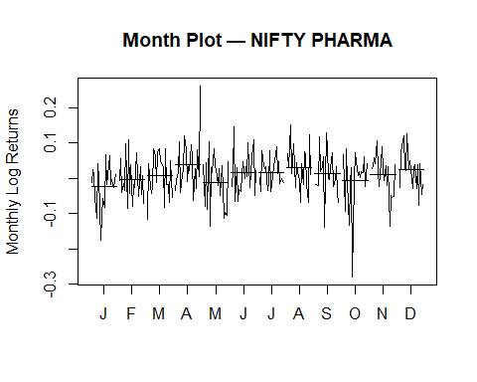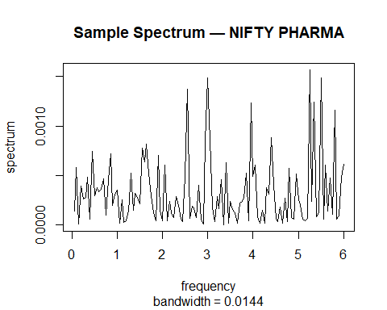
##
## Friedman rank sum test
##
## data: month_log_ret and Month and Year
## Friedman chi-squared = 11.947, df = 11, p-value = 0.3676
## Warning in adf.test(ts_month_log): p-value smaller than printed p-value
## Warning in pp.test(ts_month_log): p-value smaller than printed p-value
## Warning in kpss.test(ts_month_log, null = "Level"): p-value greater than printed p-value
##
## Augmented Dickey-Fuller Test
##
## data: ts_month_log
## Dickey-Fuller = -5.7541, Lag order = 6, p-value = 0.01
## alternative hypothesis: stationary
##
##
## Phillips-Perron Unit Root Test
##
## data: ts_month_log
## Dickey-Fuller Z(alpha) = -239.42, Truncation lag parameter = 4, p-value = 0.01
## alternative hypothesis: stationary
##
##
## KPSS Test for Level Stationarity
##
## data: ts_month_log
## KPSS Level = 0.14185, Truncation lag parameter = 4, p-value = 0.1
##
## Model BIC
## 1 ARIMA(0,0,0) -618.9985
## 2 ARIMA(1,0,0) -613.6778
## 3 ARIMA(0,0,1) -613.6728
## 4 ARIMA(1,0,1) -608.7217
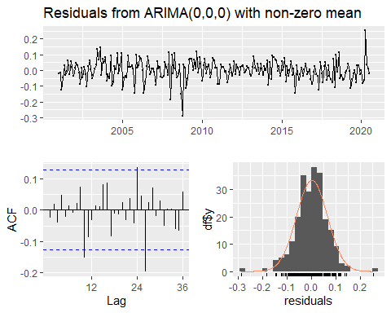
##
## Ljung-Box test
##
## data: Residuals from ARIMA(0,0,0) with non-zero mean
## Q* = 22.628, df = 24, p-value = 0.5418
##
## Model df: 0. Total lags used: 24
##
##
## Box-Ljung test
##
## data: residuals(auto_fit)
## X-squared = 10.835, df = 12, p-value = 0.5431
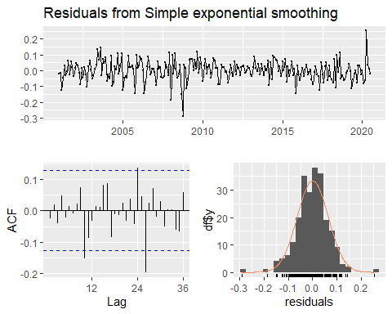
##
## Ljung-Box test
##
## data: Residuals from Simple exponential smoothing
## Q* = 22.628, df = 24, p-value = 0.5418
##
## Model df: 0. Total lags used: 24
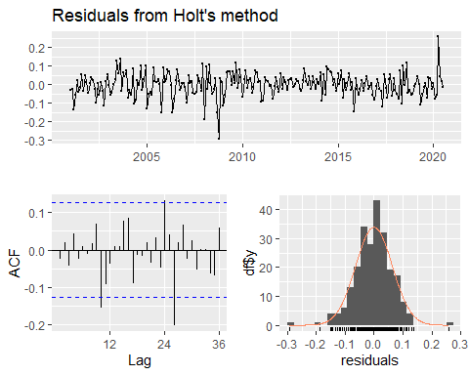
##
## Ljung-Box test
##
## data: Residuals from Holt's method
## Q* = 22.699, df = 24, p-value = 0.5376
##
## Model df: 0. Total lags used: 24
result_fmcg <- analyze_index_ts(
file_path = "C:/lehigh_academics/Homework/time series forecasting/project/index_data/NIFTY FMCG.CSV",
index_name = "NIFTY FMCG"
)
##
## ==============================
## ANALYZING: NIFTY FMCG
## ==============================
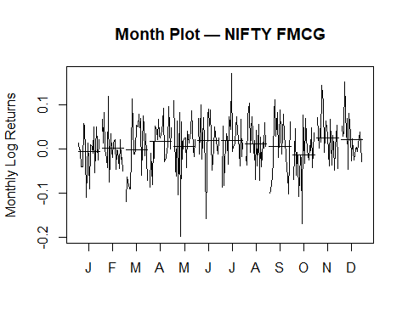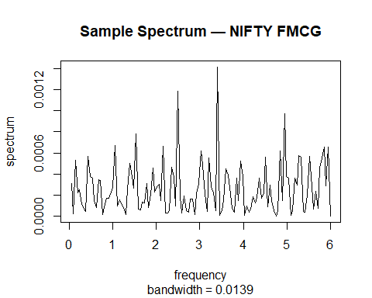
##
## Friedman rank sum test
##
## data: month_log_ret and Month and Year
## Friedman chi-squared = 7.0615, df = 11, p-value = 0.7941
## Warning in adf.test(ts_month_log): p-value smaller than printed p-value
## Warning in pp.test(ts_month_log): p-value smaller than printed p-value
## Warning in kpss.test(ts_month_log, null = "Level"): p-value greater than printed p-value
##
## Augmented Dickey-Fuller Test
##
## data: ts_month_log
## Dickey-Fuller = -5.4448, Lag order = 6, p-value = 0.01
## alternative hypothesis: stationary
##
##
## Phillips-Perron Unit Root Test
##
## data: ts_month_log
## Dickey-Fuller Z(alpha) = -243.98, Truncation lag parameter = 5, p-value = 0.01
## alternative hypothesis: stationary
##
##
## KPSS Test for Level Stationarity
##
## data: ts_month_log
## KPSS Level = 0.17683, Truncation lag parameter = 5, p-value = 0.1
##
## Model BIC
## 1 ARIMA(0,0,0) -710.8285
## 2 ARIMA(1,0,0) -705.6008
## 3 ARIMA(0,0,1) -705.6255
## 4 ARIMA(1,0,1) -700.4917
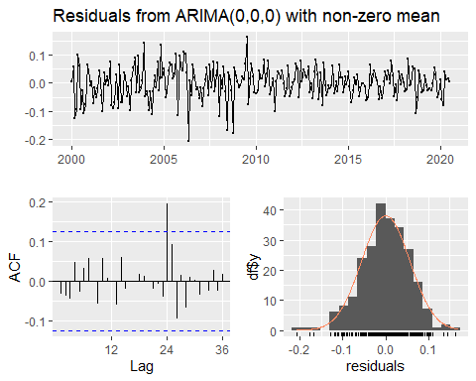
##
## Ljung-Box test
##
## data: Residuals from ARIMA(0,0,0) with non-zero mean
## Q* = 17.948, df = 24, p-value = 0.8055
##
## Model df: 0. Total lags used: 24
##
##
## Box-Ljung test
##
## data: residuals(auto_fit)
## X-squared = 4.8157, df = 12, p-value = 0.9639
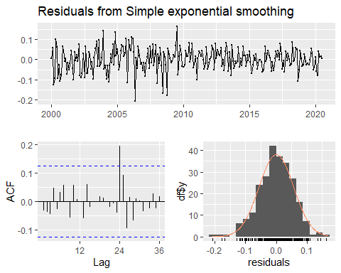
##
## Ljung-Box test
##
## data: Residuals from Simple exponential smoothing
## Q* = 17.947, df = 24, p-value = 0.8056
##
## Model df: 0. Total lags used: 24
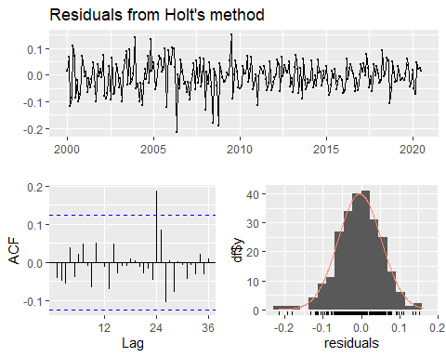
##
## Ljung-Box test
##
## data: Residuals from Holt's method
## Q* = 18.2, df = 24, p-value = 0.7932
##
## Model df: 0. Total lags used: 24
result_auto <- analyze_index_ts(
file_path = "C:/lehigh_academics/Homework/time series forecasting/project/index_data/NIFTY AUTO.CSV",
index_name = "NIFTY AUTO"
)
##
## ==============================
## ANALYZING: NIFTY AUTO
## ==============================
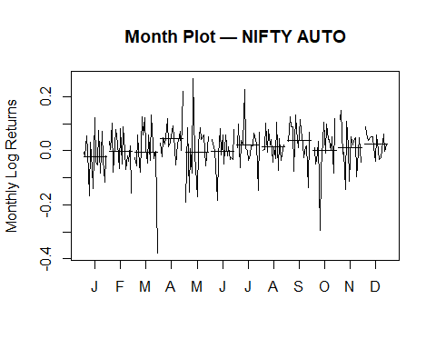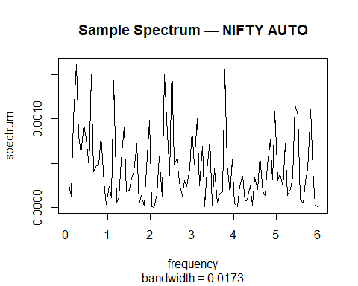
##
## Friedman rank sum test
##
## data: month_log_ret and Month and Year
## Friedman chi-squared = 9.0865, df = 11, p-value = 0.6139
## Warning in adf.test(ts_month_log): p-value smaller than printed p-value
## Warning in pp.test(ts_month_log): p-value smaller than printed p-value
## Warning in kpss.test(ts_month_log, null = "Level"): p-value greater than printed p-value
##
## Augmented Dickey-Fuller Test
##
## data: ts_month_log
## Dickey-Fuller = -5.6084, Lag order = 5, p-value = 0.01
## alternative hypothesis: stationary
##
##
## Phillips-Perron Unit Root Test
##
## data: ts_month_log
## Dickey-Fuller Z(alpha) = -185.64, Truncation lag parameter = 4, p-value = 0.01
## alternative hypothesis: stationary
##
##
## KPSS Test for Level Stationarity
##
## data: ts_month_log
## KPSS Level = 0.1536, Truncation lag parameter = 4, p-value = 0.1
##
## Model BIC
## 1 ARIMA(0,0,0) -430.7603
## 2 ARIMA(1,0,0) -426.7066
## 3 ARIMA(0,0,1) -426.6311
## 4 ARIMA(1,0,1) -421.5297
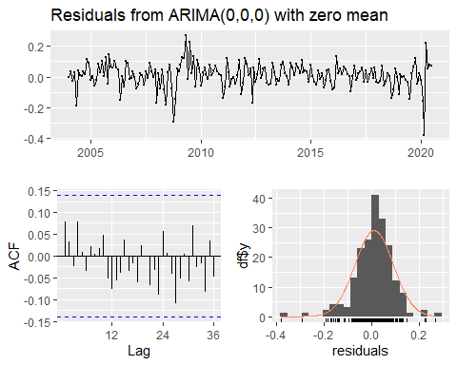
##
## Ljung-Box test
##
## data: Residuals from ARIMA(0,0,0) with zero mean
## Q* = 12.19, df = 24, p-value = 0.9777
##
## Model df: 0. Total lags used: 24
##
##
## Box-Ljung test
##
## data: residuals(auto_fit)
## X-squared = 5.6591, df = 12, p-value = 0.9323
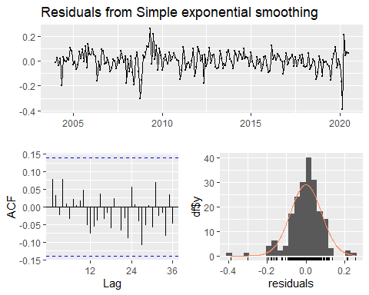
##
## Ljung-Box test
##
## data: Residuals from Simple exponential smoothing
## Q* = 12.189, df = 24, p-value = 0.9777
##
## Model df: 0. Total lags used: 24
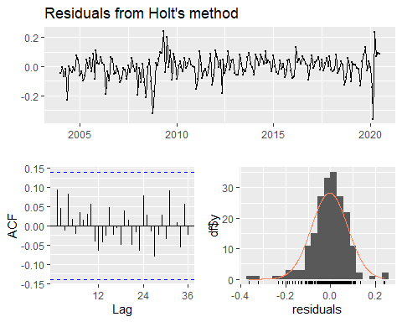
##
## Ljung-Box test
##
## data: Residuals from Holt's method
## Q* = 11.431, df = 24, p-value = 0.9856
##
## Model df: 0. Total lags used: 24
results <- list(
BANK = result_bank,
IT = result_it,
PHARMA = result_pharma,
AUTO = result_auto,
FMCG = result_fmcg
)
## all 5 monthplot
dev.new(width = 10, height = 8)
par(mfrow = c(3, 2), mar = c(3, 3, 2, 1))
for (res in results) {
monthplot(
res$ts_month_log,
main = paste("Month Plot —", res$index_name),
ylab = "Monthly Log Returns",
xlab = "Month"
)
}
par(mfrow = c(1, 1))

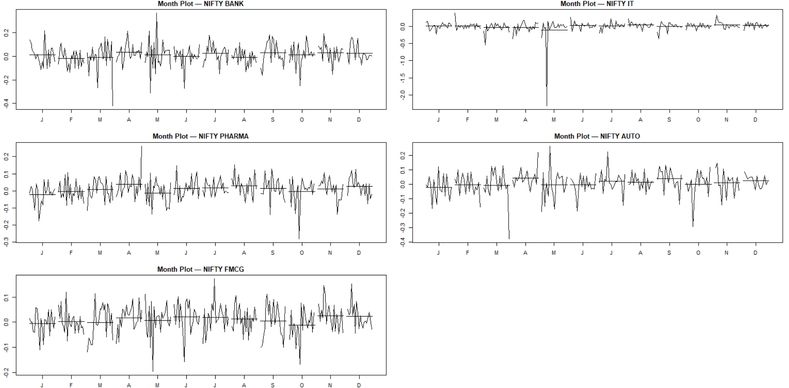
## sample spectrum for all 5
par(mfrow = c(3, 2), mar = c(3, 3, 2, 1))
for (res in results) {
spec.pgram(
res$ts_month_log,
log = "no",
main = paste("Spectrum —", res$index_name)
)
}
par(mfrow = c(1, 1))
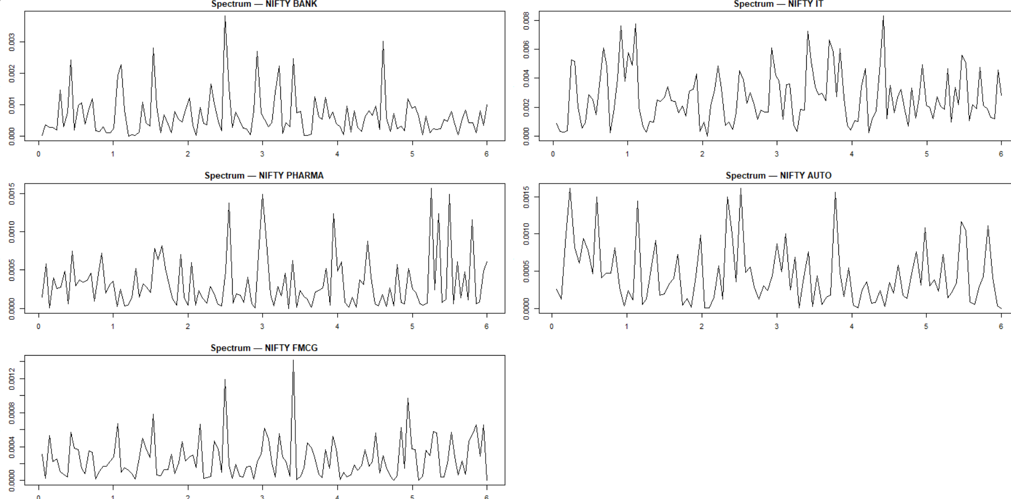
## friedman tets
friedman_table <- do.call(
rbind,
lapply(results, function(res) {
data.frame(
Index = res$index_name,
Statistic = unname(res$seasonality_tests$Friedman$statistic),
df = unname(res$seasonality_tests$Friedman$parameter),
p_value = res$seasonality_tests$Friedman$p.value,
Seasonality = ifelse(
res$seasonality_tests$Friedman$p.value < 0.05,
"Yes",
"No"
)
)
})
)
friedman_table
## Index Statistic df p_value Seasonality
## BANK NIFTY BANK 9.392308 11 0.5857292 No
## IT NIFTY IT 5.923077 11 0.8784471 No
## PHARMA NIFTY PHARMA 11.947368 11 0.3676124 No
## AUTO NIFTY AUTO 9.086538 11 0.6139046 No
## FMCG NIFTY FMCG 7.061538 11 0.7940783 No
#Stationarity test
stationarity_table <- do.call(
rbind,
lapply(results, function(res) {
data.frame(
Index = res$index_name,
ADF_p = res$stationarity_tests$ADF$p.value,
PP_p = res$stationarity_tests$PP$p.value,
KPSS_p = res$stationarity_tests$KPSS$p.value,
Stationary = ifelse(
res$stationarity_tests$ADF$p.value < 0.05 &
res$stationarity_tests$PP$p.value < 0.05 &
res$stationarity_tests$KPSS$p.value > 0.05,
"Yes",
"No"
)
)
})
)
stationarity_table
## Index ADF_p PP_p KPSS_p Stationary
## BANK NIFTY BANK 0.01 0.01 0.1 Yes
## IT NIFTY IT 0.01 0.01 0.1 Yes
## PHARMA NIFTY PHARMA 0.01 0.01 0.1 Yes
## AUTO NIFTY AUTO 0.01 0.01 0.1 Yes
## FMCG NIFTY FMCG 0.01 0.01 0.1 Yes
# ACF plot
par(mfrow = c(3, 2), mar = c(4, 4, 3, 1))
for (res in results) {
acf(
res$ts_month_log,
main = paste("ACF —", res$index_name)
)
}
par(mfrow = c(1, 1))
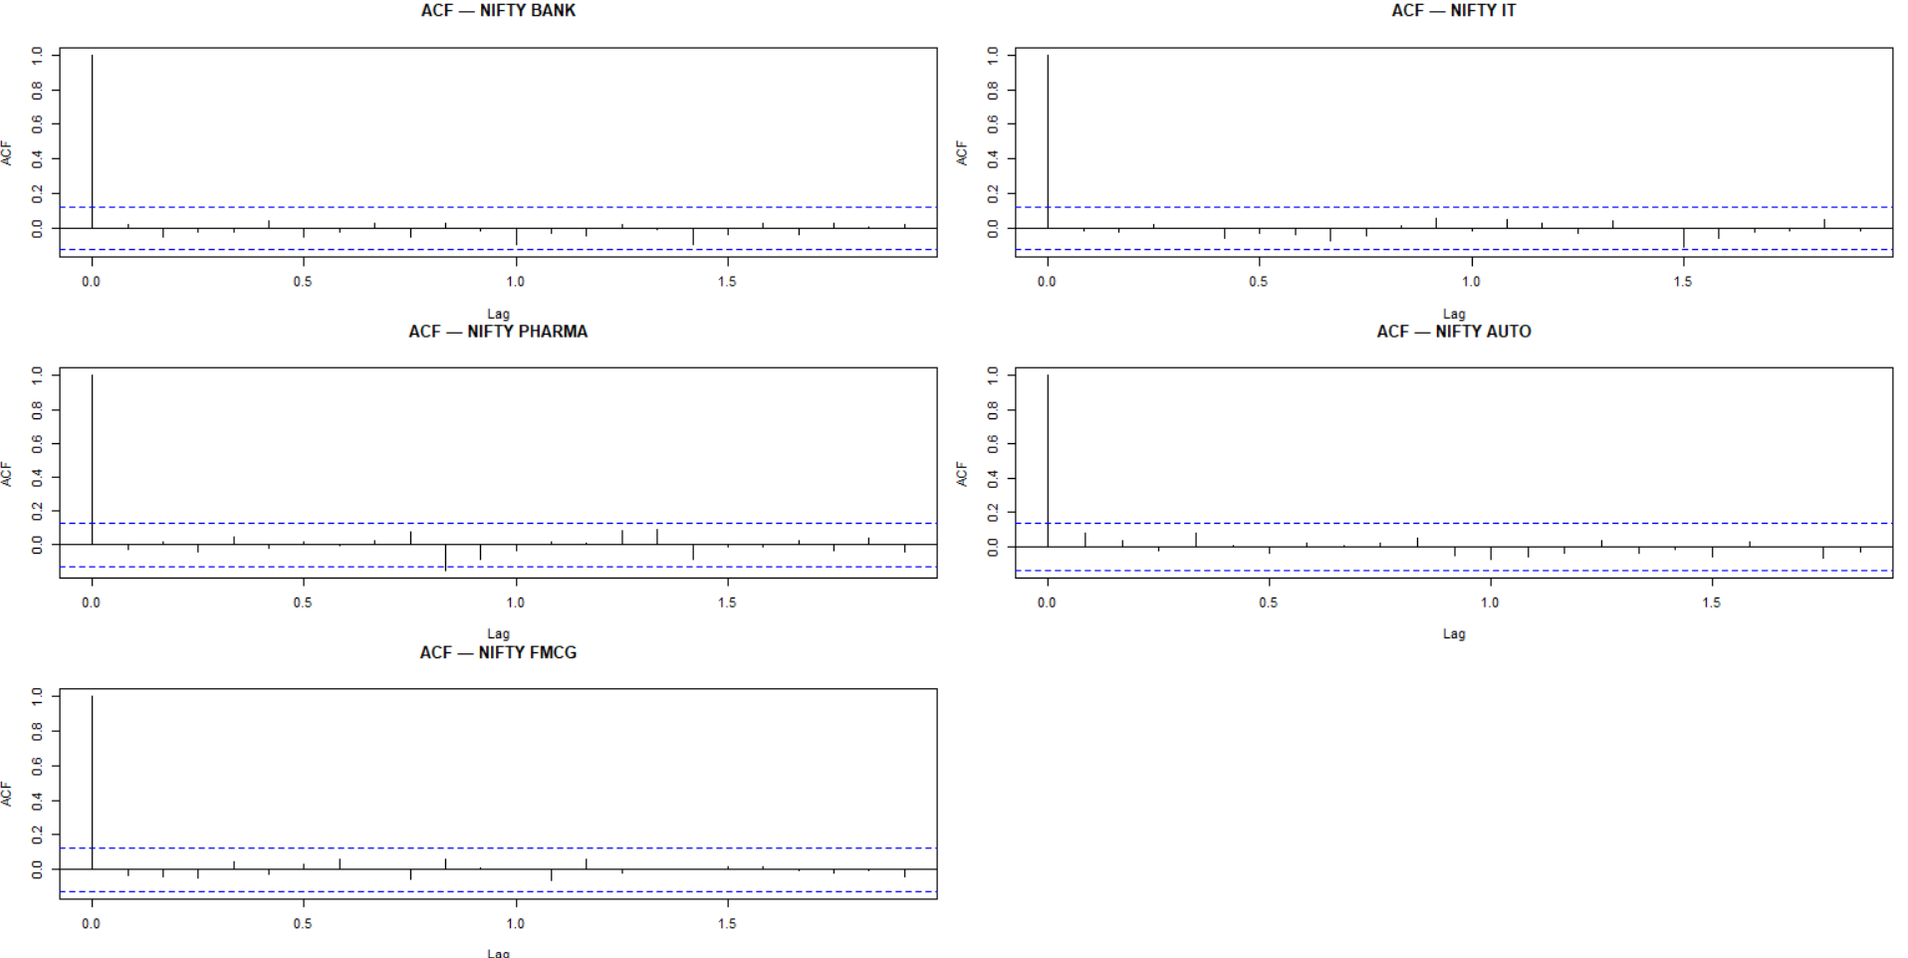
#PACF plot
par(mfrow = c(3, 2), mar = c(4, 4, 3, 1))
for (res in results) {
pacf(
res$ts_month_log,
main = paste("PACF —", res$index_name)
)
}
par(mfrow = c(1, 1))
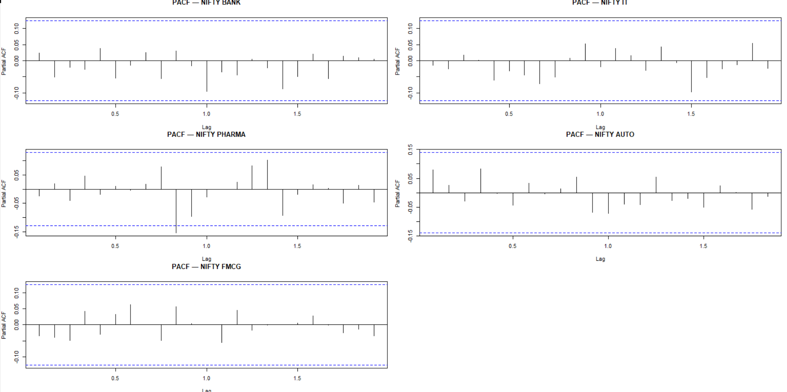
#ARIMA residual time series (ALL 5)
par(mfrow = c(3, 2), mar = c(3, 3, 2, 1))
for (res in results) {
plot(
residuals(res$auto_arima),
type = "l",
main = paste("ARIMA Residuals —", res$index_name),
ylab = "Residuals"
)
abline(h = 0, col = "red", lty = 2)
}
par(mfrow = c(1, 1))
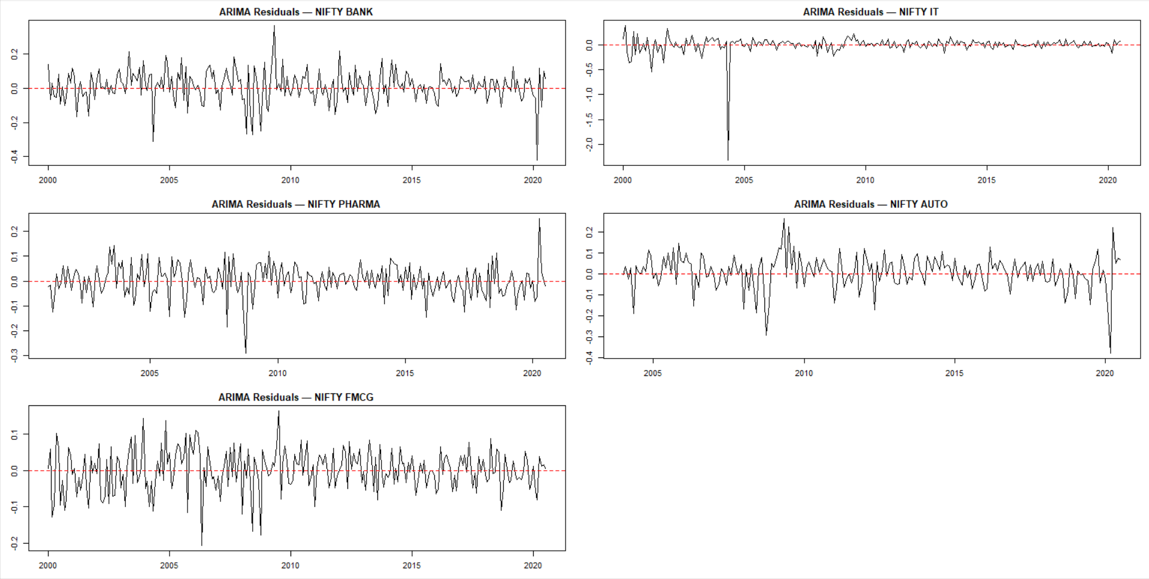
##ACF of ARIMA residuals
par(mfrow = c(3, 2), mar = c(3, 3, 2, 1))
for (res in results) {
acf(
residuals(res$auto_arima),
main = paste("ARIMA Residual ACF —", res$index_name)
)
}
par(mfrow = c(1, 1))
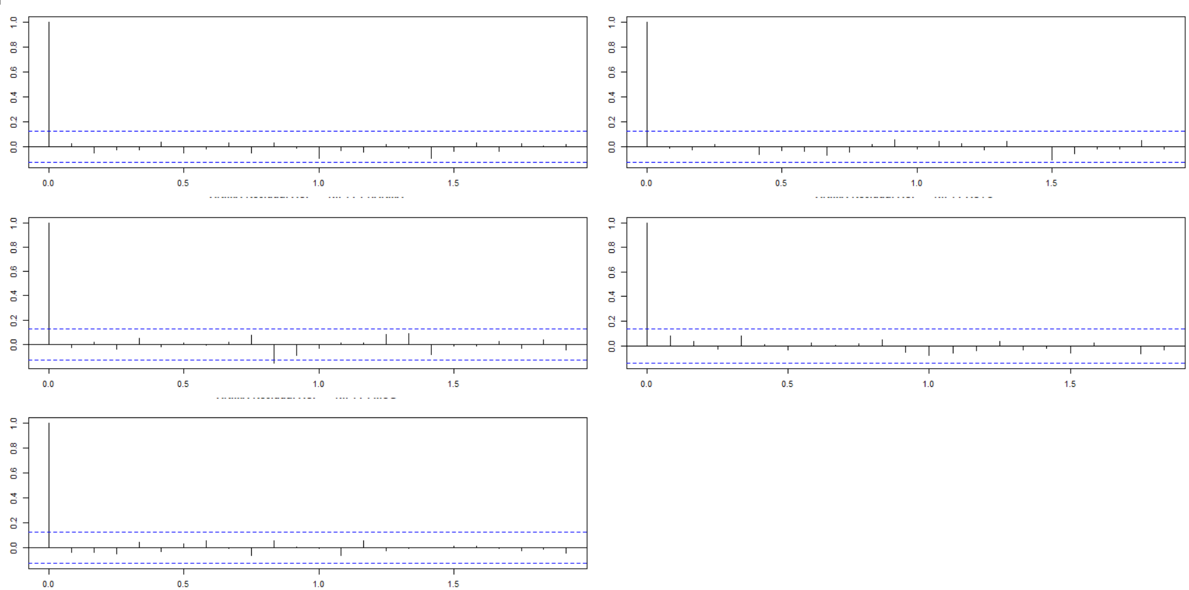
##Histogram of ARIMA residuals (ALL 5)
par(mfrow = c(3, 2), mar = c(3, 3, 2, 1))
for (res in results) {
hist(
residuals(res$auto_arima),
breaks = 20,
main = paste("ARIMA Residuals —", res$index_name),
xlab = "Residuals",
col = "lightgray"
)
}
par(mfrow = c(1, 1))
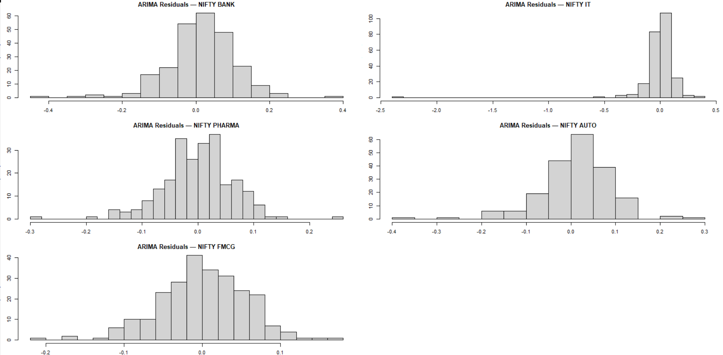
#ARIMA selection + residual whiteness (TABLE)
arima_table <- do.call(
rbind,
lapply(results, function(res) {
data.frame(
Index = res$index_name,
Selected_Model = paste0(
"ARIMA(",
paste(res$auto_arima$arma[c(1,6,2)], collapse = ","),
")"
),
LjungBox_p = res$arima_lb_test$p.value,
White_Noise = ifelse(res$arima_lb_test$p.value > 0.05, "Yes", "No")
)
})
)
arima_table
## Index Selected_Model LjungBox_p White_Noise
## BANK NIFTY BANK ARIMA(0,0,0) 0.9269600 Yes
## IT NIFTY IT ARIMA(0,0,0) 0.9671407 Yes
## PHARMA NIFTY PHARMA ARIMA(0,0,0) 0.5431038 Yes
## AUTO NIFTY AUTO ARIMA(0,0,0) 0.9322837 Yes
## FMCG NIFTY FMCG ARIMA(0,0,0) 0.9638526 Yes
## SES residual time series
par(mfrow = c(3, 2), mar = c(3, 3, 2, 1))
for (res in results) {
plot(
residuals(res$ses_fit),
type = "l",
main = paste("SES Residuals —", res$index_name),
ylab = "Residuals"
)
abline(h = 0, col = "red", lty = 2)
}
par(mfrow = c(1, 1))
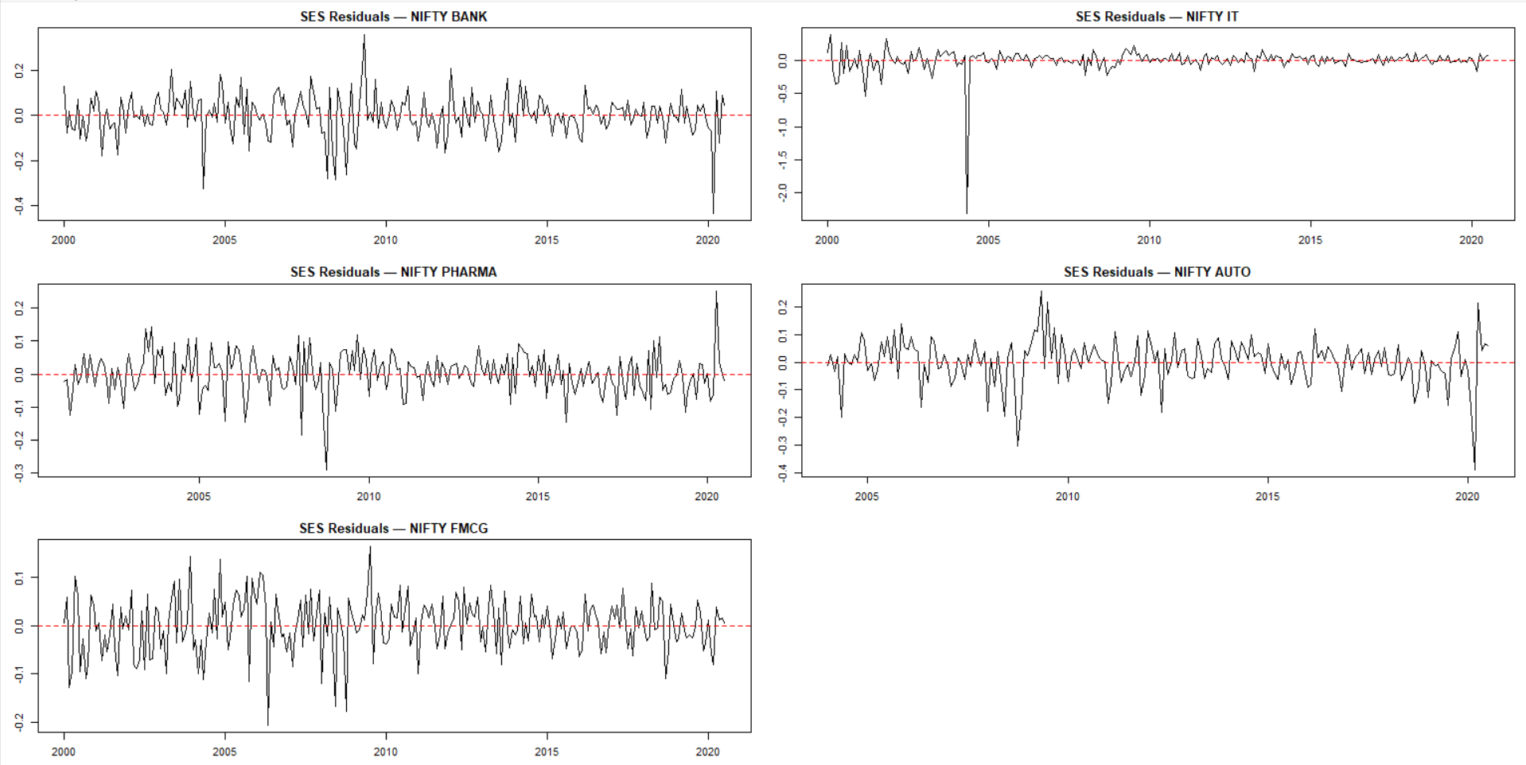
###ACF of SES residuals (ALL 5)
par(mfrow = c(3, 2), mar = c(3, 3, 2, 1))
for (res in results) {
acf(
residuals(res$ses_fit),
main = paste("SES Residual ACF —", res$index_name)
)
}
par(mfrow = c(1, 1))
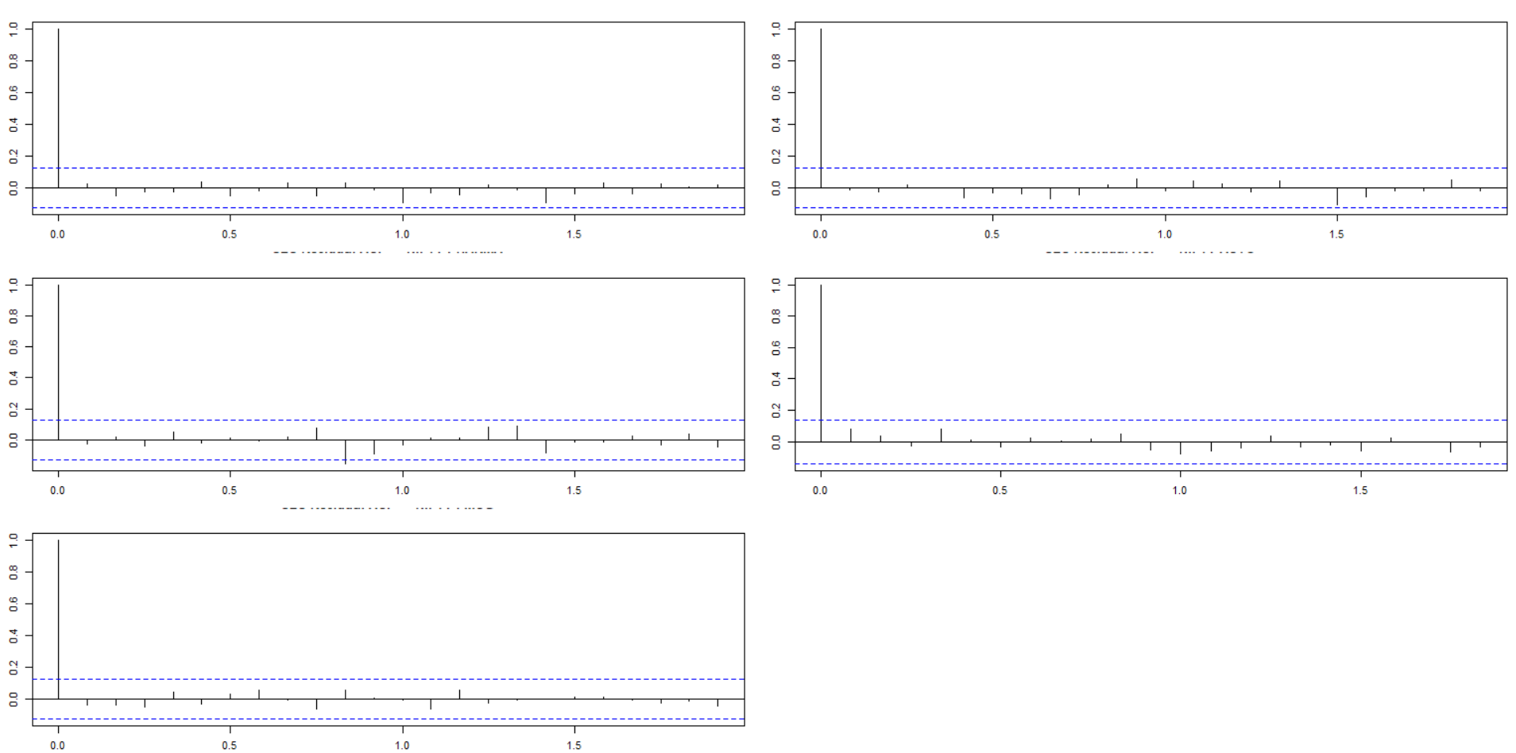
#Holt residual time series (ALL 5)
par(mfrow = c(3, 2), mar = c(3, 3, 2, 1))
for (res in results) {
plot(
residuals(res$holt_fit),
type = "l",
main = paste("Holt Residuals —", res$index_name),
ylab = "Residuals"
)
abline(h = 0, col = "red", lty = 2)
}
par(mfrow = c(1, 1))
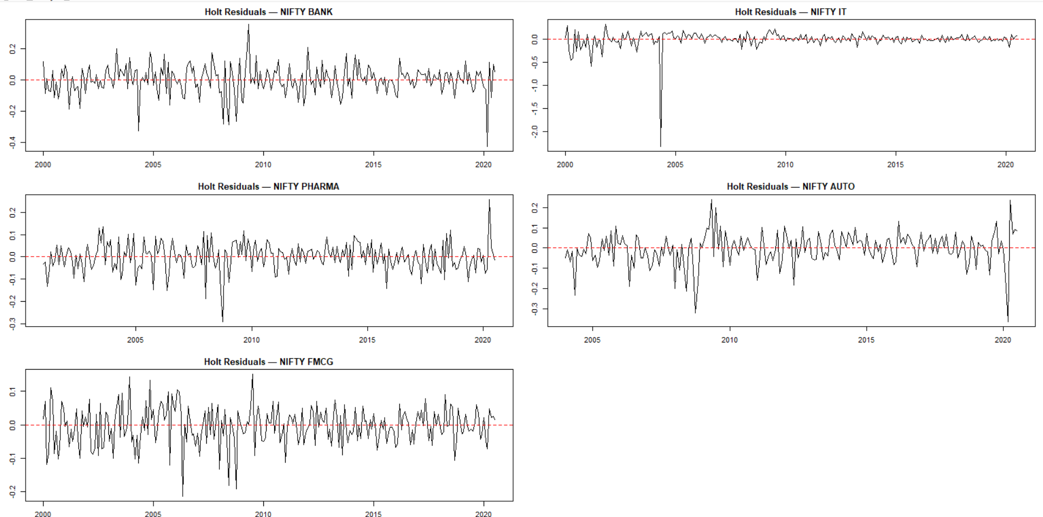
#ACF of Holt residuals (ALL 5)
par(mfrow = c(3, 2), mar = c(3, 3, 2, 1))
for (res in results) {
acf(
residuals(res$holt_fit),
main = paste("Holt Residual ACF —", res$index_name)
)
}
par(mfrow = c(1, 1))
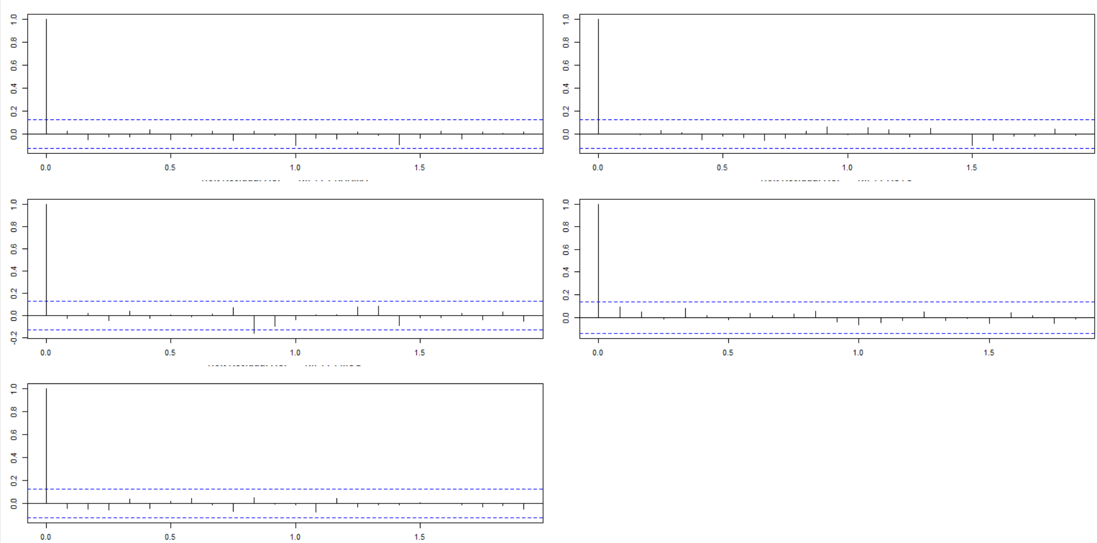
## ets table
ets_table <- do.call(
rbind,
lapply(results, function(res) {
data.frame(
Index = res$index_name,
SES_LB_p = res$ses_lb_test$p.value,
Holt_LB_p = res$holt_lb_test$p.value,
Useful = ifelse(
res$ses_lb_test$p.value < 0.05 | res$holt_lb_test$p.value < 0.05,
"Possibly",
"No"
)
)
})
)
ets_table
## Index SES_LB_p Holt_LB_p Useful
## BANK NIFTY BANK 0.9269839 0.9146888 No
## IT NIFTY IT 0.9671370 0.9867041 No
## PHARMA NIFTY PHARMA 0.5430994 0.5130910 No
## AUTO NIFTY AUTO 0.9322866 0.9050296 No
## FMCG NIFTY FMCG 0.9638586 0.9511112 No

## roll vol all in 5
library(dplyr)
library(zoo)
get_roll_vol <- function(result, window = 12) {
ts_data <- result$ts_month_log
rv <- rollapply(ts_data, width = window, FUN = sd, align = "right", fill = NA)
data.frame(
Date = time(ts_data),
RollingVol = as.numeric(rv),
Sector = result$index_name
)
}
roll_all <- bind_rows(
get_roll_vol(result_bank),
get_roll_vol(result_it),
get_roll_vol(result_pharma),
get_roll_vol(result_fmcg),
get_roll_vol(result_auto)
)
library(ggplot2)
ggplot(roll_all, aes(x = Date, y = RollingVol, color = Sector)) +
geom_line(size = 1) +
labs(
title = "Rolling 12-Month Volatility Across Sectors",
x = "Year",
y = "Rolling Volatility (12M)"
) +
theme_minimal() +
theme(legend.position = "bottom")
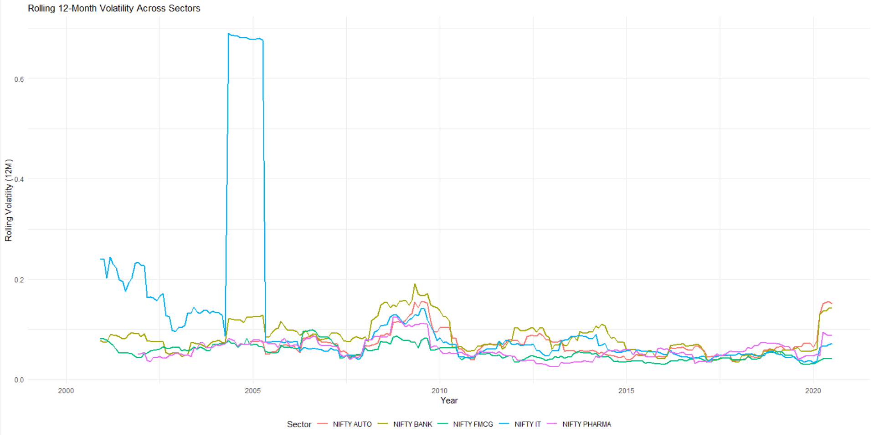
library(rugarch)
ret_bank <- result_bank$train_monthly$month_log_ret
r <- as.numeric(ret_bank)
library(forecast)
auto.arima(r, seasonal = FALSE)
## Series: r
## ARIMA(0,0,0) with non-zero mean
##
## Coefficients:
## mean
## 0.0126
## s.e. 0.0058
##
## sigma^2 = 0.008426: log likelihood = 239.91
## AIC=-475.82 AICc=-475.77 BIC=-468.8
## GARCH(1,1)
spec_garch <- ugarchspec(
variance.model = list(model = "sGARCH", garchOrder = c(1,1)),
mean.model = list(armaOrder = c(0,0), include.mean = TRUE),
distribution.model = "norm"
)
fit_garch <- ugarchfit(spec_garch, data = r)
show(fit_garch)
##
## *---------------------------------*
## * GARCH Model Fit *
## *---------------------------------*
##
## Conditional Variance Dynamics
## -----------------------------------
## GARCH Model : sGARCH(1,1)
## Mean Model : ARFIMA(0,0,0)
## Distribution : norm
##
## Optimal Parameters
## ------------------------------------
## Estimate Std. Error t value Pr(>|t|)
## mu 0.012431 0.005618 2.2128 0.026911
## omega 0.000985 0.000620 1.5894 0.111973
## alpha1 0.061530 0.037917 1.6228 0.104638
## beta1 0.823775 0.095433 8.6320 0.000000
##
## Robust Standard Errors:
## Estimate Std. Error t value Pr(>|t|)
## mu 0.012431 0.005264 2.3614 0.018204
## omega 0.000985 0.000677 1.4540 0.145950
## alpha1 0.061530 0.042816 1.4371 0.150697
## beta1 0.823775 0.074098 11.1174 0.000000
##
## LogLikelihood : 243.6862
##
## Information Criteria
## ------------------------------------
##
## Akaike -1.9408
## Bayes -1.8839
## Shibata -1.9413
## Hannan-Quinn -1.9179
##
## Weighted Ljung-Box Test on Standardized Residuals
## ------------------------------------
## statistic p-value
## Lag[1] 0.3583 0.5495
## Lag[2*(p+q)+(p+q)-1][2] 0.5473 0.6718
## Lag[4*(p+q)+(p+q)-1][5] 1.0375 0.8511
## d.o.f=0
## H0 : No serial correlation
##
## Weighted Ljung-Box Test on Standardized Squared Residuals
## ------------------------------------
## statistic p-value
## Lag[1] 0.05955 0.8072
## Lag[2*(p+q)+(p+q)-1][5] 0.23688 0.9897
## Lag[4*(p+q)+(p+q)-1][9] 0.96730 0.9876
## d.o.f=2
##
## Weighted ARCH LM Tests
## ------------------------------------
## Statistic Shape Scale P-Value
## ARCH Lag[3] 0.05669 0.500 2.000 0.8118
## ARCH Lag[5] 0.25118 1.440 1.667 0.9530
## ARCH Lag[7] 0.99025 2.315 1.543 0.9151
##
## Nyblom stability test
## ------------------------------------
## Joint Statistic: 0.6019
## Individual Statistics:
## mu 0.09167
## omega 0.08976
## alpha1 0.10970
## beta1 0.09999
##
## Asymptotic Critical Values (10% 5% 1%)
## Joint Statistic: 1.07 1.24 1.6
## Individual Statistic: 0.35 0.47 0.75
##
## Sign Bias Test
## ------------------------------------
## t-value prob sig
## Sign Bias 0.8915 0.3735
## Negative Sign Bias 0.2539 0.7998
## Positive Sign Bias 0.4759 0.6346
## Joint Effect 1.4544 0.6928
##
##
## Adjusted Pearson Goodness-of-Fit Test:
## ------------------------------------
## group statistic p-value(g-1)
## 1 20 29.03 0.065477
## 2 30 38.06 0.120992
## 3 40 55.67 0.040586
## 4 50 77.09 0.006376
##
##
## Elapsed time : 0.128243
### E_GARCH
spec_egarch <- ugarchspec(
variance.model = list(model = "eGARCH", garchOrder = c(1,1)),
mean.model = list(armaOrder = c(0,0), include.mean = TRUE),
distribution.model = "norm"
)
fit_egarch <- ugarchfit(spec_egarch, data = r)
show(fit_egarch)
##
## *---------------------------------*
## * GARCH Model Fit *
## *---------------------------------*
##
## Conditional Variance Dynamics
## -----------------------------------
## GARCH Model : eGARCH(1,1)
## Mean Model : ARFIMA(0,0,0)
## Distribution : norm
##
## Optimal Parameters
## ------------------------------------
## Estimate Std. Error t value Pr(>|t|)
## mu 0.010754 0.004777 2.2510 0.024389
## omega -0.701848 0.364175 -1.9272 0.053951
## alpha1 -0.106587 0.062083 -1.7168 0.086009
## beta1 0.852043 0.075159 11.3365 0.000000
## gamma1 0.180790 0.081511 2.2180 0.026555
##
## Robust Standard Errors:
## Estimate Std. Error t value Pr(>|t|)
## mu 0.010754 0.003858 2.78761 0.005310
## omega -0.701848 0.564854 -1.24253 0.214041
## alpha1 -0.106587 0.115442 -0.92329 0.355855
## beta1 0.852043 0.117784 7.23393 0.000000
## gamma1 0.180790 0.075620 2.39076 0.016813
##
## LogLikelihood : 247.3729
##
## Information Criteria
## ------------------------------------
##
## Akaike -1.9625
## Bayes -1.8915
## Shibata -1.9633
## Hannan-Quinn -1.9339
##
## Weighted Ljung-Box Test on Standardized Residuals
## ------------------------------------
## statistic p-value
## Lag[1] 0.3676 0.5443
## Lag[2*(p+q)+(p+q)-1][2] 0.4123 0.7363
## Lag[4*(p+q)+(p+q)-1][5] 0.8820 0.8858
## d.o.f=0
## H0 : No serial correlation
##
## Weighted Ljung-Box Test on Standardized Squared Residuals
## ------------------------------------
## statistic p-value
## Lag[1] 0.3225 0.5701
## Lag[2*(p+q)+(p+q)-1][5] 0.9629 0.8680
## Lag[4*(p+q)+(p+q)-1][9] 2.3405 0.8607
## d.o.f=2
##
## Weighted ARCH LM Tests
## ------------------------------------
## Statistic Shape Scale P-Value
## ARCH Lag[3] 0.4343 0.500 2.000 0.5099
## ARCH Lag[5] 0.8306 1.440 1.667 0.7838
## ARCH Lag[7] 2.1277 2.315 1.543 0.6903
##
## Nyblom stability test
## ------------------------------------
## Joint Statistic: 0.9721
## Individual Statistics:
## mu 0.1265
## omega 0.1666
## alpha1 0.3580
## beta1 0.1693
## gamma1 0.1166
##
## Asymptotic Critical Values (10% 5% 1%)
## Joint Statistic: 1.28 1.47 1.88
## Individual Statistic: 0.35 0.47 0.75
##
## Sign Bias Test
## ------------------------------------
## t-value prob sig
## Sign Bias 0.9817 0.3272
## Negative Sign Bias 0.2990 0.7652
## Positive Sign Bias 0.5838 0.5599
## Joint Effect 0.9937 0.8028
##
##
## Adjusted Pearson Goodness-of-Fit Test:
## ------------------------------------
## group statistic p-value(g-1)
## 1 20 20.29 0.3775
## 2 30 40.98 0.0692
## 3 40 40.13 0.4201
## 4 50 45.11 0.6318
##
##
## Elapsed time : 0.1265051
### bic for GARCH
get_vol_bic <- function(result) {
r <- as.numeric(result$train_monthly$month_log_ret)
spec_garch <- ugarchspec(
variance.model = list(model = "sGARCH", garchOrder = c(1,1)),
mean.model = list(armaOrder = c(0,0), include.mean = TRUE),
distribution.model = "norm"
)
fit_garch <- ugarchfit(spec_garch, data = r)
spec_egarch <- ugarchspec(
variance.model = list(model = "eGARCH", garchOrder = c(1,1)),
mean.model = list(armaOrder = c(0,0), include.mean = TRUE),
distribution.model = "norm"
)
fit_egarch <- ugarchfit(spec_egarch, data = r)
bic_garch <- infocriteria(fit_garch)[3]
bic_egarch <- infocriteria(fit_egarch)[3]
data.frame(
Index = result$index_name,
BIC_GARCH = round(bic_garch, 4),
BIC_EGARCH = round(bic_egarch, 4),
Better_Model = ifelse(bic_garch < bic_egarch, "GARCH(1,1)", "EGARCH(1,1)")
)
}
bic_vol_table <- do.call(rbind, lapply(
list(result_bank, result_it, result_pharma, result_fmcg, result_auto),
get_vol_bic
))
bic_vol_table
## Index BIC_GARCH BIC_EGARCH Better_Model
## 1 NIFTY BANK -1.9413 -1.9633 EGARCH(1,1)
## 2 NIFTY IT -0.6574 -1.2311 EGARCH(1,1)
## 3 NIFTY PHARMA -2.6663 -2.6646 GARCH(1,1)
## 4 NIFTY FMCG -2.9547 -2.9535 GARCH(1,1)
## 5 NIFTY AUTO -2.2563 -2.4000 EGARCH(1,1)
## EGARCH helper func
library(rugarch)
fit_egarch_sector <- function(result) {
r <- as.numeric(result$train_monthly$month_log_ret)
spec_egarch <- ugarchspec(
variance.model = list(model = "eGARCH", garchOrder = c(1,1)),
mean.model = list(armaOrder = c(0,0), include.mean = TRUE),
distribution.model = "norm"
)
fit <- ugarchfit(spec = spec_egarch, data = r)
coefs <- coef(fit)
mu <- unname(coefs["mu"])
omega <- unname(coefs["omega"])
alpha1 <- unname(coefs["alpha1"])
beta1 <- unname(coefs["beta1"])
gamma1 <- unname(coefs["gamma1"])
persistence <- alpha1 + beta1
ic <- infocriteria(fit)
aic_val <- ic[1]
bic_val <- ic[2]
out_row <- data.frame(
Index = result$index_name,
mu = mu,
omega = omega,
alpha1 = alpha1,
beta1 = beta1,
gamma1 = gamma1,
Persistence = persistence,
AIC = aic_val,
BIC = bic_val
)
return(list(
fit = fit,
summary = out_row
))
}
egarch_bank <- fit_egarch_sector(result_bank)
egarch_bank$summary
## Index mu omega alpha1 beta1 gamma1 Persistence AIC BIC
## 1 NIFTY BANK 0.0107539 -0.7018482 -0.1065868 0.8520433 0.1807901 0.7454565 -1.962534 -1.891493
egarch_it <- fit_egarch_sector(result_it)
egarch_pharma <- fit_egarch_sector(result_pharma)
egarch_fmcg <- fit_egarch_sector(result_fmcg)
egarch_auto <- fit_egarch_sector(result_auto)
egarch_table <- rbind(
egarch_bank$summary,
egarch_it$summary,
egarch_pharma$summary,
egarch_fmcg$summary,
egarch_auto$summary
)
egarch_table
## Index mu omega alpha1 beta1 gamma1 Persistence AIC BIC
## 1 NIFTY BANK 0.010753900 -0.70184823 -0.106586771 0.8520433 0.18079012 0.7454565 -1.962534 -1.891493
## 2 NIFTY IT 0.029223172 0.08233017 0.248007195 1.0000000 0.17063839 1.2480072 -1.230336 -1.159296
## 3 NIFTY PHARMA 0.008861078 -0.26861357 -0.042998224 0.9506562 0.11725475 0.9076580 -2.663740 -2.590132
## 4 NIFTY FMCG 0.009736809 -0.01418374 0.006756552 0.9982552 0.07348045 1.0050117 -2.952721 -2.881681
## 5 NIFTY AUTO 0.007534494 -0.11748762 -0.108847962 0.9773054 -0.11789649 0.8684575 -2.398799 -2.316053
### crisis period vol analysis
label_crisis_periods <- function(df) {
df$crisis <- "Normal"
df$crisis[df$month >= "2008-01-01" & df$month <= "2009-12-31"] <- "GFC 2008"
df$crisis[df$month >= "2013-05-01" & df$month <= "2013-11-30"] <- "Taper 2013"
df$crisis[df$month >= "2016-11-01" & df$month <= "2017-03-31"] <- "Demo 2016"
df$crisis[df$month >= "2020-02-01" & df$month <= "2020-12-31"] <- "COVID 2020"
return(df)
}
bank_monthly <- result_bank$train_monthly
bank_monthly <- label_crisis_periods(bank_monthly)
plot_crisis_vol <- function(result, window = 6) {
df <- result$train_monthly
df <- df %>% arrange(month)
df$vol <- zoo::rollapply(
df$month_log_ret,
width = window,
FUN = sd,
fill = NA,
align = "right"
)
df <- label_crisis_periods(df)
ggplot(df, aes(month, vol, color = crisis)) +
geom_line(size = 1) +
scale_color_manual(values = c(
"Normal" = "black",
"GFC 2008" = "red",
"Taper 2013" = "purple",
"Demo 2016" = "darkgreen",
"COVID 2020" = "blue"
)) +
labs(
title = paste("Crisis-Period Volatility –", result$index_name),
x = "Year", y = paste(window, "Month Rolling Volatility")
) +
theme_minimal()
}
plot_crisis_vol(result_bank, window = 6)
## Warning: Removed 5 rows containing missing values or values outside the scale range (`geom_line()`).
## crisis summary table
crisis_summary <- function(result, window = 6) {
df <- result$train_monthly
df <- df %>% arrange(month)
df$vol <- zoo::rollapply(
df$month_log_ret,
width = window,
FUN = sd,
fill = NA,
align = "right"
)
df <- label_crisis_periods(df)
df %>%
group_by(crisis) %>%
summarise(
AvgVol = mean(vol, na.rm = TRUE),
MedianVol = median(vol, na.rm = TRUE),
Obs = n()
)
}
crisis_summary(result_bank)
## # A tibble: 5 × 4
## crisis AvgVol MedianVol Obs
## <chr> <dbl> <dbl> <int>
## 1 COVID 2020 0.166 0.186 6
## 2 Demo 2016 0.0440 0.0456 5
## 3 GFC 2008 0.147 0.151 24
## 4 Normal 0.0735 0.0703 205
## 5 Taper 2013 0.0922 0.0873 7
plot_crisis_vol(result_it)
plot_crisis_vol(result_pharma)
plot_crisis_vol(result_auto)
plot_crisis_vol(result_fmcg)
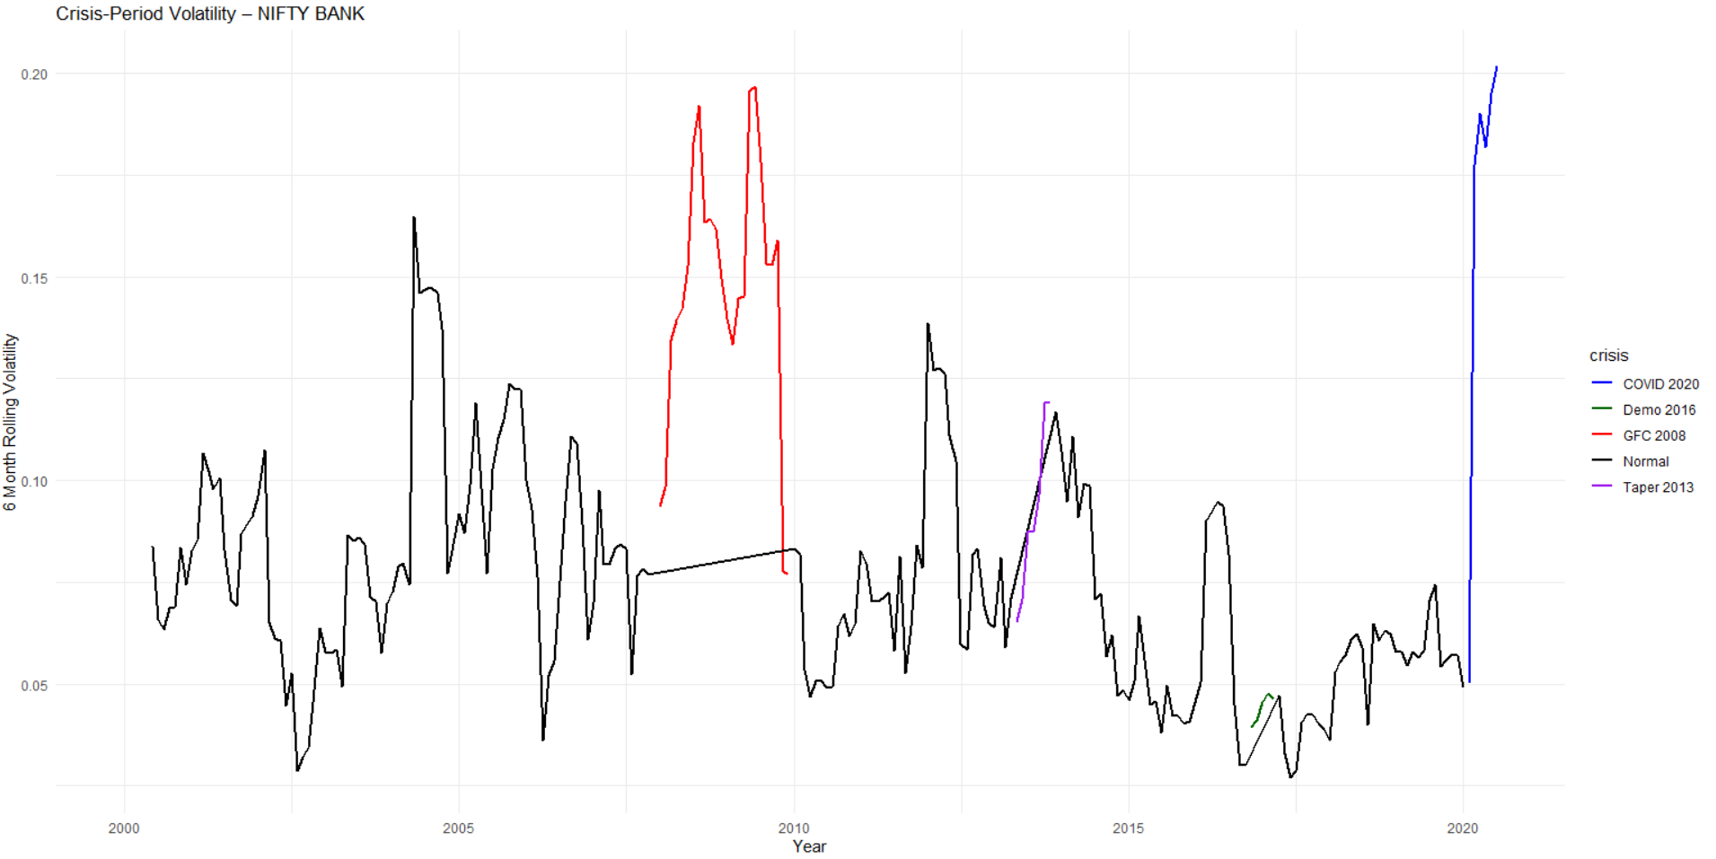
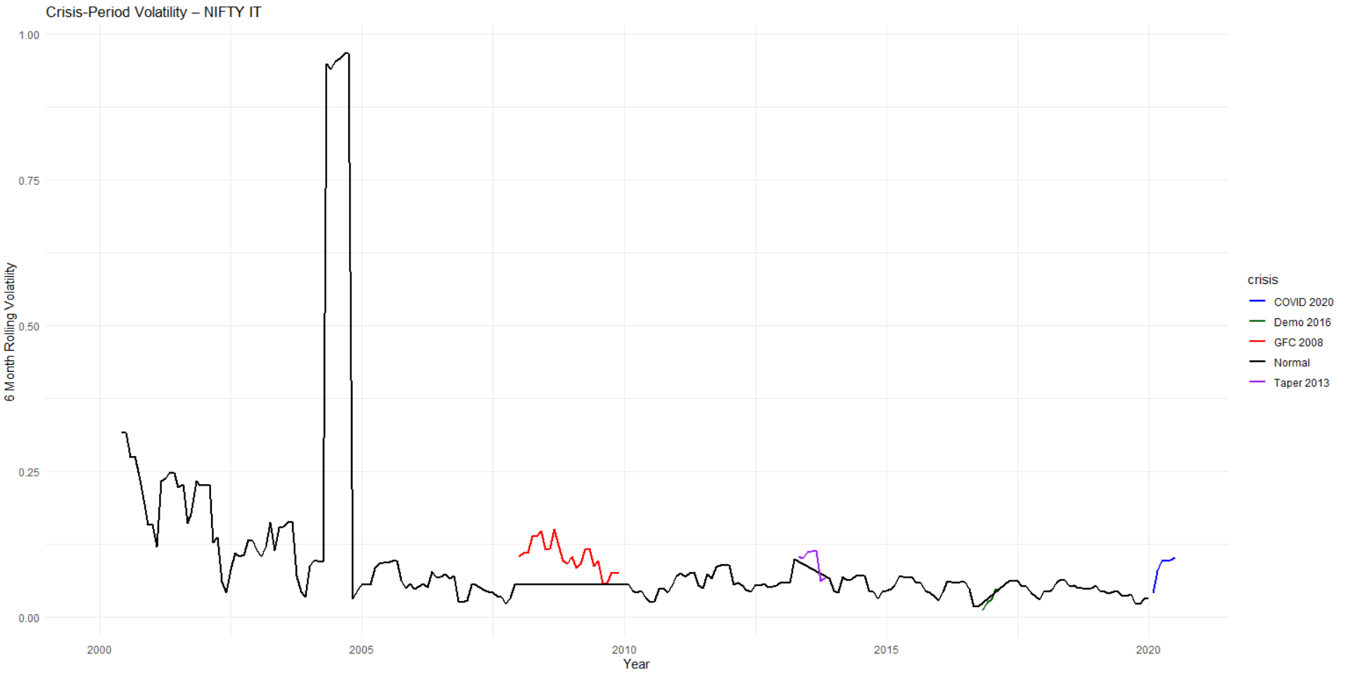
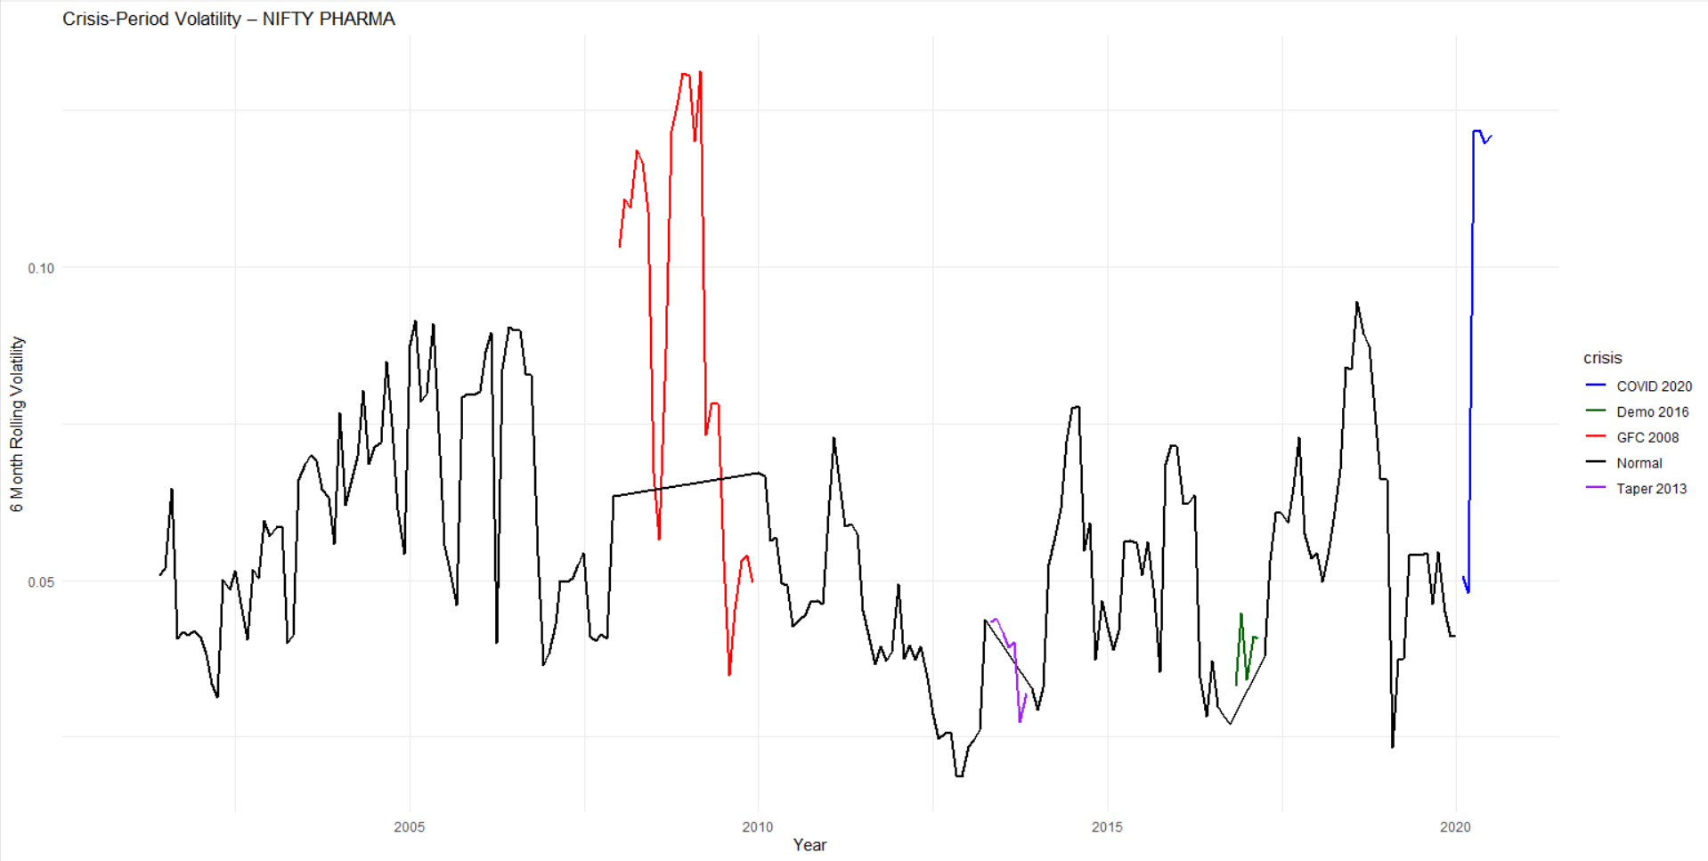
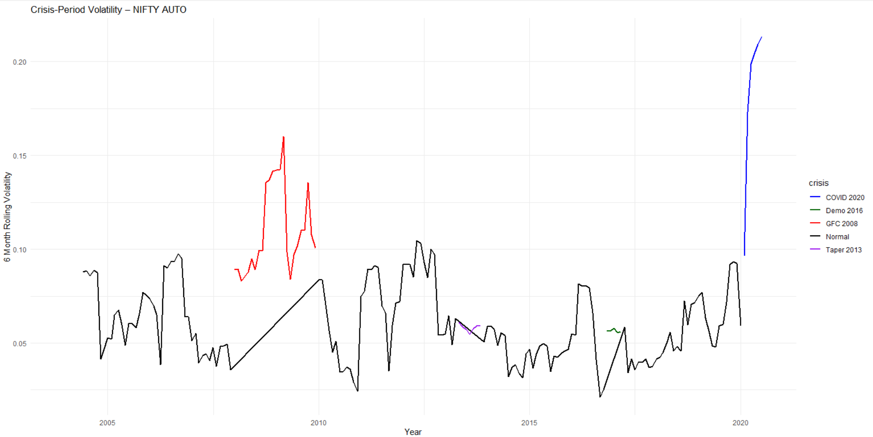
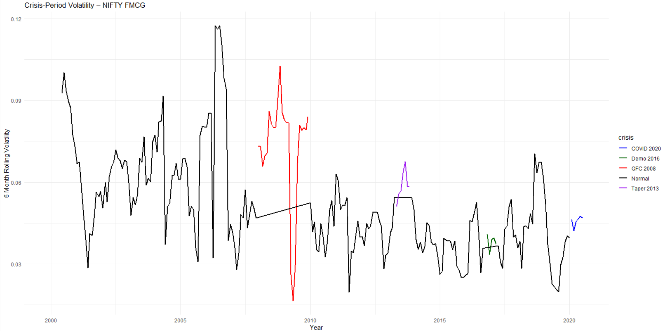
crisis_summary(result_it)
## # A tibble: 5 × 4
## crisis AvgVol MedianVol Obs
## <chr> <dbl> <dbl> <int>
## 1 COVID 2020 0.0854 0.0966 6
## 2 Demo 2016 0.0316 0.0294 5
## 3 GFC 2008 0.103 0.104 24
## 4 Normal 0.106 0.0584 205
## 5 Taper 2013 0.0961 0.104 7
crisis_summary(result_pharma)
## # A tibble: 5 × 4
## crisis AvgVol MedianVol Obs
## <chr> <dbl> <dbl> <int>
## 1 COVID 2020 0.0971 0.120 6
## 2 Demo 2016 0.0388 0.0407 5
## 3 GFC 2008 0.0899 0.0950 24
## 4 Normal 0.0546 0.0540 193
## 5 Taper 2013 0.0383 0.0402 7
crisis_summary(result_auto)
## # A tibble: 5 × 4
## crisis AvgVol MedianVol Obs
## <chr> <dbl> <dbl> <int>
## 1 COVID 2020 0.183 0.202 6
## 2 Demo 2016 0.0565 0.0564 5
## 3 GFC 2008 0.109 0.100 24
## 4 Normal 0.0601 0.0561 157
## 5 Taper 2013 0.0582 0.0586 7
crisis_summary(result_fmcg)
## # A tibble: 5 × 4
## crisis AvgVol MedianVol Obs
## <chr> <dbl> <dbl> <int>
## 1 COVID 2020 0.0458 0.0464 6
## 2 Demo 2016 0.0380 0.0389 5
## 3 GFC 2008 0.0728 0.0800 24
## 4 Normal 0.0512 0.0473 205
## 5 Taper 2013 0.0588 0.0583 7
## cross sector comparison
final_table <- data.frame(
Sector = c("BANK", "IT", "PHARMA", "AUTO", "FMCG"),
Persistence = c(
egarch_bank$summary$Persistence,
egarch_it$summary$Persistence,
egarch_pharma$summary$Persistence,
egarch_auto$summary$Persistence,
egarch_fmcg$summary$Persistence
),
Asymmetry = c(
egarch_bank$summary$gamma1,
egarch_it$summary$gamma1,
egarch_pharma$summary$gamma1,
egarch_auto$summary$gamma1,
egarch_fmcg$summary$gamma1
)
)
final_table
## Sector Persistence Asymmetry
## 1 BANK 0.7454565 0.18079012
## 2 IT 1.2480072 0.17063839
## 3 PHARMA 0.9076580 0.11725475
## 4 AUTO 0.8684575 -0.11789649
## 5 FMCG 1.0050117 0.07348045
####### forecast volatility
forecast_egarch_rolling <- function(result) {
library(rugarch)
library(zoo)
r_train <- result$train_daily$log_ret
r_test <- result$test_daily$log_ret
r_all <- c(r_train, r_test)
n_test <- length(r_test)
spec <- ugarchspec(
mean.model = list(armaOrder = c(0,0)),
variance.model = list(model = "eGARCH", garchOrder = c(1,1)),
distribution.model = "norm"
)
fit <- ugarchfit(spec, data = r_all, out.sample = n_test)
fc <- ugarchforecast(fit, n.ahead = 1, n.roll = n_test - 1)
sigma_daily <- sigma(fc)[1, ]
sigma_annual <- sigma_daily * sqrt(252)
return(sigma_annual)
}
compute_realized_vol <- function(result, window = 20) {
library(zoo)
test_r <- result$test_daily$log_ret
realized <- rollapply(
test_r,
width = window,
FUN = function(x) sd(x, na.rm = TRUE) * sqrt(252),
align = "right",
fill = NA
)
return(realized)
}
## forecast volatility engine
volatility_eval <- function(result, sector_name = result$index_name) {
library(ggplot2)
library(Metrics)
library(dplyr)
fc <- forecast_egarch_rolling(result)
rv <- compute_realized_vol(result)
df_compare <- data.frame(
Date = result$test_daily$Date,
ForecastVol = fc,
RealizedVol = rv
)
plt <- ggplot(df_compare, aes(Date)) +
geom_line(aes(y = ForecastVol, color = "Forecasted Volatility"), size = 1) +
geom_line(aes(y = RealizedVol, color = "Realized Volatility"), size = 1, alpha = 0.8) +
scale_color_manual(values = c(
"Forecasted Volatility" = "blue",
"Realized Volatility" = "red"
)) +
labs(
title = paste("Rolling 1-Step Ahead EGARCH vs Realized Vol —", sector_name),
y = "Annualized Volatility",
x = "Date",
color = "Legend"
) +
theme_minimal() +
theme(legend.position = "bottom")
df_clean <- df_compare %>% filter(!is.na(ForecastVol), !is.na(RealizedVol))
vol_rmse <- Metrics::rmse(df_clean$RealizedVol, df_clean$ForecastVol)
vol_mae <- Metrics::mae(df_clean$RealizedVol, df_clean$ForecastVol)
vol_mape <- Metrics::mape(df_clean$RealizedVol, df_clean$ForecastVol)
metrics <- c(RMSE = vol_rmse, MAE = vol_mae, MAPE = vol_mape)
return(list(
sector = sector_name,
compare = df_compare,
plot = plt,
metrics = metrics
))
}
bank_vol <- volatility_eval(result_bank)
it_vol <- volatility_eval(result_it)
pharma_vol <- volatility_eval(result_pharma)
auto_vol <- volatility_eval(result_auto)
fmcg_vol <- volatility_eval(result_fmcg)
bank_vol$plot
## Warning: Removed 19 rows containing missing values or values outside the scale range (`geom_line()`).
### plot with all 5 plots in one
library(gridExtra)
grid.arrange(
bank_vol$plot,
it_vol$plot,
pharma_vol$plot,
auto_vol$plot,
fmcg_vol$plot,
ncol = 2
)
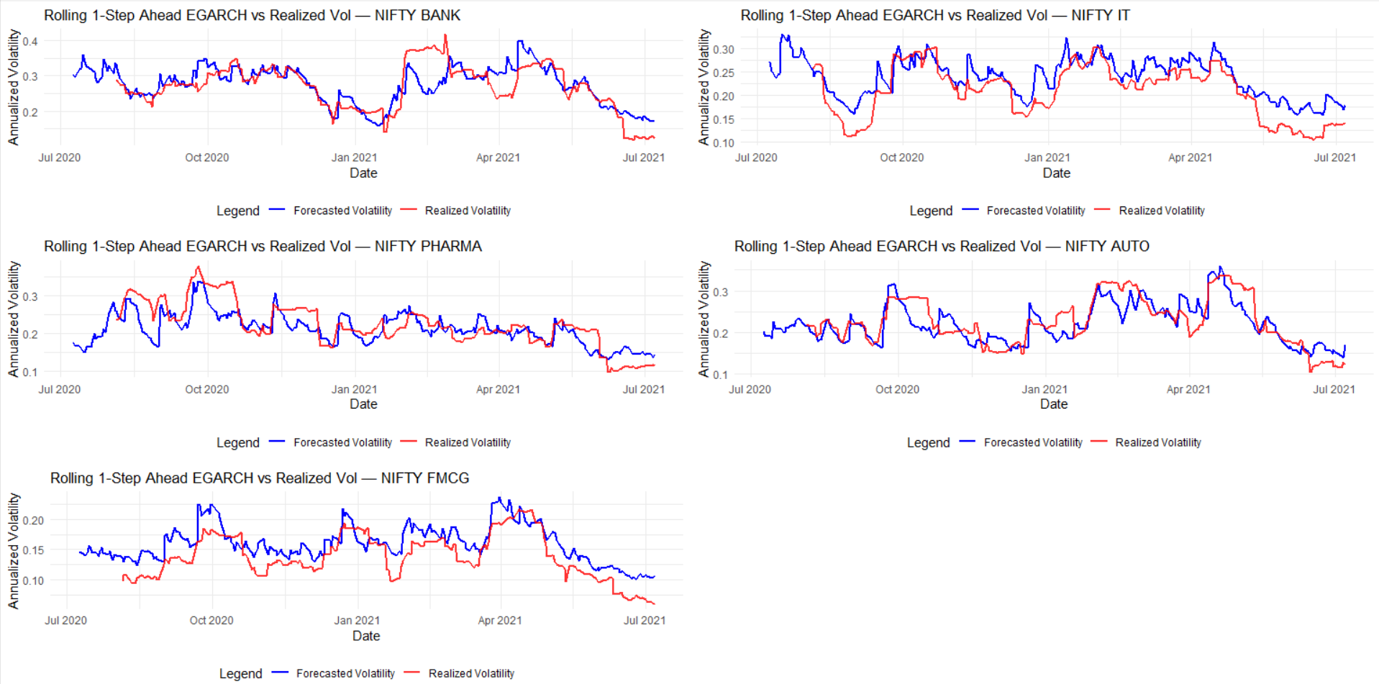
## table with all metrics
accuracy_table <- data.frame(
Sector = c(
bank_vol$sector,
it_vol$sector,
pharma_vol$sector,
auto_vol$sector,
fmcg_vol$sector
),
RMSE = c(
bank_vol$metrics["RMSE"],
it_vol$metrics["RMSE"],
pharma_vol$metrics["RMSE"],
auto_vol$metrics["RMSE"],
fmcg_vol$metrics["RMSE"]
),
MAE = c(
bank_vol$metrics["MAE"],
it_vol$metrics["MAE"],
pharma_vol$metrics["MAE"],
auto_vol$metrics["MAE"],
fmcg_vol$metrics["MAE"]
),
MAPE = c(
bank_vol$metrics["MAPE"],
it_vol$metrics["MAPE"],
pharma_vol$metrics["MAPE"],
auto_vol$metrics["MAPE"],
fmcg_vol$metrics["MAPE"]
)
)
accuracy_table
## Sector RMSE MAE MAPE
## 1 NIFTY BANK 0.04322063 0.03070600 0.1259222
## 2 NIFTY IT 0.03850968 0.03242452 0.1958424
## 3 NIFTY PHARMA 0.03888457 0.03119326 0.1461016
## 4 NIFTY AUTO 0.03478764 0.02767359 0.1272569
## 5 NIFTY FMCG 0.02962922 0.02611012 0.2216552

