 

INSTITUTE FOR ADVANCED COMPUTING AND SOFTWARE DEVELOPMENT AKURDI, PUNE

Documentation On

THE BOOKTOWN

(E-commerce) Application

PG-DAC SEPT 2022

## Submitted By:

**Group No: 26**

**Roll No. Name:**

**229041 Kshitij Chandan**

**229087 Akshay Shinde**

## Mr. Narendra Pawar Mr. Rohit Puranik Mrs. Megha Mane

**Course Coordinator Centre Coordinator Project Guide**

# ABSTRACT

This project is a web-based books shopping system for multiple vendors. The project objective is to deliver the online books shopping application into web platform.

This project is an attempt to provide the advantages of online book shopping to customers of a real shop. It helps buying the books in the shop anywhere through internet by using a website device. Thus, the customer will get the service of online book shopping and home delivery at affordable price. This system can be used by any vendor whose is willing to sell the books online and a well known editorial house can directly sell their book by using this platform.

If vendors are providing an online portal where their customers can enjoy easy book shopping from anywhere, the vendor won’t be losing any more customers . And it helps the customer to find their favorite without any problem and they have a choice to buy from the vendor they like and whose cost they fill justify.

# ACKNOWLEDGEMENT

I take this occasion to thank God, almighty for blessing us with his grace and taking our endeavor to a successful culmination. I extend my sincere and heartfelt thanks to our esteemed guide, **Mrs. Megha Mane** for providing me with the right guidance and advice at the crucial juncture sand for showing me the right way. I extend my sincere thanks to our respected **Centre Co-Ordinator Mr. Narendra Pawar**, for allowing us to use the facilities available. I would like to thank the other faculty members also, at this occasion. Last but not the least, I would like to thank my friends and family for the support and encouragement they have given me during the course of our work.

**Akshay Shinde (229087)**

**Kshitij Chandan (229041)**

**Table of Contents**

ABSTRACT 2

ACKNOWLEDGEMENT 3

INTRODUCTION 7

FEATURES 7

* 1. PROJECT OBJECTIVE 8
  2. PROJECT OVERVIEW 8
  3. PROJECT SCOPE 9
  4. STUDY OF THE SYSTEM 9
     1. MODULES 9

SYSTEM ANALYSIS 19

* 1. EXISTING SYSTEM 19
  2. PROPOSED SYSTEM 19
  3. SYSTEM REQUIREMENT SPECIFICATION 19
     1. GENERAL DESCRIPTION 19
     2. SYSTEM OBJECTIVES 20
     3. SYSTEM REQUIREMENTS 20

MODERATOR 23

DESCRIPTION OF FEATURES 23

ADMIN 23

SYSTEM DESIGN 25

* 1. INPUT AND OUTPUT DESIGN 25
     1. INPUT DESIGN 25
     2. OUTPUT DESIGN 25

DATABASE DESIGN 27

* 1. DATABASE 27
  2. SYSTEM TOOLS 27
     1. FRONT END 27
     2. BACKEND 27

ZERO LEVEL DFD FOR ADMIN 25

1. LEVEL DFD FOR CUSTOMER 26

2 LEVEL DFD FOR CUSTOMER ………………………………………………………………27

E-R DIAGRAM 30

CLASS DIAGRAM 31

TABLE STRUCTURE 32

PROJECT DIAGRAMS 37

CONCLUSION 54

REFERENCES 55

# LIST OF FIGURES

**FIGURE 1: ADMIN ACTIVITY DIAGRAM 11**

**FIGURE 2: VENDOR ACTIVITY DIAGRAM 13**

**FIGURE 3: CUSTOMER ACTIVITY DIAGRAM 15**

**FIGURE 6: ZERO LEVEL DFD FOR E-COMMERCE 25**

**FIGURE 6.1: 1 LEVEL DFD FOR CUSTOMER 26**

**FIGURE 6.2: 2 LEVEL DFD FOR CUSTOMER 27**

**FIGURE 7: E-R DIAGRAM 28**

**FIGURE 7.1: E-R DIAGRAM(MYSQL GENERATED) 29**

**FIGURE 8: CLASS DIAGRAM 31**

**FIGURE 9: TABLE STRUCTURE 32**

**FIGURE 10: PROJECT DIAGRAMS 37**

# INTRODUCTION

This project is a web-based Book Shopping Website for multiple Vendors. An Online Books shopping website where the Admin can Delete User and Delete products. The Books are divided into various categories like classic ,crime ,horror ,etc. A user can select a particular book to view the details, choose the number of book and fill in details like Name, Address, etc. to buy a book the project objective is to deliver the online shopping application into web platform. Online book shopping is the process whereby consumers directly buy books from a seller in real- time, without an intermediary service, over the Internet. It is a form of electronic commerce. This project is attempts provide the advantages of online book shopping to customer from anywhere. It helps buying the books on the website anywhere through internet. Thus, the customer will get the service of online shopping and home delivery from his favorite shop.

The objective of the project is to make an web application to purchase books. In order to build such an application complete web support, need to be provided. A complete and efficient web application which can provide the online book shopping experience is the basic objective of the project.

#### Features: -

1. Products Available-Atomic Habits ,The Fire wings ,etc
2. Search for books
3. Category of Books-Classic , Adventure ,etc.
4. Cart feature
5. The admin can add/delete Suppliers and delivery boys.
6. Allows the customers to maintain cart.

### PROJECT OBJECTIVE

The objective of the project is to make an web application to purchase books from multiple vendor. In order to build such an application complete web support, need to be provided. A complete and efficient web application which can provide the online book shopping experience is the basic objective of the project.

### PROJECT OVERVIEW

The central concept of the application is to allow the customer to shop virtually using the internet and allow customers to buy the books from multiple vendor. The information pertaining to the books are stores on an RDBMS at the server side (store).

The server processes the customers, and the books are shipped to the address submitted by them. The application was designed into two modules first is for the customers who wish to buy the books. Second is for the vendor who maintains and updates the information pertaining to the books and those of this books given by multiple vendors wherethe application is hosted on the web and the administrator maintains the database. The application, which is deploy the customer database, the details of the items are brought forward from the database for the customer view based on the selection through the menu and the database of all the products are updated at the end of each transaction. Data entry into the application can be done through various screens designed for various levels of users.

### PROJECT SCOPE

This web application is deployed on the server and multiple vendor across the globe can access anywhere. The system recommends a facility to accept the orders 24X7 and a home delivery system which can make customers happy. If shops are providing an online portal where their customers can enjoy easy shopping from anywhere, the shops won’t be losing any more customers to the trending online shopping. Since the application is available and always available.

### STUDY OF THE SYSTEM

### MODULES:

The system after careful analysis has been identified to be presented with the following modules and roles.

The modules involved are:

* Administrator
* Vendor
* Users
  + - 1. Administrator:

The administrator is the super user of this application. Only admin have access into this admin page. The administrator has all the information about the users and about all products.

This module is divided into different sub modules.

* + - * 1. Manage Vendor
        2. Manage Users
        3. Manage Books

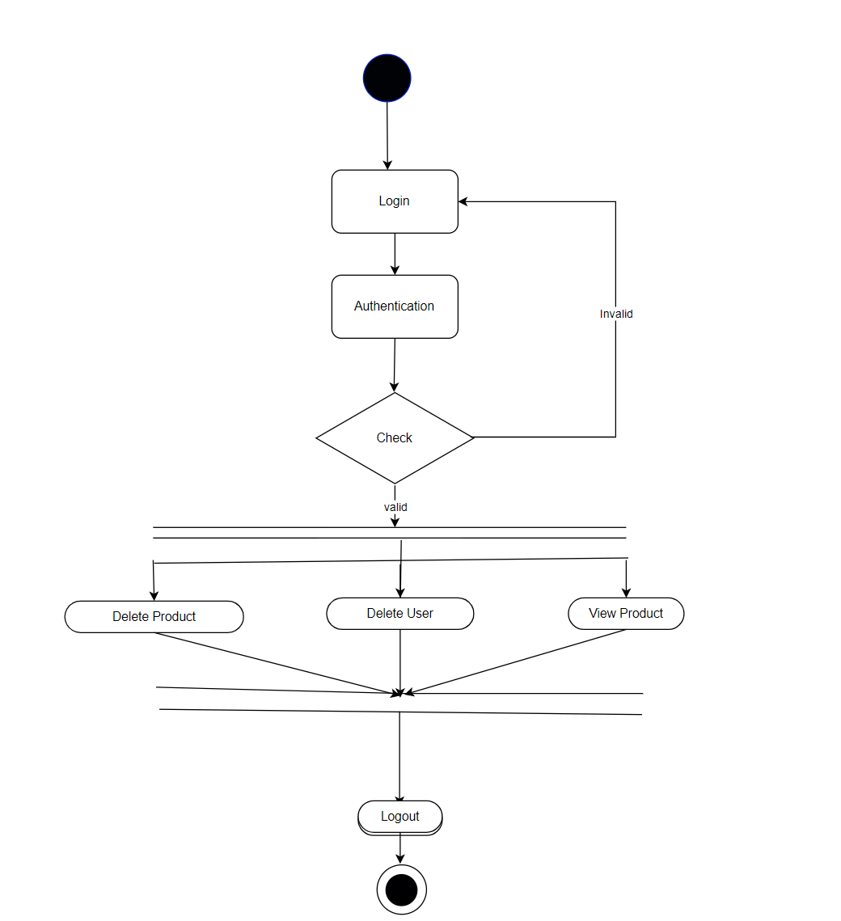

##### Figure 1 Admin Activity Diagram

Delete Products

Administrator can delete the products based on the stock of that particular product.

Remove Vendor

Admin have the privilege to remove the supplier.

Remove User

Admin have the privilege to remove the User.

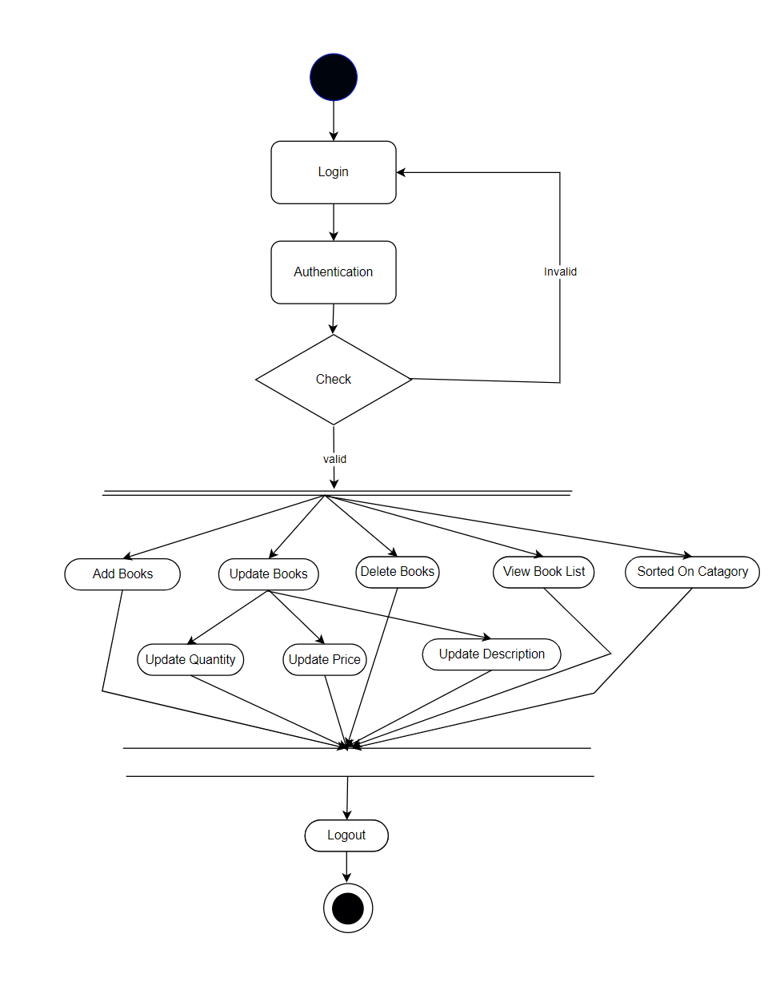

##### Figure 2 Vendor Activity Diagram

Vendor Sign in, Sign out, Create Account

This feature is provided to customer so he can sign in, sign out and create account for

new customer.

Add Product

Vendor can add the product

Edit Product

Vendor can edit his added product.

Delete Product

Vendor can delete the product .

##### Figure 3 Customer Activity Diagram

Customer sign in, sign out, create account

This feature is provided to customer so he can sign in, sign out and create account for new customer.

Add to Cart

Customer can add products to cart which he wants to buy the products.

Payments

Customer have a privilege to his order he can see his order details.

Order Details

Customer have a privilege to his order he can see his order details.

Buy Product

Customers can buy product from his cart by doing payment.

# SYSTEM ANALYSIS

System analysis is the process of gathering and interpreting facts, diagnosing problems, and using the information to recommend improvements on the system. System analysis is a problem-solving activity that requires intensive communication between the system users and system developers.

System analysis or study is an important phase of any system development process. The system is viewed as a whole, the inputs are identified, and the system is subjected to close study to identify the problem areas. The solutions are given as a proposal. The proposal is reviewed on user request and suitable changes are made. This loop ends as soon as the user is satisfied with the proposal.

### EXISTING SYSTEM

The current system for shopping is to visit the shop manually and from the available product choose the item customer want and buying the item by payment of the price of the item.

* It is less user-friendly.
* User must go to shop and select products.
* It is difficult to identify the required product.
* Description of the product limited.
* It is a time-consuming process
* Not in reach of distant users.

### PROPOSED SYSTEM

In the proposed system customer need not go to the shop for buying the products. He can order the product he wish to buy through the web application . If the book is not available in your area you can order from other vendor . The system also recommends a home delivery system for the purchased products.

### SYSTEM REQUIREMENT SPECIFICATION

###### GENERAL DESCRIPTION

Product Description:

A web application which can provide the online shopping service for the customer to access the web service from his Smartphone/System. Web application should be able to help the customer for selecting his item and to help the owner in managing the orders from the customers.

Problem Statement:

As online shopping became a trend nowadays you can order the books by comparing different vendor. Customers have effortless shopping experience and saving time through shopping online. Sometime the product you want is not available in your locality because of the web application through internet and get the products at their doors it will increase the number of customers.

###### SYSTEM OBJECTIVES

* To provide a Web application for online shopping of books.
* To provide an online platform for multiple Vendors.

###### SYSTEM REQUIREMENTS

* + - 1. **NON-FUNCTIONAL REQUIREMENTS**

###### EFFICIENCY REQUIREMENT

When an online shopping cart android application implemented customer can purchase product in an efficient manner.

###### RELIABILITY REQUIREMENT

The system should provide a reliable environment to both customers and owner. All orders should be reaching at the admin without any errors.

###### USABILITY REQUIREMENT

The Web application is designed for user friendly environment and ease of use.

###### IMPLEMENTATION REQUIREMENT

Implementation of the system using React in front end with Spring Boot as back end and it will be used for database connectivity. And the database part is developed by MySQL. Responsive web designing is used for making the website compatible for any type of screen.

###### DELIVERY REQUIREMENT

The whole system is expected to be delivered in four months of time with a weekly Evaluation by the project guide.

* + - 1. **FUNCTIONAL REQUIREMENTS**

###### USER

* **USER LOGIN**

Description offeature

This feature used by the user to login into system. A user must login with his username and password to the system after registration. If they are invalid, the user not allowed to enter the system.

Functional Requirement

* Username and password will be provided after user registration is confirmed.
* Password should be hidden from others while typing it in the field

###### REGISTER NEW

USER Description of feature

A new user will have to register in the system by providing essential details in order to view the products in the system. The admin must accept new user by unblocking him.

Functional Requirement

* System must be able to verify and validate information.
* The system must encrypt the password of the customer to provide security.

###### PURCHASING AN ITEM

Description of feature

The user can add the desired product into his cart by clicking add to cart option on the product. He can view his cart by clicking on the cart button. All products added by cart can be viewed in the cart. User can remove an item from the cart by clicking remove. After confirming the items in the cart, the user can submit the cart by providing a delivery address. On successful submitting the cart will become empty.

Functional Requirement

* System must ensure that, only a registered customer can purchase items.
* System must ensure that only the register vendor can sell their book on the platform.

# 

### ADMIN

###### MANAGE USER

Description of features

The administrator can add user, delete user, view user and block user

###### MANAGE PRODUCTS

Description of features

The administrator can add product, delete product, and view product.

###### MANAGE ORDER

Description of features

The administrator can view orders and delete orders.

Functional Requirements:

* The system must identify the login of the admin
* System must ensure that only the register vendor can sell their book on the platform

# SYSTEM DESIGN

System design is the solution for the creation of a new system. This phase focuses on the detailed implementation of the feasible system. Its emphasis on translating design. Specifications to performance specification. System design has two phases of development.

* Logical Design
* Physical Design

During logical design phase the analyst describes inputs (sources), outputs(destinations), databases (data sores) and procedures (data flows) all in a format that meets the user requirements. The analyst also specifies the needs of the user at a level that virtually determines the information flow in and out of the system and the data resources. Here the logical design is done through data flow diagrams and database design. The physical design is followed by physical design or coding. Physical design produces the working system by defining the design specifications, which specify exactly what the candidate system must do. The programmers write the necessary programs that accept input from the user, perform necessary processing on accepted data and produce the required report on a hard copy or display it on the screen.

### INPUT AND OUTPUT DESIGN

###### INPUT DESIGN:

Input design is the link that ties the information system into the world of its users. The input design involves determining the inputs, validating the data, minimizing the data entry and provides a multi-user facility. Inaccurate inputs are the most common cause of errors in data processing. Errors entered by the data entry operators can be controlled by input design. The user-originated inputs are converted to a computer-based format in the input design. Input data are collected and organized into groups of similar data. Once identified, the appropriate input media are selected for processing. All the input data are validated and if any data violates any conditions, the user is warned by a message. If the data satisfies all the conditions, it is transferred to the appropriate tables in the database. In this project the student details are to be entered at the time of registration. A page is designed for this purpose which is user friendly and easy to use. The design is done such that users get appropriate messages when exceptions occur.

###### OUTPUT DESIGN:

Computer output is the most important and direct source of information to the user. Output design

is a very important phase since the output needs to be in an efficient manner. Efficient and intelligible output design improves the system relationship with the user and helps in decision making. Allowing the user to view the sample screen is important because the user is the ultimate judge of the quality of output. The output module of this system is the selected notifications.

# DATABASE DESIGN

* 1. **DATABASE**

Databases are the storehouses of data used in the software systems. The data is stored in tables inside the database. Several tables are created for the manipulation of the data for the system. Two essential settings for a database are

* Primary key - the field that is unique for all the record occurrences
* Foreign key - the field used to set relation between tables Normalization is a technique to avoid redundancy in the tables.

### SYSTEM TOOLS

The various system tools that have been used in developing both the front end and the back end of the project are being discussed in this chapter.

###### FRONT END:

React is a library which is developed by Facebook are utilized to implement the frontend. React (also known as React.js or ReactJS) is a [free and open-source](https://en.wikipedia.org/wiki/Free_and_open-source_software) [front-end](https://en.wikipedia.org/wiki/Front_end_and_back_end) [JavaScript](https://en.wikipedia.org/wiki/JavaScript_library) [library](https://en.wikipedia.org/wiki/JavaScript_library) for building [user interfaces](https://en.wikipedia.org/wiki/User_interfaces) or UI components. It is maintained by [Facebook](https://en.wikipedia.org/wiki/Facebook%2C_Inc) and a community of individual developers and companies. React can be used as a base in the development of [single](https://en.wikipedia.org/wiki/Single-page_application) [page](https://en.wikipedia.org/wiki/Single-page_application) or mobile applications. However, React is only concerned with state management and rendering that state to the [DOM,](https://en.wikipedia.org/wiki/Document_Object_Model) so creating React applications usually requires the use of additional libraries for routing, as well as certain client-side functionality.

###### BACKEND:

The back end is implemented using MySQL which is used to design databases.

MySQL:

MySQL is the world's second most widely used open-source relational database management system (RDBMS). The SQL phrase stands for Structured Query Language. An application software called Navicert was used to design the tables in MySQL.

Spring-Boot:

This is used to connect MYSQL and fetch data from database and store the data in database. The Spring Framework is a[n application framework](https://en.wikipedia.org/wiki/Application_framework) and [inversion of control](https://en.wikipedia.org/wiki/Inversion_of_control) [container](https://en.wikipedia.org/wiki/Servlet_container) for the [Java](https://en.wikipedia.org/wiki/Java_platform) [platform.](https://en.wikipedia.org/wiki/Java_platform) The framework's core features can be used by any Java application, but there are extensions for building web applications on top of the [Java EE](https://en.wikipedia.org/wiki/Java_EE) (Enterprise Edition) platform. Although the framework does not impose any specific [programming model,](https://en.wikipedia.org/wiki/Programming_model) it has become popular in the Java community as an addition to the [Enterprise JavaBeans](https://en.wikipedia.org/wiki/Enterprise_JavaBeans) (EJB) model. The Spring Framework is Open-source Framework.

## 

Zero Level DFD-E-Commerce Portal

Shipping

Management

Category

Management

Login

Management

Customer

Management

***Figure 6 Zero Level DFD for CUSTOMER***

## 1 Level DFD for CUSTOMER

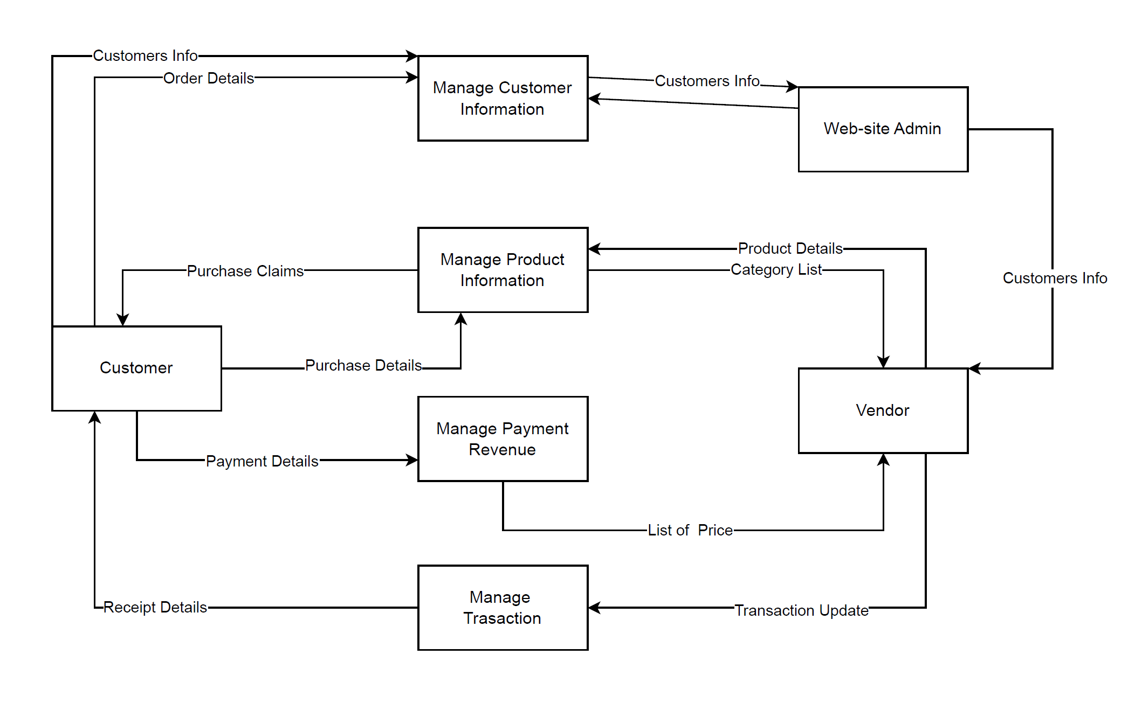

***Figure 6.1 1 Level DFD for CUSTOMER***

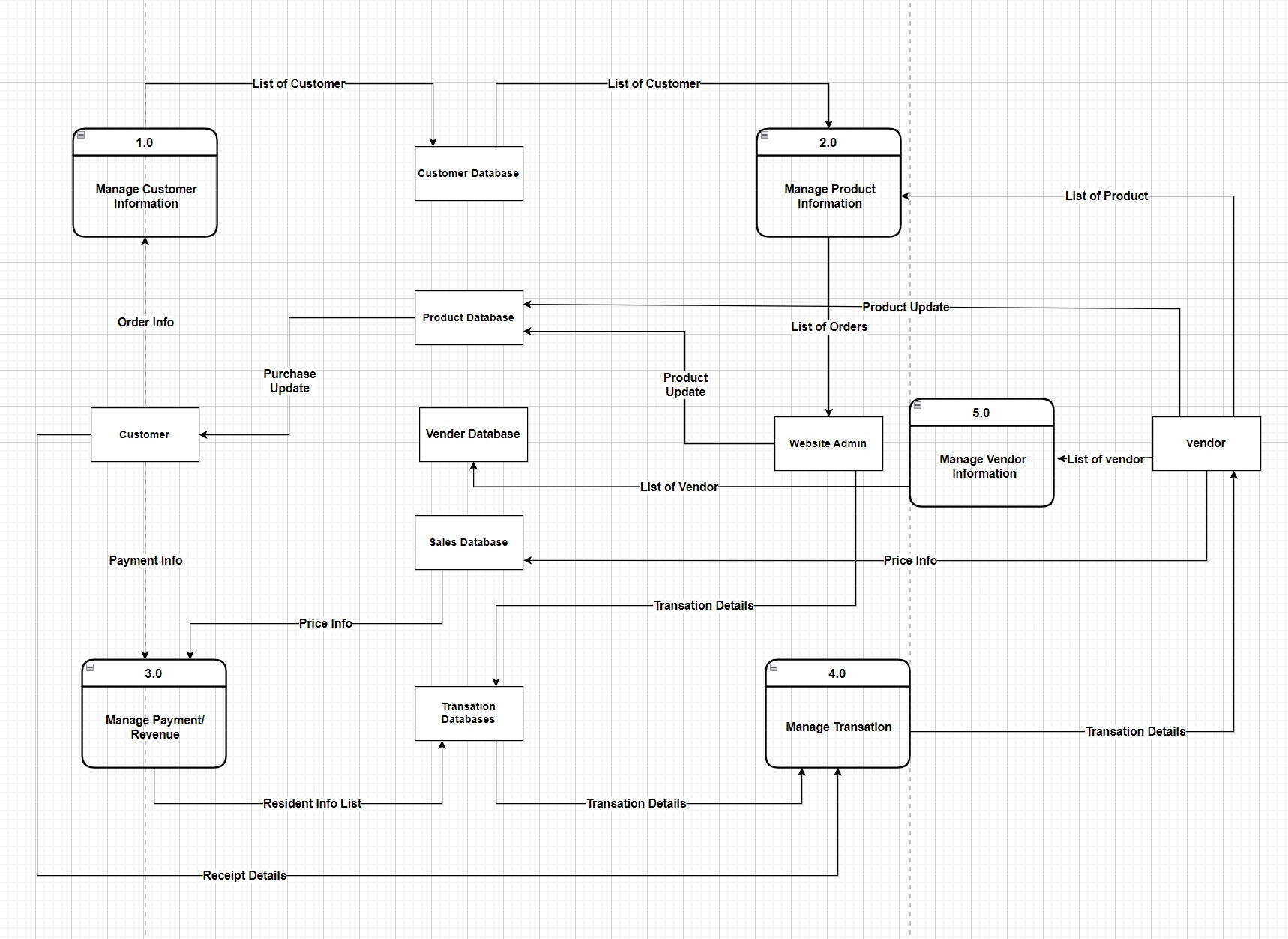***Figure 6.2 2 Level DFD for CUSTOMER***

## E-R Diagram:

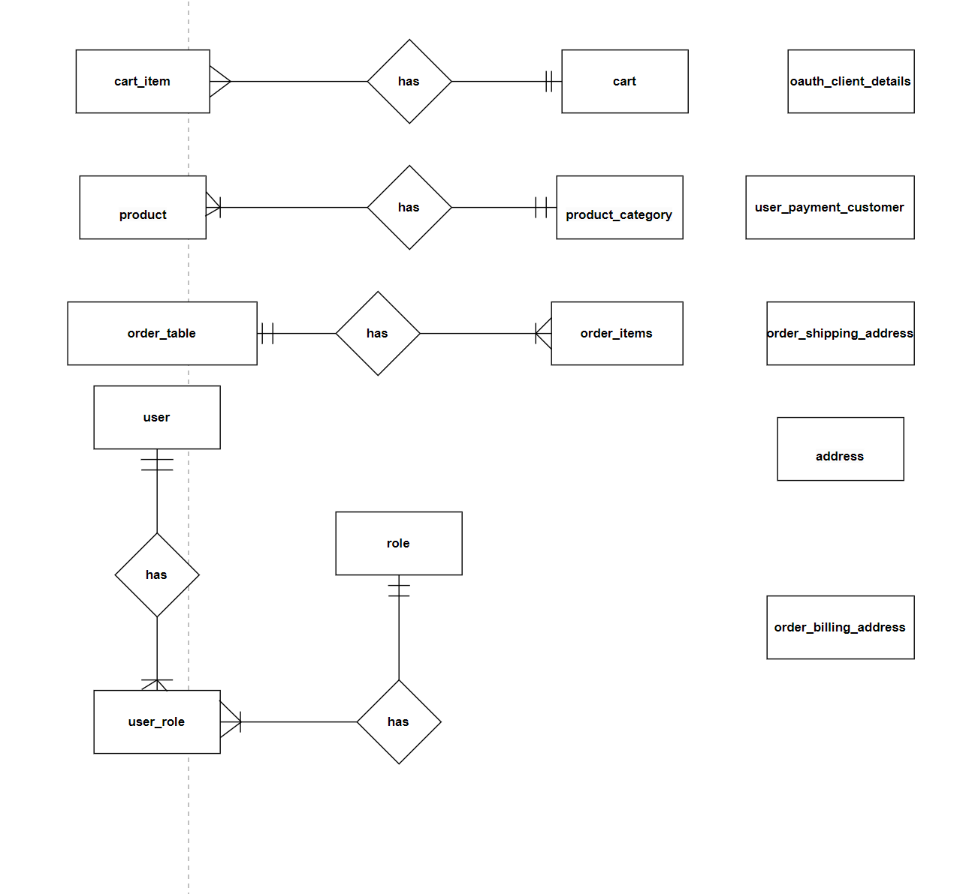

***Figure 7.1 E-R Diagram***

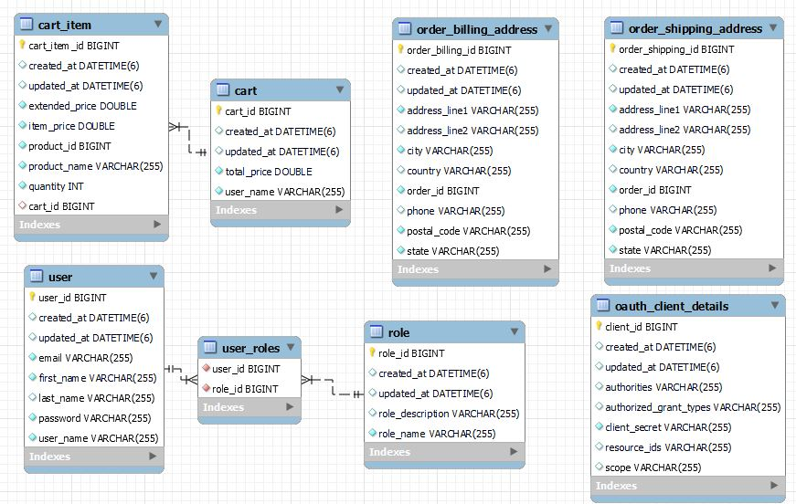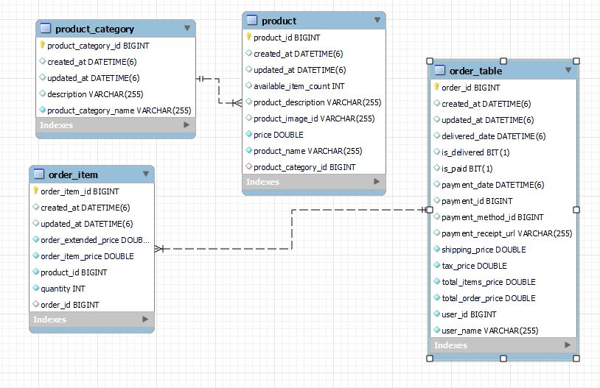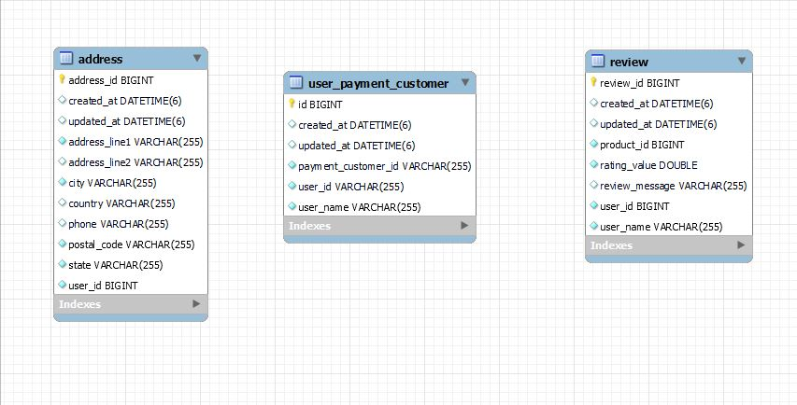

***Figure 7.2 E-R diagram (Generated by Mysql )***

## Class Diagram

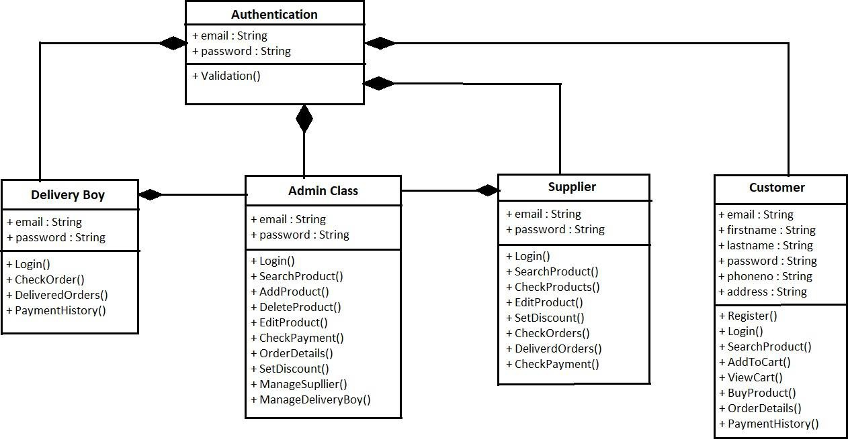

***Figure 8 Class Diagram***

# TABLE STRUCTURE:

**Tables:**

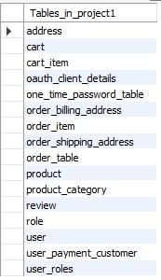

**Address:**

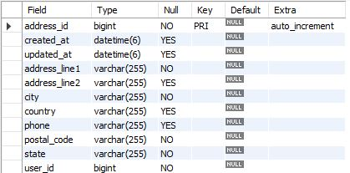

**Cart:**

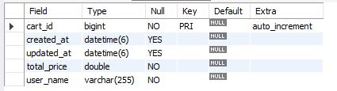

**Product Category:**

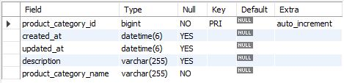

**Product:**

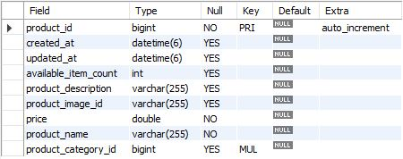

**Cart Items:**

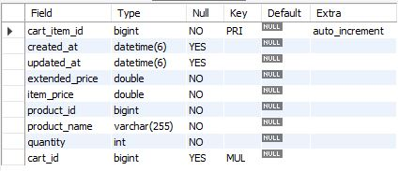

**Orders Table:**

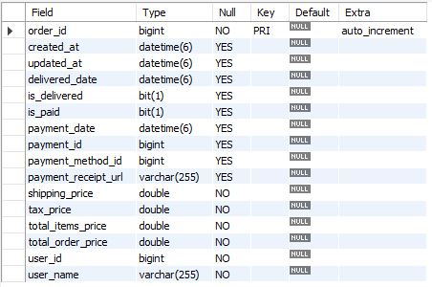

**Reviews:**

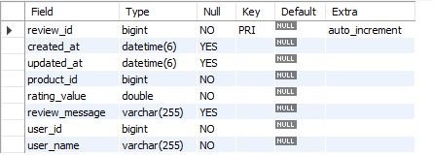

**Order Items:**

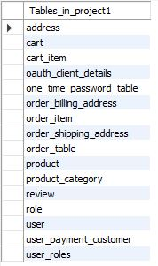

**User Role:**



**Role:**

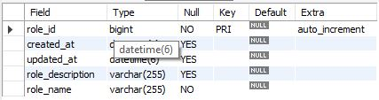

**OTP:**

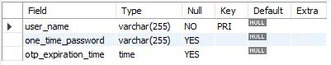

**Users:**

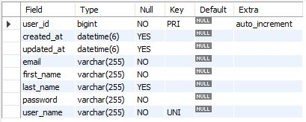

# PROJECT DIAGRAMS

# 

# 

# 

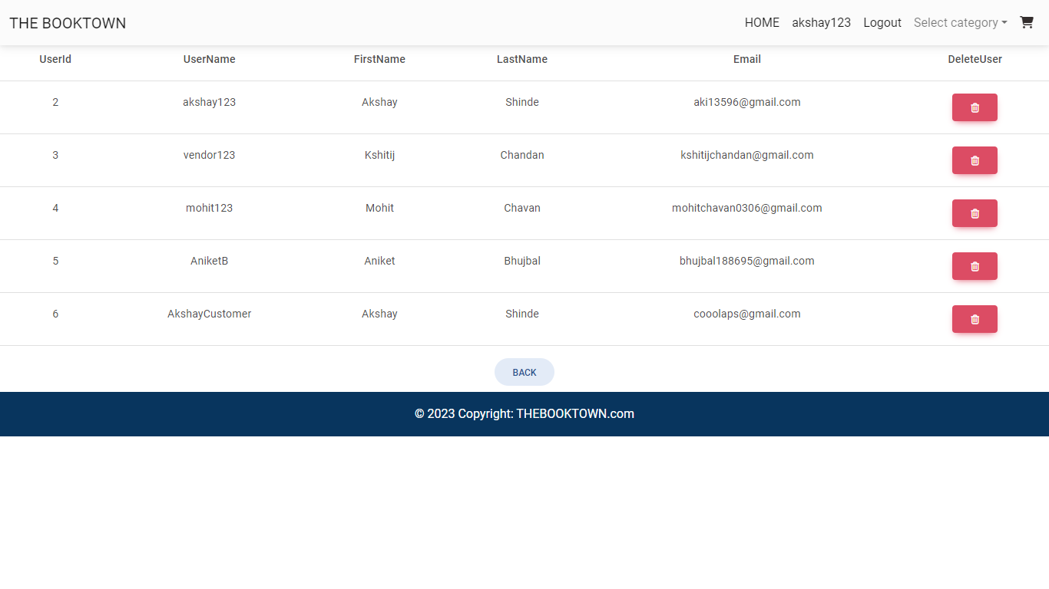

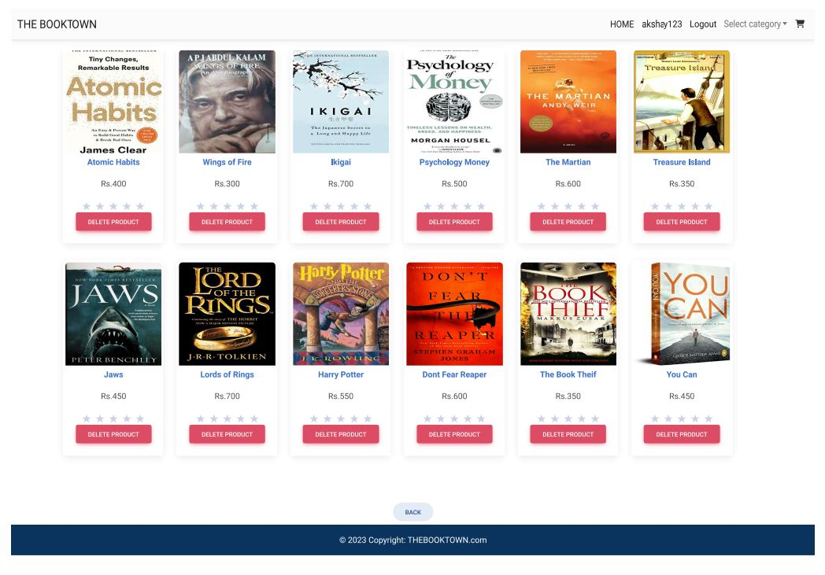

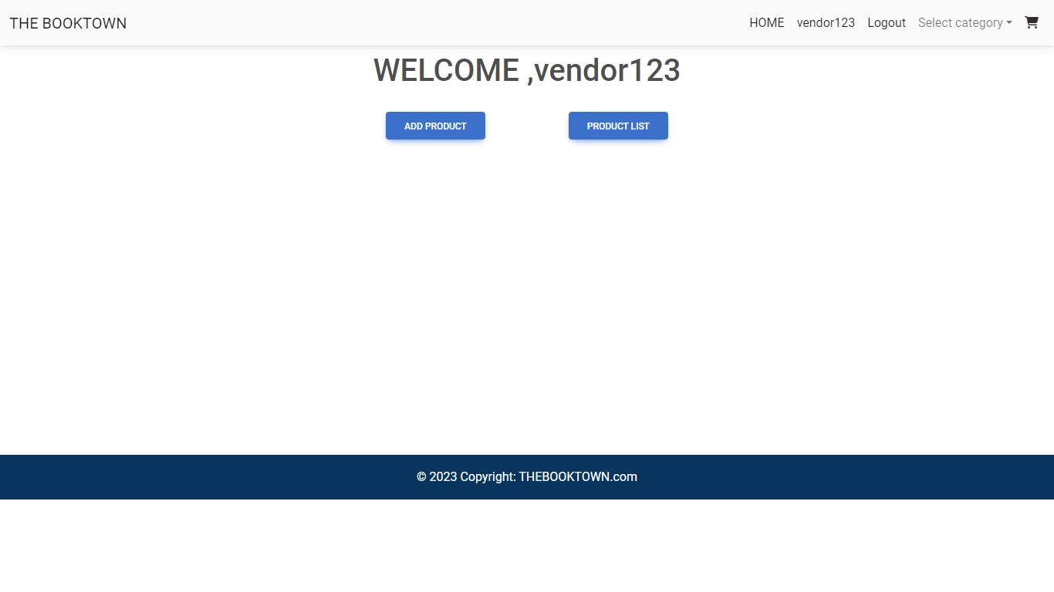

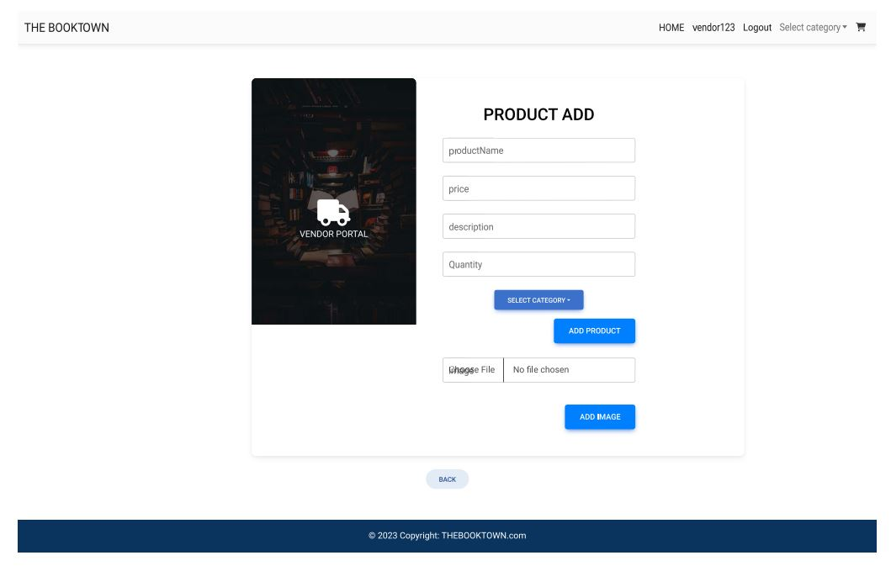

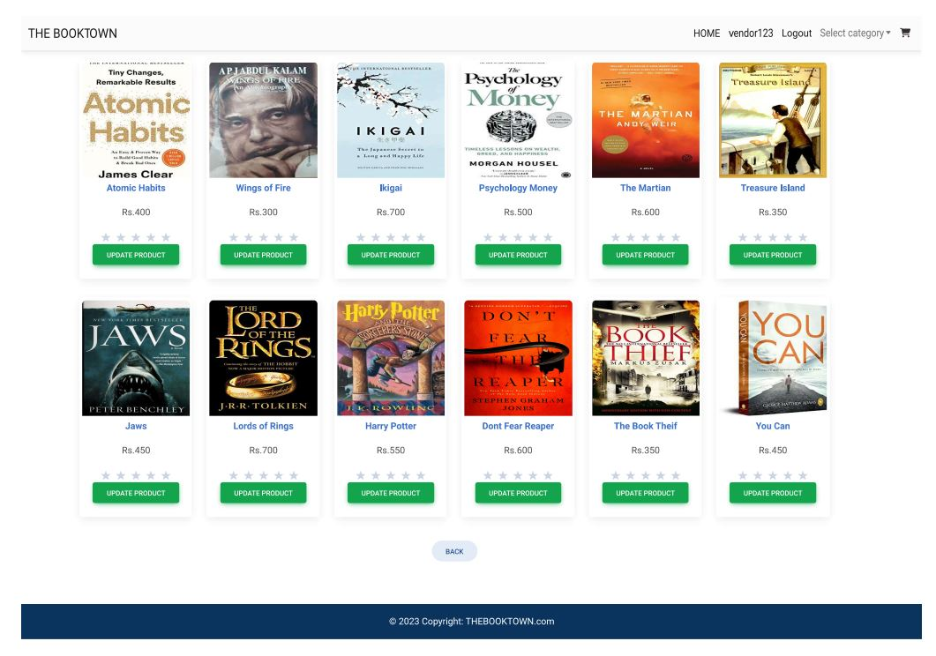

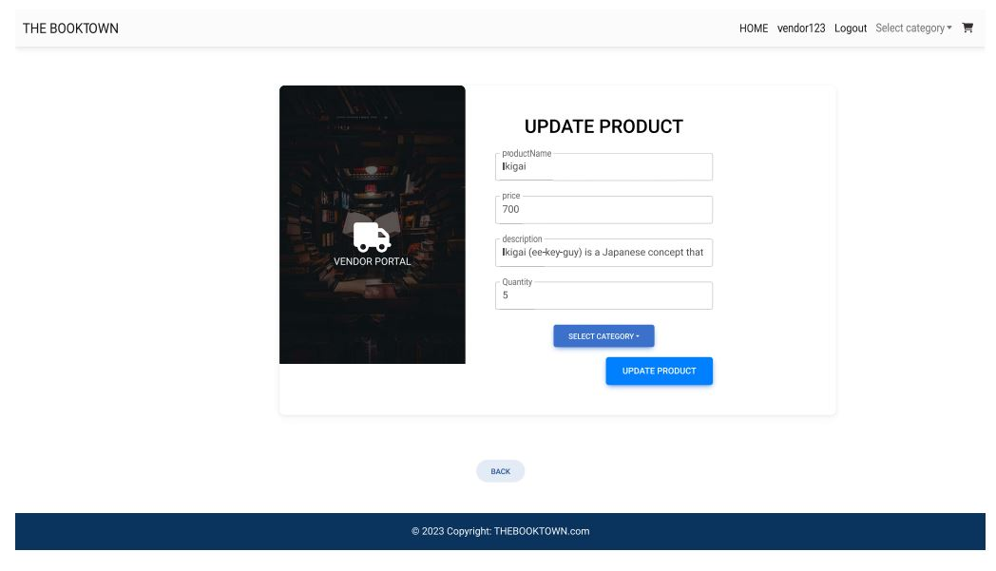

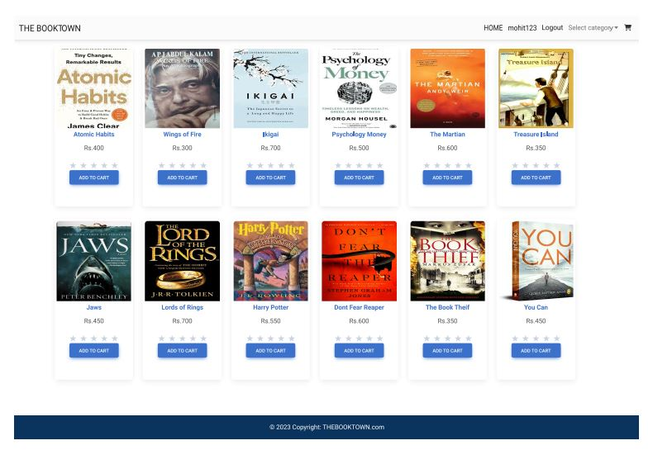

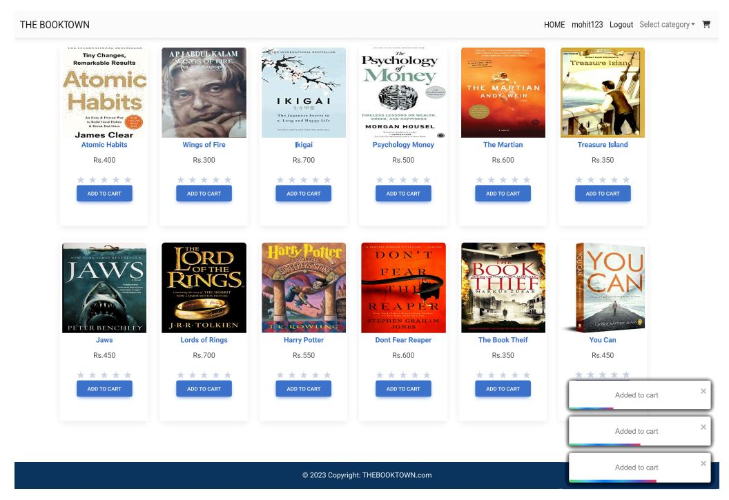

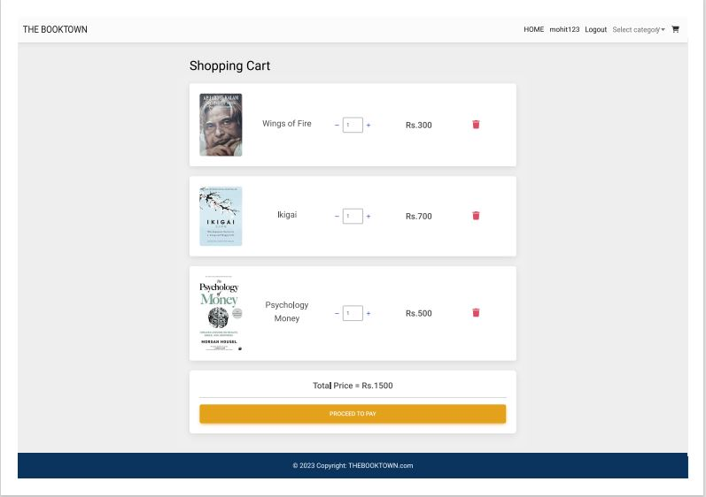

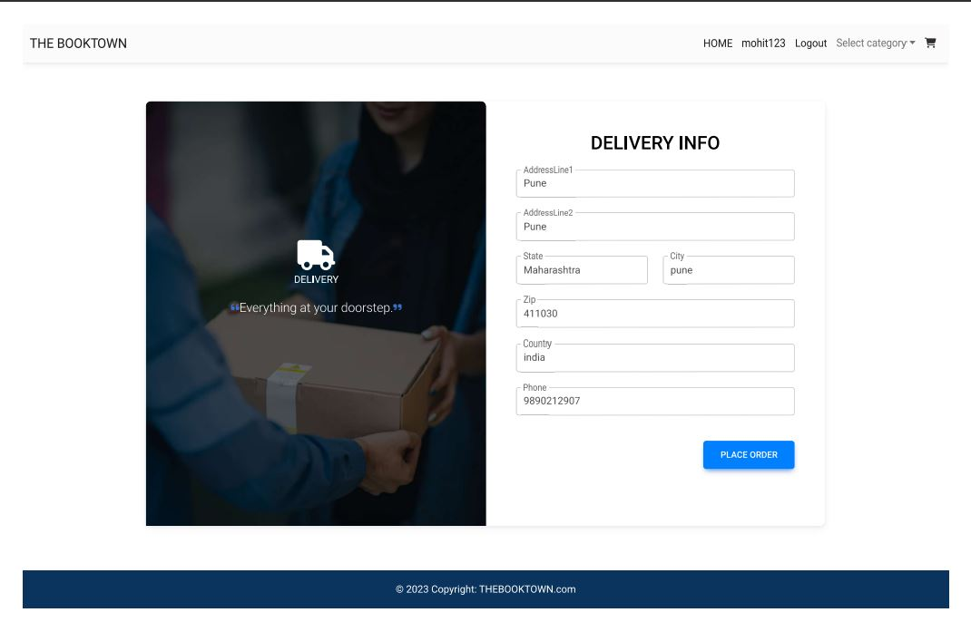

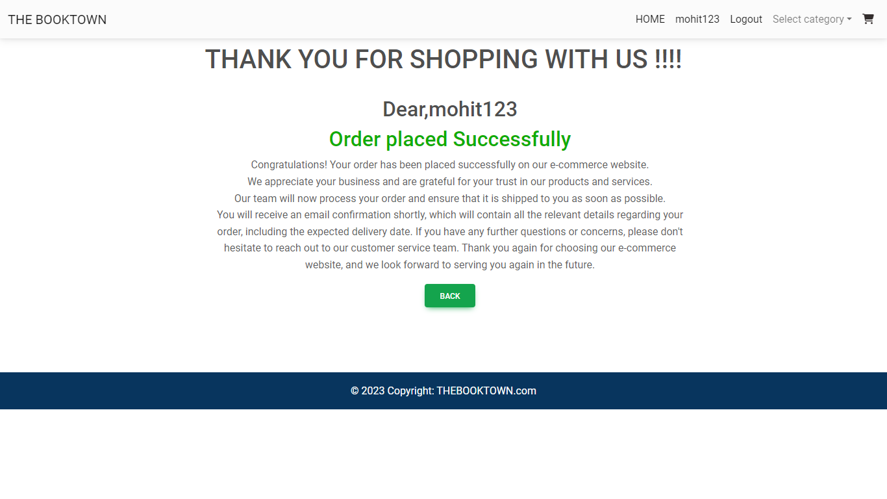

# CONCLUSION

The project entitled **THE BOOKTOWN** was completed successfully.

The system has been developed with much care and free of errors and at the same time it is efficient and less time consuming. The purpose of this project was to develop a web application and an android application for purchasing book from multiple vendors.

This project helped us in gaining valuable information and practical knowledge on several topics like designing web pages using React.js, usage of responsive templates, and management of database using MySQL. The entire system is secured. Also, the project helped us understanding about the development phases of a project and software development life cycle.

This project has given us great satisfaction in having designed an application and deployed globally so the book lover all over the world can access the website anywhere in the world and get the book they want on their doorstep.

There is a scope for further development in our project to a great extent. A number of features can be added to this system in future like providing moderator more control over products so that each moderator can verify the vendors . Another feature we wished to implement was providing classes for customers so that different offers can be given to each class. System may keep track of history of purchases of each customer and provide suggestions based on their history. These features could have implemented unless the time did not limit us.

# REFERENCES

1. JavaScript Enlightenment, Cody Lindley-First Edition, based on JavaScript 1.5, ECMA-262,

Edition

1. Mc Graw Hill’s, Java: The complete reference 7thEdition, Herbert Scheldt
2. Complete CSS Guide, Maxine Sherrin and John Allsopp-O'ReillyMedia; September 2012

### ONLINE REFERENCE

* 1. <https://bootstrapmade.com/mentor-free-education-bootstrap-theme/>
  2. <https://www.javatpoint.com/java-mail-api-tutorial>
  3. <https://www.w3schools.com/>
  4. <https://reactjs.org/docs/getting-started.html>
  5. <https://javaee.github.io/javaee-spec/javadocs/>

