**NAME: KSHITIJ GUPTA**

**Enrolment Number: 21162101007**

**Sub: CCE**

**Practical – 7[Batch-71]**

**Demonstration of Database Service RDS along with configuration.**

Steps:

* Go to RDS dashboard

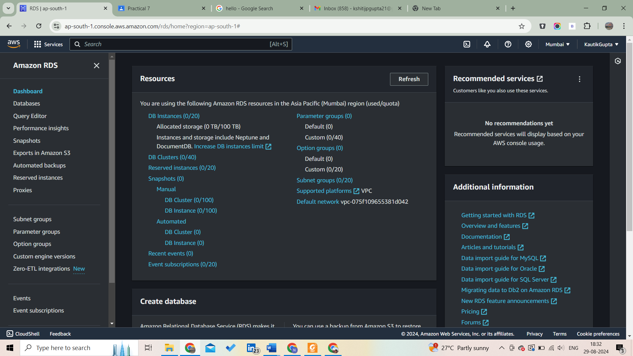

Scroll down and click on create database

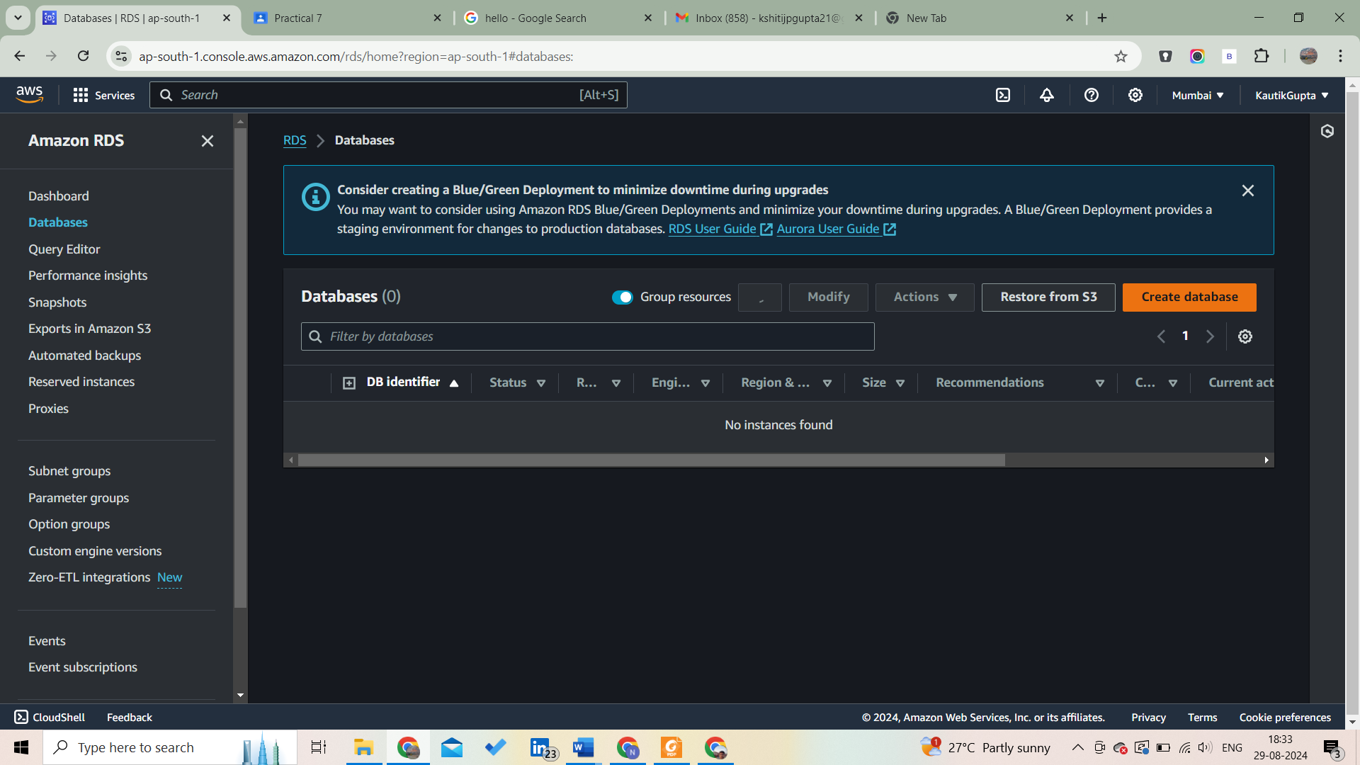

Select standard mode

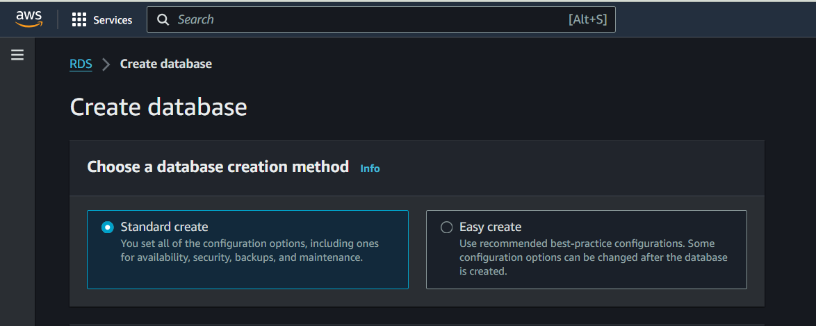

Select MySql engine

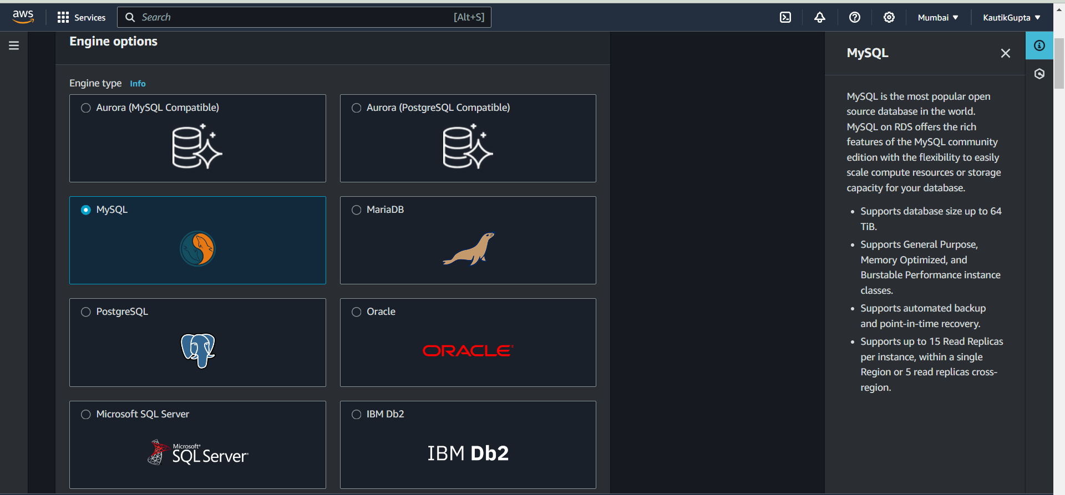

Select the version for the engine

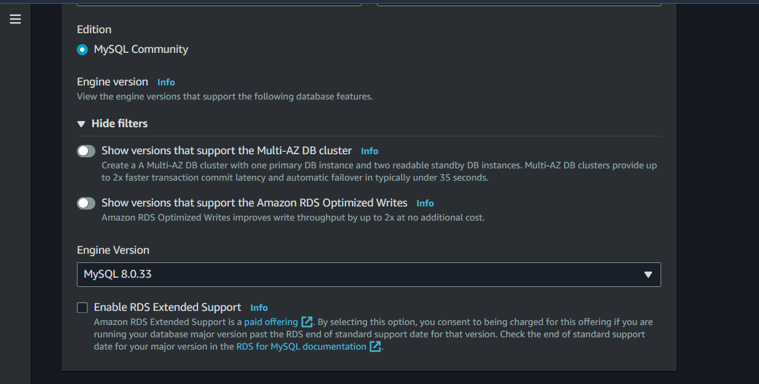

Select free tier template

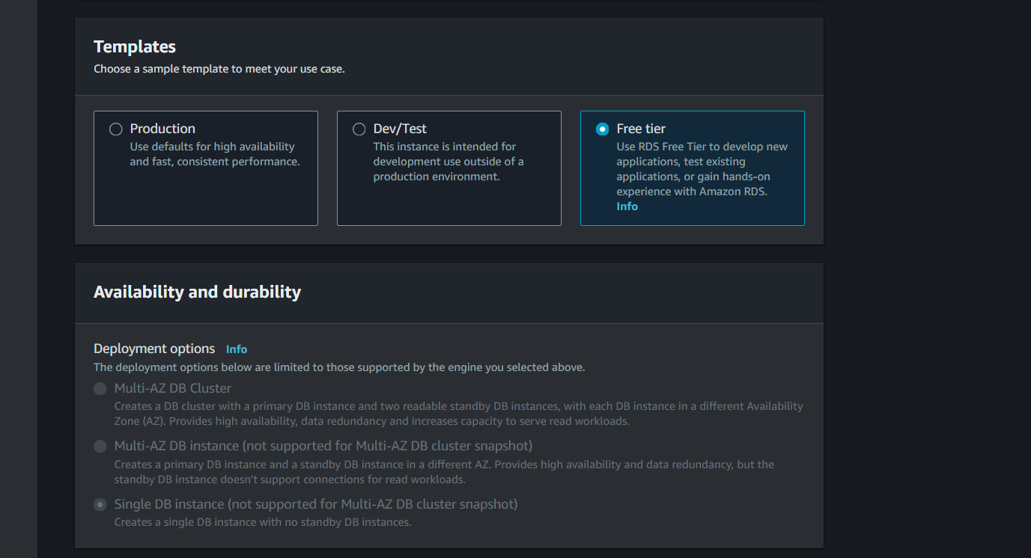

Now provide database name and master username

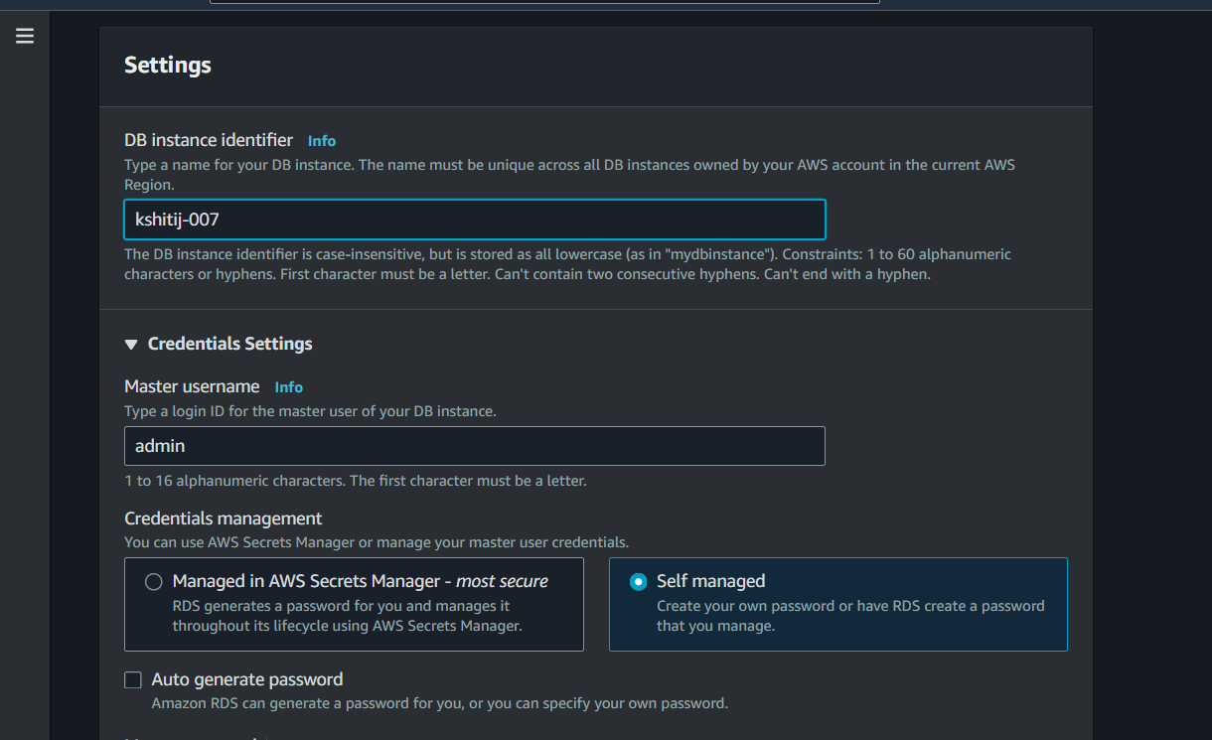

Set and confirm password

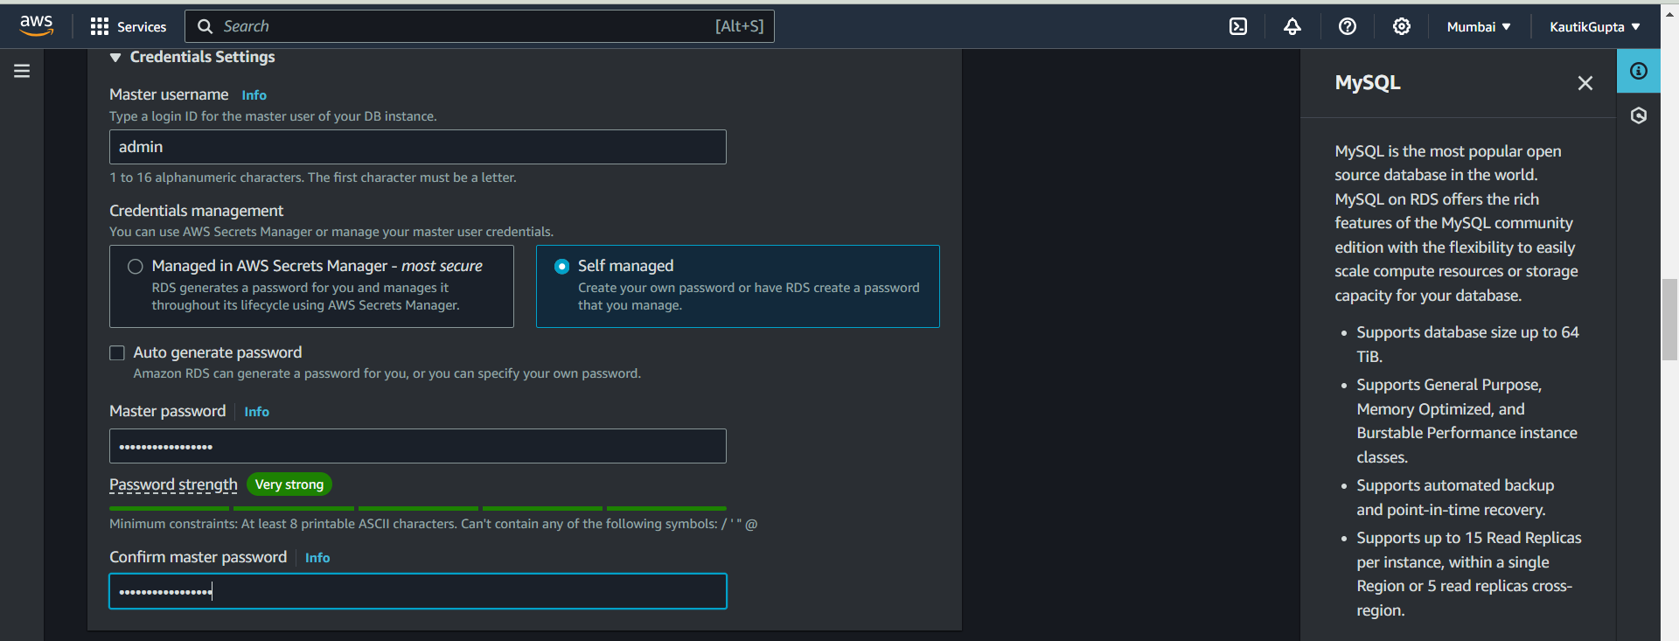

Select the db instance type

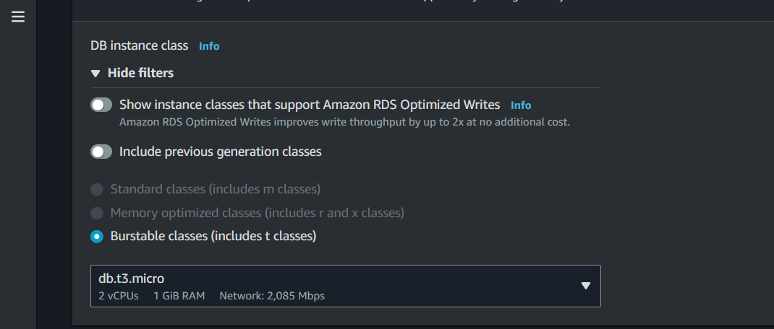

Configure storage

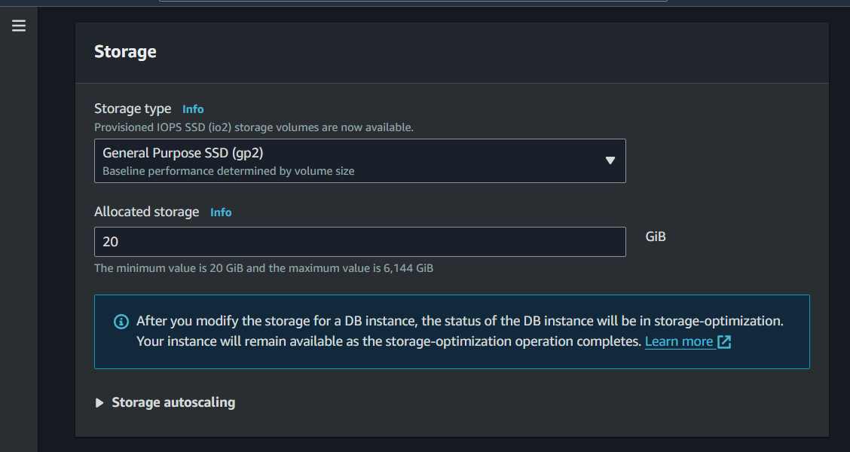

Currently not connecting it to EC2 instance

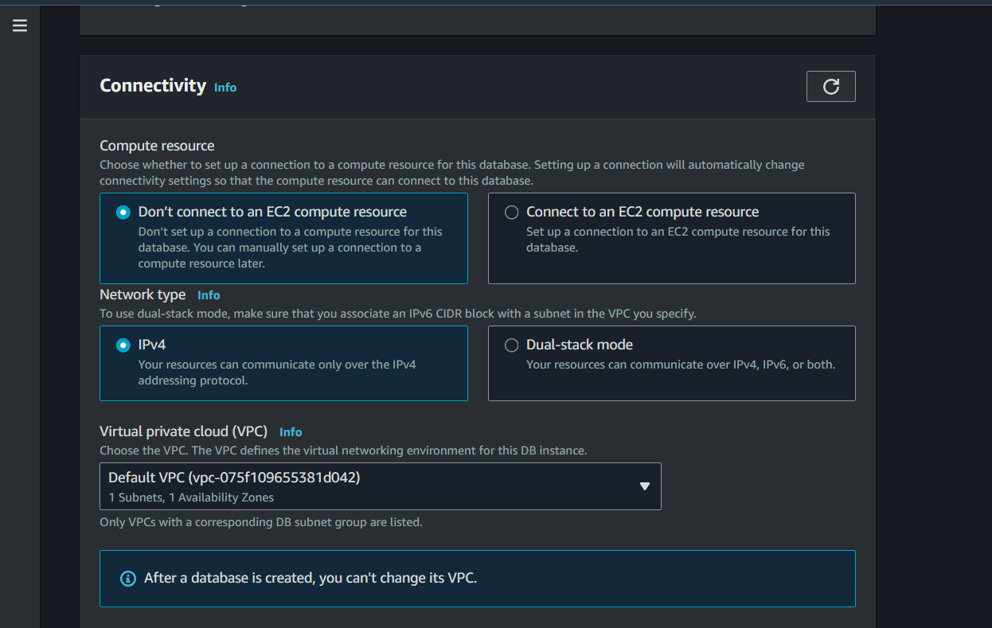

Keep public access as No and select default VPC and select the AZ

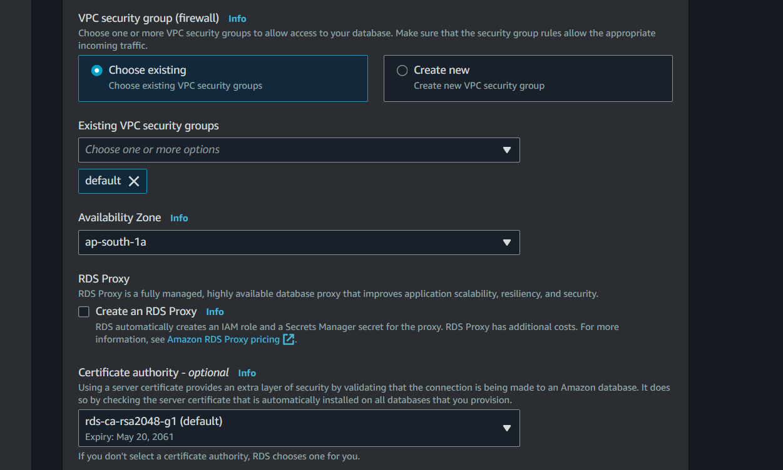

Here you can see the estimated costing

